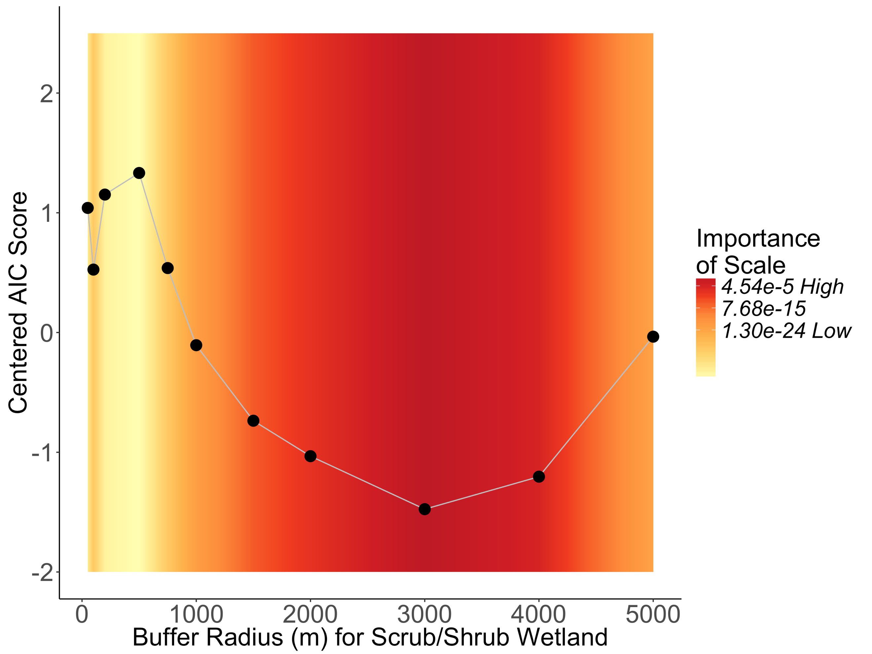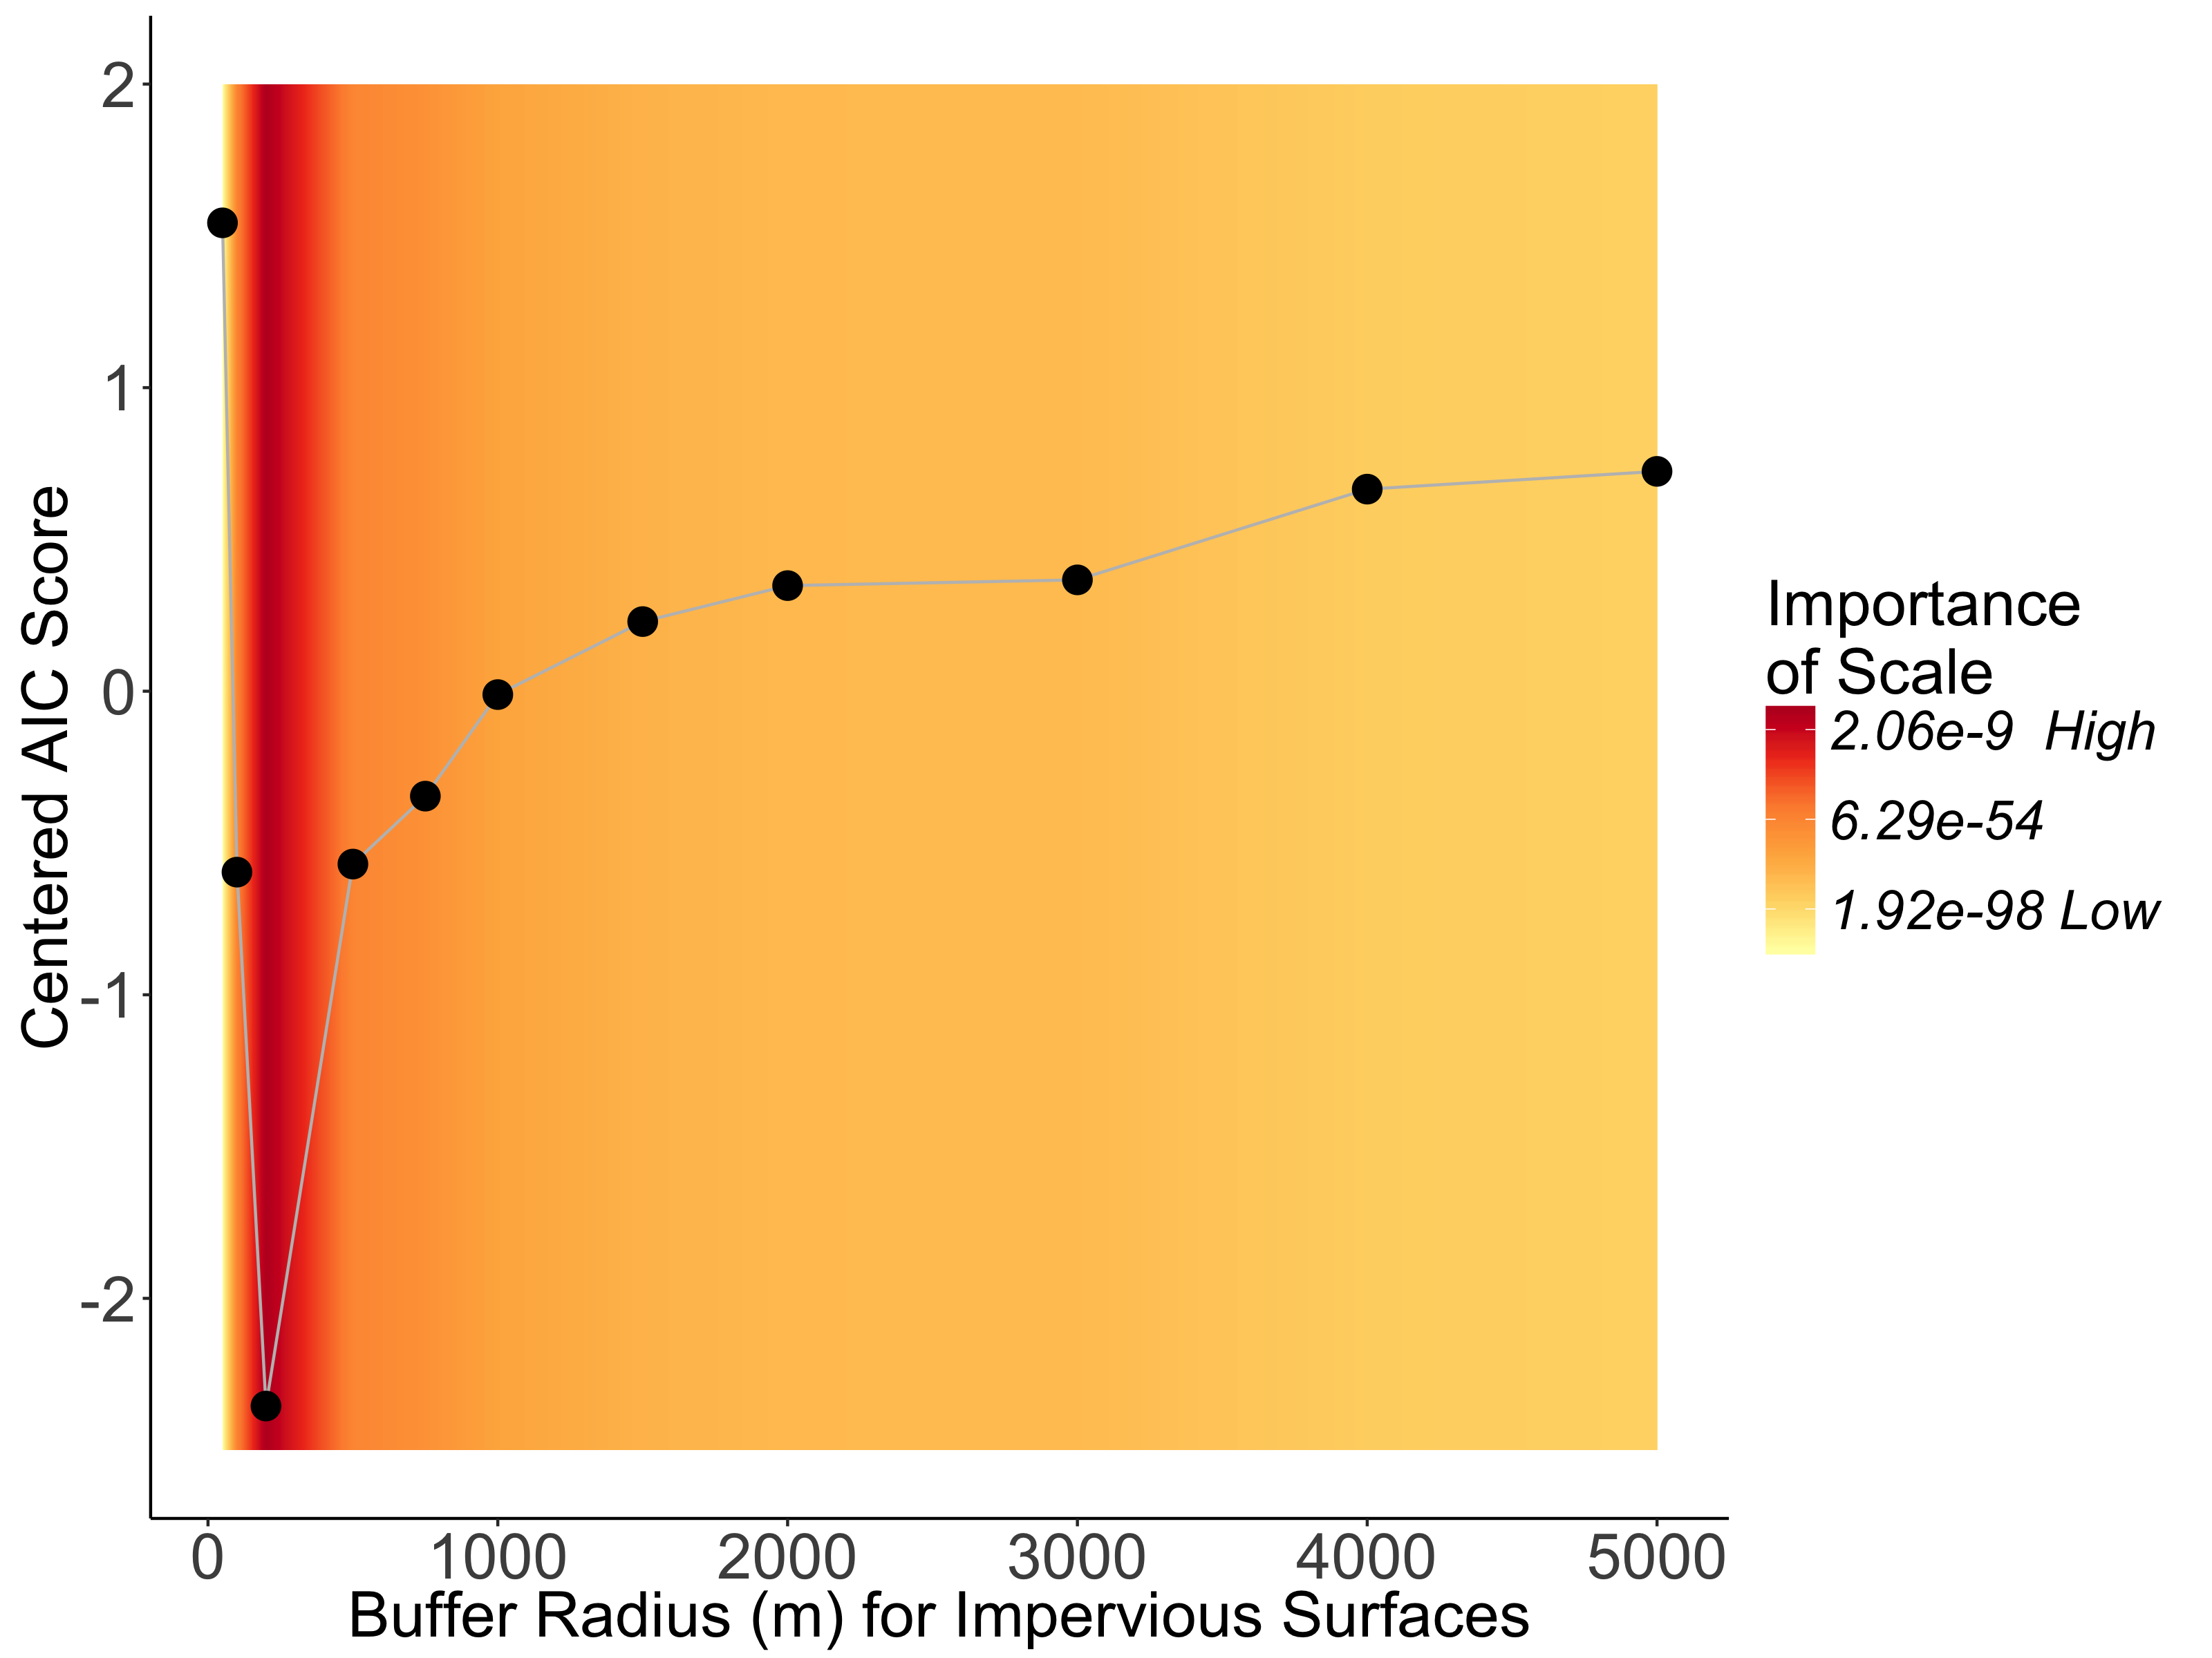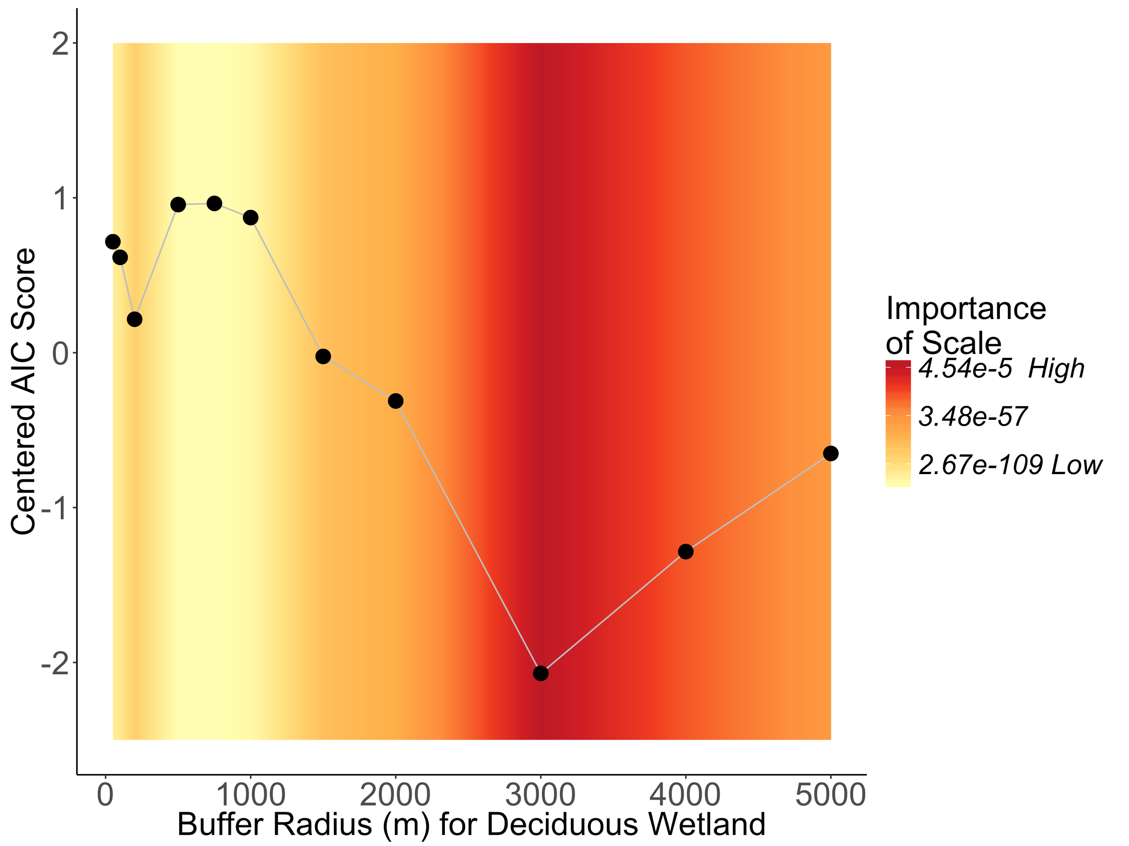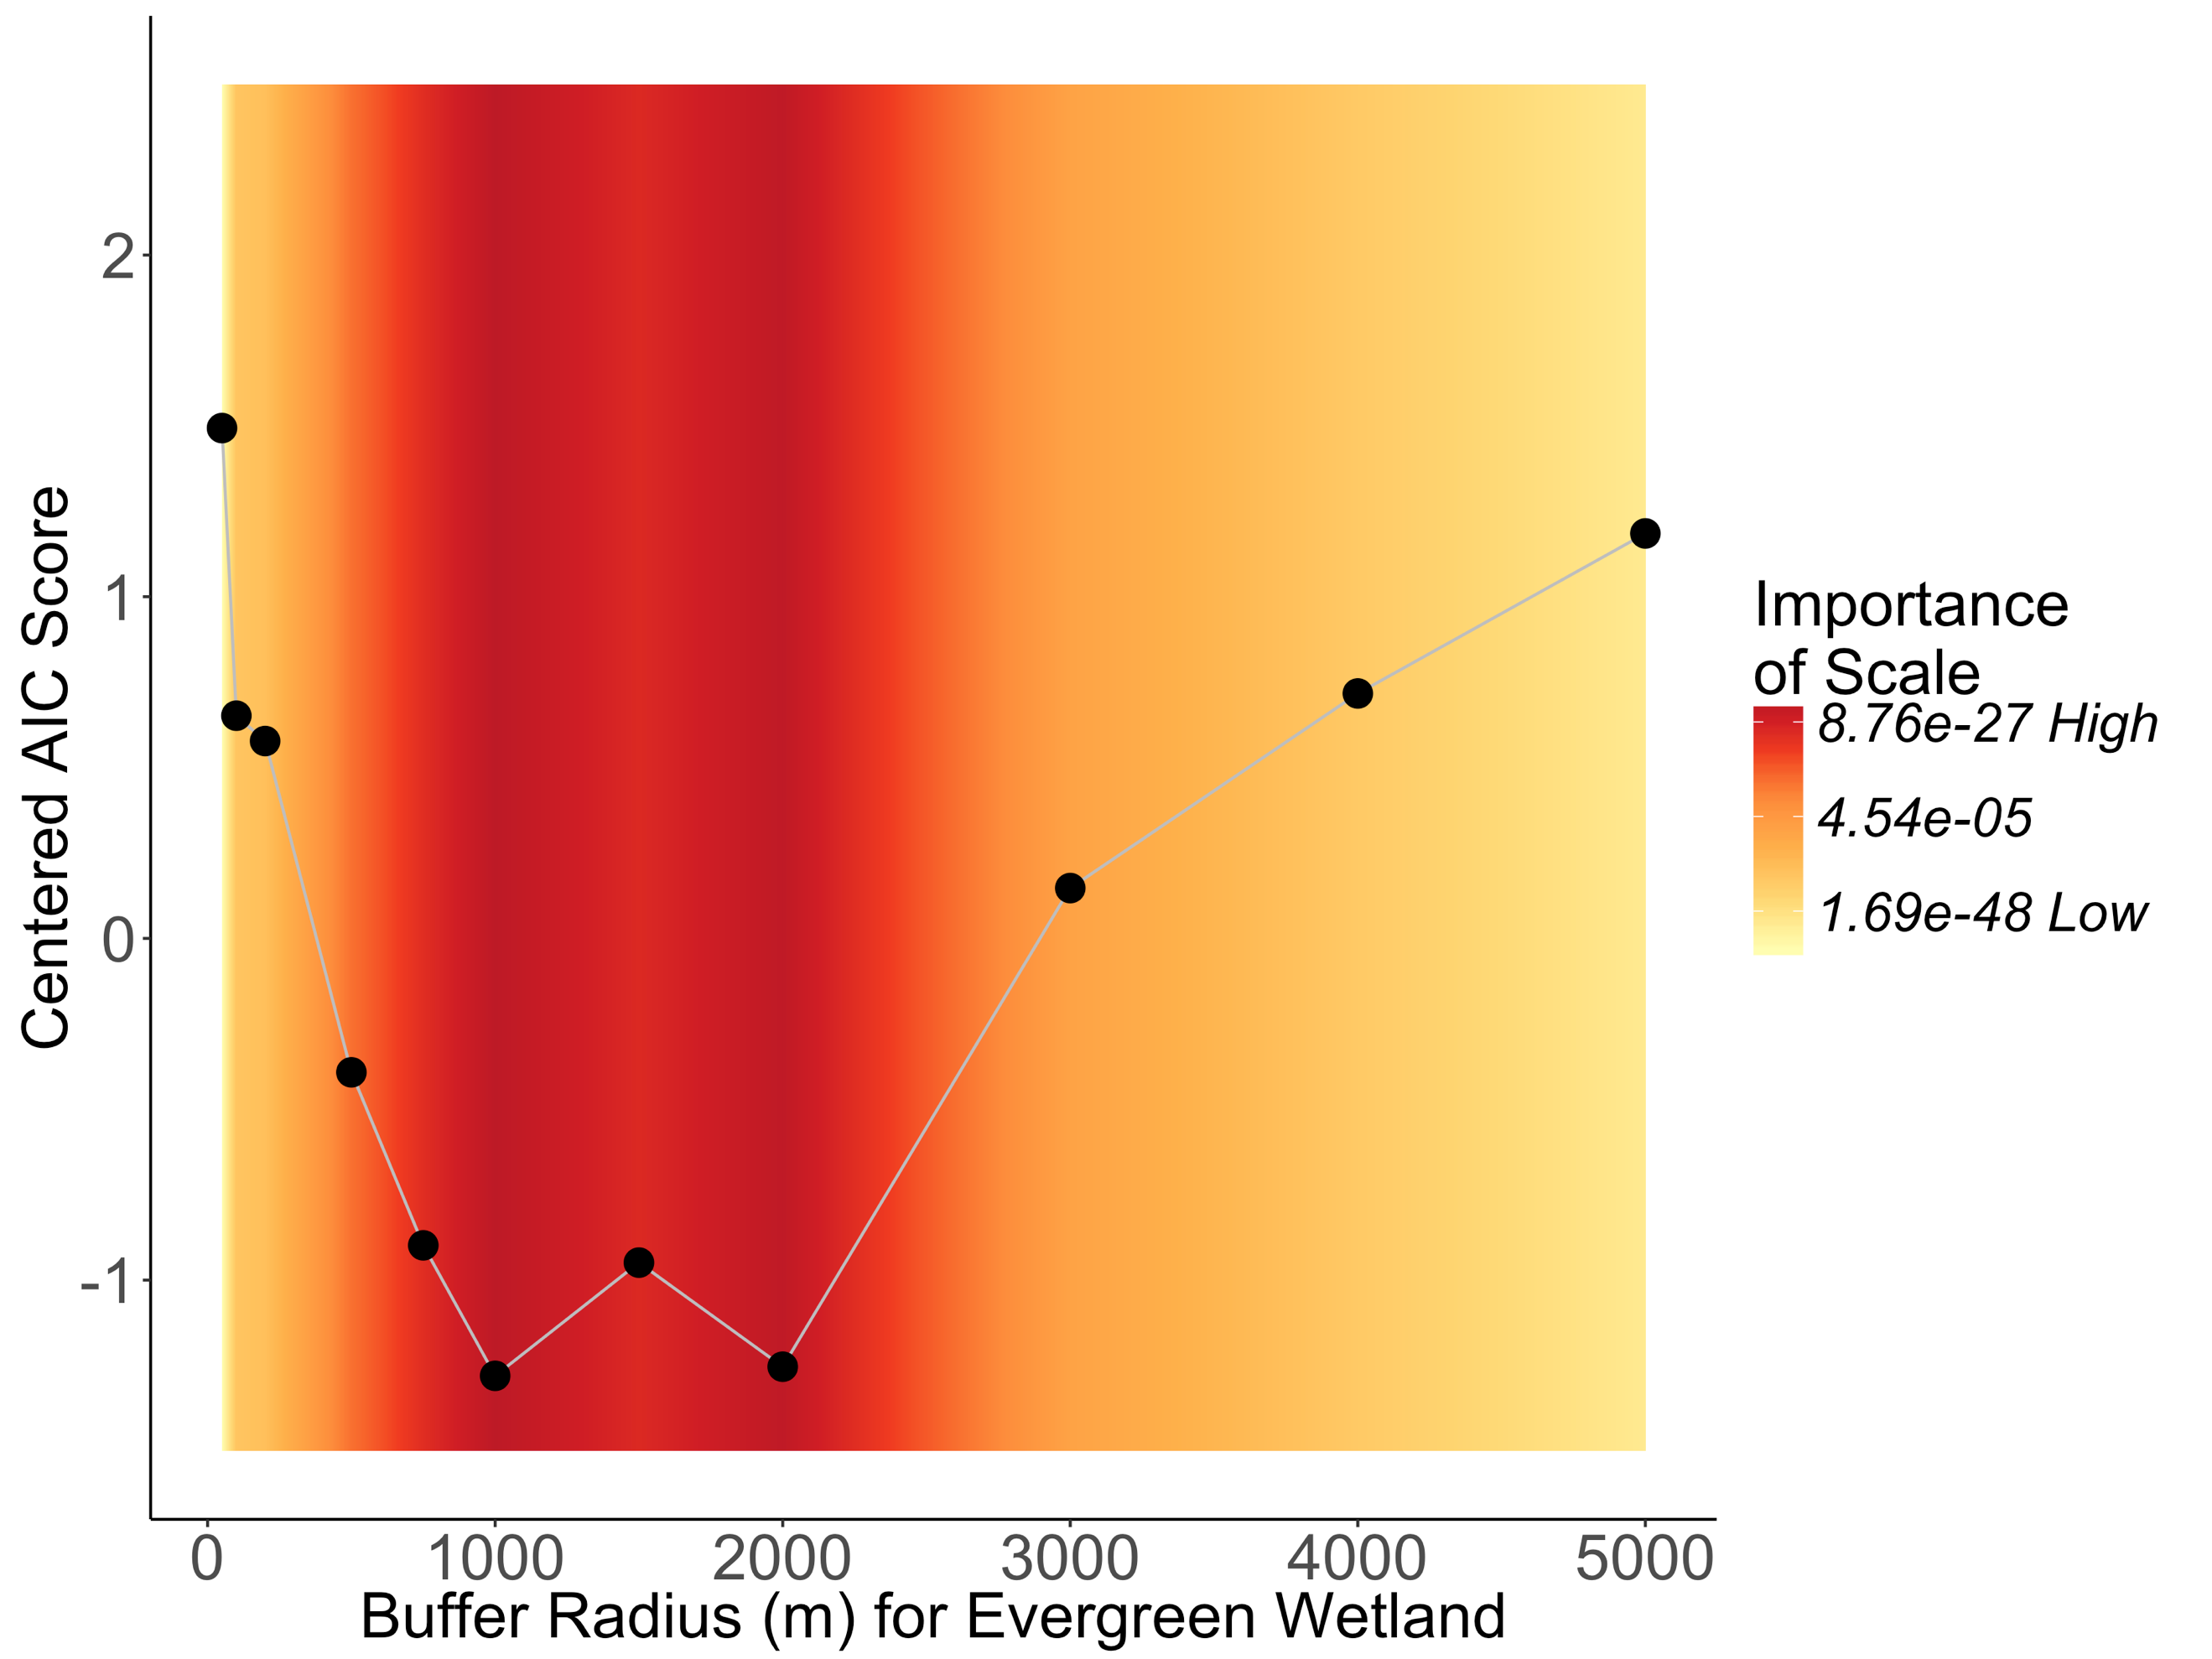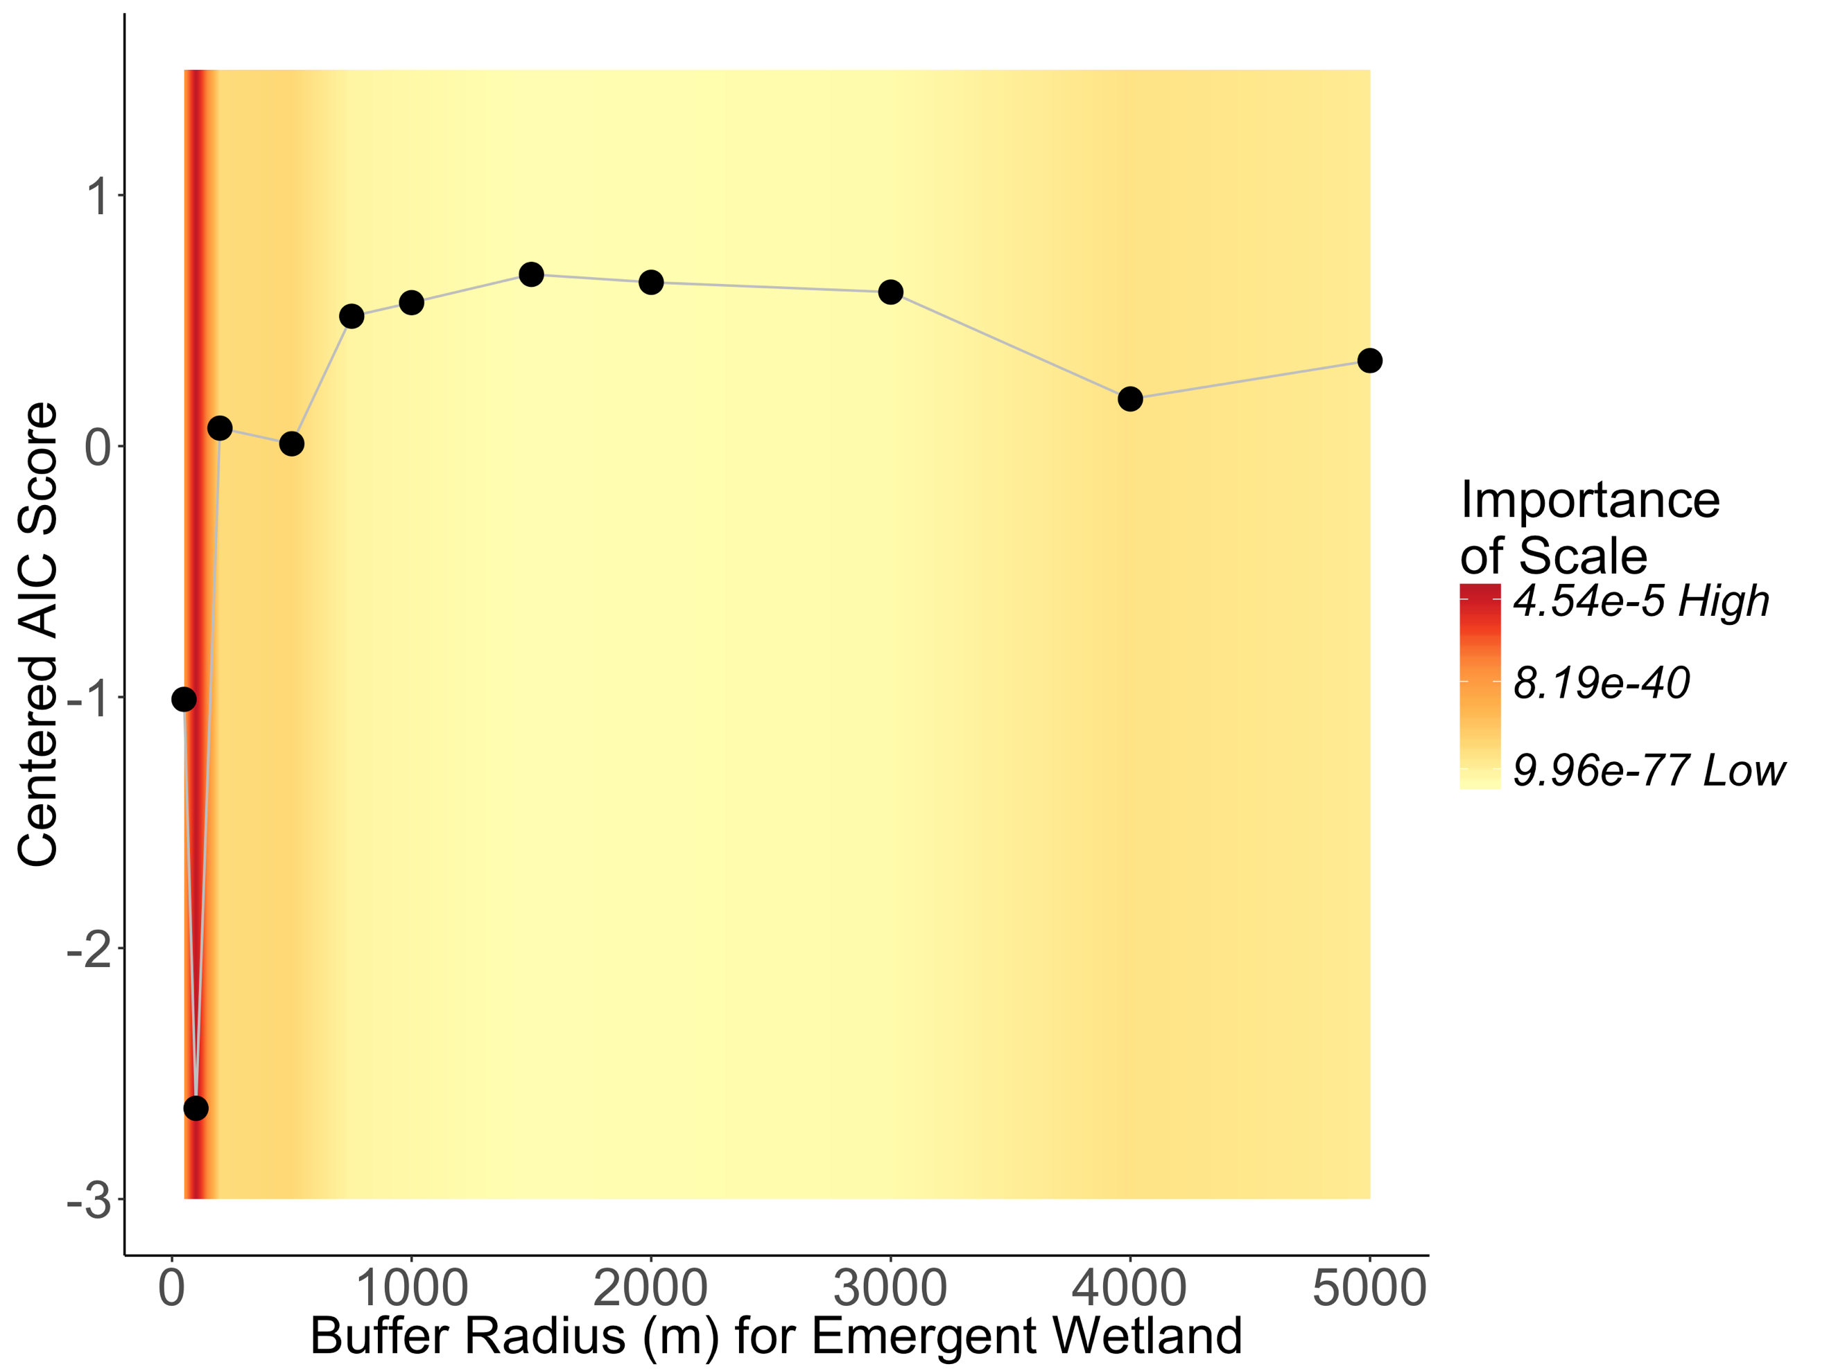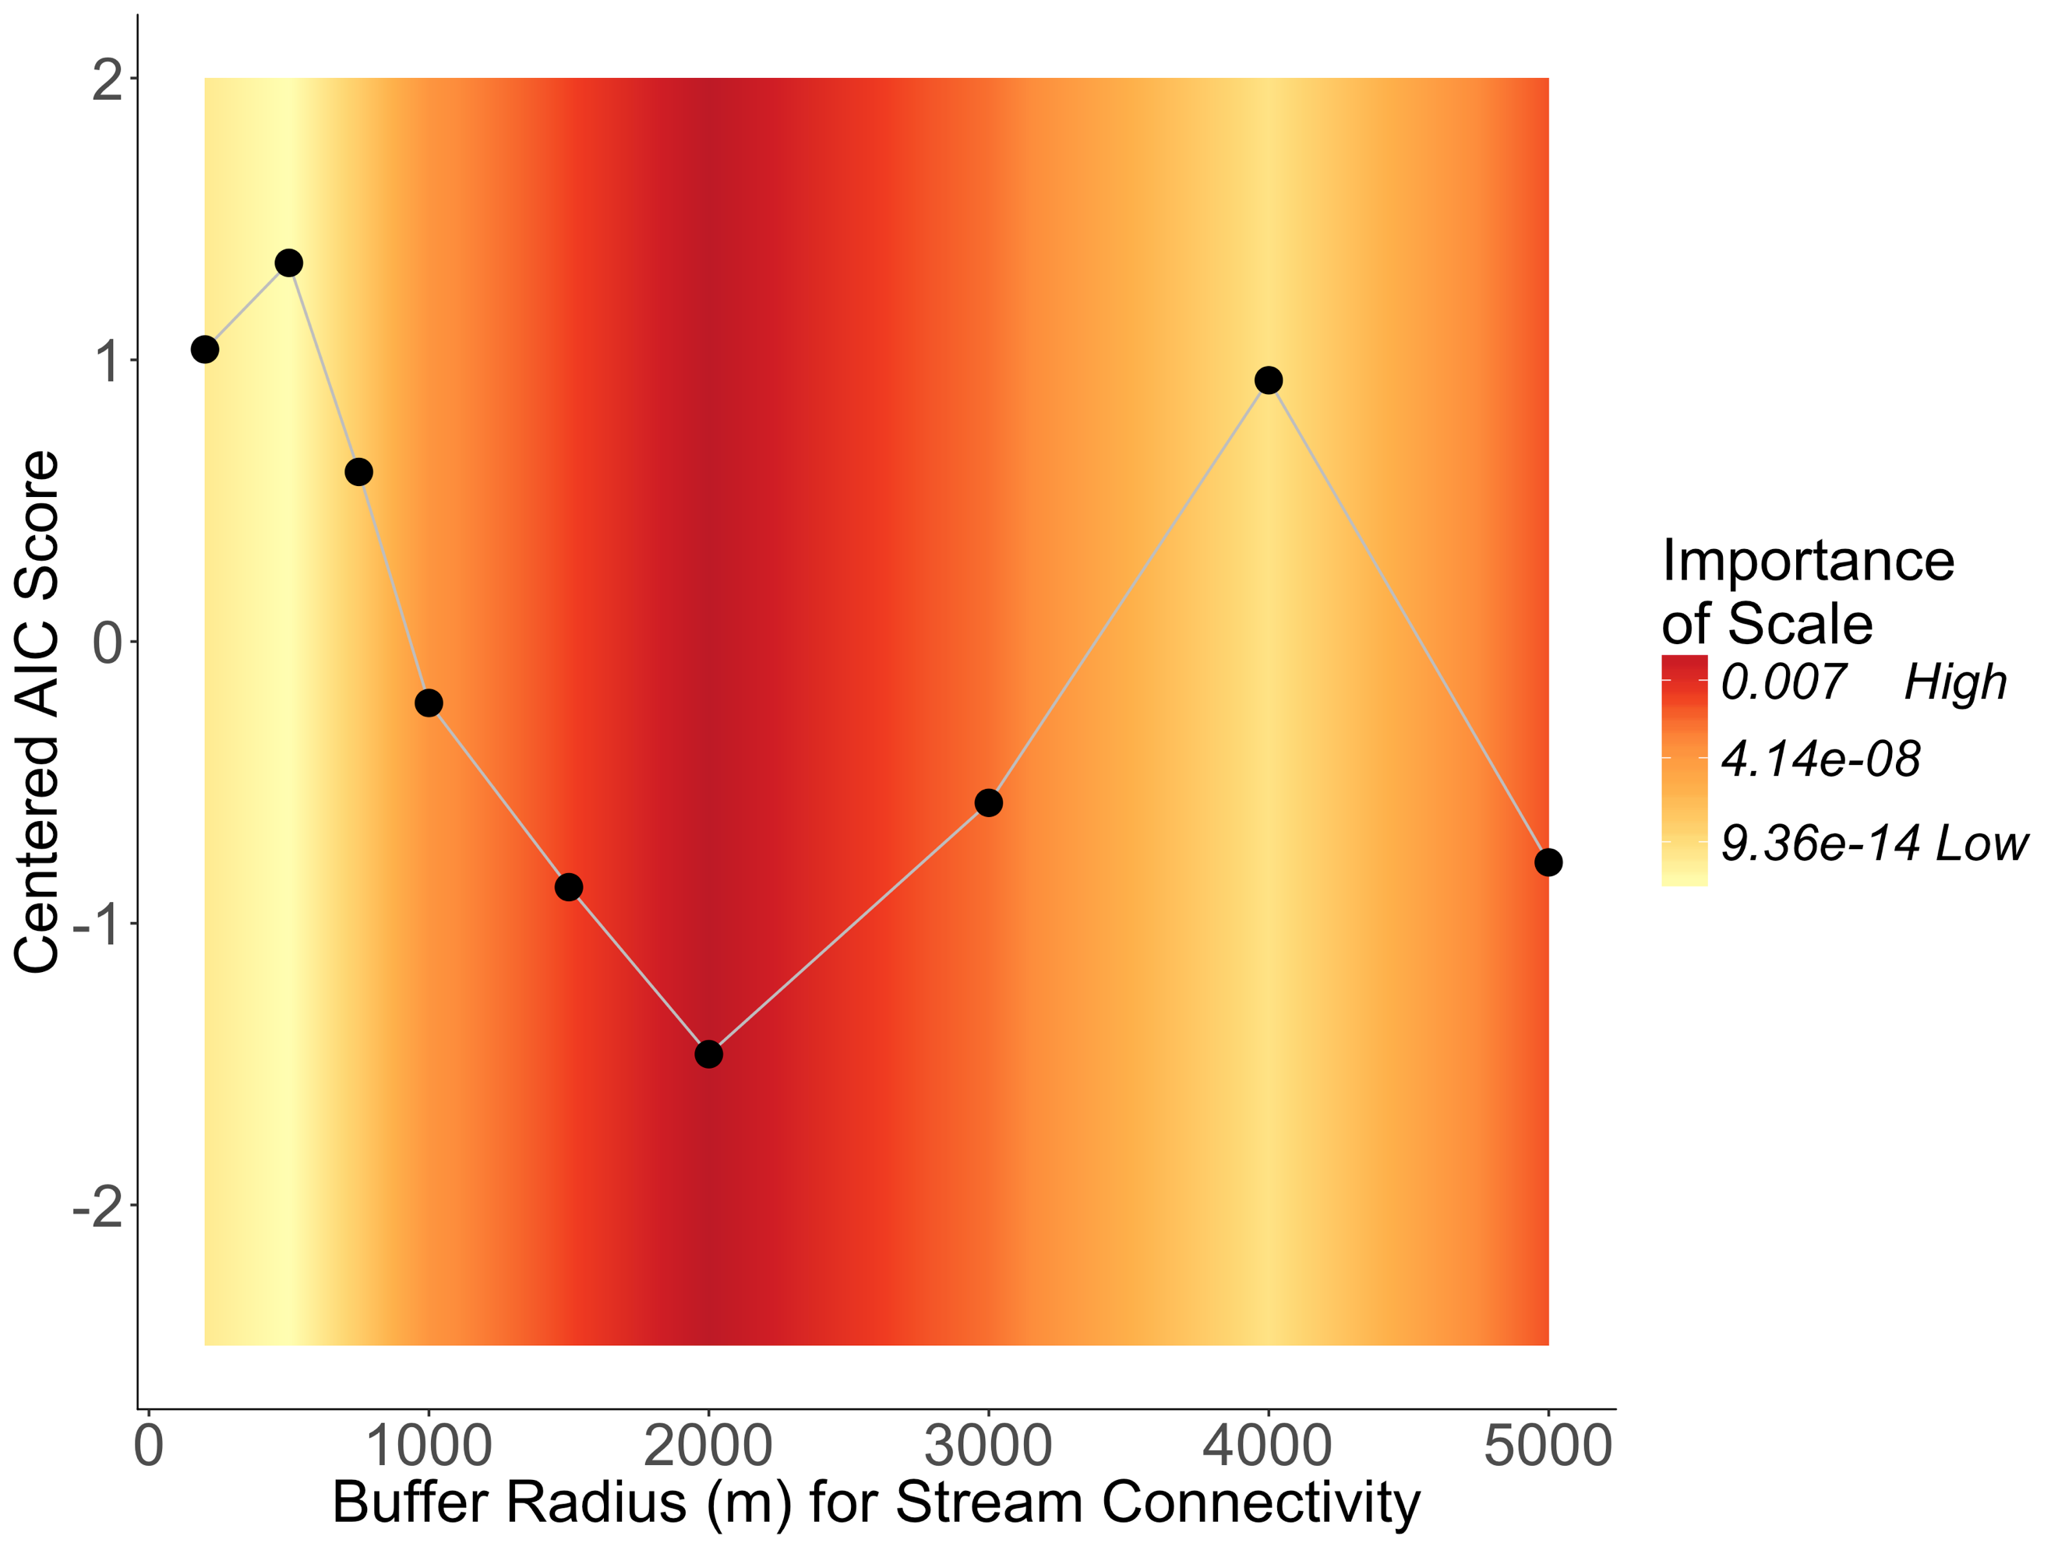

**Fig. S1:** Relative importance of spatial scales from 50 m to 5000 m for **a** mean number of stream connections to forested wetlands, **b** proportional area of emergent wetland, **c** proportional area of deciduous forested wetland, **d** proportional area of evergreen forested wetland, **e** proportional area of scrub/shrub wetland and **f** mean impervious surface coverage. Each point represents a different model explaining *Cs. melanura* abundance. The y-axis lists AIC scores for each model centered on the mean AIC score of all the models. A lower centered AIC score for a model suggests better performance for that spatial scale. The background color shows the interpolated relative importance of a particular spatial scale averaged across all the models included in the plot. Red bands indicate spatial scales where the explanatory variable has the highest relative importance

f

e

d

b

a

c