# **Supplementary Material**

**Drakesmith *et al*, Differential phonological and semantic modulation of neurophysiological responses to visual word recognition. *Neuropsychobiology*.**

1. Experiment 1 - Methods 1

1.1 Data collection 1

1.2 EEG pre-processing 2

1.3 Identification of time and regions of interest 2

2. Experiment 2 - Methods 5

2.1 MEG recording 5

2.2. Data pre-processing 5

2.3. Source localisation 5

3. Frequency × interaction effects in ERP data 6

3.1 Method 7

3.2 Results 7

3.3 Discussion 8

4. Functional significance of the N400 response 8

5. References 10

## 1. Experiment 1 - Methods

### 1.1 Data collection

Participants were seated 70 cm from a computer screen in a dimly lit room with a standard QWERTY keyboard for input. EEG data was recorded using a 64-electrode ActiveTwo system (BioSemi, Amsterdam, Netherlands) with Actiview® acquisition software (BioSemi, Netherlands) at a sampling rate of 512Hz from a 64-electrode head cap with Ag/AgCl electrodes and electrooculography (EOG) electrodes placed above and below the right eyelid to record ocular movements. In the BioSemi system, the classical “ground” and “reference” electrodes are replaced with an active and passive electrode, forming a feedback loop which drives the average potential of the subject (the Common Mode voltage) as close as possible to the ADC reference voltage in the AD-box (the ADC reference can be considered as the amplifier “zero”). A detailed description of the BioSemi electrode referencing and grounding convention can be found at <http://www.biosemi.com/faq/cms&drl.htm>.

### 1.2 EEG pre-processing

Raw data was pre-processed using the Fieldtrip toolbox [1] in MATLAB 2010a (The Mathworks, Natwick, MA, USA). The data was band-pass filtered in the range of 2-45 Hz using a Butterworth filter. For each trial, a segment of 500ms pre-stimulus and 1000ms post-stimulus were extracted. Each post-stimulus window was baseline corrected to the pre-stimulus 500ms period and detrended. Recordings were also re-referenced to the average over the scalp electrodes.

EOG artefacts were removed from the data using independent component analysis (ICA) [2]. Coherence between independent components and the EOG channel were calculated and any components showing coherence of greater than 0.7 in the 1 to 30Hz range were discarded. This frequency range was chosen as EOG components are most apparent at lower frequencies [3]. Artefacts from other sources such as electromyogram were removed using visual inspection of outliers of temporal variation. Approximately 10% of trials were rejected in total.

### 1.3 Identification of time and regions of interest

Global field power (GFP) was estimated over all sensors and subjects for each condition and window of interest. Peaks in the GFP were identified as centres for windows of interest.

A topological F-map identified topographic regions where significant effects were seen. A 1-way ANOVA testing the effects of stimulus type (words, pseudowords and consonants) was performed for each electrode, creating a statistical F-map of surface potentials. Regions on the F-map that were found significant with Bonferroni correction (applied across all EEG electrodes) were clustered together, as was a contralateral homolog of the same region. The ERP data was then averaged across all electrodes in these clusters.

The GFP from the three conditions identified three distinct components at 138ms, 207ms and 375ms. (see figure 1). The component at 375ms was only present for the consonant strings. Time windows of interest were isolated at 128-148ms, 197-217ms and 350-400ms. Hereon, these were labelled as ~130ms, ~200ms and ~400ms windows. The ~400ms window was wider (±25ms compared to ±10ms for the earlier windows) to accommodate the smoother and more sustained response seen at this point in time.

The results of the F-maps are shown in figure 2. There was a small effect in bilateral occipital regions at ~130ms which did not survive multiple comparison correction and were not considered for further analysis. There was a strong effect in bilateral occipital regions, left frontal regions and a weaker effect in right frontal regions at ~200ms. At ~400ms, there was a strong effect in bilateral frontal electrodes and central electrodes. Based on these F-maps, the electrode map was partitioned into 6 regions as in figure 3 and the averaged ERPs corresponding to each region are shown in figure 4.

MAC OS:Users:mrkdsmith:Documents:Work:Paper_ERP_LCMV_JoCN:ERP_NPS_REVISIONS:fig1.eps

Figure 1. GFP for all ERPs in all consonant and non-consonant trials.

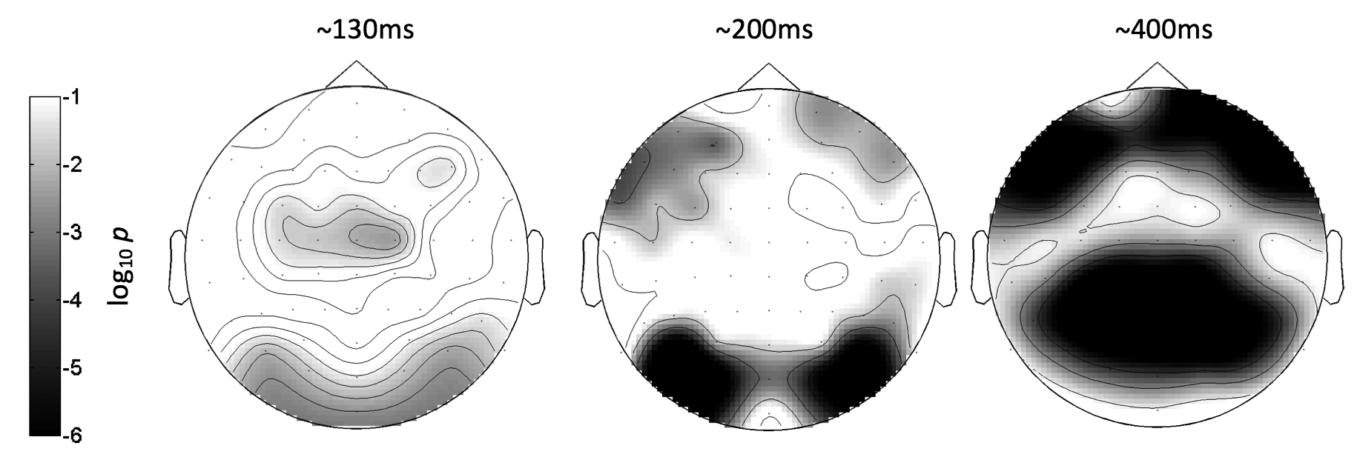

Figure 2. Topographic statistical F-maps of ANOVA testing for the effect of stimulus type on ERP amplitude in each time window.

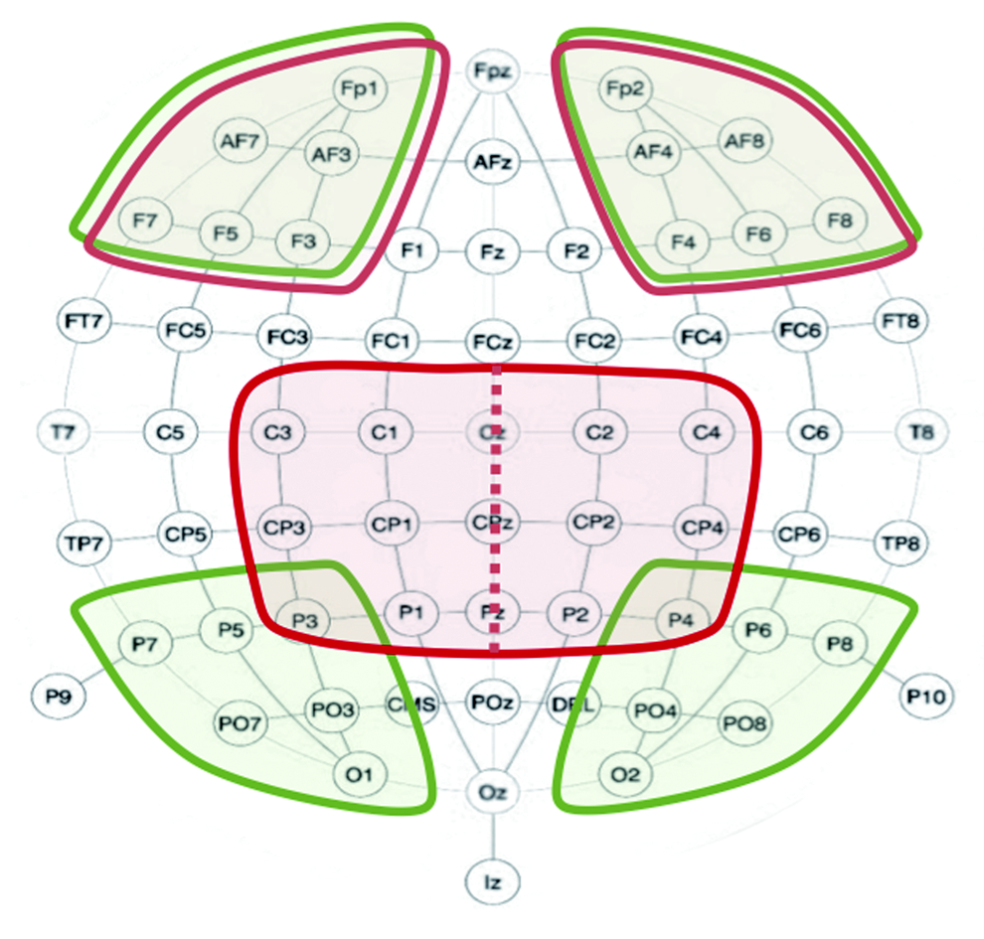

Figure 3. Grouping of EEG electrode by regions identified as showing significant stimulus effects (figure 2) and in cases of asymmetry, their contralateral homologues. Areas encircled in black and grey indicate sensors grouped for ~200ms and ~400ms, respectively.

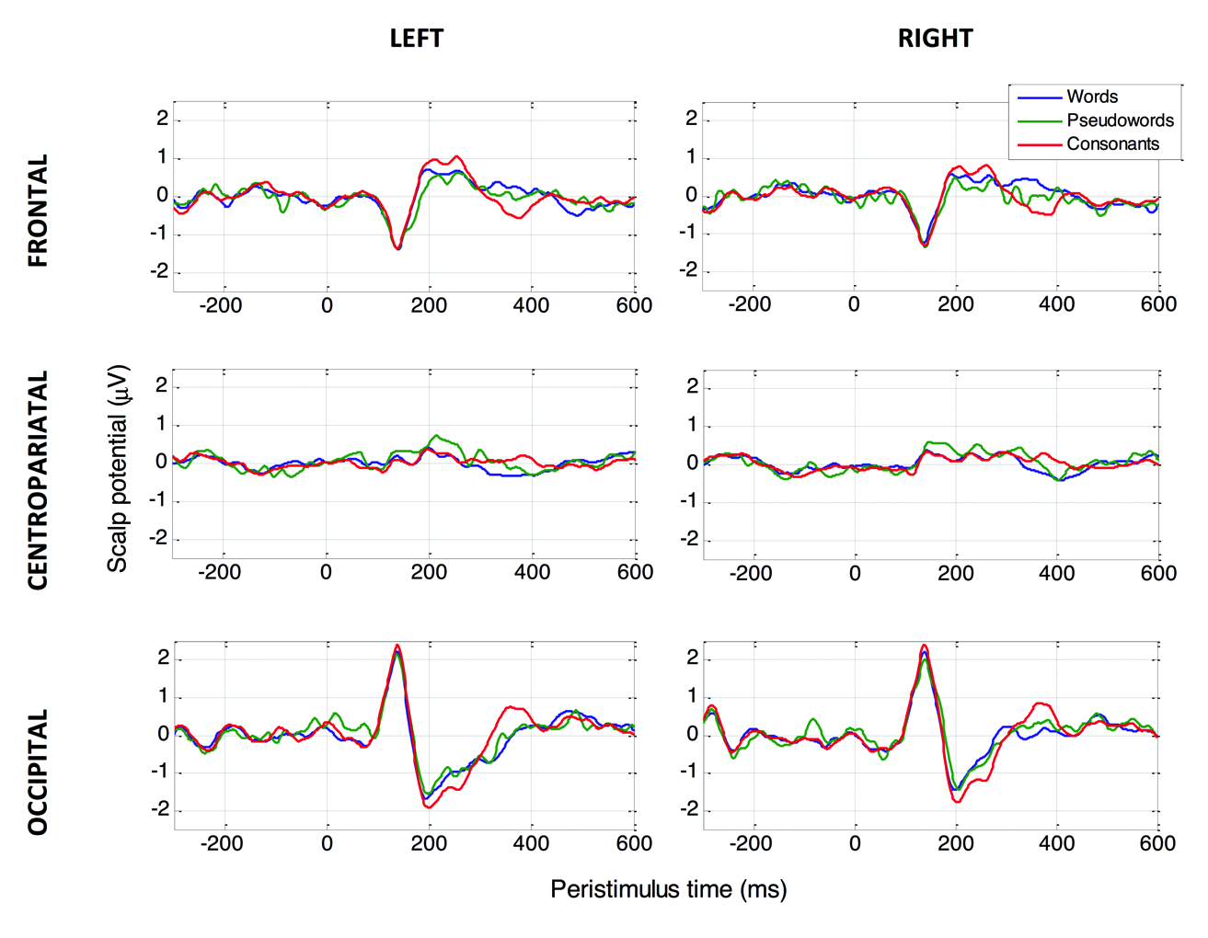

Figure 4. ERPs for the three main conditions in the three highlighted regions of interest (top: occipital, middle: frontal, bottom: central)

## 2. Experiment 2 - Methods

### 2.1 MEG recording

To identify the spatio-temporal generators of the effects observed in the ERP (at ~200 and ~400 ms), MEG data was collected from 16 healthy right-handed participants (9 male, 7 female, average age: 29.5) while performing the same task. Data was recorded in a magnetically shielded room using a 4-D MAGNES 2500 WH MEG acquisition system utilising 148 axial 1st order gradiometers (4-D Neuroimaging, San Diego, CA, USA). Participants laid in supine position with a screen directly above approximately 1m onto which the stimuli is projected from outside the room. Subjects’ head shape were digitised, and 5 head localisation coils placed on the subject’s head and localised immediately before and after the main acquisition session. The coil positions were later co-registered with the gradiometer locations with a rigid affine transform.

Electrodes were placed above and below the right eye-lid to record EOG artefacts, and on the left and right clavicles to record electrocardiography (ECG) artefacts. MEG data was digitised at 24-bit resolution and a sampling rate of 678.17Hz. Reference magnetometers and gradiometers recorded environmental noise and were used for real-time analogue noise reduction during the main acquisition session.

### 2.2. Data pre-processing

Raw data was pre-processed using the Fieldtrip toolbox [1] in MATLAB 2010a (The Mathworks, Natwick, MA, USA). The data was band-pass filtered in the range of 2-45 Hz using a Butterworth filter. For each trial, a segment of 500ms pre-stimulus and 1000ms post-stimulus were isolated. Each post-stimulus window was baseline corrected to the pre-stimulus period and detrended. EOG and ECG artefacts were removed from data using independent component analysis (ICA) [2]. Coherence between all components and the ECG/EOG were calculated and any components showing coherence of greater than 0.7 in the 1-30Hz range were discarded. Visual inspection was used to remove any trials still showing significant outliers.

### 2.3. Source localisation

Linear constrained minimum variance (LCMV) [4] spatial filtering was applied to MEG to locate sources. LCMV is a beamformer technique that uses an adaptive spatial filter to estimate the variance of source currents at a given location for a given time window. Spatial filters were calculated for each subject from the covariance matrix calculated across all epochs. The same spatial filter was used to estimate sources for all conditions. Current source variances were then estimated for the two time windows. Wider time windows were used since the LCMV is sensitive to source variance rather than absolute amplitude, the windows were 150-250ms for the ~200ms window and 325-475ms for the ~400ms window. To ensure no effects are apparent at earlier time window, source activity was also estimated for a window centered at 150ms (120-180ms).

High-resolution 3D anatomical scans were obtained from a 3T Philips MR Achieva scanner (Philips Electronics, Amsterdam, The Netherlands) using a T1-weighted Turbo gradient echo (T1-TFE) sequence: TR=8.4ms, TE=3.8ms, flip angle=8°, turbo factor=84, FOV=240×240mm, slice thickness = 1.8mm with a slice separation of -0.9mm, voxel dimensions = 0.94×0.94×0.9mm, image dimensions = 256×256×160 voxels.

These images were co-registered with the digitised head shape and head position coils using a rigid affine transform. The images were then segmented [5] into grey and white matter compartments using SPM8 (Wellcome Department of Imaging Neuroscience, London, UK). The grey matter component was used to create single-shell volume conductor models [6] from which the lead field was calculated.

Due to anatomical inconsistencies that can arise when applying traditional spatial normalisation routines to multi-subject data, the source space for each subject was defined within a normalised group template. The group template was derived using a non-rigid diffeomorphic registration routine (DARTEL) [7]. Single subject deformation fields and a normalised template were calculated for segmented grey matter, on which were positioned a 7.5mm3 resolution grid restricted to superficial grey matter within 4cm of the scalp surface. The source points were then inverse-deformed into subject native space, which then served as source points from which each subjects lead fields were calculated. This allowed the beamformer images to be rendered directly on to the template image negating the need for spatial normalisation of individual subject beamformer images.

## 3. Frequency × interaction effects in ERP data

Semantic access during word reading is often measured in behavioural studies by the interaction between word frequency and pronunciation regularity. In various lexical decision tasks, reaction times to low frequency irregular words are typically higher than for other word categories [8,9]. The triangle models of reading have demonstrated that such effects emerge as a result of the statistical properties of the concepts that the models learn during training [10,11]. Greater involvement of semantic processing is required for these words, as phonological information is in conflict with semantic information. The frequency × regularity interaction does not typically manifest in neuroimaging data, although one exception is [12], an rCBF-PET study, which found a small interaction effect in the left inferior frontal gyrus. More consistent results have been found by focussing only on low frequency / irregular words, as these place greater demands on semantic processing. These studies have generally implicated the middle and inferior temporal gyri [13,14]. These regions are, therefore, likely to be important in semantic analysis of visually presented words, even in the absence of explicit semantic processing.

### 3.1 Method

This tested for effects in the full factorial frequency (high and low) × regularity (regular and irregular) design along with the effects of hemisphere and regions, resulting in a mixed-effects ANOVA with a 2×2×2×2 fixed effect design. Subject was specified as a random effect. This attempted to identify the frequency × interaction effect. Following these ANOVAs, post-hoc *t*-tests were used to identify specific effects. Only in results where ANOVA tests found significant interactions between the effect of interest with region and/or hemisphere were the corresponding *t*-tests considered significant.

### 3.2 Results

Significant effects were found only in the ~400ms window. There was a word frequency x region interaction (F1, 10.59=5.995, p=0.026). Post hoc t-tests showed in the frontotemporal regions high frequency regular words had significantly higher amplitudes, compared to low frequency regular words (t=2.97, p=0.0015) and low frequency irregular words (t=3.56, p<0.001). The ERPs for each word sub-condition in frontal electrodes are shown in figure 5. A significant regularity × frequency interaction was not observed. There is, however, an apparent gradient of semantic ‘accessibility’ of which the high-frequency regular words and low-frequency irregular words are extremes within the word sub-types.

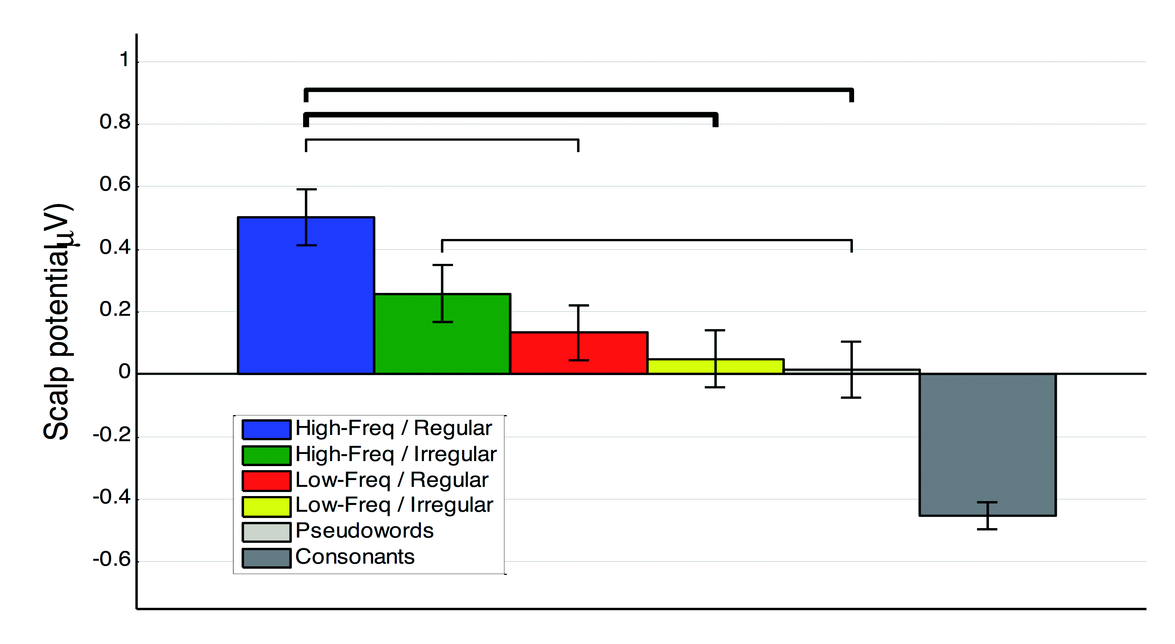

Figure 5. ERP amplitude in frontal regions at 400ms for the word sub-types. Significance bars indicate results of post-hoc t-tests (thin bars: p<0.05, thick bars: p<0.001).

### 3.3 Discussion

The failure to identify a frequency × interaction effect presents a challenge for the triangle model, which would predict that low-frequency irregular words require the up-regulation of semantic processing to compensate for phonological irregularity. This mechanism does not manifest as a significant interaction in the N400 response. However, the absence of this effect in the ERPs should not be taken as a contradiction of the triangle model *per se*, as the responses in the ERPs do appear to follow the expected direction.

## 4. Functional significance of the N400 response

The N400 response can be interpreted as a language-specific example of the oddball response, which typically occurs slightly earlier and is modulated by stimulus probability. Unlike the oddball response, the N400 is sensitive to symbol-based incongruences rather than absolute incongruences [15]. In most N400 literature, the latency of the peak of the N400 is relatively stable, while in this study, it is slightly early at 375ms. The response observed could therefore be defined as a late P3b response [16]. The gradient of high frequency / regular words to low frequency / irregular words is consistent with this. However, if it was a pure P3b response, there should be no difference between pseudowords and consonant strings, as they have equal lexical probabilities. The P3b explanation could also fit in the framework of being sensitive to phonological probability: word-forms present in the pseudowords are also encountered in natural language, but word-forms in consonant strings are not. However, this study should be able to identify a main effect of regularity in the word sub-type ANOVA if this was the case. We therefore argue that the response observed here should be regarded as an N400-like response, as it appears to be strongly sensitive to semantic content/lexical familiarity. In the context of a task where the anticipated stimuli is a proper noun the most unexpected stimulus (consonant string) generates the largest N400 response while high frequency phonologically regular words generate the smallest.

This brings into question what this 400ms response represents. The fact that the response gradient peaks with the consonant strings contradicts the assertion previous studies make that the N400 is an indicator of semantic access. However, this study does show that the N400 is better understood as representative of context integratability of the stimulus. When testing the word subtypes, there is an effect of frequency and that there is significant difference between the high-frequency regular words and low frequency irregular words. This, coupled with the failure to find a significant frequency × interaction, further suggests that integratability is responsible for the modulation of this response rather than semantic access. With there being no apparent effects of semantics in the EEG data, there are implications for interpretation of the N400, as many ERP studies treat the N400, as a metric for semantic processing. The origins of the familiarity response for lexical stimuli appears to lay predominantly in posterior parts of the left temporal lobe. This has particularly strong implications to studies that have localised ERPs apparently sensitive to lexical stimulus to similar regions in similar time windows [17,18].

A number of previous studies have used the superior spatial resolution of MEG to identify contributing components to the EEG N400. These suggest that there are multiple sources that contribute to the N400 [19]. Pylkkänen *et al* [20] looked at MEG waveforms contributing to the 400ms response via a paradigm designed to facilitate early lexical processing while also inhibiting the decision stages of the lexical decision task. They found that phonotactic probability (probability of phoneme combinations as opposed to purely lexical or phonological probabilities) was a key driver of the N400 response. This response occurred at about 350ms, placing it slightly earlier than the response observed in our study. The sensitivity of this response to phonotactic probability is also consistent with our results and clearly highlights the importance of designs that can distinguish between these factors. Additional work is required to fully understand the components that drive the N400 and the stimulus properties these components are responsive to (see [21] for further discussion).

The differentiation between phonological familiarity/integratability and semantic access is not the primary focus of this study; it is simply being exploited to obtain a metric of semantic processing, which is not dependent on processes involved in the integration into current context or the accessibility of the stimulus. However, it is of interest as it does suggest that a lot of the activity often attributed to semantic processing, include concurrent responses that are sensitive to familiarity or integratability. In an fMRI study [22], there were higher BOLD responses in the anterior temporal cortex and posterior inferior temporal gyrus, amongst other regions, when trying to integrate words into a sentence context, compared to pseudowords. Similar results were found where semantic decisions on words elicited higher BOLD responses in the anterior temporal cortex and posterior parts of the middle temporal gyrus [23].

## 5. References

1. Oostenveld R, Fries P, Maris E, Schoffelen J-M: FieldTrip: Open source software for advanced analysis of MEG, EEG, and invasive electrophysiological data. Comput Intell Neurosci 2011 Jan;2011:156869.

2. Jung TP, Makeig S, Westerfield M, Townsend J, Courchesne E, Sejnowski TJ: Removal of eye activity artifacts from visual event-related potentials in normal and clinical subjects. Clin Neurophysiol 2000 Oct;111:1745–58.

3. Hagemann D, Naumann E: The effects of ocular artifacts on (lateralized) broadband power in the EEG. Clin Neurophysiol 2001 Feb;112:215–231.

4. Van Veen BD, van Drongelen W, Yuchtman M, Suzuki A: Localization of brain electrical activity via linearly constrained minimum variance spatial filtering. IEEE Trans Biomed Eng 1997 Sep;44:867–880.

5. Ashburner J, Friston KJ: Unified segmentation. Neuroimage 2005 Jul 1;26:839–51.

6. Nolte G: The magnetic lead field theorem in the quasi-static approximation and its use for magnetoencephalography forward calculation in realistic volume conductors. Phys Med Biol 2003 Nov 21;48:3637–3652.

7. Ashburner J: A fast diffeomorphic image registration algorithm. Neuroimage 2007 Oct 15;38:95–113.

8. Andrews S: Phonological recoding: Is the regularity effect consistent? Mem Cognit 1982 Nov;10:565–575.

9. Monsell S, Patterson KE, Graham A, Hughes CH, Milroy R: Lexical and sublexical translation of spelling to sound: Strategic anticipation of lexical status. J Exp Psychol Learn Mem Cogn 1992;18:452–467.

10. Seidenberg MS, McClelland JL: A distributed, developmental model of word recognition and naming. Psychol Rev 1989;96:523–568.

11. Plaut DC, McClelland JL, Seidenberg MS, Patterson K: Understanding normal and impaired word reading: Computational principles in quasi-regular domains. Psychol Rev 1996 Jan;103:56–115.

12. Fiez JA, Balota DA, Raichle ME, Petersen SE: Effects of Lexicality, Frequency, and Spelling-to-Sound Consistency on the Functional Anatomy of Reading. Neuron 1999 Sep;24:205–218.

13. Frost S, Mencl WE, Sandak R, Moore DL, Rueckl JG, Katz L, et al.: A functional magnetic resonance imaging study of the tradeoff between semantics and phonology in reading aloud. Neuroreport 2005;16:621–624.

14. Joubert S, Beauregard M, Walter N, Bourgouin P, Beaudoin G, Leroux J-M, et al.: Neural correlates of lexical and sublexical processes in reading. Brain Lang 2004 Apr;89:9–20.

15. Kutas M, van Petten C: Event-related brain potential studies in language. Adv Psychophysiol 1988 Dec;3:139–187.

16. Chapman RM, Bragdon HR: Evoked Responses to Numerical and Non-Numerical Visual Stimuli while Problem Solving. Nature 1964 Sep 12;203:1155–1157.

17. Helenius P, Salmelin R, Service E, Connolly JF: Distinct time courses of word and context comprehension in the left temporal cortex. Brain 1998 Jun 1;121:1133–1142.

18. Wydell TN, Vuorinen T, Helenius P, Salmelin R: Neural correlates of letter-string length and lexicality during reading in a regular orthography. J Cogn Neurosci 2003 Oct 1;15:1052–62.

19. Halgren E, Dhond R, Christensen N, Vanpetten C, Marinkovic K, Lewine J, et al.: N400-like Magnetoencephalography Responses Modulated by Semantic Context, Word Frequency, and Lexical Class in Sentences. Neuroimage 2002 Nov;17:1101–1116.

20. Pylkkänen L, Stringfellow A, Marantz A: Neuromagnetic Evidence for the Timing of Lexical Activation: An MEG Component Sensitive to Phonotactic Probability but Not to Neighborhood Density. Brain Lang 2002 Apr;81:666–678.

21. Pylkkänen L, Marantz A: Tracking the time course of word recognition with MEG. Trends Cogn Sci 2003 May;7:187–189.

22. Baumgaertner A, Weiller C, Büchel C: Event-Related fMRI Reveals Cortical Sites Involved in Contextual Sentence Integration. Neuroimage 2002 Jul;16:736–745.

23. Price CJ, Moore CJ, Humphreys GW, Wise RJS: Segregating Semantic from Phonological Processes during Reading. J Cogn Neurosci 1997 Nov;9:727–733.