Supplementary Information:

Utilization of UV-Vis spectroscopy and related data analyses for dissolved organic matter (DOM) studies: A review

Penghui Li and Jin Hur*

Department of Environment and Energy, Sejong University, Seoul 143-747, South Korea

Revised and Re-submitted to Critical Reviews in Environmental Science & Technology,
February, 2017

Tables: S1 – S4.
Figures: S1-S2.

* Corresponding author:
Tel. +82-2-3408-3826
Fax +82-2-3408-4320
E-Mail: jinhur@sejong.ac.kr

Table S1. Common terms used in UV-Vis absorbance spectra
Names | Abbreviation | Unit | Definitions | Algorithm
Light intensity | I | Number of photons or energy intensity of photons | Light intensity
Transmittance | T | % | The ratio of transmitted light to the incident light | $$T=\frac{I}{I_{0}}$$
Absorbance | A | Unitless | The negative algorithm of transmittance | $A=-\log_{10}($T)
Absorption coefficient | a | m⁻¹ |  | $$a=2.303A/L$$
Specific ultraviolet absorbance | SUVA | L mg⁻¹ m⁻¹ | UV absorbance divided by the DOC concentration | $$SUVA=(\frac{A}{L})/DOC$$
Molar absorptivity | ε | L mol⁻¹ m⁻¹ | Absorption per mole of organic carbon | $$ε=a/(\frac{DOC}{12.01})$$

Table S2. Applications of absorption ratio in DOM studies
Absorbance ratios | Characteristics | Range | Relationships | DOM types | Note | References
A₂₁₀/A₂₅₄ | Aromaticity | 1.59-41.0 | Decrease with aromaticity | Commercial humic substances and polymers (SRHA, SRFA, BSA, Asparagine) | Interferences in wavelength range of 200-230 nm due to inorganic ions such as nitrates or sulfates. | (Her et al. 2008)
A₂₁₀/A₂₅₄ | Aromaticity, MW, THMFP ª | 1.277-7.980 | Negatively correlate with aromaticity, MW and THMFP | Humic substances |  | (Rodríguez et al. 2016)
A₂₁₀/A₂₅₄ | Aromaticity | 0.02-0.76 (estimate from figure) | Correlate positively with aromaticity | Storm water |  | (Huang et al. 2016)
A₂₂₀/A₂₅₄ | Polarity | 1.39-1.85 | Correlate negatively with polarity | Lake |  | (Erlandsson et al. 2012)
A₂₄₀/A₄₂₀ | Humification | 5.93-8.69 | Not correlated well | Biosolid |  | (Wang et al. 2013)
A₂₅₀/A₃₆₅ | MW | 6.2-10.3 | Negatively correlate with MW | Soil leachate |  | (Guo and Chorover 2003)
A₂₅₀/A₃₆₅ | MW | 4.16-5.72 | Negatively correlate with aromaticity and MW | River, lake water humic substances |  | (Peuravuori and Pihlaja 1997)
A₂₅₀/A₃₆₅ | MW | 5.17-8.26 | Negatively correlate with MW | Estuary |  | (Santos et al. 2016)
A₂₅₀/A₃₆₅ | Aromaticity, MW, THMFP | 2.623-5.858 | Negatively correlate with aromaticity, MW and THMFP | Humic substances |  | (Rodríguez et al. 2016)
Absorbance ratios | Characteristics | Range | Relationships | DOM types | Note | References
A₂₅₀/A₃₆₅ | Aromaticity and MW | 5.7-8.8 | Negatively correlate with aromaticity and MW | Aerosol |  | (Duarte et al. 2005)
A₂₅₀/A₃₆₄ | MW | 3.5-10.7 | Negatively correlate with MW | Lake |  | (Erlandsson et al. 2012)
A₂₅₄/A₃₆₅ | Aromaticity and MW | - | Negatively correlate with aromaticity and MW | Plant and manure DOM |  | (Hunt and Ohno 2007)
A₂₅₃/A₂₀₃ | THMFP | 0.197-0.436 | Correlate positively with THMFP | Reservoir |  | (Korshin et al. 1997)
A₂₅₄/A₂₀₄ | Terrestrial/Autochonous | 0.462-0.755 | Source discrimination | Humic substances |  | (Hur et al. 2006)
A₂₅₄/A₂₀₄ | Hydrophobicity | 0.33-0.52 (estimate from figure | Positively correlated with hydrophobic/  hydrophilic ratio | Lake and Pond |  | (Al-Juboori et al. 2016)
A₂₅₄/A₂₀₃ | Aromaticity, MW, THMFP | 0.140-0.730 | Positively correlate with aromaticity, MW and THMFP | Humic substances |  | (Rodríguez et al. 2016)
A₂₅₄/A₄₃₆ | Sources, aromaticity | 4.37-11.34 | Estimate the relative composition of autochthonous versus terrestrial DOM | River |  | (Battin 1998)
A₂₅₄/A₄₃₆ | Sources | 19.52-27.45 | Estimate the relative composition of autochthonous versus terrestrial DOM | Estuary (seawater) | Sensitive to photobleaching | (Jaffé et al. 2004)
A₂₅₄/A₄₃₆ | Sources | 5.32-7.81 | Estimate the relative composition of autochthonous versus terrestrial DOM | Humic substances |  | (Hur et al. 2006)
A₂₅₄/A₄₃₆ | Aromaticity, MW, THMFP | 4.867-17.324 | Negatively correlate with aromaticity, MW and THMFP | Humic substances |  | (Rodríguez et al. 2016)
Absorbance ratios | Characteristics | Range | Relationships | DOM types | Note | References
A₂₆₅/A₄₆₅ | Aromaticity, MW, THMFP | 5.677-22.304 | Negatively correlate with aromaticity, MW and THMFP | Humic substances |  | (Rodríguez et al. 2016)
A₂₇₀/A₄₀₀ | Aromaticity, MW, THMFP | 3.272-7.983 | Negatively correlate with aromaticity, MW and THMFP | Humic substances |  | (Rodríguez et al. 2016)
A₂₇₀/A₄₀₀ | DOM degradation | 3.2-5.4 | Source discrimination | Commercial humic substances |  | (Yakimenko et al. 2016)
A₂₈₀/A₃₅₀ | Aromaticity, MW, THMFP | 1.886-3.088 | Negatively correlate with aromaticity, MW and THMFP | Humic substances |  | (Rodríguez et al. 2016)
A₂₈₀/A₄₇₂ | Lignin proportion | 5.8-10.2 | Source discrimination | Commercial humic substances |  | (Yakimenko et al. 2016)
A₂₈₀/A₆₆₅ | Sources | 22.05-47.01 | Source discrimination (higher values were found in HA extracted from sediments in forest lakes than sediments in lakes draining  agricultural fields) | Lake sediment humic acids |  | (Cieslewicz and Gonet 2004)
A₂₈₀/A₆₆₅ | Humification degree | 29.7-47.4 | Source discrimination | Commercial humic substances | Not suitable for discrimination of peat from fossil humic substances | (Yakimenko et al. 2016)
A₂₈₀/A₆₆₄ | Humification | 10.75-27.17 | Not correlated well | Biosolid |  | (Wang et al. 2013)
A₃₀₀/A₄₀₀ | Humification | 2.67-3.10 | Correlate negatively with humification | Soil humic acids |  | (Claret et al. 2003)
A₃₀₀/A₄₀₀ | Humification | 5.14-7.03 | Correlate negatively with humification | Soil fulvic acids |  | (Claret et al. 2003)
Absorbance ratios | Characteristics | Range | Relationships | DOM types | Note | References
A₃₀₀/A₄₀₀ | Humification | 3.4-8.4 | Correlate negatively with humification | Lake |  | (Erlandsson et al. 2012)
A₃₄₀/A₂₅₄ | Prediction of DOC | 0.20-0.38 | To predict DOC concentration | River |  | (Tipping et al. 2009)
Log(A₄₀₀/A₆₀₀) | Humification and aromaticity | 0.512-0.963 | Correlate negatively with humification and aromaticity | Soil humic acids |  | (Ikeya et al. 2015)
A₄₆₅/A₆₆₅ | MW | - | Correlate inversely with DOM MW | Soil DOM |  | (You et al. 1999)
A₄₆₅/A₆₆₅ | Sources | 3.35-6.71 | Source discrimination (higher values were found in HA extracted from sediments in forest lakes than sediments in lakes draining  agricultural fields) | Lake sediment humic acids |  | (Cieslewicz and Gonet 2004)
A₄₆₅/A₆₆₅ | Humification | 2.21-2.75 | Not correlated well | Biosolid |  | (Wang et al. 2013)
A₄₆₅/A₆₆₅ | Humification | 3.85-7.65 | Correlate inversely with humification (the value of 3-5 is characteristic of humic acid and >5 for fulvic acid) | Soil DOM |  | (Kiss et al. 2014)
A₄₆₅/A₆₆₅ | Aromaticity, condensation, humification | 4.5-6.7 | No significant correlation between A465/A665 and aromaticity | Commercial humic substances |  | (Yakimenko et al. 2016)
A₄₆₅/A₄₆₅ | Aromaticity, MW, THMFP | 3.167-7.000 | Negatively related to both aromaticity and MW (Aldrich humic acid excluded) | Humic substances | Difficult to get reliable absorbance measurements at 665 nm | (Rodríguez et al. 2016)
ª: THMFP denotes trihalomethane formation potential

Table S3 Reponses of spectral slope and absorption ratio to environmental processes (composting, biodegradation, and photodegradation)
Processes | S₂₇₅₋₂₉₅ | S₃₅₀₋₄₀₀ | Spectral slope ª | Spectral slope ratio | E2:E3 | Sample Type | References
Biodegradation | - | - | S_{300-DL}: Constant | - | - | Plant leachate | (Vahatalo and Wetzel 2008)
Biodegradation | Almost constant | - | - | - | Almost constant | Soil leachates | (Olefeldt et al. 2013)
Biodegradation | Decrease | - | - | Spectral slope, linear fitting | - | Plant (Rice, Cattail, Tule) DOM, Algae DOM | (Hansen et al. 2016)
Biodegradation | Almost constant | - | - | Spectral slope, linear fitting | - | Soil DOM | (Hansen et al. 2016)
Composting | - | - | - | Decrease | - | Compost DOM | (Zhao et al. 2016)
Composting | - | - | - | - | Decrease | Compost DOM | (Xi et al. 2012)
Composting | Decrease | Decrease | - | - | Decrease | Compost DOM | (He et al. 2011)
Photodegradation | Increase | Depends on source | S₃₀₀₋₇₀₀: Decrease | Increase | Increase | River, Estuary and Ocean DOM | (Helms et al. 2008)
Photodegradation | Increase | - | - |  | Increase |  | (Olefeldt et al. 2013)
Photodegradation | Increase | Decrease | S₃₀₀₋₇₀₀: No obvious trend | Increase | - | Ocean DOM | (Helms et al. 2013)
Photodegradation | - | - | S₂₉₀₋₄₀₀: Increase | - | - | Estuarine freshwater DOM | (Moran et al. 2000)
Photodegradation | Increase | - | - | - | - | Riverine, coastal and ocean DOM | (Fichot and Benner 2012)
Photodegradation | - | - | S₂₈₀₋₄₀₀: No significant impact | - | - | Lake DOM | (Bertilsson and Tranvik 2000)
Processes | S₂₇₅₋₂₉₅ | S₃₅₀₋₄₀₀ | Spectral slope ª | Spectral slope ratio | E2:E3 | Sample Type | References
Photodegradation | Increase in first 10 days and decreased finally (57 days) (Exponential fitting) | Decrease (Exponential fitting) | - | Increase (Exponential fitting) | - | River DOM | (Spencer et al. 2009)
Photodegradation | - | - | S_{300-DL}: Increase | - | - | Plant leachate | (Vahatalo and Wetzel 2008)
Photodegradation | - | - | S₂₉₀₋₄₀₀: Increase (log-transformed linear fitting) | - | - | Swamp and lake DOM | (Obernosterer and Benner 2004)
Biodegradation (After photodegradation) | - | - | S₂₉₀₋₄₀₀: Decrease | - | - | Estuarine freshwater DOM | (Moran et al. 2000)
Biodegradation+  Photodegradation | Decrease | - | - | Spectral slope, linear fitting | - | Plant (Rice, Cattail, Tule) DOM, Algae DOM | (Hansen et al. 2016)
Biodegradation+  Photodegradation | Almost constant | - | - | Spectral slope, linear fitting | - | Soil DOM | (Hansen et al. 2016)
ª: DL denotes detection limit of the instrument

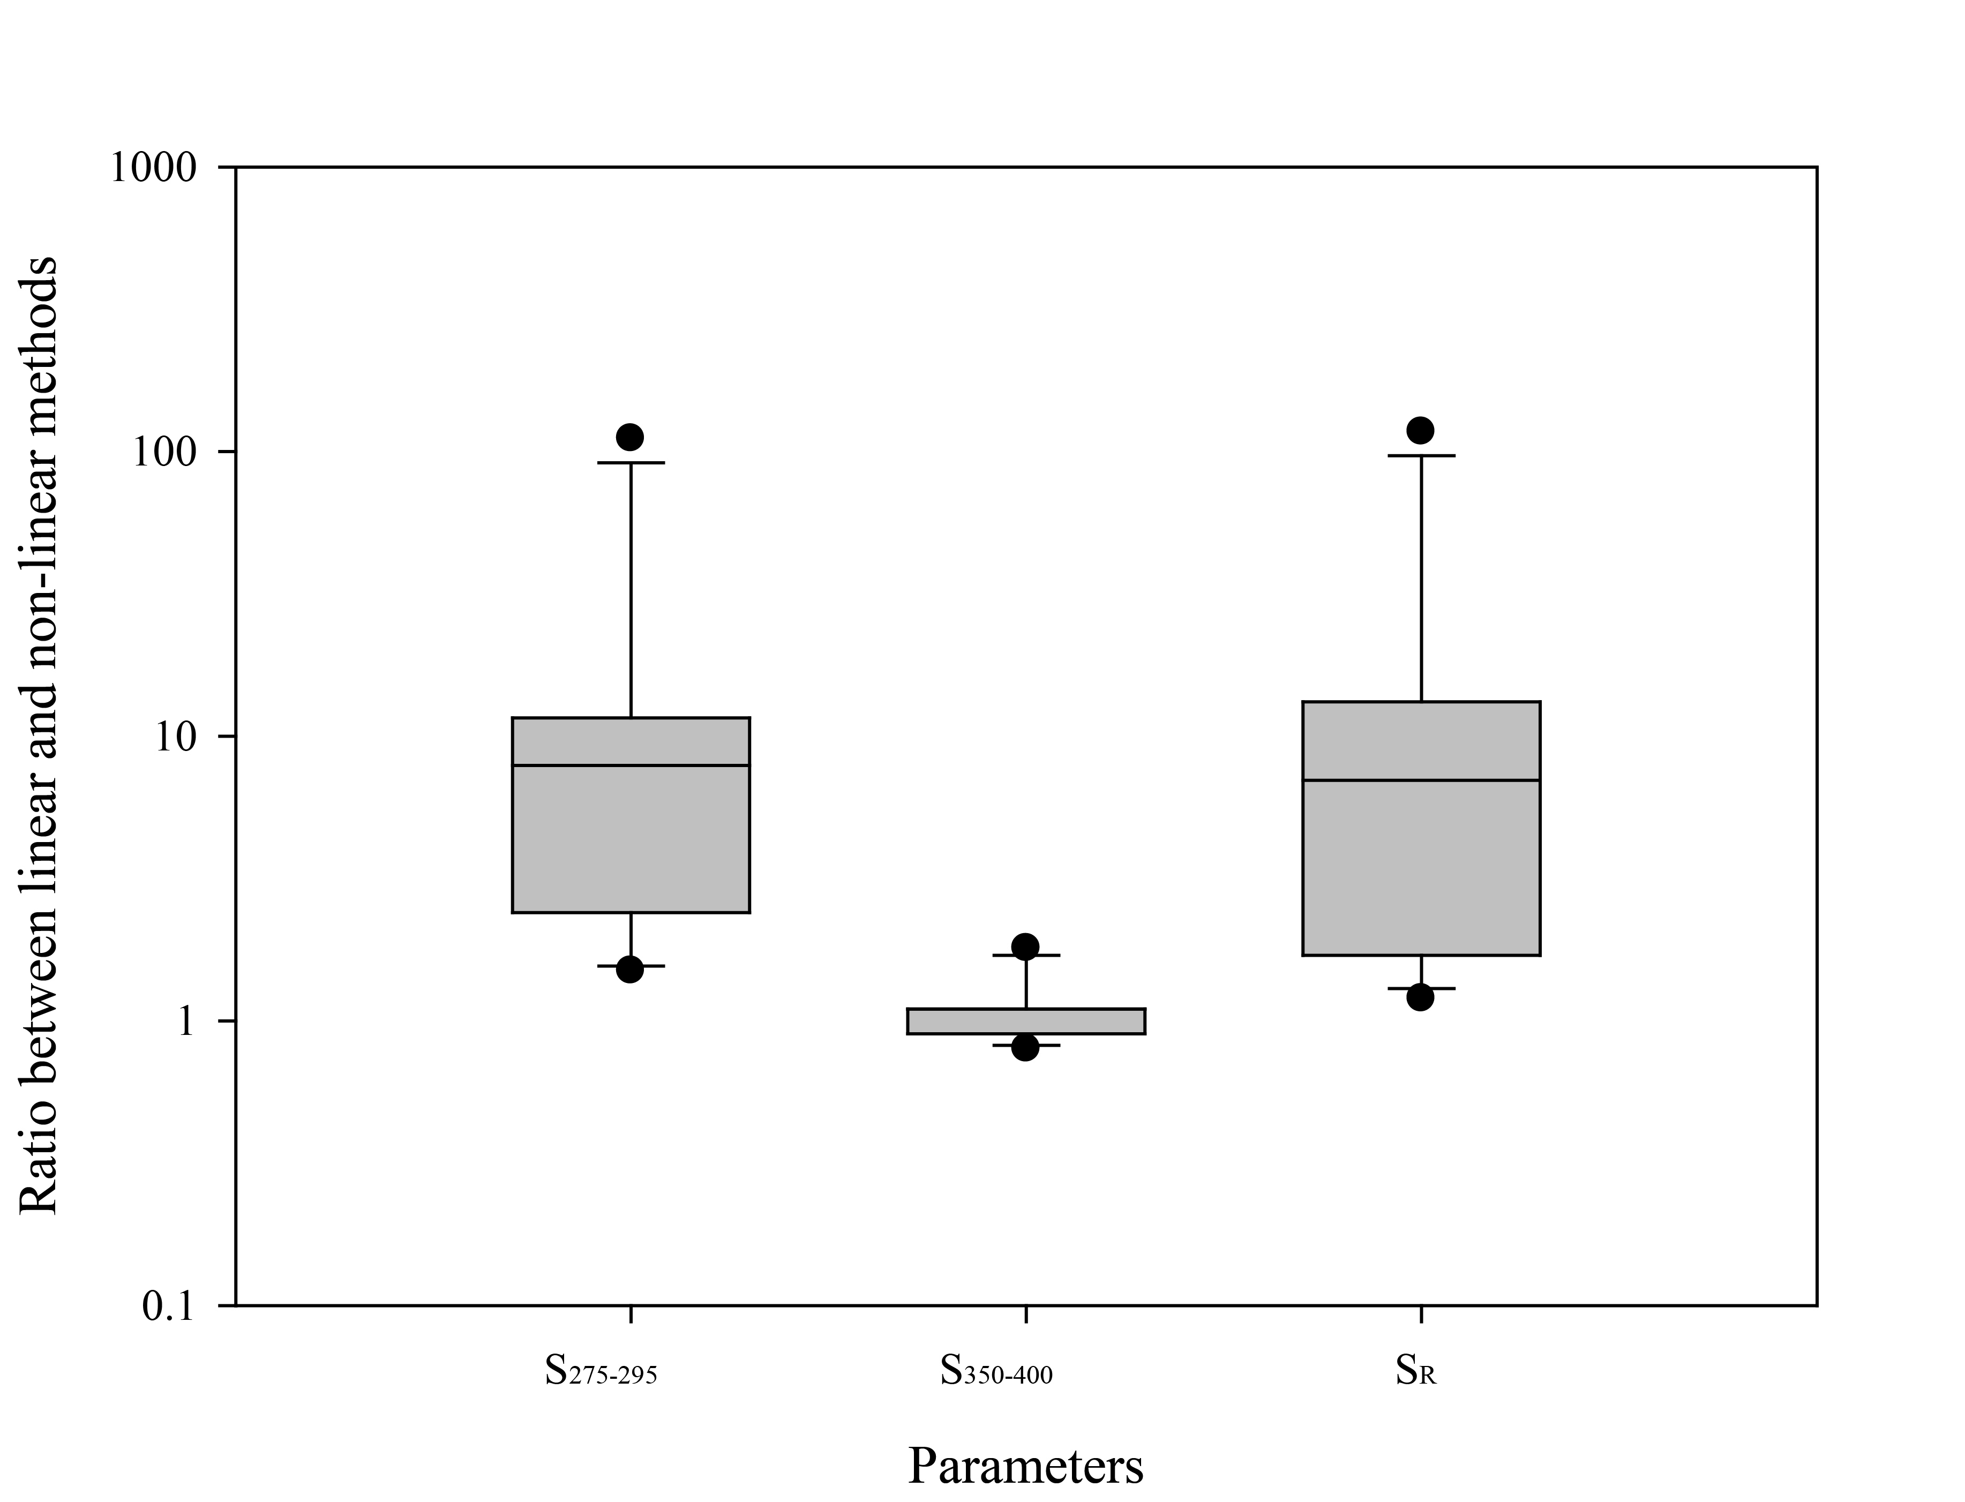
Fig. S1. Boxplot for ratios of different spectral slope parameters obtained through two different methods. Method A: Log-transformed linear fitting, the calculation was based on Helms et al. (2008) and the algorithm was presented in Table 3. Method B: Non-linear fitting (exponential), the calculation was based on Stedmon et al. (2000) and the algorithm was presented in Table 3. The ratio is defined as the corresponding parameter obtained through Method A divided by that obtained through Method B. The original absorption spectra for calculation is shown in Fig. S1.

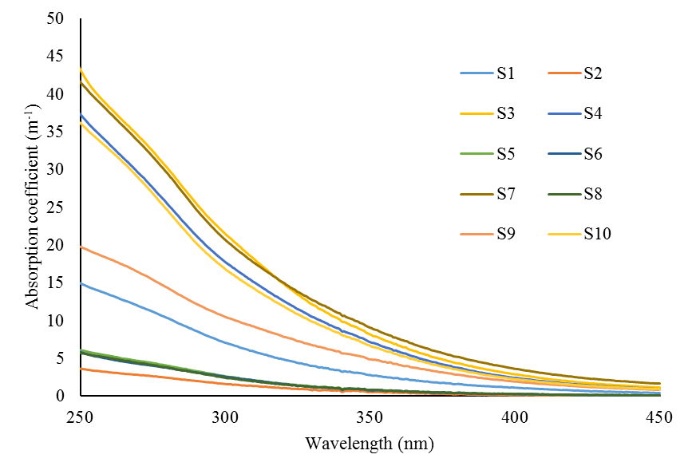
Fig. S2 Original absorption spectra used for the calculation in Fig. S1. The samples are pore water DOM from river sediments. All the samples were filtered through 0.7 μm pre-ashed GF/F filter (Whatman, UK). The absorbance spectra of all DOM samples were measured from 200 nm to 800 nm with 1 cm cell using a UV-1800 spectrophotometer (Shimadzu, Japan). Milli-Q water was used as a reference. Average absorbance between 680 nm and 700 nm was used for baseline correction for all samples. The raw spectra of these samples could be seen in Supporting Information II (Raw Spectra.xlsx).

References
Al-Juboori, R.A., Yusaf, T. and Pittaway, P.A. (2016). Exploring the correlations between common UV measurements and chemical fractionation for natural waters. Desalination and Water Treatment 57(35), 16324-16335.
Battin, T.J. (1998). Dissolved organic matter and its optical properties in a blackwater tributary of the upper Orinoco river, Venezuela. Organic Geochemistry 28(98), 561–569.
Bertilsson, S. and Tranvik, L.J. (2000). Photochemical transformation of dissolved organic matter in lakes. Limnology And Oceanography 45(4), 753-762.
Cieslewicz, J. and Gonet, S.S. (2004). Properties of humic acids as biomarkers of lake catchment management. Aquatic Sciences 66(2), 178-184.
Claret, F., Schäfer, T., Bauer, A. and Buckau, G. (2003). Generation of humic and fulvic acid from Callovo-Oxfordian clay under high alkaline conditions. Science Of The Total Environment 317(1–3), 189-200.
Duarte, R.M.B.O., Pio, C.A. and Duarte, A.C. (2005). Spectroscopic study of the water-soluble organic matter isolated from atmospheric aerosols collected under different atmospheric conditions. Analytica Chimica Acta 530(1), 7-14.
Erlandsson, M., Futter, M.N., Kothawala, D.N. and Köhler, S.J. (2012). Variability in spectral absorbance metrics across boreal lake waters. Journal Of Environmental Monitoring 14(10), 2643-2652.
Fichot, C.G. and Benner, R. (2012). The spectral slope coefficient of chromophoric dissolved organic matter (S275-295) as a tracer of terrigenous dissolved organic carbon in river-influenced ocean margins. Limnology And Oceanography 57(5), 1453-1466.
Guo, M.X. and Chorover, J. (2003). Transport and fractionation of dissolved organic matter in soil columns. Soil Science 168(2), 108-118.
Hansen, A.M., Kraus, T.E.C., Pellerin, B.A., Fleck, J.A., Downing, B.D. and Bergamaschi, B.A. (2016). Optical properties of dissolved organic matter (DOM): Effects of biological and photolytic degradation. Limnology And Oceanography.
He, X., Xi, B., Wei, Z., Guo, X., Li, M., An, D. and Liu, H. (2011). Spectroscopic characterization of water extractable organic matter during composting of municipal solid waste. Chemosphere 82(4), 541-548.
Helms, J.R., Stubbins, A., Perdue, E.M., Green, N.W., Chen, H. and Mopper, K. (2013). Photochemical bleaching of oceanic dissolved organic matter and its effect on absorption spectral slope and fluorescence. Marine Chemistry 155, 81-91.
Helms, J.R., Stubbins, A., Ritchie, J.D., Minor, E.C., Kieber, D.J. and Mopper, K. (2008). Absorption spectral slopes and slope ratios as indicators of molecular weight, source, and photobleaching of chromophoric dissolved organic matter. Limnology And Oceanography 53(3), 955-969.
Her, N., Amy, G., Sohn, J. and Gunten, U. (2008). UV absorbance ratio index with size exclusion chromatography (URI-SEC) as an NOM property indicator. Journal of Water Supply: Research and Technology - Aqua 57(1), 35-44.
Huang, H., Chow, C.W.K. and Jin, B. (2016). Characterisation of dissolved organic matter in stormwater using high-performance size exclusion chromatography. Journal of Environmental Sciences 42, 236-245.
Hunt, J.F. and Ohno, T. (2007). Characterization of Fresh and Decomposed Dissolved Organic Matter Using Excitation−Emission Matrix Fluorescence Spectroscopy and Multiway Analysis. Journal of Agricultural and Food Chemistry 55(6), 2121-2128.
Hur, J., Williams, M.A. and Schlautman, M.A. (2006). Evaluating spectroscopic and chromatographic techniques to resolve dissolved organic matter via end member mixing analysis. Chemosphere 63(3), 387-402.
Ikeya, K., Sleighter, R.L., Hatcher, P.G. and Watanabe, A. (2015). Characterization of the chemical composition of soil humic acids using Fourier transform ion cyclotron resonance mass spectrometry. Geochimica Et Cosmochimica Acta 153, 169-182.
Jaffé, R., Boyer, J.N., Lu, X., Maie, N., Yang, C., Scully, N.M. and Mock, S. (2004). Source characterization of dissolved organic matter in a subtropical mangrove-dominated estuary by fluorescence analysis. Marine Chemistry 84(3–4), 195-210.
Kiss, K., Szalai, Z., Jakab, G., Madarász, B. and Zboray, N. (2014). Soil Carbon. Hartemink, E.A. and McSweeney, K. (eds), pp. 127-136, Springer International Publishing, Cham.
Korshin, G.V., Li, C.-W. and Benjamin, M.M. (1997). Monitoring the properties of natural organic matter through UV spectroscopy: A consistent theory. Water Research 31(7), 1787-1795.
Moran, M.A., Sheldon, W.M. and Zepp, R.G. (2000). Carbon loss and optical property changes during long-term photochemical and biological degradation of estuarine dissolved organic matter. Limnology And Oceanography 45(6), 1254-1264.
Obernosterer, I. and Benner, R. (2004). Competition between biological and photochemical processes in the mineralization of dissolved organic carbon. Limnology And Oceanography 49(1), 117-124.
Olefeldt, D., Turetsky, M.R. and Blodau, C. (2013). Altered composition and microbial versus UV-mediated degradation of dissolved organic matter in boreal soils following wildfire. Ecosystems 16(8), 1396-1412.
Peuravuori, J. and Pihlaja, K. (1997). Molecular size distribution and spectroscopic properties of aquatic humic substances. Analytica Chimica Acta 337(2), 133-149.
Rodríguez, F.J., Schlenger, P. and García-Valverde, M. (2016). Monitoring changes in the structure and properties of humic substances following ozonation using UV–Vis, FTIR and 1H NMR techniques. Science Of The Total Environment 541, 623-637.
Santos, L., Pinto, A., Filipe, O., Cunha, Â., Santos, E.B.H. and Almeida, A. (2016). Insights on the Optical Properties of Estuarine DOM ? Hydrological and Biological Influences. PLoS ONE 11(5), e0154519.
Spencer, R.G.M., Stubbins, A., Hernes, P.J., Baker, A., Mopper, K., Aufdenkampe, A.K., Dyda, R.Y., Mwamba, V.L., Mangangu, A.M., Wabakanghanzi, J.N. and Six, J. (2009). Photochemical degradation of dissolved organic matter and dissolved lignin phenols from the Congo River. Journal of Geophysical Research: Biogeosciences 114(G3), n/a-n/a.
Stedmon, C.A., Markager, S. and Kaas, H. (2000). Optical properties and signatures of chromophoric dissolved organic matter (CDOM) in Danish coastal waters. Estuarine Coastal And Shelf Science 51(2), 267-278.
Tipping, E., Corbishley, H.T., Koprivnjak, J.-F., Lapworth, D.J., Miller, M.P., Vincent, C.D. and Hamilton-Taylor, J. (2009). Quantification of natural DOM from UV absorption at two wavelengths. Environmental Chemistry 6(6), 472-476.
Vahatalo, A.V. and Wetzel, R.G. (2008). Long-term photochemical and microbial decomposition of wetland-derived dissolved organic matter with alteration of C-13 : C-12 mass ratio. Limnology And Oceanography 53(4), 1387-1392.
Wang, K., Li, W., Gong, X., Li, Y., Wu, C. and Ren, N. (2013). Spectral study of dissolved organic matter in biosolid during the composting process using inorganic bulking agent: UV–vis, GPC, FTIR and EEM. International Biodeterioration & Biodegradation 85, 617-623.
Xi, B.-D., He, X.-S., Wei, Z.-M., Jiang, Y.-H., Li, M.-X., Li, D., Li, Y. and Dang, Q.-L. (2012). Effect of inoculation methods on the composting efficiency of municipal solid wastes. Chemosphere 88(6), 744-750.
Yakimenko, O., Khundzhua, D., Izosimov, A., Yuzhakov, V. and Patsaeva, S. (2016). Source indicator of commercial humic products: UV-Vis and fluorescence proxies. Journal of Soils and Sediments, 1-13.
You, S.-J., Yin, Y. and Allen, H.E. (1999). Partitioning of organic matter in soils: effects of pH and water/soil ratio. Science Of The Total Environment 227(2–3), 155-160.
Zhao, X., He, X., Xi, B., Gao, R., Tan, W., Zhang, H. and Li, D. (2016). The evolution of water extractable organic matter and its association with microbial community dynamics during municipal solid waste composting. Waste Management 56, 79-87.

