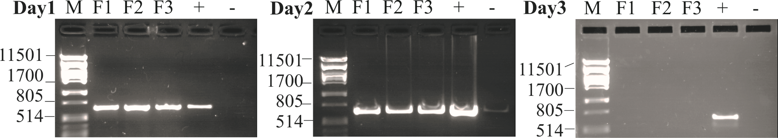

Additional File 4. Effect of storage time (-20°C) on PCR amplification of the PC-IGS region from three sonified Planktothrix filaments (F1, F2, F3) during three subsequent days. M, PstI lambda DNA size marker. Positive control was amplified from P. agardhii NIVA-CYA126/8 (AJ441056).

