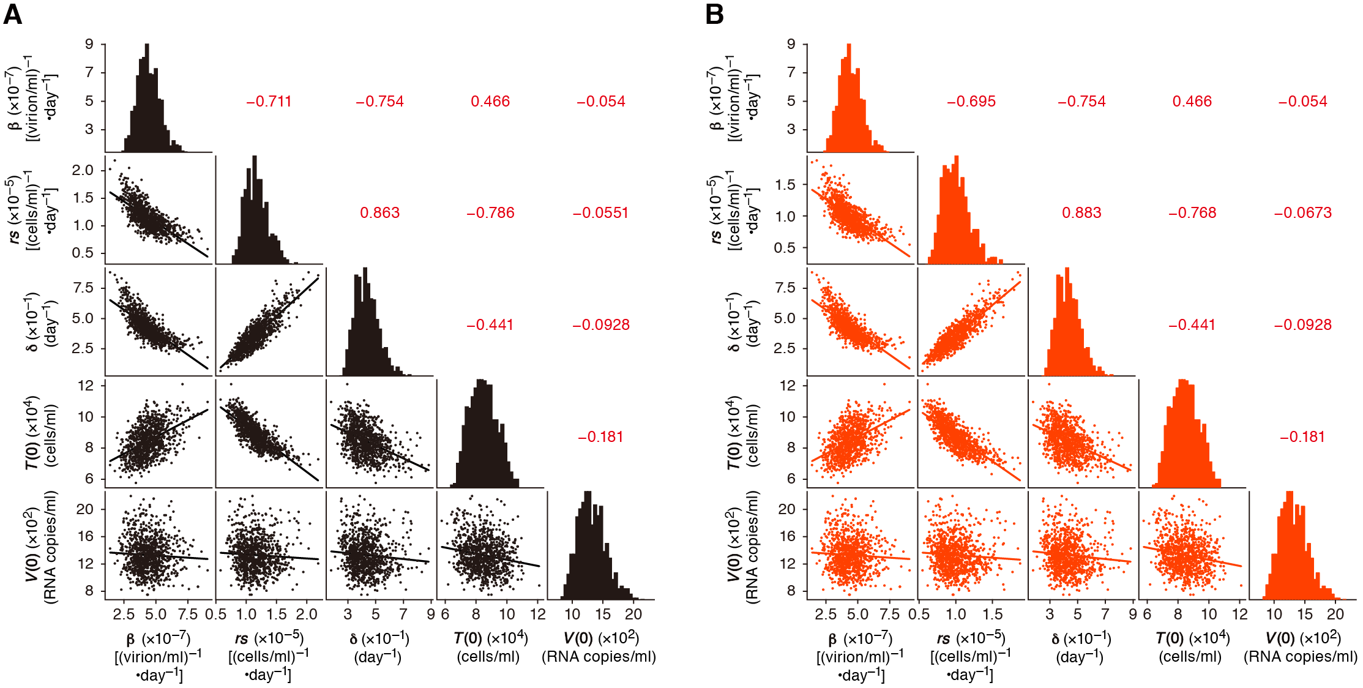
Additional file 2: Supplementary Figures

Figure S1. Posterior distributions for the estimated parameters with pairwise scatter plots. Each distribution on the diagonal represents the posterior distribution of a parameter, based upon the last 7,000 MCMC samples of the total of 10,000 samples. Each panel in the lower-diagonal block represents a pairwise scatter plot with a linear regression line. The correlation coefficients between the pairwise parameter distributions are shown in the upper-diagonal block. Panels (A) and (B) represent computed results for WT HIV-1 and HIV-1Δvpu infection, respectively.

