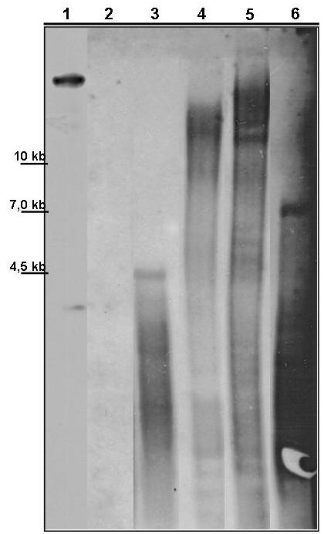
SM Figure 4 - Southern blot hybridization of four randomly picked T. virens gfp-tagged strains. Genomic DNA of the isolates were digested with restriction enzyme EcoRI, which cuts T-DNA twice and do not cut gfp gene sequence, a electrophoresis were performed in 0.8% agarose gel, transferring to nylon membrane and hybridized with the 700 pb fragment (gfp gene) labeled with digoxigenine. Column 1 positive control (pFAT-gfp plasmid); column 2 is the negative control (Wild strain T.v.223); columns 3-6 are the transformed strains (T20, T10, T7 and T2). Visualized bands are indicated with arrow.

