Supporting Figures
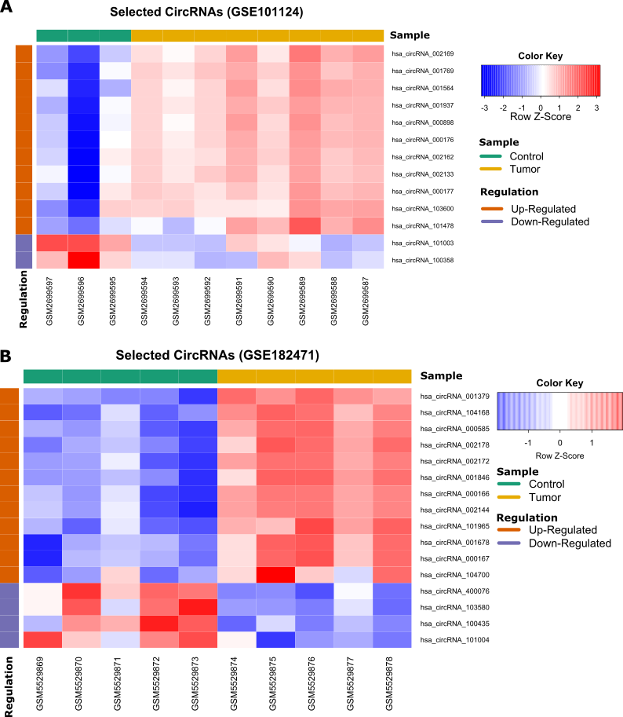
S1 Fig. Heatmap for the overlapped up- and down-regulated DECs for each microarray datasets, A: GSE101124, B: GSE182471. The heatmap was created by R package ‘gplots’. DECs: differently expressed circRNAs.

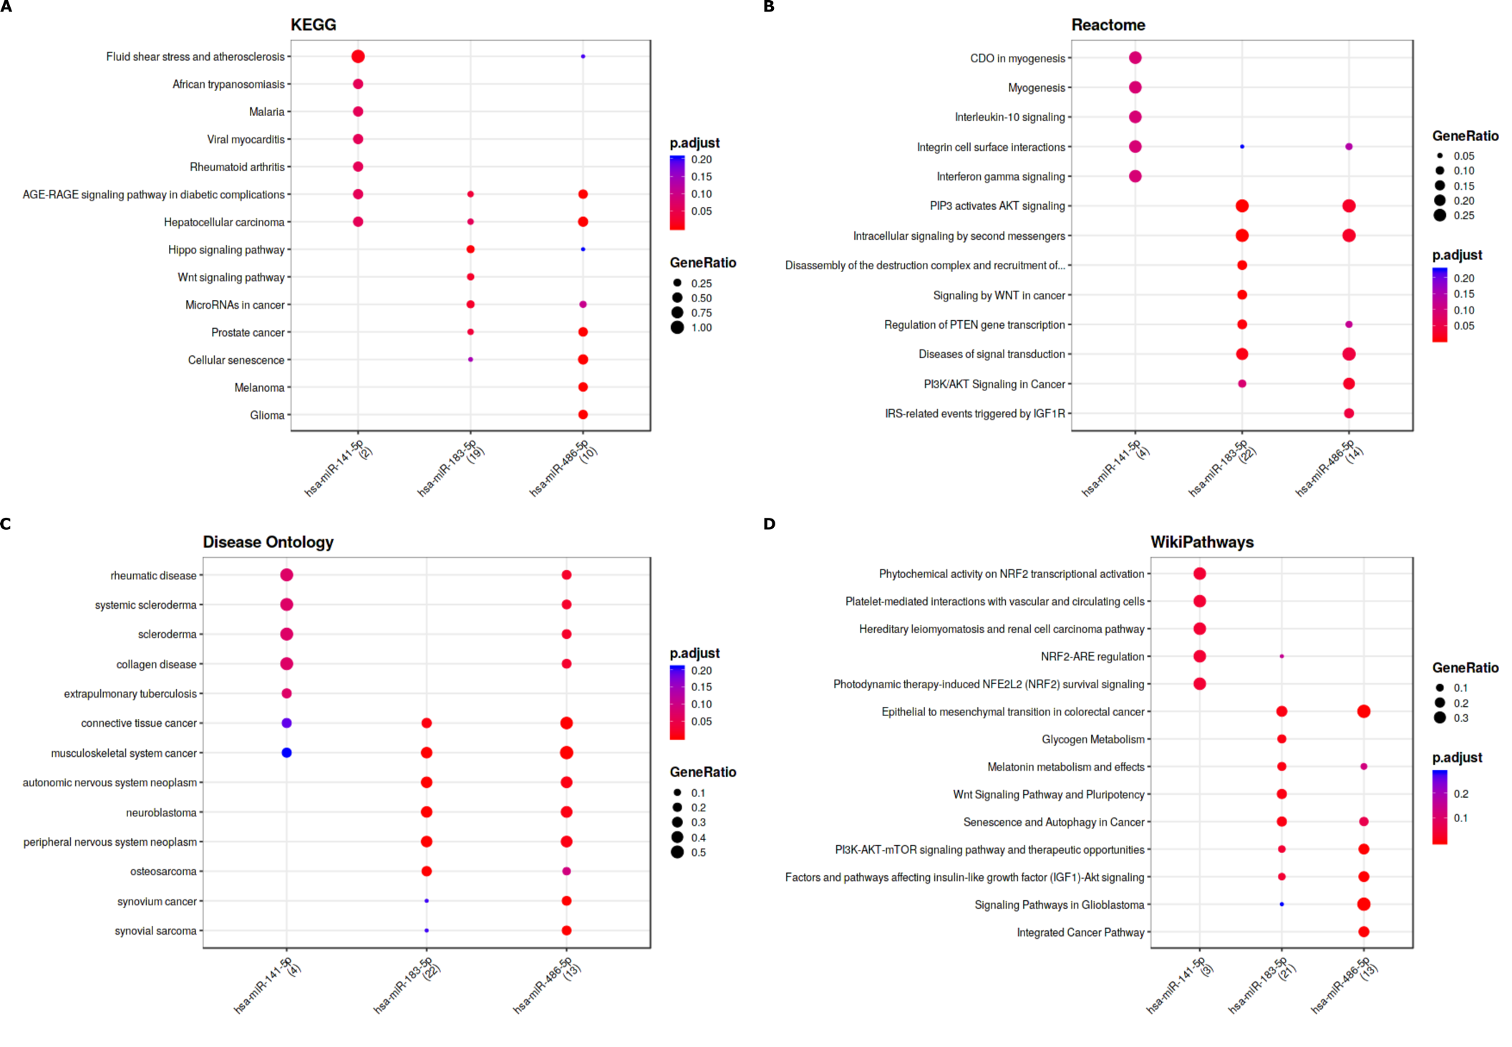
S2 Fig. Enrichment analysis results for the significant signaling pathways that the three miRNAs (miR-486-5p, miR-141-5p, and miR-183-5p) related according to the MIENTURNET (http://userver.bio.uniroma1.it/apps/mienturnet/). A: KEGG pathways, B: Reactome pathways, C: Disease Ontology, D: WikiPathways.
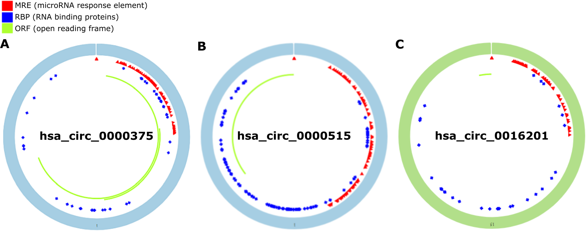
S3 Fig. Structural patterns of the three DECs by the Cancer-Specific CircRNA (CSCD v2.0, http://geneyun.net/CSCD2/), a: has_circRNA_0000375, b: has_circRNA_0000515, c: has_circRNA_0016201. DECs: differently expressed circRNAs.

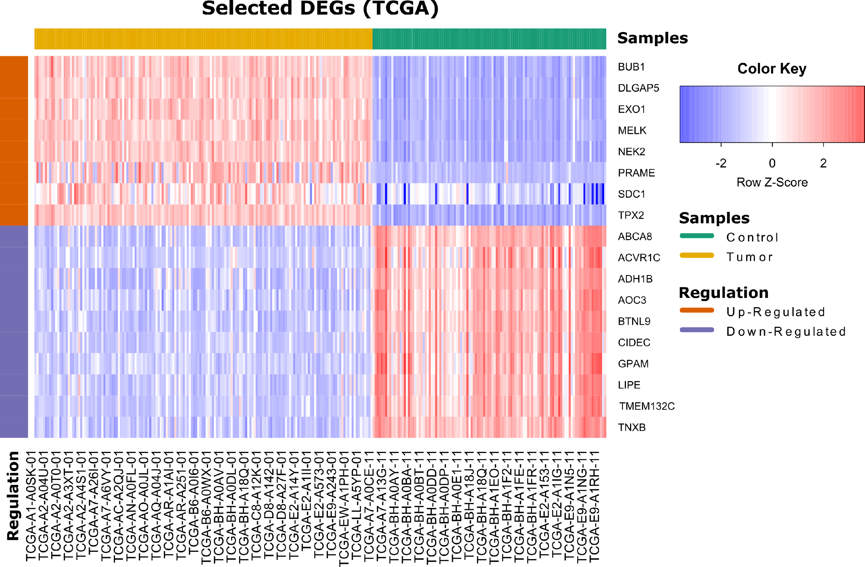
S4 Fig. The heatmap of 18 selected differentially expressed genes in BLBC versus control group.
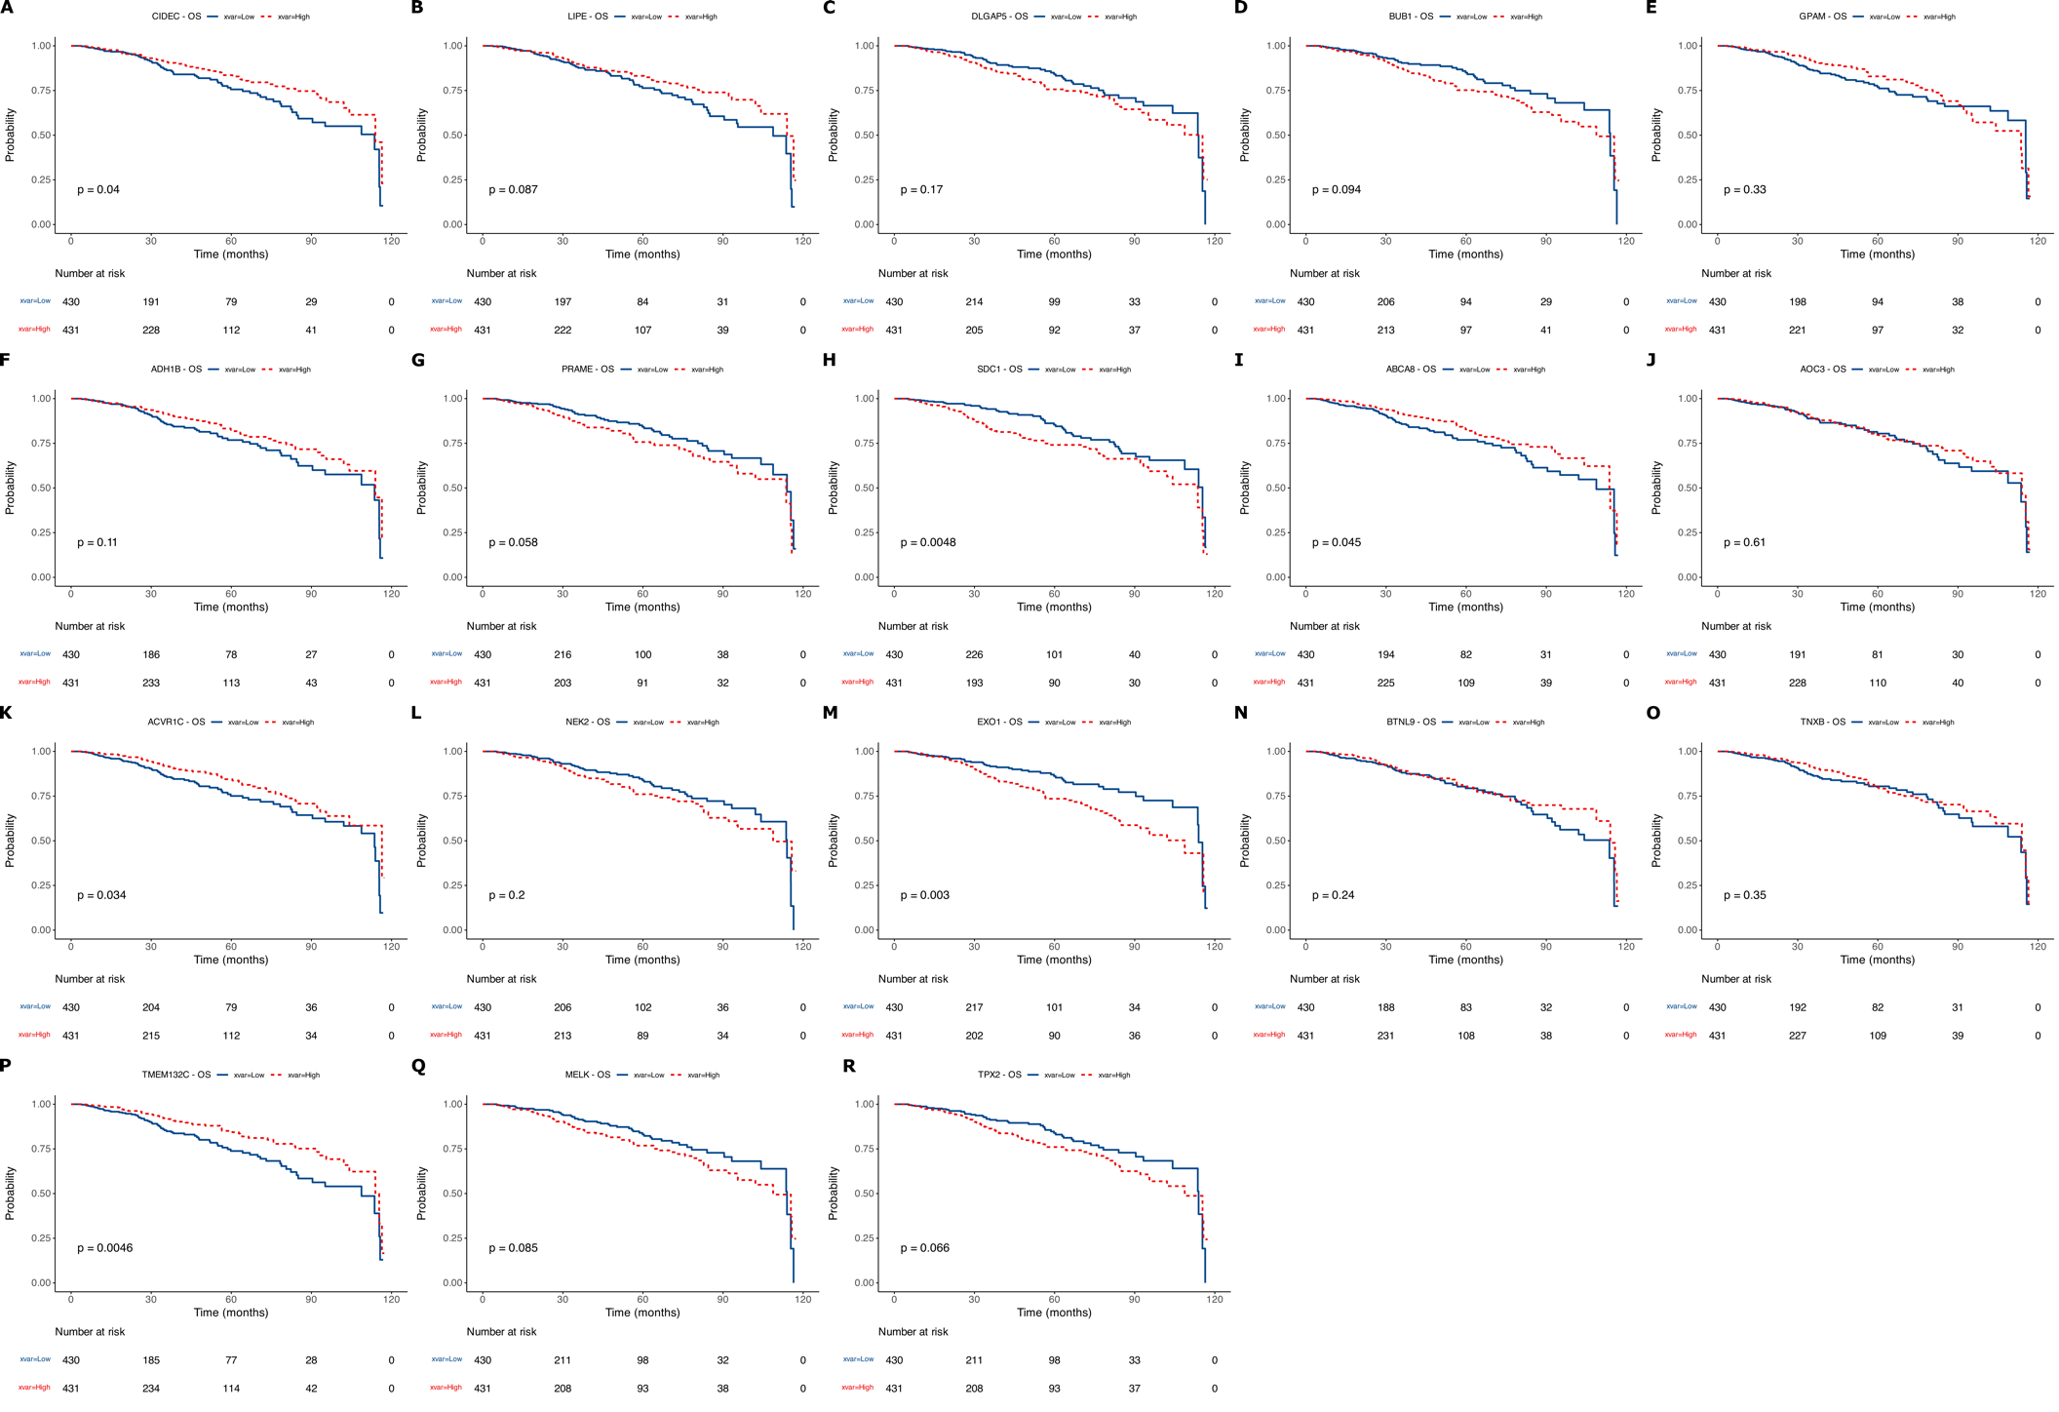
S5 Fig. Overall survival analysis results of 18 selected genes (TCGA).
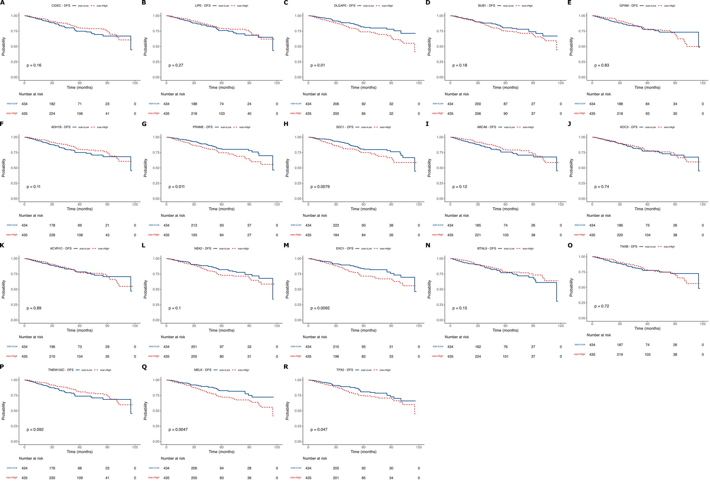
S6 Fig. Disease-free survival analysis results of 18 selected genes (TCGA).

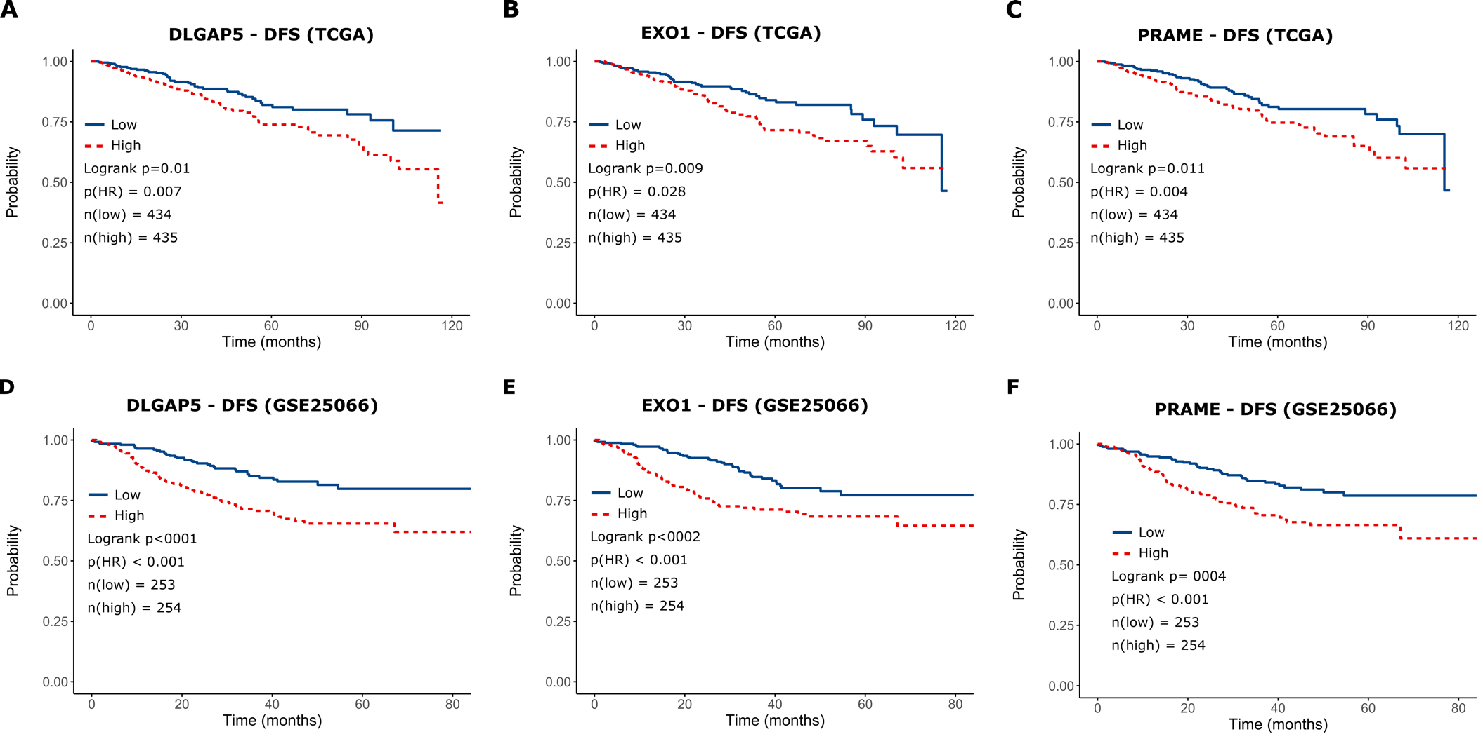
S7 Fig. Disease-free survival analysis of selected genes from TCGA and GSE25066 datasets. A: DLGAP5 (TCGA), B: EXO1 (TCGA), C: PRAME (TCGA), D: DLGAP5 (GSE25066), E: EXO1 (GSE25066), F: PRAME (GSE25066). DFS: Disease-free survival.

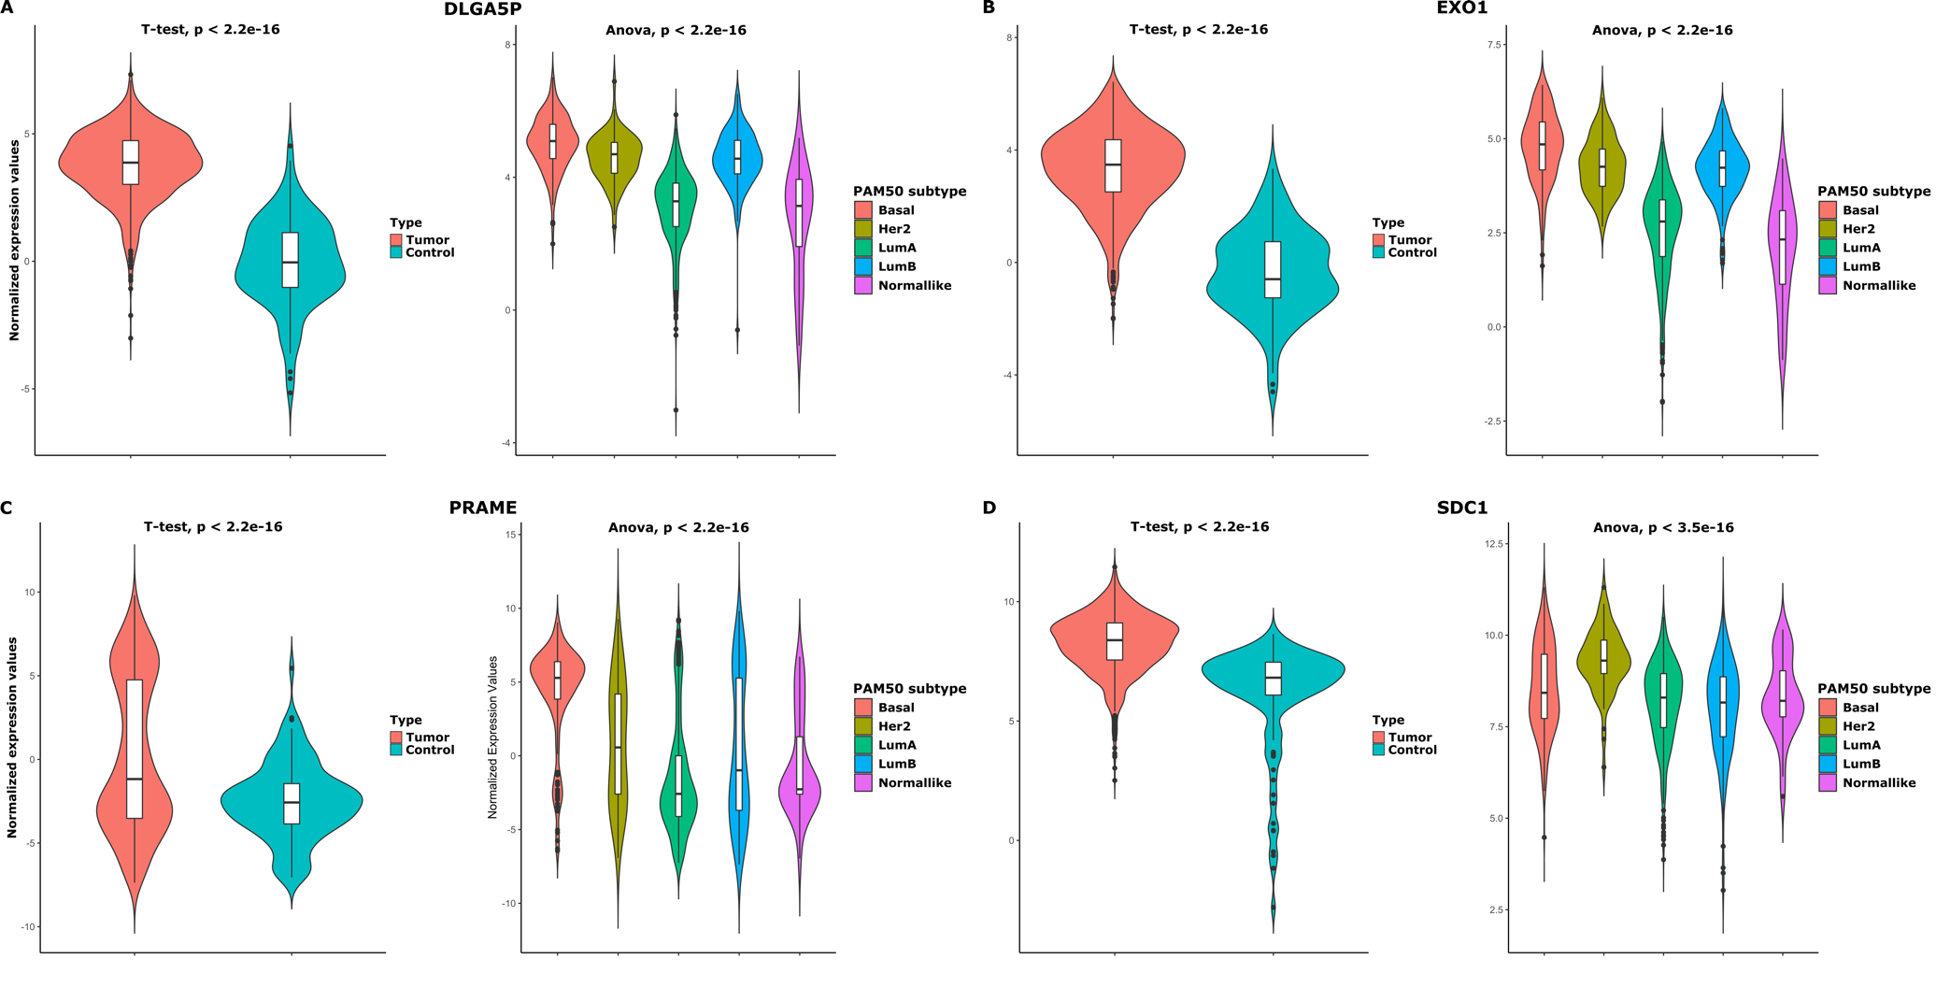
S8 Fig. The combined violin and box plots for the normalized expression values of selected genes in tumor versus normal tissue and PAM50 subtypes. A: DLGAP5, B:EXO1, C: PRAME, D: SDC1.

