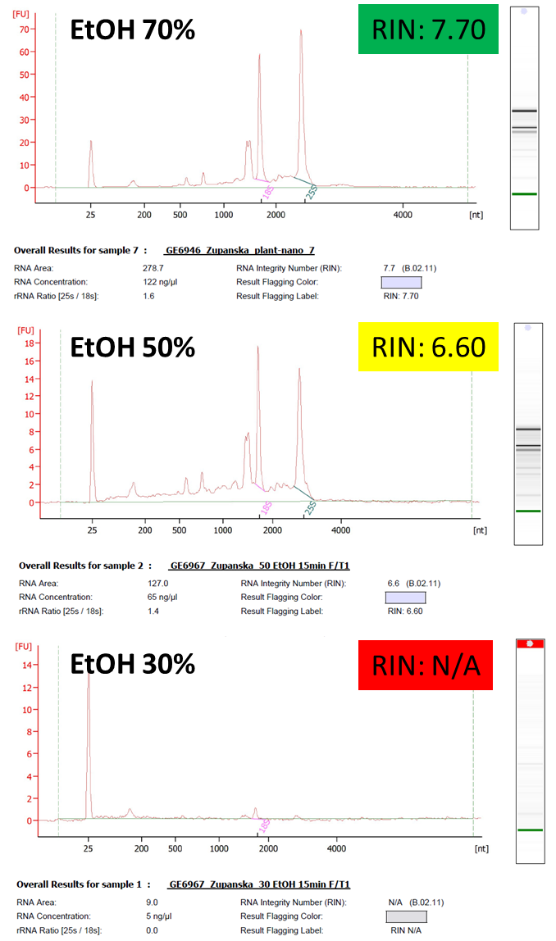
Figure 1S. Electropherograms of total RNA extracted from the moss tissue fixed in Ethanol for 15 min at RT, frozen at -80°C for 24 h and then fully thawed.

