SUPPLEMENTAL MATERIAL

Supplemental figures
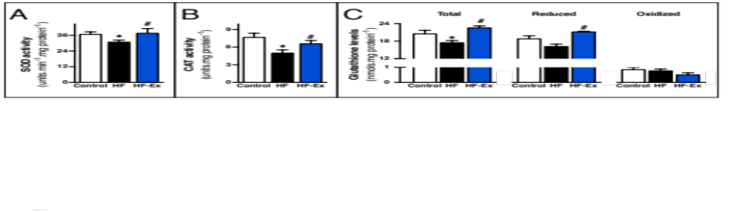
Figure S1. Exercise improves antioxidant defense in failing hearts. (A) SOD (superoxide dismutase) and (B) CAT (catalase) activities, and (C) glutathione levels in heart lysate from sedentary sham-treated (control), sedentary heart failure (HF) and exercised heart failure (HF-Ex) rats. Data are presented as mean ± SEM. *, p<0.05 vs. control; #, p<0.05 vs. HF rats.

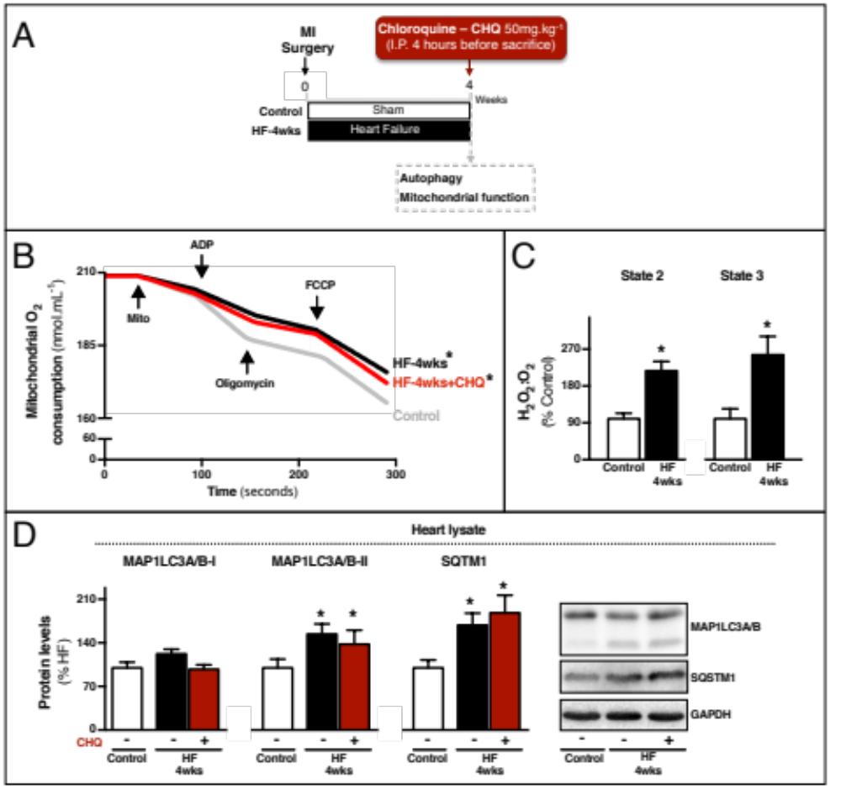
Figure S2. Failing hearts display mitochondrial dysfunction and impaired autophagic flux 4 weeks after myocardial infarction. (A) Schematic panel of the study: male Wistar rats were submitted to myocardial infarction (MI) or sham surgery. Four weeks later physiological parameters were evaluated, and animals were randomly assigned into sham-treated (control) and heart failure (HF-4wks) groups. Animals were killed 4 h after a single intraperitoneal injection of chloroquine (CHQ; 50 mg.kg⁻¹) to inhibit autophagic flux, and cardiac autophagy-related markers and mitochondrial function were assessed. (B) O₂ consumption in cardiac-isolated mitochondria from control and HF-4wks rats treated with saline (-) or CHQ (+). (C) H₂O₂ release per O₂ consumption (H₂O₂:O₂) in state 3 and state 4 respiratory rates in cardiac-isolated mitochondria from control and HF-4wks rats. (D) Protein levels of autophagy-related markers (SQSTM1 and MAP1LC3A/B) in heart lysate from control and HF-4wks rats treated with saline (-) or CHQ (+).
Data are presented as mean ± SEM.*, p<0.05 vs. control (-).

Figure S3. Exercise promotes mitochondrial biogenesis along with improved mitochondrial bioenergetics in healthy hearts. (A) O₂ consumption, respiratory control ratio (state 3:state 4 ratio) and (B) maximal Ca²⁺ uptake in cardiac-isolated mitochondria, and (C) cardiac ATP levels in heart lysate from sedentary sham-treated (control) and exercised sham-treated (Ex) rats. (D) H₂O₂ release per O₂ consumption (H₂O₂:O₂) in state 3 and state 4 respiratory rates in cardiac-isolated mitochondria, (E) mitochondrial O₂⁻ production and representative confocal images in isolated cardiomyocytes stained with MitoSOX Red and (F) lipid peroxidation, protein carbonyl and 4-HNE-protein adducts in heart lysate from control and Ex rats. (G) Representative images of cardiac mitochondrial morphology (S, sarcomere; M, mitochondria), quantification of mitochondrial number and area, and frequency distribution of mitochondrial area evaluated by transmission electron microscopy, and protein levels of mitochondrial electron transport chain (ETC) complex I (NDUFA9), complex III (UQCRC1) and complex V (ATP5A1) in heart lysate from control and Ex rat hearts. (H) MFN1, MFN2 and DNM1L protein levels in heart lysate and DNM1L protein levels in cardiac-isolated mitochondria from control and Ex rats. (I) MFN1, MFN2 and DNM1L GTPase activity in cardiac-isolated mitochondria from control and Ex rats. (J) Confocal images of cardiac mitochondrial distribution in isolated adult cardiomyocytes stained with MitoTracker Green and (C) mitochondrial membrane potential (Δψ) estimated through fluorescence changes of safranin O in cardiac-isolated mitochondria from control and Ex rats. Data are presented as mean ± SEM. *, p<0.05 vs. control.

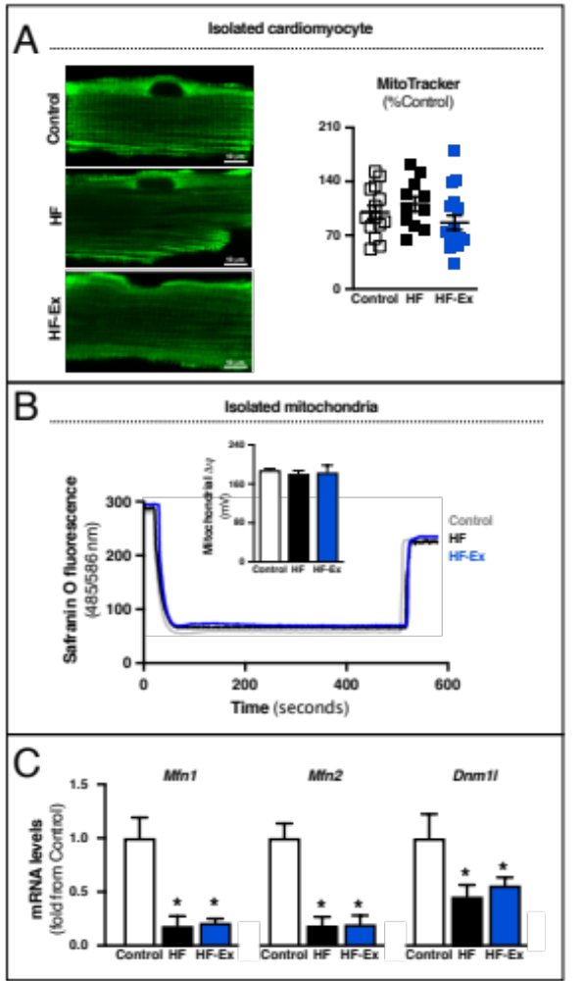

Figure S4. Mitochondrial membrane potential is unaltered in heart failure. (A) Confocal images of cardiac mitochondrial distribution in isolated adult cardiomyocytes stained with MitoTracker Green and (B) mitochondrial membrane potential (Δψ) estimated through fluorescence changes of safranin O in cardiac-isolated mitochondria from sedentary sham-treated (control), sedentary heart failure (HF) and exercised heart failure (HF-Ex) rats. (C) mRNA levels from mitochondrial fusion and fission-related markers (Mfn1, Mfn2 and Dnm1l) in heart lysate from control, HF and HF-Ex rats. Data are presented as mean ± SEM. *, p<0.05 vs. Control.

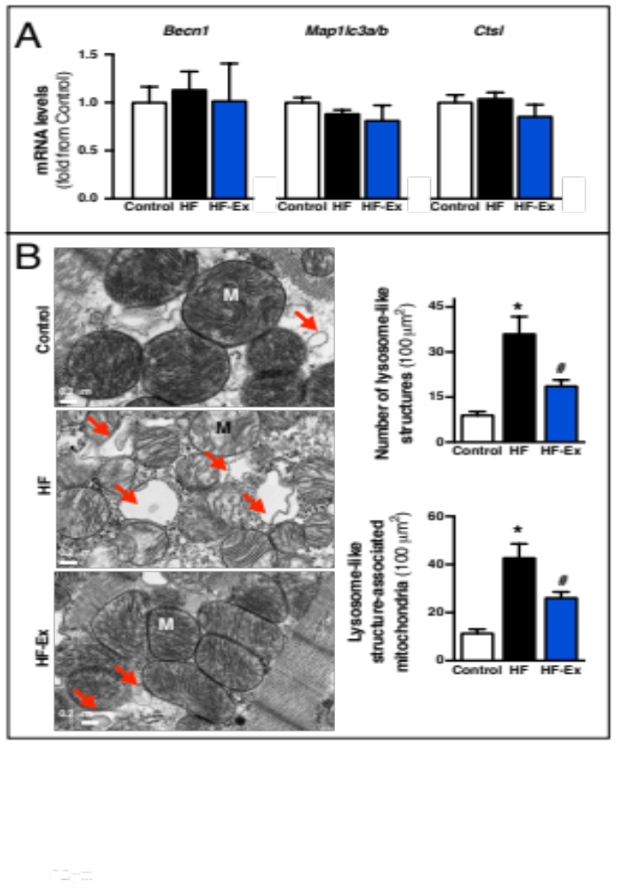
Figure S5. Exercise reduces the accumulation of fragmented mitochondria associated with lysosome-like structures in failing hearts. (A) mRNA levels from autophagy-related markers (Map1lc3a/b, Becn1 and Ctsl) in heart lysate from sedentary sham-treated (control), sedentary heart failure (HF) and exercised heart failure (HF-Ex) rats. (B) Representative images of lysosome-like structures (M, mitochondria; arrows indicate lysosome-like structures) and quantification of lysosome-like structures number and lysosome-like structure-associated mitochondria evaluated by transmission electron microscopy from control, HF and HF-Ex rats. Data are presented as mean ± SEM.*, p<0.05 vs. Control; #, p<0.05 vs. HF rats.
Supplemental table

Table S1. Physiological and echocardiographic parameters.
 | 4 weeks after MI  Before experimental protocol |  |  |  | 12 weeks after MI  After experimental protocol
Parameters | Control | HF | HF-Ex |  | Control | HF | HF-Ex
Heart rate, bpm | 481±16 | 480±19 | 464±13 |  | 480±14 | 479±17 | 393±16$*#
Blood pressure, mmHg | 113±03 | 116±04 | 122±03 |  | 114±02 | 117±03 | 112±05
Distance run, meters | 469±32 | 457±49 | 469±31 |  | 445±24 | 437±28 | 855±70$*#
Body weight, g | 412±11 | 393±07 | 395±09 |  | 452±16$ | 424±14 | 431±08
HW:BW, mg. g⁻¹ | - | - | - |  | 2.83±0.08 | 3.10±0.071* | 3.05±0.07
MI size, % | - | - | - |  | - | 28.07±4.45 | 28.78±3.19
EF, % | 77.8±1.79 | 56.1±3.27* | 57.1±2.86* |  | 76.5±2.68 | 53.7±6.15* | 69.0±3.81$*#
FS, % | 40±2 | 25±2* | 25±2* |  | 41±3 | 24±4* | 33±3$*#
LVEdD, mm | 7.41±0.33 | 8.83±0.36* | 8.74±0.36* |  | 8.05±0.42 | 8.71±0.43* | 8.26±0.39
LVEsD, mm | 4.46±0.19 | 6.73±0.42* | 6.60±0.39* |  | 4.94±0.35 | 6.70±0.59* | 5.55±0.42$
IVSd, mm | 0.90±0.09 | 0.91±0.04 | 0.97±0.05 |  | 1.15±0.09 | 1.03±0.05 | 1.05±0.06
IVSs, mm | 1.90±0.19 | 1.45±0.10* | 1.38±0.12* |  | 1.89±0.11 | 1.70±0.10$ | 1.86±0.14$
LVPWd, mm | 1.29±0.05 | 1.23±0.07 | 1.33±0.05 |  | 1.38±0.12 | 1.33±0.05 | 1.30±0.08
LVPWs, mm | 2.31±0.05 | 2.06±0.08* | 1.90±0.14* |  | 2.40±0.14 | 2.48±0.16$ | 2.40±0.11$
Heart rate (bpm, beats per minute), blood pressure (mmHg), distance run (meters), body weight (grams), heart weight:body weight ratio (HW: BW, mg.g⁻¹), myocardial infarction (MI, %) size, left ventricular ejection fraction (EF), fractional shortening (FS), left ventricular end-diastolic diameter (LVEdD), left ventricular end-systolic diameter (LVEsD), interventricular septum in diastole (IVSd), interventricular septum in systole (IVSs), left ventricular posterior wall in diastole (LVPWd) and left ventricular posterior wall in systole (LVPWs) from sedentary sham-treated (control), sedentary heart failure (HF) and exercised heart failure (HF-Ex) rats, 4 and 12 weeks after surgery (before and after exercise). Data are presented as mean ± SEM. $, p<0.05 vs. 4 weeks after MI; *, p<0.05 vs. control; #, p<0.05 vs. HF rats. The EF data suggest the myocardial infarction was mild, as no further loss of contractility was seen from 4 to 12 weeks post-MI.

Supplemental Materials and Methods

Cardiovascular measurements
Heart rate and blood pressure were determined, noninvasively, using a computerized tail-cuff system (BP 2000 Visitech Systems) described elsewhere.¹

Infarct size measurement
Myocardial infarction size was estimated in cardiac chambers submitted to routine histological processing at the end of the protocol.² Forty-eight h after the end of the protocol all rats were perfused with KCl and fixed with 4% buffered formalin. Hearts were embedded in paraffin for routine histological processing. Sections (4 μm) were stained with Masson’s trichrome (Sigma, HT15) for myocardial infarction size quantification.

Antioxidant capacity
In order to evaluate antioxidant capacity, we measured SOD (superoxide dismutase) and CAT (catalase) activity, and glutathione levels in the left ventricular remote area.
SOD activity: The assay was based on the inhibition of xanthine-XDH/xanthine oxidase-driven CYCS (cytochrome c, somatic) reduction by enzyme present in heart sample, measured by spectrophotometry as described previously.³ Hearts were homogenized in phosphate buffer (50 mM NaH₂PO₄, 1 mM EDTA, protease inhibitor cocktail [Roche, 05056489001], pH 7.4) and centrifuged at 12000 g for 15 min at 4°C; the pellet was discarded and the supernatant was used for the assay. Initially, the CYCS reduction rate was followed in the absence of the sample for 5 min at 550 nm (absorbance) in a mixture containing 1.18 mM xanthine (Sigma, X0626), 19 mM CYCS (Sigma, C3131) and XDH/xanthine oxidase (Sigma, X1875), diluted in sodium phosphate buffer (50 mM NaH₂PO₄, pH 7.8). XDH concentration was adjusted in order to obtain a standard rate of CYCS reduction of 0.025 U of absorbance per min. Subsequently, the CYCS reduction rate was measured in the presence of the sample. The difference between the 2 rates was attributed to enzyme present in the tested sample. SOD activity was measured within the linear range of the assay.
CAT activity: This was measured by O₂ production in a Clark-type electrode (OROBOROS, Oxygraph-2k) in the presence of H₂O₂, according to Aebi.⁴ The assay was made in the same experimental buffer of mitochondrial function described above. 500 µM H₂O₂ was added to 20 µg heart homogenized sample and the activity was calculated by the rate of O₂ production by time and normalized by the amount of protein added. U = 1 µmoles of O₂ produced per min.
Glutathione levels: Total, reduced and oxidized glutathione were measured in heart homogenates using the Glutathione Fluorescent Detection Kit (Arbor Assay, K006-F1), following the manufacturer´s instructions.

RNA isolation, cDNA synthesis and quantitative real-time polymerase chain reaction
In order to quantify messenger RNA levels, total RNA was isolated from heart samples with Trizol (Life Technologies, AM9738) following the manufacturer’s instruction. RNA integrity and purity were assessed by electrophoresis in agarose gels followed by staining with Nancy-520 (Sigma, 01494) and determining the 260:280-nm ratio, respectively. cDNA was synthesized using RevertAidTM Reverse Transcriptase (200 U; Thermo Fisher Scientific, EP0442), oligo dT (0.5 μg; Thermo Fisher Scientific, 18418012), RiboLockTM RNase inhibitor (20 U; Thermo Fisher Scientific, EO0382) and dNTP mix (1 mM), which were incubated at 42°C for 1 h, plus 10 min at 70ºC for reverse transcription termination.
Quantitative real time polymerase chain reaction for target genes and the endogenous reference gene Ppia/cyclophilin were run separately and amplifications were performed with an ABI Prism 7500 Sequence Detection System by using Maxima® SYBR Green/ROX qPCR Master Mix (Thermo Fisher Scientific, K0221). Specificity was tested by melting curve analysis. Results were expressed using the comparative cycle threshold (Ct) method as described by the manufacturer. The ΔCt values were calculated in every sample for each gene of interest as Ctgene of interest minus Ctreporter gene; Ppia was the control gene. The calculation of the relative changes in the expression level of one specific gene (ΔΔCt) was performed by subtraction of the ΔCt from the control group (the control group was used as a calibrator) to the corresponding ΔCt from other groups. The values and ranges were determined as follows: 2-ΔΔCt with ΔΔCt. Control levels were arbitrarily set to 1. Primer sequences are shown below:
Nppa – 1 forward 5’ GAGGAGAAGATGCCGGTAG 3’
Nppa – 1 reverse 5’ CTAGAGAGGGAGCTAAGTG 3’
Mfn1 forward 5’ GTTGGGGGCGTGATTTGGAA 3’
Mfn1reverse 5’ AACGCTCTCTCTTTCGCACG 3’
Mfn2 forward 5’ ATGATCAGGTTCAGCGTCCTC 3’
Mfn2reverse 5’ CGACCACGAGAATGCCCATA 3’
Dnm1l forward 5’ CCCGAGAACAGCGAGATTGT 3’
Dnm1l reverse 5’ CCTTTGGGACGCTGTCTTGA 3’
Becn1 forward 5’ GGTAGCTTTTCTGGACTGTGTGCAGCAG 3’
Becn1reverse 5’ GTCTTCAATCTTGCCTTTCTCCACGTCC 3’
Map1lc3a/b forward 5’ ACCCTCCCTGCATGCAGCTGTCC 3’
Map1lc3a/b reverse 5’ ACCAGGGACATGACGACGTACACAACC 3’
Ctsl forward 5’ CACTACATCCGAAGGAGTTCATCTT 3’
Ctsl reverse 5’ ATTCAAGTACCATGGTCTCACTCAGA 3’
Ppia forward 5’ TGGCAAGCATGTGGTCTTTGGGAAG 3’
Ppia reverse 5’ GGTGATCTTCTTGCTGGTCTTGCCATTC 3’

Statistical analysis
Data are presented as means ± standard error of the mean (SEM). Shapiro-Wilk normality test was used to verify data normal distribution. One-way analysis of variance (ANOVA) with a post-hoc testing by Duncan was used to analyze data from Figures S1, S2B, S2D, S4 and S5. Two-way ANOVA for repeated measures with a post-hoc testing by Duncan was used to analyze data from Table S1. Unpaired Student’s t test was used to analyze data from Figures S2C and S3. Statistical significance was considered achieved when the value of P was < 0.05.

References
1. Ferreira JC, Moreira JB, Campos JC, Pereira MG, Mattos KC, Coelho MA, Brum PC. Angiotensin receptor blockade improves the net balance of cardiac Ca(2+) handling-related proteins in sympathetic hyperactivity-induced heart failure. Life sciences 2011; 88:578-85.
2. Kido M, Du L, Sullivan CC, Li X, Deutsch R, Jamieson SW, Thistlethwaite PA. Hypoxia-inducible factor 1-alpha reduces infarction and attenuates progression of cardiac dysfunction after myocardial infarction in the mouse. Journal of the American College of Cardiology 2005; 46:2116-24.
3. Kuthan H, Haussmann HJ, Werringloer J. A spectrophotometric assay for superoxide dismutase activities in crude tissue fractions. Biochem J 1986; 237:175-80.
4. Aebi H. Catalase in vitro. Methods Enzymol 1984; 105:121-6.

