Supplementary Material
Use of satellite imagery to estimate distribution and abundance of Cumberland Sound beluga whales reveals frequent use of a glacial river estuary
Belanger, A.M.*, Sherbo, B.A.H., Roth, J.D., Watt, C.A.
* Correspondence: Amanda Belanger: belang21@myumanitoba.ca

Supplementary Figures
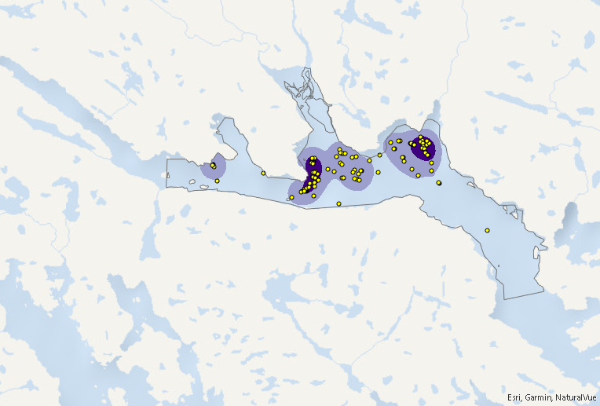

Supplementary Figure 1. August 21, 2020 points overlayed on KDE utilization distribution maps in Clearwater Fiord.
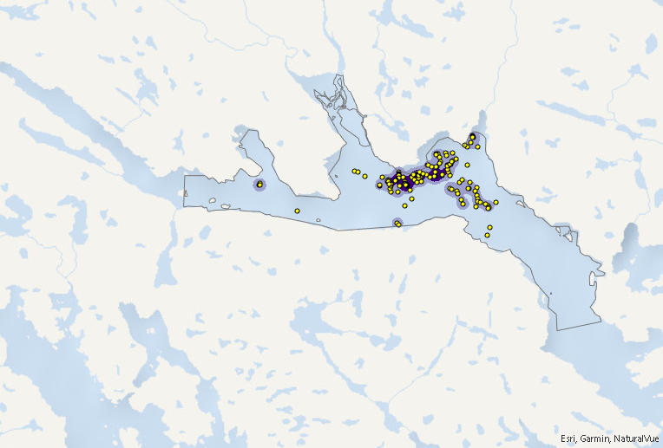

Supplementary Figure 2. August 30, 2020 points overlayed on KDE utilization distribution maps in Clearwater Fiord.
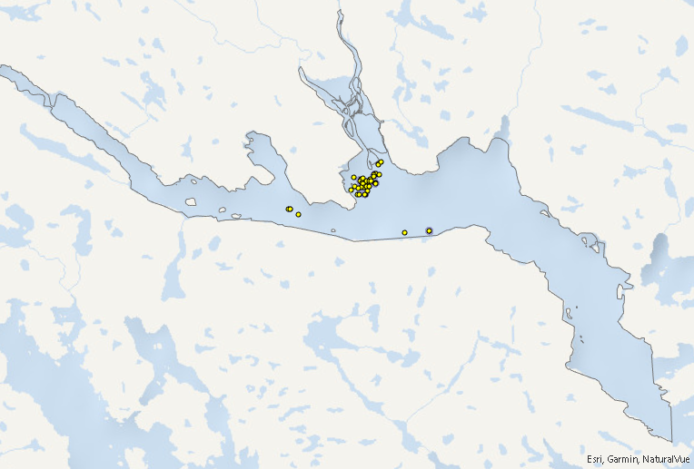
Supplementary Figure 3. September 4, 2021 points overlayed on KDE utilization distribution maps in Clearwater Fiord.
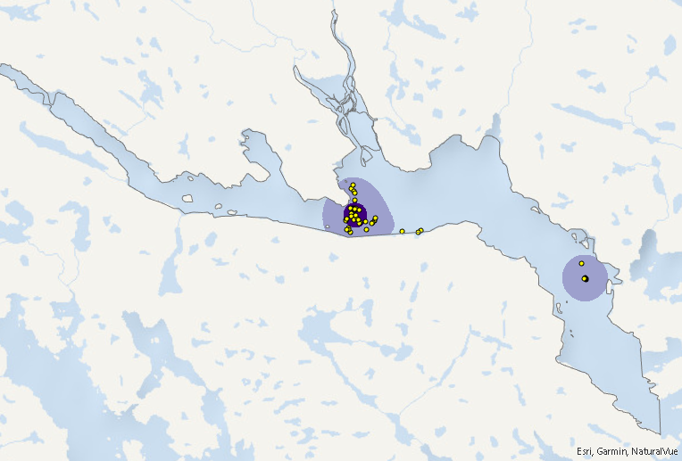

Supplementary Figure 4. September 7, 2021 points overlayed on KDE utilization distribution maps in Clearwater Fiord.
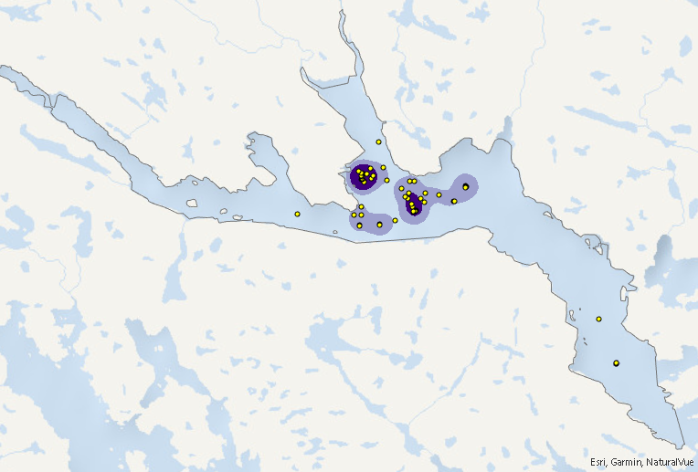

Supplementary Figure 5. August 17, 2022 points overlayed on KDE utilization distribution map in Clearwater Fiord.
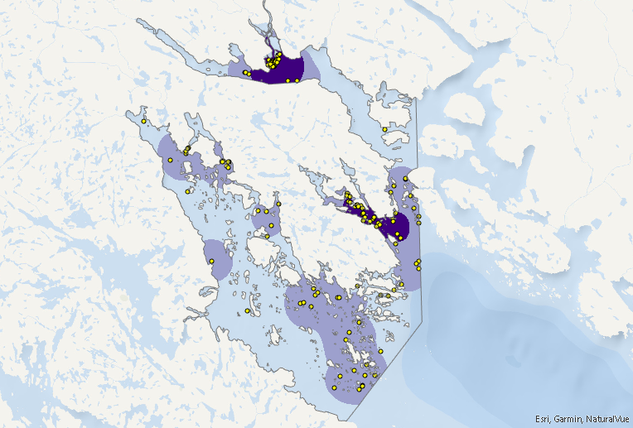

Supplementary Figure 6. Septemeber 4, 2021 points overlayed on KDE utilization distribution map of Clearwater, Kangilo, and Kangerk Fiords.
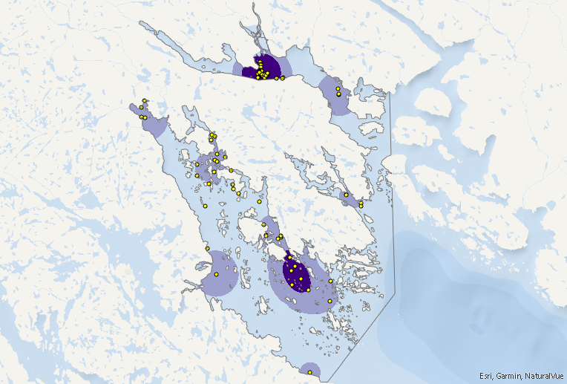

Supplementary Figure 7. September 7, 2021 points overlayed on KDE utilization distribution map of Clearwater, Kangilo, and Kangerk Fiords.
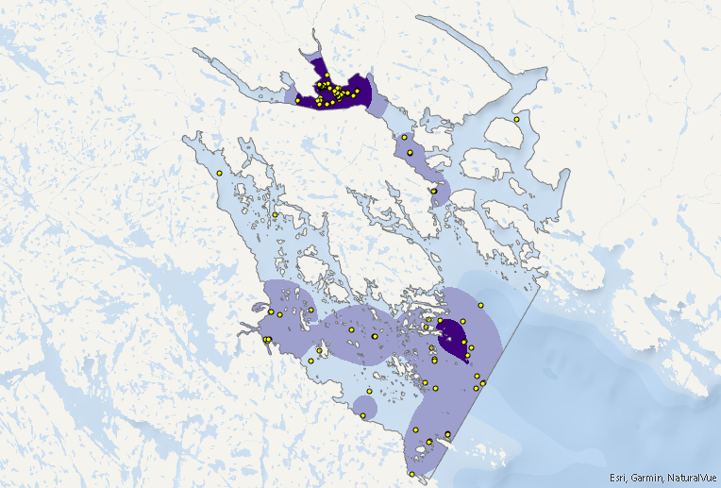

Supplementary Figure 8. August 17, 2022 points overlayed on KDE utilization distribution maps of Clearwater, Kangilo, Kangerk, and Shark Fiords.

