Longitudinal dissolved oxygen patterns in Atlantic salmon aquaculture sites in British Columbia, Canada

Supplementary Material
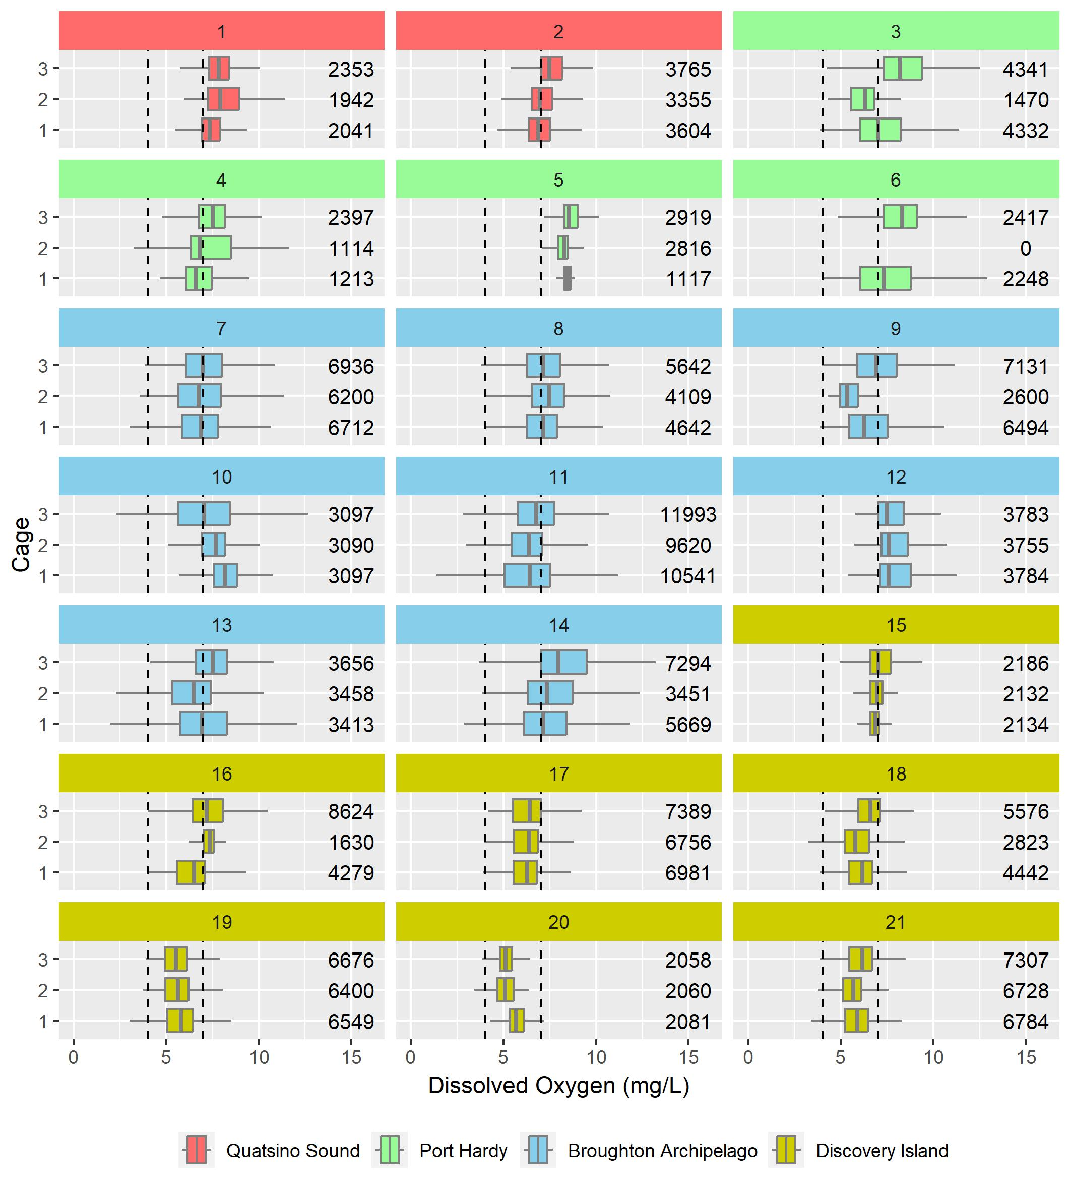
Supplementary Figure 1. Distribution of hourly dissolved oxygen (DO) levels from 21 aquaculture sites (each with 3 cages, except Site 6). The number of observations are presented on the right of each boxplot. The black vertical dashed lines are placed at 4 and 7 mg/L cutoff values, based on the Production Impairment Classification for stressed, sub-optimal, and optimal DO levels, respectively. The color for each site corresponds to its respective aquaculture area in British Columbia (see Figure 1).
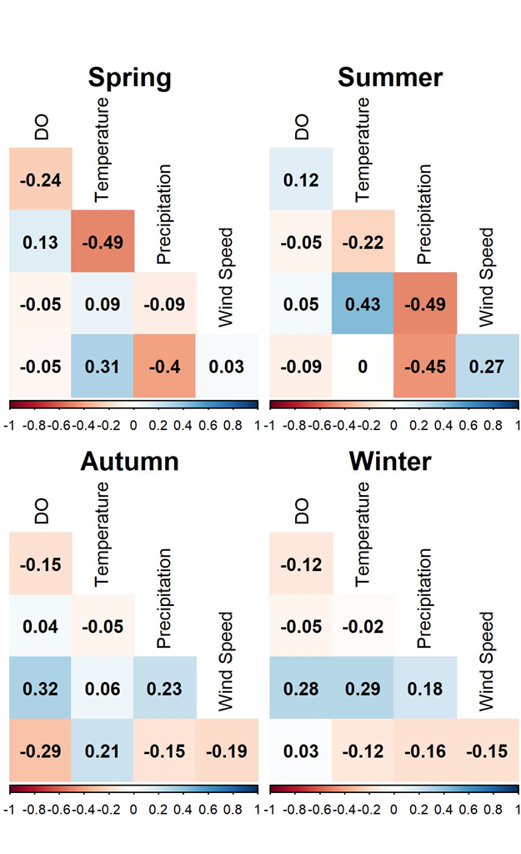
Supplementary Figure 2. Spearman’s correlation matrix of daily minimum dissolved oxygen (DO), daily maximum temperature, daily total precipitation, daily wind speed (max. gust above 30 km/h), and daily regionally-averaged a_{ph}(443) coefficients, stratified by seasons.

