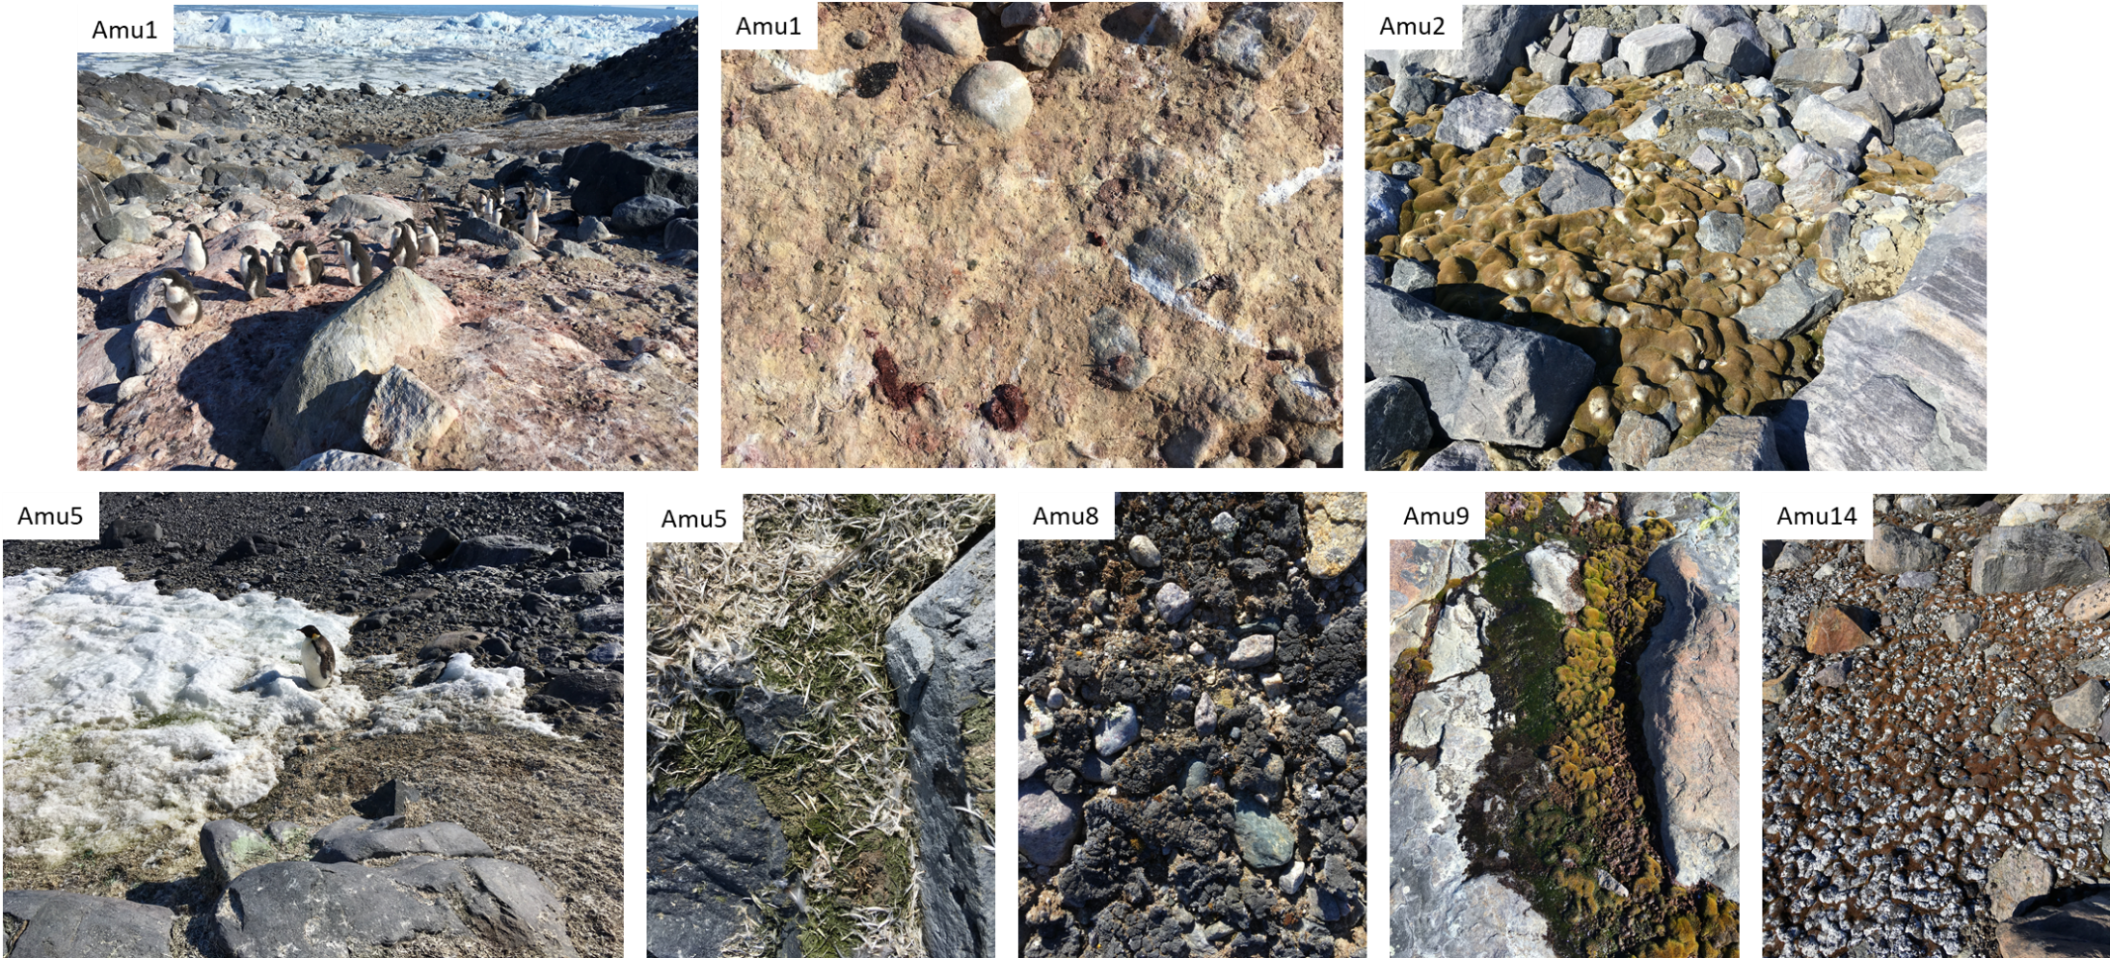
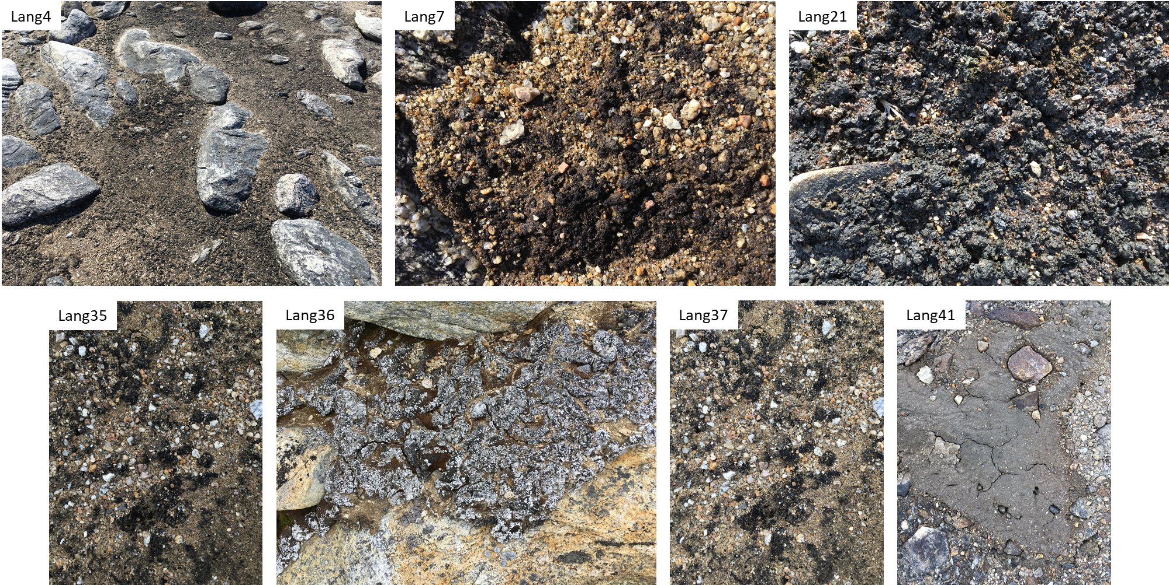
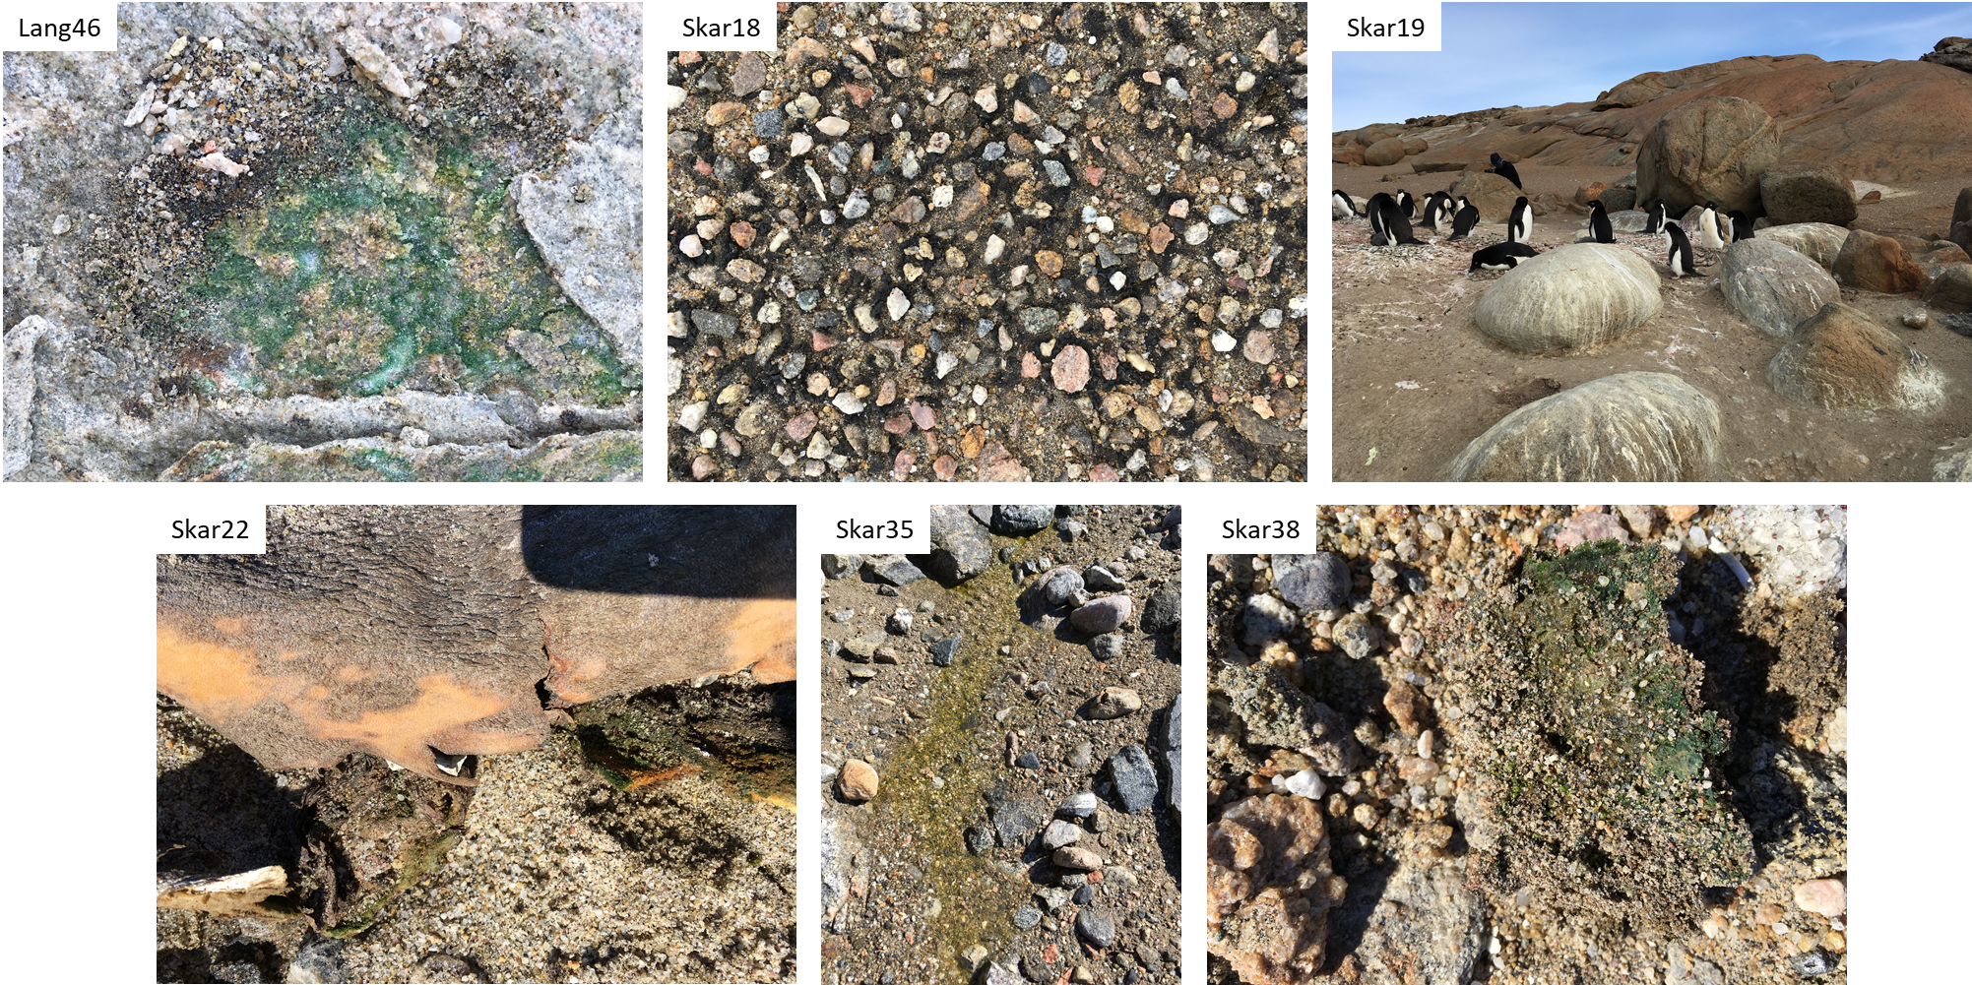
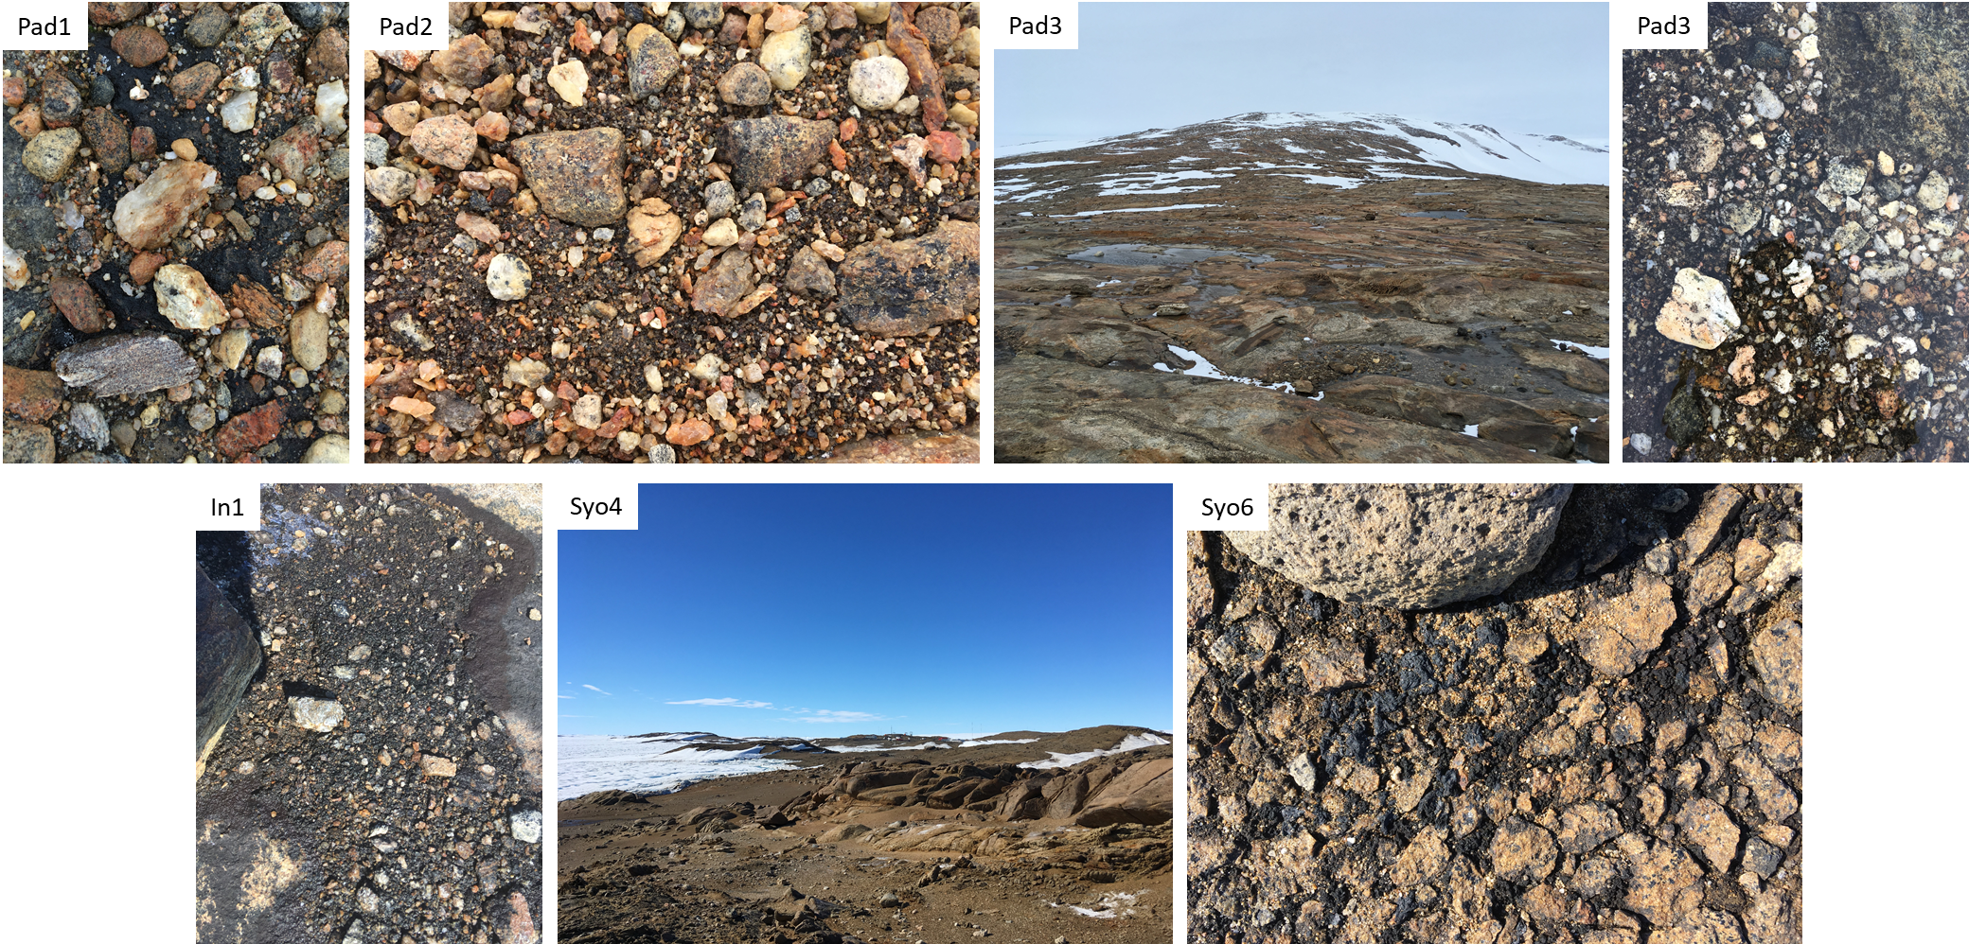
Supplementary Figure 1 – Photos of the collected samples from Antarctica.

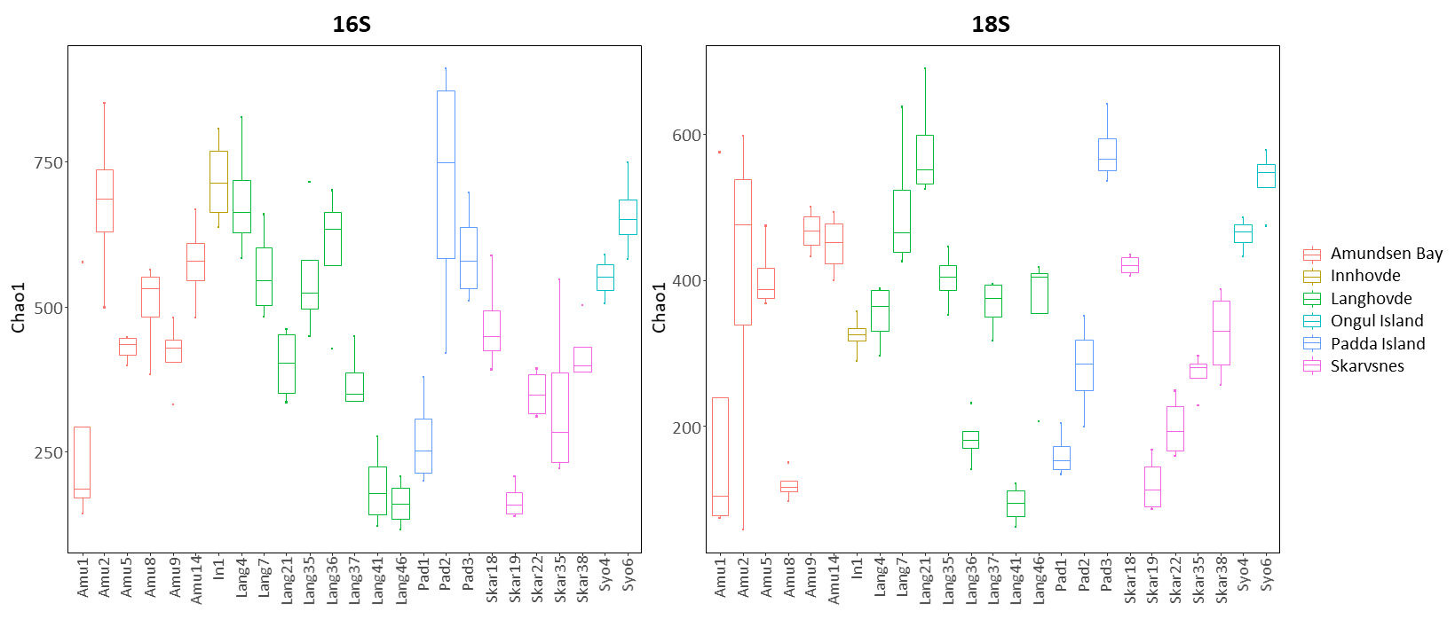
Supplementary Figure 2 – Chao1 diversity index in studied samples: (16S) – bacteria and (18S) – eukaryotes. Boxes represent the interquartile range and the horizontal line inside the box defines the median

a.
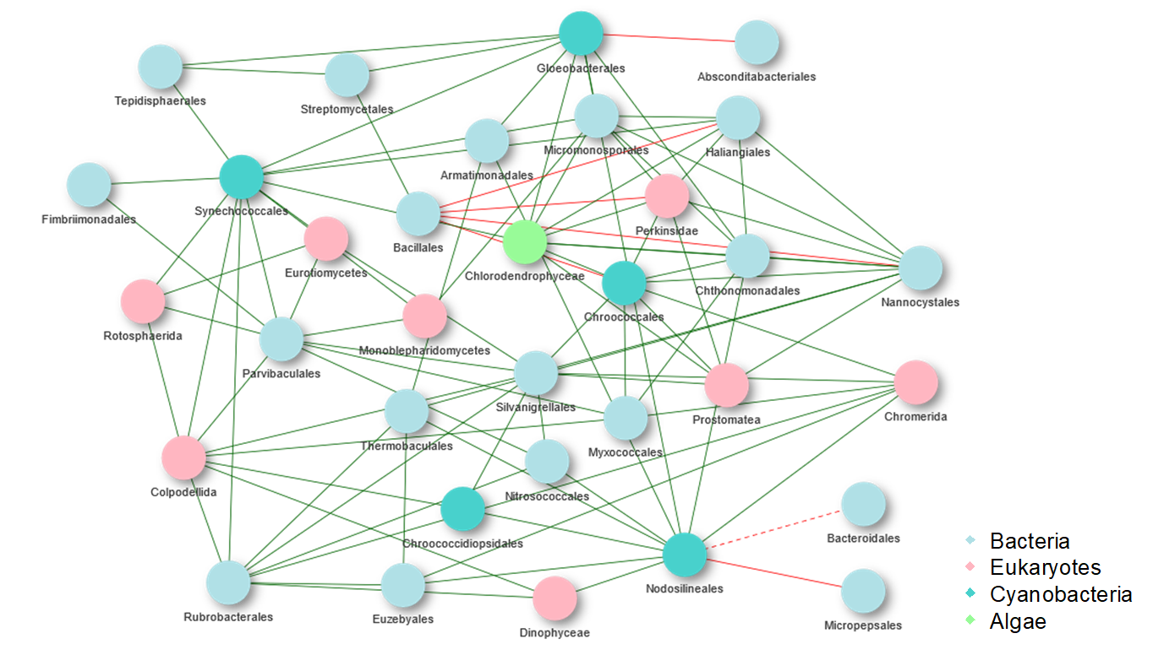

b.
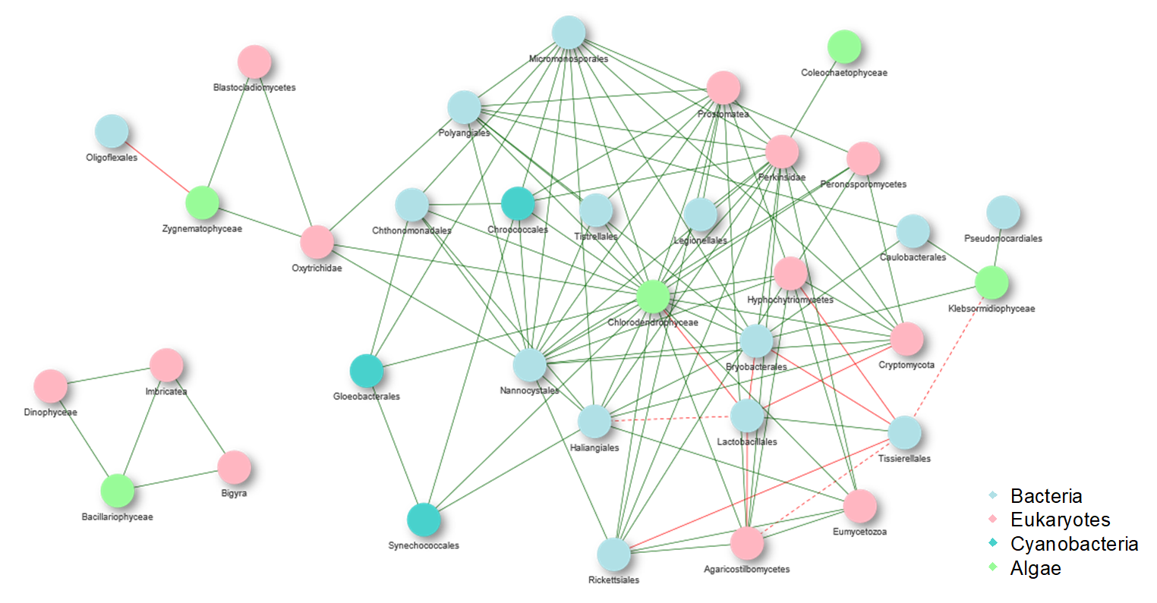
Supplementary Figure 3 – Co-occurrence networks of cyanobacteria (a) and eukaryotic microalgae (b). Green and red lines indicate positive and negative correlations, respectively.

