Supplementary Material

Example Air Mas Back Trajectory for Godzilla Dust
Cellulose filters collected at Ragged Point, Barbados between June 21st-24th, 2020, were used for the seawater incubation. Air mass back trajectories (from NOAA HYSPLIT) confirmed that the dust collected at Ragged Point originated in Northern Africa.
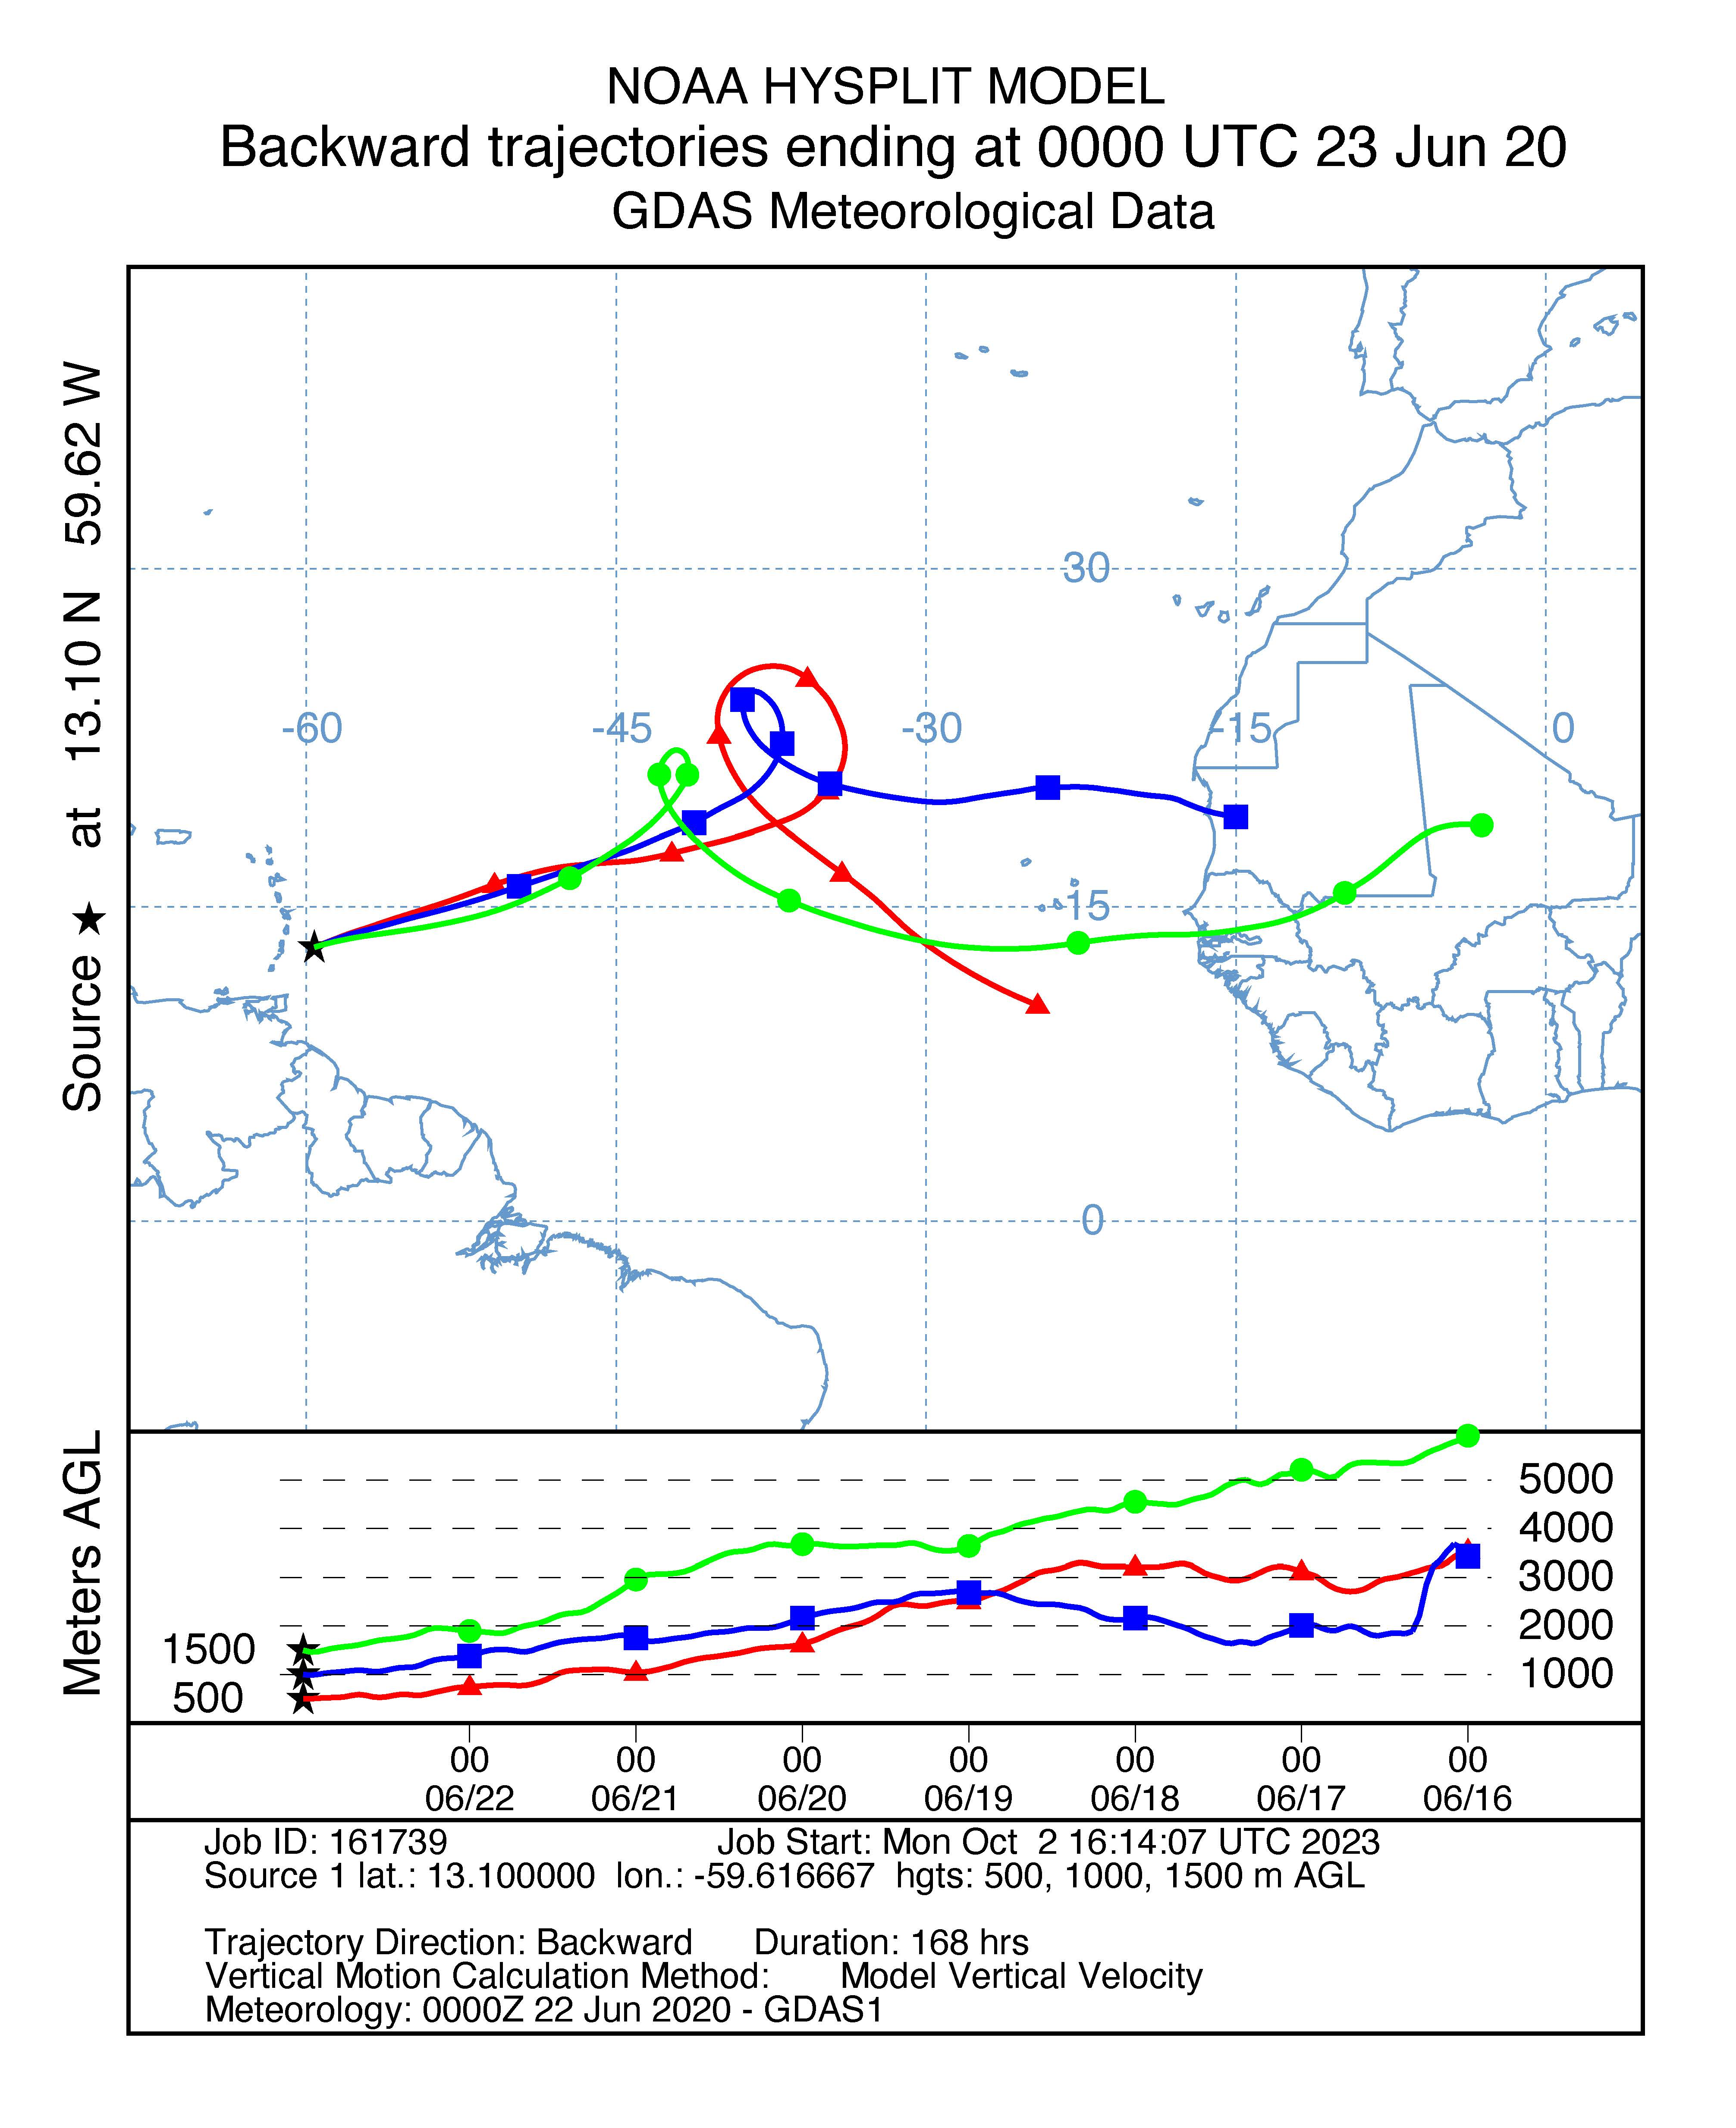
SI Figure 1. NOAA HYSPLIT 7-day air mass back trajectory from Ragged Point, Barbados. This example back trajectory is from 00:00 UTC on June 23, 2020 (during the Godzilla dust event). Trajectories at 500, 1000, and 1500 meters AGL show that air masses reaching the site on the June 23rd came from Northern Africa.

ICP-MS Analytical Methods for Total P and Total Fe Concentrations
Elemental concentrations in both mineral dust and volcanic ash were determined at the University of Miami, Rosenstiel School of Marine, Atmospheric & Earth Science using triple quadrupole inductively coupled plasma mass spectrometry (Agilent 8900, Agilent Technologies, Santa Clara, CA, USA). Sample dilutions were performed in a in a Class 100 UL 1805 certified polypropylene trace metal workstation. The 8900 was equipped with an integrated autosampler (SPS-4) with HEPA filtration and coverkit, Ni skimmer and sampler cones, and standard electron multiplier detector. In these analyses, the instrument had a standard sample introduction system, including a glass MicroMist nebulizer, a quartz double pass spray chamber, and quartz torch with 2.5mm id injector, and either a general purpose batch or a batch with UHMI setting of 8 was used for online sample dilution using Ar gas. Instrument operation was conducted in Mass Hunter 4.5 Workstation Software (C.01.05). Instrument tuning was conducted prior to each analysis, and the tuning solution contained 1 ug/g Li, Y, and Tl (Agilent Technologies Tuning solution) which allowed for the optimization of signal sensitivity and peak resolution at low, mid, and high m/z ranges as previously (Harouaka et al., 2020). Plasma-derived oxides and doubly charged ions were monitored before each analytical batch and maintained below 2% and 3% respectively. Three replicate analyses consisting of 100 sweeps each were conducted for each measurement. Scandium was introduced using the Agilent online internal standard kit to serve as internal standards. An external calibration curve was produced from commercially available multi-element solutions produced by Agilent Technologies and was certified using NIST-traceable Spex Certiprep solution with reproducibility better than ±8% difference from certified values. For a blank correction, one-eighth of a blank W-41 filter was digested along with the mineral dust sample, then the concentration in the running solution was subtracted from all sample measurements. Filter blank values in the running solution were <2.5% of the mineral dust sample P concentration and <0.2% of the mineral dust sample Fe concentration. An acid blank was used for blank corrections with the volcanic ash. Acid blank values in the running solution were below the instrument's limit of detection for P and <0.4% of the volcanic ash sample Fe concentration. Absolute P and Fe values measured for the samples and CRMs (and the certified values for the CRMs) are reported in SI Table 1. Maximum RSD %s for each element are reported in SI Table 2. Method validation was performed using two CRMs; BHVO-2 (Hawaiian Basalt, USGS) and AGV-2 (Guano Valley Andesite, USGS). Calculations of average percent difference from the certified values (certified-analyzed)/certified*100), are reported in SI Table 2.

SI Table 1. Absolute P and Fe values measured for mineral dust, volcanic ash, and CRMs. (CRM values are represented as averages of multiple CRM measurements used as checks)
Sample or CRM ID | Measured P concentration (mg/kg) | Certified P concentration (mg/kg) for CRMs only | Measured Fe concentration (mg/kg) | Certified Fe concentration (mg/kg) for CRMs only
Godzilla mineral dust | 856.8 | N/A | 52177.6 | N/A
La Soufrière volcanic ash | 586.3 | N/A | 54169.9 | N/A
AGV-2 | 2142.8 | 2100 | 49887.2 | 46800
BHVO-2 | 1197.2 | 1200 | 86384.1 | 86300

SI Table 2. Measurement RSDs and Percent Difference from Certified Reference Values calculated for P and Fe
 |  | Average % Difference from Certified Values for CRMS
Element | Sample %RSD | AGV-2 | # of replicate analyses | BHVO-2 | # of replicate analyses
P | ≤4% | 3.63 % | 3 | 3.12 % | 4
Fe | ≤4% | 8.08 % | 4 | 4.00 % | 3

ICP-MS Analytical Methods for TDP in Volcanic Ash Leachate
P concentrations in leachate were also determined at the Rosenstiel School of Marine, Atmospheric & Earth Science using an Agilent 8900 ICP-QQQ, Agilent Technologies, Santa Clara, CA, USA). Sample dilutions were performed in a in a Class 100 UL 1805 certified polypropylene trace metal workstation. No UMHI was used for leachate analysis. Instrument operation was conducted in Mass Hunter 4.5 Workstation Software (C.01.05). Instrument tuning was conducted prior to each analysis, and the tuning solution contained 1 ug/g Li, Y, and Tl (Agilent Technologies Tuning solution) which allowed for the optimization of signal sensitivity and peak resolution at low, mid, and high m/z ranges as previously (Harouaka et al., 2020). Plasma-derived oxides and doubly charged ions were monitored before each analytical batch and maintained below 2% and 3% respectively. Three replicate analyses consisting of 100 sweeps each were conducted for each measurement. Scandium was introduced using the Agilent online internal standard kit to serve as internal standards. An external calibration curve was produced from commercially available multi-element solutions produced by Agilent Technologies. For P measurements, the instrument was operated in MS/MS mode using O₂ gas in the collision-reaction cell (CRC) and analyzing the O₂ mass shifted analyte in the third quadrupole at mass 47. For blank correction, sodium bicarbonate solution was also acidified for analysis, and the P concentration measured in the sodium bicarbonate blank running solution was subtracted from the samples. NIST-traceable inorganic reference standards (n=2, SPEX CertiPrep, Metuchen, NJ, USA) were used to assess accuracy of the method, with recovery for P within ±8.5%.

HOBO MX2202 Data
Temperature and light were monitored in the two flow-through incubators on the Rosenstiel School dock over the course of the incubation. Diurnal temperature and light changes were clearly observed (SI Figure 2).
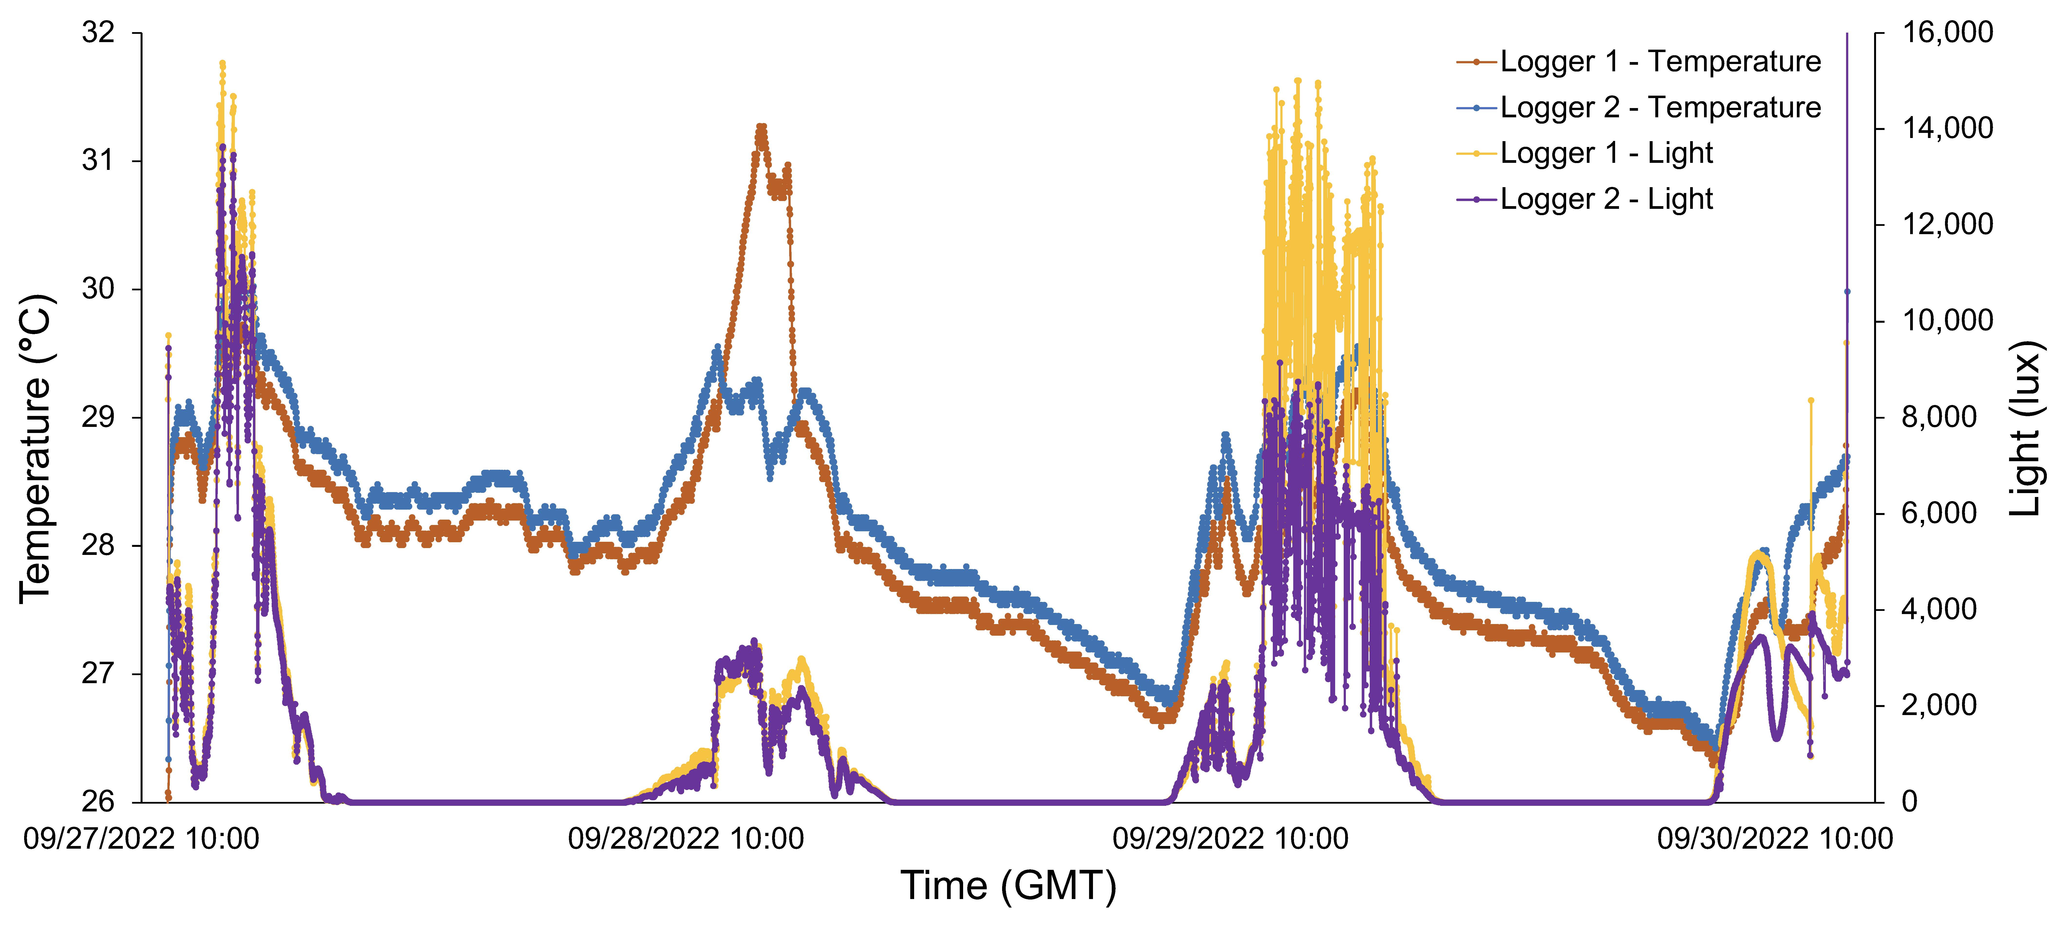
SI Figure 2. Temperature and light data recorded for two HOBO MX2202 loggers (one in each flow-through incubator).

Phosphate Uptake Rate Calculations
Uptake rate of radioactivity into marine microbial cells (dpm/L/min) was calculated as the slope between the volume-corrected sample activity (using the blank filter-derived activity for activity at the radioactive spike time) and time since the radioactive spike. Filter blanks were collected at both t=0 and t=3, but activity measured in the blanks collected at t=0 was negligible and likely does not accurately represent actual radioisotope carryover from the filter rig during sampling, so the average radioactivity of the four filter blanks collected at t=3 was used as the baseline filter activity at the time of the radioisotope spike for each incubation (providing the y-intercept for determining P uptake rate as the slope of activity per time). This filter blank activity was often <10% percent of the filter activity within 15 minutes of radioisotope spike. Specific activity (SA, dpm/nmol P) was calculated by dividing TA (dpm/L) by SRP (nmol P/L). Phosphate uptake rate (nmol PO₄/L/hr) was calculated as uptake rate of radioactivity (dpm/L/hr) divided by SA (SI Equation 1). Phosphate turnover time was calculated by dividing TA by uptake rate of radioactivity (SI Equation 2).
SI Equation 1.
$$Uptake Rate (nmol PO_{4}^{3-}/L/hr)= \frac{sample activity (dpm)}{volume filtered \left(L\right)× time since{}_{}^{32}{P added} (hr)}×\frac{1}{SA (\frac{dpm}{nmol PO_{4}^{3-}})}$$
SI Equation 2.
$$Turnover Time (hr)=TA (\frac{dpm}{L})× \frac{volume filtered \left(L\right)× time since {}_{}^{32}{P added} (hr)}{sample activity(dpm)}$$

Phosphate Turnover Times
Phosphate turnover time is normalized to the relevant controls in Fig. 6 in the text. SI Figure 3 shows the absolute phosphate turnover time for each of the six conditions represented in minutes (not normalized to the control).
SI Figure 3. Phosphate turnover time in minutes at t=0-2 for volcanic ash (left) and mineral dust (right) experimental and control conditions.

APA Calculations
Standard curve concentrations for APA measurements ranged from 0-5 μM MUB, and standard curve slope was calculated as (fluorescence/μM MUB, which is equivalent to fluorescence/μM phosphate released). For samples, APA (μM P/hr) was determined by calculating the increase in sample fluorescence as a slope over time (fluorescence/time since MUF-P addition), then dividing by the standard curve slope (SI Equation 3). APA was reported as nM P/hr.

SI Equation 3.
$$APA (nM P/hr)= \frac{sample fluorescence}{time since MUF\text{-}P addition (hr) } × \frac{mM P}{standard fluorescence} × \frac{1000 nM P}{1 mM P}$$

Data from Incubation Day 4
Cell count data demonstrates that phytoplankton abundance was greatest on day 4 (t=3) of the experiment for all experimental and control conditions (SI Figure 4). Since phytoplankton counts increased for all experimental and control conditions, this result likely reflects the response of the microbial community to the incubation set-up/conditions rather than the aerosol additions. Therefore, the day 4 (t=3) data was not included in the analysis.
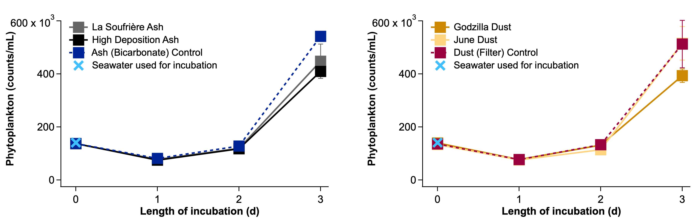
SI Figure 4. Phytoplankton abundance over the entire 4-day incubation for volcanic ash (left) and mineral dust (right) experimental conditions and controls.

References
Harouaka, K., Allen, C., Bylaska, E., Cox, R.M., Eiden, G.C., di Vacri, M.R., et al. (2021). Gas-phase ion-molecule interactions in a collision reaction cell with triple quadrupole-inductively coupled plasma mass spectrometry: Investigations with N₂O as the reaction gas. Spectrochimica Acta Part B: Atomic Spectroscopy 186:106309. doi: 10.1016/j.sab.2021.106309

