The combined effects of acidification and acute warming on the embryos of Pacific herring (Clupea pallasii)
Nicole R. Singh*, Brooke Love, Christopher S. Murray, Kathryn L. Sobocinski, W. James Cooper
* Correspondence: Nicole R. Singh: singh.nicole13@gmail.com
1. Supplementary Figures and Tables

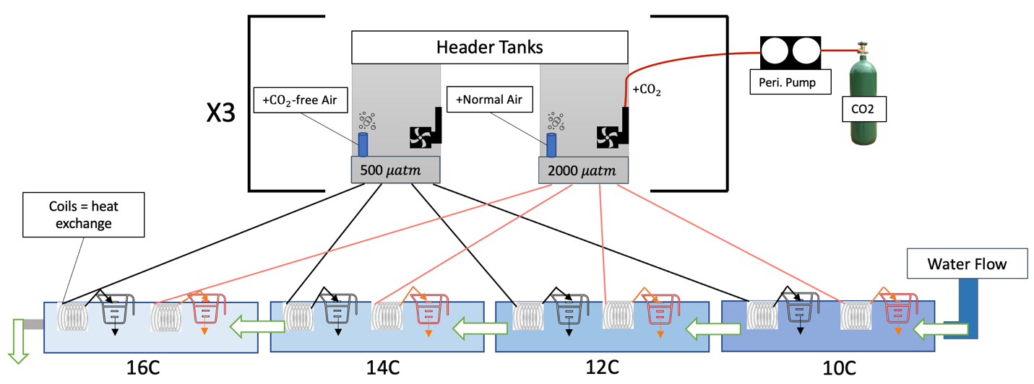

Figure S1. Schematic of the $p{CO}_{2}$ control system for the winter experiment, performed at Shannon Point Marine Center (SPMC). 3 header tanks designated as “ambient $p{CO}_{2}$” received ${CO}_{2}$-free air to reduce inlet seawater. 3 header tanks designated as “high $p{CO}_{2}$” received additional ${CO}_{2}$ gas from a peristaltic pump, which was broken up into small bubbles by powerhead pumps. Water from header tanks was adjusted to the main tank temperature with 8 feet of plastic coils used for heat exchange. After passing through the coil, water was distributed into an individual cup that housed embryos. 6 replicate cups per $p{CO}_{2}$ treatment were placed in each of the 4 temperature tank for a total of 48 cups (2 $p{CO}_{2}$ treatments $×$ 6 cups $×$ 4 temperature tanks). Water in the main tanks flowed from ambient (10°C) to extreme (16°C) in increments of 2°C (spring experiment: omission of 12° and 14°C; 8 replicate cups per $p{CO}_{2}$ treatment).

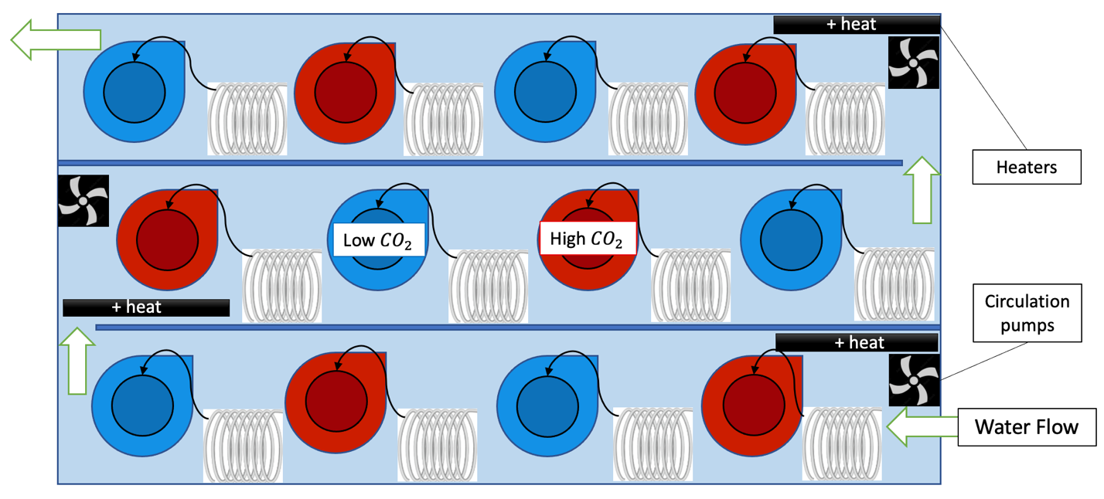
Figure S2. Superior view of temperature tank for the winter experiment, performed at Shannon Point Marine Center (SPMC). Temperature tanks were controlled with 4 temperature controllers (Elitech® STC-1000) connected to three heaters per tank. Circulation pumps increased heat exchange throughout the temperature tanks. 6 replicate cups per $p{CO}_{2}$ treatment were placed in each temperature tank. Water from $p{CO}_{2}$ header tanks were fed through 8-foot-long plastic tubes, coiled, and submerged in the temperature tank to enhance heat exchange. Tubing was connected to stopcocks and dripped into replicate cups where embryos were housed. (Spring: 8 replicate cups per $p{CO}_{2}$ treatment).

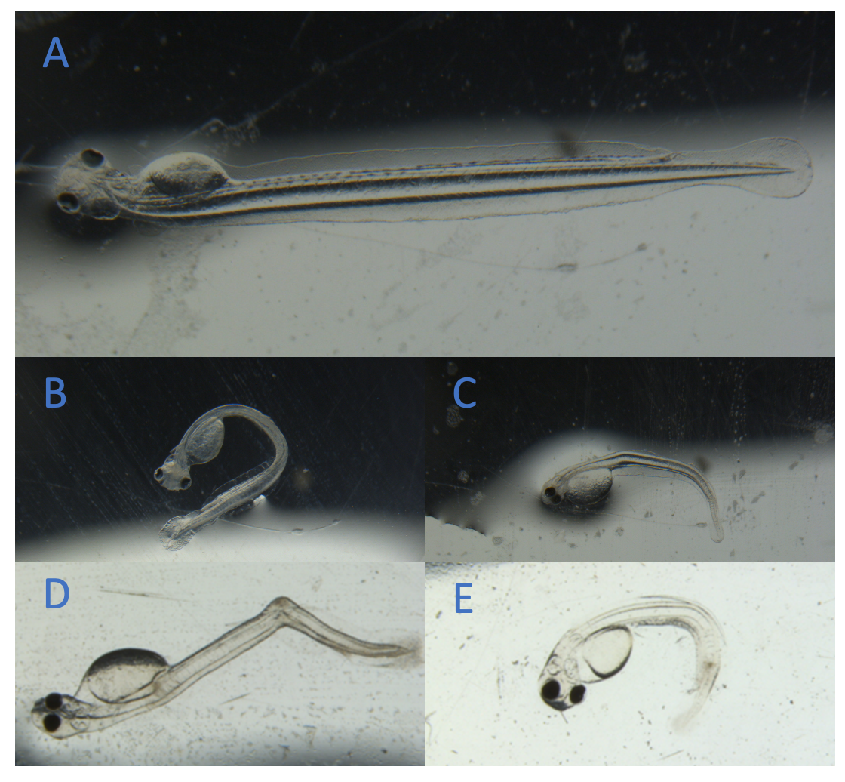

Figure S3. A. Example of a healthy Pacific herring hatchling. B. Developmental malformation: notochord curvature. C. Development malformation: underdeveloped jaw. D. Developmental malformation: spinal deviation. E. Developmental malformation: yolk sac edema and notochord shortening.

Table S1. Average in-situ parameters and calculated carbonate chemistry values at incubation conditions for the winter experiment, performed in March 2021. Treatment combinations of $p{CO}_{2}$ + temperature are represented at ambient and high $p{CO}_{2}$ (average 677.91 ± 152 $μatm$; 1365 ± 407 $μatm$) and 4 discrete temperatures (10$°$, 12$°$, 14$°$, 16$℃$) with mean ± 1 SD. Typical nutrient concentrations of seawater source include total P: 2.2 µmol kg⁻¹ and total Si: 2 µmol kg⁻¹. Equilibrium constants for the dissociation of carbonic acid in seawater (K1 and K2) followed Mehrbach et al. (1973) refitted by Dickson and Millero (1987) and the constant for KHSO₄ was supplied by Dickson (1990). Sample size (N) varies from 14 to 21 for treatment combination.
 |  | In-Situ Measurements |  | Carbonate Chemistry Values
Test Temp.  ($℃$) | Test p${CO}_{2}$ | pH  (NIST) | Temperature  ($℃$) | p${CO}_{2}$  ($μatm$) | pH  (Total) | DIC
10 | Ambient | 7.90 ± 0.14 | 10.20 ± 0.17 | 613.49 ± 120.84 | 7.86 ± 0.06 | 1986.08 ± 23.95
10 | High | 7.49 ± 0.10 | 10.35 ± 0.12 | 1222.15 ± 330.88 | 7.59 ± 0.14 | 2063.56 ± 18.67
12 | Ambient | 7.88 ± 0.05 | 12.07 ± 0.78 | 630.37 ± 92.43 | 7.85 ± 0.06 | 1983.77 ± 23.22
12 | High | 7.41 ± 0.04 | 12.27 ± 0.31 | 1363.59 ± 443.03 | 7.56 ± 0.17 | 2068.34 ± 18.88
14 | Ambient | 7.86 ± 0.05 | 13.48 ± 0.26 | 670.66 ± 94.77 | 7.83 ± 0.06 | 1985.30 ± 13.84
14 | High | 7.42 ± 0.11 | 13.53 ± 0.15 | 1401.15 ± 469.50 | 7.55 ± 0.16 | 2062.04 ± 30.27
16 | Ambient | 7.81 ± 0.06 | 15.56 ± 0.38 | 797.12 ± 300.12 | 7.77 ± 0.12 | 1991.85 ± 29.91
16 | High | 7.41 ± 0.07 | 15.57 ± 0.25 | 1473.59 ± 385.12 | 7.52 ± 0.13 | 2066.14 ± 21.83
Average | Ambient | 7.86 ± 0.3 | --- | 677.91 ± 152 | 7.83 ± 0.08 | 1986.75 ± 23
Average | High | 7.42 ± 0.08 | --- | 1365.12 ± 407 | 7.55 ± 0.15 | 2065.02 ± 22

Table S2. Average in-situ parameters and calculated carbonate chemistry values at incubation conditions for the spring experiment, performed in May 2021. Treatment combinations of $p{CO}_{2}$ + temperature are represented at ambient and high $p{CO}_{2}$ (average 902.35 ± 83 $μatm$, 2170.61 ± 531 $μatm$) and 2 discrete temperatures (10$°$, 16$℃$) with mean ± 1 SD. Typical nutrient concentrations of seawater source include total P: 2.2 µmol kg⁻¹ and total Si: 2 µmol kg⁻¹. Equilibrium constants for the dissociation of carbonic acid in seawater (K1 and K2) followed Mehrbach et al. (1973) refitted by Dickson and Millero (1987) and the constant for KHSO₄ was supplied by Dickson (1990). Sample size (N) varies from 12 to 16 for treatment combinations.
 |  | In-Situ Measurements |  | Carbonate Chemistry Values
Test Temp.  ($℃$) | Test p${CO}_{2}$ | pH  (NIST) | Temperature  ($℃$) | p${CO}_{2}$  ($μatm$) | pH  (Total) | DIC
10 | Ambient | 7.94 ± 0.15 | 10.46 ± 0.36 | 932.88 ± 99.95 | 7.70 ± 0.04 | 1946.22 ± 8.61
10 | High | 7.55 ± 0.08 | 10.68 ± 0.53 | 2111.40 ± 545.02 | 7.39 ± 0.11 | 2038.00 ± 30.50
16 | Ambient | 7.92 ± 0.02 | 15.53 ± 0.20 | 871.81 ± 65.29 | 7.73 ± 0.03 | 1943.19 ± 11.77
16 | High | 7.45 ± 0.04 | 15.53 ± 0.26 | 2229.82 ± 516.68 | 7.36 ± 0.10 | 2048.45 ± 20.63
Average | Ambient | 7.93 ± 0.09 | --- | 902.35 ± 83 | 7.72 ± 0.04 | 1944.71 ± 10
Average | High | 7.5 ± 0.06 | --- | 2170.61 ± 531 | 7.38 ± 0.11 | 2043.23 ± 26

Table S3. ANOVA results for oxygen consumption rates per embryo (${MO}_{2}$) (nmol $O_{2}$ ${hr}^{-1}$) in the winter experiment. Significant values indicated in bold. Arrow indicates the direction of trait effect trend with increasing factor.
Factor | Df | F | p
$p{CO}_{2}$ ↑ | 1 | 8.08 | 0.012
Temp ↑ | 3 | 4.90 | 0.013
$p{CO}_{2}$ $×$ Temp | 3 | 0.21 | 0.884

Table S4. LMM results for heart contractions in control embryos and those held at 25$℃$ in measurements taken 3 days post-${CT}_{max}$ exposure in the spring experiment. Significant values indicated in bold. Arrow indicates the direction of trait effect trend with increasing factor.
Factor | Df | Std. Error | p
Incubation Temp | 20 | 7.654 | 0.199
Max Temp | 199 | 05.076 | 0.478
Duration ↑ | 195 | 2.905 | 0.001
Incubation Temp ↓ $×$ Duration ↑ | 198 | 4.115 | 0.053

Table S5. Winter ANOVA results for time to first hatch (dpf), peak hatch (dpf), total hatch (%), malformation rate of total embryos per replicate (%), malformation rate of total hatchlings (%), and hatching success (%). Significant treatment effects are indicated in bold. Arrow indicates the direction of the trait effect trend with increasing factor.
Trait | Factor | Df | F | p
Time to First hatch | $$p{CO}_{2}$$ | 1 | 4 | 0.063
 | Temp ↓ | 3 | 480 | <0.001
 | $p{CO}_{2}$ $×$ Temp ↓ | 3 | 4 | 0.027
Time to Peak hatch | $p{CO}_{2}$ ↑ | 1 | 5 | 0.039
 | Temp ↓ | 3 | 498.86 | <0.001
 | $p{CO}_{2}$ $×$ Temp | 3 | 2.86 | 0.069
Cumulative hatch | $$p{CO}_{2}$$ | 1 | 1.93 | 0.183
 | Temp | 3 | 0.97 | 0.429
 | $p{CO}_{2}$ $×$ Temp | 3 | 0.77 | 0.526
Malformation rate  (total embryos) | $p{CO}_{2}$ ↑ | 1 | 12.85 | 0.002
 | Temp ↑ | 3 | 6.19 | 0.005
 | $p{CO}_{2}$ $×$ Temp ↑ | 3 | 3.58 | 0.037
Malformation rate  (total hatch) | $$p{CO}_{2}$$ | 1 | 3.20 | 0.093
 | Temp ↑ | 3 | 7 | 0.003
 | $p{CO}_{2}$ $×$ Temp | 3 | 1.70 | 0.207
Hatching success | $$p{CO}_{2}$$ | 1 | 0.05 | 0.457
 | Temp ↓ | 3 | 5.12 | 0.054
 | $p{CO}_{2}$ $×$ Temp | 3 | 0.10 | 0.389

Table S6. Spring ANOVA results for time to first hatch (dpf), peak hatch (dpf), total hatch (%), malformation rate of total embryos per replicate (%), malformation rate of total hatchlings (%), and hatching success (%). Significant treatment effects are indicated in bold. Arrow indicates the direction of trait effect trend with increasing factor.
Trait | Factor | Df | F | p
Time to First hatch | $$p{CO}_{2}$$ | 1 | 0.05 | 0.512
 | Temp ↓ | 1 | --- | <0.001
 | $p{CO}_{2}$ $×$ Temp | 1 | 0.05 | 0.512
Time to Peak hatch | $$p{CO}_{2}$$ | 1 | 0.09 | 0.768
 | Temp ↓ | 1 | 87.36 | <0.001
 | $p{CO}_{2}$ $×$ Temp | 1 | 0.81 | 0.384
Cumulative hatch | $$p{CO}_{2}$$ | 1 | 2.90 | 0.114
 | Temp ↓ | 1 | 14.17 | 0.003
 | $p{CO}_{2}$ $×$ Temp | 1 | 3.60 | 0.082
Malformation rate  (total embryos) | $$p{CO}_{2}$$ | 1 | 0.42 | 0.526
 | Temp ↓ | 1 | 6.803 | 0.023
 | $p{CO}_{2}$ $×$ Temp | 1 | 0.75 | 0.402
Malformation rate  (total hatch) | $$p{CO}_{2}$$ | 1 | 1.61 | 0.228
 | Temp | 1 | 0.051 | 0.825
 | $p{CO}_{2}$ $×$ Temp | 1 | 1.11 | 0.313
Hatching success | $$p{CO}_{2}$$ | 1 | 3.37 | 0.091
 | Temp ↓ | 1 | 5.38 | 0.039
 | $p{CO}_{2}$ $×$ Temp | 1 | 3.12 | 0.103

References

Dickson, A. G. (1990). Standard potential of the reaction: AgCl(s)+ 12H2(g) = Ag(s)+HCl(aq),
and the standard acidity constant of the ion HSO4– in synthetic sea water from 273.15 to 318.15 K. J. Chem. Thermodyn. 22 (2), 113–127. doi: 10.1016/0021-9614(90)90074-Z
Dickson, A., and Millero, F. (1987). A comparison of the equilibrium constants for the
dissociation of carbonic acid in seawater media. Deep Sea Res. A. Oceanogr. Res. Pap. 34 (10), 1733–1743. doi: 10.1016/0198-0149(87)90021-5
Mehrbach, C., Culberson, C. H., Hawley, J. E., and Pytkowicx, R. M. (1973). Measurements of
the apparent dissociation constants of carbonic acid in seawater at atmospheric pressure. Limnol. Oceanogr. 18 (6), 897–907. doi: 10.4319/lo.1973.18.6.0897

