Supplementary Material
This supplementary material covers a more detailed description of the parametrization of the population dynamics, such as the spatial distribution modelling, stock abundance estimates and the estimation of stock recruitment parameters of M. muelleri and B. glaciale in the Northeast Atlantic Ocean in Section 1. Details on the parametrization of the fishery and associated economic parameters can be found in Section 2, and the parametrization for the depletion from other countries is detailed in Section 3. Section 4 provides a detailed overview of the population dynamics equations and the equations regarding economic indicators. Section 5 finally comprises of additional relevant results, including sensitivity studies of the DISPLACE model and the current parametrization to different parameter settings.

Population dynamics parametrization

Overview of survey length distributions
We used length frequencies collected during the field campaigns of the EU-2020 MEESO project www.meeso.org) and other scientific surveys, described in (Vastenhoud et al., 2023). See Vastenhoud et al. (2023)for a detailed description of the data sources and data cleaning. We compiled the length-frequency dataset by region, as length data were obtained with different sampling gears and trawl codend mesh sizes during different time periods and potentially cover different populations in each region. Length-frequency distributions of the different stocks are shown in SM Figure 1.

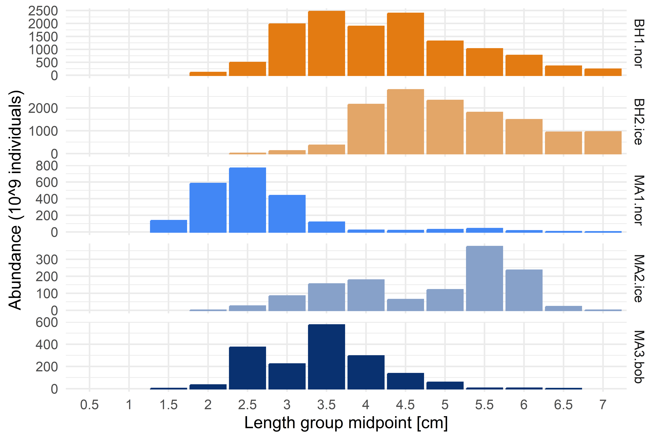
Figure 1. The number of individuals in each size group for the populations of Maurolicus muelleri and Benthosema glaciale.

Estimation of stock abundance
The total areas for which we estimated abundances are shown in Figure 2.
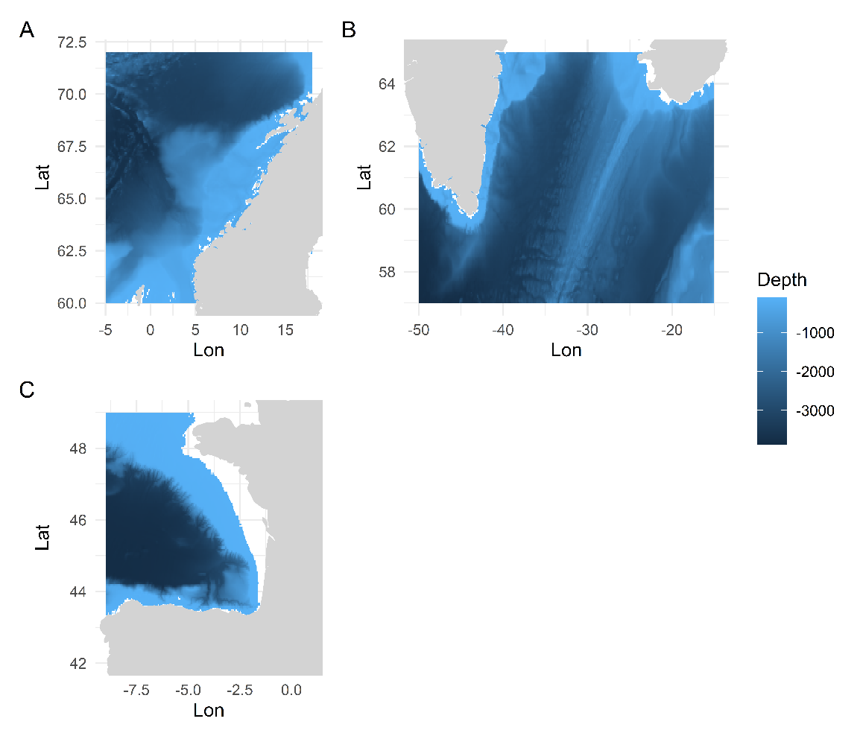
Figure 2. The areas for which we estimated abundances for each population (A = Norwegian Sea, B = Icelandic waters and Irminger Sea, C = Bay of Biscay). The color scale indicates bathymetry deeper than 100m.
To parametrize the specific populations of M. muelleri in the Norwegian shelf and offshore areas we used parameters for the Neritic west of Great Britain and Norway, where M. muelleri is dominant from (Gjosaeter and Kawaguchi, 1980) – page 122). Abundance estimates from the Icelandic region originated from an Icelandic survey in 2010 which specifically targeted M. muelleri (Jónsson et al., 2010), where the abundance per square nautical mile was converted to a number per km². Abundance estimates in the Bay of Biscay originate from the acoustic trawl survey JUVENA from 2014-2017 (Sobradillo et al., 2019). We estimated abundances based on the reported biomass, mean weight of M. muelleri and the area covered with the survey:
$$Abundance \left(\frac{million}{km2}\right)= {Biomass \left(tonnes\right)}/{{mean weight \left(g\right)}/{Area \left({km}^{2}\right)}}$$
( 1)
Due to the absence of species- and region- specific abundance and biomass estimates of B. glaciale we used mesopelagic abundance estimates for the full Northeast Atlantic region, where B. glaciale is dominant. (Gjosaeter and Kawaguchi, 1980) – page 122).
Table 1. Overview of the population densities used to estimate the total density in each area.
Stock | Relative abundance (10⁶ individuals/km²) | Observed range of relative abundance (10⁶ individuals/km²) | Reference
MA1.nor | 10.84 | 5.26-18.42 | (Gjosaeter and Kawaguchi, 1980)
MA2.ice | 7.99 | 3.5-11.19 | (Jónsson et al., 2010)
MA3.bob | 6.38 | 3.86-7.58 | (Sobradillo et al., 2019)
BH1.nor | 1.05 | 0.1-2 | (Gjosaeter and Kawaguchi, 1980)
BH2.ice | 1.05 | 0.1-2 | (Gjosaeter and Kawaguchi, 1980)

Estimation of stock-recruitment parameters
In absence of information regarding the stock-recruitment relationship of M. muelleri and B. glaciale we derived the parameters $α$ and $β$ from a Beverton-Holt stock-recruitment relationship based on eq. 4-5 in (Mangel et al., 2010a):
$$α= \frac{B_{0}}{R_{0}}\frac{1-h}{4h}$$
( 2 )
$$β=\frac{5h-1}{4hR_{0}}$$
( 3 )
The species-specific steepness parameter $\left(h\right)$, indicating the fraction of recruitment from an unfished population when the SSB declines to 20% of its unfished level ${(B}_{0})$, was extracted from the estimations from (Thorson et al., 2017; Thorson, 2020). Often, and more so in data-poor situations, plausible values for steepness are used if other information is missing as a form of an implicit Bayesian approach (Mangel et al., 2010a). The steepness parameter h is related to the resilience of a species, and determines the average productivity of fishery resources within an environmental system at equilibrium (Mangel et al., 2010b).
The ratio $\frac{B_{0}}{R_{0}}$ indicates the spawning stock biomass per recruit, and was here calculated following eq 1-3 in (Zhou et al., 2020), where this ratio is referred to as the spawning stock biomass per recruit (SSBPR). We here define SSBPR₀ as the SSBPR for an unfished stock where fishing mortality F=0:
$${SSBPR}_{0}=\frac{B_{0}}{R_{0}}=\sum_{t=1}^{t_{max}}{S_{t}W_{t}m_{t}}$$
( 4 )
Here, $S_{t}$ is the number of survivors at time t, $W_{t}$ the weight at time of an individual and $m_{age}$ the probability of being mature. For each species we used the values for the life-history parameters M, L_{inf}, K and t₀ provided of the FishLife package (Thorson, 2020) to calculate the SSBPR₀. This was necessary to respect the correlation between the parameters when studying the sensitivity of this method to different parameters (see below). The number of survivors $S_{t}$ was calculated using a constant mortality M over all size classes:
$$S_{t+1}=S_{t}e^{-M}$$
( 5 )
With $S_{age=1}=1$. The weight at age $W_{t}$ was calculated using the parameters L_{inf}, K and t₀ of the Von Bertalanffy growth function (VBGF) and parameters a and b of the allometric length-weight relationship (Table 1) according to:
$$W_{t}=a{\left[L_{inf}(1-e^{-K\left(t-t_{0}\right)})\right]}^{b}$$
( 6 )
The unfished recruitment was calculated as:
$$R_{0}=\frac{B_{0}}{{SSBPR}_{0}}$$
( 7 )
B₀ of each stock was assumed equal to the total stock biomass, assuming that individuals mature quickly and that recruits are too small to be caught. An overview of the stock-recruitment parameters can be found in Table 2.
Table 2. Stock-recruitment parameters of the different stocks. The parameter values used for the DISPLACE parametrization are underlined.
Stock | SSBPR₀ (g/#) | B₀ (Mt) | R₀ (#) | h | Alpha (g/#) | beta (#⁻¹)
MA1.nor | 2.92 | 24.62 (11.94-41.83) | 8.44 x 10¹² | 0.83 (±0.20) | 0.15 | 1.12 x 10⁻¹³
MA2.ice | 2.92 | 24.51 (10.74-34.32) | 8.40 x 10¹² | 0.83 (±0.20) | 0.15 | 1.13 x 10⁻¹³
MA3.bob | 2.92 | 4.09 (2.48-4.86) | 1.40 x 10¹² | 0.83 (±0.20) | 0.15 | 6.76 x 10⁻¹³
BH1.nor | 0.85 | 2.64 (0.25-5.02) | 3.11 x 10¹² | 0.89 (±0.13) | 0.03 | 3.12 x 10⁻¹³
BH2.ice | 0.85 | 3.56 (0.34-6.78) | 4.20 x 10¹² | 0.89 (±0.13) | 0.03 | 2.31 x 10⁻¹³
We did a sensitivity study on the input parameters to identify influential factors. This study was applied on one stock, MA1.nor, where we studied the effect of a 25% increase and decrease of the parameter values of L_{inf}, K, M, t_{m}, h and B₀. We assume that for the other stocks similar sensitivities occur. In this case, we used for the growth, mortality and maturity parameters, the parameter estimates from (Thorson et al., 2017). For each sensitivity study, first the respective parameter is adjusted, and then the parameter estimations from (Thorson et al., 2017) are updated to take into account confounding relationships between parameters.
The results of the sensitivity study are shown in Table 3 and Figure 3. Although all parameter choices influence the estimation of alpha and beta, the parameter alpha is highly dependent on the input parameter h, and in lesser amount on M and L_{inf}. The estimation of beta is mostly influenced by the parameter choices of L_{inf} and M. Although there are efforts made to improve the knowledge of L_{inf} and M of the two species, and the spatio-temporal variability therein (See also Section 1.5), little is known about the steepness parameter h of the two species. For more reliable stock-recruitment parameters for these mesopelagic species using the method described here, it is therefore especially important to improve knowledge on the steepness parameter h.
Table 3. Overview of the sensitivity studies on estimation of the alpha and beta parameters for MA1.nor.The changed parameter value is each time shown in bold.
Scenario | L_{inf} (mm) | K (year⁻¹) | M (year⁻¹) | t_{m} (year) | h | B₀ (Mt) | Alpha (g/#) | Difference compared to baseline | beta (#⁻¹) | Difference compared to baseline
Baseline | 66.89 | 0.86 | 1.43 | 0.85 | 0.83 | 24.62 | 0.15 |  | 1.12 x 10⁻¹³
Baseline L_{inf} - 25% | 58.75 | 0.90 | 1.50 | 0.82 | 0.83 | 24.62 | 0.10 | 66.67 % | 7.29 x 10⁻¹⁴ | 65.09 %
Baseline L_{inf} + 25% | 73.97 | 0.84 | 1.38 | 0.87 | 0.83 | 24.62 | 0.21 | 140 % | 1.57 x 10⁻¹³ | 140.18 %
Baseline K - 25% | 67.60 | 0.81 | 1.36 | 0.90 | 0.83 | 24.62 | 0.16 | 106.67 % | 1.18 x 10⁻¹³ | 105.36 %
Baseline K + 25% | 66.34 | 0.91 | 1.49 | 0.81 | 0.83 | 24.62 | 0.14 | 93.33 % | 1.07 x 10⁻¹³ | 95.54 %
Baseline M - 25% | 67.69 | 0.83 | 1.20 | 0.94 | 0.83 | 24.62 | 0.22 | 146.67 % | 1.63 x 10⁻¹³ | 145.54 %
Baseline M + 25% | 66.27 | 0.89 | 1.63 | 0.79 | 0.83 | 24.62 | 0.11 | 73.33 % | 8.37 x 10⁻¹⁴ | 74.73 %
Baseline t_{m} - 25% | 66.25 | 0.91 | 1.59 | 0.67 | 0.83 | 24.62 | 0.13 | 86.67 % | 9.79 x 10⁻¹⁴ | 87.41 %
Baseline t_{m} + 25% | 67.38 | 0.83 | 1.31 | 1.01 | 0.83 | 24.62 | 0.16 | 106.67 % | 1.21 x 10⁻¹³ | 108.04 %
Baseline h - 20% | 66.89 | 0.86 | 1.43 | 0.85 | 0.66 | 24.62 | 0.37 | 246.67 % | 1.03 x 10⁻¹³ | 91.96 %
Baseline h + 20% | 66.89 | 0.86 | 1.43 | 0.85 | 0.99 | 24.62 | 0.002 | 1.33 % | 1.18 x 10⁻¹³ | 105. 36 %
Lower limit of B₀ | 66.89 | 0.86 | 1.43 | 0.85 | 0.83 | 18.46 | 0.15 | - | 1.50 x 10⁻¹³ | 133.93 %
Upper limit of B₀ | 66.89 | 0.86 | 1.43 | 0.85 | 0.83 | 30.77 | 0.15 | - | 8.99 x 10⁻¹⁴ | 80.27 %

Figure 3. The change of the stock recruitment relationships when changing the input parameters (A) L_{inf}, (B) K, (C) M, (D) tm, (E) h and (F) B₀.

Spatial distribution modelling
The length frequency data is covering the North Atlantic region, from the Bay of Biscay in the South (43°N) up to Svalbard (82°N) and between 16°W and 35°E (Figure 4).
Figure 4. Top panel: Sampling locations of Maurolicus muelleri. Bottom panel: Sampling locations of Benthosema glaciale. The dots indicate single trawl haul samples, colours indicate the region according to which we analyzed the data.
We modelled the spatial distribution of each species using General Additive Models (GAMs) with the sum of the abundance in the hauls used to establish length distributions in SM Section 1.1 as a response variable. This non-parametric regression method establishes a relationship between a response variable and a smoothed function of explanatory variables, without making any assumptions about the shape of those relationships (Hastie and Tibshirani, 1986). A GAM modelling approach allowed us to deal with the highly variable availability of spatially distributed densities, due to its flexibility regarding non-linear and non-monotonic relationships between explanatory and response variables, as in the current case. To create GAMs we used the ‘mgcv’ pachage (version 1.8-41) in R (Wood, 2011).
Due to the limited data availability of M. muelleri in Iceland we created one model using the densities from both the Norwegian and Irminger Sea. A second model was created for the Bay of Biscay population of M. muelleri. We created one model for each population of B. glaciale. In an initial ‘simple’ approach, for each population we created GAMs solely using depth and spatial coordinates, with haul duration as an offset and a Tweedie distribution. We used a thin plate regression spline on depth $\left(bs='tp'\right)$, and a Gaussian process smoother on the spatial coordinates to take into account spatial autocorrelation between observations $(bs=^{'}{gp}^{'})$, with a power exponential covariance function ($m=2$) between range and power (Wood, 2003). The parameter k indicates the basis dimension when using penalized regression smoothers, which in practice sets the upper limit on the degrees of freedom associated with the smoother. The exact choice of k is not critical but should indicate enough degrees of freedom to cover the underlying dynamics while keeping computationally efficient (Wood, 2003). Due to the limited data we were able to refit the models with different levels of k, and selected the k values where most of the residuals were explained.
Bathymetric depth for each observation was extracted from the NOAA ETOPO 2022 database (NOAA National Centers for Environmental Information, 2022) on a 1 minute resolution using the ‘marmap’ package (Pante and Simon-Bouhet, 2013).
Models were selected according to significant covariates and the lowest Akaike’s Information Criterion (AIC). We started with a model including all above mentioned covariates, and reduced the models until all predictors were significant. The final models for each population, together with the model performance, are shown in Table 4. The residuals $ε$ were assumed to be normally distributed (Figure 5 to Figure 8). After model calibration and validation, the selected models were used to predict an annual species distribution for each population in the regions where depth was shallower than 100m due to the vertical distribution range of the species.
Table 4. The selected model for each population with the model performance indicated by the Deviance explained.
Population | Model |  | Deviance Explained
MA1.nor and MA2.ice | $$Density \sim s\left(Lon,Lat,bs=^{'}{gp}^{'}, k = 100, m=2\right)+s\left(Gear, bs='re'\right)+ε$$ |  | 46.7%
 | Approximate significance of the model terms
 | Model term | p-value
 | Intercept | 2.59e-10
 | s(Lon,Lat) | < 2e-16
 | s(Gear) | 0.00126
MA3.bob | $$Density \sim s\left(Depth, bs='tp'\right)+ s\left(Lon,Lat,bs=^{'}{gp}^{'}, k = 150, m=2\right)+ε$$ |  | 19.7%
 | Approximate significance of the model terms
 | Model term | p-value
 | Intercept | <2e-16
 | s(Lon,Lat) | 0.190
 | s(Depth) | 0.173
BH1.nor | $$Density \sim s\left(Depth, bs='tp'\right)+ s\left(Lon,Lat,bs=^{'}{gp}^{'}, k = 150, m=2\right)+ε$$ |  | 67%
 | Approximate significance of the model terms
 | Model term | p-value
 | Intercept | <2e-16
 | s(Lon,Lat) | <2e-16
 | s(Depth) | 0.212
BH2.ice | $$Density \sim s\left(Depth, bs='tp'\right)+ s\left(Lon,Lat,bs=^{'}{gp}^{'}, k = 150, m=2\right)+ε$$ |  | 3.75%
 | Approximate significance of the model terms
 | Model term | p-value
 | Intercept | <2e-16
 | s(Lon,Lat) | 0.7119
 | s(Depth) | 0.0409

Figure 5. Residuals of the combined model for MA1.nor and MA2.ice.
Figure 6. Residuals of the MA3.bob model.
Figure 7. Residuals of the BH1.nor model.
Figure 8. Residuals of the BH2.ice model.

Population dynamics parameters
Table 5. Parameters for the length-weight relationships: $weight = a {length}^{b}$, where weight is measured in gram and length in mm.
Species | a | b | Reference
Maurolicus muelleri | 2.04 10⁻⁵ | 2.87 | (Gjosaeter, 1981b)
Benthosema glaciale | 7.6 10⁻⁷ | 3.66 | (Gjosaeter, 1981a)
Table 6. Growth and mortality parameters of each population. From (Vastenhoud et al., 2023).
Stock | L_{inf} (cm) | K (year⁻¹) | t₀ (year) | M (year⁻¹)
Maurolicus muelleri | 5.80 | 1.28 | 0.33 | 1.51
Benthosema glaciale | 7.90 | 0.41 | 0.39 | 0.75

Fishery dynamics parametrization

Departure and landing harbors
- Skagen
- Hirtshals
- Thyboron
- Hanstholm
- Bergen
- Narvik
- Alesund
- Stavanger
- Haugesund
- MaloyVagsoy
- Trondheim
- Tromso
- Bodo
- Reykjavik
- Akureyi
- Grindavík
- Bolungavík
- HelguvikReykjanesbær
- Siglufjörður
- Höfn í Hornafirði
- Þórshöfn
- Fáskrúðsfjörður
- Neskaupstaður Norðfjörður
- Vopnafjörður
- Vestmannaeyjar
- Seydisfjordur
- Peterhead
- Aberdeen
- Torshavn
- Klaksvik
- Lerwick
- Killybegs
- Vigo
- Ondarroa
- Bermeo
- Guetaria
- Castletownbere
Note: The harbor list originates from the VMS data (see Section 2.3) where the harbors were selected where landings were registered by the selected fishing vessels in 2015-2019. Today not all listed harbors have processing factories anymore.

Additional details regarding fleet selection and vessel properties
Details of the six selected large-scale Danish fishing vessels that participated in the blue whiting fishery from 2015 to 2019 are shown below in Table 7. All the discontinued vessels are registered in the Søfartsstyrelsens Register (https://shipregister.dma.dk/) as “Ophørt”, meaning that the vessel is no longer an operating fishing vessel.
Table 7. Overview of individual vessel characteristics of the case fleet.
Vessel | VE_LEN (m) | Tonnage | Fuel tank size (l) | Vessel status
Vessel 1 | 69.95 | 2352 | 599 000 | Discontinued on 17/03/2021
Vessel 2 | 75.40 | 2967 | 500 000 | Discontinued on 21/06/2022
Vessel 3 | 75.90 | 2150 | 560 000 | Discontinued on 12/06/2021
Vessel 4 | 76.25 | 2499 | 560 000 | Discontinued on 12/04/2022
Vessel 5 | 78.00 | 2760 | 550 000 | Active
Vessel 6 | 87.80 | 3720 | 599 000 | Discontinued on 12/04/2020
The new vessel Isafold, with the dimensions described below, is however not included here yet. This type of vessel would be very representative for the case specific fishery, as likely new vessels would be built to fish for mesopelagic resources (Paoletti et al., 2021). This vessel was sold to Rederiet Isafold in 2022 by Henning Kjeldsen in 2022. This vessel (87m by 20m, and with a 3700 cubic meter RSW tank capacity for pelagic fish), has currently acquired quota for among others blue whiting in the Northeast Atlantic. The primary reason to invest in such a new vessel was that primary target species of mackerel and herring are distant from the Danish coast, and an energy-efficient and high-capacity vessel makes economic sense for such fisheries. The vessel has a lower environmental cost per kilo of catch compared to the previous vessels from the company. The vessel is the first of the Danish fleet with diesel-electric propulsion, where a high-capacity battery generates power and automatically switches on and off one of the five diesel engines on board the ship. It has two propellers, ensuring efficient towing power. The reason for not including and using this vessel for our case specific fleet is that there are not adequate historical data and time series available from the fishery associated to this vessel to provide adequately robust analyses and estimates of fisheries dynamics. This includes estimates of uncertainty and evaluation of variability in fishing patterns and switching behavior for this vessel compared to the analyses case vessels for an extensive data time series for the period 2015-2019. Further, it is not included in the analyses and resulting parameter estimations in (Paoletti et al., 2021) as used in the current study.

Definition of vessel steaming speed
We defined the steaming speed according to data from the Vessel Monitoring System (VMS) of the six selected fishing vessels during the period 2015-2019. This data was made available by the Danish Fishery Directorate according to the EU CFP Data Collection Framework standards (EC, 2015, 2016). A VMS is present on board every vessel larger than 12m in DK (EU), and records the location and vessel speed continuously every two hours. During a fishing trip a vessel can be fishing at low vessel speed or steaming at higher vessel speed. We therefore defined the steaming speed as the location of the second maximum in the histogram of the vessel speed (Figure 9).
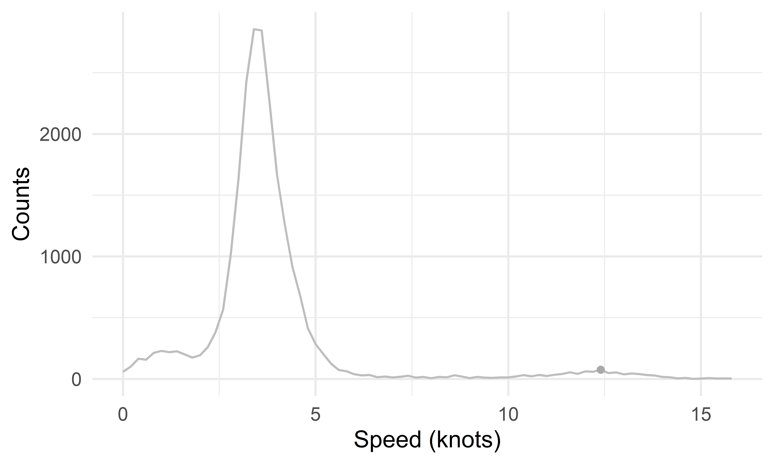
Figure 9. Counts of observations of fishing speeds. The dot indicates the location of the second peak, which was used to identify the steaming speed of the vessels.

Details on vessel economics
The economic parameters are for each vessel parametrized based on data from the EU Scientific, Technical and Economic Committee for Fisheries (STECF). We extracted data for 2012 to 2018 from the STECF website, which is aggregated according to fleet segment. We selected data from the ‘DNK NAO TM 40XX NGI’ fleet segment, which includes our selected vessels. The STECF data are shown below in Table 8.
Table 8. Extracted raw STECF data from 2012-2018 for the selected case fleet segment.
variable_group | variable_name | unit | 2012 | 2013 | 2014 | 2015 | 2016 | 2017 | 2018
Income | Gross value of landings | euro | 1,29E+08 | 1,2E+08 | 1,29E+08 | 1,56E+08 | 1,85E+08 | 1,17E+08 | 1,43E+08
Income | Income from leasing out quota | euro | 1931858 | 7430685 | 8460723 | 11947531 | 15542383 | 6072109 | 19388928
Income | Operating subsidies | euro | 0 | 15803,24 | 29049,34 | 0 | 0 | 0 | 0
Income | Other income | euro | 563767,7 | 1935526 | 1736271 | 5469891 | 4870584 | 2302742 | 5992046
Expenditure | Consumption of fixed capital | euro | 39222322 | 36294762 | 42076987 | 46775474 | 43319698 | 27948590 | 38090470
Expenditure | Energy costs | euro | 12850787 | 15245207 | 16364496 | 12262843 | 11070109 | 9216637 | 14784788
Expenditure | Lease/rental payments for quota | euro | 6318250 | 6120791 | 6537784 | 10027456 | 13739569 | 5012069 | 9651396
Expenditure | Other non-variable costs | euro | 4088366 | 3543905 | 5260006 | 4617952 | 6087960 | 4192471 | 4600430
Expenditure | Other variable costs | euro | 2629883 | 3585531 | 3961191 | 4236338 | 5394948 | 2493897 | 3341049
Expenditure | Personnel costs | euro | 16365273 | 16258079 | 19260494 | 20078569 | 24090016 | 14597756 | 18368667
Expenditure | Repair & maintenance costs | euro | 7810135 | 7090455 | 9591619 | 10005151 | 12649449 | 8839025 | 11894196
Expenditure | Value of unpaid labour | euro | 2013273 | 1846565 | 2363857 | 2644009 | 4175493 | 2944558 | 3365364
Employment | Engaged crew | number | 119,2477 | 101 | 122 | 110 | 130,1507 | 69 | 95
Employment | FTE national | number | 130,7112 | 188,3508 | 202,0258 | 174,2468 | 197,449 | 124,3099 | 166,6661
Employment | Total hours worked per year (engaged crew) | hour | 217634,1 | 313604 | 336373 | 290121 | 328752,6 | 206976 | 277499
Employment | Unpaid labour | number | 2,1187 | 1,6485 | 2,1504 | 2,6922 | 1,3728 | 0,9504 | 0,9982
Effort | Days at sea | day | 2350,054 | 2606,819 | 2699,716 | 3194,99 | 3245,3 | 2138,933 | 2839,001
Effort | Energy consumption |  | 18516166 | 23953831 | 27712475 | 28068648 | 30491289 | 22218416 | 29043803
Effort | Fishing days | day | 1185,099 | 1597,167 | 1608,5 | 1927 | 1858,723 | 1216,5 | 1736,538
Effort | GT days at sea | GTday
Effort | GT fishing days | GTday | 1503774 | 2350274 | 2395102 | 2525106 | 2293874 | 1859541 | 2547676
Effort | kW days at sea | kWday
Effort | kW fishing days | kWday | 3000482 | 4309828 | 4224332 | 4498328 | 4258945 | 3151726 | 4310447
Effort | Maximum days at sea | day
Effort | Number of fishing trips | number | 362,9998 | 366 | 407,9996 | 520 | 587 | 406,9998 | 495,0006
Capital | Gross debt | euro | 4,85E+08 | 4,84E+08 | 5,82E+08 | 5,38E+08 | 6,83E+08 | 5,15E+08 | 6,13E+08
Capital | Investments | euro | 66882012 | 35411783 | 74943448 | 28856477 | 1,07E+08 | -7012036 | 23060782
Capital | Subsidies on investments | euro | 0 | 0 | 0 | 0 | 0 | 0 | 0
Capital | Total assets | euro | 5,87E+08 | 6,23E+08 | 7,39E+08 | 7,83E+08 | 1,17E+09 | 8,8E+08 | 9,53E+08
Capital | Value of physical capital | euro | 1,68E+08 | 1,75E+08 | 2,33E+08 | 2,89E+08 | 3,47E+08 | 2,76E+08 | 3,12E+08
Capital | Value of quota and other fishing rights | euro | 3,78E+08 | 3,97E+08 | 4,77E+08 | 4,66E+08 | 7,56E+08 | 6,35E+08 | 5,69E+08
Capacity | Mean age of vessels | year | 21,7059 | 18,3077 | 18,375 | 19,8333 | 21,5 | 17,1818 | 17,2
Capacity | Mean LOA of vessels | metre | 54,8782 | 59,9346 | 60,4675 | 56,315 | 55,845 | 61,3391 | 59,3853
Capacity | Number of vessels | number | 17 | 13 | 16 | 18 | 22 | 11 | 15
Capacity | Total vessel power | kW | 40769,5 | 34591,3 | 44655,88 | 44043,21 | 52527,94 | 28788,21 | 38857,94
Capacity | Total vessel tonnage | GT | 19581 | 18120 | 25217 | 24600 | 27738 | 17490 | 23512
The data was averaged over the years (2012-2018) and standardized to be on a per-vessel basis. The final economic parameters, which are the same for all selected vessels, are presented below in Table 9. Additional variables were calculated according to the equations in Table 9. Economic indicators are estimated according to the equations in Error! Reference source not found..
Table 9. The parameter values, units and references that were used to parametrize the economics of the selected vessels in the case fleet.
Variable | Equation | Value | Unit | Reference
Number of crew | $$\frac{Engaged crew}{Number of vessels}$$ | 6.66 | #
Annual other income | $$\frac{Other income+Income from leasing out quota}{Number of vessels}$$ | 836116.3 | €
Crewshare and unpaid labor costs | $$\frac{Personnel costs+Value of unpaid labour}{Gross value of landings}*100$$ | 15.18 | €
Other variable costs per unit of effort | $$\frac{Other variable costs+Repair \& maintenance costs}{Days at sea*24}$$ | 204.29 | €/hour
Other annual fixed costs | $$\frac{Other non-variable costs}{Number of vessels}$$ | 289 206.2 | €
Annual depreciation rate |  | 0.04 | Year⁻¹
Vessel value | $$\frac{Value of fixed capital}{Number of vessels}$$ | 16 074 038 | €
Opportunity interest rate |  | 0.04 | Year⁻¹ | Fixed
Annual discount rate |  | 0.04 | Year⁻¹ | Fixed
Landing costs percent |  | 4 | - | Fixed
Annual insurance costs per crew |  | 0 | - | Fixed
Standard labour hour opportunity costs |  | 46.9 | € | https://ec.europa.eu/eurostat/statistics-explained/index.php?title=File:Hourly_labour_costs_in_euro.png  Value for Denmark, 2021
Standard annual full-time employment hours |  | 1923.96 | hours
Fuel consumption | $$\frac{Energy consumption}{Days at sea*24}$$ | 393.2 | l/hour

Depletion from other countries
To make a realistic assumption regarding the depletion from other countries in absence of a fishery, we first simulated a baseline scenario without depletion from other countries. Due to the small size of the Danish fleet, we assume that the vessels will not be able to fish until reaching Maximum Sustainable Yield (MSY) reflecting likely TACs.
Currently there is no official advice regarding fishing opportunities in the mesopelagic zone according to MSY for the species and stocks in question. If there is insufficient data or knowledge on stock dynamics, ICES (International Council for Exploration of the Sea) doesn’t provide advice according MSY according to their advice standards, but based on an advice rule based solely on precautionary conditions (ICES, 2019). This precautionary approach is used for stocks of category 3-6 according to the ICES classification, and a larger precautionary margin should be used if there’s limited information on stock status. We here estimated the reference points F_{msy}, B_{msy} and MSY using relationships with steepness, natural mortality M and virgin stock biomass $B_{0}$ following (Mangel et al., 2013) for the stocks covered here. The reference points are calculated according to:
$$F_{msy}=M\left(\sqrt{\frac{4h}{1-h}}-1\right)$$
( 8 )
$$B_{msy}=B_{0}\left[\frac{\sqrt{\frac{4h}{1-h}}-1}{\frac{4h}{1-h}-1}\right]$$
( 9 )
$$MSY= F_{msy}B_{msy}$$
( 10 )
The parameters M and h were extracted from the FishLife package (Thorson et al., 2017), the virgin biomass $B_{0}$ is equal to the total stock biomass in an unexploited case. To be precautionary, we estimated the reference levels for each stock using the lowest biomass estimate of each region (See Table 3 in main text). For the parameters M and h we extracted both the predictive mean and predictive covariance from the FishLife package, and we calculated the standard deviation using the square root of the diagonal elements of this matrix (which indicates the variance). To obtain a range of F_{msy}, for both parameters h and M we sampled 1000 random values from a normal distribution with above mentioned means and standard deviations. From those samples we only used values of M between 0 and 3, and values of h between 0 and 1. Subsequently we calculated F_{msy} using each combination of the M and h samples, and again limited the F_{msy} results to be between 0 and 3. For precautionary reasons we used the F_{msy} and B_{msy} values of the 1st quantile for the calculation of MSY. An overview of the input parameters, their standard deviations, and the value at the first quantile (Q1) of the estimated reference points can be found in Table 10.

Table 10. The input parameters and estimated reference points and Maximum Sustainable Yield (MSY) for the stocks. The standard deviations are indicated between brackets, the first quantile value (Q1) are underlined.
Stock | $B_{0}$ (Mt) | M (year⁻¹) | h | F_{msy} (year⁻¹) |  | B_{msy} (Mt) |  | MSY (Mt/year)
MA1.nor | 11.94 | 1.43 (± 1.69) | 0.83 (± 0.2) | 1.52 (±0.83) | Q1:  0.78 | 2.46 (± 0.94) | Q1:  1.77 | 1.38
MA2.ice | 10.74 | 1.43 (± 1.69) | 0.83 (± 0.2) | 1.52 (±0.83) | Q1:  0.78 | 2.22 (± 0.85) | Q1:  1.59 | 1.24
MA3.bob | 2.48 | 1.43 (± 1.69) | 0.83 (± 0.2) | 1.52 (±0.83) | Q1:  0.78 | 0.51 (± 0.19) | Q1:  0.37 | 0.29
BH1.nor | 0.25 | 0.87 (± 1.20) | 0.89 (± 0.13) | 1.60 (±0.89) | Q1:  0.77 | 0.04 (± 0.02) | Q1:  0.03 | 0.02
BH2.ice | 0.34 | 0.87 (± 1.20) | 0.89 (± 0.13) | 1.60 (±0.89) | Q1:  0.77 | 0.06 (± 0.02) | Q1:  0.04 | 0.03
To estimate the stock depletion of other countries we estimated the MSY for the different stocks, and assumed that the difference between MSY and the catch from the Danish mesopelagic fleet corresponds to the total mesopelagic catch from the other fishing countries. The catches are proportionally assigned to other countries according to their distance to the different fishing grounds (Table 13).
Table 11. Definition of depletion of stocks by other countries per year. The catches from the Danish fleet are indicated in orange. Grey boxes indicate that those stocks are not depleted by the respective fleets.
Stock | Denmark | Norway | Iceland | Spain | Ireland | Faroe Islands
MA1.nor | 1 125.69 t/y | 459 624.8 t/y | 459 624.8 t/y |  |  | 459 624.8 t/y
MA2.ice | 739.32 t/y | 247 852.3 t/y | 247 852.3 t/y | 247 852.3 t/y | 247 852.3 t/y | 247 852.3 t/y
MA3.bob | 196.85 t/y |  |  | 144 901.6 t/y | 144 901.6 t/y
BH1.nor | 2059.21 t/y | 5 980.09 t/y | 5 980.09 t/y |  |  | 5 980.09 t/y
BH2.ice | 2 270.28 t/y | 5 545.94 t/y | 5 545.94 t/y | 5 545.94 t/y | 5 545.94 t/y | 5 545.94 t/y

Detailed equations of the DISPLACE model
The individual-based DISPLACE model allows to evaluate the bio-economic efficiency of fishing vessel movements based on recent and high-resolution spatial fishery data (Bastardie et al., 2014). The underlying resource availability accounts for the size-based dynamics of the targeted stocks, and spatial distributions of the stock are based on survey data. The fishing process is stochastic, and specific to the catching power of individual vessels and to the encountered population abundances. Table 12 gives an overview of the population dynamics equations used to model the dynamics of the targeted stocks. Table 13 shows the calculation of the economic indicators from the simulations. For a detailed description of the model, we refer to (Bastardie et al., 2014). The open-source code can be found online (Bastardie, 2023).
Table 12. Overview of population dynamics equations.
Process | Equation | Unit | Explanation
Growth increments | $$X=L\left(S+∆S\right)-L(S)=\left[L_{∞}-L(S)\right]∙\left[1-e^{-K∆S}\right]$$ | cm | Growth parameters and growth increments are included as random variables with the parameter values as means and proportional variances.
Transition probabilities in the GTM | $$g_{i,j}=\int_{{mid}_{i}-∆l/2}^{{mid}_{i}+∆l/2}{\left[\int_{\left({mid}_{j}-\frac{∆l}{2}\right)-y}^{\left({mid}_{j}+\frac{∆l}{2}\right)+y}{f\left(x\right)dx}\right]dy}$$ | - | Distributions of growth increments per length group are used to calculate transition probabilities in the Growth Transition Matrix (GTM) to calculate the transition probability $g_{i,j}$ to transition from length group $z_{i}$ to $z_{j}$.
$$f\left(x\right)$$ | $$f\left(x\right)=\frac{1}{σ×\sqrt{2π}e^{-\frac{{\left(x-μ\right)}^{2}}{2σ^{2}}}},$$  $$V\left(x\right)=σ^{2},E\left(x\right)=μ$$ |  | The assumed density function applied to growth increment X
Survival | $${SURV}_{S}=N_{s,z}e^{-M/12}$$
Maturity ogive | $${MAT}_{z}=1/{1+e^{-r({mid}_{z}-L_{50})}}$$ |  | Logistic function with L₅₀ the length at which 50% of the  population is mature and a maturation rate r = 0.2
Spawning stock biomass = TSB | $${SSB}_{S}=\sum_{z}{N_{s,z}{WGT}_{s,z}{MAT}_{s,z}}$$
Weight at length | $${WGT}_{s,z}=a_{s}×{L_{s,z}}^{b_{s}}$$
Beverton-Holt stock-recruitment relationship | $${REC}_{s}=\frac{α_{s}{SSB}_{s}}{1+β_{s}{SSB}_{s}}$$ |  | With a lognormal stochastic variation to the number of recruits with a CV of 20%
Contribution of new recruits to length bins | $$N_{s,z}←N_{s,z}+{(REC}_{s}×{RAG}_{s,z})$$ |  | Distribution according to the age proportion in each group RAG on each annual time step.

Table 13. Overview of the equations used to calculate economic indicators.
Variable | Equation | Unit | Definition
Revenue | $$Revenue=Landing income+Annual other income$$ | €
Variable costs | $$Variable costs=Fuel costs+Repair and maintenance costs+other variable costs$$
Gross Value Added (GVA) | $$GVA=Revenue-(Variable costs+Fixed costs)$$ | € | Net output of a sector after deducing the intermediate inputs from all outputs
GVA to Revenue | $$\frac{GVA}{Revenue}$$ | - | The share of revenue that contributes to the economy through factors of production
Gross Profit | $$GVA-(Crew costs+Unpaid labour costs)$$ | € | Normal profit after accounting for operating costs, excluding capital costs
Labour opportunity costs | $$Standard labour opportunity costs∙Number of crew∙Hours at sea$$ | €
Labour surplus | $$\left(GVA∙\frac{Percentage of crewshare and unpaid labour costs}{100}\right)-\left(Annual insurance costs per crew+Labour opportunity costs\right)$$ | €
Capital opportunity costs | $$\left(Vessel value∙\frac{Opportunity interest rate}{100}\right)$$ | €
Net profit | $$GrossProfit-Capital opportunity costs-Vessel value∙\left(100-\frac{Annual deprecation rate}{100}\right)$$ | € | Difference between revenue and explicit costs and opportunity costs.
Net profit margin | $$\frac{Net profit}{Revenue}∙100$$ | % | A measure of profitability after all costs have been accounted for, reflecting the percentage of revenue that a sector retains as profit
Labour productivity (GVA/FTE) | $$FTE= \frac{GVA}{\frac{Hours at sea∙Number of crew}{Standard annual full time employment hours }}$$ |  | Output per unit of labour. Measure for economic growth, competitiveness and living standard.
Rate of Return on Fixed Tangible Assets (RoFTA) | $$RoFTA=\frac{Net profit+Capital opportunity costs}{Vessel value∙\left(100-\frac{Annual depreciation rate}{100}\right)}$$
Break-even Revenue (BER) | $$BER= \frac{Fixed costs}{1-\frac{Variable costs}{Revenue}}$$
Revenue to break-even ratio (CR/BER) | $$CR/BER= \frac{Revenue}{BER}$$
Net present value | $$NPV= GVA∙\frac{1}{e^{1+\frac{AnnualDiscountRate}{100}}}$$ | %

Additional results

Sensitivity studies
We performed sensitivity studies on different life-history parameters, on a limitation of trip duration to 3 days and on the patchiness of the distributions of the populations, to identify key parameter settings (Table 14).
Table 14. Description of sensitivity studies.
Parameter | Scenario definition
Maturity (L₅₀) | Scenario A1 | Baseline L₅₀ - 25%
 | Scenario A2 | Baseline L₅₀ + 25%
Natural mortality (M) | Scenario B1 | Baseline M - 25%
 | Scenario B2 | Baseline M + 25%
Von Bertalanffy growth coefficient (K) | Scenario C1 | Baseline K - 25%
 | Scenario C2 | Baseline K + 25%
Asymptotic length (L_{inf}) | Scenario D1 | Baseline L_{inf} - 25%
 | Scenario D2 | Baseline L_{inf} + 25%
Beverton-Holt parameter alpha (alpha) | Scenario E1 | Baseline alpha - 25%
 | Scenario E2 | Baseline alpha + 25%
Beverton-Holt parameter beta (beta) | Scenario F1 | Baseline beta - 25%
 | Scenario F2 | Baseline beta + 25%
Trip duration | Scenario G1 | 3 days due to quicker deterioration
Patchiness | Scenario H1 | Patches of 30x30km with distance of 30 km
 | Scenario H2 | Patches of 150x150km with distance of 150 km
 | Scenario H3 | Patches of 300x300km with distance of 300 km
The sensitivity studies indicate that all parameter choices related to maturity, growth and mortality influence the final model outcomes (Figure 10, Table 15). A 25% decrease of the parameter L₅₀, indicating the length at 50% maturity, has a minor effect on the landings of the M. muelleri population in Iceland (6.17% decrease in landings with decreasing the parameter with 25%). Natural mortality M has the highest impact on the catch efficiency (CPUE at fishing) and landings, but only with a marginal impact on the economy of the vessels due to effort limitations (F. effort) resulting from the maximum storage capacity (Figure 12). The parameter K showed marginally positive effects with a decrease of 25%, which resulted in an increase in the CR/BER ratio of 21.53%. Both an increase and a decrease in L_{inf} resulted in an increase in the CR/BER ratio of 5.74% and 58.45%, respectively. Varying the stock-recruitment parameter alpha resulted in minor positive impacts on the catch efficiency and landings of most stocks with a 25% increase of alpha, and oppositely a 25% decrease in alpha led to minor negative impacts on the same indicators. There were no significant impacts resulting from varying the parameter beta. Neither stock -recruitment parameters showed impacts on the economic indicators. The stock-recruitment parameters were updated according to the new life-history parameter with each sensitivity study, which could have resulted in cumulative positive or negative impacts on the population dynamics.
Limiting the trip duration to a maximum of 3 days between the first catch and landing results in a slight increase in the landings of M. muelleri in the Bay of Biscay (5.03 % increase) and a small decrease in landings of M. muelleri in the Norwegian Sea (4.48% decrease), likely because of displacement of some effort to the Bay of Biscay due to the shorter distance between harbors and fishing grounds in the region. This limitation resulted only in a very minor reduction of profitability (a decrease in CR/BER of 3.34%), indicating that this will likely not be one of the main limiting factors of the fishery.
The scenarios with varying patch sizes (30x30km patches with 30km in between, 150x150km patches with 150km in between, 300x300km patches with 300km in between) resulted for all scenarios in very large negative impacts on the landings of all populations except the landings of M. muelleri in the Bay of Biscay. With increasing patch size and distance between patches the fuel limitations become more pronounced, as those patches are not always in the vicinity of a landing harbor. Most of the effort is therefore displaced to the Bay of Biscay, where the conditions (i.e. distance between harbors and fishing grounds) are more optimal. However, the overall catch efficiency is lower for all scenarios indicating that the gain in landings from the Bay of Biscay cannot counterbalance the reduction in landings from other regions. The patchiness has a large impact on the profitability of the potential fishery, where the increasing patch sizes and distances between patches resulted in decreases in the CR/BER of 87.26%, 89.72% and 91.94% respectively. Since there is large uncertainty in the spatio-temporal distribution of the species and the drivers thereof, those results suggest that this uncertainty might have a highly significant impact on the potential viability of a mesopelagic fishery.

Figure 10. Boxplots of the percentage difference compared to the profitable baseline of each indicator by sensitivity study of maturity, growth, and mortality parameters, trip duration and patch distribution size. Grey indicates trip-related indicators, yellow indicates biological indicators and blue indicates economic indicators.
Table 15. The percentage difference compared to the baseline for each of the sensitivity scenarios. The percentage is the average of all simulations per scenario. Colors indicate a large positive effect with an increase of > 25% (dark green), a small positive effect with an increase of > 5% (light green), no real effect (light yellow), a small negative effect with a decrease of < 5% (light red), a large negative effect with a decrease of < 25% (dark red).
Scenario | Difference compared to the baseline
 | F. effort | S. effort | Nb. Of trips | Trip duration | CPUE at fishing | Total landings | Landings MA1.nor | Landings MA2.ice | Landings MA3.bob | Landings BH1.nor | Landings BH2.ice | GVA | Fuel costs | VPUF | CR/BER
Baseline L₅₀ - 25% | -0.48 | 0.10 | -0.29 | 0.38 | 0.27 | -0.04 | 0.89 | -6.17 | -2.55 | 0.73 | 2.94 | -0.70 | 0.12 | -0.74 | -2.56
Baseline L₅₀ + 25% | 0.45 | -0.08 | 0.10 | -0.18 | 0.48 | 1.01 | -0.07 | -0.36 | -1.72 | 2.61 | 3.47 | -2.39 | -0.07 | -2.05 | -3.96
Baseline M - 25% | -13.17 | 0.09 | 0.32 | -0.33 | 109.06 | 81.44 | 132.51 | 184.11 | 180.09 | 42.24 | 50.88 | -9.30 | 0.10 | -7.89 | -0.98
Baseline M + 25% | 5.60 | 0.06 | 0.27 | -0.16 | -18.84 | -14.33 | -229.12 | -17.17 | -21.63 | -10.91 | -6.47 | -1.41 | 0.07 | -1.30 | 2.13
Baseline K - 25% | 0.65 | -0.01 | -0.18 | 0.17 | 2.37 | 3.05 | -3.53 | 31.87 | -1.39 | 17.87 | -14.19 | 9.59 | 0.01 | 8.19 | 21.53
Baseline K + 25% | 1.24 | -0.02 | -0.20 | 0.17 | -2.91 | -1.54 | -1.77 | -4.80 | 6.93 | -1.66 | 0.63 | 3.33 | 0.01 | 2.47 | 2.77
Baseline L_{inf} - 25% | 0.43 | 0.05 | -0.19 | 0.23 | 38.04 | 38.39 | 3.14 | -49.21 | -2.39 | 101.54 | 34.96 | 41.30 | 0.07 | 33.22 | 58.45
Baseline L_{inf} + 25% | 1.82 | 0.13 | 0.28 | -0.16 | -4.00 | -2.10 | 6.48 | -12.59 | 16.06 | -0.40 | -3.46 | -1.20 | 0.16 | -1.07 | 5.74
Baseline alpha - 25% | 4.28 | 0.13 | -0.02 | 0.16 | -14.79 | -11.19 | -3.01 | -5.53 | 14.23 | -13.46 | -15.50 | -3.89 | 0.15 | -3.43 | 2.12
Baseline alpha + 25% | -0.28 | -0.01 | -0.38 | 0.33 | 5.75 | 5.62 | 1.89 | 8.47 | 6.75 | 8.15 | 6.95 | -0.40 | -0.01 | -0.31 | 3.33
Baseline beta - 25% | 1.18 | -0.08 | 0.19 | -0.31 | 0.32 | 1.59 | 1.49 | 4.85 | 9.51 | 4.55 | -0.22 | 0.05 | -0.06 | -0.16 | 2.34
Baseline beta + 25% | -0.01 | 0.08 | -0.17 | 0.23 | 0.30 | 0.32 | 0.40 | 1.76 | -5.56 | 3.37 | -0.58 | 1.41 | 0.08 | 0.95 | 1.24
Trip duration max. 3 days | 0.72 | -0.03 | -0.18 | 0.11 | -2.28 | -1.59 | -4.48 | -1.92 | 5.03 | -0.82 | 0.51 | -0.59 | -0.02 | -0.67 | -3.34
30x30 km patch size | 13.35 | -0.11 | -0.37 | 0.35 | -67.20 | -62.80 | -64.25 | -48.84 | 70.53 | -69.04 | -72.06 | -84.67 | -0.12 | -69.68 | -87.26
150x150 km patch size | 14.71 | 0.03 | -0.32 | 0.49 | -69.68 | -65.24 | -66.75 | -52.53 | 61.21 | -70.76 | -73.99 | -87.77 | 0.07 | -72.17 | -89.72
300x300 km patch size | 15.90 | 0.02 | -0.31 | 0.45 | -73.82 | -69.69 | -71.48 | -59.01 | 44.03 | -74.62 | -77.21 | -89.78 | 0.05 | -73.95 | -91.94

Reason back

Figure 11. The proportion of trips in the main scenarios where the decision to return to port was due to reaching the maximum storage capacity (blue) or due to an empty fuel tank (yellow).

Figure 12. The proportion of trips in the sensitivity studies on life-history parameters where the decision to return to port was due to reaching the maximum storage capacity (blue) or due to an empty fuel tank (yellow).

Break-even revenues of current Danish pelagic fishing vessels (Paoletti et al., 2021)
Table 16. The average break-even revenue per trip and yearly profit for each métier that Danish pelagic fishing vessels between 70-80m were engaged in over the period 2015-2019.
Métier | BER/trip (€) | Average yearly GVA (€) | Average fish price (€)
OTB Sandeel | 139 400 | 11 962 473 | 0.204
OTM/PTM Sprat | 233 502 | 3 766 162 | 0.241
OTM Blue whiting | 191 935 | 21 616 701 | 0.234
OTM/PS Herring (industrial) | 132 173 | 782 090 | 0.288
OTM/PS Herring (consumption) | 172 377 | 165 608 789 | 0.570
OTM/PS Atlantic mackerel | 182 203 | 170 010 372 | 1.066

References
Bastardie, F. (2023). DISPLACE. https://displace-project.org/.
Bastardie, F., Nielsen, J. R., and Miethe, T. (2014). DISPLACE: A dynamic, individual-based model for spatial fishing planning and effort displacement - integrating underlying fish population models. Canadian Journal of Fisheries and Aquatic Sciences 71, 366–386. doi: 10.1139/cjfas-2013-0126.
EC (2015). Commission Delegated Regulation (EU) 2017/117 of 5 September 2016 establishing fisheries conservation measures for the protection of the marine environment in the Baltic Sea and repealing Delegated Regulation (EU). 1778. Available at: http://eur-lex.europa.eu/legal-content/EN/TXT/?uri=uriserv:OJ.L_.2017.019.01.0001.01.ENG [Accessed July 18, 2017].
EC (2016). Commission Implementing Decision (EU) 2016/1701 of 19 August 2016 - Laying Down Rules on the Format for the Submission of Work Plans for Data Collection in the Fisheries and Aquaculture Sectors (notified Under Document C(2016) 5304).
Gjosaeter, J. (1981a). Growth, production and reproduction of the myctophid fish Benthosema glaciale from western Norway and adjacent seas. Serie Havundersokelser - Fiskeridirektoratets Skrifter 17, 79–108.
Gjosaeter, J. (1981b). Life history and ecology of Maurolicus muelleri ( Gonostomatidae) in Norwegian waters. Serie Havundersokelser - Fiskeridirektoratets Skrifter 17, 109–131.
Gjosaeter, J., and Kawaguchi, K. (1980). A Review Of The World Resources Of Mesopelagic Fish. FAO Fisher. Rome: FAO Fisheries Technical Paper.
Hastie, T., and Tibshirani, R. (1986). Generalized Additive Models. Statistical Science 1, 297–310. doi: 10.1214/ss/1177013604.
ICES (2019). ICES Advice basis. In Report of the ICES Advisory Committee, 2019., section 1.2. doi: 10.17895/ICES.ADVICE.5757.
Jónsson, S., Bárðarson, B., Mariano Burgos, J. M., Gunnarson, L., and Gunnarsdóttir, S. (2010). Cruise Report B3-2010.
Mangel, M., Brodziak, J., and Dinardo, G. (2010a). Reproductive ecology and scientific inference of steepness: a fundamental metric of population dynamics and strategic fisheries management. doi: 10.1111/j.1467-2979.2009.00345.x.
Mangel, M., Brodziak, J., and DiNardo, G. (2010b). Reproductive ecology and scientific inference of steepness: a fundamental metric of population dynamics and strategic fisheries management. Fish and Fisheries 11, 89–104. doi: 10.1111/J.1467-2979.2009.00345.X.
Mangel, M., MacCall, A. D., Brodziak, J., Dick, E. J., Forrest, R. E., Pourzand, R., et al. (2013). A perspective on steepness, reference points, and stock assessment. https://doi.org/10.1139/cjfas-2012-0372 70, 930–940. doi: 10.1139/CJFAS-2012-0372.
NOAA National Centers for Environmental Information (2022). ETOPO 2022 15 Arc-Second Global Relief Model. NOAA National Centers for Environmental Information. doi: https://doi.org/10.25921/fd45-gt74.
Pante, E., and Simon-Bouhet, B. (2013). marmap: A Package for Importing, Plotting and Analyzing Bathymetric and Topographic Data in R. PLoS One 8, e73051. doi: 10.1371/journal.pone.0073051.
Paoletti, S., Nielsen, J. R., Sparrevohn, C. R., Bastardie, F., and Vastenhoud, B. M. J. (2021). Potential for Mesopelagic Fishery Compared to Economy and Fisheries Dynamics in Current Large Scale Danish Pelagic Fishery. Front Mar Sci 8. doi: 10.3389/fmars.2021.720897.
Sobradillo, B., Boyra, G., Martinez, U., Carrera, P., Peña, M., and Irigoien, X. (2019). Target Strength and swimbladder morphology of Mueller’s pearlside (Maurolicus muelleri). Sci Rep 9, 1–14. doi: 10.1038/s41598-019-53819-6.
Thorson, J. T. (2020). Predicting recruitment density dependence and intrinsic growth rate for all fishes worldwide using a data-integrated life-history model. Fish and Fisheries 21, 237–251. doi: 10.1111/FAF.12427.
Thorson, J. T., Munch, S. B., Cope, J. M., and Gao, J. (2017). Predicting life history parameters for all fishes worldwide. Ecological Society of America 27, 2262–2276.
Vastenhoud, B. M. J., Mildenberger, T. K., Kokkalis, A., Paoletti, S., Alvarez, P., Garcia, D., et al. (2023). Growth and natural mortality of Maurolicus muelleri and Benthosema glaciale in the Northeast Atlantic Ocean. Front Mar Sci 10. doi: 10.3389/fmars.2023.1278778.
Wood, S. N. (2003). Thin plate regression splines. J R Stat Soc Series B Stat Methodol 65, 95–114. doi: 10.1111/1467-9868.00374.
Wood, S. N. (2011). Fast stable restricted maximum likelihood and marginal likelihood estimation of semiparametric generalized linear models. J R Stat Soc Series B Stat Methodol 73, 3–36. doi: 10.1111/J.1467-9868.2010.00749.X.
Zhou, S., Punt, A. E., Lei, Y., Deng, R. A., and Hoyle, S. D. (2020). Identifying spawner biomass per-recruit reference points from life-history parameters. Fish and Fisheries 21, 760–773. doi: 10.1111/faf.12459.

https://fiskerforum.com/isafold-takes-over-denmarks-greenest-pelagic-vessel/

