Supplementary Material

Supplementary Video SV1 (supplementary digital media). Live recording of dysteriid ciliates sampled on petri dish from blowhole exhalation of M1 on July 14, 2021, observed under a dissecting microscope (Olympus SZX16; 3.5–90X).

Table S1. Relative abundances of the major groups of eukaryotic taxa in the blow microbiome. Relative abundance numbers represent percentages, and are the averages from each sample set; H=Habitat.
Anti-metazoan 18S rDNA Relative Frequencies | M1 | F1 | F2 | H
Unassigned eukaryota | 77.68 | 86.63 | 94 | 8.54
Alveolata, Ciliophora, Phyllopharyngea, Cyrtophoria, Dysteriidae | 22.22 | 12.10 | 6.02 | 0.0
Alveolata, Dinoflagellata, Dinophyceae, Peridiniales, Thoracosphaeraceae | 0.0 | 1.04 | 0.0 | 59.85
Stramenopiles , Gyrista, Bacillariophyceae | 0.0 | 0.0 | 0.0 | 27.10
Archaeplastida, Chlorophyta_X, Chlorodendrophyceae, Chlorodendrales, Chlorodendraceae. | 0.15 | 0.57 | 0.0 | 4.24
Eukaryota, Obazoa, Opisthokonta, Metazoa, Arthropoda, Hexapoda, Insecta | 0.0 | 0.0 | 0.0 | 0.27

Table S2. Relative abundances of 19 core ASVs. A: 11 ASVs found in all M1, F1, and F2 samples. B: 8 ASVs found in M1, F1, F2, and Habitat samples. Relative abundance numbers represent percentages, and are the averages from each sample set; H=Habitat.
A |  | M1 | F1 | F2 | H
11 ASVs unique to M1, F1, F2 | Proteobacteria--Gammaproteobacteria--Cardiobacteriales--Cardiobacteriaceae--unc. bacterium | 15.82 | 18.24 | 5.90
 | Bacteroidota--Bacteroidia--Flavobacteriales-Flavobacteriaceae—Gangjinia sp. | 8.50 | 5.33 | 0.33
 | Proteobacteria--Gammaproteobacteria--Cardiobacteriales--Cardiobacteriaceae—Suttonella sp. | 2.13 | 1.80 | 2.98
 | Proteobacteria--Gammaproteobacteria--Pseudomonadales--Moraxellaceae—Psychrobacter—unc. bacterium | 0.43 | 1.49 | 10.24
 | Proteobacteria--Gammaproteobacteria--Pseudomonadales--Moraxellaceae—Psychrobacter—unc. bacterium | 0.31 | 0.34 | 3.50
 | Bacteroidota—Bacteroidia—Flavobacteriales—Weeksellaceae—uncultured bacterium | 0.40 | 1.41 | 0.59
 | Bacteroidota—Bacteroidia—Bacteroidales—Porphyromonadaceae—Porphyromonas sp. | 0.59 | 0.77 | 0.18
 | Bacillota—Clostridia—Lachnospirales—Lachnospiraceae—Buytrivibrio--unc. bacterium | 0.76 | 0.73 | 0.05
 | Proteobacteria--Gammaproteobacteria--Alteromonadales--Shewanellaceae—Shewanella sp. | 1.08 | 4.13 | 30.81
 | Bacteroidota--Bacteroidia--Bacteroidales--Marinifilaceae—Marinifilum sp. | 0.05 | 1.17 | 0.05
B
8 ASVs found in M1, F1, F2 and Habitat | Campilobacterota--Campylobacteria--Campylobacterales--Arcobacteraceae--unc. bacterium | 14.37 | 6.80 | 0.93 | 0.10
 | Proteobacteria--Gammaproteobacteria--Oceanospirillales--Saccharospirillaceae--unc. bacterium | 11.57 | 19.97 | 2.10 | 0.22
 | Fusobacteriota--Fusobacteriia--Fusobacteriales--Leptotrichiaceae—Oceanivirga sp. | 14.53 | 4.47 | 0.70 | 0.09
 | Bacteroidota--Bacteroidia--Flavobacteriales--Flavobacteriaceae—Tenacibaculum sp. | 8.83 | 6.95 | 6.47 | 0.16
 | Campilobacterota--Campylobacteria--Campylobacterales--Campylobacteraceae—Campylobacter sp. | 1.84 | 2.60 | 0.28 | 0.15
 | Proteobacteria--Gammaproteobacteria--Vibrionales--Vibrionaceae—Vibrio sp. | 0.27 | 3.54 | 16.1 | 0.36
 | Proteobacteria--Gammaproteobacteria--Pasteurellales--Pasteurellaceae—Phocoenobacter sp. | 0.20 | 0.15 | 3.39 | 0.09
 | Fusobacteriota--Fusobacteriia--Fusobacteriales--Fusobacteriaceae—Fusobacterium sp. | 0.06 | 0.15 | 0.05 | 0.04

Table S3. Group pairwise significance ANOSIM results for pairwise comparison groupings based on Bray-Curtis values.

 |  | Pairwise ANOSIM
Group Significance
Group 1 | Group 2 | Sample size | Permutations | R statistic | p-value | q-value
M1 | F1 | 7 | 999 | 0.029 | 0.029 | 0.105
M1 | F2 | 7 | 999 | 0.035 | 0.035 | 0.105
M1 | Habitat | 5 | 999 | 0.213 | 0.213 | 0.261
F1 | F2 | 6 | 999 | 0.104 | 0.104 | 0.208
F1 | Habitat | 4 | 999 | 0.239 | 0.239 | 0.261
F2 | Habitat | 4 | 999 | 0.261 | 0.261 | 0.261

Table S4. Overall group pairwise significance ANOSIM results for pairwise group significance.

 | ANOSIM
permutations | 999
sample size | 11
number of groups | 4
R test statistic | 1.0
p-value | 0.001

Table S5. Group pairwise significance of alpha diversity. Pairwise comparison groupings based on Kruskal-Wallis tests.

 | Alpha Diversity
Kruskal-Wallis Pairwise
Group 1 |  | Group 2 | H | p-value | q-value
M1(n=4) |  | F1 (n=3) | 0.5 | 0.480 | 0.480
M1(n=4) |  | F2 (n=3) | 4.5 | 0.034 | 0.149
M1(n=4) |  | Habitat(n=1) | 2.0 | 0.157 | 0.216
F1(n=3) |  | F2 (n=3) | 3.9 | 0.049 | 0.149
F1(n=3) |  | Habitat(n=1) | 1.8 | 0.180 | 0.216
F2 (n=3) |  | Habitat(n=1) | 1.8 | 0.180 | 0.216

Table S6. Overall group significance in alpha diversity. Based on Kruskal-Wallis tests.

 | Alpha Diversity
 | Kruskal-Wallis (all groups)
H |  | 7.4848
sample size |  | 0.0579
number of groups |  | 4

Table S7. Core microbiota. Top: List of ASVs that are shared among all whale samples (M2, F2, and F3) but not found in Habitat. Bottom: List of ASVs shared among all samples (M2, F2, F3, and Habitat). Columns at right indicate previously reported studies. [W] represents wild animals, [H] represents animals under professional human care.
This Study |  | Previously Reported
 |  | Animal | Body site | Reference
11 ASVs unique to M1, F1, F2 | Proteobacteria--Gammaproteobacteria--Cardiobacteriales--Cardiobacteriaceae--uncultured bacterium | Bottlenose dolphin (Tursiops truncatus) [W] | Blow | Apprill et al 2017
 | Bacteroidota--Bacteroidia--Flavobacteriales-Flavobacteriaceae—Gangjinia sp. | Southern resident killer whale (Orcinus orca) [W] | Mucus | Rhodes et al 2022
 | Proteobacteria--Gammaproteobacteria--Cardiobacteriales--Cardiobacteriaceae—Suttonella sp. | Blue whale (Balaenoptera musculus) [W]  Short-beaked common dolphin (Delphinus delphis) [W]  Harbour porpoise [W]  (Phocoena phocoena)  Striped dolphin [W] (Stenella coeruleoalba) | Blow  Oral cavity  Oral cavity  Oral cavity | Dominguez-Sanchez et al 2022  Soares-Castro et al 2019  Soares-Castro et al 2019  Soares-Castro et al 2019
 | Proteobacteria--Gammaproteobacteria--Pseudomonadales--Moraxellaceae—Psychrobacter—uncultured bacterium | Bottlenose dolphin [W] (Tursiops truncatus)  Humpback whale [W] (Megaptera novaeangiliae) | Mouth, blowhole  Skin, blowhole | Smies et al 2022  Apprill et al 2017
 | Proteobacteria--Gammaproteobacteria--Pseudomonadales--Moraxellaceae—Psychrobacter—uncultured bacterium | Bottlenose dolphin [W] (Tursiops truncatus)  Humpback whale [W] (Megaptera novaeangiliae) | Mouth, blowhole  Skin, blowhole | Smies et al 2022  Apprill et al 2017
 | Bacteroidota—Bacteroidia—Flavobacteriales—Weeksellaceae—uncultured bacterium | Bottlenose dolphin [H] (Tursiops truncatus) | Blow | Biancani et al 2021
 | Bacteroidota—Bacteroidia—Bacteroidales—Porphyromonadaceae—Porphyromonas sp. | Short-beaked common dolphin (Delphinus delphis) [W]  Harbour porpoise [W]  (Phocoena phocoena)  Striped dolphin [W] (Stenella coeruleoalba) | Oral cavity  Oral cavity  Oral cavity | Soares-Castro et al 2019  Soares-Castro et al 2019  Soares-Castro et al 2019
 | Bacillota—Clostridia—Lachnospirales—Lachnospiraceae—Buytrivibrio--uncultured bacterium | Pygmy sperm whale [W] (Kogia breviceps) | Gut | Erwin et al 2017
 | Proteobacteria--Gammaproteobacteria--Alteromonadales--Shewanellaceae—Shewanella sp. | Bryde’s whale [W]  Balaenoptera brydei  Bottlenose dolphin  Tursiops truncatus [H] | Skin  Skin | Li et al 2019  Smirnova et al 2017
 | Bacteroidota--Bacteroidia--Bacteroidales--Marinifilaceae—Marinifilum sp. | Short-beaked common dolphin (Delphinus delphis) [W]  Harbour porpoise [W]  (Phocoena phocoena)  Striped dolphin [W] (Stenella coeruleoalba) | Oral cavity  Oral cavity  Oral cavity | Soares-Castro et al 2019  Soares-Castro et al 2019  Soares-Castro et al 2019
 | Proteobacteria--Alphaproteobacteria--Rhodobacterales--Rhodobacteraceae—Paracoccus sp. | Killer whale [H] (Orcinus orca)  Bottlenose dolphin [H]  Tursiops truncatus | Skin  Skin | Chiarello et al 2017  Chiarello et al 2017
8 ASVs found in M1, F1, F2 and Habitat | Campilobacterota--Campylobacteria--Campylobacterales--Arcobacteraceae--uncultured bacterium | Seawater, widespread throughout aquatics  Southern resident killer whale (Orcinus orca) | Water column  Mucus | Venancio et al 2022  Rhodes et al 2022
 | Proteobacteria--Gammaproteobacteria--Oceanospirillales--Saccharospirillaceae--uncultured bacterium | Marine waters, coastal sediment, tidal flats  Bottlenose dolphins [W] (Tursiops truncatus) (T. aduncus) | Blowhole | Chen et al., 2009; Choi et al., 2011; Labrenz et al., 2003; Pinhassi et al., 2007  Lima et al 2012
 | Fusobacteriota--Fusobacteriia--Fusobacteriales--Leptotrichiaceae—Oceanivirga sp. | Atlantic salmon (Salmo salar),  common dolphin (Delphinus delphis) striped dolphin (Stenella coeruleoalba)  harbour seals (Phoca vitulina) | Scales  skin, oral | Eisenberg et al . 2016  Palmer et al 2020
 | Bacteroidota--Bacteroidia--Flavobacteriales--Flavobacteriaceae—Tenacibaculum sp. | pelagic fish (parasitic)  Humpback whales (Megaptera novaeangliae) | Scales, external parasite  Skin | Avendaño-Herrera et al 2006  Apprill et al 2016
 | Campilobacterota--Campylobacteria--Campylobacterales--Campylobacteraceae—Campylobacter sp. | grey seals (Halichoerus grypus)  terrestrial species (65+) | Gut  Gut | Baily et al 2015  Brooks et al 2023
 | Proteobacteria--Gammaproteobacteria--Vibrionales--Vibrionaceae—Vibrio sp. | Highly common in marine systems  Shellfish  Pacific pilot whales [W](Globicephala macrorhynchus)  Bottlenose [H] (Tursiops truncatus)  Snapper (Lutjanus campechanus) | Water column  Gills  Gut  Stomach tissue  Gills | Howard and Bennett 1993  Howard and Bennett 1993  Buck and Spotte 1986  Buck and Spotte 1986  Sehnal et al 2021
 | Proteobacteria--Gammaproteobacteria--Pasteurellales--Pasteurellaceae—Phocoenobacter sp. | Striped dolphin [W] (Stenella coeruleoalba)  Harbour porpoise [W] (Phocoena phocoena) | Oral cavity  Uterus | Foster et al 2000  Godoy-Vitorino et al 2017
 | Fusobacteriota--Fusobacteriia--Fusobacteriales--Fusobacteriaceae—Fusobacterium sp. | Bottlenose dolphin [H] (Tursiops truncatus)  California sea lions [H] (Zalophus californianus) | Oral and rectal cavity  Oral, rectal, gut | Bik et al 2016  Bik et al 2016
s

Supplementary Figures
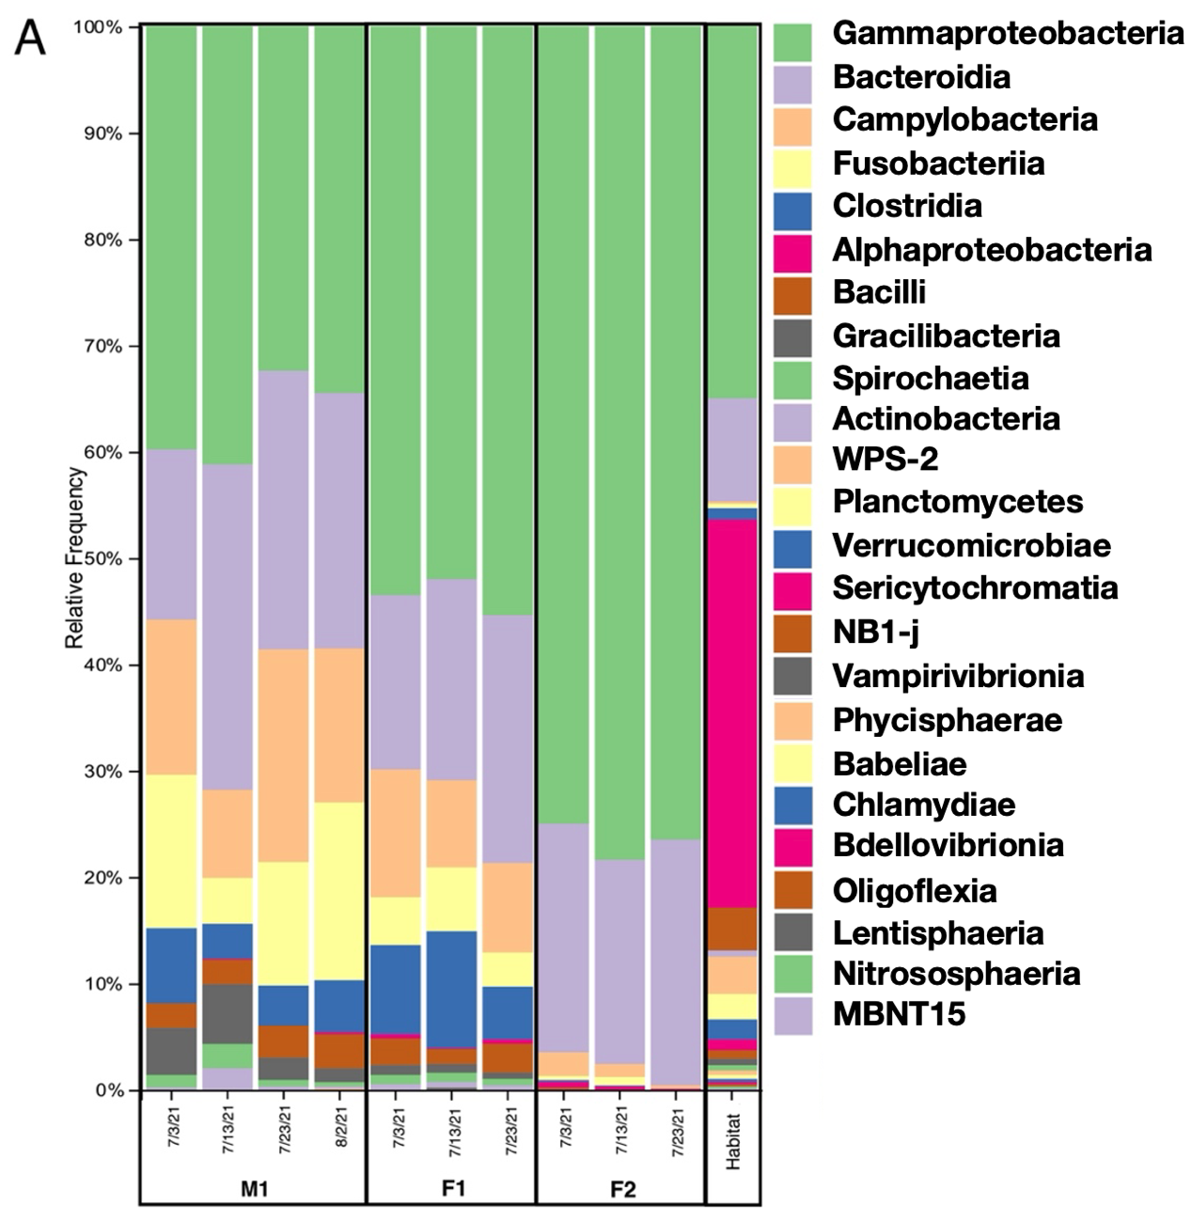
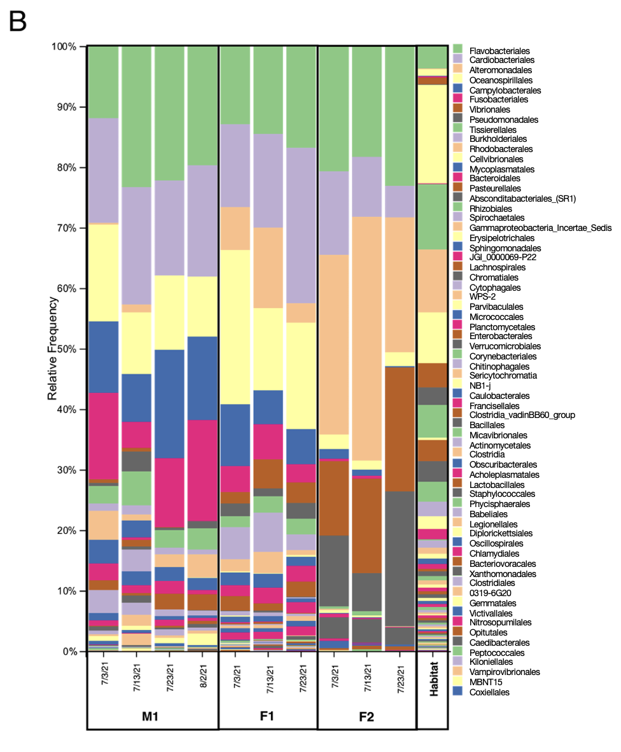
Figure S1. Taxonomic bar plots. Relative frequencies of the bacterial taxa present in the blow microbiome of all three animals and habitat water on all sampling dates (M1=male 1; F1= female 1; F2= female 2). Different plots represent taxonomic levels: A.
Class level: 24 classes identified; B. Order level: 66 bacterial orders identified.
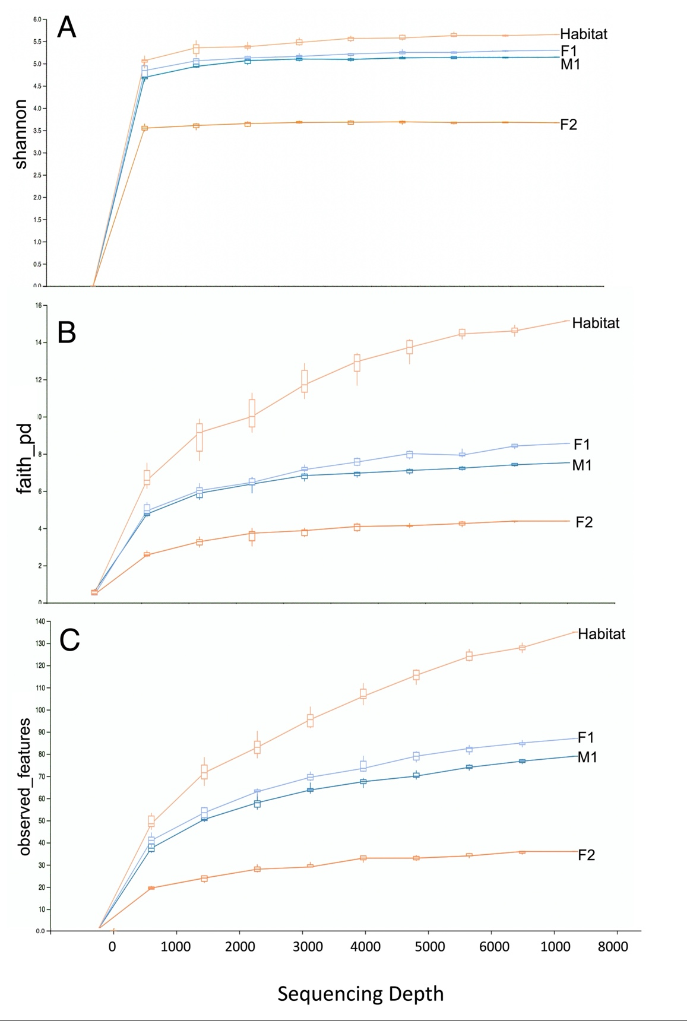
Figure S2. Alpha rarefaction for all groups. A. Shannon index analysis; B. Faith’s Phylogenetic Diversity (PD) index; C. Alpha rarefaction of the observed features (i.e representative sequences) for each group. Sequencing depth is represented on the x-axis for all indices.
Supplementary References Cited
Rhodes, L. D., Emmons, C. K., Wisswaesser, G., Wells, A. H., Hanson, M. B. (2022). Bacterial microbiomes from mucus and breath of southern resident killer whales (Orcinus orca). Conservation Physiology, 10(1), coac014.
Dominguez-Sanchez, C., Alvarez-Martinez, R., Gendron, D., & Acevedo-Whitehouse, K. (2022). Core respiratory microbiome of the blue whale, Balaenoptera musculus. bioRxiv, 2022-12.
Soares-Castro, P., Araújo-Rodrigues, H., Godoy-Vitorino, F., Ferreira, M., Covelo, P., López, et al. (2019). Microbiota fingerprints within the oral cavity of cetaceans as indicators for population biomonitoring. Scientific reports, 9(1), 13679.
Smies, A. G. (2022). An Antimicrobial Polydopamine Surface Coating to Reduce Biofouling on Telemetry Tags Used in Marine Conservation Practices (Doctoral dissertation, Michigan Technological University).
Apprill, A. (2017). Marine animal microbiomes: toward understanding host–microbiome interactions in a changing ocean. Frontiers in Marine Science. 4, 222
Apprill, A., Miller, C. A., Moore, M. J., Durban, J. W., Fearnbach, H., & Barrett-Lennard, L. G. (2017). Extensive core microbiome in drone-captured whale blow supports a framework for health monitoring. MSystems, 2(5), e00119-17.
Erwin, P. M., Rhodes, R. G., Kiser, K. B., Keenan-Bateman, T. F., McLellan, W. A., Pabst, D. A. (2017). High diversity and unique composition of gut microbiomes in pygmy (Kogia breviceps) and dwarf (K. sima) sperm whales. Scientific reports, 7(1), 7205.
Biancani, B. Characterization of the Microbial Ecosystem of Two Groups of Bottlenose Dolphins (Tursiops truncatus) Under Human Care IAAAM 2021.
Smirnova, L. I., Kapustina, E. Y., Chuprak, D. I. (2017). Biological properties of Shewanella putrefaciens divided from marine mammals. Mezhdunarodnyy vestnik veterinarii, (4), 27-32.
Chiarello, M., Villéger, S., Bouvier, C., Auguet, J. C., & Bouvier, T. (2017). Captive bottlenose dolphins and killer whales harbor a species-specific skin microbiota that varies among individuals. Scientific Reports, 7(1), 15269.
Venâncio, I., Luís, Â., Domingues, F., Oleastro, M., Pereira, L., & Ferreira, S. (2022). The prevalence of Arcobacteraceae in aquatic environments: a systematic review and meta-analysis. Pathogens, 11(2), 244.
Chen, Y. G., Cui, X. L., Li, Q. Y., Wang, Y. X., Tang, S. K., Liu, Z. et al. (2009). Saccharospirillum salsuginis sp. nov., a gammaproteobacterium from a subterranean brine. International journal of systematic and evolutionary microbiology, 59(6), 1382-1386.
Choi, A., & Cho, J. C. (2010). Reinekea aestuarii sp. nov., isolated from tidal flat sediment. International journal of systematic and evolutionary microbiology, 60(12), 2813-2817.
Labrenz, M., Lawson, P. A., Tindall, B. J., Collins, M. D., Hirsch, P. (2003). Saccharospirillum impatiens gen. nov., sp. nov., a novel γ-Proteobacterium isolated from hypersaline Ekho Lake (East Antarctica). International journal of systematic and evolutionary microbiology, 53(3), 653-660.
Pinhassi, J., Pujalte, M. J., Macian, M. C., Lekunberri, I., Gonzalez, J. M., Pedros-Alio, C., (2007). Reinekea blandensis sp. nov., a marine, genome-sequenced gammaproteobacterium. International journal of systematic and evolutionary microbiology, 57(10), 2370-2375.
Lima, N., Rogers, T., Acevedo‐Whitehouse, K., Brown, M.V. (2012). Temporal stability and species specificity in bacteria associated with the bottlenose dolphins respiratory system. Environ. Microbiol. Rep. 4, 89–96.
Eisenberg, T., Kämpfer, P., Ewers, C., Semmler, T., Glaeser, S.P., Collins, E., et al. (2016). Oceanivirga salmonicida gen. nov., sp. nov., a member of the Leptotrichiaceae isolated from Atlantic salmon (Salmo salar). International Journal of Systematic and Evolutionary Microbiology 66, 2429–2437.
Palmer, R., Fleming, G. T., Glaeser, S., Semmler, T., Flamm, A., Ewers, C., et al. (2020). Marine mammals are natural hosts of Oceanivirga salmonicida, a bacterial pathogen of Atlantic salmon. Diseases of aquatic organisms, 139, 161-174.
Avendaño-Herrera, R., Toranzo, A. E., & Magariños, B. (2006). Tenacibaculosis infection in marine fish caused by Tenacibaculum maritimum: a review. Diseases of aquatic organisms, 71(3), 255-266.
Baily, J. L., Méric, G., Bayliss, S., Foster, G., Moss, S. E., Watson, E., et al. (2015). Evidence of land‐sea transfer of the zoonotic pathogen Campylobacter to a wildlife marine sentinel species. Molecular Ecology, 24(1), 208-221.
Brooks, M., Medley, S., Ponder, M., & Alexander, K. A. Corrigendum (2023). Campylobacter in aquatic and terrestrial mammals is driven by life traits: A systematic review and meta-analysis. Frontiers in Ecology and Evolution, 11, 363.
Howard, R. J., & Bennett, N. T. (1993). Infections caused by halophilic marine Vibrio bacteria. Annals of surgery, 217(5), 525.
Buck, J. D., & Spotte, S. (1986). Microbiology of captive white‐beaked dolphins (Lagenorhynchus albirostris) with comments on epizootics. Zoo Biology, 5(4), 321-329.
Sehnal, L., Brammer-Robbins, E., Wormington, A. M., Blaha, L., Bisesi, J., Larkin, I., et al. (2021). Microbiome composition and function in aquatic vertebrates: small organisms making big impacts on aquatic animal health. Frontiers in Microbiology, 358.

Foster, G., Whatmore, A.M., Dagleish, M.P., Malnick, H., Gilbert, M.J., Begeman, L., Macgregor, S.K., Davison, N.J., Roest, H.J., Jepson, P. and Howie, F., 2019. Forensic microbiology reveals that Neisseria animaloris infections in harbour porpoises follow traumatic injuries by grey seals. Scientific Reports, 9(1), p.14338.
Godoy-Vitorino, F., Rodriguez-Hilario, A., Alves, A. L., Gonçalves, F., Cabrera-Colon, B., Mesquita, C. S., et al. (2017). The microbiome of a striped dolphin (Stenella coeruleoalba) stranded in Portugal. Research in microbiology, 168(1), 85-93.
Bik, E. M., Costello, E. K., Switzer, A. D., Callahan, B. J., Holmes, S. P., Wells, R. S., et al. (2016). Marine mammals harbor unique microbiotas shaped by and yet distinct from the sea. Nature communications, 7(1), 10516.

