Supplementary Material

Permafrost Trapped Natural Gas in Svalbard, Norway
Authors: Thomas Birchall*¹, Malte Jochmann^{1, 2}, Peter Betlem^{1, 3}, Kim Senger¹, Andrew Hodson¹, Snorre Olaussen¹
* Correspondence: Tom@Geobirch.com

Supplementary Data
The supplementary data in this section provides more in-depth observations and analyses of specific locations across Svalbard.

Case studies: Permafrost Trapped Gas

Tromsøbreen
Two hydrocarbon exploration wells, Tromsøbreen-I (7617/1-1) and Tromsøbreen -2 (7617/1-2), were drilled at Haketangen in south-eastern Spitsbergen in 1977 and 1988, respectively. Both were drilled in close proximity on the coast at 6 m above mean sea level (AMSL) (Senger et al., 2019).
The wells primarily targeted the Jurassic-Triassic sandstones in an anticline trap mapped on the surface to the west (Figure S3 A) with the wells planned to be slightly deviated to intersect this at the prospect depth (Norsk Polar Navigasjon a/S, 1977b, a; Polargas Prospektering Kb, 1988). The outcrops in this area are predominantly the Carolinefjellet and Helvetiafjellet sandstones. Gamma ray was the only petrophysical data acquired over shallow intervals, though gas chromatography, drilling parameters and drilling and well reports provide a good indication of the subsurface.
Both wells suffered major drilling problems at the apparent base of permafrost at 179 m. The permafrost interval showed no permeability and in Tromsøbreen-1 it was exceptionally hard and took 45 days to successfully drill through, with the entire 990 m deep wellbore taking a total of 90 days (Norsk Polar Navigasjon a/S, 1977b). Both wells suffered major drilling fluid losses into the formation; this was measured in Tromsøbreen-1 at 150 to 200 barrels (24 to 32 cubic metres) of drilling mud (Norsk Polar Navigasjon a/S, 1977b). At the same time as drilling fluid was lost from the wellbores, gas influxes into both wells also occurred. Indeed, measurements show significant natural gas from this point continuously until the Triassic stratigraphy including a gas kick at 960 m in Tromsøbreen-1. Immediately after the first gas influx lost circulation material was used to remedy drilling fluid losses: Lost circulation material (LCM) is used to plug cavities in the formation to prevent further losses, it also renders the equipment necessary to measure gas content unusuable while it is used, as is shown by “LCM in mud” in Figure S3 B. The shallowest gas sample was taken at 768 m and comprised predominantly methane and is discussed later in this section. Gas observed throughout the intervals of both wellbores was deemed by the operator as important enough to plan a third well approximately one kilometre to the north (Polargas Prospektering Kb, 1988), although it was never drilled.
Based on bottom-hole temperatures in both wells, the Tromsøbreen area has an extremely high geothermal gradient, with averages for Tromsøbreen-2 suggesting 43°C/km and Tromsøbreen-1 indicating 52°C/km (Betlem et al., 2018). Figure S3C shows a simple modelled permafrost thickness using this geothermal regime and surface temperatures. The apparent permafrost encountered in the wellbores has a discrepancy with the steady-state assumption model of approximately forty metres, which may be indicative of incorrect heatflow or geothermal gradient values for this specific site.

Hopen
The island of Hopen is 34 km long and 0.5-2.5 km wide and is comprised almost entirely of the heterolithic Triassic De Geerdalen Formation, which is approximately 650 m thick here (Lord et al., 2014). Two wells were completed on Hopen, Hopen-1 (7625/7-1) and Hopen-2 (7625/5-1), drilled in 1971 and 1973, respectively (Senger et al., 2019). Hopen is one of the few cases where the operator took interest in the sub-permafrost gas accumulation and sampled it. Hopen-1 was drilled on the southern beach while Hopen-2 was drilled in the highlands in the northern part of the island (Figure S4). Modelling suggests that the gas encountered on Hopen is likely located within the gas hydrate stability zone (S5)
Both wells sustained gas influxes attributed to the base of permafrost (Norske Fina a/S, 1971b, a, 1973b, a). In terms of petrophysical data, operations at Hopen-1 only acquired gamma ray data over the uppermost interval while Hopen-2 gathered gamma ray and temperature data. However, it is important to note that the wells also used heated drilling fluids to prevent freezing in the permafrost interval so absolute temperature values in this section are of limited use. Gas samples were taken in the Hopen-1 well from approximately 150 m while at Hopen-2 a gas chromatograph was used in the drilling mud traps. Based on temperature data from these wells the geothermal gradient of Hopen is 25-34°C/km (Betlem et al., 2018).
Hopen-1 was drilled on the southern coast and encountered a gas kick at approximately 150 m which was deemed significant enough to be sampled. This gas is much heavier in composition than the gas encountered in Adventdalen and Tromsøbreen and is discussed later in this section. The wellsite geologist noticed an abrupt change in the cuttings characteristics, but not their lithological composition, at 138 m (Norske Fina a/S, 1971a) which was attributed to the base of permafrost. Gas was recorded from permafrost base to the bottom of the well at 908 m (Norske Fina a/S, 1971b, a).
Hopen-2 was drilled approximately 30 km further north on Lyngefjellet. Elevated gas readings in returning drilling mud were recorded from approximately 250 m (approximately 30 m AMSL) with no apparent changes in cutting lithology.

Slaknosa and Kapp Amsterdam
In 1990 Store Norske Spitsbergen Kulkompani’s (SNSK) 399 m deep coal exploration wellbore 1990-12 encountered a gas blowout at around approximately 550 m AMSL on Slaknosa plateau on the southern edge of Reindalen (SNSK, 1991). The blowout exerted enough force to blow rocks, gravel, and gas out of the wellbore. Little data remains from this wellbore and the exact interval of the gas kick is unknown although it was hypothesised to originate from fractured intervals having migrated from nearby coal seams.
Kapp Amsterdam is a cape close to the mining settlement of Svea. It is comprised of a glacial moraine approximately 600 years old (Kristensen et al., 2009). In 1986 a methane blowout occurred when drilling through these deposits at a depth of 33.5 m (SNSK, 1986). According to the drilling report, thermistors were placed in the wellbore with suggestion that permafrost was acting as a top seal (SNSK, 1986).

Gipsdalen
There are very limited data from Gipsdalen, but a single drilling summary report (Senger et al., 2019; SNSK, 1982b, 1979) shows that eight coal exploration wells were drilled in the area. One of these, DDH7, encountered overpressured water at the base of permafrost at 200 m in either Permian or Carboniferous rocks. The basis for determining base permafrost is not given but the report states a depth of 300 m was expected prior to drilling. Another well, DDH1, suffered a gas kick from the same apparent interval. The wellhead pressure from the water influx in DDH7 was 23 bar while no flow rates were recorded. If the aquifer overpressure is artesian, it equates to a hydraulic head at approximately 330 m AMSL which may correlate to recharge from heavily glaciated areas to the east.

Petuniabukta
At Petuniabukta, Verba (2013) describes gas accumulations in Carboniferous reservoirs that do not have an overlying lithological seal due to denudation and inclined and outcropping bedding. The author suggests a permafrost interval of 250 to 400 m where no liquid water was encountered and suggests this must be sealing. Oil has also been encountered in the area in small quantities (Senger et al., 2019). This indicates the accumulations are likely thermogenic and that there are source rocks capable of generating and expelling hydrocarbons, at least locally.

Case studies: Permafrost present with no trapped gas

Kapp Laila and Colesbukta
Given the coastal location, permafrost is considered to be relatively thin, if present, and is almost certainly absent further offshore (Majewski and Zajaczkowski, 2007). Data from the Trust Arktikugol Colesbukta hydrocarbon exploration well (7815/10-1) are very limited though gas was reported to flow from deeper Triassic intervals (Senger et al., 2019). The SNSK Kapp Laila hydrocarbon exploration well (7814/12-1) does document some fifty metres of permafrost; although it is unclear on what information this is based on (SNSK, 1994). The well and prospect locations are shown in Figure S6, interestingly, the crest of the prospect coincides with a cluster of pockmarks offshore (Roy et al., 2015). Gas shows in the form of dull yellow fluorescence were also documented at 44-52 m (Figure S7), which coincides with the stated permafrost depth. It is important to note that fluorescence shows are not unequivocal proof of hydrocarbons and that yellow fluorescence can also be caused by dolomite and aragonite, although there is no evidence of these minerals in this interval. We have also identified methane seeps through a pingo system approximately 8 km to the east at Trodalen which are the subject of ongoing research in the area. Shows may represent a potential migration pathway at the base of permafrost with the crestal structure of this unit situated off the coast (Figure S6) which is also coincidental with the presence of pockmarks on the seafloor (Roy et al., 2015) which arguably points to the leak point where permafrost has tapered out.
Trust Arktikugol coal boreholes from the early twentieth century apparently typically encountered permafrost at 100 m depth (Lyutkevich, 1937). Though no specific wells are mentioned, the approximate location of these boreholes is highlighted in Figure S6. These wells also encountered artesian water at depths of 229-339 m which flowed at 110 litres per minute (Lyutkevich, 1937).

Reindalen
The Reindalspasset well (7816/12-1) was drilled in 1991 by SNSK and Norsk Hydro and was the first well to target a prospect identified by seismic data (Senger et al., 2019). It also has a good set of petrophysical data over the permafrost-bearing interval. The Reindalen well is situated on the eastern fringes of the Central Tertiary Basin (Figure S8 A) but its primary target was a deeper rotated fault block of the Carboniferous Billefjorden fault zone. Well data suggests a geothermal gradient of 31°C/km (Betlem et al., 2018). Another observation of this area is the prevalence of open system pingos in the valley to the east and west which are indicative of migration pathways through the permafrost, some of which also exhibit methane seepage.
The well data shown in Figure S8 B demonstrates the challenges in identifying permafrost from petrophysical data, particularly in Svalbard where rocks are typically overcompacted. The rapid resistivity cycling in upper parts is likely due to thawing of permafrost and intermittent invasion of highly conductive, saline drilling fluids, though this is purely speculative. There are no major indicators in the acoustic data. Indeed, in both acoustic and resistivity data, probably due to low porosity in the permafrost bearing zone. The first good quality sandstone intervals at around 170 m do possess low resistivities which are probably indicative of liquid water. Although the 2D seismic line is of good quality, the permafrost does not manifest itself for reasons previously discussed.
No accumulations or gas influxes occurred in upper parts of the Reindalspasset well, though a background gas increase was observed. A 12 ¼” (31.115 cm) pilot hole was drilled to 164 m and background gas was recorded steadily at 0.2%. This hole was subsequently opened up to the planned 16” (40.64 cm); at 120 m depth background gas suddenly rose to 6% (Norsk Hydro, 1991). Because widening the hole resulted in greater fluid circulation, drillers and the wellsite geologist attributed the rise in gas due to thawing of the permafrost. They further speculated that it may be due to hydrate dissociation, though as no samples or pressures were measured this hypothesis remains impossible to assess. It is also important to note that this occurred in a low permeability siltstone interval where any gas accumulations are unlikely to flow at a good rate.
At Lunckefjellet, approximately 5 km southwest of the 7816/12-1 hydrocarbon well, permafrost has been demonstrated to be approximately 550 m thick (Juliussen et al., 2010). Drilling fluid losses were encountered in several boreholes on the plateau (SNSK, 2011b, c, d), well within the permafrost interval.

Edgeøya
The Plurdalen (7721/6-1) and Raddedalen (7722/3-1) wells are some 29 km apart (Figure S9 A) and were both drilled in 1972 by different operators. They both penetrate thick Permian carbonates and Carboniferous rift successions. The uppermost 130 m of the Plurdalen well also encounters the lowermost parts of the Triassic Botneheia shales.
The permafrost base occurs here in very hard, low porosity and low permeability rocks. Because of this petrophysical data are, again, somewhat ambiguous here. Indeed, at Raddedalen the hard rocks in combination with permafrost meant the well initially failed to make any progress during spudding (Total Marine Norsk, 1972). Drilling the upper hundred metres was very slow and wellbore cavings were also common, possibly due to permafrost thawing. The drilling report for Raddedalen suggested the permafrost base was at 95 m (Total Marine Norsk, 1972). This interpretation is based on resistivity peaks above 5000 Ωm at depths shallower than 95 m, but not deeper, though we also note that this resistivity drop also coincided with a lithological change to shale. The report also describes cycling and skipping in the acoustic log over this depth due to intermittent tool contact with the wellbore wall caused by thawing at the permafrost base. The Raddedalen well data in Figure S10 B also exhibits similar skipping at approximately 60 m depth. A water influx occurred at 224 m and probably originated from the carbonate Wordiekammen Formation. The water influx was measured at 830 litres a minute and had a temperature of 5°C, so is evidently from well below permafrost. Assuming the well-derived geothermal gradient of 30°C/km (Betlem et al., 2018) this would put the base permafrost at 57 m depth, which matches well with the observed skipping in the acoustic log. The aquifer is also overpressured by 4.41 bar and probably of artesian origin.
At Plurdalen, a more complete set of petrophysical logs shows no clear evidence of permafrost or base permafrost. Temperature data apparently (Norske Fina a/S, 1972b, a) suggests base permafrost anywhere from 205 to 325 m. The log data does not appear to show any similar characteristics used to determine the base permafrost of the Raddedalen well. Liquid water, probably in the same Wordiekammen interval as at the Raddedalen well, was encountered at approximately 500 m. The temperature or salinity of this water was not recorded but, surprisingly, the pressure was 12 bar below hydrostatic. The most likely explanation for the underpressure is due to outflow and equilibrium with the fjord to the west, as 12 bar of underpressure at the wellhead corresponds to a hydraulic head approximately at sea level.
Neither wells encountered hydrocarbons, neither did the Plurdalen well report any shows. Raddedalen had minor gas shows between 387-390 m and a trace increase in background gas in the mud returns (Norske Fina a/S, 1972a; Total Marine Norsk, 1972).

Platåberget, Breinosa, Foxfonna, Operafjellet and Ispallen (dry permafrost)
A drilling summary (SNSK, 1982a) documents two wells drilled at approximately 400 m above mean sea level (AMSL) on Platåberget, on the southern side of Adventdalen. Both wells encountered total drilling fluid losses at 160 - 170 m depth with no record of gas influxes. This is within the permafrost interval based on the presence of permafrost in the coal mine, Gruve-3, some 200 m below the surface. This demonstrates that the permafrost interval here is permeable. Similarly, on Breinosa, where the Gruve-7 mine is situated some fifteen kilometres to the east, wells 81-05 and 81-06 both encountered total fluid losses at a similar depth of 170m (SNSK, 1982a), well within the permafrost interval (Juliussen et al., 2010). The mine itself is situated entirely within the permafrost interval and has suffered from meltwater influxes from the overlying cold-based glacier, Foxfonna, on numerous occasions (Christiansen et al., 2005). Similar losses occurred in several intervals between 106 and 196 m in well 19-2011 on Operafjellet, a plateau on the northern side of Adventdalen (SNSK, 2011a). Freezing in the wellbore at 132 m indicates at least some, if not all, of these losses occurred in the permafrost interval. Similarly on the 750 m plateau of Ispallen, near the mining town of Svea, drilling fluid losses were encountered in the upper parts of a SNSK coal exploration well.

Modelling
The areas where permafrost has been modelled show broad agreement with well-based observations in the areas. Discrepancies are due to both the fact the modelled permafrost is based on temperatures, as per definition, while borehole-based observations identify the base of ice-bearing permafrost which is also dependent on water content, flow and its salinity. In addition, subsurface complexities are not captured in the model, for example the forty-metre discrepancy between modelled and observed permafrost at Tromsøbreen is probably additionally influenced by an overestimation of the geothermal gradient, the complex local geology is in a heavily glaciated area. The modelled baric conditions assume a hydrostatic fluid pressure from the topographic surface, which is probably reasonable in valleys, but as discussed in the main article, likely overestimates pressures in highlands.

Supplementary Figures and Tables

Supplementary Figures
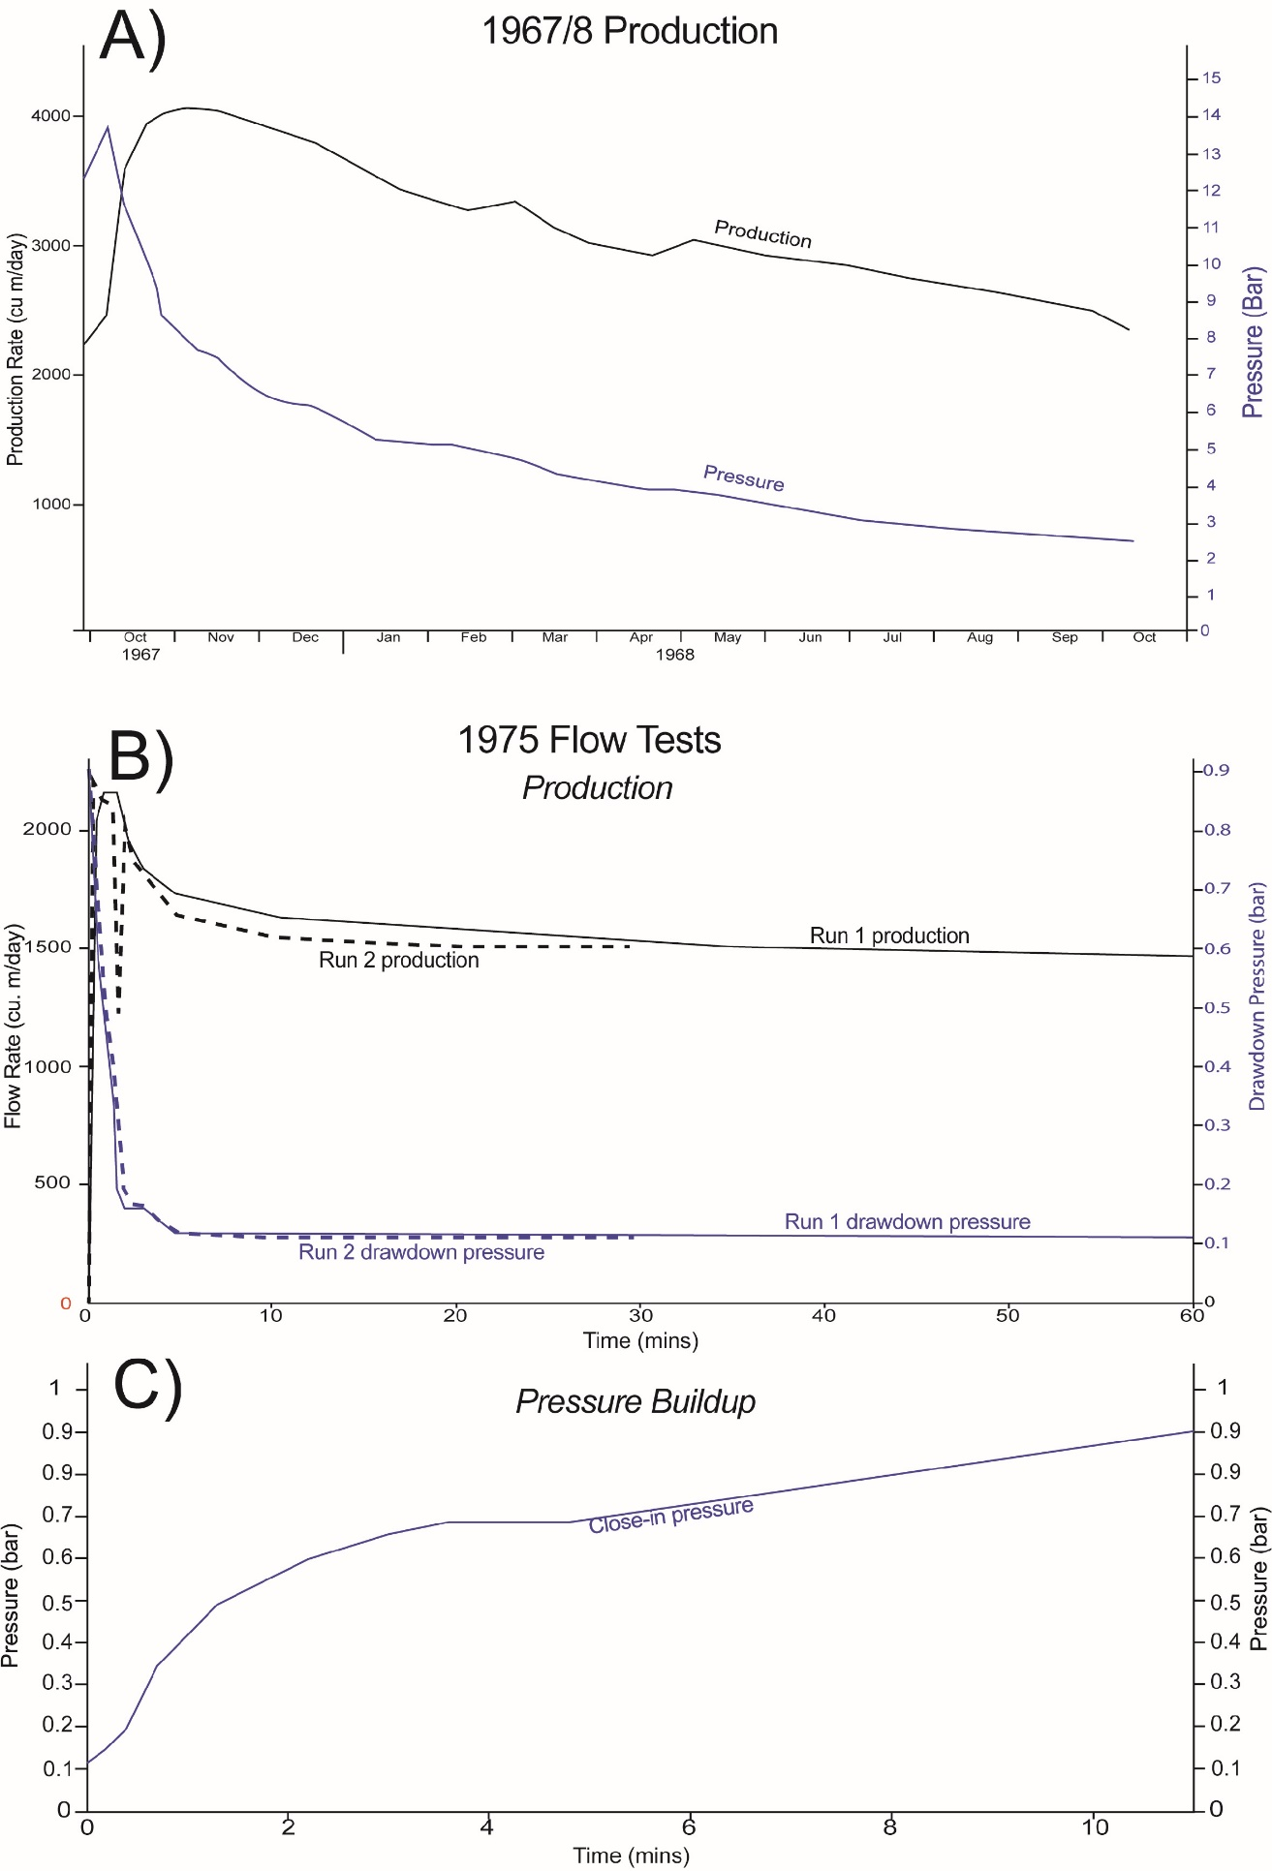
Figure S1 – Gas production tests on the 1967-1 well in Adventdalen where it was produced and flared. A) Gas production and pressure depletion for the first year of production. B) An oilfield-standard production test of production and pressure drawdown carried out by Statoil in 1975. The relatively fast flattening of the curves suggests stable flow and strong pressure communication in the reservoir. C) Pressure build up following shut-in of the well also indicating appreciable fluid communication.

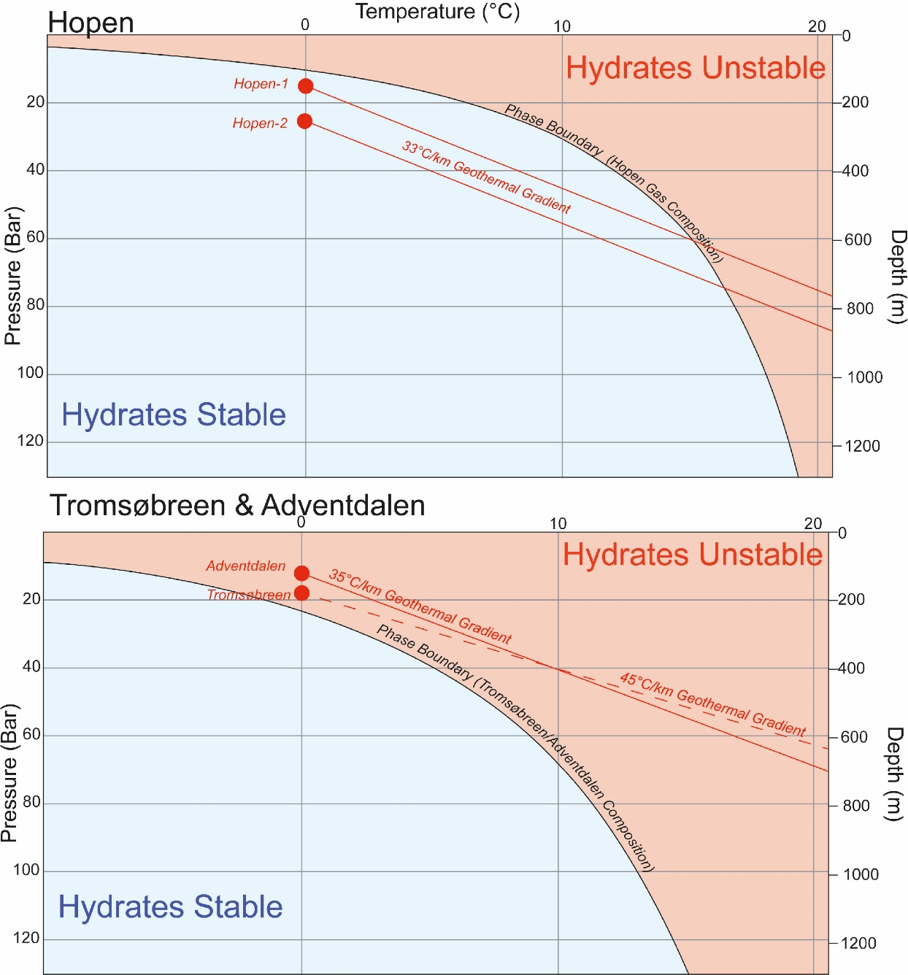
Figure S2 – The upper graph shows the natural gas hydrate stability diagrams for the Hopen gas composition (Table 4). The lower graph shows the same for the Adventdalen (well DH4) and Tromsøbreen methane dominated gas compositions (Table 4 and Figure 8). Red circles represent the base permafrost (0° C) depths using pressures based on a hydrostatic gradient from the surface. Lines represent stability with increasing depths at each locality based on local geothermal gradients (Betlem et al., 2018; Isaksen et al., 2000).

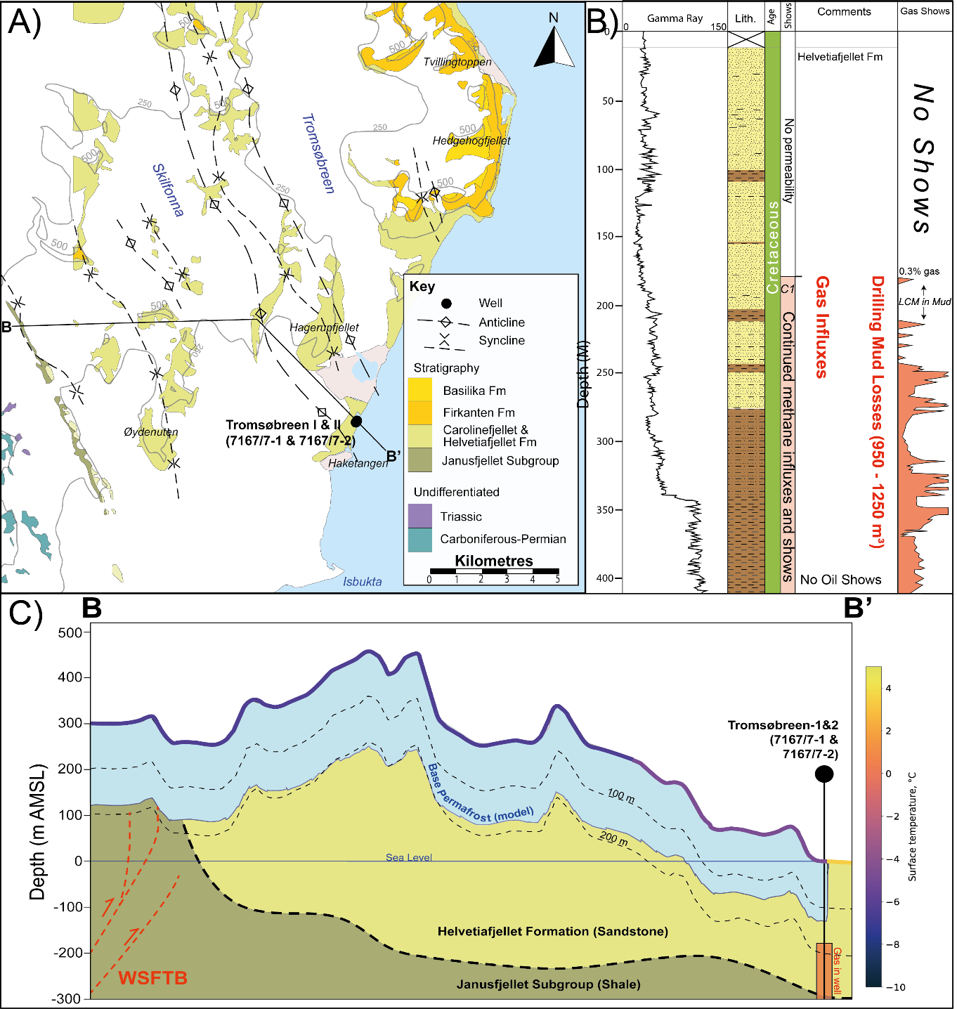
Figure S3 – A) Geological map from Tromsøbreen redrawn from Birkenmajer et al. (1992). B) All available data over the shallow intervals at Tromsøbreen combined from the two wells. The petrophysical, lithological and gas data is from 7617/7-1 (Tromsøbreen-I) while 7617/7-2 (Tromsøbreen-II) recorded very little data over the shallow intervals, though did corroborate drilling fluid losses and gas influxes at the same depths. C) Cross-section (shown in A) of modelled permafrost thickness and the important reservoir and sealing formations, and inferred faults of the West Spitsbergen Fold and Thrust Belt (WSFTB) based on outcrop data (Birkenmajer et al, 1992).

Figure S4 – A) Geology and outline of the island of Hopen based on Lord et al. (2014) with the map location shown in Figure 1). Profile C-C’ is shown in C) B) Petrophysical and lithological information from the respective wells. Gas samples were taken in Hopen I while a chromatograph in the mud traps was used in Hopen II. The muted gamma ray response in the upper 350 m of Hopen II is probably due to the recording through casing.
Figure S5 - Cross sectional (shown in A) of Hopen showing the modelled permafrost and gas hydrate stability zones (the geology here is comprised of the Heterolithic sandstones, siltstones and mudstones of the De Geerdalen Formation).

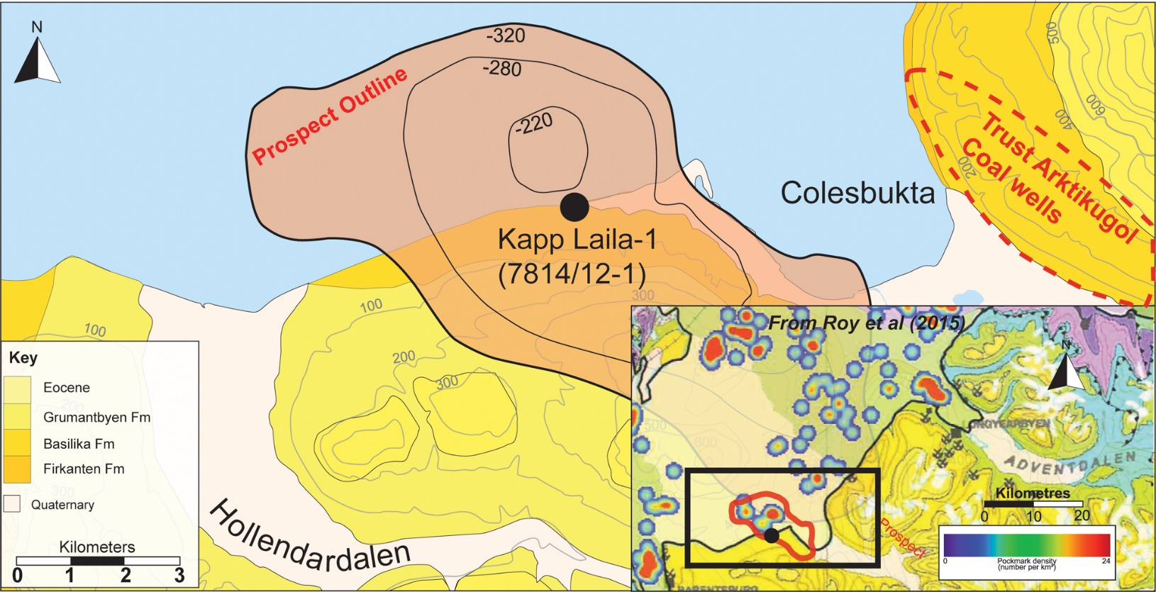
Figure S6 - Map of the Kapp Laila area (based on Norsk Polarinstitutt, 2015 and SNSK, 1994) with the SNSK prospect and well location shown. Inset is a map of pockmarks on the seafloor of Isfjorden from Roy et al (2015). A high concentration of pockmarks on the seabed apparently overlies the crest of the prospect. The map location is shown in Figure 1 of the main article.

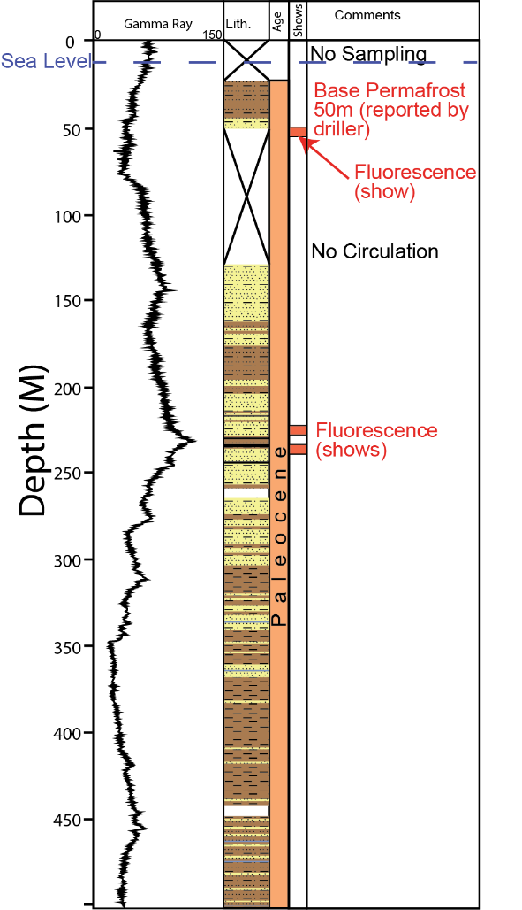
Figure S7 - The Kapp Laila well with all available data and geological and drilling comments. Minor gas shows occur at 50 m depth which coincides with the stated base of permafrost (SNSK, 1994).

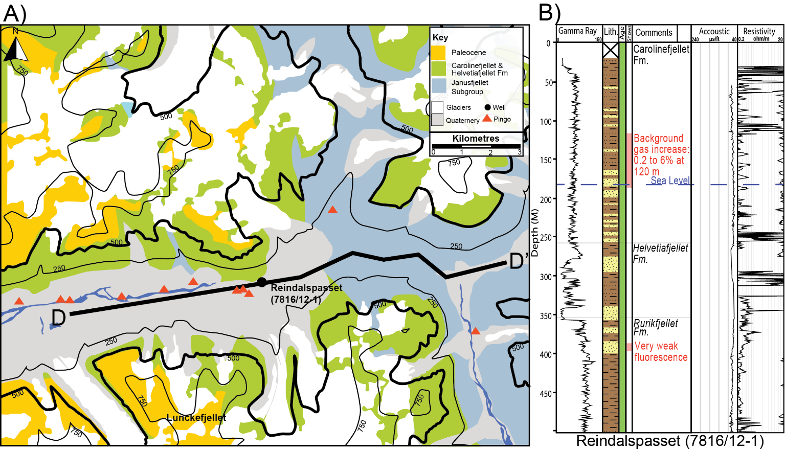
Figure S8 – A) A Geological map of Reindalen (based on Norsk Polarinstitutt, 2015) with the Reindalspasset borehole shown. Lunckefjellet plateau is also shown, where several coal boreholes that experienced fluid losses. The map location is shown in Figure 1. B) The petrophysical log over shallow intervals in Reindalspasset (7816/12-1). The well sits in the valley of Reindalen where a series of pingos are situated updip from the wellbore, on the north side of the valley. Line D to D’ shows the location of the seismic line shown in . 12.

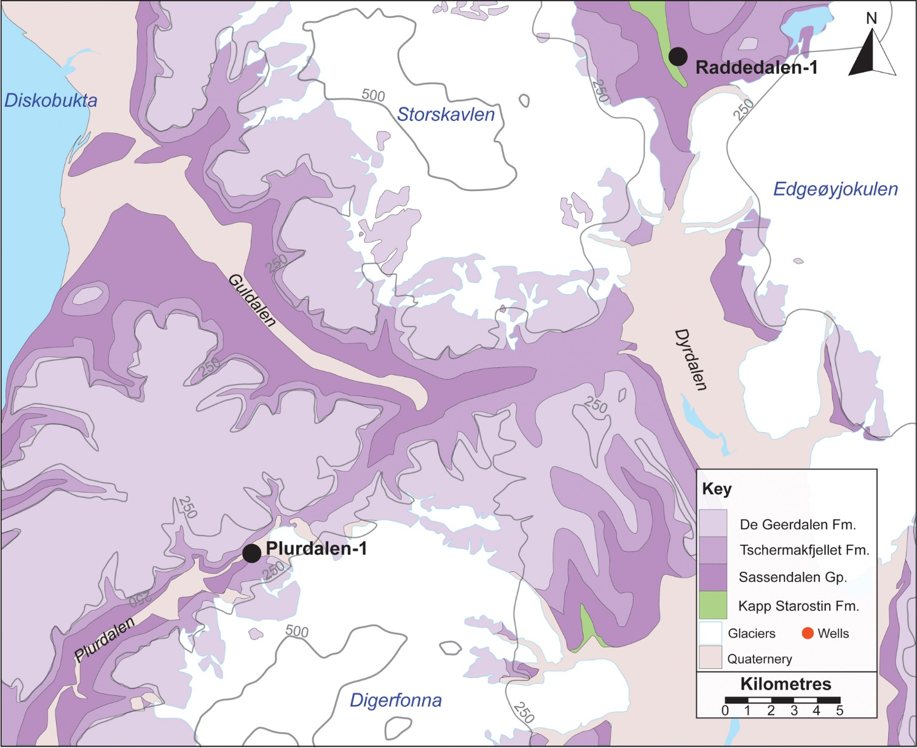Figure S9 - Geological map of central western Edgeøya based on Norsk Polarinstitutt (2015) showing the two hydrocarbon exploration wells on the island. The map location is shown in Figure 1.
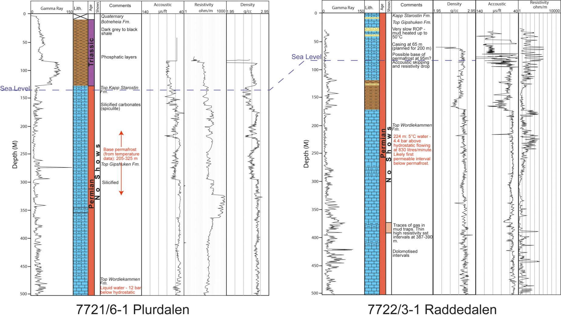
Figure S10 - Petrophysical logs from the hydrocarbon exploration wells at Plurdalen (7721/6-1) and Raddedalen (7722/3-1).

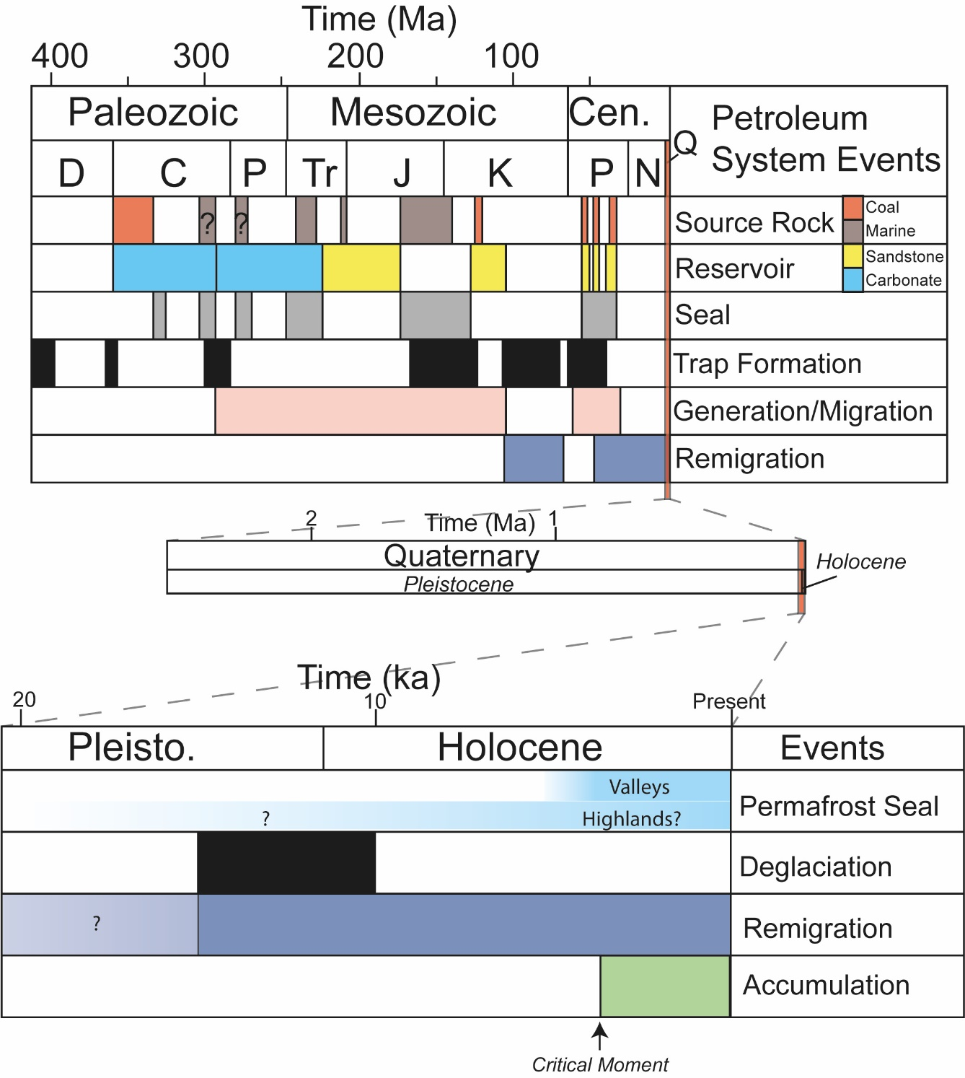
Figure S11 - Petroleum systems chart for Svalbard. The upper part covers the important elements of the past 400 million years whereas the lower parts show the importance of the most recent events. The critical moment is the timing of permafrost formation, which is also evidence that gas migration must also have been occurring recently, and most likely ongoing today.

Supplementary References
Betlem, P., Midttømme, K., Jochmann, M., Senger, K., and Olaussen, S.: Geothermal Gradients on Svalbard, Arctic Norway, First EAGE/IGA/DGMK Joint Workshop on Deep Geothermal Energy, cp-577-00017, 2018
Christiansen, H. H., French, H. M., and Humlum, O.: Permafrost in the Gruve-7 mine, Adventdalen, Svalbard, Norsk Geografisk Tidsskrift-Norwegian Journal of Geography, 59, 109-115, https://doi.org/10.1080/00291950510020592, 2005.
Hynne, I. B.: Depositional environment on eastern Svalbard and central Spitsbergen during Carnian time (Late Triassic): A sedimentological investigation of the De Geerdalen Formation, Institutt for geovitenskap og petroleum, Norwegian University of Science and Technology, Trondheim, 2010.
Kristensen, L., Benn, D. I., Hormes, A., and Ottesen, D.: Mud aprons in front of Svalbard surge moraines: evidence of subglacial deforming layers or proglacial glaciotectonics?, Geomorphology, 111, 206-221, 2009.
Majewski, W. and Zajaczkowski, M.: Benthic foraminifera in Adventfjorden, Svalbard: Last 50 years of local hydrographic changes, The Journal of Foraminiferal Research, 37, 107-124, https://doi.org/10.2113/gsjfr.37.2.107, 2007.
Lyutkevich, E. M.: Geology of Tertiary Coals of Spitzbergen, Isfjord Region, Truds Arkticheskogo Instituta, 76, 7-24, 1937.
Majorowicz, J. and Hannigan, P.: Stability Zone of Natural Gas Hydrates in a Permafrost-Bearing Region of the Beaufort—Mackenzie Basin: Study of a Feasible Energy Source1 (Geological Survey of Canada Contribution No. 1999275), Natural resources research, 9, 3-26, https://doi.org/10.1023/A:1010105628952, 2000.
Mørk, M. B. E.: Diagenesis and quartz cement distribution of low-permeability Upper Triassic–Middle Jurassic reservoir sandstones, Longyearbyen CO2 lab well site in Svalbard, Norway, AAPG Bulletin, 97, 577-596, https://doi.org/10.1306/10031211193, 2013.
Norsk Polar Navigasjon A/S: Final Drilling Report - Tromsøbreen No. 1, Stabekk, Oslo, 1977b.
Polargas Prospektering KB: Geological Report - Tromsøbreen No. 2, Stabekk, Oslo, 1988.
Norske Fina A/S: Final Drilling Report - Well Hopen No. 1, Stabekk, Oslo, 1971a
Norske Fina A/S: Final Drilling Report - Well Hopen No. 1, Stabekk, Oslo, 1971b.
Norske Fina A/S: Geological Report - Well: Plurdalen No. 1, Norske Fina, 1972a.
Norske Fina A/S: Final Drilling Report - Well Hopen No. 2, 1973b.
Norsk Hydro: Final Well Report - 7816/12-1, HarstadSVA021, 122, 1991.
Roy, S., Hovland, M., Noormets, R., and Olaussen, S.: Seepage in Isfjorden and its tributary fjords, West Spitsbergen, Marine Geology, 363, 146-159, http://dx.doi.org/10.1016/j.margeo.2015.02.003, 2015.
Senger, K., Brugmans, P., Grundvåg, S.-A., Jochmann, M. M., Nøttvedt, A., Olaussen, S., Skotte, A., and Smyrak-Sikora, A.: Petroleum, coal and research drilling onshore Svalbard: a historical perspective, Norwegian Journal of Geology, 99, 30, https://doi.org/10.17850/njg99-3-1, 2019.
SNSK: Report SN1979_002, Longyearbyen, 14, 1979.
SNSK: Report SN1981_008, Longyearbyen, 52, 1981.
SNSK: Report SN1982_004, Longyearbyen, 14, 1982a.
SNSK: Report SN1982_005, Longyearbyen, 14, 1982b.
SNSK: Report SN1986_001, Longyearbyen, 14, 1986.
SNSK: Report SN1991.04, Longyearbyen, 14, 1991.
SNSK: Report - Kapp Laila - 1, Longyearbyen, 110, 1994.
SNSK: BH 19-2011 Drilling Report, Longyearbyen, 14, 2011a.
Total Marine Norsk: Final Well Report - Raddedalen I, 1972.
Verba, M.: Kollektornye svoystva porod osadochnogo chekhla arkhipelaga Shpitsbergen [Sedimentary cover reservoir of Svalbard archipelago], Neftegazovaya Geologiya. Teoriya I Praktika, 8, 1-45, 2013.
Vonk, J. E. and Gustafsson, Ö.: Permafrost-carbon complexities, Nature Geoscience, 6, 675-676, https://doi.org/10.1038/ngeo1937, 2013.

