Supplementary Material

Figure S1. WSS ice core sample from bag 2. The LA-ICP-MS image consists of 50 lines measured with a 40 micron spot and shows Na, Mg, Al in red, green and blue color scale, respectively for an area of 2 x 5 mm. All elements are found mostly co-localized at grain boundaries (bright lines), while Al and Mg also form some isolated spots.

Figure S2. WSS ice core sample from bag 18. LA-ICP-MS image shows Na, Mg, Al in red, green and blue colorscale, respectively for an area of 3 x 4 mm.

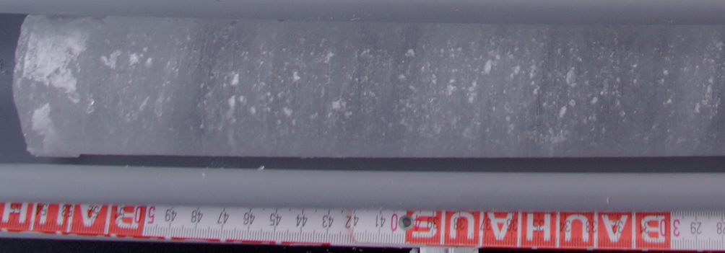
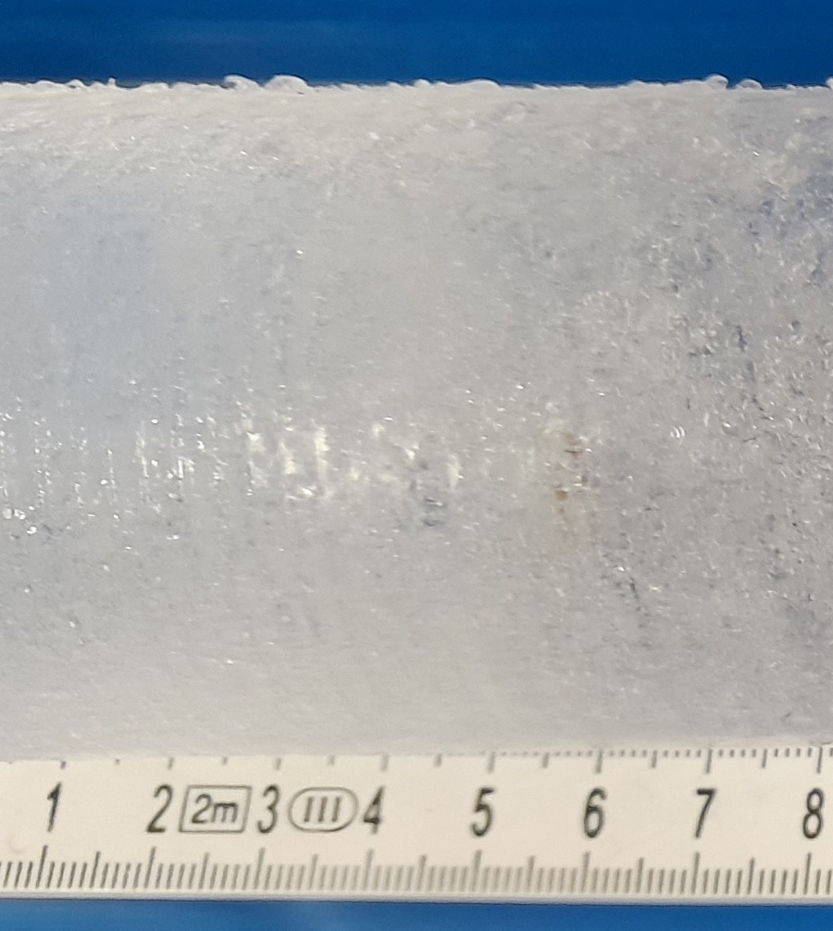

Figure S3. Example for typical visual stratigraphy in the WSS ice core. Note the visible bubble-rich ice layers with white appearance.

