Supplementary Material

Seasonal SIMS δ¹⁸O record in Astarte borealis from the Baltic Sea tracks a modern regime shift in the NAO
Hunter P. Hughes*, Donna Surge, Ian J. Orland, Michael L. Zettler, David K. Moss
* Correspondence: hphughes@email.unc.edu

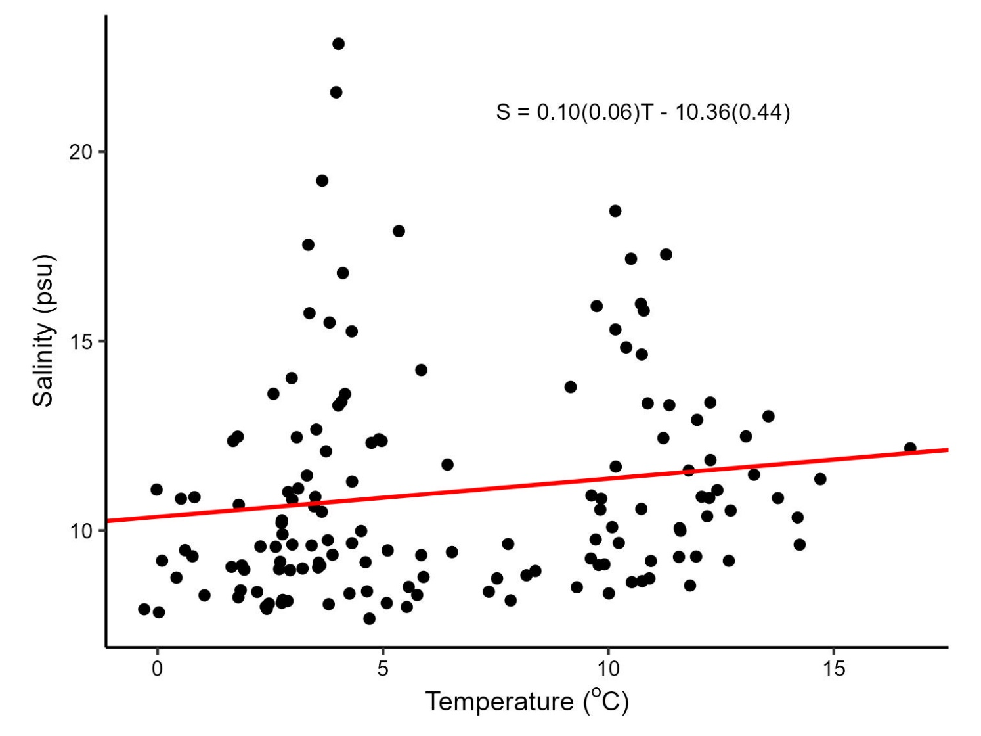
Supplemental Figure 1. Cross-plot of in situ temperature and salinity measured less than 2 km from where specimen RFP3S-47 was collected (54º47’30.1”N, 13º03’29.9”E). There is no significant relationship between temperature and salinity (n = 146, r² = 0.02, p = 0.08), indicating that there is no seasonal cycle of salinity at our study site.

Supplemental Table 1. P-values from Mann-Whitney tests applied to four different subsets of the in situ salinity dataset. ‘Cold’ (‘Warm’) represents salinities where temperatures were below (above) the median temperature value. ‘DJFM’ represents salinities collected in December, January, February, and March. ‘JJAS’ represents salinities collected in June, July, August, and September. The sample size for each dataset is as follows: Cold = 73, Warm = 73, DJFM = 63, JJAS = 30.
Mann-Whitney Test p-values | Cold | Warm | DJFM | JJAS
Cold | 1.00 | - | - | -
Warm | 0.13 | 1.00 | - | -
DJFM | 0.56 | 0.43 | 1.00 | -
JJAS | 0.81 | 0.19 | 0.59 | 1.00

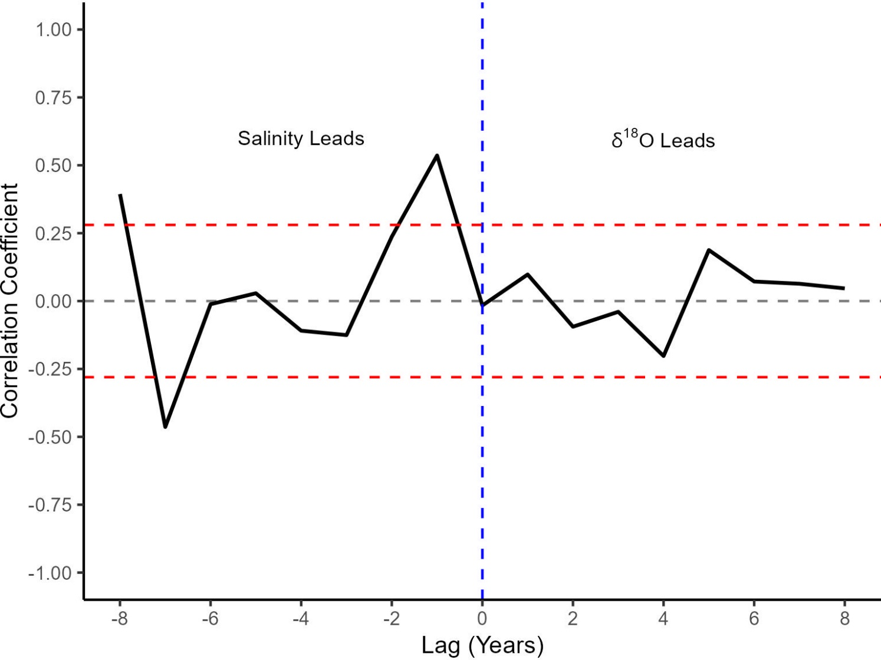
Figure S2. Lagged correlation analysis between yearly-averaged SIMS δ¹⁸O_{shell} values and in situ salinity. The x-axis values represent the number of years that salinity lags SIMS δ¹⁸O_{shell} values. The red-dotted lines (r = ± 0.28) indicate the point at which the correlation becomes significant at the 95% confidence level (Hu et al., 2017)

