Supplementary Material

A step forward to understanding the development of volcanotectonic rifts: the structure of the Fremrinamar Fissure Swarm (Iceland)

**Martina Pedicini1, Fabio Luca Bonali1,2*, Noemi Corti1, Federico Pasquaré Mariotto3, Kyriaki Drymoni1, Alessandro Tibaldi1,2**

1 Department of Earth and Environmental Sciences, University of Milan-Bicocca, 20126 Milan, Italy;

2 CRUST-Interuniversity Center for 3D Seismotectonics with Territorial Applications, 66100 Chieti Scalo, Italy

3 Department of Human and Innovation Sciences, Insubria University, 21100 Varese, Italy

\***Corresponding author**:

Fabio Luca Bonali

[fabio.bonali@unimib.it](mailto:fabio.bonali@unimib.it)

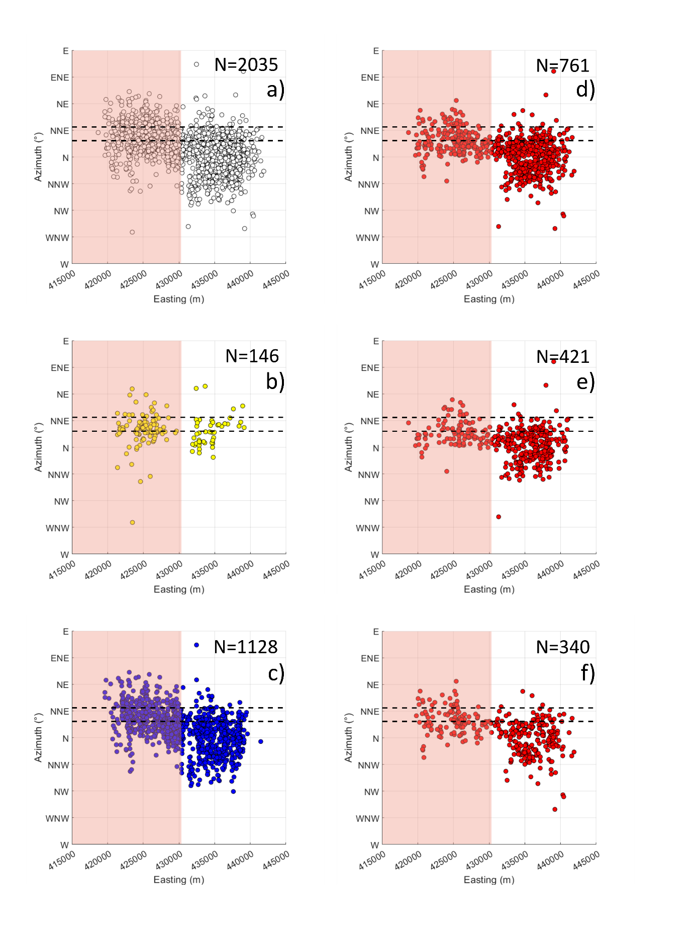

**Supplementary Figure 1.** Relation between the X coordinate (here referred to as “Easting”) and strike values for the entire dataset of structures (a), eruptive fissures (b), extension fractures (c), normal faults (d), E-dipping normal faults (e), and W-dipping normal faults (f). Black dashed lines identify the perpendicular to the main spreading direction of the NVZ (review in Corti et al., 2021), and the red area identifies the location of the Fremrinamar central volcano. See below for a more detailed comment.

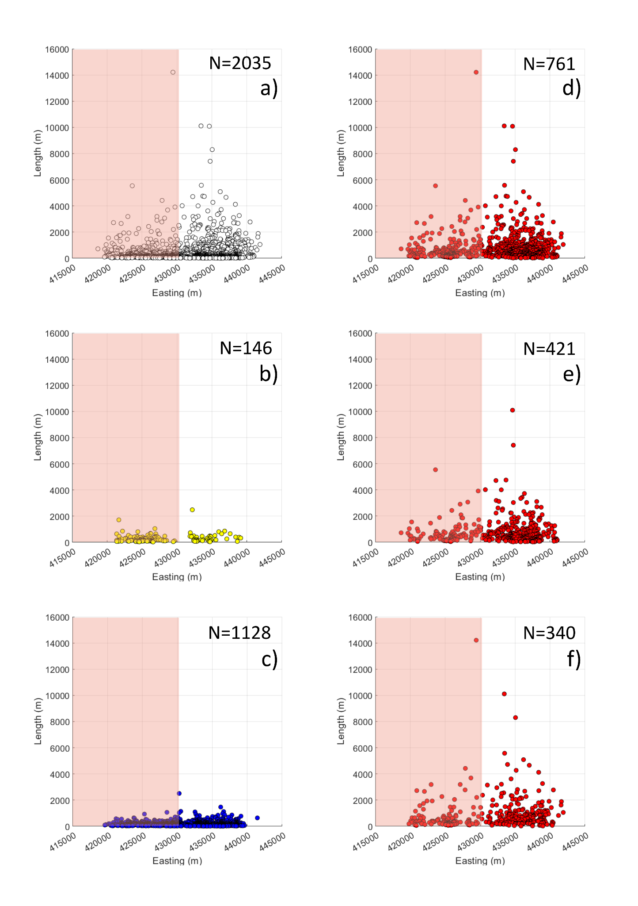

**Supplementary Figure 2.** Relation between the X coordinate (here referred to as “Easting”) and length values for the entire dataset of structures (a), eruptive fissures (b), extension fractures (c), normal faults (d), E-dipping normal faults (e), and W-dipping normal faults (f). The red area identifies the location of the Fremrinamar central volcano. See below for a more detailed comment.

The spatial relation between our dataset and the X coordinate (WGS84 UTM zone 28N) reveals a paucity of structures near the X coordinate 430000 (Fig. S1). Both extension fractures and normal faults are affected by a reduction in frequency near this area (Fig. S1). This is particularly clear for the eruptive fissures that are clustered into two distinct groups, located in the eastern and western portions of the fissure swarm (Fig. S1). Strike values vary along the X coordinates, with the western portion of the fissure swarm that is mostly characterised by N-S to NNE-SSW strike values, while the eastern portion is mainly defined by NNW-SSE values (Fig. S1). Also, the length distribution is not constant along the X coordinates, with the eastern portion of the rift that is affected by the presence of the longest structures (Fig. S2). This is particularly noticeable for the normal fault set, which shows a clear increase in length values towards the east (Fig. S2), while this is less explicit for eruptive fissures and extension fractures (Fig. S2).

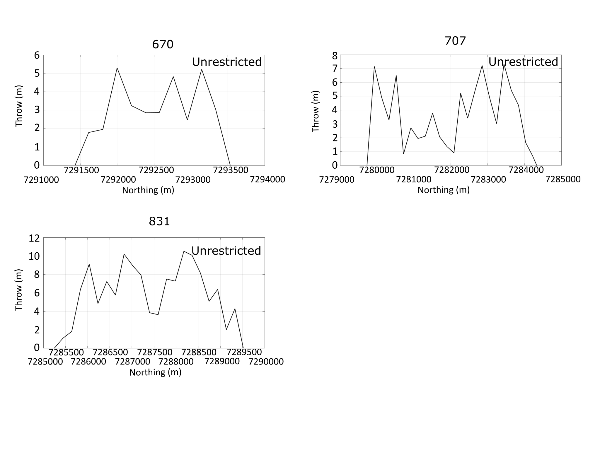

**Supplementary Figure 3.** Chart of the entire dataset of symmetric slip profiles.

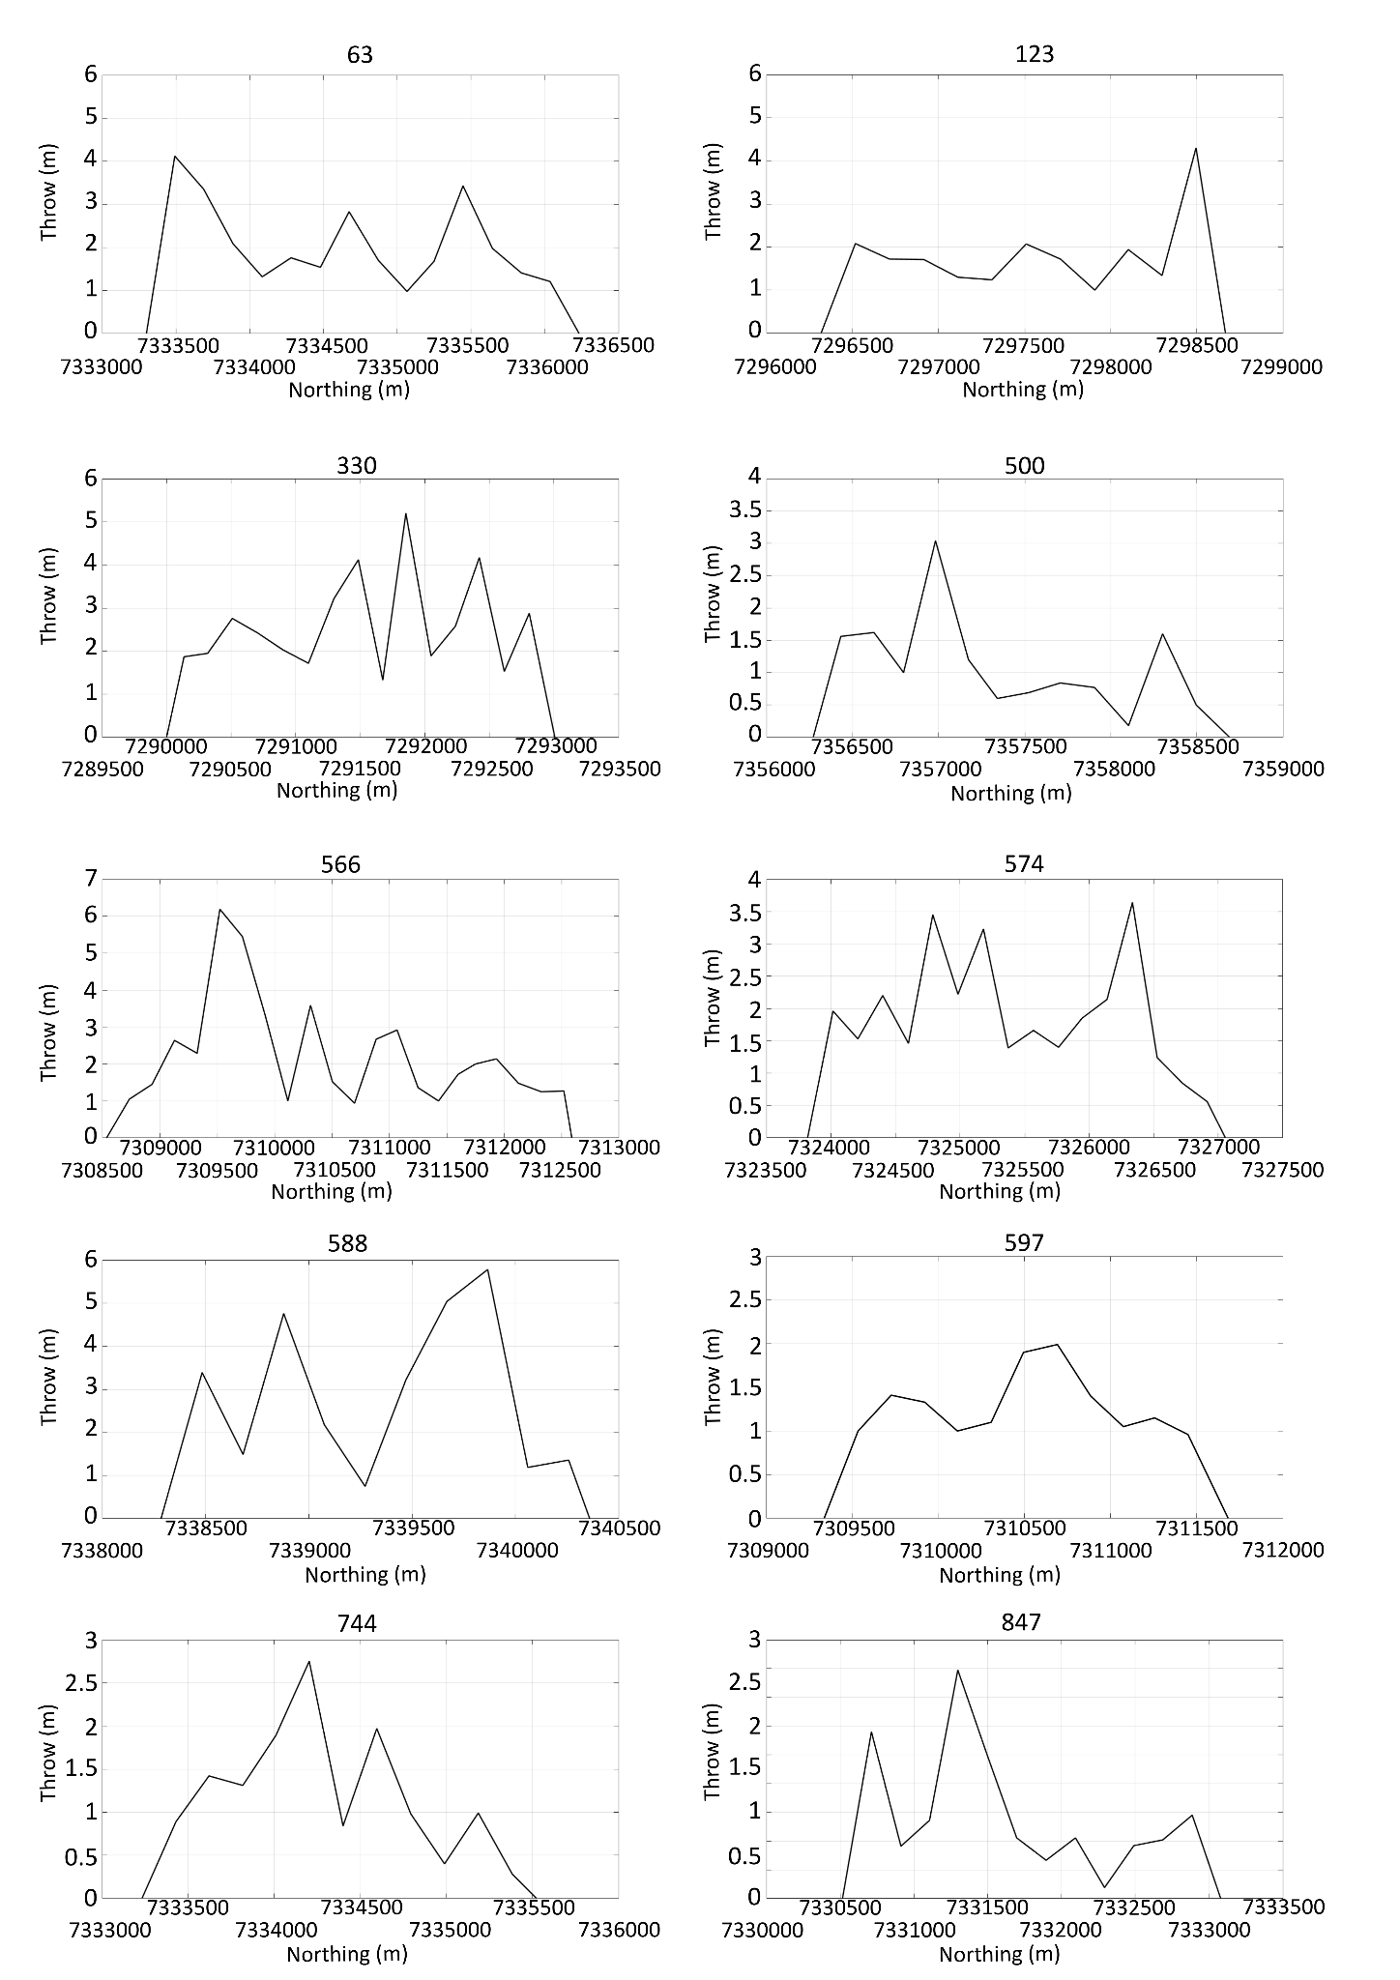

**Supplementary Figure 4.** Chart of the entire dataset of unclassified slip profiles (continues below).

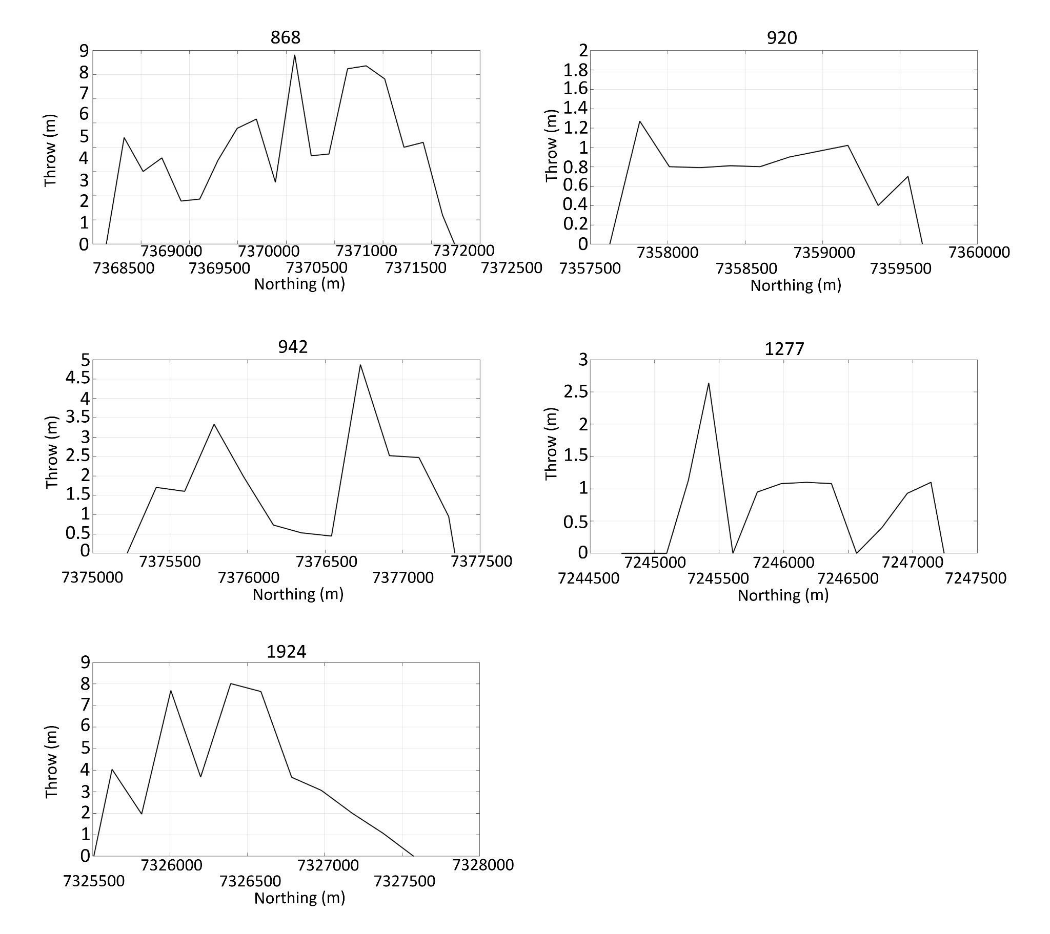

**Supplementary Figure 4.** Chart of the entire dataset of unclassified slip profiles

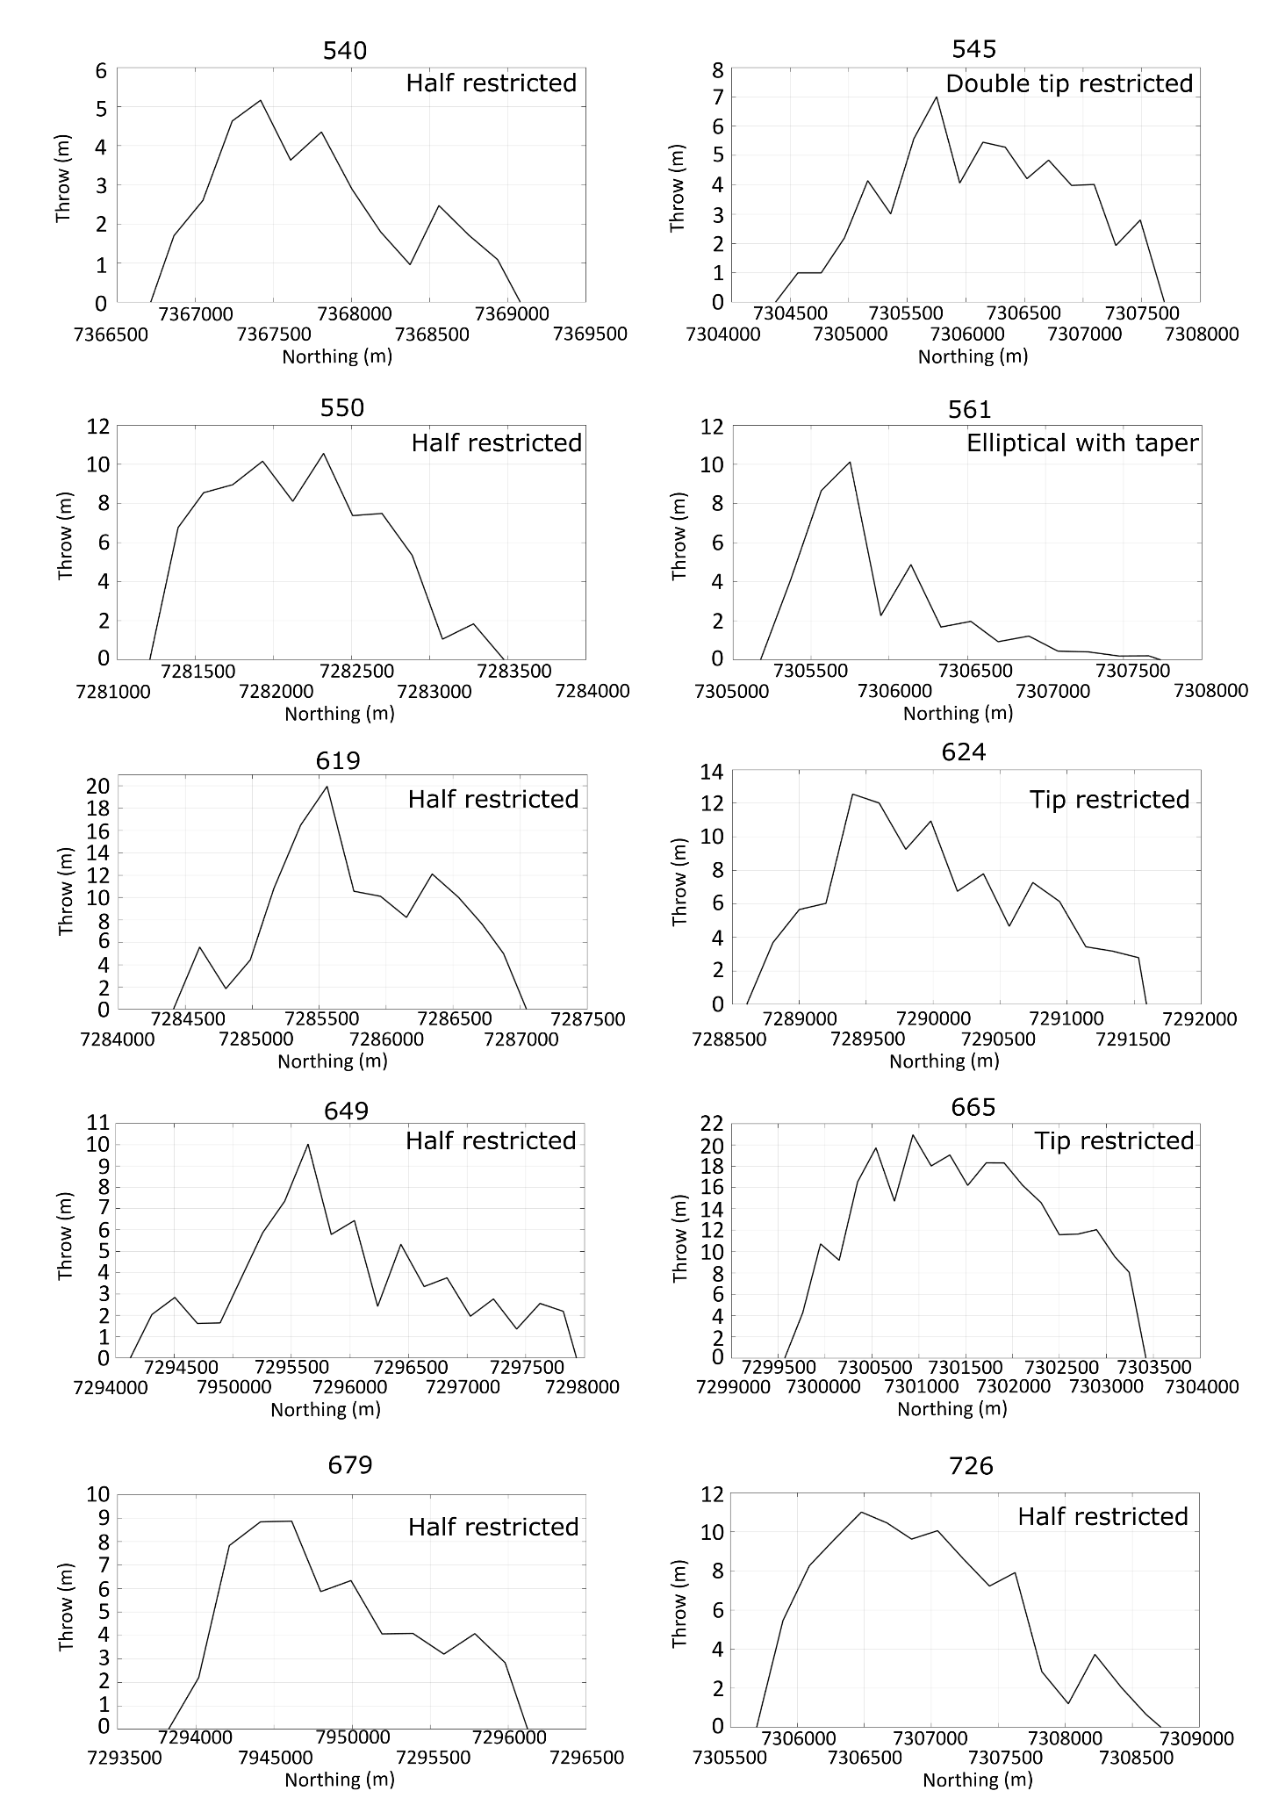

**Supplementary Figure 5**. Chart of the entire dataset of northward slip profiles (continues below).

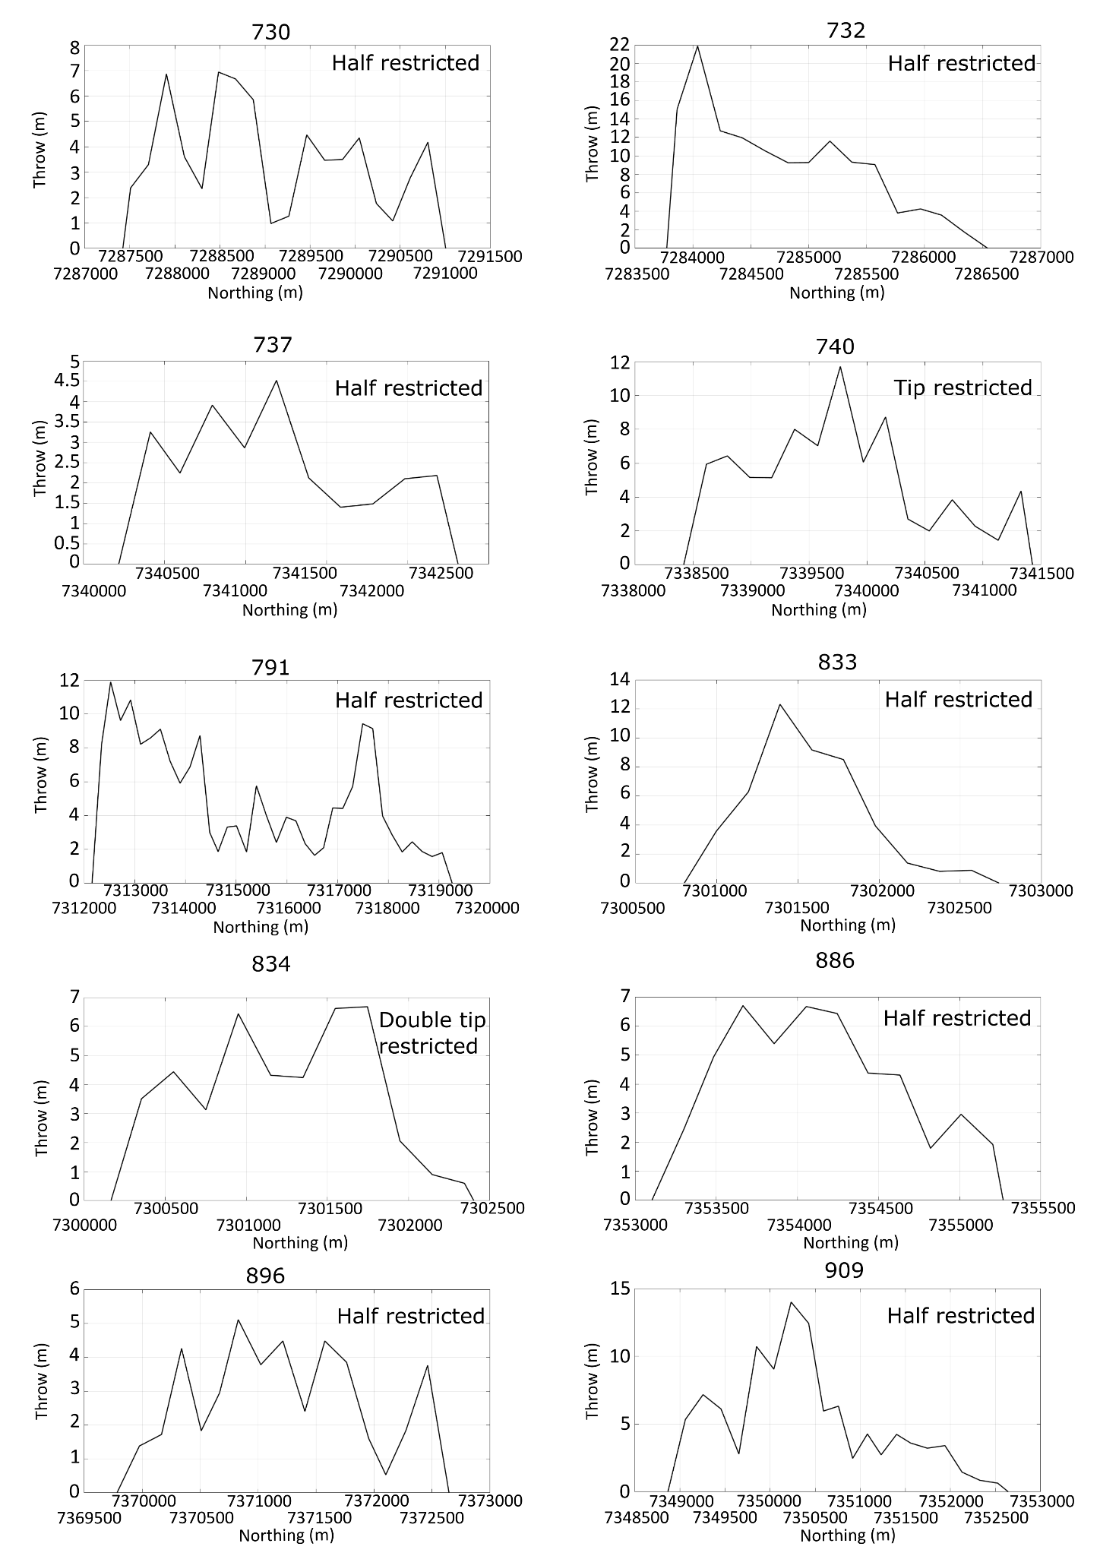

**Supplementary Figure 5**. Chart of the entire dataset of northward slip profiles (continues below).

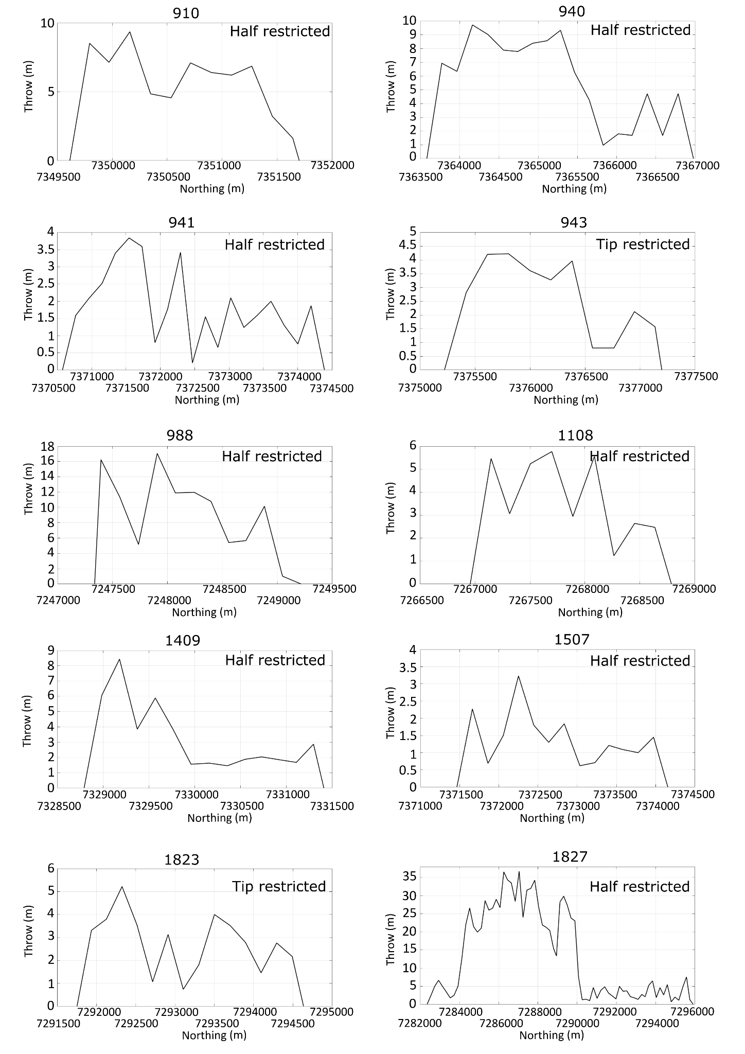

**Supplementary Figure 5**. Chart of the entire dataset of northward slip profiles (continues below).

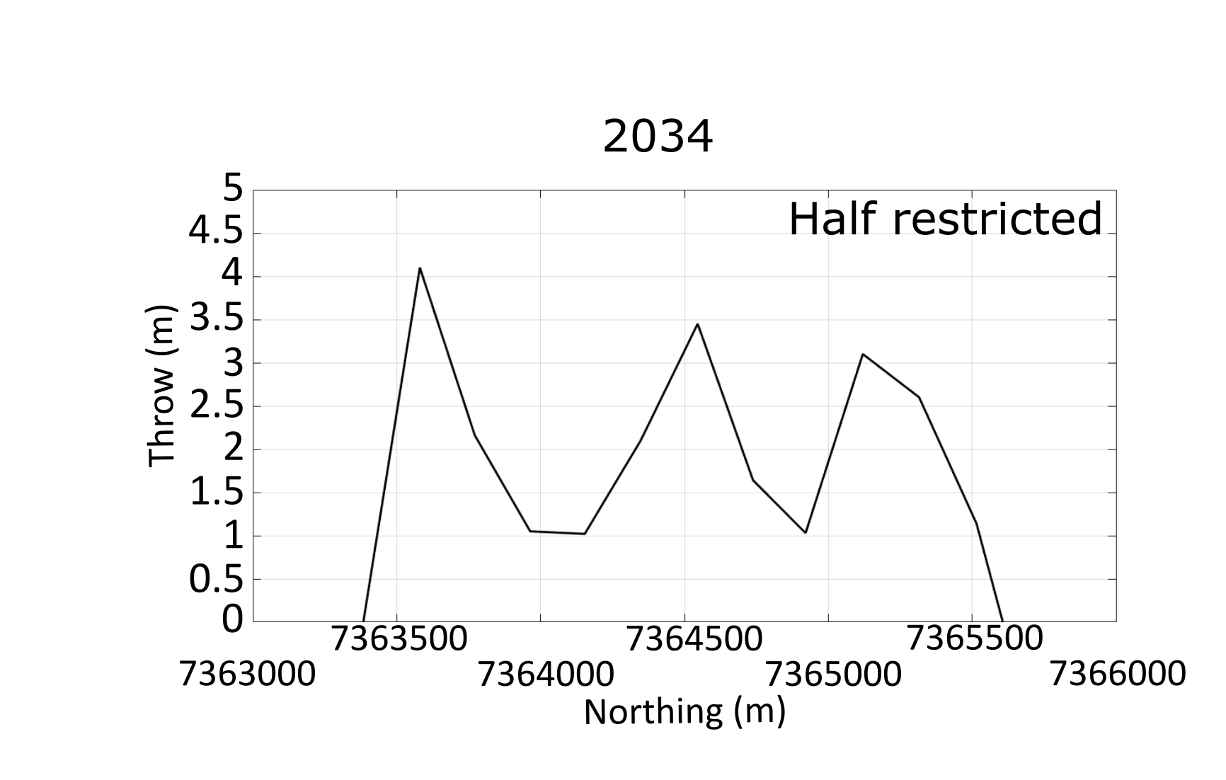

**Supplementary Figure 5**. Chart of the entire dataset of northward slip profiles.

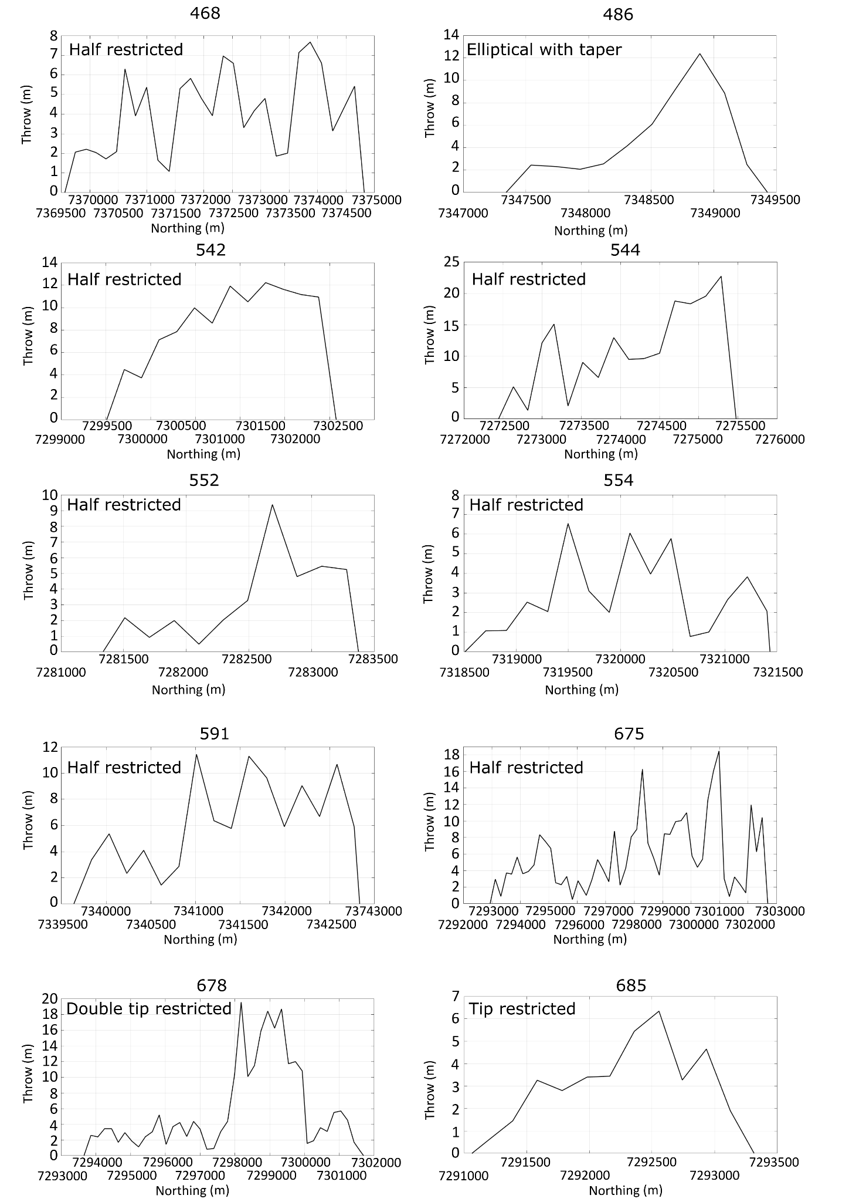

**Supplementary Figure 6.** Chart of the entire dataset of southward slip profiles (continues below).

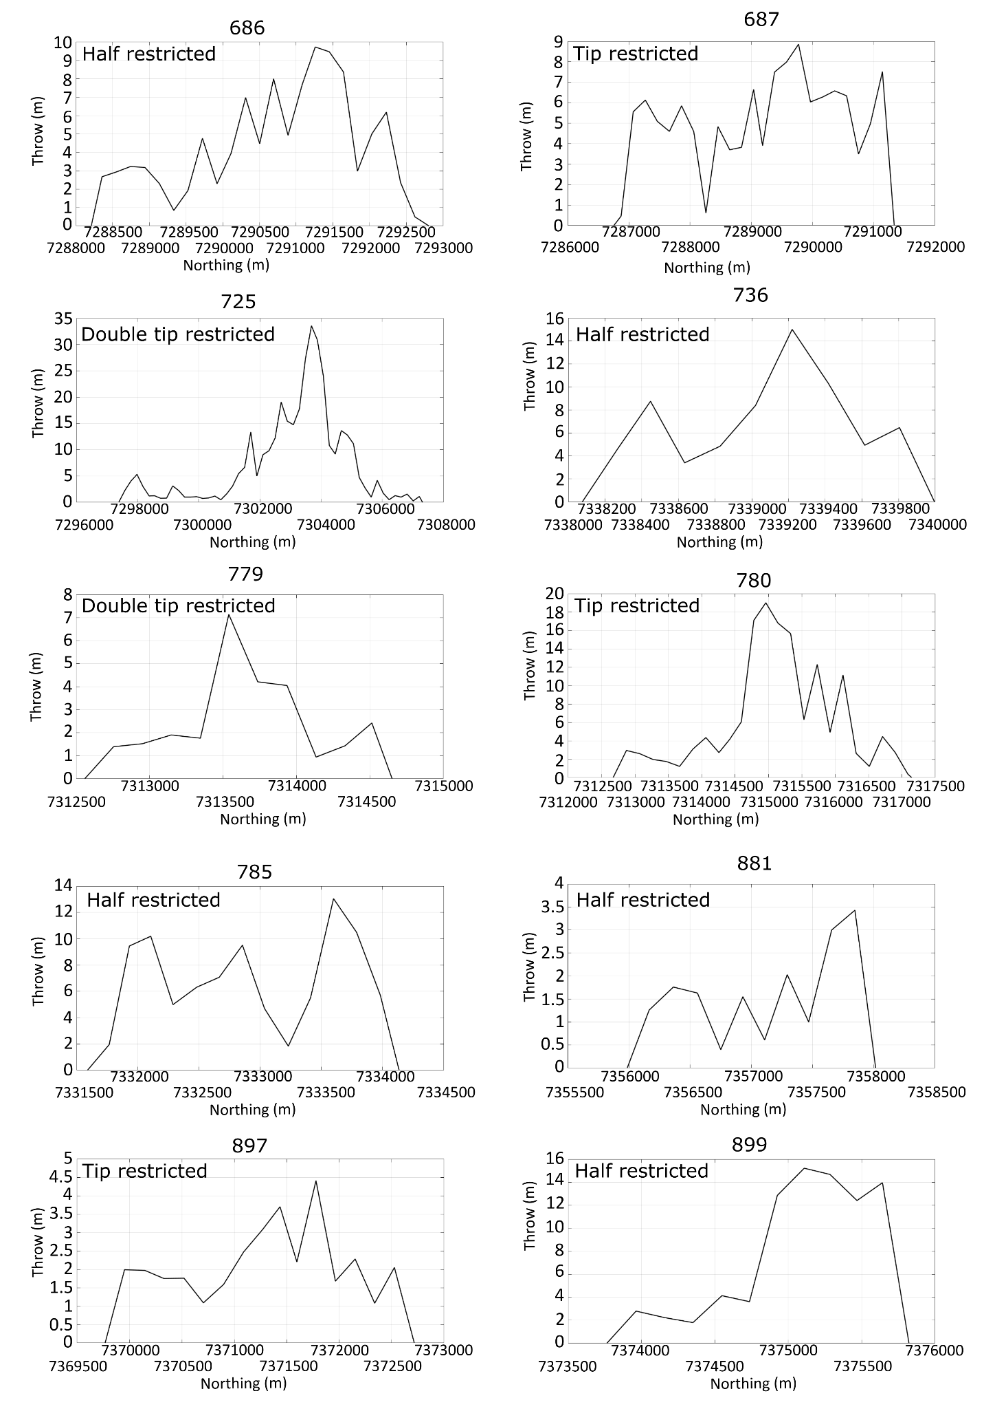

**Supplementary Figure 6.** Chart of the entire dataset of southward slip profiles (continues below).

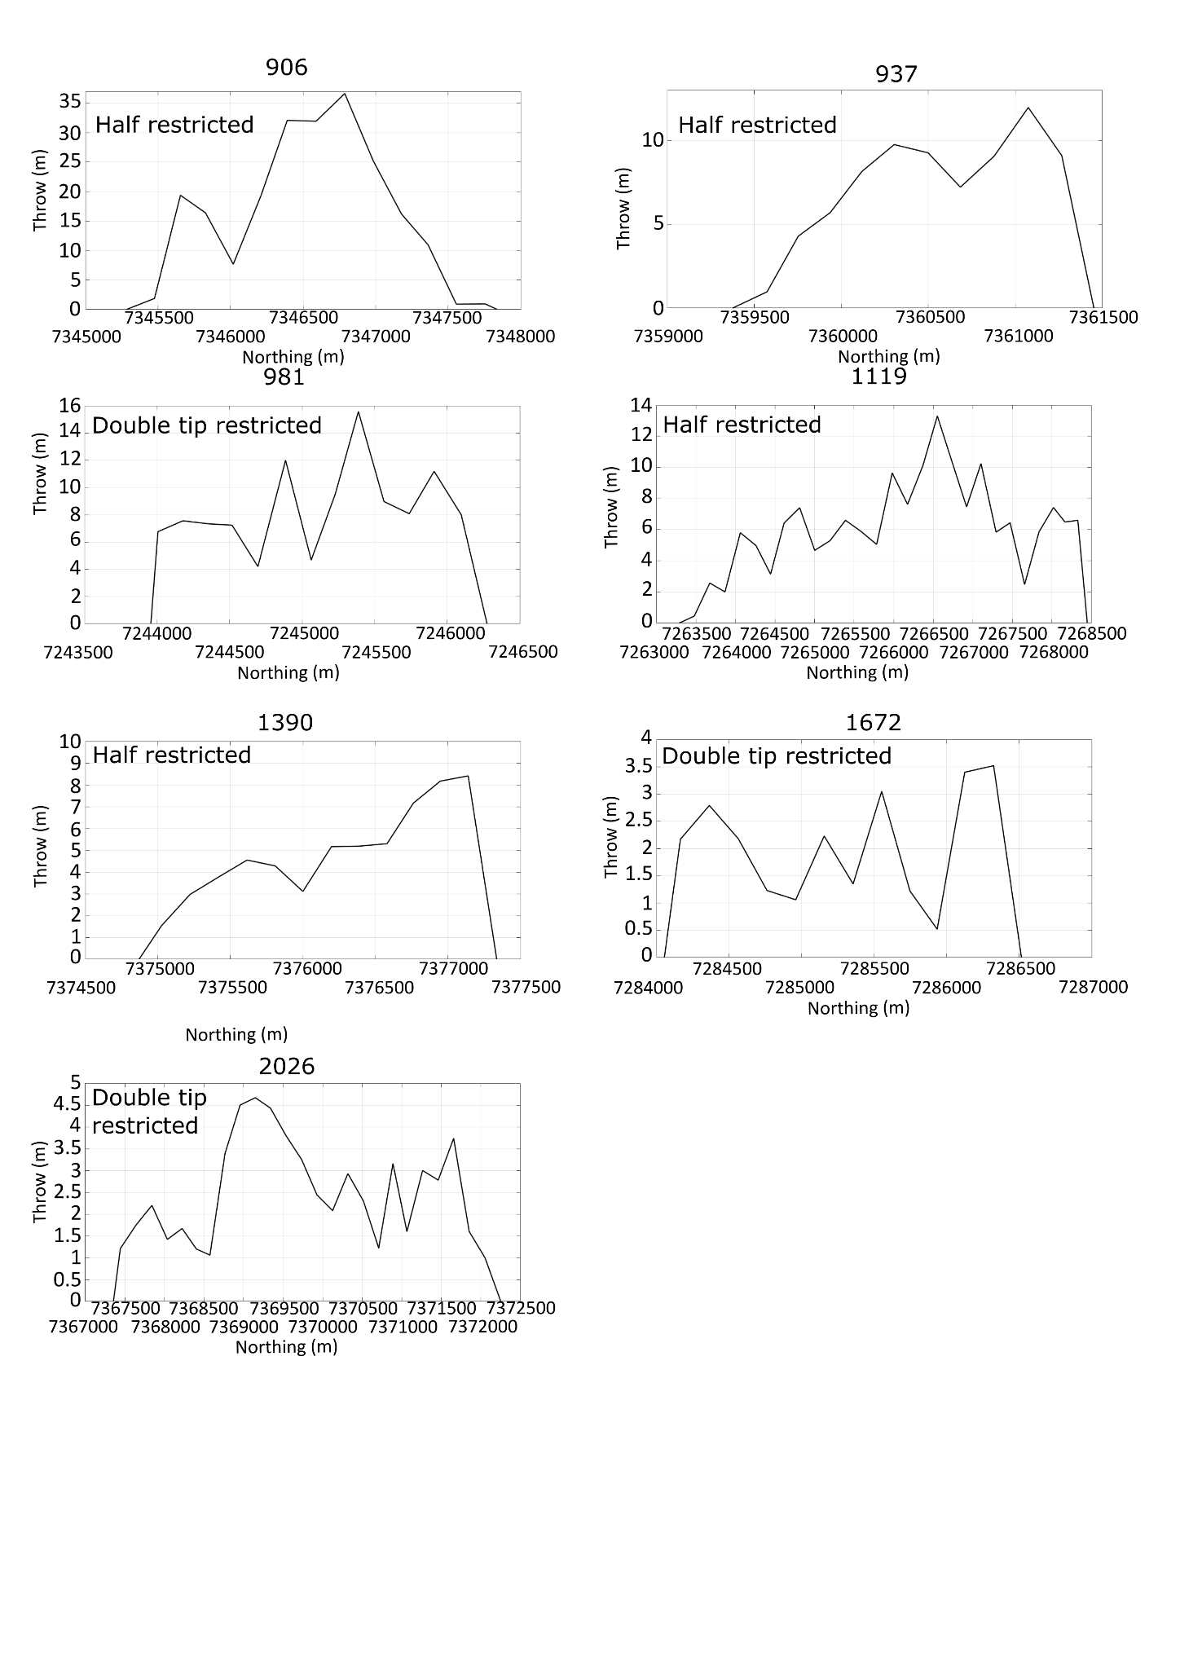

**Supplementary Figure 6.** Chart of the entire dataset of southward slip profiles.

Considering the classification proposed by Manighetti et al. (2001), we identified 64% of half-restricted slip profiles (the rupture starts generating near a barrier and the profile tapers towards the direction of fault propagation), 14.7% of tip-restricted ones (the shape of the profile results from the propagation in the opposite direction of the barrier), 13.1% of double tip-restricted profiles (the fault propagates and then barriers locked its tips), 4.9% of unrestricted profiles (the rupture is not arrested and the profile tapers in two directions), and 3.3% of elliptical with taper slip profiles (the fault is able to rupture the barrier).

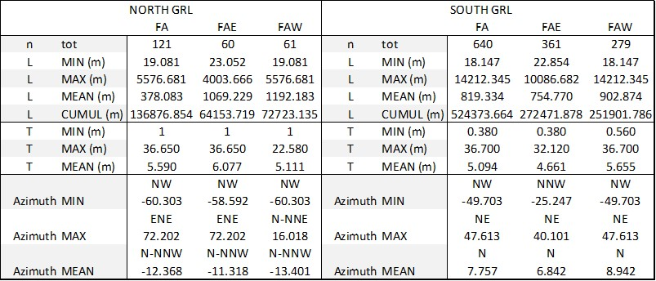

**Supplementary Table 1.** Overview table for the entire dataset of normal fault, reporting length, throw and azimuth values. Data are divided considering faults location with respect to the GRL.



**Supplemetary Table 2.** Overview table for the dataset of normal fault longer that 2 km, along with length, throw and azimuth values. Data are divided considering fault locations with respect to the GRL*.*