Supplementary Material

Supplementary Figures
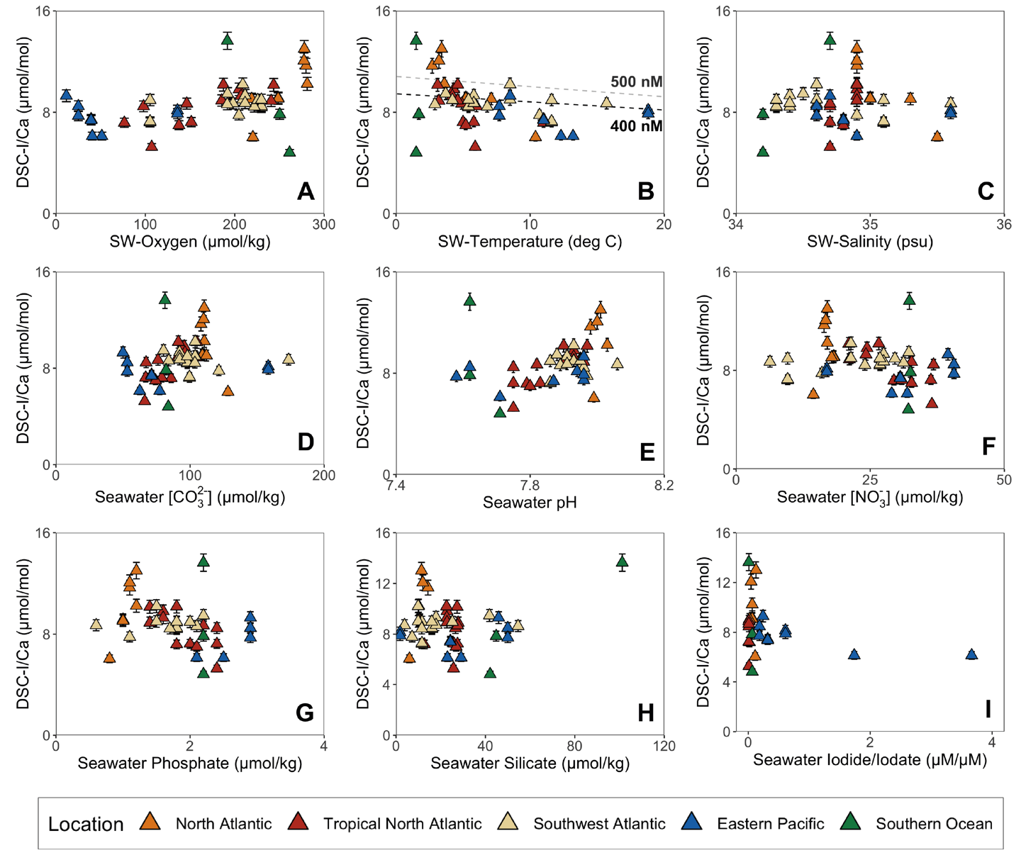
Supplementary Figure 1. Cross-plots for scleractinian deep-sea coral (DSC) I/Ca and ambient seawater hydrographic data from published studies: (A) oxygen, (B) temperature, (C) salinity, (D) [CO₃²⁻], (E) pH, (F) nitrate, (G) phosphate, (H) silicate, and (I) seawater iodide/iodate ratio. The dashed lines in B panel are partitioning estimates: the equation between temperature and KD (([I/Ca]/[IO₃⁻]) is taken from the calcite synthesis experiments (Zhou et al., 2014) under two iodate concentrations (400 nM (black) and 500 nM (gray)), and the correlation factor between aragonite and calcite is applied (see Figure 4B). Error bar I/Ca in coral: 1 σ = 5 %.

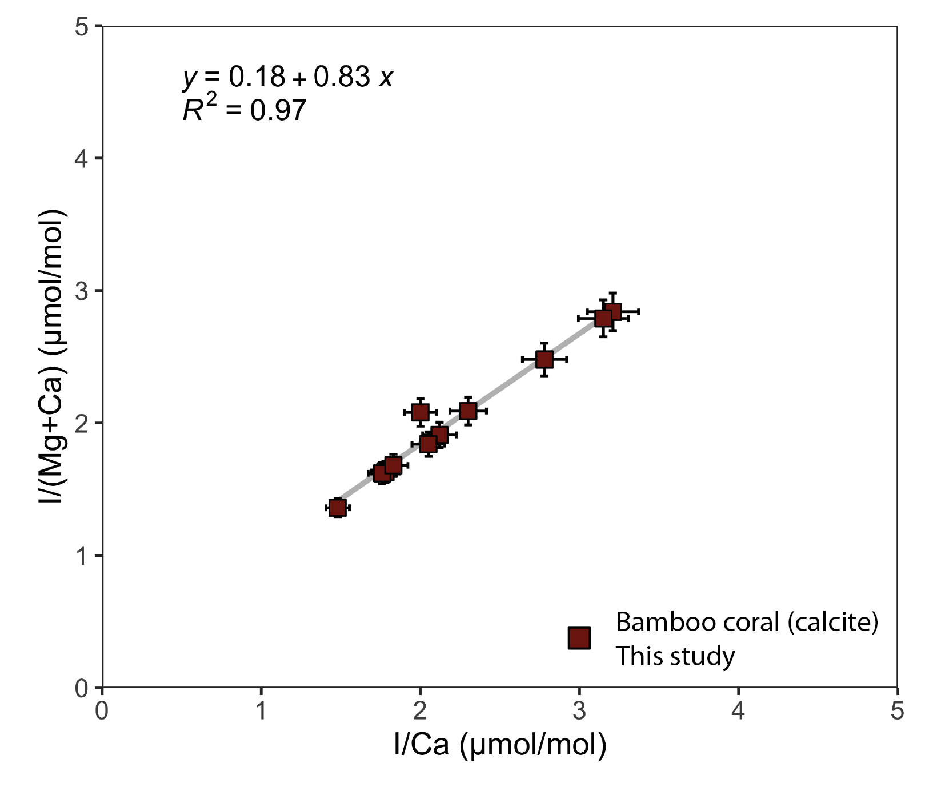
Supplementary Figure 2. Cross-plot for bamboo deep-sea coral (DSC, calcite) I/Ca and I/(Mg+Ca). The Mg/Ca for the bamboo coral samples is in range of 60-95 mmol/mol. This result is a minor difference between I/Ca and I/(Mg+Ca). To better compare with aragonite corals, here we applied I/(Mg+Ca) for bamboo corals in this study. Error bar I/Ca in coral: 1 σ = 5 %.

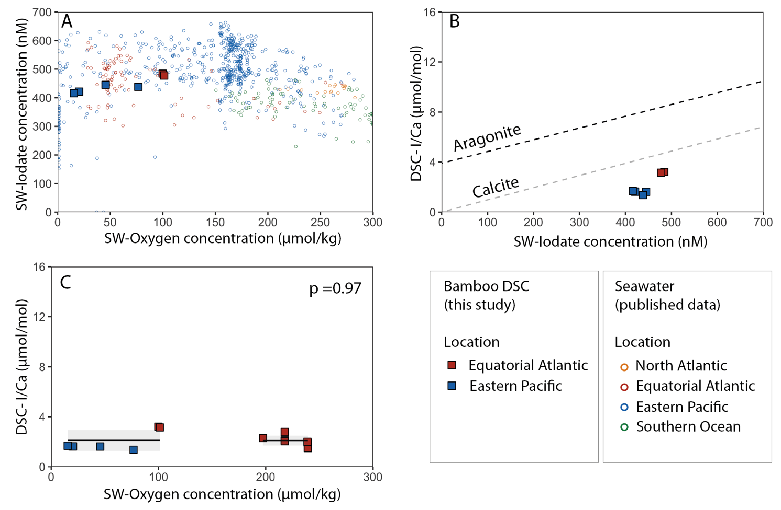
Supplementary Figure 3. Cross-plots for bamboo deep-sea coral (DSC, calcite) I/Ca and ambient seawater oxygen concentration. (A) Dissolved oxygen concentration versus dissolved iodate concentration in seawater (Cutter et al., 2018; Chance et al.,2014; Bluhm et al., 2011; Wong & Brewer, 1974). Data from Equatorial Atlantic (dark blue) and Eastern Pacific (red). (B) seawater iodate concentration versus coral I/Ca. The black dashed line is linear regression line of scleractinian DSC I/Ca (aragonite) without samples from North Atlantic and Southern Ocean (y = 0.00937x + 3.90). The grey dashed line is the iodine incorporation results from calcite synthesis (y = 0.00974x; Lu et al., 2010). (C) Dissolved oxygen concentration versus I/Ca in deep-sea coral. The grey areas represent 1 SD. Error bar I/Ca in coral: 1 σ = 5 % (smaller than symbol).

Supplementary Tables
Supplementary Table 1. Full deep-sea coral sample metadata and paired seawater from this study.
Supplementary Table 2. Water masses discussed in this study and their hydrographic properties (potential temperature, salinity, dissolved oxygen concentration) from published studies. The end-member values differ among ocean basins. Water masses are categorized by depth range: S = surface layer; I = intermediate layer; D = deep layer.
Supplementary Table 3. Accuracy and precision of reference standard JCp-1 (Porites coral; aragonite) and in-house coral standard (Porites coral; aragonite) for I/Ca analyses. Data includes iodine measurements from both laboratories at Woods Hole Oceanographic Institution (WHOI) and Michigan State University (MSU).

