Supplementary Material
Long-term changes in bloom dynamics of Southern and Central Baltic cold-water phytoplankton
Carolin Paul*, Ulf Gräwe, Anke Kremp
* Correspondence: Corresponding Author: carolin.paul@io-warnemuende.de

Supplementary Figures and Tables

Supplementary Figures
Supplementary Figure 1. Biomass (mg m⁻³) of the species a-c) Pauliella taeniata, d-f) Thalassiosira baltica, g-i) Thalassiosira levanderi, k-m) Melosira spp., n-p) Peridinella catenata in the Eastern Gotland Basin (left side), Bornholm Basin (middle) and the Arkona Basin (right side). Each circle represents the measured biomass from a single sample taken, separated for each species over the analyzed period.
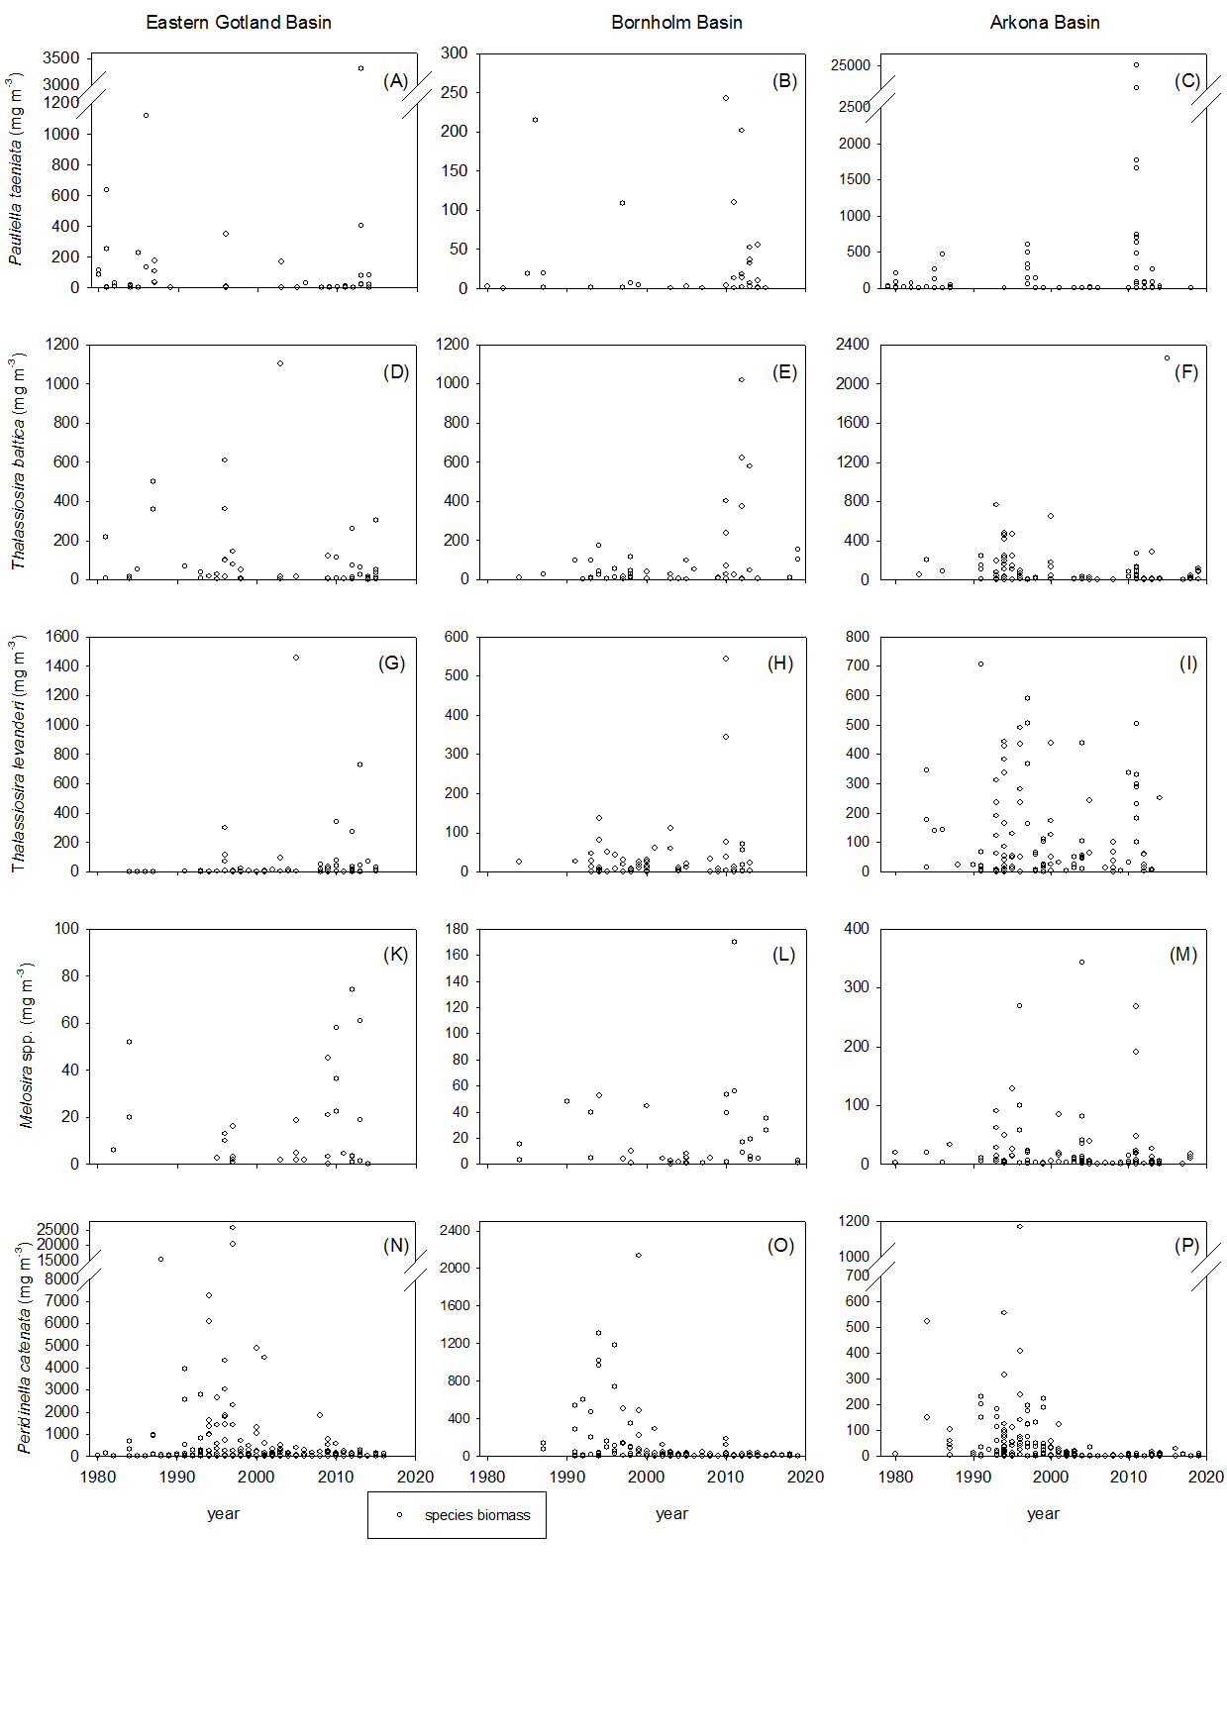

Supplementary Figure 2. Biomass (mg m⁻³) of the species a-b) Pauliella taeniata, c-d) Thalassiosira baltica, e-f) Thalassiosira levanderi, g-h) Melosira spp., i-k) Peridinella catenata in the Mecklenburg Bight: open sea area (left side) and the coastal stations (right side). Each circle represents the measured biomass from a single sample taken, separated for each species over the analyzed period.

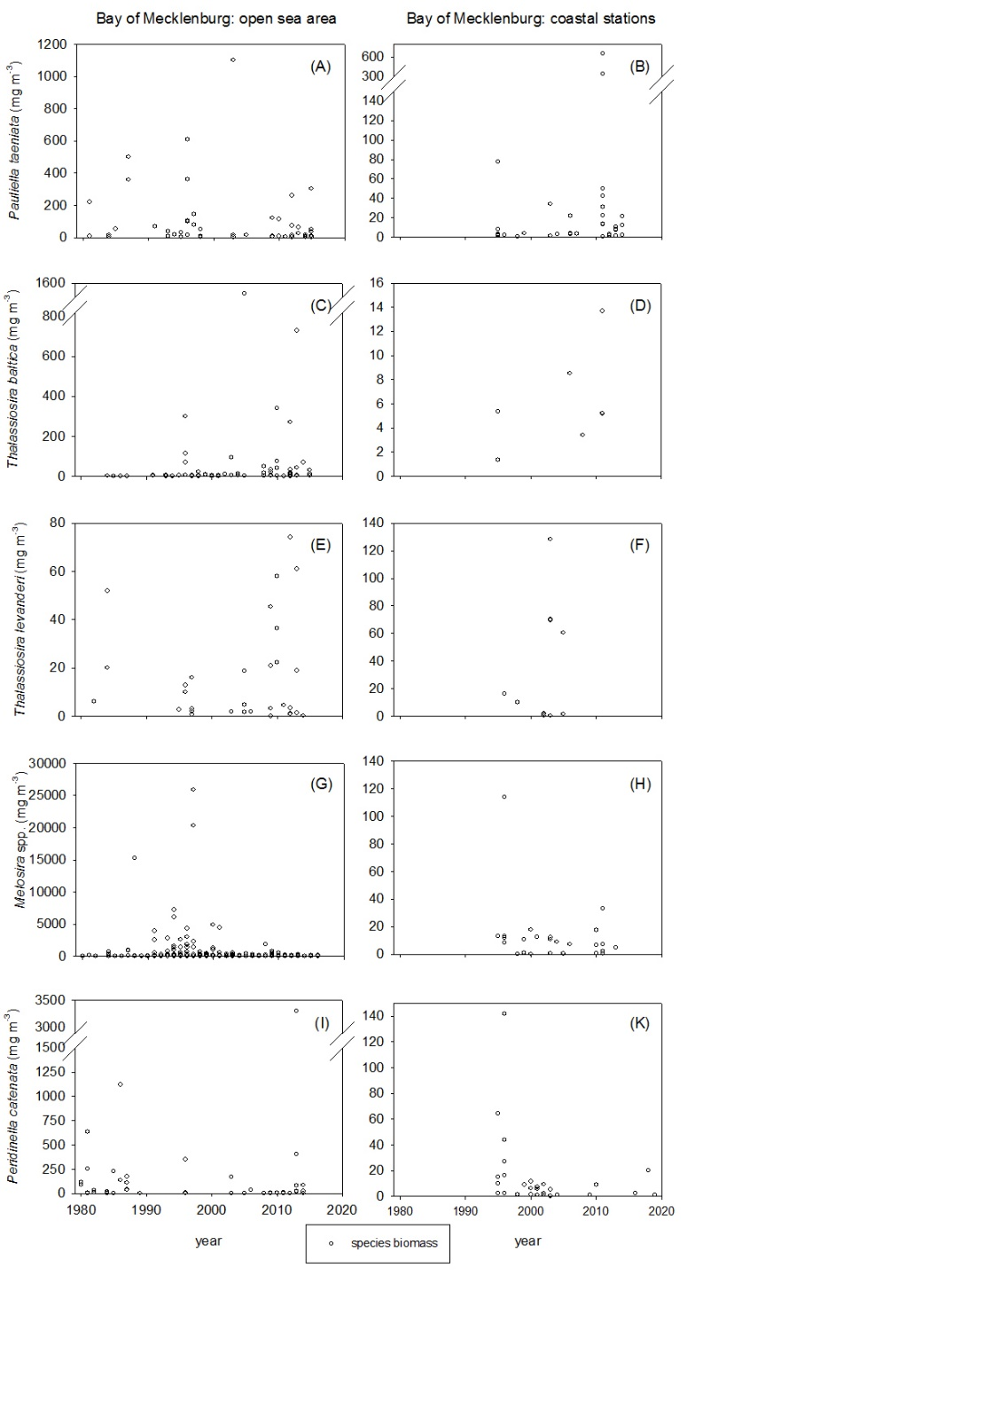

Supplemtary Figure 3. Maximum spring biomass (mg m⁻³) of the cold-water species P. taeniata, T. baltica, T. levanderi, Melosira spp. and P. catenata in dependence of the minimum spring temperature (°C): a) Eastern Gotland Basin, b) Bornholm Basin, c) Arkona Basin, d) Mecklenburg Bight: open sea area, e) Mecklenburg Bight: coastal stations. For symbol attribution see legend.
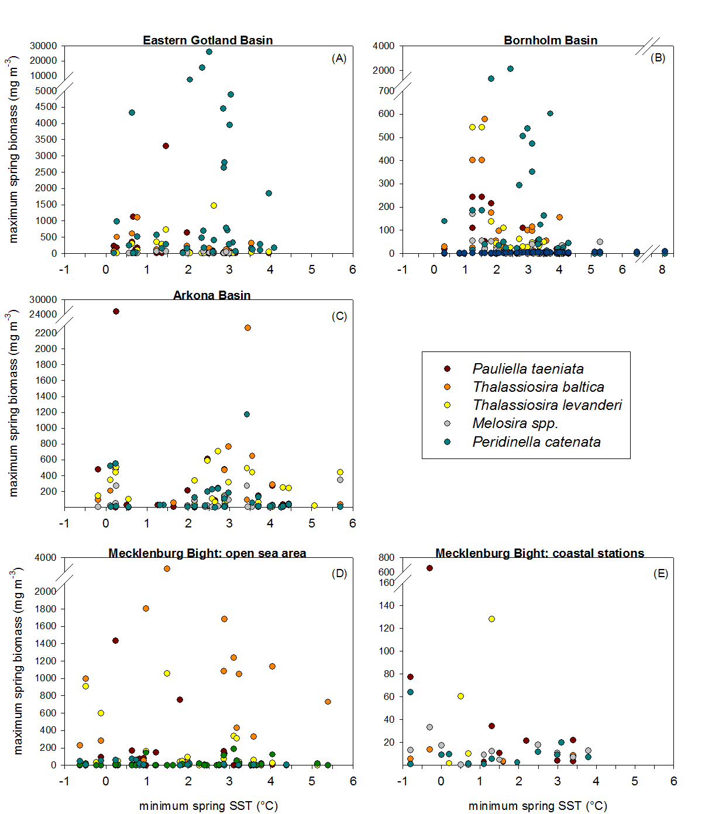

1.2 Supplementary Tables

Supplementary Table 1. Number of sampling events during spring for each sub-basin.
Sub-basin | Number of samplings events | Time period
Mecklenburg Bight: open sea area | 324 | 1980-2019
coastal stations  Arkona Basin  Bornholm Basin  Eastern Gotland Basin | 242  430  197  306 | 1995-2019  1979-2019  1979-2019  1980-2019

Supplementary Table 2. Non-significant statistical results of the lm-model, tested for the effects of minimum spring temperature on log (x+1)-transformed maximum species biomass, separated for each sub-basin.
response variable | abiotic factor | df | r square | f-value | adjusted  p-value
Eastern Gotland Basin
Thalassiosira baltica | min spring temperature | 35 | 0.00649759 | 0.22890286 | 0.7798574
Thalassiosira levanderi | min spring temperature | 35 | 0.00645026 | 0.22722482 | 0.703125
Melosira spp. | min spring temperature | 35 | 0.01917907 | 0.68439351 | 0.703125
Peridinella catenata | min spring temperature | 35 | 0.0501934 | 1.84960725 | 0.31490015
Bornholm Basin
Melosira spp. | min spring temperature | 38 | 0.05882433 | 2.3750344 | 0.16534867
Arkona Basin
Peridinella catenata | min spring temperature | 37 | 0.02894282 | 1.10280254 | 0.69444444
Mecklenburg Bight: open sea area
Thalassiosira baltica | min spring temperature | 35 | 0.00649759 | 0.22890286 | 0.90196078
 | mean sea ice volume sum | 35 | 0.00074216 | 0.02599503 | 0.96078431
Thalassiosira levanderi | min spring temperature | 35 | 0.00645026 | 0.22722482 | 0.87826797
 | mean sea ice volume sum | 35 | 0.0264689 | 0.95159919 | 0.62130178
Melosira spp. | min spring temperature | 35 | 0.01917907 | 0.68439351 | 0.45707472
 | mean sea ice volume sum | 35 | 0.0020947 | 0.07346824 | 0.90686275
Peridinella catenata | min spring temperature | 35 | 0.0501934 | 1.84960725 | 0.42402416
 | mean sea ice volume sum | 35 | 0.04938966 | 1.81845059 | 0.44719828
Mecklenburg Bight: coastal stations
Pauliella taeniata | min spring temperature | 22 | 0.12533793 | 3.15257129 | 0.16534867
 | mean sea ice volume sum | 22 | 0.00806956 | 0.17897456 | 0.74275362
Thalassiosira baltica | min spring temperature | 22 | 0.00830892 | 0.18432776 | 0.87826797
 | mean sea ice volume sum | 22 | 7.99E-07 | 1.76E-05 | 0.99999
Thalassiosira levanderi | min spring temperature | 22 | 0.09330312 | 2.26389727 | 0.27547317
 | mean sea ice volume sum | 22 | 0.09456387 | 2.29768281 | 0.13533392
Peridinella catenata | min spring temperature | 22 | 0.01285468 | 0.28648557 | 0.73696145

Supplementary Table 3. Additional results to the manuscript Table 3 of the ocean model analyses. Results represent conditions of Baltic Sea ice coverage (km²), winter minimum, mean SST (°C), and the number of days with an SST < 3°C, supporting or preventing bloom biomass build-up of P. taeniata, T. baltica, T.levanderi, Melosira spp., and P. catenata. Data analyses include the Eastern Gotland Basin, Bornholm Basin, Arkona Basin, and the open sea area of the Mecklenburg Bight.

response variable | abiotic factor | presence | absence | t-test (p-value) for differences in mean abiotic factor | correlation  (p-value)
Eastern Gotland
Thalassiosira baltica | ice coverage | 24203 + 7419 | 20138 + 5802 | 0.25 | +0.08 (0.65)
 | minimum SST | 1.3 + 0.5 | 1.9 + 0.6 | 0.06 | -0.25 (0.82)
Thalassiosira levanderi | ice coverage | 20201 + 5006 | 24839 + 8745 | 0.19 | +0.20 (0.38)
 | minimum SST | 1.7 + 0.4 | 1.6 + 0.7 | 0.7 | -0.27 (0.22)
 | mean SST | 2.1 + 0.3 | 2.6 + 0.7 | 0.52 | -0.23 (0.48)
 | days SST < 3°C | 77.1 + 17.3 | 72.5 + 27.7 | 0.69 | +0.15 (0.51)
Peridinella catenata | ice coverage | 22573 + 5103 | 19162 + 8307 | 0.56 | -0.14 (0.42)
 | minimum SST | 1.6 + 0.4 | 1.9 + 0.9 | 0.47 | +0.11 (0.55)
 | mean SST | 2.1 + 0.3 | 3.2 + 0.5 | 0.21 | -0.08 (0.65)
 | days SST <3°C | 76.6 + 16.3 | 61.5 + 15.2 | 0.42 | +0.15 (0.63)
Bornholm Basin
Pauliella taeniata | ice coverage | 26533 + 10356 | 20650 + 4817 | 0.12 | +0.30 (0.27)
 | minimum SST | 1.5 + 0.7 | 2.0 + 0.5 | 0.06 | -0.36 (0.19)
Thalassiosira baltica | ice coverage | 22973 + 6279 | 22698 + 8203 | 0.94 | +0.26 (0.23)
 | minimum SST | 1.8 + 0.5 | 2.0 + 0.8 | 0.08 | -0.32(0.14)
 | mean SST | 3.0 + 0.5 | 3.3 + 0.8 | 0.26 | -0.13 (0.55)
 | days SST <3°C | 64.0 + 17.5 | 43.1 + 28.5 | 0.07 | +0.05 (0.83)
Thalassiosira levanderi | ice coverage | 22352 + 6017 | 23361 + 8002 | 0.79 | +0.01 (0.91)
 | minimum SST | 1.9 + 0.5 | 1.8 + 0.7 | 0.13 | -0.13 (0.58)
 | mean SST | 3.0+ 0.5 | 3.2 + 0.8 | 0.57 | -0.18 (0.44)
 | days SST < 3°C | 60.6 + 18.5 | 49.0 + 25.8 | 0.32 | +0.24 (0.56)
Melosira spp. | ice coverage | 20901+ 6401 | 24625 + 7413 | 0.31 | +0.20 (0.41)
 | minimum SST | 2.2 + 0.6 | 1.6 + 0.6 | 0.88 | -0.21 (0.39)
 | mean SST | 3.3 + 0.6 | 3.0 + 0.7 | 0.29 | -0.21 (0.38)
 | days SST < 3°C | 48.7 + 22.4 | 60.3 + 22.4 | 0.33 | +0.12 (0.49)
Peridinella catenata | ice coverage | 21139 + 5213 | 28009 + 11834 | 0.10 | +0.00 (0.98)
 | minimum SST | 2.1 + 0.4 | 1.5 + 1.3 | 0.91 | -0.15 (0.43)
 | mean SST | 3.5 + 0.4 | 2.8 + 1.2 | 0.21 | -0.23 (0.21)
 | days SST <3°C | 46.6 + 16.7 | 64.4 + 41.2 | 0.15 | +0.20 (0.29)
Arkona Basin
Pauliella taeniata | minimum SST | 1.5 + 0.4 | 2.4 + 0.6 | 0.06 | -0.38 (0.09)
Thalassiosira baltica | ice coverage | 23512 + 5963 | 19921+ 7928 | 0.33 | -0.21 (0.31)
 | minimum SST | 1.8 + 0.5 | 2.3 + 0.8 | 0.08 | +0.22 (0.29)
 | mean SST | 3.0 + 0.5 | 3.6 + 0.8 | 0.07 | -0.12 (0.56)
Thalassiosira levanderi | ice coverage | 22906 + 5685 | 20684 + 9016 | 0.56 | +0.15 (0.47)
 | minimum SST | 2.0 + 0.5 | 1.9 + 0.9 | 0.16 | -0.38 (0.07)
 | mean SST | 3.1 + 0.5 | 3.3 + 0.8 | 0.64 | -0.41 (0.09)
 | days SST <3°C | 59.3 + 17.9 | 41.9 + 13.2 | 0.09 | +0.26 (0.19)
Melosira spp. | ice coverage | 22708 + 5761 | 21130 + 8792 | 0.68 | +0.09 (0.64)
 | minimum SST | 1.9 + 0.5 | 2.1 + 0.9 | 0.11 | -0.30 (0.13)
 | mean SST | 3.0 + 0.5 | 3.5 + 0.8 | 0.13 | -0.33 (0.09)
Peridinella catenata | ice coverage | 20291 + 4627 | 27826 + 12614 | 0.06 | +0.08 (0.69)
 | minimum SST | 2.2 + 0.5 | 1.4 + 1.1 | 0.66 | -0.11 (0.57)
 | mean SST | 3.3 + 0.5 | 2.7 + 1.0 | 0.11 | -0.24 (0.21)
Mecklenburg Bight: open sea area
Thalassiosira baltica | ice coverage | 283 + 176 | 266 + 166 | 0.8 | -0.1 (0.66)
 | minimum SST | 1.0 + 0.4 | 1.1 + 0.5 | 0.23 | -0.03 (0.92)
 | mean SST | 3.0 + 0.5 | 3.3 + 0.7 | 0.4 | -0.17 (0.48)
 | days SST < 3°C | 69.0 + 14.4 | 61.1 + 18.3 | 0.4 | +0.10 (0.67)
Thalassiosira levanderi | ice coverage | 283 + 176 | 266 + 66 | 0.6 | +0.05 (0.83)
 | minimum SST | 1.0 + 0.4 | 1.1 + 0.5 | 0.11 | -0.04 (0.88)
 | mean SST | 3.0 + 0.5 | 3.3 + 0.7 | 0.5 | -0.48 (0.09)
 | days SST <3°C | 74.2 + 12.8 | 61.2 + 11.1 | 0.24 | +0.57 (0.01)
Melosira spp. | mean SST | 2.4 + 0.5 | 3.4 + 0.7 | 0.06 | -0.32 (0.17)
Peridinella catenata | ice coverage | 260 + 185 | 286 + 159 | 0.8 | -0.14 (0.57)
 | mean SST | 2.2 + 0.6 | 3.1 + 0.7 | 0.12 | -0.05 (0.85)
 | days SST <3°C | 65.0 + 16.4 | 65.1 + 16.7 | 0.95 | -0.06 (0.81)

Supplementary Table 4. Additional results to Table 4 in the manuscript. Current flow speed, Salinity and mixing depth in the Eastern Gotland Basin, Bornholm Basin, Arkona Basin, and adjacent areas like the Gulf of Riga and the Gulf of Finland, showing differences during bloom and no-bloom situations.
GoF mean flow: mean current speed out of the Gulf of Finland in upper 20m
GoR mean flow: mean current speed out in the Gulf of Riga in upper 10m
eGo mean flow: mean current speed in the Eastern Gotland Basin in upper 20m
eGo mean circ: mean difference in current flow speed in the Eastern Gotland Basin
GoF mld: depth in the Gulf of Finland with a density difference > 0.5 kg m⁻³ (mixing depth)
eGo mld: depth in the Eastern Gotland Basin with a density difference > 0.5 kg m⁻³ (mixing depth)
GoR mld: depth in the Gulf of Riga with a density difference > 0.5 kg m⁻³ (mixing depth)
BB mean flow: mean current flow speed directed towards the Arkona Basin in the upper 20m
BB mean circ: mean difference in current flow speed in the Bornholm Basin
BB mean salinity: mean surface salinity in the Bornholm Basin (g/kg)
BB mld: depth in the Bornholm Basin with a density difference > 0.5 kg m⁻³ (mixing depth)
AB mean flow: mean current flow speed directed towards the Arkona Basin in upper 20m
AB circ: mean difference in current flow speed in the Arkona Basin (north to south)
AB mean salinity: mean surface salinity in the Arkona Basin (g/kg)
AB mld: depth in the Arkona Basin with a density difference > 0.5 kg m⁻³ (mixing depth)

response variable | abiotic factor | presence | absence | t-test (p-value) for differences in mean abiotic factor | correlation (p-value)
Eastern Gotland Basin
Pauliella taeniata | GoR mean flow | +0.5 + 0.6 | -0.8 + 0.5 | 0.17 | +0.13 (0.62)
 | eGo mean flow | +1.5 + 0.6 | +1.7 + 0.5 | 0.88 | +0.08 (0.78)
 | eGo mean circ | +2.1 + 0.6 | +2.9 + 0.3 | 0.17 | +0.10 (0.72)
Thalassiosira baltica | GoR mean flow | -0.2 + 0.7 | -0.3 + 0.7 | 0.73 | +0.03(0.91)
 | GoF mean flow | +0.6 + 0.5 | +1.5 + 0.5 | 0.43 | -0.38 (0.10)
 | eGo mean circ | +2.3 + 0.4 | +2.7 + 0.5 | 0.53 | -0.16 (0.55)
 | GoF mean mld | +49.8 + 11.5 | +52.0 + 7.4 | 0.66 | -0.22 (0.36)
 | eGo mean mld | +48.7 + 3.1 | +52.5 + 2.4 | 0.94 | -0.07 (0.36)
 | GoR mld | +17.3 + 1.3 | +19.3 + 1.1 | 0.29 | -0.13 (0.58)
Thalassiosira levanderi | GoF mean mld | +52.1 + 10.1 | +49.2 + 9.0 | 0.58 | -0.24 (0.28)
 | eGo mean mld | +49.6 + 2.6 | +51.2 + 2.9 | 0.15 | -0.74 (0.09)
 | GoR mld | +17.9 + 0.9 | +18.5 + 1.7 | 0.28 | -0.57 (0.0.4)
Melosira spp. | eGo mean flow | +1.3 + 0.7 | +1.7 + 0.4 | 0.41 | +0.42 (0.16)
 | eGo mean circ | +2.1 + 0.6 | +2.9 + 0.4 | 0.28 | +0.40 (0.18)
 | GoF mean mld | +46.2 + 15.4 | +53.2 + 6.9 | 0.19 | +0.04 (0.89)
 | eGo mean mld | +47.8 + 3.7 | +54.9 + 2.4 | 0.34 | -0.05 (0.88)
 | GoR mld | +16.2 + 2.0 | +19.7 + 0.6 | 0.06 | +0.30 (0.32)
Peridinella catenata | GoF mean flow | +0.3 + 0.7 | +0.0 + 1.5 | 0.76 | -0.25 (0.15)
 | GoR mean flow | -0.3 + 0.5 | -0.2 + 0.3 | 0.86 | -0.21 (0.23)
 | eGo mean flow | +1.5 + 0.4 | +1.1 + 1.3 | 0.24 | -0.10 (0.58)
 | eGo mean circ | +2.3 + 0.3 | +2.5 + 1.2 | 0.44 | -0.20 (0.25)
 | GoF mean mld | +50.2 + 7.2 | +56.2 + 25.4 | 0.48 | +0.12 (0.48)
 | eGo mean mld | +48.9 + 2.0 | +50.8 + 7.2 | 0.46 | +0.33 (0.07)
 | GoR mld | +17.5 + 0.9 | +20.0 + 0.0 | 0.29 | +0.24 (0.16)
Bornholm Basin
Pauliella taeniata | BB mean flow | +0.1 + 0.9 | +0.9 + 0.6 | 0.45 | -0.43 (0.11)
 | BB mean salinity | +7.1 + 0.3 | +7.1 + 0.2 | 0.95 | +0.48 (0.18)
 | BB mean mld | +39.7 + 1.8 | +39.5 + 1.5 | 0.77 | +0.05 (0.85)
Thalassiosira baltica | BB mean flow | +0.3+0.7 | +0.8+0.8 | 0.18 | -0.38 (0.08)
 | BB mean salinity | +7.1 + 0.2 | +7.2 + 0.2 | 0.12 | +0.24 (0.36)
 | BB mean mld | +39.7 + 1.4 | +39.5 + 1.8 | 0.83 | +0.05 (0.82)
Thalassiosra levanderi | BB mean flow | +0.4 + 0.8 | +06 + 0.7 | 0.07 | +0.22 (0.35)
 | BB mean circ | +2.1 + 0.4 | +2.1 + 0.5 | 0.74 | +0.54 (0.01)
 | BB mean salinity | +7.1 + 0.2 | +7.2 + 0.4 | 0.09 | 0.01 (0.96)
 | BB mean mld | +39.4 + 1.4 | +39.8 + 1.8 | 0.68 | 0.06 (0.81)
Melosira spp. | BB mean circ | +2.0 + 0.5 | +2.2 + 0.4 | 0.62 | +0.20 (0.41)
 | BB mean salinity | +7.1 + 0.2 | +7.2 + 0.3 | 0.11 | -0.24 (0.21)
Peridinella catenata | BB mean flow | +0.5 + 0.6 | +0.6 + 1.4 | 0.28 | +0.04 (0.83)
Arkona Basin
Pauliella taeniata | AB mean circ | +1.9 + 0.3 | +2.0 + 0.3 | 0.36 | +0.06 (0.79)
 | AB mean salinity | +7.8 + 0.4 | +7.9 + 0.3 | 0.66 | -0.05 (0.83)
 | AB mean mld | +21.1 + 1.6 | +21.2 + 1.5 | 0.99 | +0.24 (0.30)
Thalassiosira baltica | AB mean circ | +1.9 +0.2 | +2.0 +0.4 | 0.38 | +0.07 (0.75)
 | AB mean flow | +1.8 + 0.4 | +0.8 + 0.8 | 0.07 | -0.11 (0.32)
 | AB mean mld | +20.7 + 1.4 | +21.9 + 1.4 | 0.14 | -0.09 (0.75)
Thalassiosira levanderi | AB mean flow | +1.1 + 0.5 | +1.3 + 0.6 | 0.32 | +0.14 (0.48)
 | AB mean salinity | +7.5 + 0.3 | +8.1 + 0.4 | 0.06 | -0.27 (0.37)
 | AB mean circ | +1.9 + 0.2 | +2.1 + 0.5 | 0.24 | -0.12 (0.48)
 | AB mean mld | +21.3 + 1.2 | +20.9 + 2.4 | 0.69 | -0.06 (0.77)
Melosira spp. | AB mean flow | +1.3 + 0.4 | +1.0 + 0.8 | 0.14 | +0.25 (0.13)
 | AB mean salinity | +7.7 + 0.3 | +8.0 + 0.5 | 0.18 | -0.27 (0.17)
 | AB mean circ | +1.9 + 0.2 | +2.2 + 0.4 | 0.08 | -0.01 (0.88)
 | AB mean mld | +21.3 + 1.3 | +20.9 + 2.0 | 0.69 | -0.16 (0.41)
Peridinella catenata | AB mean flow | +1.1 + 0.5 | +1.4 + 0.8 | 0.24 | +0.30 (0.23)
 | AB mean salinity | +7.5 + 0.3 | +8.1 + 0.5 | 0.11 | -0.16 (0.49)
 | AB mean mld | +18.4 + 1.1 | +21.4 + 2.8 | 0.39 | -0.16 (0.41)

Supplementary Table 5. Results of the pooled ocean model analysis including all Central Baltic Sea areas (Eastern Gotland Basin, Bornholm Basin, Arkona Basin). Bold face indicates p-value <0.05 of the t-test for differences in mean abiotic factor.

species | abiotic factor | presence | absence
Peridinella catenata | ice coverage | 5764 + 1464 | 3520 + 1342
 | minimum SST | 1.6 + 0.5 | 1.9 + 0.5
 | days (SST<3°C) | 64.2 + 6.4 | 63.0 + 62
Pauliella taeniata | ice coverage | 6249 + 1869 | 4325 + 1530
 | minimum SST | 1.3 + 0.5 | 2.4 + 0.5
 | days (SST<3°C) | 66.8 + 7.4 | 57.5 + 11.4
Thalassiosira baltica | ice coverage | 5701 + 1762 | 5543 + 2725
 | minimum SST | 1.5 + 0.5 | 2.0 + 1.0
 | days (SST<3°C) | 63.1 + 7.4 | 67.4 + 13.6
Thalassiosira levanderi | ice coverage | 5771 + 1796 | 5543 + 2725
 | minimum SST | 1.6 + 0.5 | 1.7 + 1.0
 | days (SST<3°C) | 63.6 + 7.7 | 65.8 + 12.1
Melosira spp. | ice coverage | 5880 + 1607 | 4750 + 4012
 | minimum SST | 1.5 + 0.5 | 2.2 + 1.2
 | days (SST<3°C) | 64.0 + 7.0 | 65.3 + 18.0

