SUPPLEMENTARY MATERIAL
Table S1. ANOVA results after experiments at different temperatures (2°C and 8°C) and time (3 and 5-day) over the total carbon content in Monostroma hariotii, Adenocystis utricularis and Pyropia endiviifolia p < 0.05**
 |  |  | Total Carbon
 |  | df | MS | F | P
M. hariotii | Time (T) | 1 | 3589.4 | 12.669 | **
 | temperature (t) | 1 | 1750.2 | 6.177 | **
 | T*t | 1 | 7.0 | 0.025
 | Res | 8 | 283.3
A. utricularis | Time (T) | 1 | 94 | 0.391
 | temperature (t) | 1 | 11160 | 46.339 | **
 | T*t | 1 | 166 | 0.689
 | Res | 8 | 241
P. endiviifolia | Time (T) | 1 | 115 | 2.31
 | temperature (t) | 1 | 100 | 2.01
 | T*t | 1 | 222 | 4.45
 | Res | 8 | 50
Res: Residual

Table S2. ANOVA results after experiments at different temperatures (2°C and 8°C) and time (3 and 5-day) over the total nitrogen content in Monostroma hariotii, Adenocystis utricularis and Pyropia endiviifolia p < 0.05**

 |  |  | Total Nitrogen
 |  | df | MS | F | P
M. hariotii | Time (T) | 1 | 55.10 | 29.831 | **
 | temperature (t) | 1 | 70.65 | 38.255 | **
 | T*t | 1 | 27.68 | 14.987 | **
 | Res | 8 | 1.85
A. utricularis | Time (T) | 1 | 0.209 | 0.159
 | temperature (t) | 1 | 285.929 | 217.478 | **
 | T*t | 1 | 5.088 | 3.870
 | Res | 8 | 1.315
P. endiviifolia | Time (T) | 1 | 34.80 | 5.343 | **
 | temperature (t) | 1 | 44.33 | 6.805 | **
 | T*t | 1 | 64.64 | 9.923 | **
 | Res | 8 | 6.51
Res: Residual
Table S3. ANOVA results after experiments at different temperatures (2°C and 8°C) and time (3 and 5-day) over the ratio C:N in Monostroma hariotii, Adenocystis utricularis and Pyropia endiviifolia p < 0.05**
 |  |  | Ratio C:N
 |  | df | MS | F | P
M. hariotii | Time (T) | 1 | 0.168 | 0.524
 | temperature (t) | 1 | 13.235 | 41.193 | **
 | T*t | 1 | 2.533 | 7.884 | **
 | Res | 8 | 0.321
A. utricularis | Time (T) | 1 | 0.107 | 0.177
 | temperature (t) | 1 | 9.399 | 15.456 | **
 | T*t | 1 | 0.232 | 0.381
 | Res | 8 | 0.608
P. endiviifolia | Time (T) | 1 | 0.428 | 1.940
 | temperature (t) | 1 | 0.621 | 2.814
 | T*t | 1 | 0.837 | 3.795
 | Res | 8 | 0.221
Res: Residual

Table S4. ANOVA results after experiments at different temperatures (2°C and 8°C) and time (3 and 5-day) over the chlorophyll a content in Monostroma hariotii, Adenocystis utricularis and Pyropia endiviifolia p < 0.05**

 |  |  | Chlorophyll a
 |  | df | MS | F | P
M. hariotii | Time (T) | 1 | 173.27 | 14.719 | **
 | temperature (t) | 1 | 2.51 | 0.213
 | T*t | 1 | 138.01 | 11.723 | **
 | Res | 8 | 11.77
A. utricularis | Time (T) | 1 | 83.52 | 4.253
 | temperature (t) | 1 | 397.62 | 20.247 | **
 | T*t | 1 | 3.50 | 0.178
 | Res | 8 | 19.64
P. endiviifolia | Time (T) | 1 | 15.353 | 9.3868 | **
 | temperature (t) | 1 | 128.832 | 78.7700 | **
 | T*t | 1 | 6.247 | 3.8194
 | Res | 8 | 1.636
Res: Residual
Table S5. ANOVA results after experiments at different temperatures (2°C and 8°C) and time (3 and 5-day) over the phenolic compounds in Monostroma hariotii, Adenocystis utricularis and Pyropia endiviifolia p < 0.05**

 |  |  | Phenolic compounds
 |  | df | MS | F | P
M. hariotii | Time (T) | 1 | 0.8469 | 2.461
 | temperature (t) | 1 | 0.0021 | 0.006
 | T*t | 1 | 1.9514 | 5.67 | **
 | Res | 8 | 0.3442
A. utricularis | Time (T) | 1 | 98.215 | 54.127 | **
 | temperature (t) | 1 | 433.345 | 238.821 | **
 | T*t | 1 | 175.922 | 96.953 | **
 | Res | 8 | 1.815
P. endiviifolia | Time (T) | 1 | 0.121 | 0.678
 | temperature (t) | 1 | 3.445 | 19.233 | **
 | T*t | 1 | 0.220 | 1.226
 | Res | 8 | 0.179
Res: Residual
Table S6. ANOVA results after experiments at different temperatures (2°C and 8°C) and time (3 and 5-day) over the DPPH in Monostroma hariotii, Adenocystis utricularis and Pyropia endiviifolia p < 0.05**

 |  |  | DPPH
 |  | df | MS | F | P
M. hariotii | Time (T) | 1 | 16.8482 | 22.0221 | **
 | temperature (t) | 1 | 5.7271 | 7.4858 | **
 | T*t | 1 | 9.8756 | 12.9083 | **
 | Res | 8 | 0.7651
A. utricularis | Time (T) | 1 | 0.0298 | 0.097
 | temperature (t) | 1 | 0.0641 | 0.209
 | T*t | 1 | 0.4069 | 1.325
 | Res | 8 | 0.3071
P. endiviifolia | Time (T) | 1 | 1.3189 | 1.9856
 | temperature (t) | 1 | 0.4725 | 0.7112
 | T*t | 1 | 0.0003 | 0.0005
 | Res | 8 | 0.6643
Res: Residual

Figure S1. Spectral sweep from 250 to 500 nm to detect single phenolic compounds in A) Monostroma hariotii, B) Adenocystis utricularis and C) Pyropia endiviifolia, exposed to 2 °C and 8 °C, at days 3 and 5 of experiments.

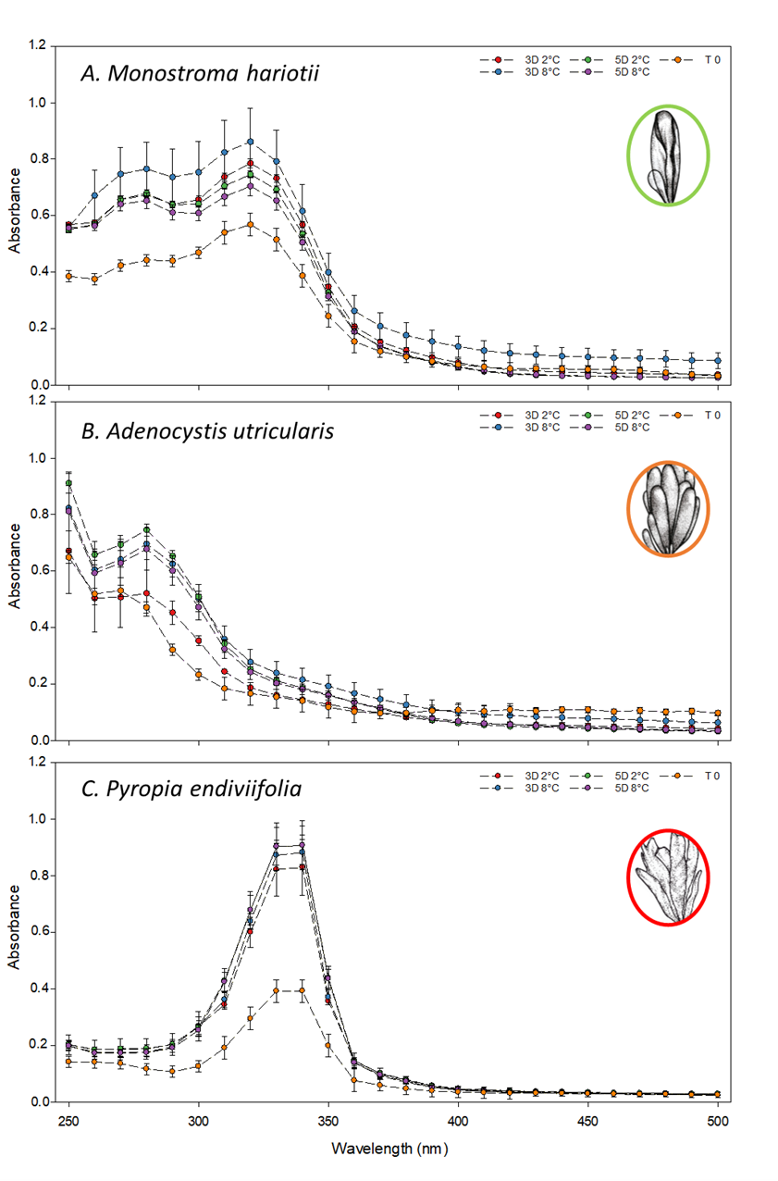

Figure S2. The UV visible spectrum of phenolic compounds standards, A) p-coumaric acid, B) Rutin, C) 3, 4 – Dihydroxy benzaldehyde, D) 4 - Hydroxybenzoic acid, E) Esculetin, F) Trans - Cinnamic acid, G) Protocatechuic acid and H) Phloroglucinol.

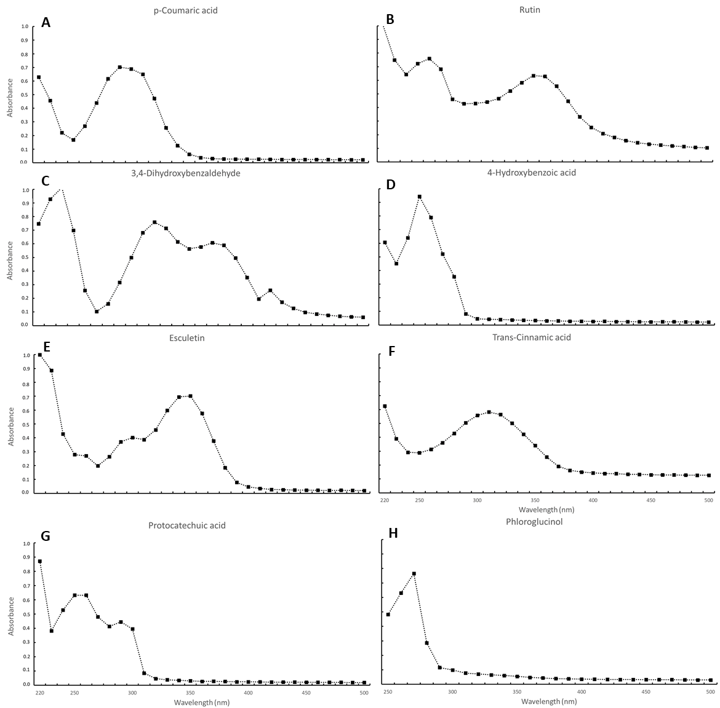

Table S7. ANOVA results after experiments at different temperatures (2°C and 8°C) and time (3 and 5-day) over the Total MAAs in Pyropia endiviifolia p < 0.05**

 |  |  | Total MAAs
 |  | df | MS | F | P
P. endiviifolia | Time (T) | 1 | 0.7586 | 22.078 | **
 | temperature (t) | 1 | 1.5197 | 44.224 | **
 | T*t | 1 | 0.0737 | 2.146
 | Res | 8 | 0.0344
Res: Residual

