Geometric morphometrics analysis
Proterosuchidae is included in the analysis. As the rostrum shape of Hescheleria ruebeli and Nectosaurus halius is too bizarre and nearly vertically downturned, we chose Proterorsuchidae for comparison. Proterosuchidae also bear vertically downturned rostrum. Ezcurra (2017) regarded this feature as a possible social or sexual selection. Thus, we included Proterosuchidae in order to found if the strongly downturned rostrum in Thalattosauria could function in the same way. As we focus on the shape of the rostrum rather than the homegenetic relationship of the same bones, 17 semi-landmarks were selected as shown in Figure S1.
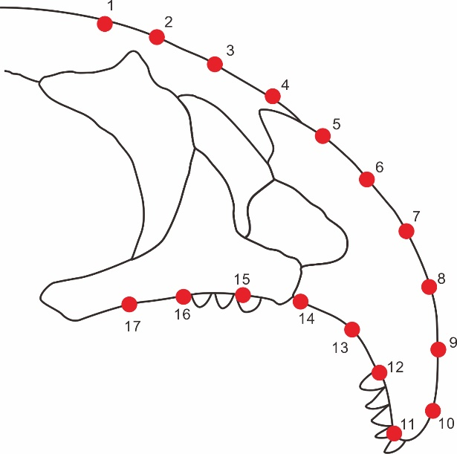
Figure S1 Semi-landmarks selection on the rostrum

Discussion of the synapomorphy of Askeptosauroidea
Wayaosaurus bellus should be classified as a member of the Askeptosauroidea. There is no detailed definition of the synapomorphy of Askeptosauroidea in previous study. Nicholls (1999) defined Thalattosauria are members of all Thalattosauriformes except Askeptosaurus italicus and Endennasaurus acutirostris. Askeptosaurus Italicus and Endennasaurus acutirostris were not yet a clade. However, as Thalattosauriformes are classified as Askeptosauroidea and Thalattosauroidea, and the none-Thalattosauroidea members are classified as Askeptosauroidea, those characters that are not seen in Thalattosauroidea could be regarded as the synapomorphy of Askeptosauroidea. Based on this inference, the synapomorphy of Askeptosauroidea should include: 1) the supratemporal foramen narraw, but not completely become a slit; 2) parietal flange present; 3) the supratemporal does not extend forward and contact the frontal; 4) the anterior tip of the premaxilla is not curved; 5) the symphysis of dentary is not bent; 6) no diastema between premaxilla and maxilla. In addition, combined with the character matrix defined by Druckenmiller et al. (2020) and supported by the node-based definition obtained from the phylogeny, the synapomorphy of Askeptosauroidea should also include: 7) no vomer teeth; 8) no pterygoid teeth; 9) more than 11 cervical vertebrae; 10) the height of the posterior cervical neural spine is less than or nearly equal to its anteroposterior length; 11) the height of dorsal neural spine is close to or slightly higher than the height of the centrum.

Table S1 The comparison of the measurements of Askeptosauroidea found in southwest China
 | Miodentosaurus brevis |  | Anshunsaurus huangguoshuensis |  | Anshunsaurus wushaensis
 | NMNS-004727  /F003960 | ZMHN M8742 | IVPP  V 11834 | IVPP  V 11835 | IVPP  V 13872
Rostrum length | 15.90 | 12.43 | 22.59 | 24.13 | 9.40
Skull length | 37.87 | 31.98 | 37.59 | 42.40 | 17.86
Rostrum length/ Skull length | 0.4 | 0.4 | 0.6 | 0.6 | 0.5
Glenoid-acetabulum length | 107.39 | 90.95 | 66.56 | 71.91 | 56.98
Skull length / glenoid-acetabulum length | 0.4 | 0.4 | 0.6 | 0.6 | 0.3
Post-orbit length | / | / | / | 10.83 | 6.34
Post-orbit length / Skull length | / | / | / | 0.3 | 0.4
Anterior most one-third height of the lower jaw | 4.80 | 1.88 | 1.46 | 2.03 | 1.31
Medium one third height of the lower jaw | 4.61 | 1.67 | 1.98 | 2.31 | 1.95
Posterior one third height of the lower jaw | 5.72 | 3.19 | 2.92 | 3.12 | 1.81
Average height of the lower jaw | 5.04 | 2.25 | 2.12 | 2.49 | 1.69
Lower jaw length | 33.80 | 34.73 | 35.85 | 40.96 | 19.58
Average height/length of the lower jaw | 0.15 | 0.06 | 0.06 | 0.06 | 0.09
Posterior shaft length of interclavicle | 22.66 | 10.02 | 13.09 | 18.52 | 12.02
Transverse process length of the interclavicle | 10.01 | 5.70 | 8.34 | 12.32 | 6.75
Transverse process length / posterior shaft length of the interclavicle | 2 | 2 | 2 | 2 | 2
Bend degree at the base of iliac dorsal process (°) | 118 | 125 | 117 | 121 | /
Width of the iliac dorsal process shaft | 1.81 | 3.69 | 1.92 | 4.11 | /
Width of base of the ilium | 5.90 | 7.61 | 3.66 | 8.66 | /
Width of base / width of the dorsal process shaft of ilium | 3 | 2 | 2 | 2 | /
Humerus length | 17.41 | 18.69 | 11.62 | 13.07 | 11.79
Shaft length of humerus | 4.66 | 2.39 | 3.07 | 1.28 | 2.04
Width of the distal end of the humerus | 6.33 | 8.90 | 5.64 | 6.11 | 3.46
Expansion of the distal end of the humerus | 1.91 | 1.91 | 2.36 | 1.99 | 2.70
Femur length | 21.82 | 19.84 | 12.24 | / | 12.16
Humerus length/Femur length | 0.80 | 0.94 | 0.95 | / | 0.97
Width of the distal end of the fibula | 3.92 | 6.57 | 4.75 | / | 2.99
Width of the shaft of the fibula | 2.31 | 2.20 | 1.61 | / | 0.95
Expansion of the distal end of the fibula | 2 | 3 | 3 | / | 3

Reference
Nicholls EL. 1999. A reexamination of Thalattosaurus and Nectosaurus and the relationships of the Thalattosauria (Reptilia: Diapsida). PaleoBios. 19: 1-29.
Ezcurra M D. 2017. Can social and sexual selection explain the bizarre Rostrum of proterosuchid archosauriforms? Historical Biology, 29:3, 348-358, DOI:10.1080/08912963.2016.1161033
Druckenmiller PS, Kelley NP, Metz ET, Baichtal J. 2020. An articulated Late Triassic (Norian) thalattosauroid from Alaska and ecomorphology and extinction of Thalattosauria. Scientific Report, 10:1746, DOI: 10.1038/s41598-020-57939-2

