Additional Figures for “A colonial-nesting seabird shows limited heart rate responses to natural variation in threats of polar bears”
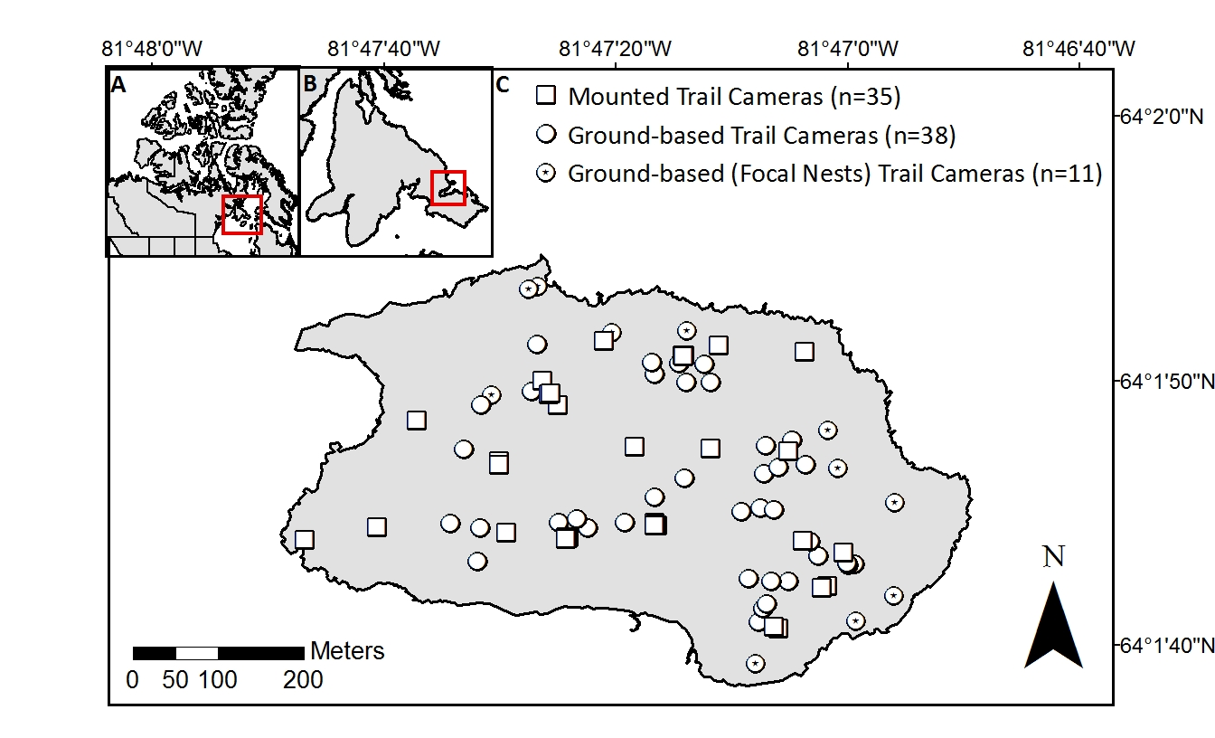Figure S1. Map of the study area, displaying our A) general location (Northern Hudson Bay, Nunavut, Canada), B) regional location (Southampton Island, Nunavut, Canada), and C) study site (East Bay Island, Nunavut, Canada) with the distribution of trail cameras.
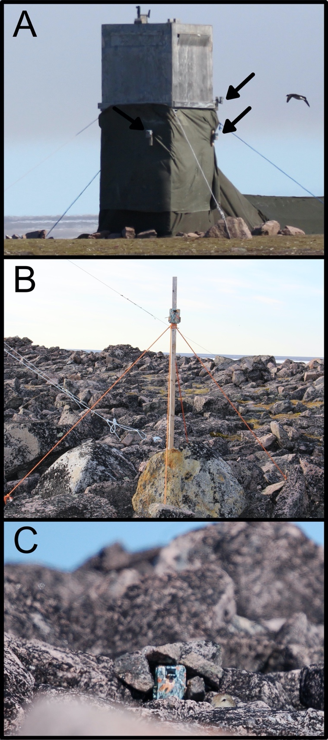
Figure S2. Photographs of trail cameras (Browning Inc. model BTC-5HDPX) on East Bay Island, Nunavut, Canada: A) mounted on a bird observation blind (arrows point to cameras), B) mounted on a wooden post (photo credit to Erica Geldart), and C) on the ground, next to an active common eider (Somateria mollissima) nest (photo credit to Russell Turner).
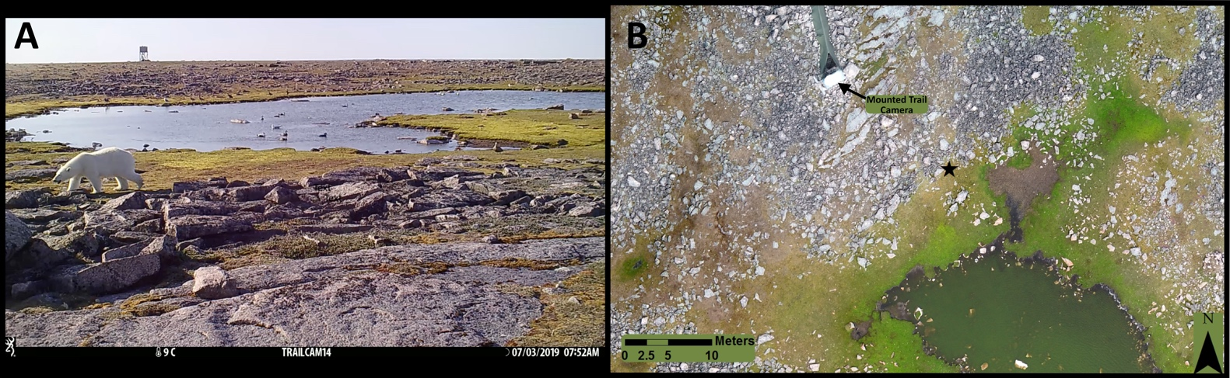
Figure S3. A) Photo of trail camera (Browning Inc. model BTC-5HDPX) footage showing a polar bear (Ursus maritimus) on East Bay Island, Nunavut, Canada, and B) location of polar bear (black star) plotted on orthomosaic map of East Bay Island at 7:52AM on July 3 2019

