Supplementary Materials
The mitochondrial genome of the endemic and endangered ‘trumpet nosed’ bat Musonycteris harrisoni (Chiroptera: Phyllostomidae)
S. Basaldúa-González^{1,+}, Milena A. Rodriguez-Pilco^{2,+}, Y. T. Gutiérrez-Guerrero³, J. Ortega⁴, J. A. Baeza^{5,6,7,*}
¹Laboratorio de Bioconservación y Manejo, Posgrado en Ciencias Quimicobiológicas, Departamento de Zoología, Escuela Nacional de Ciencias Biológicas, Instituto Politécnico Nacional. 11340 Mexico City, Mexico. sonia.basaldua55@gmail.com
²Facultad de Ciencias Biológicas, Universidad Nacional de San Agustin, Av. Daniel Alcides Carrion s/n, Arequipa 04001, Peru. milealee101@gmail.com
³Museum of Vertebrate Zoology, Departamento de Biologia Integrativa, University of California Berkeley, Berkeley, CA, US. ygutierrezgro@berkeley.edu
⁴Laboratorio de Bioconservación y Manejo, Posgrado en Ciencias Quimicobiológicas, Departamento de Zoología, Escuela Nacional de Ciencias Biológicas, Instituto Politécnico Nacional. 11340 Mexico City, Mexico. artibeus2@aol.com
⁵Department of Biological Sciences, Clemson University, 132 Long Hall, Clemson, SC 29634, USA. baeza.antonio@gmail.com
⁶Smithsonian Marine Station at Fort Pierce, 701 Seaway Drive, Fort Pierce, FL 34949, USA. baeza.antonio@gmail.com
⁷Departamento de Biología Marina, Facultad de Ciencias del Mar, Universidad Católica del Norte, Larrondo, Coquimbo 1281, Chile. baeza.antonio@gmail.com

* corresponding author, + equal authorship
Supplementary Materials
Table S1: Microsatellites present in the control region (CR) of Musonycteris harrisoni.
Position | Cicle | Repeats | Sequence
0 | 2 | 3 | ACACAC
7 | 2 | 3 | CACACA
28 | 2 | 3 | CACACA
135 | 2 | 3 | ATATAT
509 | 2 | 3 | TTTTTT
602 | 2 | 3 | CCCCCC
762 | 2 | 3 | ACACAC
774 | 2 | 3 | ACACAC
786 | 2 | 3 | ACACAC
796 | 2 | 4 | ACACACAC
808 | 2 | 3 | ACACAC
818 | 2 | 3 | ACACAC
828 | 2 | 4 | ACACACAC
840 | 2 | 4 | ACACACAC
852 | 2 | 4 | ACACACAC
864 | 2 | 3 | ACACAC
874 | 2 | 3 | ACACAC
884 | 2 | 3 | ACACAC
894 | 2 | 3 | ACACAC
924 | 4 | 3 | ACGCACGCACGC
972 | 2 | 3 | CCCCCC
980 | 2 | 3 | CCCCCC

Table S2. Tandem repeats finder results for the control region of the mitochondrial genome of Musonycteris harrisoni.
Consensus pattern (10 bp): GTATACACAC
Consensus pattern (21 bp): GTATACACACACGTATAACAC

Figure S1a. Secondary Structure for the control region of the mitochondrial genome of Musonycteris harrisoni.
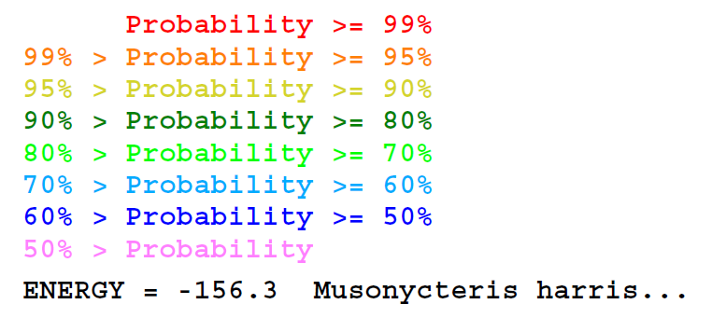
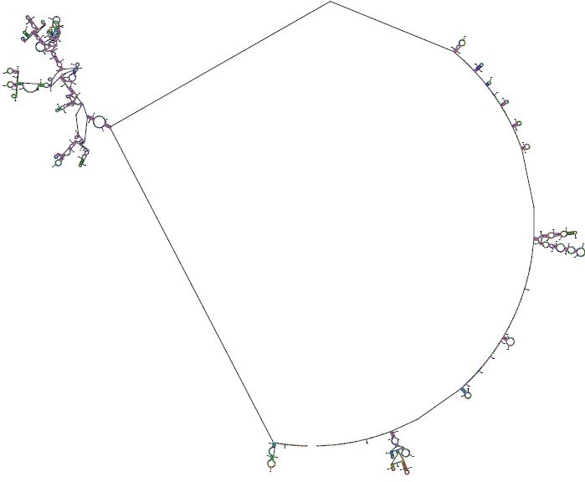
Figure S1b. Secondary Structure for the control region of the mitochondrial genome of Musonycteris harrisoni.

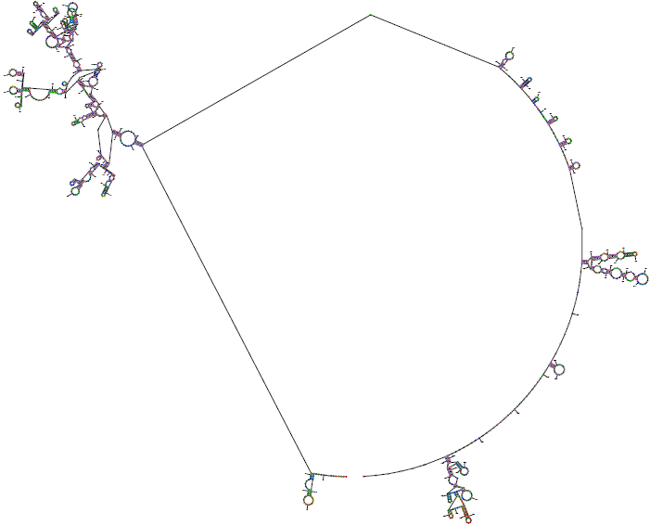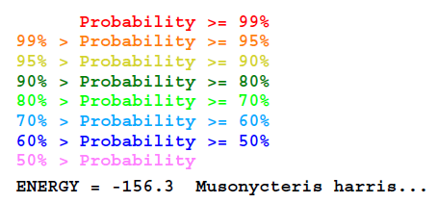
Figure S1c. Secondary Structure for the control region of the mitochondrial genome of Musonycteris harrisoni.

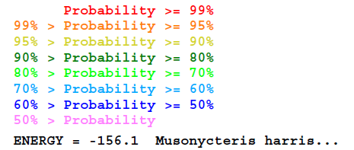
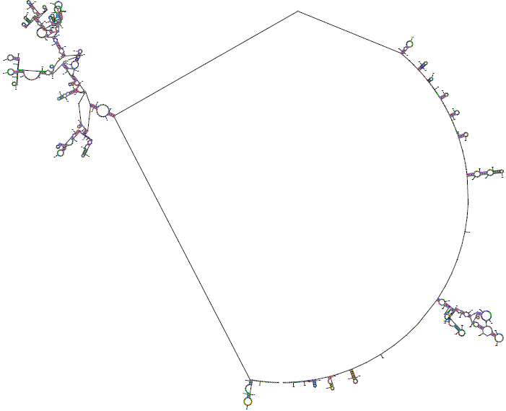
Figure S1d. Secondary Structure for the control region of the mitochondrial genome of Musonycteris harrisoni.

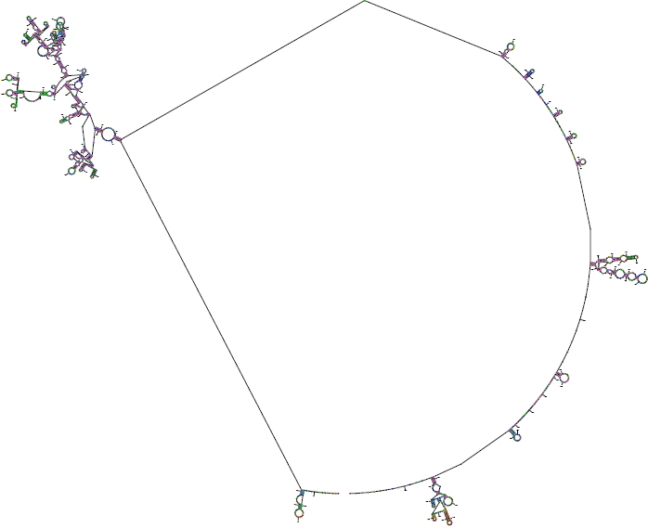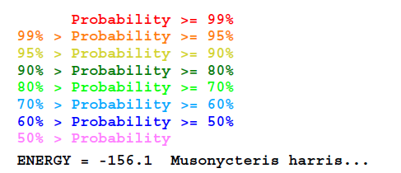
Figure S1e. Secondary Structure for the control region of the mitochondrial genome of Musonycteris harrisoni.

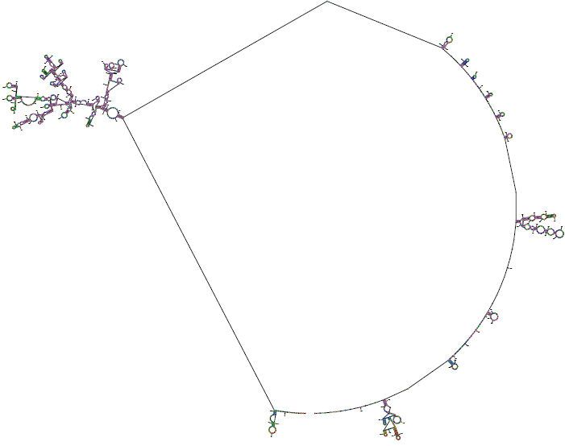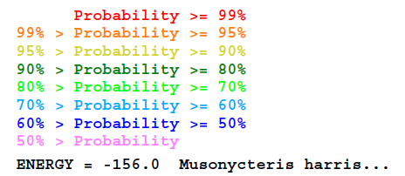
Figure S1f. Secondary Structure for the control region of the mitochondrial genome of Musonycteris harrisoni.

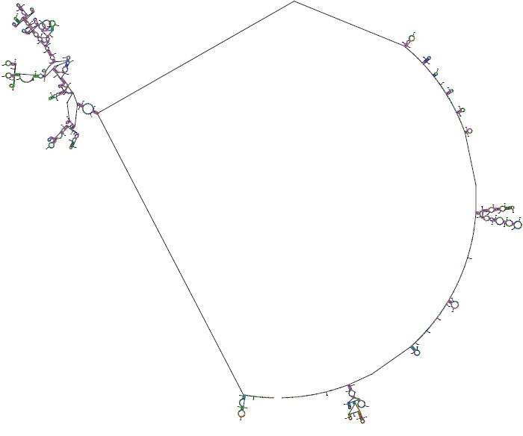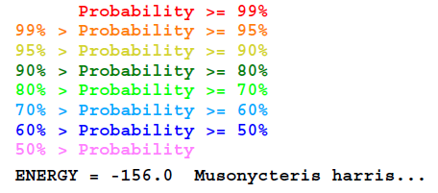
Figure S1g. Secondary Structure for the control region of the mitochondrial genome of Musonycteris harrisoni.

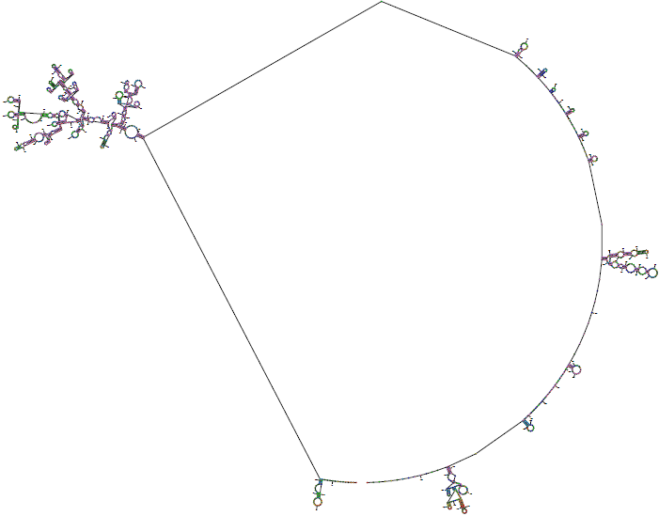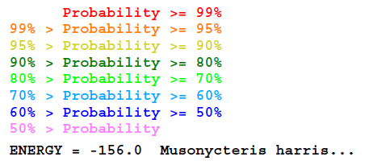
Figure S1h. Secondary Structure for the control region of the mitochondrial genome of Musonycteris harrisoni.

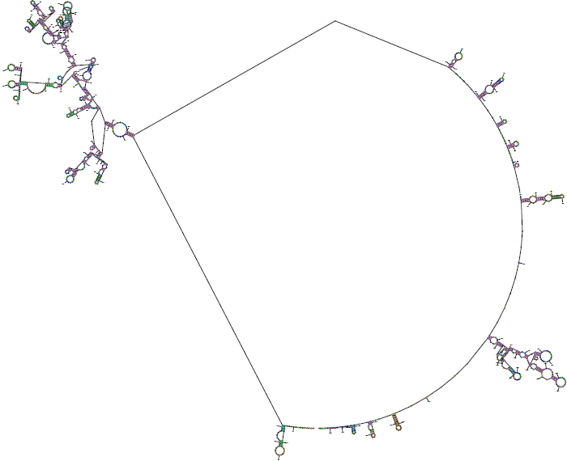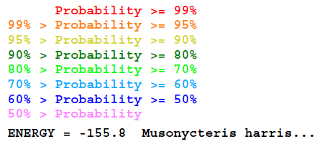
Figure S1i. Secondary Structure for the control region of the mitochondrial genome of Musonycteris harrisoni.

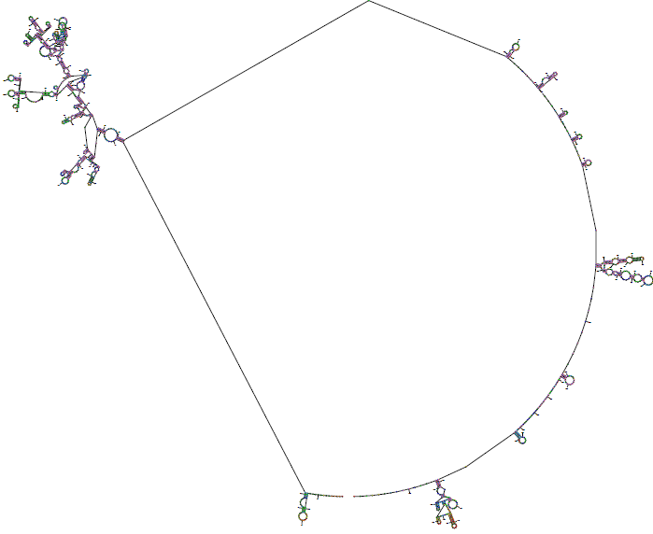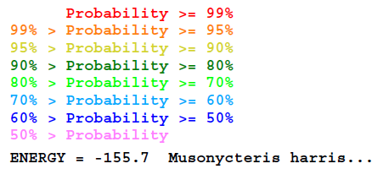
Figure S1j. Secondary Structure for the control region of the mitochondrial genome of Musonycteris harrisoni.

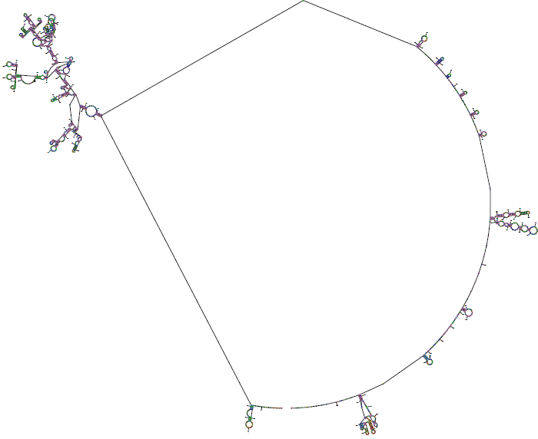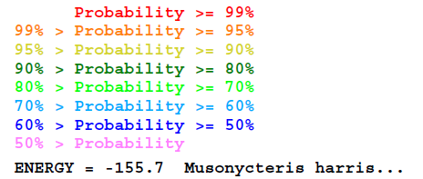
Figure S1k. Secondary Structure for the control region of the mitochondrial genome of Musonycteris harrisoni.

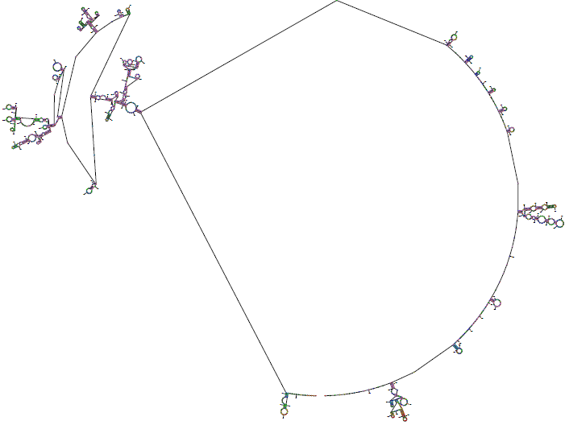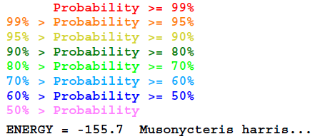
Figure S1l. Secondary Structure for the control region of the mitochondrial genome of Musonycteris harrisoni.

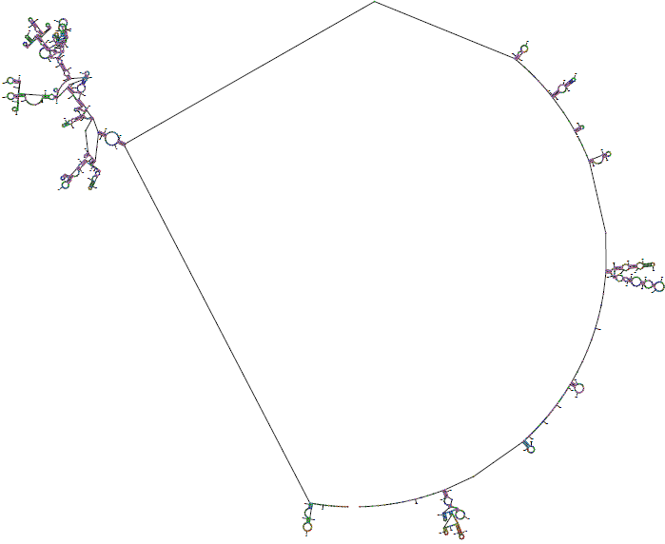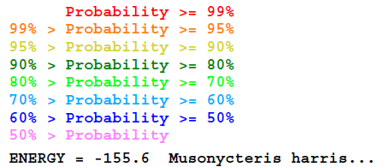
Figure S1m. Secondary Structure for the control region of the mitochondrial genome of Musonycteris harrisoni.

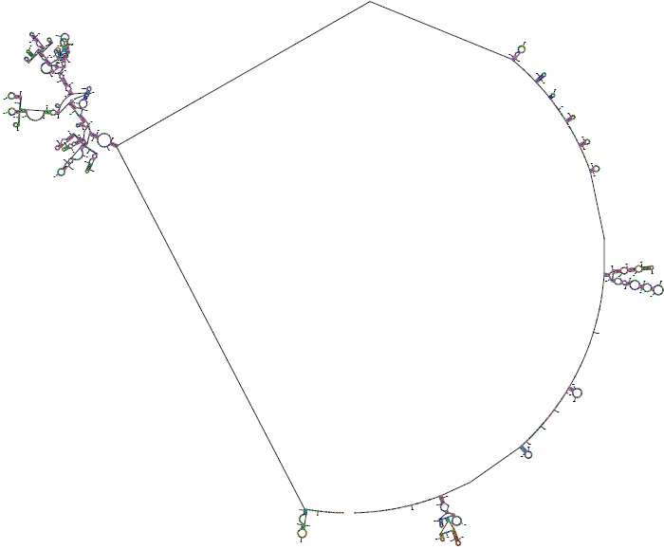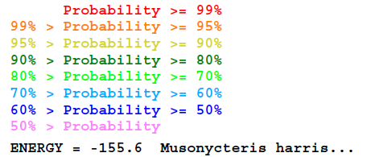
Figure S1n. Secondary Structure for the control region of the mitochondrial genome of Musonycteris harrisoni.

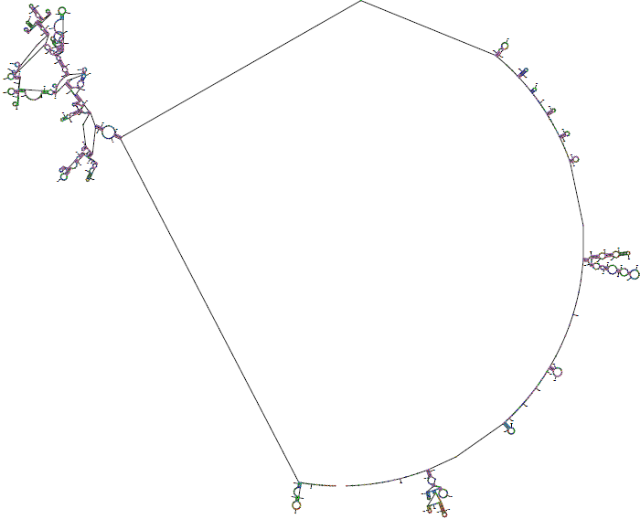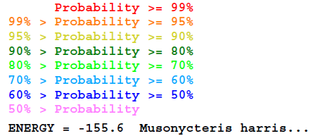
Figure S1o. Secondary Structure for the control region of the mitochondrial genome of Musonycteris harrisoni.

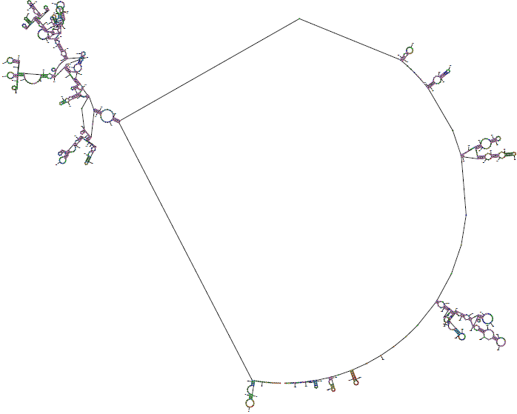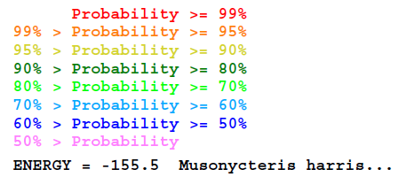
Figure S1p. Secondary Structure for the control region of the mitochondrial genome of Musonycteris harrisoni.

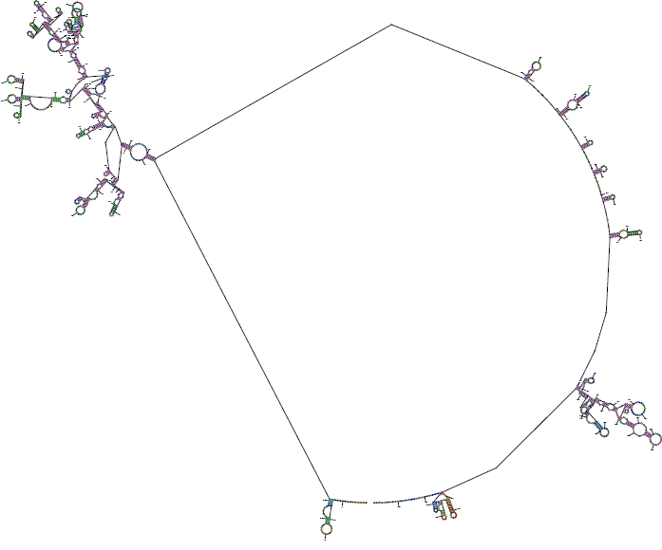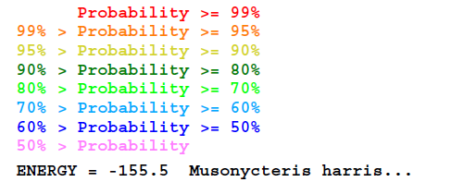
Figure S1q. Secondary Structure for the control region of the mitochondrial genome of Musonycteris harrisoni.

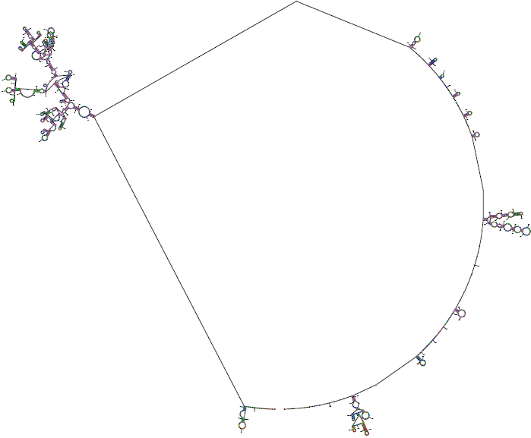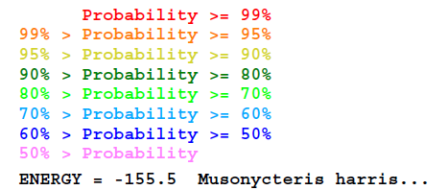
Figure S1r. Secondary Structure for the control region of the mitochondrial genome of Musonycteris harrisoni.

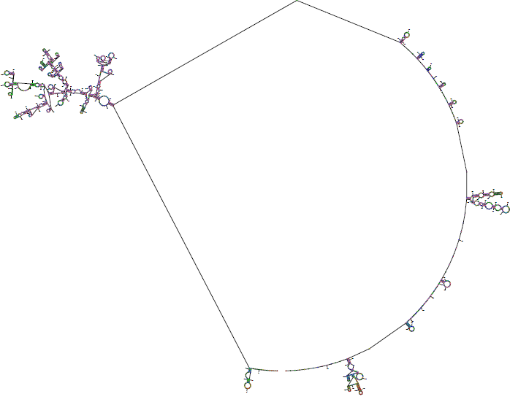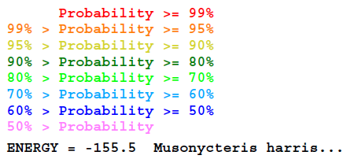
Figure S1s. Secondary Structure for the control region of the mitochondrial genome of Musonycteris harrisoni.

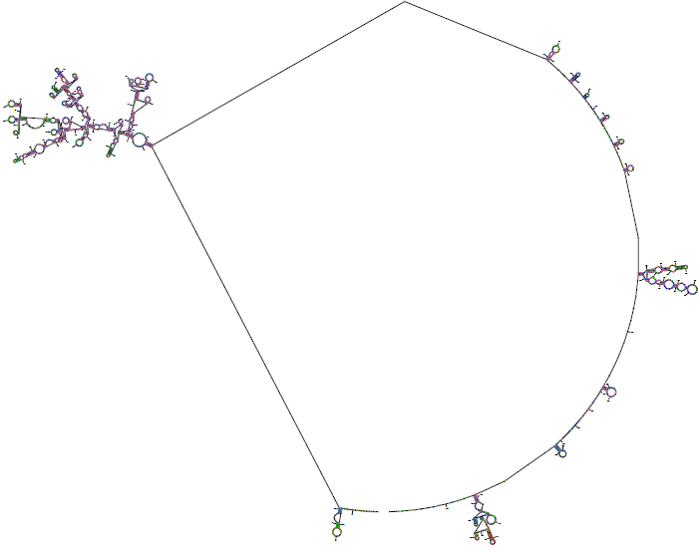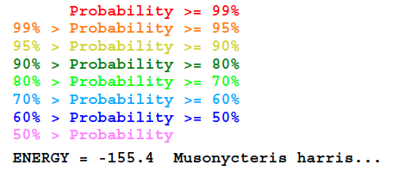
Figure S1t. Secondary Structure for the control region of the mitochondrial genome of Musonycteris harrisoni.

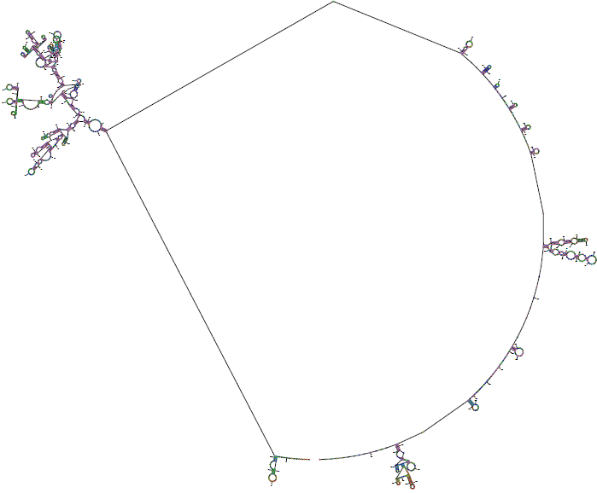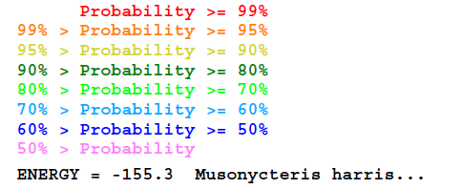
Figure S1u. Secondary Structure for the control region of the mitochondrial genome of Musonycteris harrisoni.

