Supplementary materials

Holocene deglaciation drove rapid genetic diversification of Atlantic walrus.

Emily J. Ruiz-Puerta#, Xénia Keighley, Sean P. A. Desjardins, Anne Birgitte Gotfredsen, Shyong En Pan, Bastiaan Star, Sanne Boessenkool, James H. Barrett, Morgan L. McCarthy, Liselotte W. Andersen, Erik W. Born, Lesley R. Howse, Paul Szpak, Snæbjörn Pálsson, Hilmar J. Malmquist, Scott Ruffolo, Peter D. Jordan, Morten Tange Olsen#
#Corresponding author:
Emily Johana Ruiz-Puerta: emily.puerta@sund.ku.dk
Morten Tange Olsen: morten.olsen@sund.ku.dk

This PDF file includes:

- Figure S1. Relaxed exponential clock Bayesian phylogeny identical to Figure 1 in the main text, but providing node numbers for easier interpretation of each nodes’ posterior, age and 95% HPD, as provided in Supplementary Table S3.

- Figure S2. Maximum likelihood phylogeny obtained from IQTree.

- Figure S3. Changing ice coverage across the North Atlantic over the last 30 000 years and delineation of current Atlantic walrus (Odobenus rosmarus rosmarus) subpopulations.

- Table S1. Information for each sample used for this study.
- Table S2. Posterior, likelihood and prior statistics for the Bayesian phylogeny using a relaxed exponential clock model (Figure 1 and Supplementary Figure S1).
- Table S3. Posteriors, age (kya) and 95% HPD for each node in the Bayesian phylogeny using a relaxed exponential clock (Figure 1 and Supplementary Figure S1).
- Table S4. Posterior, likelihood and prior statistics using strict clock model for Bayesian phylogeny.
- Table S5. Genetic differentiation among North Atlantic walrus populations.
- Table S6. Sample size and measures of genetic diversity for each walrus population.

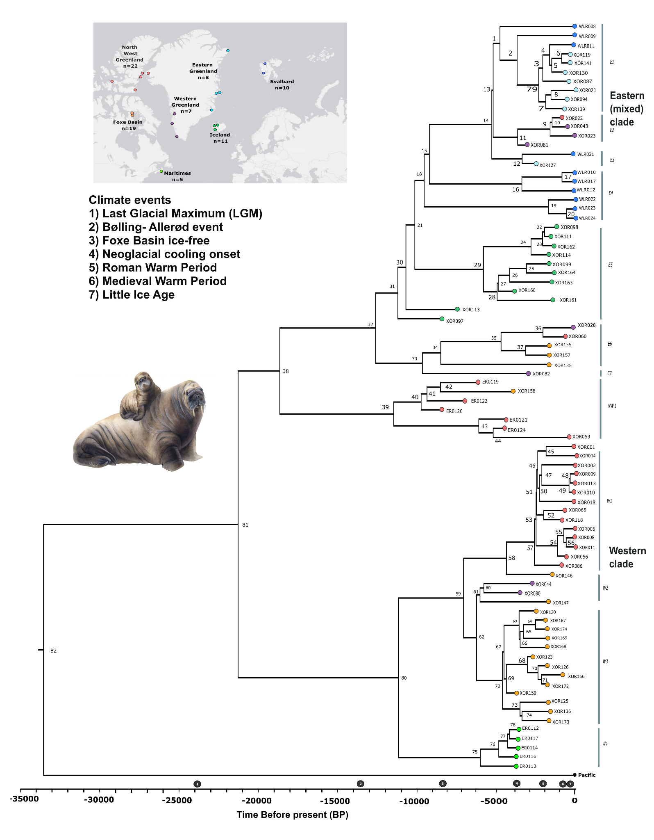
Supplementary Figure S1: Bayesian phylogeny using a relaxed exponential clock model. Tips are number-coded to aid interpretation of posterior parameter estimates provided in Supplementary Table S3.

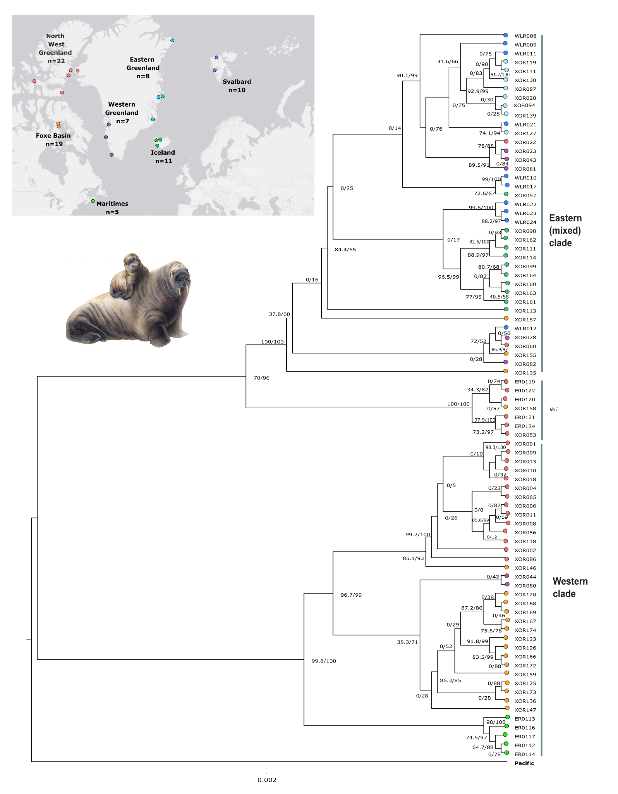
Supplementary Figure. S2: Maximum likelihood phylogeny with mitogenomes with at least 95% breadth of coverage (n=82) and with Pacific walrus as output obtained from IQtree to support the topology presented in the Bayesian phylogeny (Figure 1).
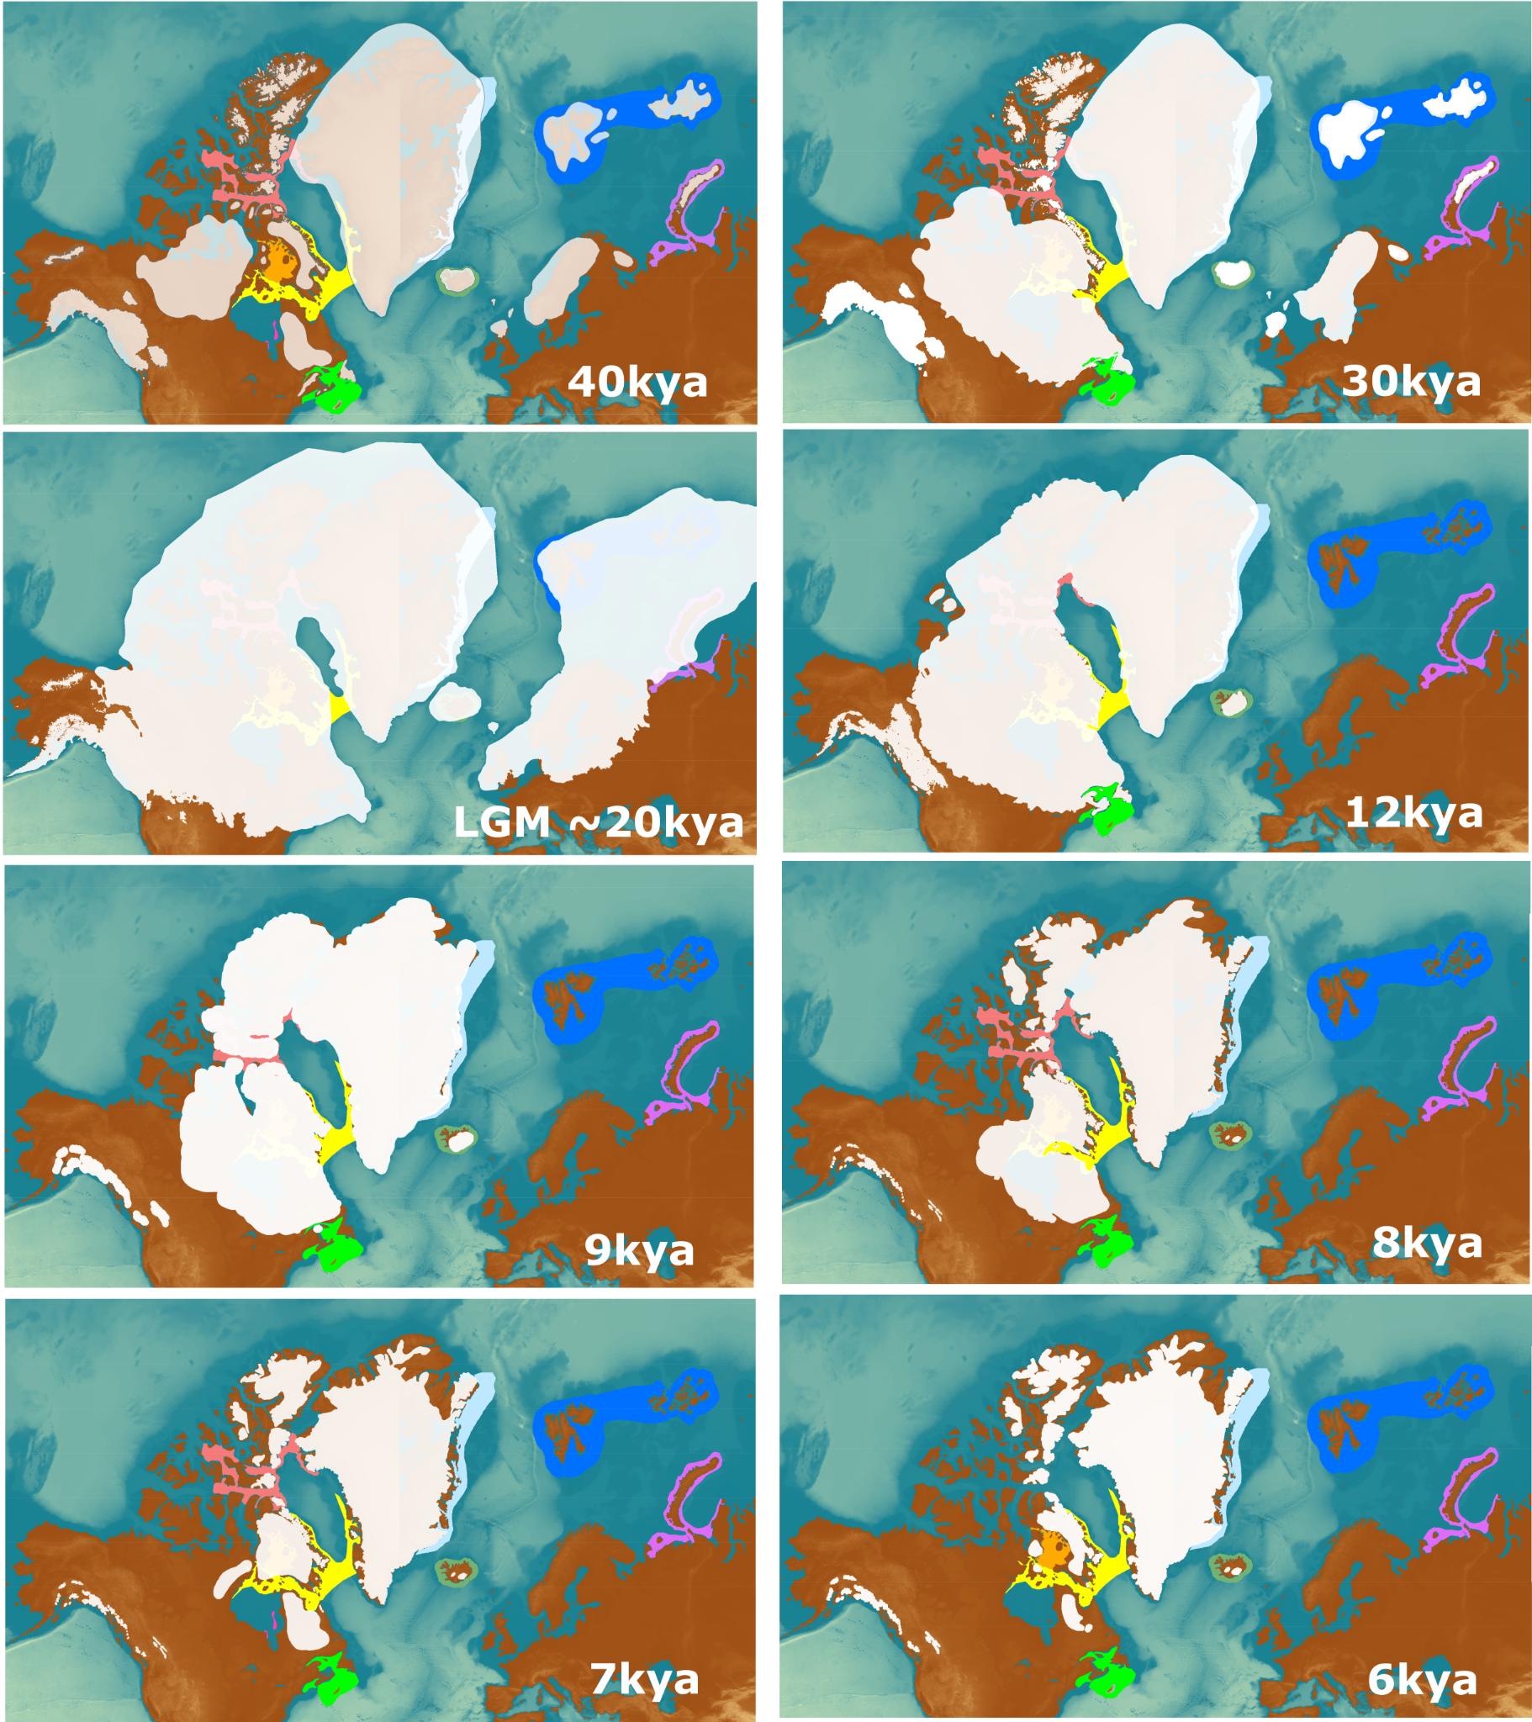
Supplementary Figure S3. Changing ice coverage across the North Atlantic over the last 30 000 years. A time series adapted from (Dyke et al. 2003), (Hughes et al. 2016) and (Batchelor et al. 2019). Ages are labelled in the bottom right-hand corner of each of the six maps. Ice sheets are shown in white. The distribution of contemporary walruses is shown as shaded areas in colours reflecting contemporary population structure based on (Born et al. 1995; Andersen et al. 2009; Andersen et al. 2014; Dietz et al. 2014; McLeod et al. 2014). Basemap was adapted and obtained from ETOPO1 Arc-Minute Global Relief Model available at: https://www.ngdc.noaa.gov/mgg/global/

Supplementary Table S1. Information about the samples included in this study. Out of 187 initially screened specimens, only 82 specimens with mitogenomes with at least 95% breadth of coverage were included. Institution where the sample was found, geographic locality, age. Sample dates are historical, archaeological or indicate the midpoint of a calibrated radiocarbon probability date distribution of the sample, or dated terrestrial mammal remains from the same context. Only one sample had neither radiocarbon or cultural dating, this was removed from the analysis. Walruses from North Baffin Bay, Jones Sound and Penny Strait-Lancaster Sound were grouped together under 'North West Greenland’, as the current stock designation for modern Atlantic walruses is still debated in this region (e.g., Heide-Jørgensen et al. 2017).

​​
Sample_ID | Storage | Skeletal element | Ontogenetic age | Age (cal BP) years before 1950 | Year collected | Locality | Geographic region based upon extant stocks | Endogenous percentage | Mitochondrial depth of coverage | Museum ID | Source
WLR008 | University Museum, University of Bergen | Petrous bone | Unknown | 100 | Unknown | Moffen | Svalbard | Na | 36.65 | in reference | Star et al. 2018
WLR009 | University Museum, University of Bergen | Petrous bone | Unknown | 100 | Unknown | Russekeila | Svalbard | Na | 16.88 | in reference | Star et al. 2018
WLR010 | University Museum, University of Bergen | Petrous bone | Unknown | 100 | Unknown | Moffen | Svalbard | Na | 55.76 | in reference | Star et al. 2018
WLR011 | University Museum, University of Bergen | Petrous bone | Unknown | 100 | Unknown | Moffen | Svalbard | Na | 6.88 | in reference | Star et al. 2018
WLR012 | University Museum, University of Bergen | Petrous bone | Unknown | 100 | Unknown | Moffen | Svalbard | Na | 28.58 | in reference | Star et al. 2018
WLR017 | University Museum, University of Bergen | Petrous bone | Unknown | 100 | Unknown | Moffen | Svalbard | Na | 107.9 | in reference | Star et al. 2018
WLR021 | University Museum, University of Bergen | Petrous bone | Unknown | 100 | Unknown | Moffen | Svalbard | Na | 71.3 | in reference | Star et al. 2018
WLR022 | University Museum, University of Bergen | Petrous bone | Unknown | 100 | Unknown | Moffen | Svalbard | Na | 78.73 | in reference | Star et al. 2018
WLR023 | University Museum, University of Bergen | Petrous bone | Unknown | 100 | Unknown | Moffen | Svalbard | Na | 69.59 | in reference | Star et al. 2018
WLR024 | University Museum, University of Bergen | Petrous bone | Unknown | 100 | Unknown | Moffen | Svalbard | Na | 41.28 | in reference | Star et al. 2018
XOR001 | Natural History Museum of Denmark | Skull | Unknown | 50 | 2016 | SW Coast Appat (Saunders Island) | North West Greenland | 24.4 | 8.80 | - | Keighley et al. 2019
XOR002 | Natural History Museum of Denmark | Skull | Unknown | 50 | 2016 | SW Coast Appat (Saunders Island) | North West Greenland | 11.3 | 17.80 | - | Keighley et al. 2019
XOR004 | Natural History Museum of Denmark | Tooth | Unknown | 50 | 2016 | SW Coast Appat (Saunders Island) | North West Greenland | 26.5 | 78.20 | - | Keighley et al. 2019
XOR006 | Natural History Museum of Denmark | Tooth | Adult | 12 | 1938 | Thule | North West Greenland | 41.5 | 36.47 | M1269 | This paper
XOR008 | Natural History Museum of Denmark | Tusk | Adult | 12 | 1938 | Thule | North West Greenland | 46.4 | 156.99 | M1269 | This paper
XOR009 | Natural History Museum of Denmark | Mandible | Unknown | 35 | 1915 | Thule | North West Greenland | 2.3 | 52.71 | 403 | This paper
XOR010 | Natural History Museum of Denmark | Skull | Unknown | 35 | 1915 | Thule | North West Greenland | 19.4 | 34.87 | 403 | This paper
XOR011 | Natural History Museum of Denmark | Skull | Adult | 12 | 1938 | Thule | North West Greenland | 0.6 | 1.56 | M1269 | This paper
XOR013 | Natural History Museum of Denmark | Skull | Unknown | 35 | 1915 | Thule | North West Greenland | 27.4 | 158.11 | 403 | This paper
XOR018 | Natural History Museum of Denmark | Mandible | Unknown | 50 | 2016 | SW Coast Appat (Saunders Island) | North West Greenland | 26.5 | 78.20 | - | Keighley et al. 2019
XOR020 | Natural History Museum of Denmark | Mandible | Unknown | 26 | 1924 | Scoresby Sound | Eastern Greenland | 10.8 | 70.20 | - | Keighley et al. 2019
XOR022 | Natural History Museum of Denmark | Tooth | Unknown | 820 | 1997 | Qeqertaaraq, Hatherton Bay, Inglefield Land | North West Greenland | 4.6 | 56.36 | ZMK 73/1997 | This paper
XOR023 | Natural History Museum of Denmark | Mandible | Unknown | 24 | 1926 | Jakobshavn | Western Greenland | 23 | 17.00 | - | Keighley et al. 2019
XOR028 | Natural History Museum of Denmark | Tusk | Unknown | 38 | 1915 | Sjæret Saitok, off Disko | Western Greenland | 0.4 | 5.43 | 385 | This paper
XOR043 | Natural History Museum of Denmark | Tooth | Unknown | 475 | 1989 | Isuamiut | Western Greenland | 27.3 | 16.66 | ZMK 135/1989 | This paper
XOR044 | Natural History Museum of Denmark | Tusk | Unknown | 2630 | 1978 | Sermersooq | Western Greenland | 62.5 | 125.00 | ZMK 3/1978 | This paper
XOR053 | Canadian Museum of History | Limb | Unknown | 475 | Unknown | Bathurst Island | North West Greenland | 5.8 | 25.60 | - | Keighley et al. 2019
XOR056 | Canadian Museum of History | Tooth | Unknown | 580 | 1974 | Porden Point Brook | North West Greenland | 63.3 | 28.95 | TEAL6598 | This paper
XOR060 | Canadian Museum of History | Limb | Unknown | 630 | 1978-1980 | Skraeling Island | North West Greenland | 31 | 26.40 | - | Keighley et al. 2019
XOR065 | Canadian Museum of History | Skull | Unknown | 630 | Unknown | Skraeling Island | North West Greenland | 10.5 | 4.14 | TEAL-7549 | This paper
XOR080 | Natural History Museum of Denmark | Tusk | Adult | 3543 | 1992 | Nipisat I, Sisimiut | Western Greenland | 1.3 | 18.23 | ZMK136/1989 | This paper
XOR081 | Natural History Museum of Denmark | Tooth | Adult | 3135 | 1993 | Nipisat I, Sisimiut | Western Greenland | 4.7 | 29.20 | - | Keighley et al. 2019
XOR082 | Natural History Museum of Denmark | Tusk | Juvenile | 3010 | 1992 | Nipisat I,  Sisimiut | Western Greenland | 2 | 89.17 | ZMK 136/1989 | This paper
XOR086 | Natural History Museum of Denmark | Mandible | Unknown | 820 | 1997 | Qeqertaaraq, Hatherton Bay, Inglefield Land | North West Greenland | 3.9 | 5.69 | ZMK 73/1997 | This paper
XOR087 | Natural History Museum of Denmark | Fragmentary | Unknown | 384 | 2008 | Walrus Island, south of Sabine Ø | Eastern  Greenland | 3.9 | 6.32 | ZMK 65/2008 | This paper
XOR094 | Natural History Museum of Denmark | Fragmentary | Unknown | 475 | 2007 | Clavering Ø | Eastern  Greenland | 9.5 | 24.80 | - | Keighley et al. 2019
XOR097 | Institude of Natural History, Iceland | Tusk | Unknown | 8529 | 1989 | Iceland | Iceland | 2 | 5.30 | MOR#16 | This paper
XOR098 | Institude of Natural History, Iceland | Tusk + Skull | Adult | 1231 | 1955 | Iceland | Iceland | 23.5 | 128.09 | MOR#11 | This paper
XOR099 | Private ownserhip, stored Bjarnarfoss | Tusk + Skull | Unknown | 1642 | Pre 1990 | Iceland | Iceland | 2.1 | 5.90 | - | Keighley et al. 2019
XOR111 | Institude of Natural History, Iceland | Tusk | Unknown | 1573 | 1894 | Iceland | Iceland | 1.7 | 12.62 | MOR#18 | This paper
XOR113 | Institude of Natural History, Iceland | Tusk | Unknown | 7367 | 1910 | Iceland | Iceland | 7.5 | 109.60 | - | Keighley et al. 2019
XOR114 | Institude of Natural History, Iceland | Tusk | Unknown | 1649 | 1907 | Iceland | Iceland | 4.7 | 5.40 | MOR#26 | This paper
XOR118 | Natural History Museum of Denmark | Tooth | Unknown | 775 | 1996 | Qeqertaaraq, Hatherton Bay, Inglefield Land | North West Greenland | 22.1 | 32.50 | Keighley et al. 2019 | Keighley et al. 2019
XOR119 | Natural History Museum of Denmark | Tusk | Unknown | 475 | 2008 | Clavering Ø | Eastern Greenland | 0.9 | 7.29 | ZMK 63/2008 | This paper
XOR120 | Nunavut Department of Culture and Heritage, Canadian Museum of Nature | Tusk | Unknown | 2510 | 2015 | Foxe Basin | Foxe Basin | 2.2 | 9.80 | - | Keighley et al. 2019
XOR123 | Nunavut Department of Culture and Heritage, Canadian Museum of Nature | Tooth | Unknown | 2630 | 2015 | Foxe Basin | Foxe Basin | 3.8 | 32.20 | - | Keighley et al. 2019
XOR125 | Nunavut Department of Culture and Heritage, Canadian Museum of Nature | Tooth | Unknown | 1695 | 2015 | Foxe Basin | Foxe Basin | 7.3 | 20.30 | - | Keighley et al. 2019
XOR126 | Nunavut Department of Culture and Heritage, Canadian Museum of Nature | Tusk | Unknown | 1690 | 2015 | Foxe Basin | Foxe Basin | 0.1 | 16.30 | - | Keighley et al. 2019
XOR127 | Natural History Museum of Denmark | Tusk | Unknown | 2610 | 1993 | Holm Land | Eastern Greenland | 1.4 | 32.49 | ZMK 54/1993 | This paper
XOR130 | Natural History Museum of Denmark | Tusk | Unknown | 820 | 1993 | Amdrup Land | Eastern Greenland | 5 | 48.44 | ZMK 50/1993 | This paper
XOR135 | Natural History Museum of Denmark | Mandible | Unknown | 1575 | 1954 | Alarniq, Foxe Basin | Foxe Basin | 23.9 | 57.50 | - | Keighley et al. 2019
XOR136 | Natural History Museum of Denmark | Tooth | Unknown | 1575 | 1954 | Alarniq, Foxe Basin | Foxe Basin | 37.9 | 13.90 | - | Keighley et al. 2019
XOR139 | Natural History Museum of Denmark | Tusk | Unknown | 820 | 1993 | Amdrup Land | Eastern Greenland | 0.7 | 36.35 | ZMK 50/1993 | This paper
XOR141 | Natural History Museum of Denmark | Baculum | Unknown | 475 | 2007 | Clavering Ø | Eastern Greenland | 22.9 | 28.89 | ZMK 119/2007 | This paper
XOR146 | Natural History Museum of Denmark | Mandible | Unknown | 1575 | 1954 | Alarniq, Foxe Basin | Foxe Basin | 7.6 | 13.90 | - | Keighley et al. 2019
XOR147 | Natural History Museum of Denmark | Mandible | Unknown | 1575 | 1954 | Alarniq, Foxe Basin | Foxe Basin | 8.8 | 43.30 | - | Keighley et al. 2019
XOR155 | Natural History Museum of Denmark | Tooth | Unknown | 1575 | 1954 | Alarniq, Foxe Basin | Foxe Basin | 26.3 | 9.17 | ZMK 123a/1955 | This paper
XOR157 | Natural History Museum of Denmark | Tusk | Unknown | 1575 | 1954 | Alarniq, Foxe Basin | Foxe Basin | 2.3 | 49.70 | - | Keighley et al. 2019
XOR158 | Natural History Museum of Denmark | Tooth | Unknown | 3850 | 1957 | Kaleruserk, Igloolik Ø | Foxe Basin | 10.1 | 13.20 | - | Keighley et al. 2019
XOR159 | Natural History Museum of Denmark | Tooth | Unknown | 3850 | 1957 | Kaleruserk, Igloolik Ø | Foxe Basin | 31.2 | 13.50 | - | Keighley et al. 2019
XOR160 | Institute of Natural History, Iceland | Tusk | Unknown | 3755 | 1986 | Iceland | Iceland | Na | 200.1 | MOR#22 | This paper
XOR161 | Institute of Natural History, Iceland | Tusk | Unknown | 1373 | 1978 | Iceland | Iceland | Na | 131.0 | MOR#17 | This paper
XOR162 | Institute of Natural History, Iceland | Tusk + Skull | Unknown | 1336 | 1952 | Iceland | Iceland | 2.3 | 15.50 | MOR#23 | This paper
XOR163 | Institute of Natural History, Iceland | Tusk | Unknown | 1431 | 1954 | Iceland | Iceland | 3.7 | 2.40 | MOR#14 | This paper
XOR164 | Private ownership, stored Bjarnarfoss | Tusk + Skull | Unknown | 1306 | 1990 | Iceland | Iceland | 27.5 | 113.50 | - | Keighley et al. 2019
XOR166 | Nunavut Department of Culture and Heritage, Canadian Museum of Nature | Tooth | Unknown | 950 | 2015 | Foxe Basin | Foxe Basin | 4.4 | 15.69 | NhHd-9:264 | This paper
XOR167 | Nunavut Department of Culture and Heritage, Canadian Museum of Nature | Tusk | Unknown | 1900 | 2015 | Foxe Basin | Foxe Basin | 27.9 | 30.03 | NhHd-3:1454 | This paper
XOR168 | Nunavut Department of Culture and Heritage, Canadian Museum of Nature | Tooth | Unknown | 1833 | 2017 | Foxe Basin | Foxe Basin | 7.4 | 6.49 | NhHd-1:DNA1 | This paper
XOR169 | Nunavut Department of Culture and Heritage, Canadian Museum of Nature | Tooth | Unknown | 1833 | 2017 | Foxe Basin | Foxe Basin | 1.2 | 25.55 | NhHd-1:DNA2 | This paper
XOR172 | Nunavut Department of Culture and Heritage, Canadian Museum of Nature | Tooth | Unknown | 1702 | 2017 | Foxe Basin | Foxe Basin | 26.4 | 31.48 | NhHe-11:DNA5 | This paper
XOR173 | Nunavut Department of Culture and Heritage, Canadian Museum of Nature | Tooth | Unknown | 1702 | 2017 | Foxe Basin | Foxe Basin | 39.6 | 46.31 | NhHe-11:DNA6 | This paper
XOR174 | Nunavut Department of Culture and Heritage, Canadian Museum of Nature | Tooth | Unknown | 1716 | 2017 | Foxe Basin | Foxe Basin | 14.3 | 27.77 | NhHe-11:DNA7 | This paper
ER0112 | Fossil Vertebrae Collection, Canadian Museum of Nature | maxilla | Unknown | 3659 | Unknown | Sable Island | Maritimes | Na | 52.527 | CMNFV 35797 | This paper
ER0113 | Fossil Vertebrae Collection, Canadian Museum of Nature | Temporal | Unknown | 3659 | Unknown | Sable Island | Maritimes | Na | 13.39 | CMNFV 43818 | This paper
ER0114 | Fossil Vertebrae Collection, Canadian Museum of Nature | maxilla | Unknown | 3659 | Unknown | Sable Island | Maritimes | Na | 80.506 | CMNFV 43819 | This paper
ER0116 | Fossil Vertebrae Collection, Canadian Museum of Nature | maxilla | Unknown | 3659 | Unknown | Sable Island | Maritimes | Na | 43.459 | CMNFV 43821 | This paper
ER0117 | Fossil Vertebrae Collection, Canadian Museum of Nature | mandible | Unknown | 3659 | Unknown | Sable Island | Maritimes | Na | 99.4 | CMNFV 43825 | This paper
ER0119 | Fossil Vertebrae Collection, Canadian Museum of Nature | Tusk | Unknown | 6200 | 1999 | North West Baffin Island | North West Greenland | Na | 346.64 | CMNFV 48389- S3093 | This paper
ER0120 | Fossil Vertebrae Collection, Canadian Museum of Nature | Tusk | Unknown | 8640 | 1999 | North West Baffin Island | North West Greenland | Na | 627.46 | CMNFV 48390 - S3092 | This paper
ER0121 | Fossil Vertebrae Collection, Canadian Museum of Nature | mandible | Unknown | 4730 | Unknown | North West Baffin Island | North West Greenland | Na | 33.488 | CMNFV 55070,TO-4985 | This paper
ER0122 | Fossil Vertebrae Collection, Canadian Museum of Nature | Tusk | Unknown | 7050 | Unknown | Devon Island | North West Greenland | Na | 10.67 | CMNFV 55135, S-3527 | This paper
ER0124 | Fossil Vertebrae Collection, Canadian Museum of Nature | maxilla | Unknown | 4500 | Unknown | Devon Island | North West Greenland | Na | 77.556 | CMNFV 56803- 94DCA 001 | This paper

Supplementary Table S2. The posterior, likelihood and prior statistics for the Bayesian phylogeny using a relaxed exponential clock model (Figure 1).

This study | Relaxed clock model
Summary statistic | mean | stderr of mean | stdev | variance | median | value range | 95% HPD interval | auto-correlation time (ACT) | effective sample size (ESS)
Posterior | -23500.7325 | 0.7154 | 18.3868 | 338.0736 | -23500.0729 | [-23579.3011, -23426.836] | [-23537.1702, -23465.1813] | 1.09E+05 | 660.6
Likelihood | -22528.2472 | 0.2404 | 9.4389 | 89.0927 | -22527.8548 | [-22574.9133, -22492.8169] | [-22546.1997, -22509.4037] | 46703.9997 | 1541.6
Prior | -972.4853 | 0.8626 | 17.8768 | 319.5794 | -971.9939 | [-1057.6703, -905.6171] | [-1007.5426, -937.7287] | 1.68E+05 | 429.5
Tree height | 33535.9031 | 927.6382 | 15006.0852 | 2.25E+08 | 29696.9243 | [12283.8567, 1.7605E5] | [14068.1022, 62022.561] | 2.75E+05 | 261.7
Coalescent exponential | -921.8897 | 0.8553 | 17.4015 | 302.8129 | -921.4646 | [-1006.0882, -858.1903] | [-955.9305, -887.8113] | 1.74E+05 | 413.9
ePopSize | 39153.0021 | 613.4827 | 13175.9362 | 1.74E+08 | 36797.3067 | [10041.1302, 1.5776E5] | [18605.3443, 66196.4991] | 1.56E+05 | 461.3
UcedMean (rate) | 1.49E-07 | 1.19E-09 | 2.90E-08 | 8.39E-16 | 1.47E-07 | [6.1139E-8, 3.1883E-7] | [9.576E-8, 2.0719E-7] | 1.22E+05 | 589.5
Growth rate | 6.21E-05 | 2.28E-06 | 4.43E-05 | 1.97E-09 | 5.75E-05 | [-0.0001, 2.7266E-4] | [-0, 1.5152E-4] | 1.91E+05 | 377

Supplementary Table S3. Posterior values, age (kya) and 95% HPD for each node in the Bayesian phylogeny using a relaxed exponential clock model, as illustrated in Figure 1 and according to node numbers provided in Supplementary Figure S1.

Node # | Posterior value | Node age (kya) | 95% HPD | Node # | Posterior value | Node age (kya) | 95% HPD
1 | 0.24 | -4771.9 | [2488.32,7404.59] | 22 | 0.38 | -1960.29 | [1573,2689.99]
2 | 0.78 | -3695.28 | [1763.32,6163.97] | 23 | 1 | -2086.42 | [1573.19,2893.55]
3 | 0.41 | -2078.06 | [1067.52,3313.88] | 24 | 1 | -2818.02 | [1677.87,4384.61]
4 | 0.74 | -1643.88 | [877.62,2525.68] | 25 | 0.71 | -3103.57 | [1895.53,4553.89]
5 | 0.35 | -1510.82 | [820.36,2339.2] | 26 | 0.61 | -4159.78 | [2434.57,6064.13]
6 | 1 | -881.64 | [500.31,1388.14] | 27 | 0.17 | -4883.09 | [3851.1,6313.11]
7 | 0.41 | -1892.38 | [881.64,3078.01] | 28 | 0.98 | -4948.62 | [3878.01,6438.26]
8 | 0.41 | -1558.99 | [496.51,2834.42] | 29 | 1 | -5814.52 | [3878.01,6438.26]
9 | 1 | -1612.72 | [820.01,2857.48] | 30 | 0.3 | -10700.31 | [7775.61,13841.16]
10 | 0.23 | -1484.02 | [820.01,2720] | 31 | 0.53 | -11203.75 | [9136.63,14074.96]
11 | 1 | -3658.28 | [3138.72,4510.84] | 32 | 1 | -12608.06 | [9422.29,16863.34]
12 | 0.99 | -3371.34 | [2644.74,4448.86] | 33 | 0.27 | -9662.24 | [3147.55,16312.64]
13 | 0.13 | -5201.33 | [3494.57,7471.13] | 34 | 0.17 | -8506.57 | [2376.92,15979.77]
14 | 1 | -5287.41 | [3551.29,7568.53] | 35 | 0.33 | -4705.71 | [1800.93,11179.65]
15 | 0.1 | -9221.56 | [4367.09,13681.61] | 36 | 1 | -2060.86 | [807.78,3653.82]
16 | 0.94 | -3392.24 | [799.29,10391.51] | 37 | 0.6 | -3155.61 | [1593.55,6176.79]
17 | 1 | -862.9 | [158.78,1880.82] | 38 | 0.9 | -18651.67 | [12162.04,26782.63]
18 | 0.19 | -9549.31 | [4536.4,13794.26] | 39 | 1 | -11470.06 | [8480.36,15255.76]
19 | 1 | -1725.36 | [416.64,3570.08] | 40 | 0.95 | -9740.91 | [8480.06,11807.23]
20 | 1 | -567.22 | [107.23,1322.78] | 41 | 0.42 | -9368.91 | [7439.32,11674.77]
21 | 0.22 | -10139.09 | [5771.31,14010.12] | 42 | 0.48 | -8524.24 | [6223.42,10990.67]
Node # | Posterior value | Node age (kya) | 95% HPD | Node # | Posterior value | Node age (kya) | 95% HPD
43 | 1 | -6108.21 | [4602.25,8336.46] | 65 | 0.29 | -3292.19 | [2276.54,4323.96]
44 | 0.92 | -5199.2 | [4501.91,6524.62] | 66 | 0.22 | -3499.5 | [2596.76,4497.44]
45 | 0.14 | -1865.62 | [364.65,3317.96] | 67 | 0.16 | -4519.47 | [3850,5644.24]
46 | 0.01 | -2392.19 | [1216.51,3773.23] | 68 | 1 | -3039.28 | [2630.02,3745.23]
47 | 0.06 | -2134.42 | [842.77,3551.71] | 69 | 0.17 | -4369.38 | [3850,5365.35]
48 | 0.33 | -345.4 | [35.01,908.64] | 70 | 1 | -2377.41 | [1798.48,2997.86]
49 | 1 | -420.87 | [40.47,1005.37] | 71 | 0.54 | -2163.45 | [1702.01,2801.65]
50 | 0.02 | -2288.6 | [1042.08,3670.86] | 72 | 1 | -4621.73 | [3850,5831.63]
51 | 0.06 | -2455.62 | [1335.69,3809.63] | 73 | 0.71 | -3514.09 | [2130.11,5151.32]
52 | 0.1 | -2016.1 | [866.84,3307.46] | 74 | 0.23 | -3386.82 | [1934.76,5080.37]
53 | 0.24 | -2495.14 | [1394.84,3849.11] | 75 | 1 | -6007.06 | [4151.79,8475.93]
54 | 1 | -1159.8 | [633.39,1847.41] | 76 | 0.99 | -4848.46 | [3863.58,6254.38]
55 | 0.7 | -752.84 | [22.17,1601.08] | 77 | 0.93 | -4285.54 | [3717.62,5164.23]
56 | 0.32 | -598.77 | [12.01,1482.67] | 78 | 0.3 | -4184.72 | [3666.06,4981.07]
57 | 1 | -2606.72 | [1498.47,3983.57] | 79 | 1 | -2332.98 | [1272.05,3580.72]
58 | 1 | -4365.2 | [2220.19,6967.99] | 80 | 1 | -11171.77 | [6244.69,17620.3]
59 | 1 | -7066.25 | [4509.38,10255.98] | 81 | 1 | -21269.83 | [12919.33,32028.36]
60 | 0.23 | -5792.23 | [3736.93,8363.07] | 82 | 1 | -33535.9 | [14068.1,62022.56]
61 | 0.25 | -6028.39 | [3942.47,8681.59]
62 | 0.66 | -6249.36 | [4284.78,8785.49]
63 | 0.98 | -3569.13 | [2720.43,4504.34]
64 | 0.98 | -2531.81 | [1943.75,3281.22]

Supplementary Table S4. The posterior, likelihood and prior statistics for strict clock Bayesian phylogenies based on our 82 walrus mitogenomes, but using the original settings by Star et al. 2018 and Andersen et al. 2017.

Strict clock | Andersen et al. (2017) |  |  |  |  |  | Star et al. (2018)
Summary statistic | Posterior | Likelihood | Prior | TreeHeight | Yule Model | Birth rate | Posterior | Likelihood | Prior | TreeHeight | Yule Model | Birth rate
mean | -24161.4023 | -23186.1809 | -975.2213 | 7.95E+05 | -968.6985 | 2.48E-05 | -24194.1847 | -23227.1688 | -967.0159 | 6.97E+05 | -960.5881 | 2.68E-05
stderr  of mean | 1.5278 | 0.1059 | 1.5103 | 26559.5783 | 1.5109 | 3.58E-07 | 3.2396 | 0.1772 | 3.2322 | 52611.6051 | 3.2327 | 8.19E-07
stdev | 56.6092 | 7.7255 | 55.3454 | 1.03E+06 | 55.3488 | 1.43E-05 | 53.3996 | 7.2682 | 52.5105 | 9.11E+05 | 52.5094 | 1.45E-05
variance | 3204.6015 | 59.6834 | 3063.1129 | 1.05E+12 | 3063.4925 | 2.03E-10 | 2851.5153 | 52.8264 | 2757.354 | 8.30E+11 | 2757.235 | 2.10E-10
median | -24152.9526 | -23185.7646 | -966.543 | 5.31E+05 | -960.009 | 2.26E-05 | -24186.1154 | -23226.677 | -958.9155 | 4.75E+05 | -952.5378 | 2.48E-05
value_range | [-24523.0467, -24027.0084] | [-23228.1403, -23158.7606] | [-1332.6283, -843.1146] | [98361.9045, 5.076E7] | [-1326.048, -835.4459] | [2.3349E-7, 1.066E-4] | [-24488.741, -24072.7445] | [-23261.4277, -23205.3739] | [-1259.366, -859.0494] | [1.2091E5, 2.0104E7] | [-1253.9741, -852.4613] | [7.2775E-7, 9.2559E-5]
95% HPD interval | [-24276.8971, -24064.1805] | [-23201.5585, -23171.4403] | [-1090.3682, -883.512] | [1.2564E5, 2.164E6] | [-1083.7084, -876.9286] | [1.5726E-6, 5.1616E-5] | [-24298.2223, -24104.7348] | [-23241.3001, -23212.629] | [-1067.6974, -879.1333] | [1.4238E5, 1.6964E6] | [-1062.0244, -873.5199] | [2.0255E-6, 5.4624E-5]

Supplementary Table S5. Genetic differentiation among North Atlantic walrus populations. Values below the diagonal line are the net number of nucleotide substitution per site between populations (Nei’s d_{A}). Values above the diagonal are F_{ST}. Asterisks present p-values from 1000 permutations. *: p>0.5, **: 0.01 < p < = 0.05, ***: 0.001 < p < =0.01, ****: p <= 0.001,

 | Svalbard | Northwestern Greenland | Western Greenland | Eastern Greenland | Foxe Basin | Iceland | Sable Island
Svalbard |  | 0.02653** | 0.01164* | 0.06329** | 0.01668** | 0.0110* | 0.14074****
Northwestern Greenland | 0.00213 |  | 0.01033* | 0.06452**** | 0.02108** | 0.01594* | 0.13409**
Western Greenland | 0.00025 | 0.00093 |  | 0.05477* | 0.00641* | 0.0000* | 0.13774**
Eastern Greenland | 0.00027 | 0.00245 | 0.00047 |  | 0.05487** | 0.05125** | 0.19214**
Foxe Basin | 0.00191 | 0.00043 | 0.00068 | 0.00223 |  | 0.00609* | 0.12495****
Iceland | 0.00030 | 0.00226 | 0.00045 | 0.00061 | 0.00206 |  | 0.12655**
Sable Island | 0.00311 | 0.00126 | 0.00182 | 0.00339 | 0.00109 | 0.00324

Supplementary Table S6. Sample size and measures of genetic diversity for each walrus population. Groupings have been made according to fine and broad scale geographic region, as well as phylogenetic affinity to either ‘eastern’ clade, ‘western’ clade or ‘northwestern clade’. Therefore, a single walrus may be included in multiple groupings (e.g. all, North Western Greenland and ‘western’ clade).

 | Sample number | Number of haplotypes | Nucleotide diversity (Pi) | Standard deviation | Theta per sequence | Gene diversity | Standard deviation | Fu's Fs statistic | Tajima D |  | Biallelic sites Fu and Li's D stat | Biallelic sites F stat
All | 82 | 69 | 0.00275 | 0.00009 | 62.879 | 0.995 | 0.003 | -22.924 | -1.51088 | P > 0.10 | -4.5083 | -3.71459
Sable Island | 5 | 3 | 0.00016 | 0.00007 | 2.4 | 0.7 | 0.218 | 0.804 | -0.56199 | P > 0.10 | -0.56199 | -0.56199
East Greenland | 8 | 7 | 0.00038 | 0.0001 | 7.328 | 0.964 | 0.077 | -1.859 | -1.57336 | 0.10 > P > 0.05 | -1.62975 | -1.6398
Iceland | 11 | 11 | 0.00085 | 0.0002 | 17.754 | 1 | 0.039 | -3.683 | -1.60967 | 0.10 > P > 0.05 | -1.87965 | -1.86707
Svalbard | 10 | 10 | 0.00135 | 0.00013 | 24.037 | 1 | 0.045 | -1.939 | -1.13761 | P > 0.10 | -1.22845 | -1.24714
West Greenland | 7 | 7 | 0.00219 | 0.00055 | 30.612 | 1 | 0.076 | 0.079 | -0.11641 | P > 0.10 | 0.17551 | 0.11089
Northwest Greenland | 22 | 17 | 0.00239 | 0.00032 | 32.919 | 0.97 | 0.024 | 0.437 | -0.11506 | P > 0.10 | -0.34327 | -0.29322
Foxe Basin | 18 | 16 | 0.00155 | 0.00039 | 29.074 | 0.987 | 0.023 | -2.266 | -1.18997 | P > 0.10 | -1.43289 | -1.44663
Eastern clade (mixed) | 46 | 41 | 0.00177 | 0.00021 | 48.237 | 0.994 | 0.006 | -14.794 | -1.86548 | P < 0.05* | -3.26754 | -3.07784
Western clade | 36 | 28 | 0.00109 | 0.00008 | 23.874 | 0.983 | 0.011 | -7.782 | -1.47948 | P > 0.10 | -3.01805 | -2.74682
Northwestern clade | 7 | 6 | 0.00061 | 0.00011 | 8.571 | 0.952 | 0.096 | -0.14 | -0.06252 | P > 0.10 | -0.32567 | -0.26898

