Supplementary Material

Decadal modulation of ENSO and IOD impacts on the Indian Ocean Upwelling

Xiaolin Zhang¹ and Takashi Mochizuki¹
- Department of Earth and Planetary Sciences, Kyushu University, 744 Motooka, Nishiku, Fukuoka, 819-0395, Japan

Figure S1: Standard deviation (STD) of annual mean of (a) SSHA (units: cm) based on AVISO SSHA from 1993-2016, (b) SSHA (referred to as ZOS) based on ORAS4 reanalysis from 1993-2016, (c) WOA13 upper-700m thermosteric sea level anomaly (SLA; cm) for 1958-2015, and (d) SSHA based on ORAS4 reanalysis from 1958-2016.

Figure S2: The regression of atmospheric and oceanic variability onto the ENSO index from 1958-2016 in the results of SLM. Color shades and vectors show (a) SSH and (c) precipitation anomalies and zonal and meridional winds anomaly at 1000hPa (vectors; unit: m/s) induced by ENSO, respectively. Panels b and d are the same as panels a and c, respectively, but for IOD effect. The units for SSHA, precipitation anomaly, wind are cm, mm/day, and m/s, respectively.

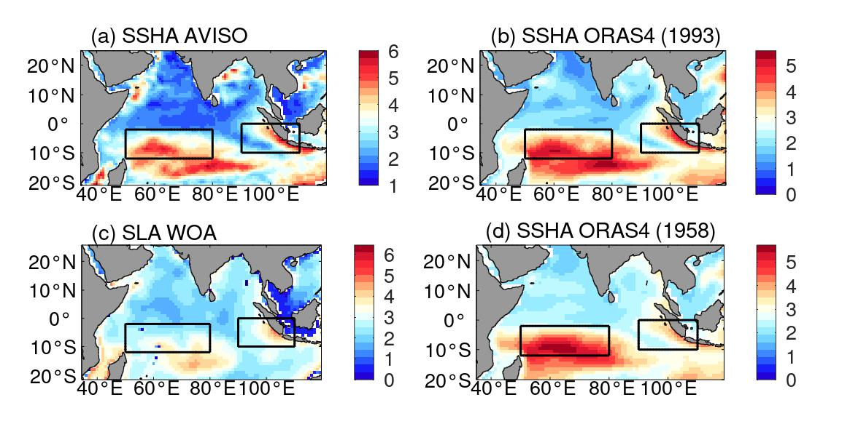

Figure S1: Standard deviation (STD) of annual mean of (a) SSHA (units: cm) based on AVISO SSHA from 1993-2016, (b) SSHA (referred to as ZOS) based on ORAS4 reanalysis from 1993-2016, (c) WOA13 upper-700m thermosteric sea level anomaly (SLA; cm) for 1958-2015, and (d) SSHA based on ORAS4 reanalysis from 1958-2016.

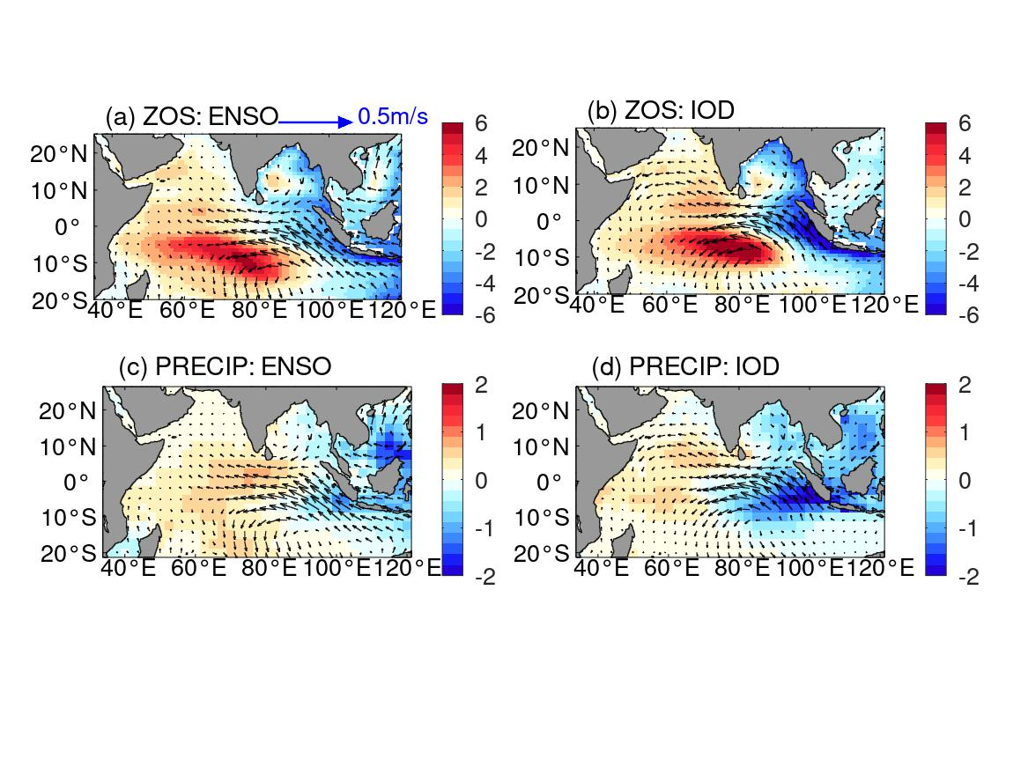

Figure S2: The regression of atmospheric and oceanic variability onto the ENSO index from 1958-2016 in the results of SLM. Color shades and vectors show (a) SSH and (c) precipitation anomalies and zonal and meridional winds anomaly at 1000hPa (vectors; unit: m/s) induced by ENSO, respectively. Panels b and d are the same as panels a and c, respectively, but for IOD effect. The units for SSHA, precipitation anomaly, wind are cm, mm/day, and m/s, respectively.

