Supplemental Material for “Effect of Sequence Pattern on Conformation of DOPA-Peptide Conjugate Aggregates: A Discontinuous Molecular Dynamics Simulation Study”

Supplemental Material

S1. Trial Results for Design Set 1 (Effect of Varying the DOPA percentage)

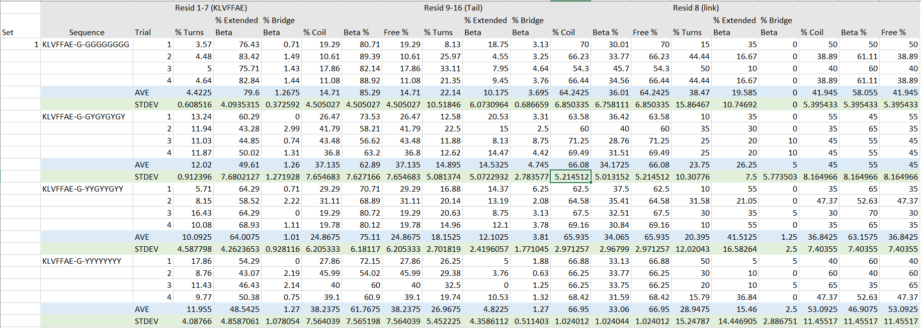

S2. Trial Results for Design Set 2 (Effect of Varying the DOPA pattern)
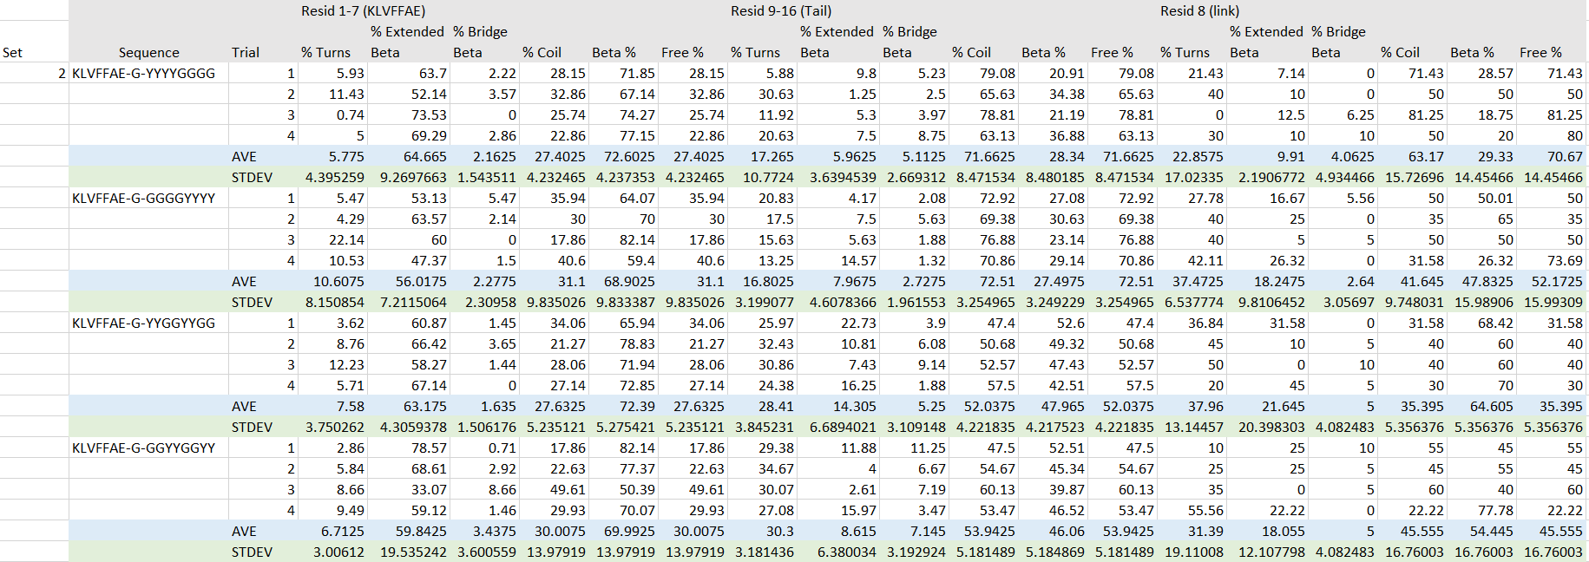
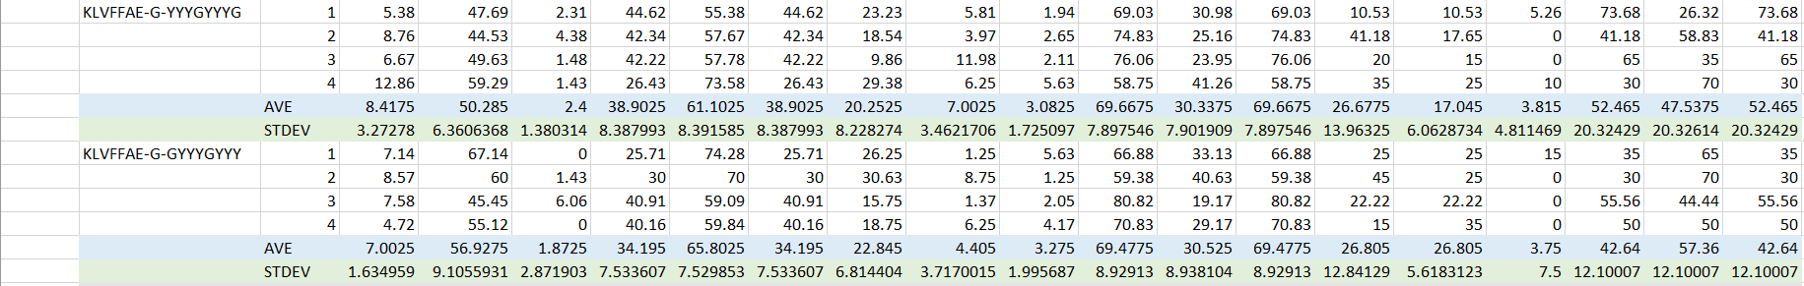

S3. Contact Maps for Design Set 2 Sequences
A) KLVFFAE-G-YYYYGGGG | B) KLVFFAE-G-GGGGYYYY
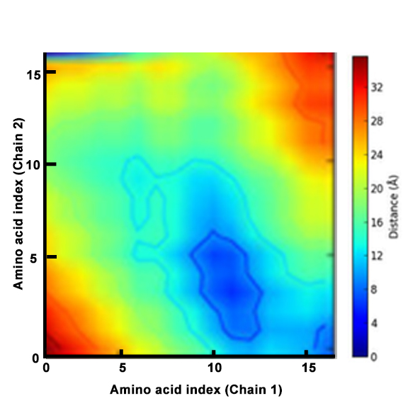 | 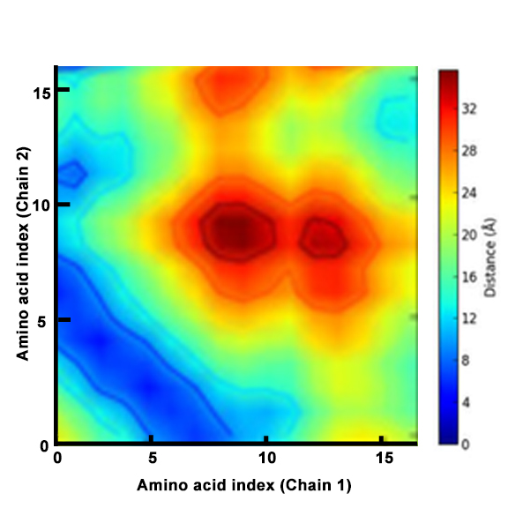
C) KLVFFAE-G-YYGGYYGG | D) KLVFFAE-G-GGYYGGYY
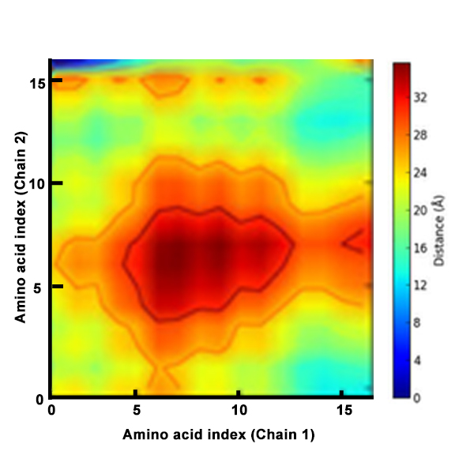 | 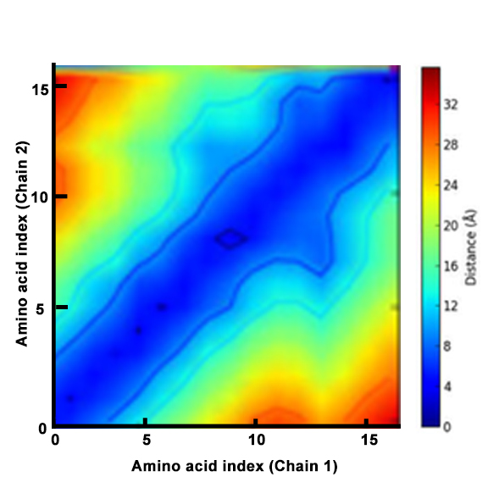
E) KLVFFAE-G-YYYGYYY | F) KLVFFAE-G-GYYYGYYY
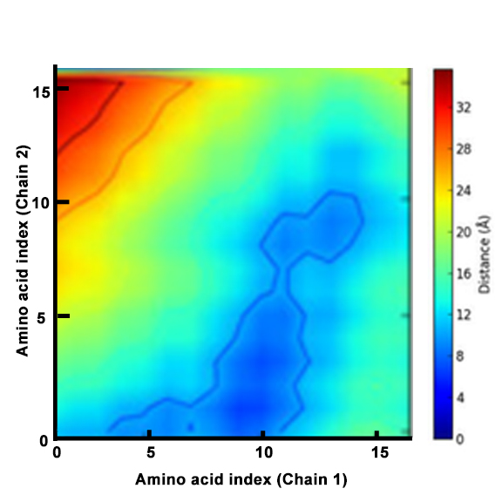 | 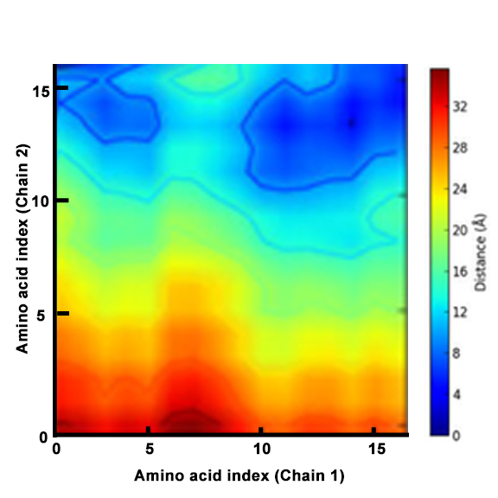
Figure S3: Design Set 2. Contact maps comparing the distances between the amino acid residues of two sample chains for designs varying in DOPA tail pattern

S4. Trial Results for Design Set 3 (Effect of Adding K to DOPA Tail to Impart Stiffness)

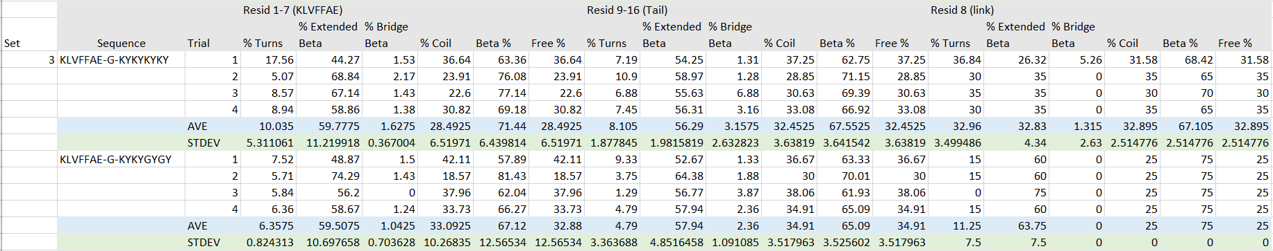

S5. Contact Maps for Design Set 3 Sequences
A) KLVFFAE-G-KYKYKYKY | B) KLVFFAE-G-KYKYGYGY
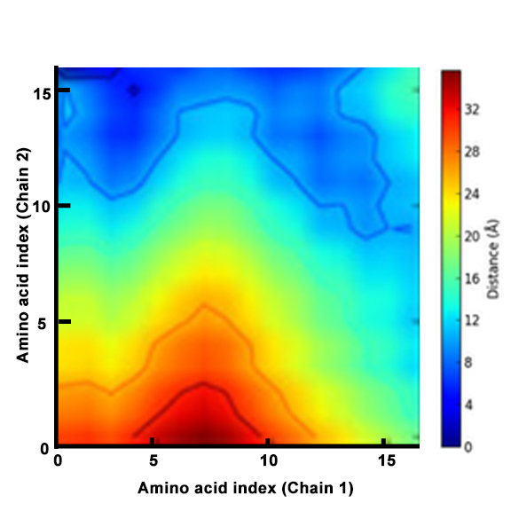 | 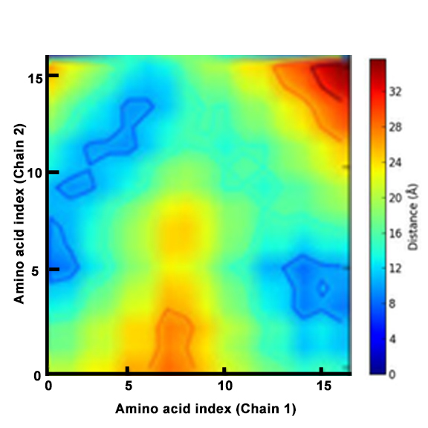
Figure S5: Design Set 3. Contact maps comparing the distances between the amino acid residues of two sample chains for designs including K in the tail for stiffness

S6. Trial Results for Design Set 4 (Effect of Linker Sequence in Design)

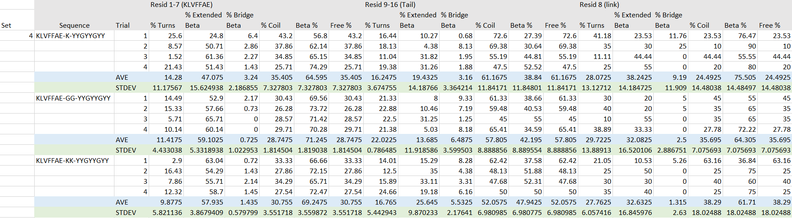

S7. Contact Maps for Design Set 4 Sequences
A) KLVFFAE-K-YYGYYGYY | B) KLVFFAE-GG-YYGYYGYY
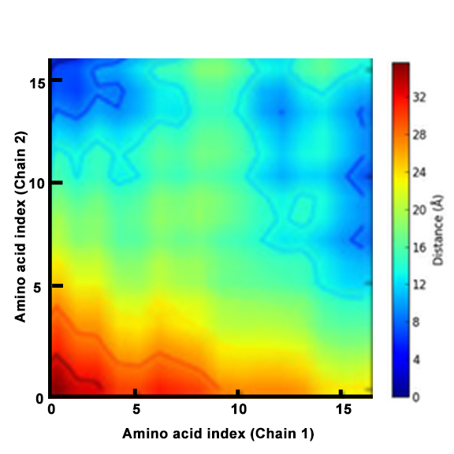 | 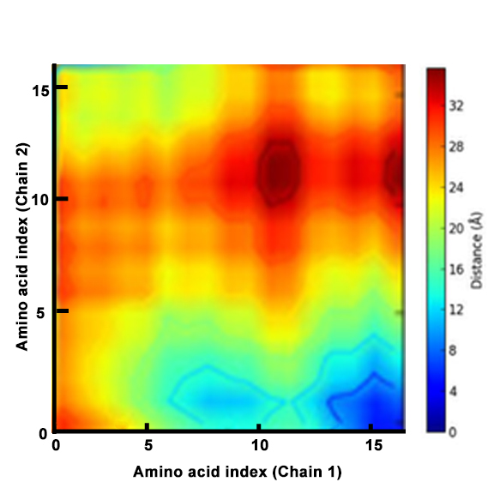
C) KLVFFAE-KK-YYGYYGYY
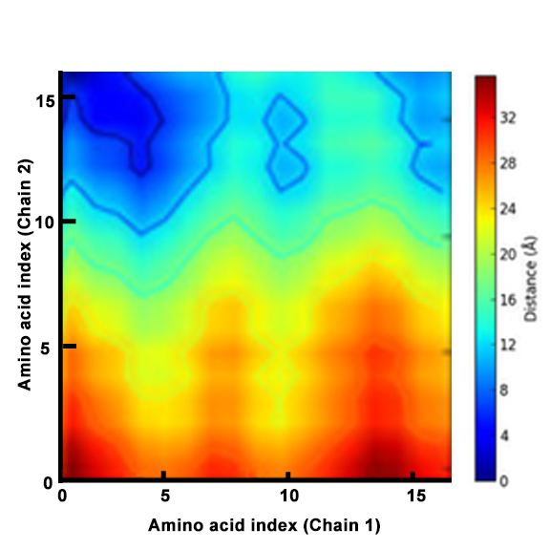
Figure S7: Design Set 4. Contact maps comparing the distances between the amino acid residues of two sample chains for designs varying in linker type
Note that for the GG and KK linker sequences, the contact maps include 17 amino acid residues in each of the two chains, so the indices go up to 17 on each of the axes.

