Supplementary Material

Patterns of winter occurrence of three sympatric killer whale populations off eastern Vancouver Island, Canada, based on passive acoustic monitoring
James Pilkington, Eva H. Stredulinsky, Katherine Gavrilchuk, Sheila J. Thornton, John K.B. Ford† and Thomas Doniol-Valcroze†*
† These authors share senior authorship
* Correspondence:
Thomas Doniol-Valcroze
thomas.doniol-valcroze@dfo-mpo.gc.ca

Supplementary Figures
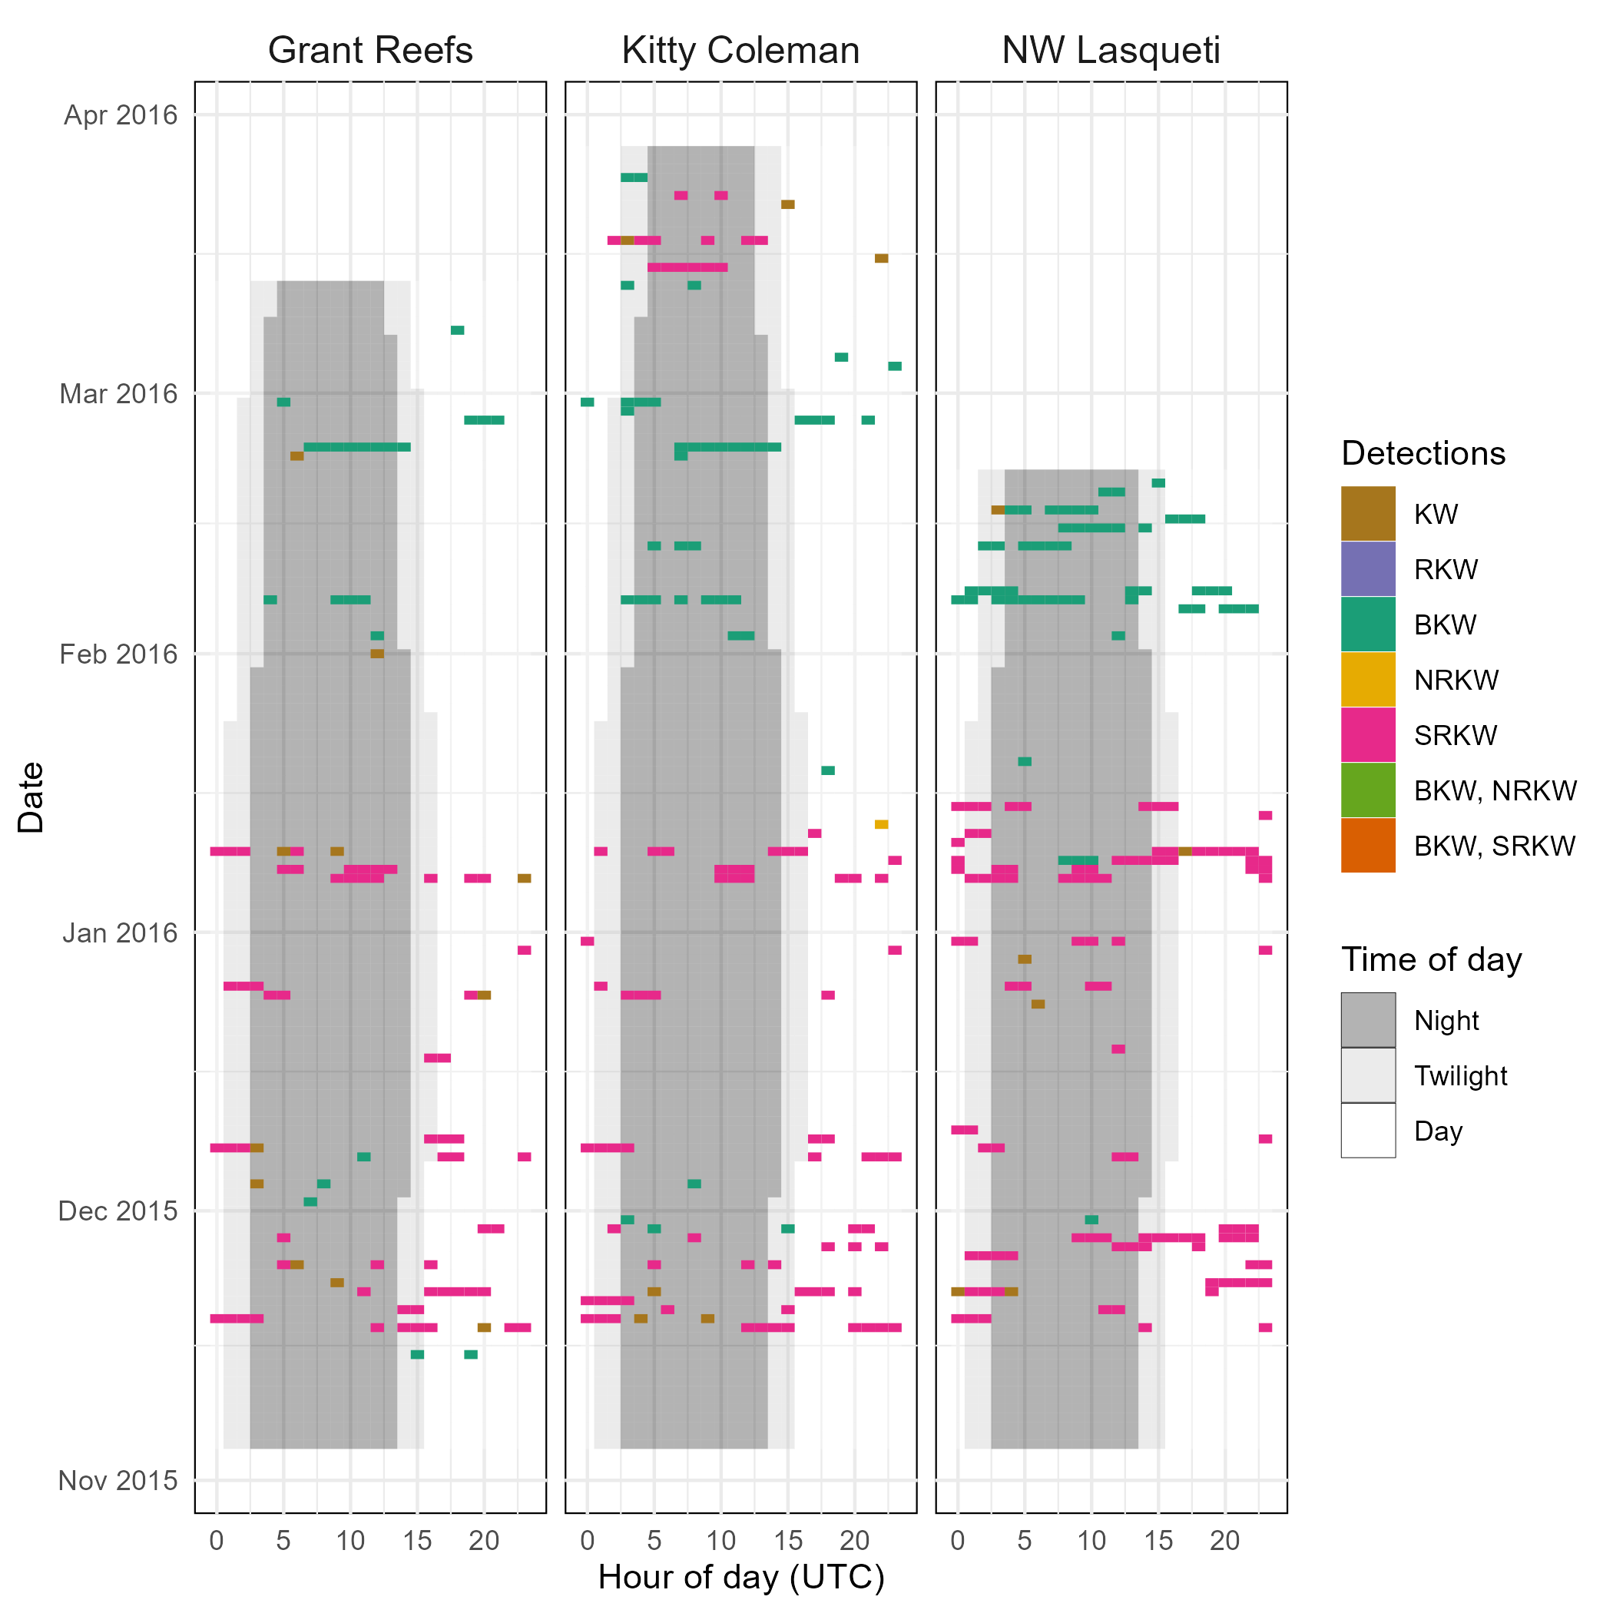
Supplementary Figure 1. Raw detections for each recorder site by date and time of day for the first winter season (Nov 2015 – Mar 2016). Time of day coloring only displayed for the duration of the deployment(s) (i.e., a completely blank row of cells indicates no recorder was active at the site on that day). Detections with multiple populations listed indicate those populations were detected within the same hour at the given site. RKW refers to detection(s) of resident killer whales, where acoustic clan (and therefore population) could not be determined. KW refers to detections of killer whales where ecotype could not be assigned.

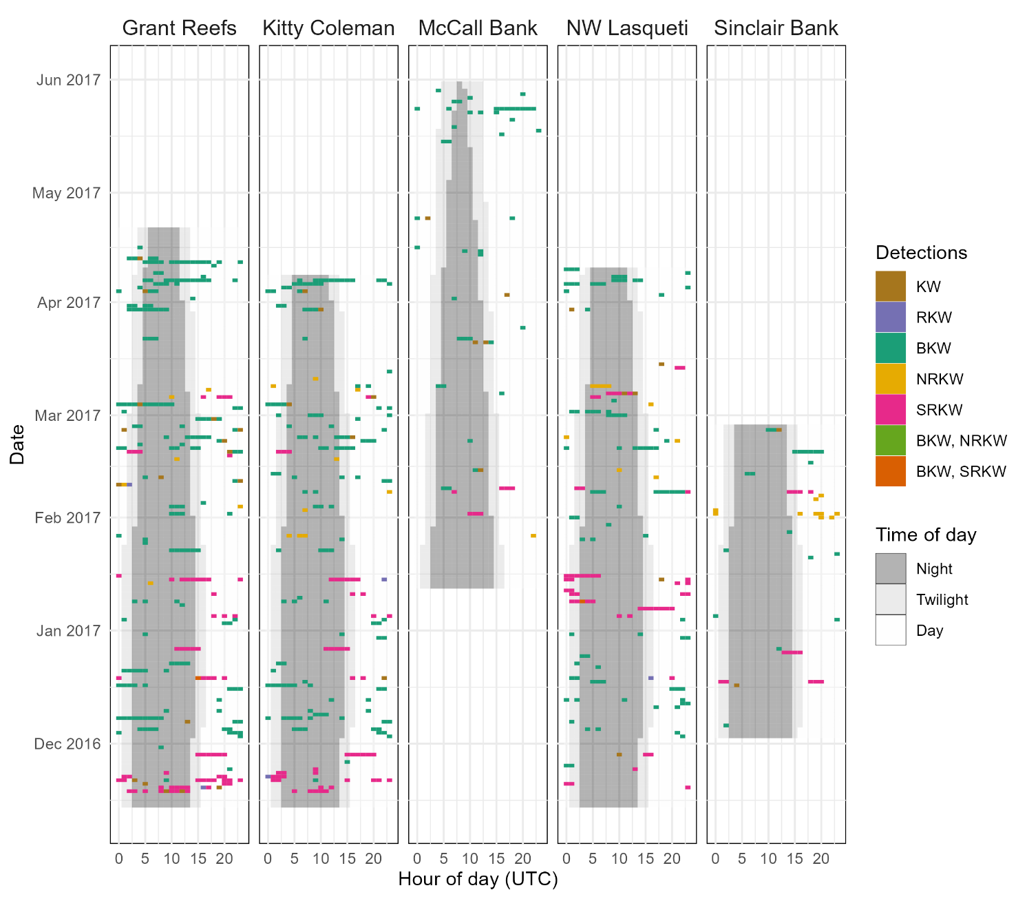
Supplementary Figure 2. Raw detections for each recorder site by date and time of day for the second winter season (Nov 2016 – May 2017). Time of day coloring only displayed for the duration of the deployment(s) (i.e., a completely blank row of cells indicates no recorder was active at the site on that day). Detections with multiple populations listed indicate those populations were detected within the same hour at the given site. RKW refers to detection(s) of resident killer whales, where acoustic clan (and therefore population) could not be determined. KW refers to detections of killer whales where ecotype could not be assigned.

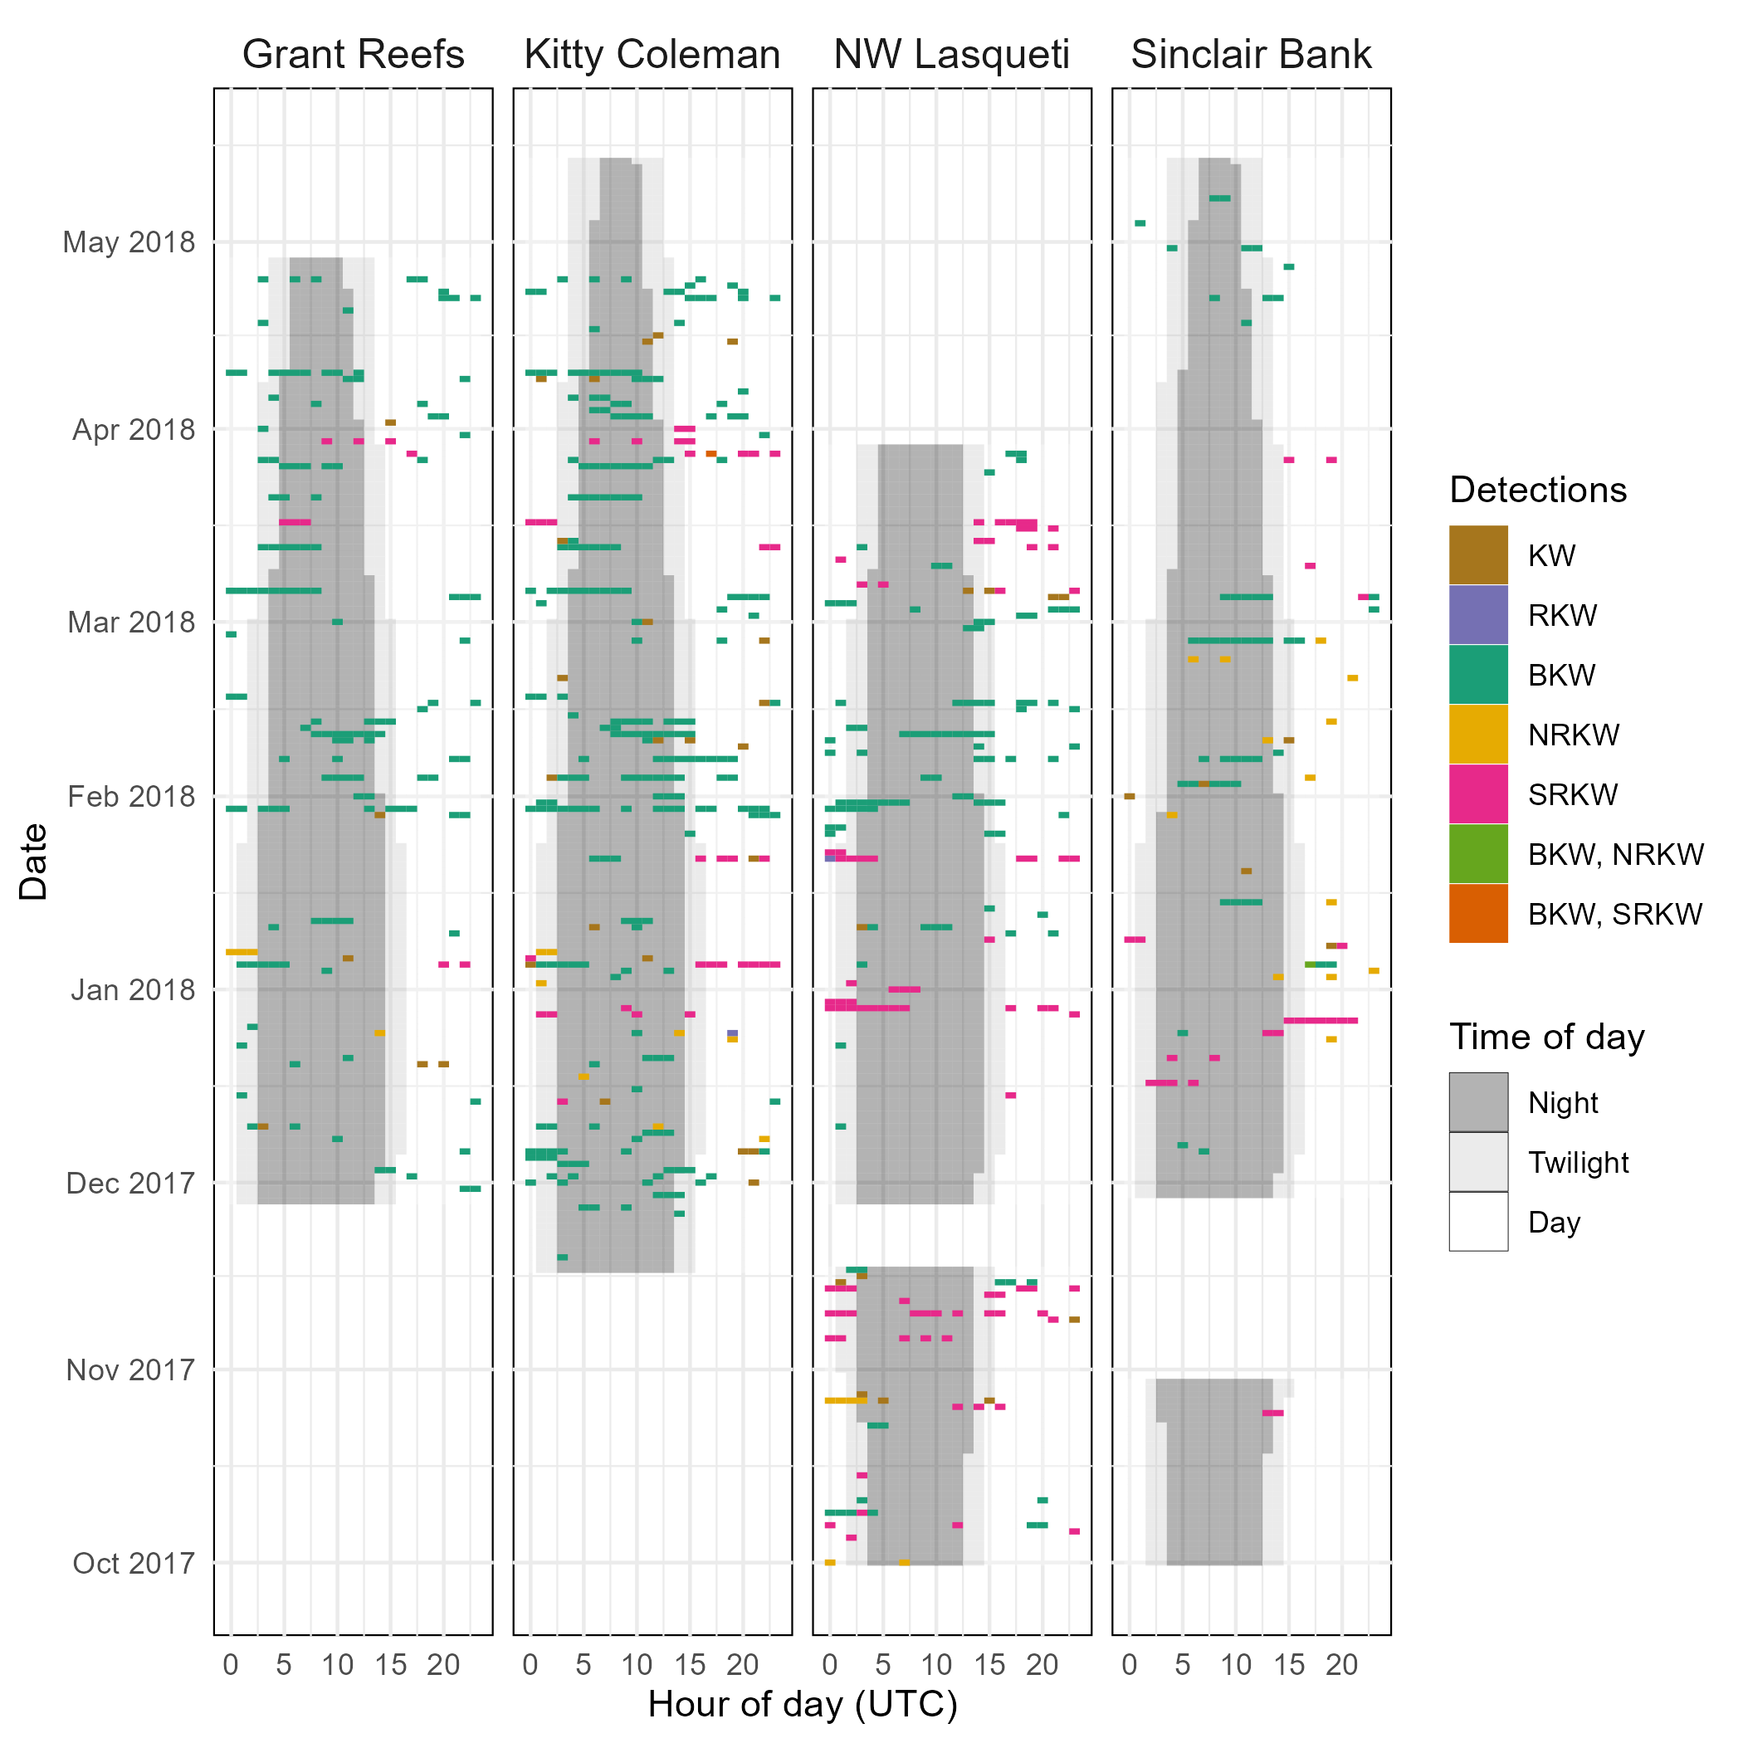
Supplementary Figure 3. Raw detections for each recorder site by date and time of day for the third winter season (Oct 2017 – May 2018). Time of day coloring only displayed for the duration of the deployment(s) (i.e., a completely blank row of cells indicates no recorder was active at the site on that day). Detections with multiple populations listed indicate those populations were detected within the same hour at the given site. RKW refers to detection(s) of resident killer whales, where acoustic clan (and therefore population) could not be determined. KW refers to detections of killer whales where ecotype could not be assigned.

Supplementary Tables
Supplementary Table 1. Acoustic recorder deployment details for deployments analyzed in this study (n=14).
ID | Site | Latitude | Longitude | Recorder  depth  (m) | Recorder  type | Sample  Frequency  (Hz) | Start date | End date | Total duration (days)
AM077 | Grant Reefs | 49.8902 | -124.8356 | 40 | MicroMARS | 25000 | 2015-11-05 | 2016-03-13 | 129
AM088 | Grant Reefs | 49.8900 | -124.8360 | 40 | ST303HF | 48000 | 2016-11-14 | 2017-04-21 | 158
AM113 | Grant Reefs | 49.8902 | -124.8361 | 41 | MicroMARS | 25000 | 2017-11-28 | 2018-04-28 | 151
AM078 | Kitty Coleman | 49.8060 | -124.9939 | 39 | MicroMARS | 25000 | 2015-11-05 | 2016-03-28 | 144
AM089 | Kitty Coleman | 49.8065 | -124.9941 | 37 | MicroMARS | 25000 | 2016-11-14 | 2017-04-08 | 145
AM111 | Kitty Coleman | 49.8058 | -124.9941 | 36 | ST303HF | 48000 | 2017-11-17 | 2018-05-14 | 178
AM092 | McCall Bank | 49.3532 | -123.6769 | 220 | ST303STD | 36000 | 2017-01-13 | 2017-05-31 | 138
AM079 | NW Lasqueti | 49.5144 | -124.3899 | 35 | ST303STD | 36000 | 2015-11-05 | 2016-02-21 | 108
AM090 | NW Lasqueti | 49.5143 | -124.3899 | 32 | MicroMARS | 25000 | 2016-11-14 | 2017-04-10 | 147
AM107 | NW Lasqueti | 49.5145 | -124.3892 | 32 | ST303STD | 36000 | 2017-10-01 | 2017-11-17 | 47
AM114 | NW Lasqueti | 49.5144 | -124.3897 | 29 | MicroMARS | 25000 | 2017-11-28 | 2018-03-29 | 121
AM091 | Sinclair Bank | 49.70385 | -124.2787 | 44 | MicroMARS | 25000 | 2016-12-03 | 2017-02-26 | 85
AM108 | Sinclair Bank | 49.7040 | -124.2791 | 42 | MicroMARS | 25000 | 2017-10-01 | 2017-10-30 | 29
AM112 | Sinclair Bank | 49.7039 | -124.2791 | 44 | ST303STD | 36000 | 2017-11-29 | 2018-05-14 | 166

Supplementary Table 2. Residence model parameter estimates (and their standard errors, se) and model fit metrics (pseudo-R²) for site-specific and regional models, where a = mean time acoustically present, b = mean time acoustically absent (before ‘returning’), and P_{inf} = average probability of detecting a population at any given time. Models for which P_{inf} is not reached within the range of observed values report instead the probability of detecting a population after the maximum time lag observed in the given year, denoted by asterisk. ‘Sites pooled’ presents average at-site acoustic presence and absence. Dashes indicate a model was unable to be fit (typically due to paucity of data) and therefore no residency estimates are available. Sites with no effort in the given study year indicated by ‘n/a’. Models with pseudo-R² values > 0.2 are considered better than the null model. As recorder detection ranges varied among sites and years, depending on the recorder depth and prevailing oceanographic conditions, site-specific estimates are best evaluated as a relative comparison among populations.
BKW
 |  | Grant Reefs | Kitty Coleman | McCall Bank | NW Lasqueti | Sinclair Bank | Sites pooled | Region
2015-16 | a | 2.5 h (se: 0.15) | 2.6 h (se: 0.15) | n/a | 3 h (se: 0.2) | n/a | 2.7 h (se: 0.1) | 9.8 d (se: 0.7)
 | b | 93 h (se: 17.7) | 76 h (se: 8.8) | n/a | 44 h (se: 3.7) | n/a | 54 h (se: 3.4) | 301.1 d (se: 114.1)
 | P_{inf} | 0.026 (se: 0.004) | 0.034 (se: 0.003) | n/a | 0.065 (se: 0.003) | n/a | 0.048 (se: 0.002) | 0.031* (se: 0.011)
 | R² | 0.76 | 0.65 | n/a | 0.50 | n/a | 0.57 | 0.47
2016-17 | a | 3.6 h (se: 0.14) | 2.3 h (se: 0.09) | - | 1.9 h (se: 0.07) | - | 1.9 h (se: 0.06) | 13.0 d (se: 1.1)
 | b | 61 h (se: 3.2) | 53 h (se: 3.1) | - | 62 h (se: 4.1) | - | 42 h (se: 1.9) | 57.4 d (se: 7.0)
 | P_{inf} | 0.056 (se: 0.002) | 0.041 (se: 0.002) | - | 0.029 (se: 0.001) | - | 0.044 (se: 0.001) | 0.184* (se: 0.010)
 | R² | 0.72 | 0.64 | - | 0.68 | - | 0.47 | 0.52
2017-18 | a | 2.7 h (se: 0.09) | 3.1 h (se: 0.11) | n/a | 2.5 h (se: 0.11) | 2.7 h (se: 0.12) | 2.7 h (se: 0.06) | 41.4 d (se: 2.2)
 | b | 76 h (se: 4.1) | 47 h (se: 2.3) | n/a | 50 h (se: 3.2) | 108 h (se: 14.8) | 58 h (se: 1.9) | 835.6 d (se: 399.2)
 | P_{inf} | 0.035 (se: 0.001) | 0.061 (se: 0.002) | n/a | 0.047 (se: 0.002) | 0.024 (se: 0.003) | 0.045 (se: 0.001) | 0.047* (se: 0.016)
 | R² | 0.77 | 0.72 | n/a | 0.63 | 0.80 | 0.69 | 0.63
SRKW
 |  | Grant Reefs | Kitty Coleman | McCall Bank | NW Lasqueti | Sinclair Bank | Sites pooled | Region
2015-16 | a | 2.9 h (se: 0.13) | 2.2 h (se: 0.1) | n/a | 2.3 h (se: 0.12) | n/a | 2.5 h (se: 0.07) | 8.5 d (se: 0.8)
 | b | 68 h (se: 4.9) | 61 h (se: 4.3) | n/a | 38 h (se: 2.6) | n/a | 52 h (se: 2.2) | 64.9 d (se: 9.9)
 | P_{inf} | 0.041 (se: 0.002) | 0.035 (se: 0.002) | n/a | 0.057 (se: 0.002) | n/a | 0.045 (se: 0.001) | 0.116* (se: 0.010)
 | R² | 0.69 | 0.66 | n/a | 0.52 | n/a | 0.6 | 0.54
2016-17 | a | 3.5 h (se: 0.15) | 2.2 h (se: 0.09) | - | - | 1.9 h (se: 0.23) | 2.3 h (se: 0.08) | 3.9 d (se: 0.5)
 | b | 104 h (se: 9) | 98 h (se: 9.3) | - | - | 63 h (se: 26.1) | 65 h (se: 4) | 38.0 d (se: 7.1)
 | P_{inf} | 0.032 (se: 0.002) | 0.022 (se: 0.002) | - | - | 0.03 (se: 0.011) | 0.034 (se: 0.002) | 0.094 (se: 0.009)
 | R² | 0.67 | 0.71 | - | - | 0.71 | 0.58 | 0.21
2017-18 | a | 1.2 h (se: 0.14) | 2.2 h (se: 0.08) | n/a | 2.3 h (se: 0.13) | 2.4 h (se: 0.23) | 2.1 h (se: 0.07) | 2.3 d (se: 0.2)
 | b | 50 h (se: 14.5) | 222 h (se: 38.2) | n/a | 95 h (se: 11.5) | 43 h (se: 6.9) | 87 h (se: 7.4) | 43.6 d (se: 5.7)
 | P_{inf} | 0.023 (se: 0.006) | 0.01 (se: 0.002) | n/a | 0.024 (se: 0.002) | 0.054 (se: 0.006) | 0.023 (se: 0.002) | 0.050 (se: 0.004)
 | R² | 0.26 | 0.65 | n/a | 0.5 | 0.55 | 0.46 | 0.45
NRKW
 |  | Grant Reefs | Kitty Coleman | McCall Bank | NW Lasqueti | Sinclair Bank | Sites pooled | Region
2015-16 | a | - | - | n/a | - | n/a | - | -
 | b | - | - | n/a | - | n/a | - | -
 | P_{inf} | - | - | n/a | - | n/a | - | -
 | R² | - | - | n/a | - | n/a | - | -
2016-17 | a | 0.9 h (se: 0.1) | 0.8 h (se: 0.08) | - | - | 1.5 h (se: 0.21) | 0.9 h (se: 0.06) | 0.6 d (se: 0.07)
 | b | 105 h (se: 48.9) | 49 h (se: 14.6) | - | - | 27 h (se: 6.3) | 38 h (se: 6) | 23 d (se: 5.4)
 | P_{inf} | 0.009 (se: 0.004) | 0.017 (se: 0.004) | - | - | 0.052 (se: 0.009) | 0.023 (se: 0.003) | 0.024 (se: 0.004)
 | R² | 0.39 | 0.31 | - | - | 0.21 | 0.19 | 0.13
2017-18 | a | 1.4 h (se: 0.31) | - | n/a | - | - | - | 0.2 d (se: 0.08)
 | b | 60 h (se: 45.9) | - | n/a | - | - | - | 25.9 d (se: 12.4)
 | P_{inf} | 0.023 (se: 0.016) | - | n/a | - | - | - | 0.007 (se: 0.001)
 | R² | 0.3 | - | n/a | - | - | - | 0.00

