Intraindividual variability of the histological, chronological and growth patterns in post-cranial elements of Liaoningvenator curriei (Paraves: Troodontidae).
Damien Martin^{a,b}, Shen Caizhi^{c,d} and Martin Kundrát^{b,}*

Supplementary file

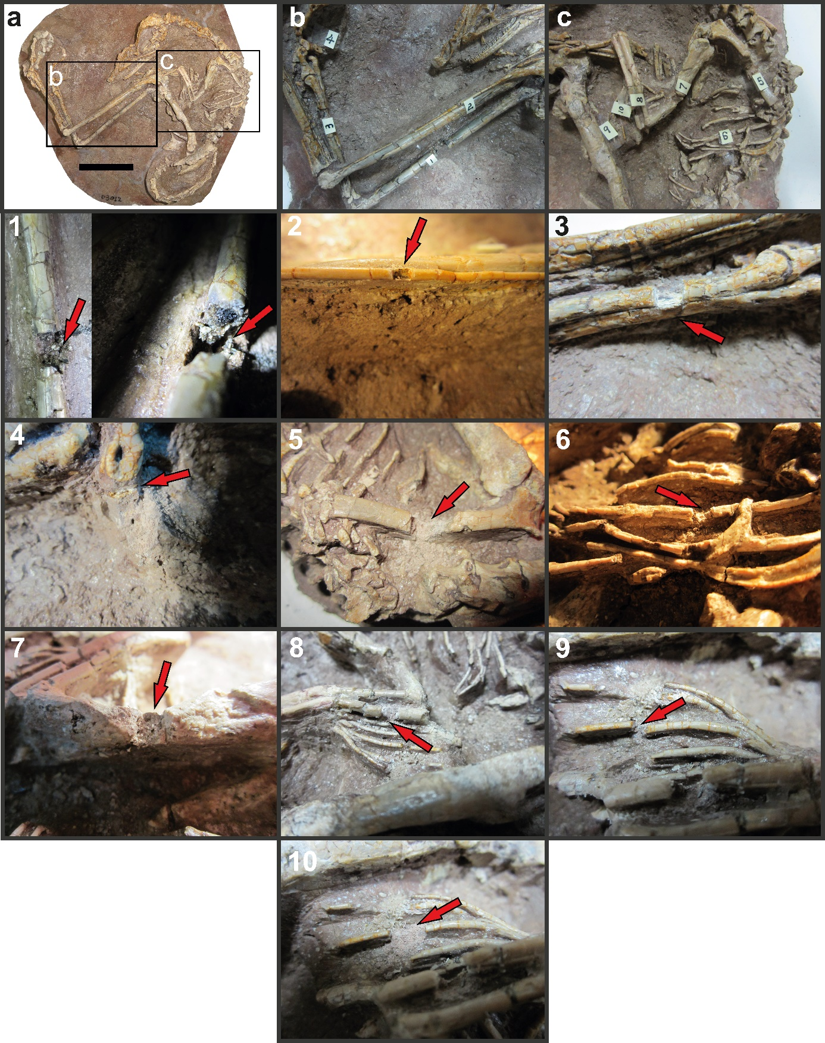
Figure S1: Photos of the holotype of Liaoningvenator curriei showing the location of sample extraction for the preparation of thin sections.

