Supplementary information for

In silico evaluation of pharmacokinetic parameters, delivery, distribution, and anticoagulative effects of new 4,7-dihydroxycoumarin derivative

Žiko Milanović ^{a*}, Marko Antonijević ª , Edina Avdović ª, Vladimir Simić ª, Miljan Milošević ^{a,b,c}, Zana Dolićanin ^{d}, Miloš Kojić ^{b,d,e} and Zoran Marković ^{a,d}
ª Institute for Information Technologies, Department of Science, University of Kragujevac, 34000 Kragujevac, Serbia
^{b} Bioengineering Research and Development Center (BioIRC), Prvoslava Stojanovića 6, 34000 Kragujevac, Serbia
^{c} Faculty of Information Technology, Belgrade Metropolitan University, Tadeuša Košćuška 63, Belgrade 11158, Serbia.
^{d} Department of Natural Science and Mathematics, State University of Novi Pazar, Vuka Karadžića bb, 36300, Novi Pazar, Serbia
^{e} Serbian Academy of Sciences and Arts, Kneza Mihaila 35, Belgrade 11000, Serbia
^{f}Houston Methodist Research Institute, Houston TX 77030, USA.

*Corresponding author’s e-mail address: ziko.milanovic@uni.kg.ac.rs (Ž.M)
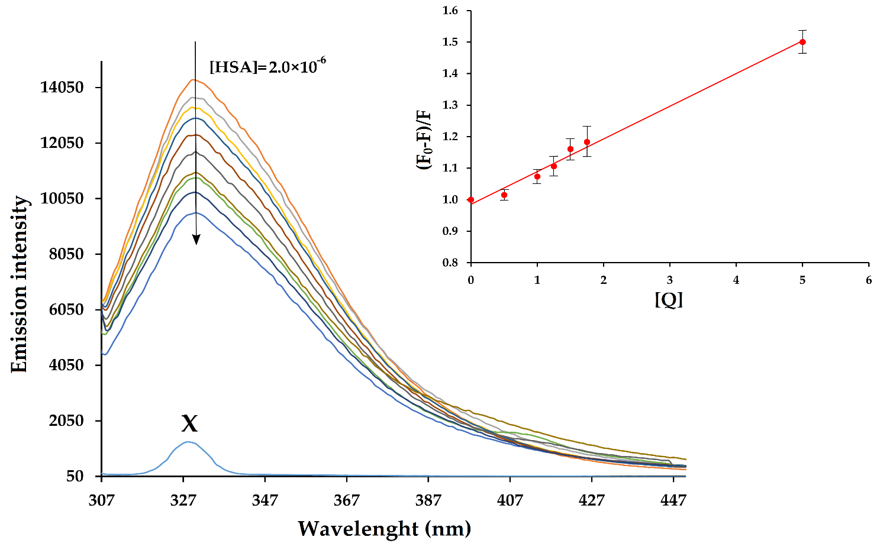
Figure S1. Fluorescence emission spectra of HSA with the presence of different concentrations of L (T = 303 K, pH = 7.4). The initial concentration was [HSA] = 2 µM; The concentration of L was in the range of [L]= 0–5 µM. Inset: Graph dependence of (F₀-F)/F on [Q] – Stern-Volmer plots of the fluorescence quenching of HSA-L at 303 K with error bars estimated from at three individual measurements.

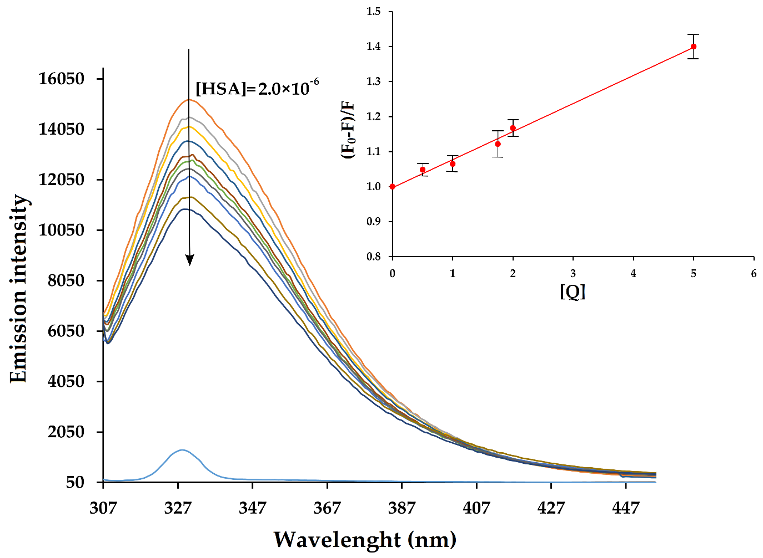

Figure S2. Fluorescence emission spectra of HSA with the presence of different concentrations of L (T = 310 K, pH = 7.4). The initial concentration was [HSA] = 2 µM; The concentration of L was in the range of [L]= 0–5 µM. Inset: Graph dependence of (F₀-F)/F on [Q] – Stern-Volmer plots of the fluorescence quenching of HSA-L at 310 K with error bars estimated from at three individual measurements.

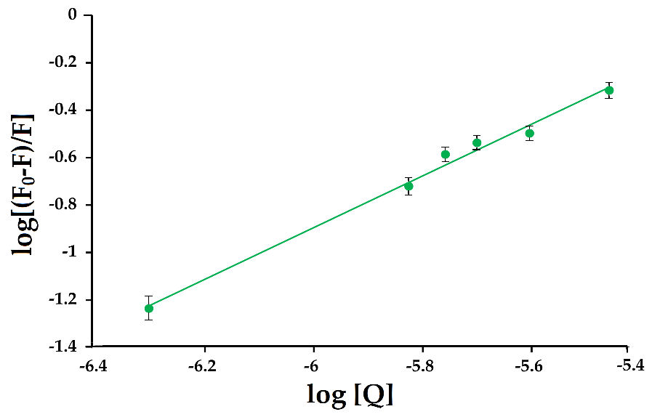
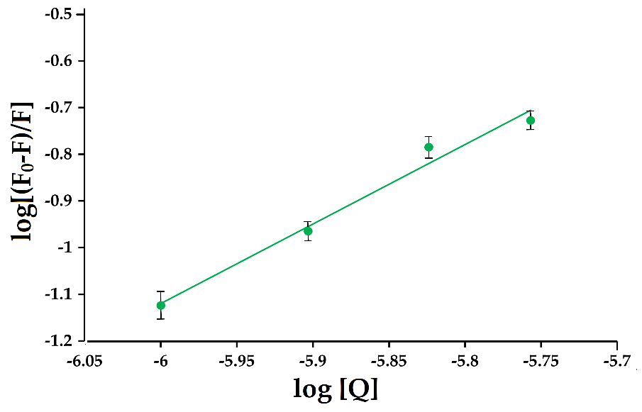
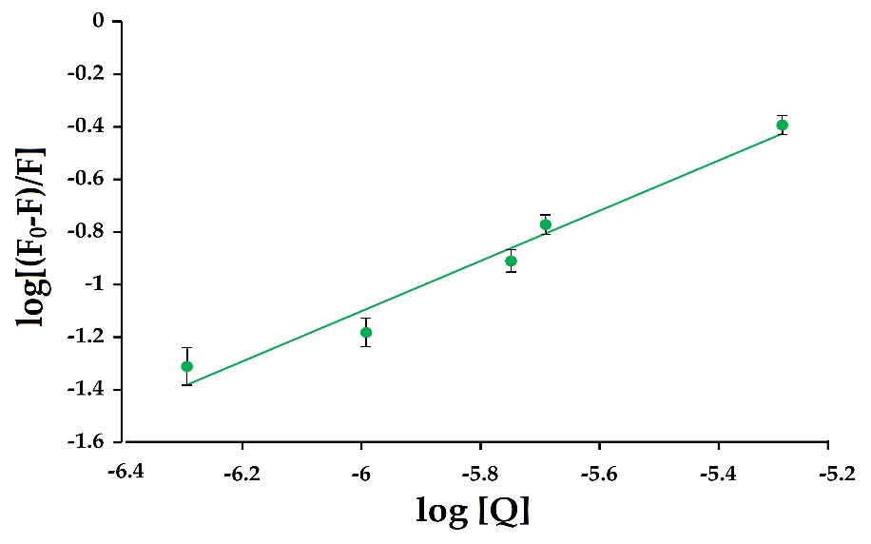
Figure S3. Graphs of the dependence of log[(F₀-F)/F] on log[Q] at different temperatures 296 (up), 303 (middle), and 310 (down) K with error bars estimated from at three individual measurements.
Table S1. Binding energies (ΔG_{bind}) obtained through the molecular dynamic simulations (kJ mol^{–1})

Compound/Protein | HSA | VKOR
WF | -136.4 | -166.8
L | -108.2 | -179.8

