*Marine and Freshwater Behaviour and Physiology* Supplementary material for

**A modified CTAB method for high-molecular-weight DNA preparation from deep-sea holothurians**

Yujin Pua,b, Jun Liua, Nannan Zhangc, Shanshan Liuc and Haibin Zhanga, @

a Sanya Institute of Deep-sea Science and Engineering, Chinese Academy of Sciences, , China; b University of Chinese Academy of Sciences, Beijing, China; c BGI-Qingdao, BGI-Shenzhen, Qingdao, China

*Corresponding author: Haibin Zhang, hzhang@idsse.ac.cn

Table A1. Reagents of DNA extraction in this study

|  |  |
| --- | --- |
| Categories | Reagents |
| Kits | Animals Genomic DNA Quick extraction Kit (Sangon Biotech, Shanghai, China) |
| TIANamp Marine Animals DNA Kit (Tiangen, Beijing, China) |
| QIAamp DNA Mini Kit (Qiagen, Hilden, Germany) |
| E.Z.N.A. Mollusc DNA Kit (Omega Bio-tek, Inc., Georgia, USA) |
| Lysis buffer | CTAB (Solarbio, cat. no. C8440) |
| 10% SDS solution (Sangon Biotech, cat. no. SD8118) |
| 1M Tris-HCl, pH9.5, Sterile, DNase free (Beyotime, cat. No. ST790) |
| 1M Tris-HCl, pH8.0, Sterile, DNase free (Beyotime, cat. No. ST780) |
| 0.5 M EDTA, PH8.0 (Solarbio, cat. no. E1170) |
| NaCl (Xilong Scientific, cat. No 10101101) |
| PVP-40, polyvinylpyrrolidone (Biosharp, cat. no. BS015) |
| β-mercaptoethanol, βME (Macklin, cat. No. M828395) |
| Phase separation | DNA Extraction Reagent, phenol: Chloroform: Isoamylol=25:24:1, pH>7.8 (Solarbio, cat. no. P1012) |
| DNA/RNA Extraction Reagent, Chloroform: Isoamylol=24:1 (Solarbio, cat. no. P1014) |
| DNA precipitation | 3M sodium acetate pH5.2 (Biosharp, cat. no. BL541A) |
| Ethanol (Xilong Scientific, cat. no. 12803401) |
| Elution buffer | Buffer TE (Tiangen, cat. no. RK121-03) |
| Enzymes | Proteinase K 20 mg mL-1 (Tiangen, cat. no. RT403-02) |
| RNaseA 100 mg mL-1 (Tiangen, cat. no. RT405-12) |

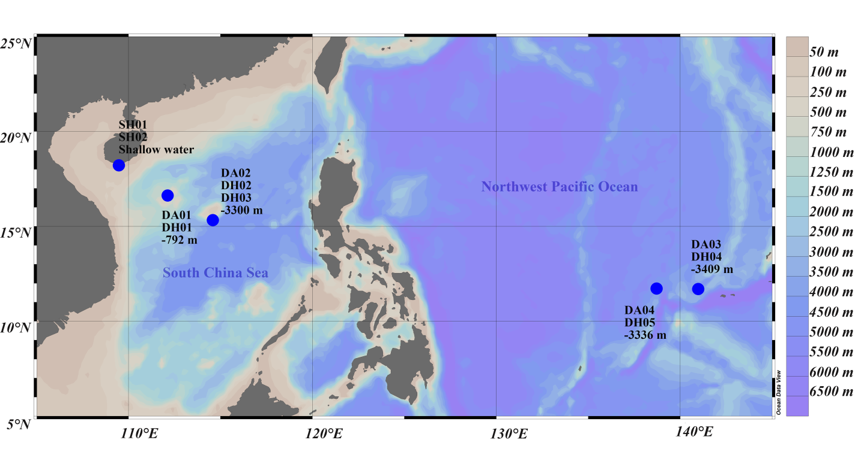

Figure A1. Locations of sample collected sites on map using Ocean Data View software (Schlitzer 2018).



Figure A2. Experimental design.