Supplementary Material

Supplementary Figures
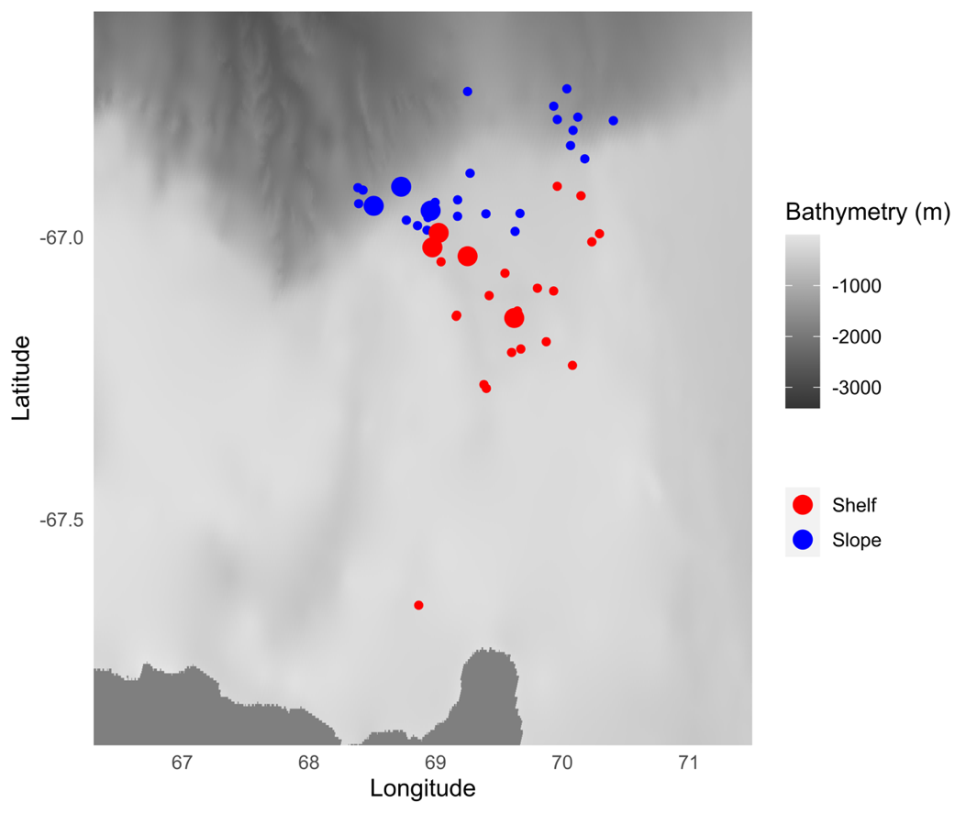
Figure S1. Geographic distribution of chlorophyll fluorescence profiles recorded within Cape-Darnley polynya in August. Profiles are represented by a different color according to their location: red and blue points correspond to profiles recorded on the continental shelf and on the continental slope, respectively. Bigger points represent profiles with a fluorescence signal greater than 0.06 mg.m⁻³ between 125 and 170 m depth. Those points were located within the continental slope or in its vicinity. The bathymetry used for the map is the one from GEBCO data (2021).

Supplementary Tables
Table S1. Temporal and vertical distribution of the water masses identified within Cape-Darnley polynya on the shelf. When the sum is not equal to 100% this means that other water masses, not considered in this study, were present. The number of profiles used to compute the percentages is indicate in the column title.
 |  | Feb  n = 13 | Mar  n = 11 | Apr  n = 19 | May  n = 12 | Jun  n = 43 | Jul  n = 3 | Aug  n = 23 | Sep  n = 12
1 – 50 m | AASW | 98.95% | 100% | 100% |  | 3.30% | 70.80% | 70.87% | 75%
 | mCDW
 | ISW |  |  |  | 11.17% | 0.17%
 | DSW |  |  |  | 61.5% | 71.61% |  | 9.83% | 8.33%
 | mSW |  |  |  |  |  |  |  | 8.33%
51 – 100 m | AASW | 90.86% | 100% | 98.95% |  | 2.17% | 60% | 55.83% | 58.67%
 | mCDW |  |  |  |  |  | 16% | 4.09% | 3.17%
 | ISW |  |  |  | 48.83% | 16.96%
 | DSW |  |  |  | 31.67% | 62.48% |  | 11.13% | 6.33%
 | mSW |  |  |  |  |  |  |  | 12%
101 – 150 m | AASW | 66.57% | 100% | 86.25% |  | 2.23% | 58.33% | 48.70% | 48.91%
 | mCDW | 3.33% |  |  |  |  | 20.83% | 10.26% | 7.56%
 | ISW |  |  |  | 84.83% | 41.96%
 | DSW |  |  |  | 5.67% | 47.68% |  | 19.04% | 14.29%
 | mSW |  |  |  | 1.17% |  |  |  | 13.11%
151 – 170 m | AASW | 38.1% | 92.73% | 78.42% |  | 1.98% | 33.33% | 26.09% | 39.1%
 | mCDW | 23.57% |  |  |  |  | 58.33% | 8.70% | 9.1%
 | ISW |  |  |  | 75% | 39.53%
 | DSW |  |  |  | 8.33% | 55.81% |  | 26.09% | 18.18%
 | mSW |  |  |  | 5% |  |  | 0.65% | 9.1%

Table S2. Temporal and vertical distribution of the water masses identified within Cape-Darnley polynya on the slope. When the sum is not equal to 100% this means that other water masses, not considered in this study, were present. The number of profiles used to compute the percentages is indicate in the column title.
 |  | Feb  n = 13 | Mar  n = 53 | Apr  n = 18 | May  n = 4 | Jun  n = 25 | Jul  n = 18 | Aug  n = 25 | Sep  n = 2
1 – 50 m | AASW | 100% | 99.61% | 100% | 71.43% | 87.10% | 100% | 96.15% | 100%
 | mCDW
 | ISW |  | 0.25% |  | 7.71% | 2.06%
 | DSW |  |  |  | 20.86% | 10.84%
 | mSW
51 – 100 m | AASW | 100% | 99.12% | 100% | 71.43% | 86.30% | 100% | 92.46% | 100%
 | mCDW
 | ISW |  |  |  | 28.57% | 8.01%
 | DSW |  |  |  |  | 2.67%
 | mSW |  |  |  |  | 0.82%
101 – 150 m | AASW | 97.69% | 98.24% | 100% | 70.15% | 86.01% | 100% | 88.42% | 100%
 | mCDW |  |  |  |  |  |  | 0.15%
 | ISW |  |  |  | 19.70% | 10.49%
 | DSW |  |  |  | 10.15%
 | mSW
151 – 170 m | AASW | 84.62% | 98.18% | 100% | 31.25% | 84% | 100% | 88% | 100%
 | mCDW
 | ISW |  |  |  |  | 12%
 | DSW |  |  |  | 50%
 | mSW |  |  |  |  | 2.40%

Table S3. Temporal and vertical distribution of the water masses identified within Shackleton polynya. When the sum is not equal to 100% this means that other water masses, not considered in this study, were present. The number of profiles used to compute the percentages is indicate in the column title.
 |  | Jan  n = 32 | Feb  n = 110 | Mar  n = 63 | Apr  n = 55 | May  n = 57 | Jun  n = 11 | Jul  n = 44 | Aug  n = 35
1 – 50 m | AASW | 95.86% | 98.47% | 100% | 100% | 100% | 100% | 100% | 94.29%
 | mCDW | 1.21% | 0.3%
 | ISW | 0.6%
 | DSW | 0.09%
 | mSW
51 – 100 | AASW | 81.62% | 90.52% | 100% | 100% | 100% | 100% | 100% | 93.94%
 | mCDW | 2.6% | 2%
 | ISW | 5.35% | 1.77%
 | DSW | 5.81% | 1.92%
 | mSW | 0.98% | 0.18%
101 – 150 m | AASW | 71.1% | 84.46% | 96.77% | 100% | 100% | 100% | 100% | 89.09%
 | mCDW | 0.71% | 0.05% | 0.47%
 | ISW | 15.37% | 8.58%
 | DSW | 3.13% | 2.57%
 | mSW | 0.2% | 0.35%
151 – 170 m | AASW | 52.9% | 73.22% | 89.13% | 100% | 100% | 100% | 100% | 79.86%
 | mCDW | 3.35% | 2.75% | 4.2%
 | ISW | 19.82% | 10.66%
 | DSW | 4.57% | 1.78%
 | mSW

References
GEBCO Bathymetric Compilation Group 2021 (2021). The GEBCO_2021 Grid - a continuous terrain model of the global oceans and land. doi: 10.5285/c6612cbe-50b3-0cff-e053-6c86abc09f8f.

