Supplementary material

Supplementary Table 1. Pygmy right whale baleen growth estimates. Plate position intervals represents the two nitrogen (δ¹⁵N) minimums used to estimate the growth rate of that cycle.
Individual ID | Plate position intervals | Growth rate (cm/year)
M18943 | 3 - 25 | 22.0
 | 25 - 39 | 14.0
 | 39 - 51 | 12.0
 |  | 16 ± 5.3
M15696 | 8 - 24 | 16.0
 |  | 16.0
M14580 | 22 - 44 | 22.0
 |  | 22.0
M17363 | 2 - 27 | 25.0
 | 27 - 38 | 11.0
 | 38 - 57 | 19.0
 |  | 18.3 ± 7.0
M17362 | 12 - 25 | 13.0
 | 25 -42 | 17.0
 | 42 - 52 | 10.0
 |  | 13.3 ± 3.5
M18944 | 10 - 27 | 17.0
 |  | 17.0
M18945 | 20 - 48 | 28.0
 |  | 28.0
M21460 | 20 - 40 | 20.0
 | 40 - 57 | 17.0
 |  | 18.5 ± 2.1
M23548 | 10 - 22 | 12.0
 | 22 - 45 | 23.0
 | 45 - 69 | 24.0
 |  | 19.7 ± 6.7
M23863 | 19 - 40 | 21.0
 | 40 - 57 | 17.0
 |  | 19 ± 2.8
M25607 | 5 - 29 | 24.0
 | 29 - 50 | 21.0
 |  | 22.5 ± 2.1
M26437 | 16 - 40 | 24.0
 |  | 24.0
M28059 | 9 - 30 | 21.0
 | 30 - 44 | 14.0
 |  | 17.5 ± 4.9
M5589 | 15 - 34 | 19.0
 | 34 -51 | 17.0
 |  | 18 ± 1.4
Species average: |  | 18.5 ± 4.8

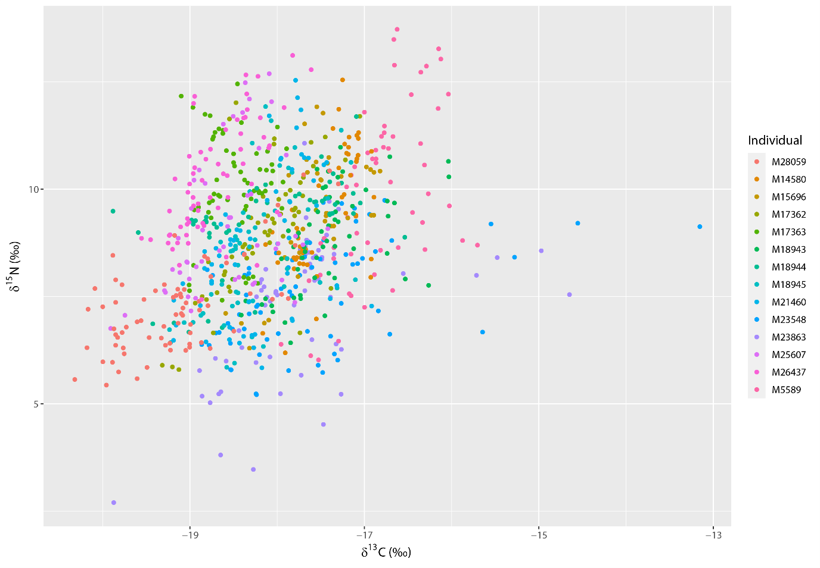
Supplementary Figure 1. Isoscape of nitrogen (δ¹⁵N) and carbon (δ¹³C) bulk stable isotope values for all individuals (n = 14).

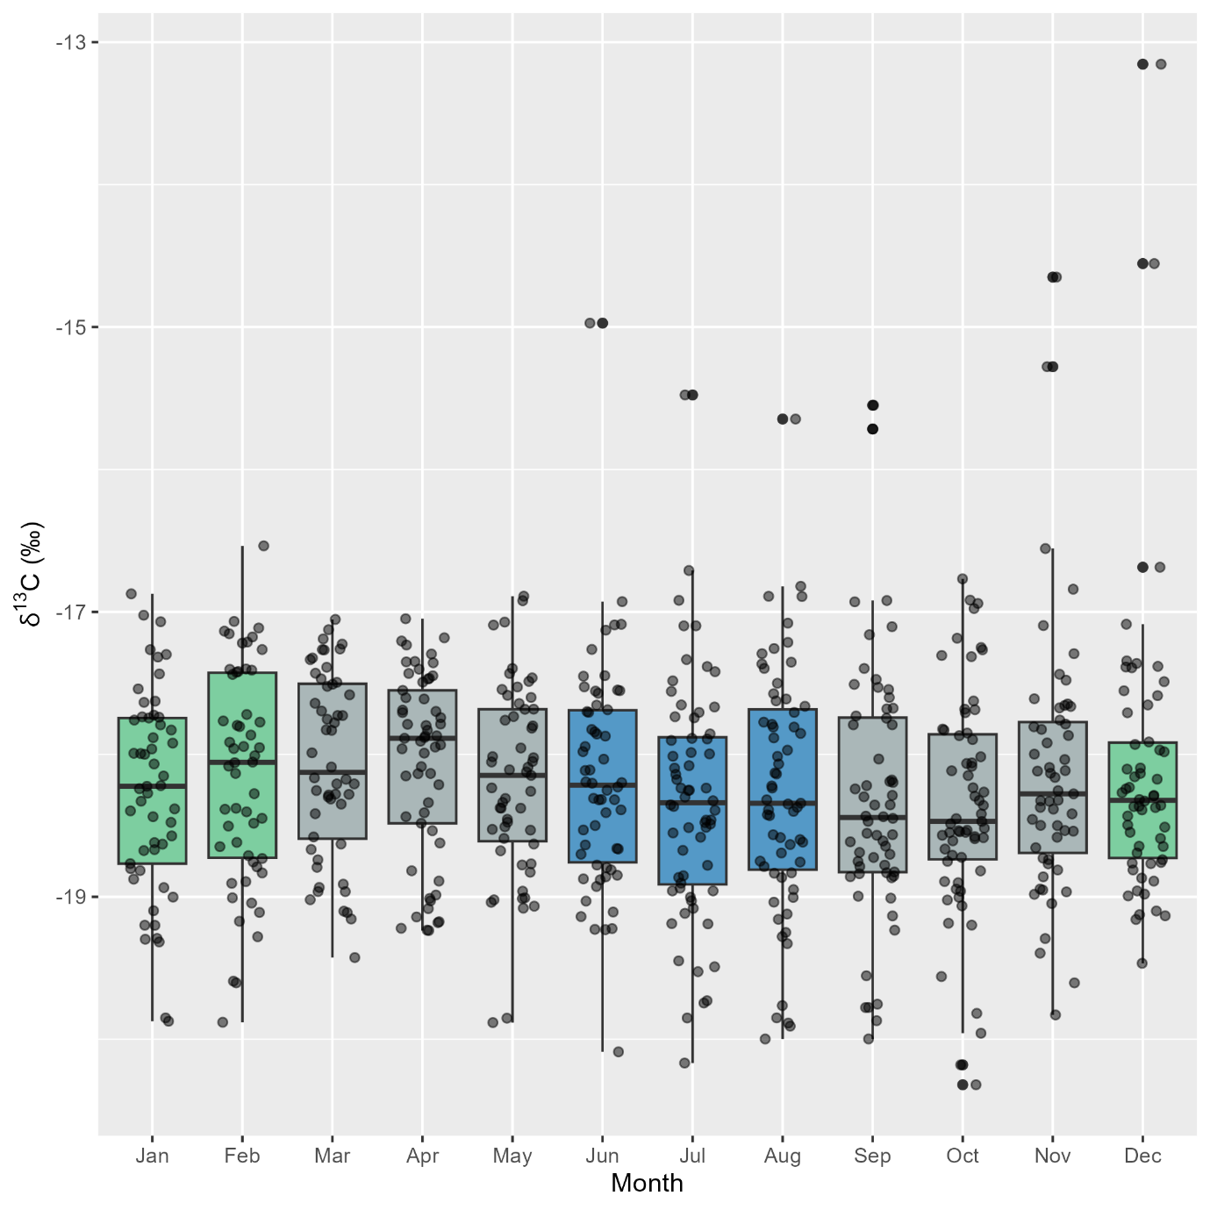
Supplementary Figure 2. Intra-annual variation in δ¹³C stable isotope values for adult pygmy right whales (n = 12 whales, 692 sequentially sampled points along baleen) grouped by month (Bartlett test: p = 0.06). Points represent individual values for the 12 individuals that had stranding dates. Box plots show median and 95% confidence intervals. Green = summer, blue = winter, and grey = autumn and spring.

Supplementary Figure 3. Relationship between δ¹⁵N values in the baleen of both female (purple) and male (orange) pygmy right whales and SST with no lag. Females showed a positive trend and males a negative trend between δ¹⁵N values and SST at both the eastern GAB (pictured here) and Bonney Upwelling, though these results were statistically non-significant (p = 0.23, p = 0.23 respectively).

Supplementary Table 2. Estimated baleen growth rates.

Species | Growth rate (cm/year) | Source
Blue whale (Balaenoptera musculus) | 13.5 - 15.5±2.2 | (Busquets-Vass et al., 2017; Trueman et al., 2019)
Humpback whale (Megaptera novaeangliae) | 12-20 | (Eisenmann et al., 2016)
Fin whale (Balaenoptera physalus) | 20±2.6 | (Bentaleb et al., 2011)
Common minke whale (Balaenoptera acutorostrata) | 12.9 | (Mitani et al., 2006)
Bowhead whale (Balaena mysticetes) | ~20 | (Matthews & Ferguson, 2015; Schell et al., 1989a, 1989b)
Southern right whale (Eubalaena australis) | ~27 | (Best & Schell, 1996)
Sei whale (Balaenoptera borealis) | 10-16.5 | (Reiss et al., 2020)
North Atlantic right whale (Eubalaena glacialis) | 24 | (Hunt et al., 2016; Lysiak et al., 2018; Lysiak, 2009)

References

Bentaleb, I., Martin, C., Vrac, M., Mate, B., Mayzaud, P., Siret, D., De Stephanis, R., & Guinet, C. (2011). Foraging ecology of Mediterranean fin whales in a changing environment elucidated by satellite tracking and baleen plate stable isotopes. Marine Ecology Progress Series, 438, 285-302. https://doi.org/10.3354/meps09269

Best, P. B., & Schell, D. M. (1996). Stable isotopes in southern right whale (Eubalaena australis) baleen as indicators of seasonal movements, feeding and growth. Marine Biology, 124(4), 483-494. https://doi.org/10.1007/BF00351030

Busquets-Vass, G., Newsome, S., Calambokidis, J., Serra-Valente, G., Jacobsen, J., Aguíñiga-García, S., & Gendron, D. (2017). Estimating blue whale skin isotopic incorporation rates and baleen growth rates: Implications for assessing diet and movement patterns in mysticetes. PLoS One, 12(5). https://doi.org/10.1371/journal.pone.0177880

Eisenmann, P., Fry, B., Holyoake, C., Coughran, D., Nicol, S., & Bengtson Nash, S. (2016). Isotopic evidence of a wide spectrum of feeding strategies in Southern Hemisphere humpback whale baleen records. PLoS One, 11(5). https://doi.org/10.1371/journal.pone.0156698

Hunt, K. E., Lysiak, N. S., Moore, M. J., & Rolland, R. M. (2016). Longitudinal progesterone profiles in baleen from female North Atlantic right whales (Eubalaena glacialis) match known calving history. Conservation Physiology, 4(1). https://doi.org/10.1093/conphys/cow014

Lysiak, N. S., Trumble, S. J., Knowlton, A. R., & Moore, M. J. (2018). Characterizing the duration and severity of fishing gear entanglement on a North Atlantic right whale (Eubalaena glacialis) using stable isotopes, steroid and thyroid hormones in baleen. Frontiers in Marine Science, 5, 168. https://doi.org/10.3389/fmars.2018.00168

Lysiak, N. S. J. (2009). Investigating the migration and foraging ecology of North Atlantic right whales with stable isotope geochemistry of baleen and zooplankton. ProQuest.

Matthews, C. J., & Ferguson, S. H. (2015). Seasonal foraging behaviour of Eastern Canada-West Greenland bowhead whales: an assessment of isotopic cycles along baleen. Marine Ecology Progress Series, 522, 269-286. https://doi.org/10.3354/meps11145

Mitani, Y., Bando, T., Takai, N., & Sakamoto, W. (2006). Patterns of stable carbon and nitrogen isotopes in the baleen of common minke whale Balaenoptera acutorostrata from the western North Pacific. Fisheries Science, 72(1), 69-76. https://doi.org/10.1111/j.1444-2906.2006.01118.x

Reiss, L., Häussermann, V., & Mayr, C. (2020). Stable isotope records of sei whale baleens from Chilean Patagonia as archives for feeding and migration behavior. Ecology and Evolution, 10(2), 808-818. https://doi.org/10.1002/ece3.5939

Schell, D., Saupe, S., & Haubenstock, N. (1989a). Bowhead whale (Balaena mysticetus) growth and feeding as estimated by δ13C techniques. Marine Biology, 103(4), 433-443. https://doi.org/10.1007/BF00399575

Schell, D., Saupe, S., & Haubenstock, N. (1989b). Natural isotope abundances in bowhead whale (Balaena mysticetus) baleen: markers of aging and habitat usage. In Stable isotopes in ecological research (pp. 260-269). Springer. https://doi.org/10.1007/978-1-4612-3498-2_15

Trueman, C. N., Jackson, A. L., Chadwick, K. S., Coombs, E. J., Feyrer, L. J., Magozzi, S., Sabin, R. C., & Cooper, N. (2019). Combining simulation modeling and stable isotope analyses to reconstruct the last known movements of one of Nature’s giants. PeerJ, 7, e7912. https://doi.org/10.7717/peerj.7912

