Supplementary Material
Active gas seepage in western Spitsbergen fjords, Svalbard archipelago: spatial extent and geological controls
Nil Rodes¹*, Peter Betlem^{1,3}, Kim Senger¹, Miriam Römer^{2,4}, Andy Hodson^{1,5}, Martin Liira^{6,7}, Tom Birchall¹, Srikumar Roy⁸, Riko Noormets¹, Aleksandra Smyrak-Sikora¹, Snorre Olaussen¹, Gerhard Bohrmann^{2,4}
¹Department of Arctic Geology, The University Centre in Svalbard, Longyearbyen, Norway
²Department of Geosciences, University of Bremen, Bremen, Germany
³Department of Geosciences, University of Oslo, Oslo, Norway
⁴General Geology - Marine Geology, MARUM - Center for Marine Environmental Sciences, Bremen, Germany
⁵Department of Environmental Sciences, Western Norway University of Applied Sciences, Sogndal Campus, Bergen, Norway
⁶Department of Geology, University of Tartu, Tartu, Estonia
⁷The Geological Survey of Estonia, Rakvere, Estonia
⁸Irish Centre for Research in Applied Geosciences, University College Dublin, School of Earth Sciences, Dublin, Ireland

* Correspondence:
Nil Rodes
nilrodes@yahoo.com

Supplementary Data
The datasets generated and analyzed in this study can be found in Zenodo repository, https://doi.org/10.5281/zenodo.7822180. We provide a minimal working example as a Python script to calculate the flare density per multibeam area of outcropping geological units.

Supplementary Figures and Tables

Supplementary Figures
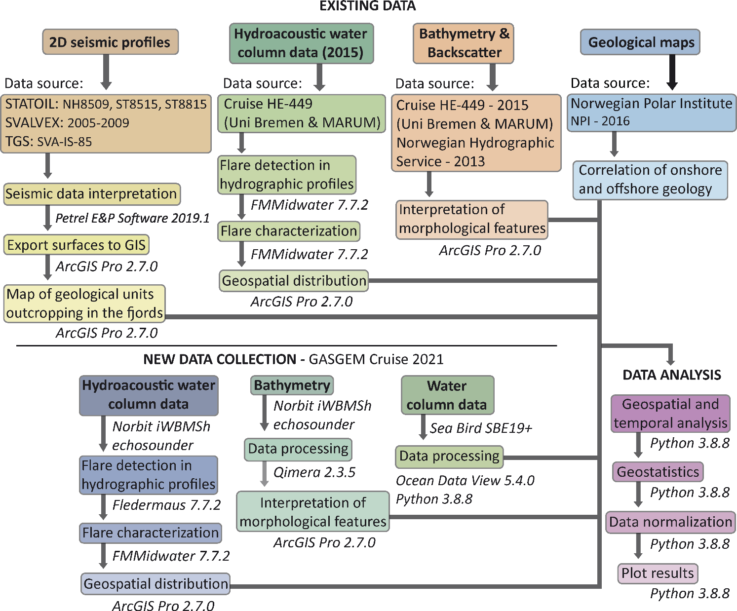
Supplementary Figure 1: 2D seismic interpretation of the general stratigraphy of the fjords and onshore geological maps, multibeam and backscatter data for describing seabed morphologies, hydroacoustic data for flares detection, and CTD sampling for the water column characteristics have been used to make geostatistical analysis of the study data. The flow chart is complemented by Table 1, which integrates all relevant datasets and sources utilized.

Supplementary Tables
Supplementary Table 1:
Data type | Location/extent | Characteristics | Source | Purpose
Water column data | Isfjorden 2015 and 2021; Van Mijenfjorden 2015 | Isfjorden 2015: 741 km; Van Mijenfjorden 2015: 203 km;  Isfjorden 2021: 523.8 km | University of Bremen & MARUM (HE-449 cruise, 2015);  GASGEM 2021 cruise | Detection of gas flares in the water column. Comparison of the spatial and temporal distribution
Bathymetry and multibeam echosounder | Isfjorden and tributary fjords; Van Mijenfjorden | 5 m resolution | Norwegian Hydrographic Service; The University Centre in Svalbard (UNIS); University of Bremen & MARUM | Description of seabed morphologies in the fjords. Investigate if there is a correlation between fjord characteristics and flaring
Geological maps | Onshore Svalbard | Mapped at 1:100000 scale in most areas, at 1:250000 in east Svalbard | Norwegian Polar Institute, NPI (2016) | Correlation of onshore and offshore geology
2D Seismic | Isfjorden and tributary fjords; Van Mijenfjorden; Onshore Svalbard | Isfjorden: 47 seismic profiles (1615 km); Van Mijenfjorden: 17 seismic profiles (328.5 km) | STATOIL (surveys NH8509, ST8515 and ST8815); SVALEX (surveys 2005, 2006, 2007, 2008 and 2009); TGS (survey SVA-VM-85); Bælum et al., 2012; Blinova et al., 2012; Blinova et al., 2013; Roy et al., 2019 | Interpretation of the fjords sub-surface structure and description of structural heterogeneities. Tie the flare spatial distribution with sub-surface structures
Boreholes | Reindalen | Reindalpasset I (7819/12-1) | Bælum et al., 2012; Roy et al., 2014; Senger et al., 2019 | Tie borehole-described stratigraphic units with seismic lines
Seabed morphologies | Isfjorden and tributary fjords | 5 m resolution | Pockmarks (Roy et al., 2015; Roy et al., 2016; Roy et al., 2019); Faults (Blinova et al., 2012; Roy et al., 2014; Roy et al., 2015); Glacial lineations (Roy et al., 2015) | Geostatistical analysis and correlation with gas flares
Gas hydrate stability zone | Isfjorden | Thermobaric conditions; Modeled distribution in Isfjorden (quantile 0.1, 0.5, 0.9) | Betlem et al., 2019; Betlem et al., 2021 | Geostatistical analysis and correlation with gas flares
Offshore geochemical sampling | Isfjorden and tributary fjords | Chemical composition | Liira, et al., 2019; Damm et al., 2021 | Determine the nature of the gas in the fjords. Discuss potential source rocks
CTD data | Isfjorden, Tempelfjorden, Nordfjorden | 16 stations along 4 transects | GASGEM 2021 cruise | Calculate Sound Velocity Profiles (SVP) for calibration of hydrographic data
Supplementary Table 1. Synthesis of datasets acquired and integrated in this study. Existing datasets in regular typography; new datasets presented in this publication are represented in italics.

