Supplementary material

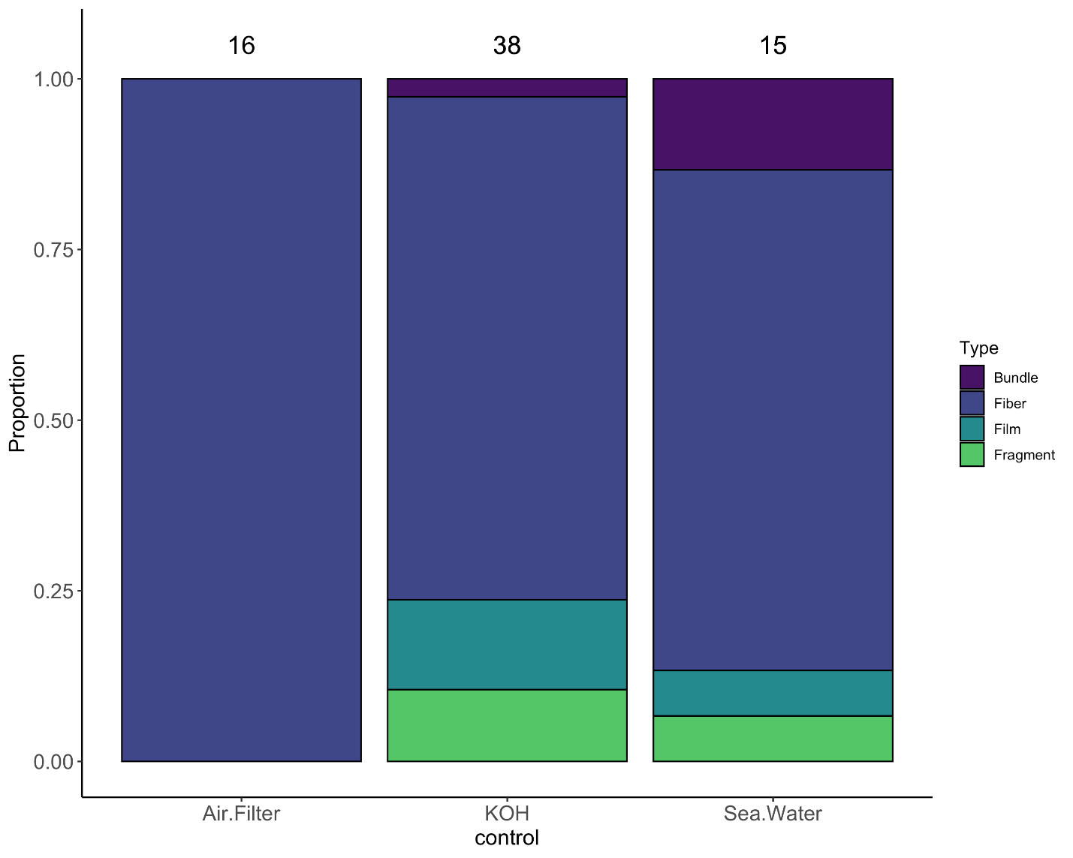
Figure S1. The proportion of microparticle morphotypes found in lab controls (air filter and potassium hydroxide (KOH)) during microparticle processing and seawater samples collected near fecal sample collection locations. The sample size for each control type is denoted above all columns.

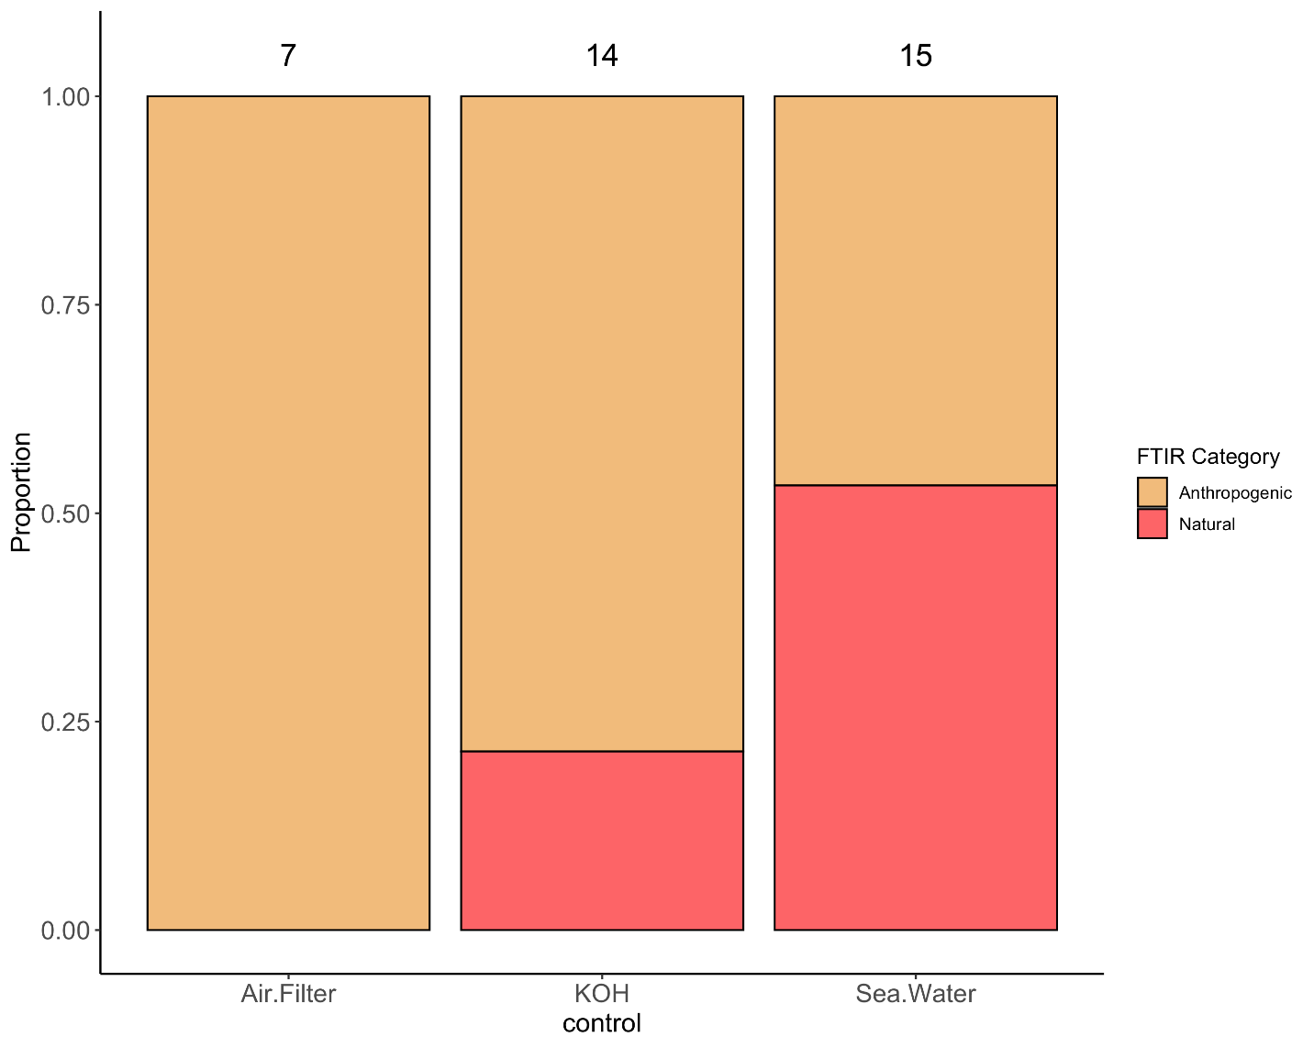
Figure S2. The proportion of Fourier transform infrared (FTIR) spectroscopy categories of microparticle found in lab controls (air filter and potassium hydroxide (KOH)) during microparticle processing and seawater samples collected near fecal sample collection locations. The sample size for each control type analyzed by FTIR is denoted above all columns.

