Appendix B: Spatiotemporal distributions (with diagnostic plots) and abundance indices of taxa used in chukchi survey evaluation
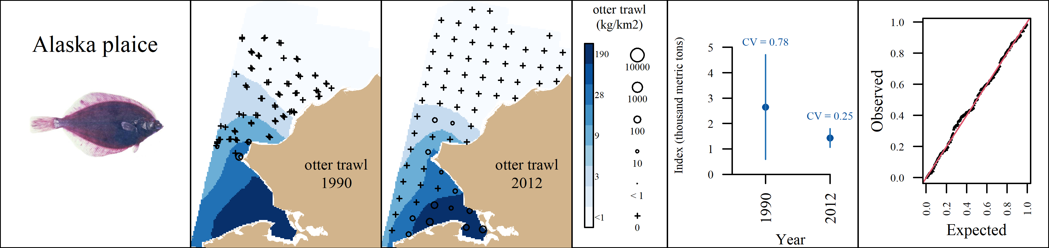 Appendix B1: VAST output for Alaska plaice (Pleuronectes quadrituberculatus) for the the otter trawl. From left to right, plots are generally formatted as: A) predicted density with observed densities superimposed, B) abundance indices with associated coefficients of variation, and C) QQ diagnostic plot.

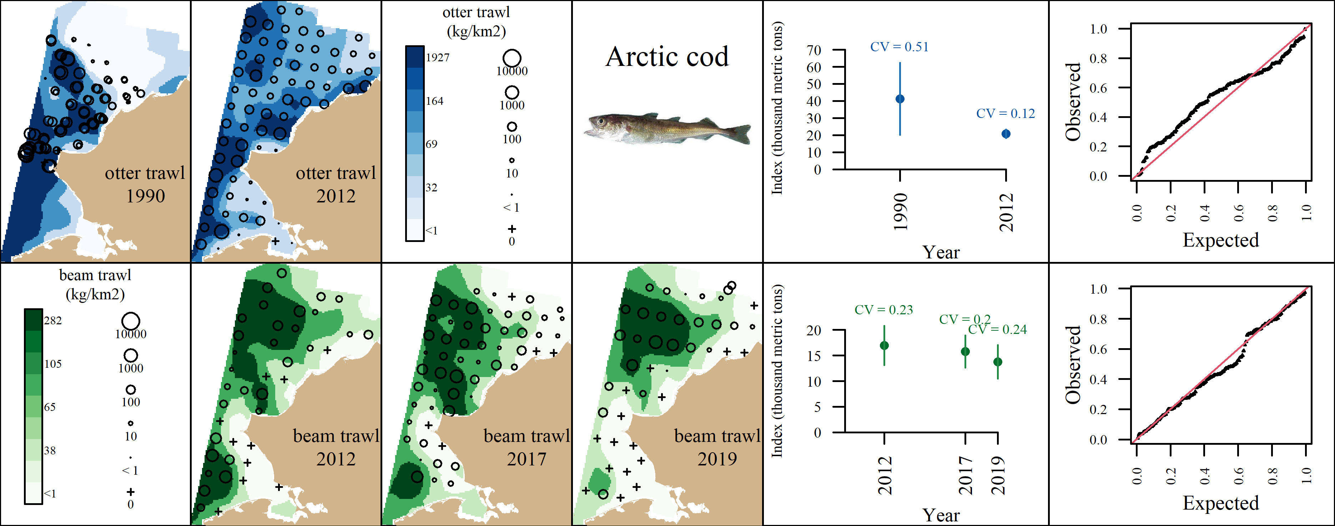 Appendix B2: VAST output for Arctic cod (Boreogadus saida) for the the otter trawl (top row) and the beam trawl (bottom row). From left to right, plots are generally formatted as: A) predicted density with observed densities superimposed, B) abundance indices with associated coefficients of variation, and C) QQ diagnostic plot.

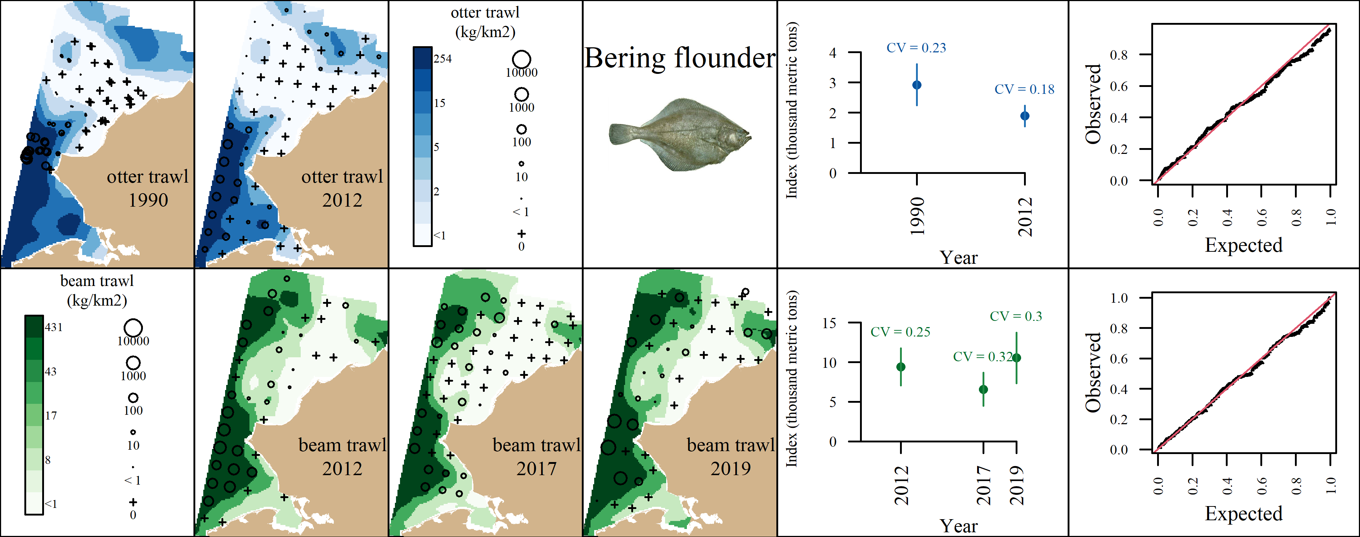 Appendix B3: VAST output for Bering flounder (Hippoglossoides robustus) for the the otter trawl (top row) and the beam trawl (bottom row). From left to right, plots are generally formatted as: A) predicted density with observed densities superimposed, B) abundance indices with associated coefficients of variation, and C) QQ diagnostic plot.

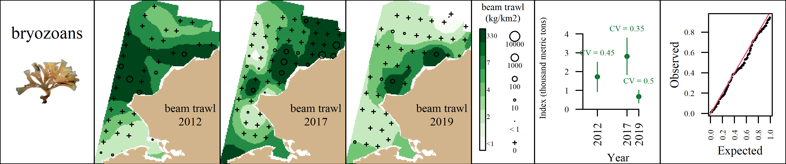 Appendix B4: VAST output for bryozoans (Phylum: Bryozoa) for the the beam trawl. From left to right, plots are generally formatted as: A) predicted density with observed densities superimposed, B) abundance indices with associated coefficients of variation, and C) QQ diagnostic plot.

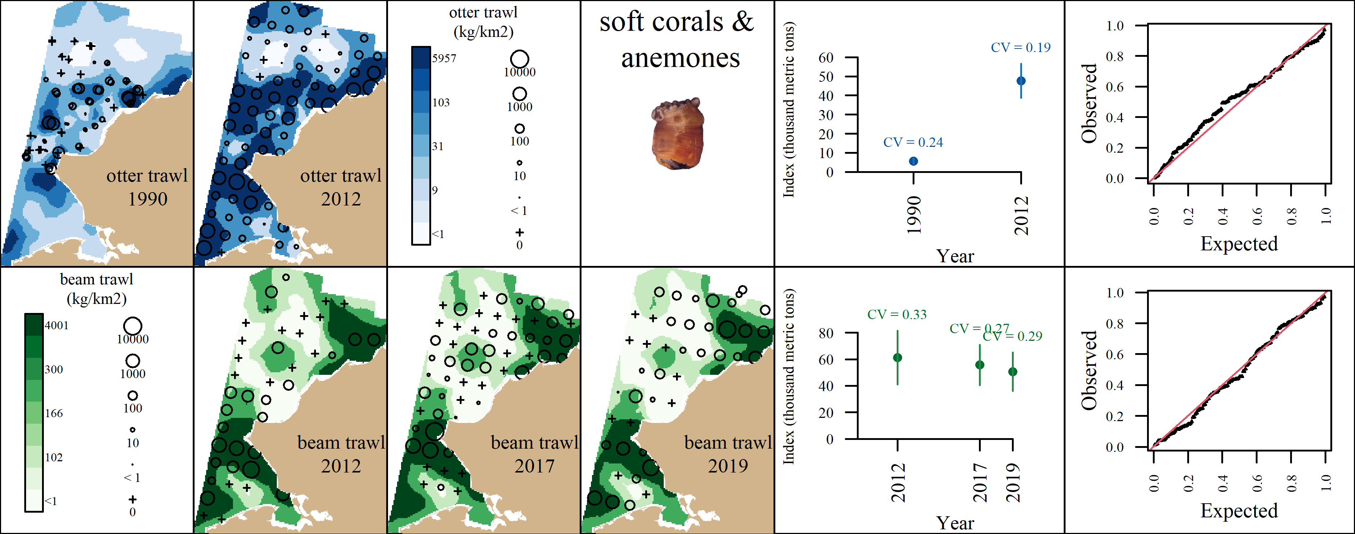 Appendix B5: VAST output for soft corals and sea anemones (Class: Anthozoa) for the the otter trawl (top row) and the beam trawl (bottom row). From left to right, plots are generally formatted as: A) predicted density with observed densities superimposed, B) abundance indices with associated coefficients of variation, and C) QQ diagnostic plot.

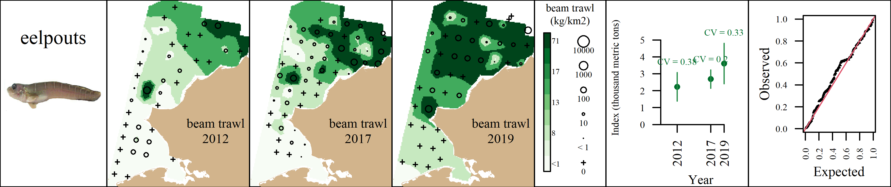 Appendix B6: VAST output for eelpouts (Family: Zoarchidae) for the the beam trawl. From left to right, plots are generally formatted as: A) predicted density with observed densities superimposed, B) abundance indices with associated coefficients of variation, and C) QQ diagnostic plot.

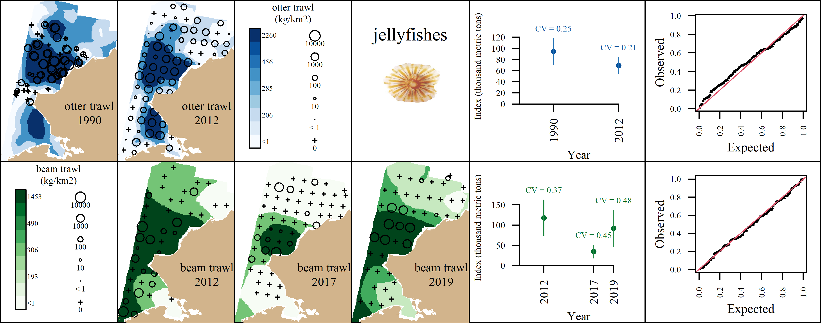 Appendix B7: VAST output for jellyfishes (Class: Scyphozoa) for the the otter trawl (top row) and the beam trawl (bottom row). From left to right, plots are generally formatted as: A) predicted density with observed densities superimposed, B) abundance indices with associated coefficients of variation, and C) QQ diagnostic plot.

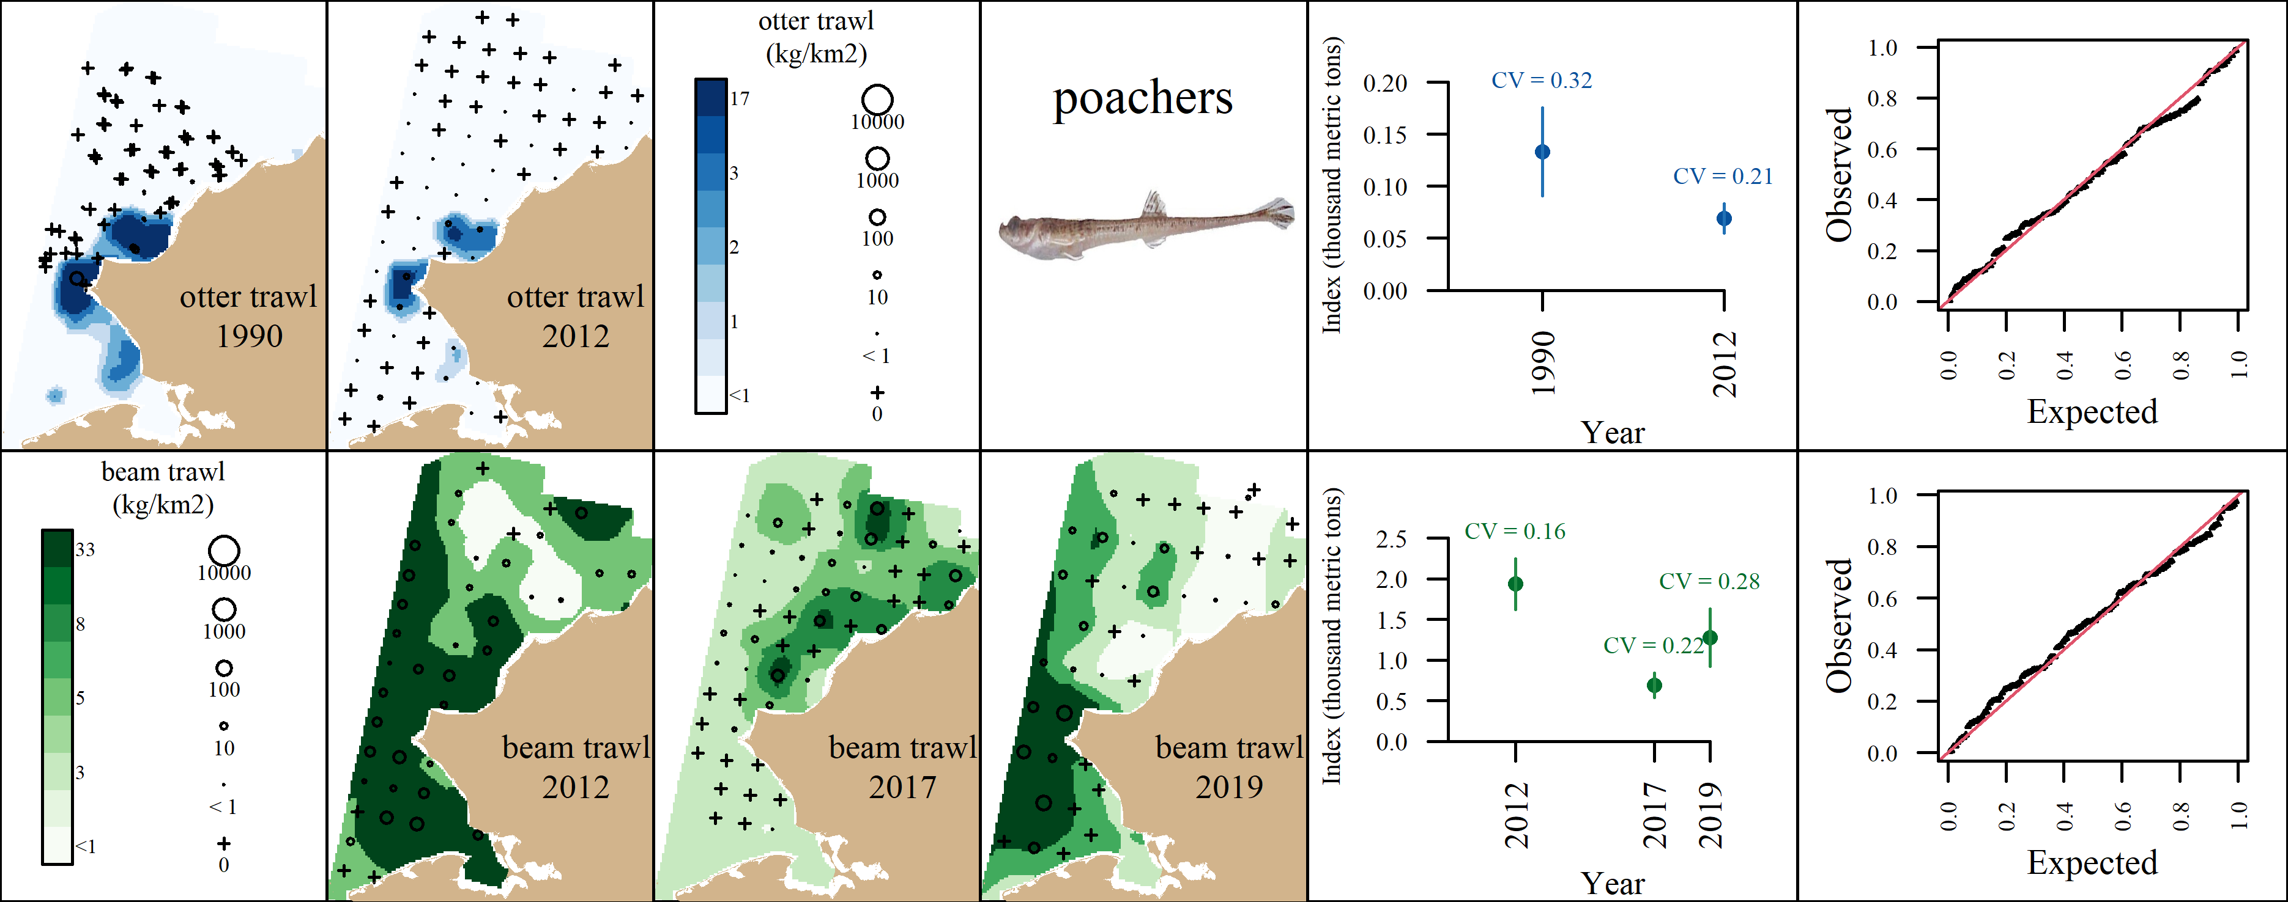 Appendix B8: VAST output for poachers (Family: Agonidae) for the the otter trawl (top row) and the beam trawl (bottom row). From left to right, plots are generally formatted as: A) predicted density with observed densities superimposed, B) abundance indices with associated coefficients of variation, and C) QQ diagnostic plot.

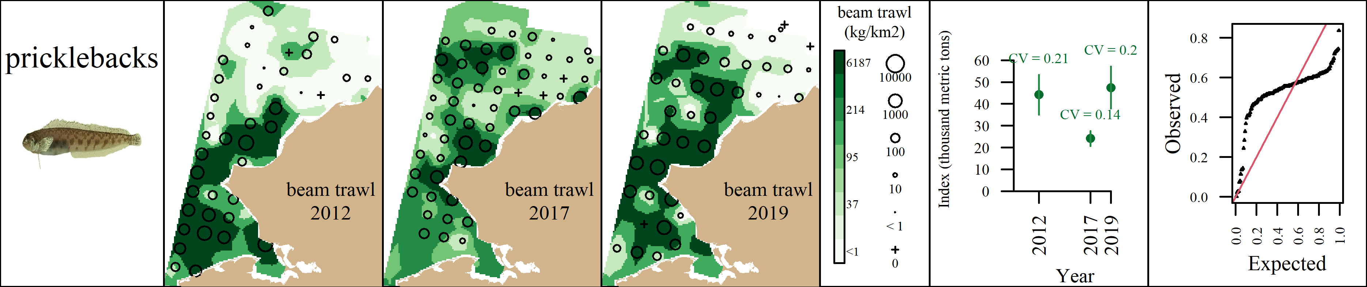 Appendix B9: VAST output for pricklebacks (Family: Stichaeidae) for the the beam trawl. From left to right, plots are generally formatted as: A) predicted density with observed densities superimposed, B) abundance indices with associated coefficients of variation, and C) QQ diagnostic plot.

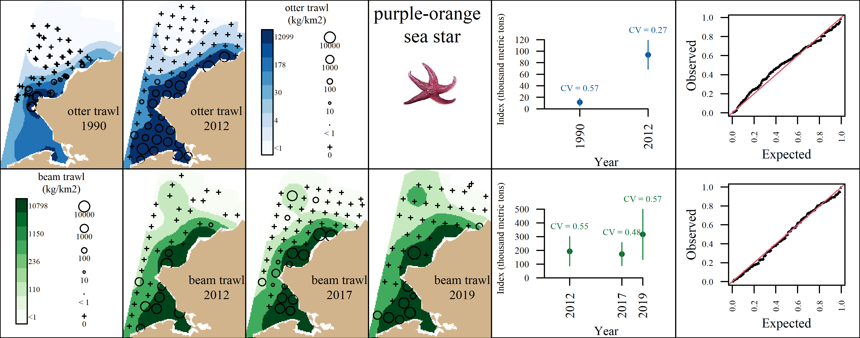 Appendix B10: VAST output for purple-orange sea star (Asterias amurensis) for the the otter trawl (top row) and the beam trawl (bottom row). From left to right, plots are generally formatted as: A) predicted density with observed densities superimposed, B) abundance indices with associated coefficients of variation, and C) QQ diagnostic plot.

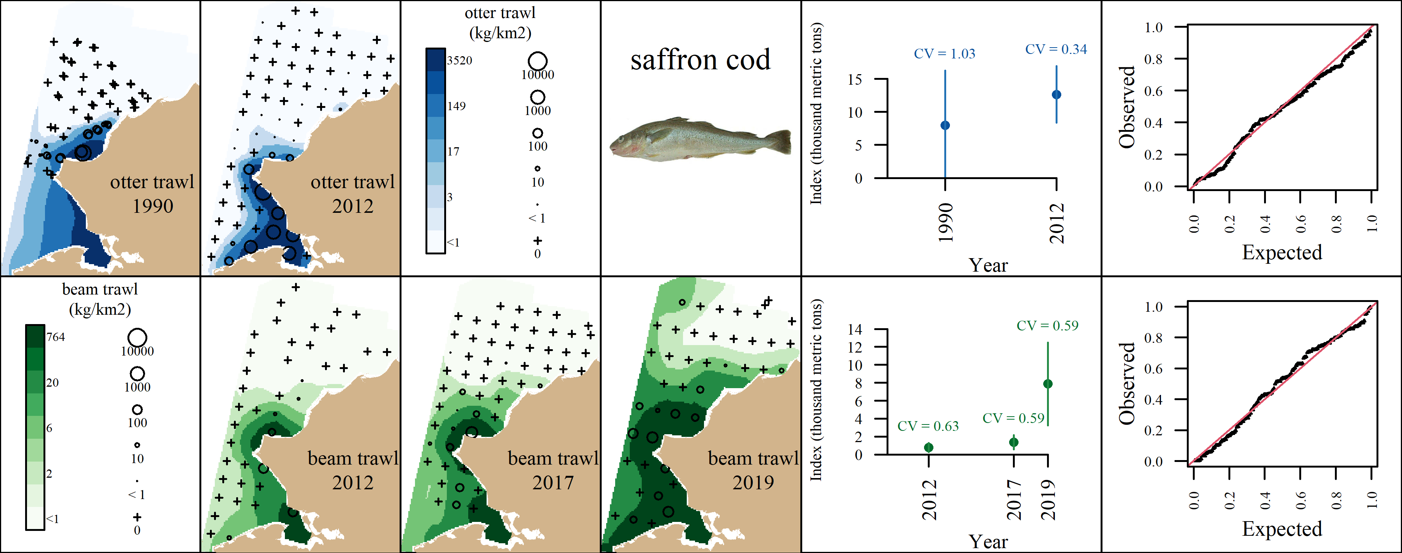 Appendix B11: VAST output for saffron cod (Eleginus gracilis) for the the otter trawl (top row) and the beam trawl (bottom row). From left to right, plots are generally formatted as: A) predicted density with observed densities superimposed, B) abundance indices with associated coefficients of variation, and C) QQ diagnostic plot.

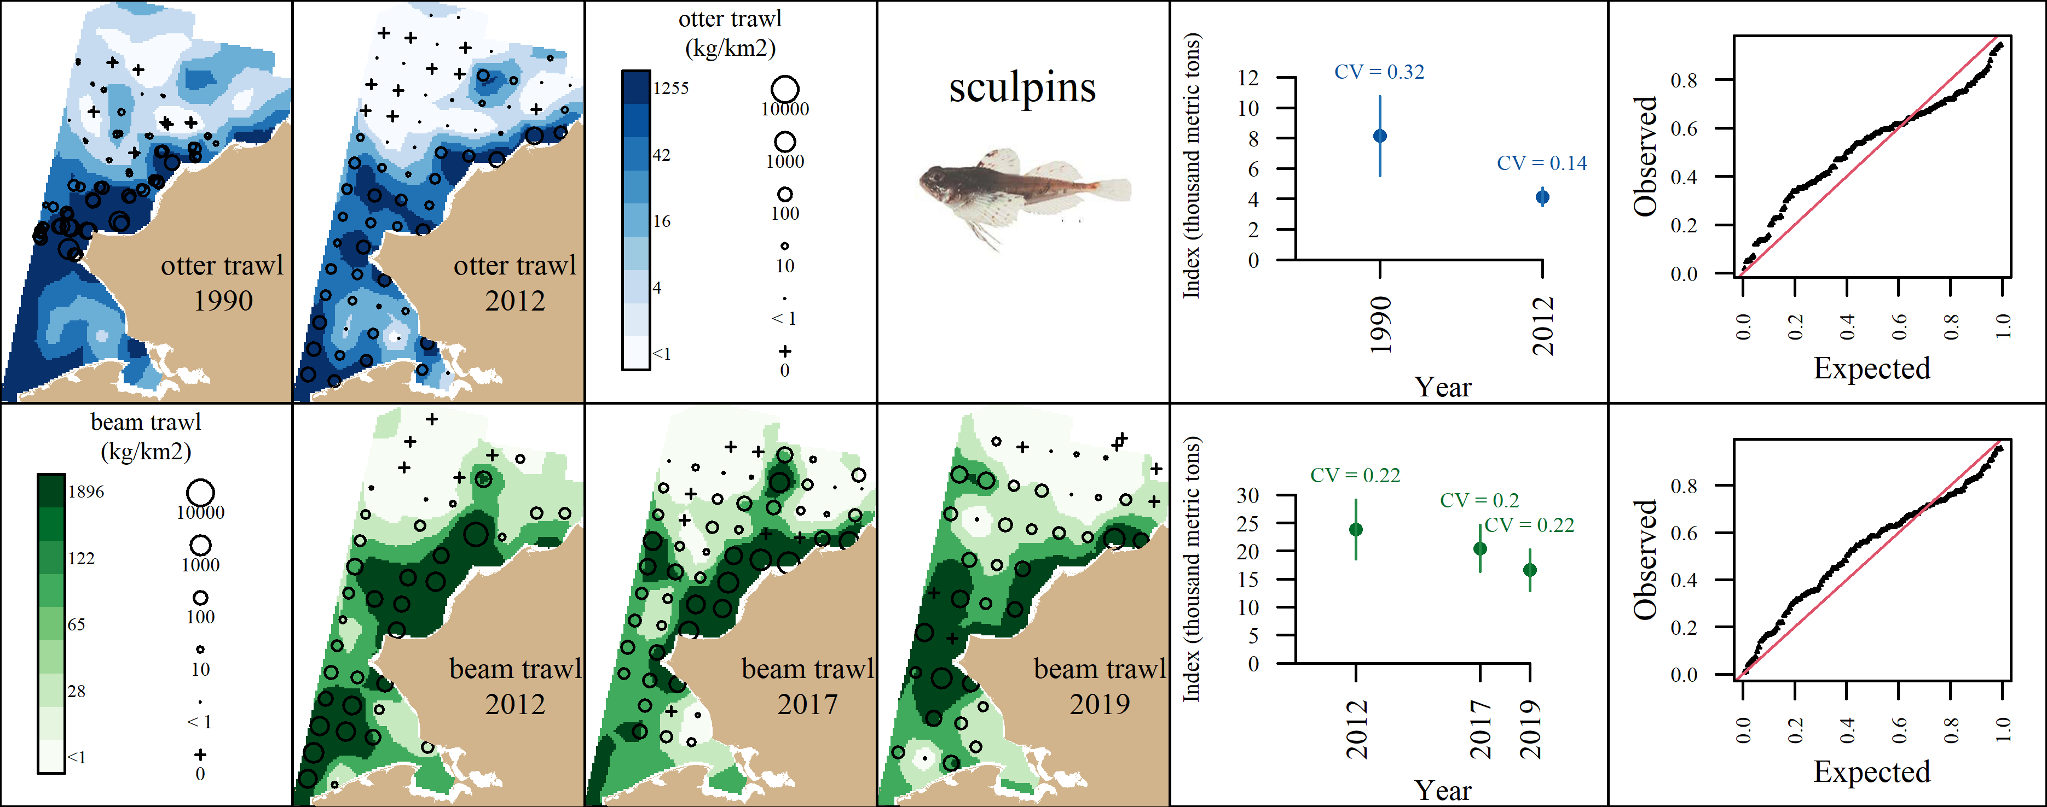 Appendix B12: VAST output for sculpins (Family: Cottidae) for the the otter trawl (top row) and the beam trawl (bottom row). From left to right, plots are generally formatted as: A) predicted density with observed densities superimposed, B) abundance indices with associated coefficients of variation, and C) QQ diagnostic plot.

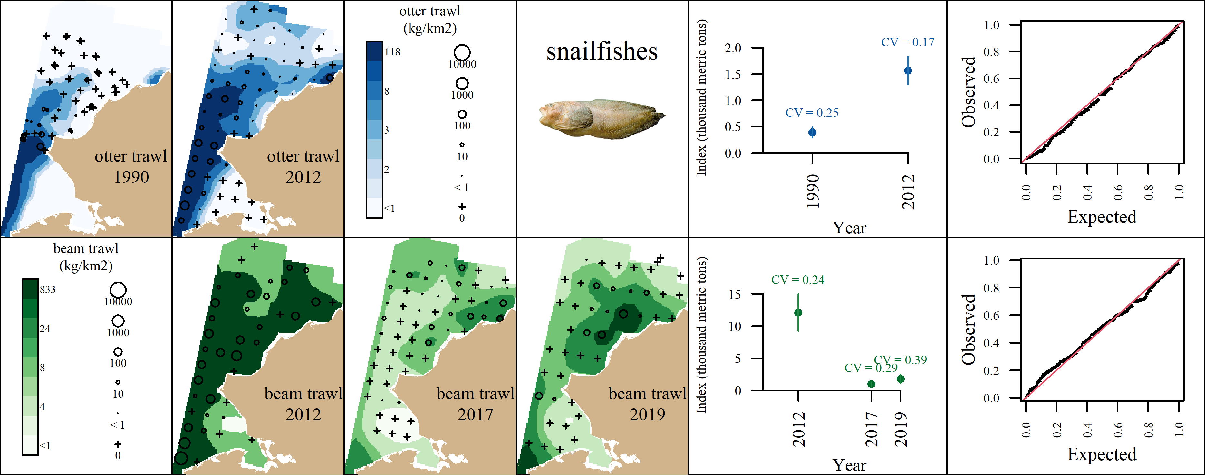 Appendix B13: VAST output for snailfishes (Family: Liparidae) for the the otter trawl (top row) and the beam trawl (bottom row). From left to right, plots are generally formatted as: A) predicted density with observed densities superimposed, B) abundance indices with associated coefficients of variation, and C) QQ diagnostic plot.

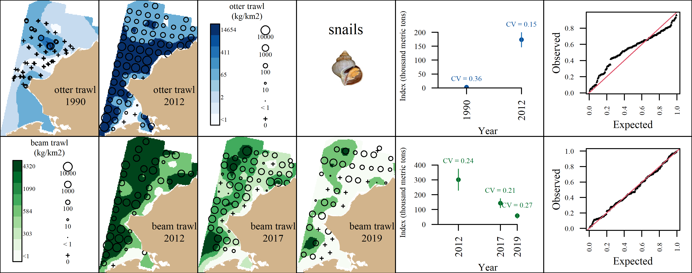 Appendix B14: VAST output for snails (Class: Gastropoda) for the the otter trawl (top row) and the beam trawl (bottom row). From left to right, plots are generally formatted as: A) predicted density with observed densities superimposed, B) abundance indices with associated coefficients of variation, and C) QQ diagnostic plot.

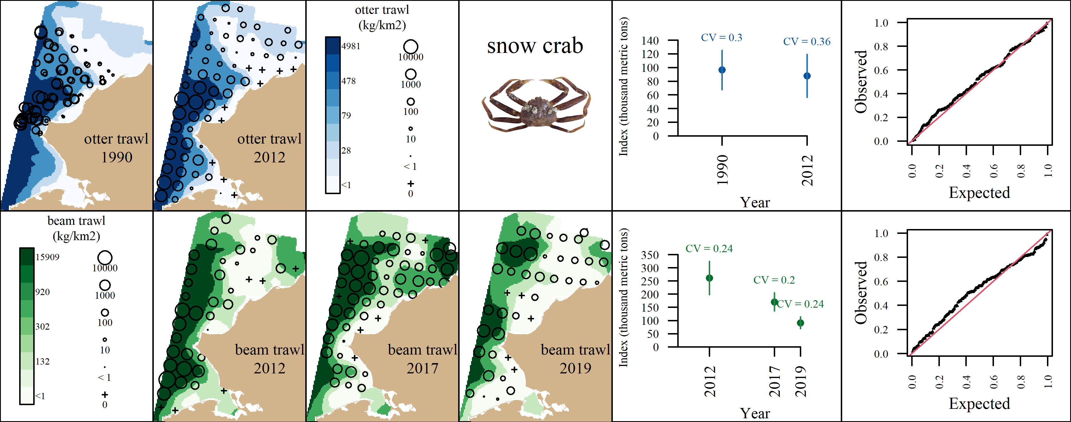 Appendix B15: VAST output for snow crab (Chionoecetes opilio) for the the otter trawl (top row) and the beam trawl (bottom row). From left to right, plots are generally formatted as: A) predicted density with observed densities superimposed, B) abundance indices with associated coefficients of variation, and C) QQ diagnostic plot.

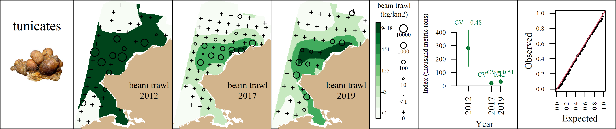 Appendix B16: VAST output for tunicates (Subphylum: Tunicata) for the the beam trawl. From left to right, plots are generally formatted as: A) predicted density with observed densities superimposed, B) abundance indices with associated coefficients of variation, and C) QQ diagnostic plot.

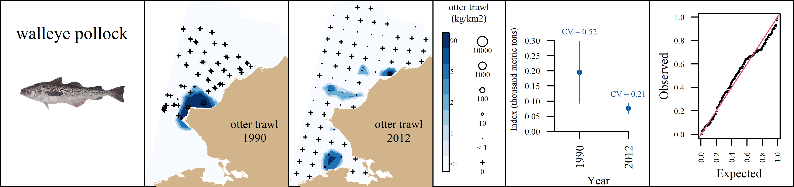 Appendix B17: VAST output for walleye pollock (Gadus chalcogrammus) for the the otter trawl. From left to right, plots are generally formatted as: A) predicted density with observed densities superimposed, B) abundance indices with associated coefficients of variation, and C) QQ diagnostic plot.

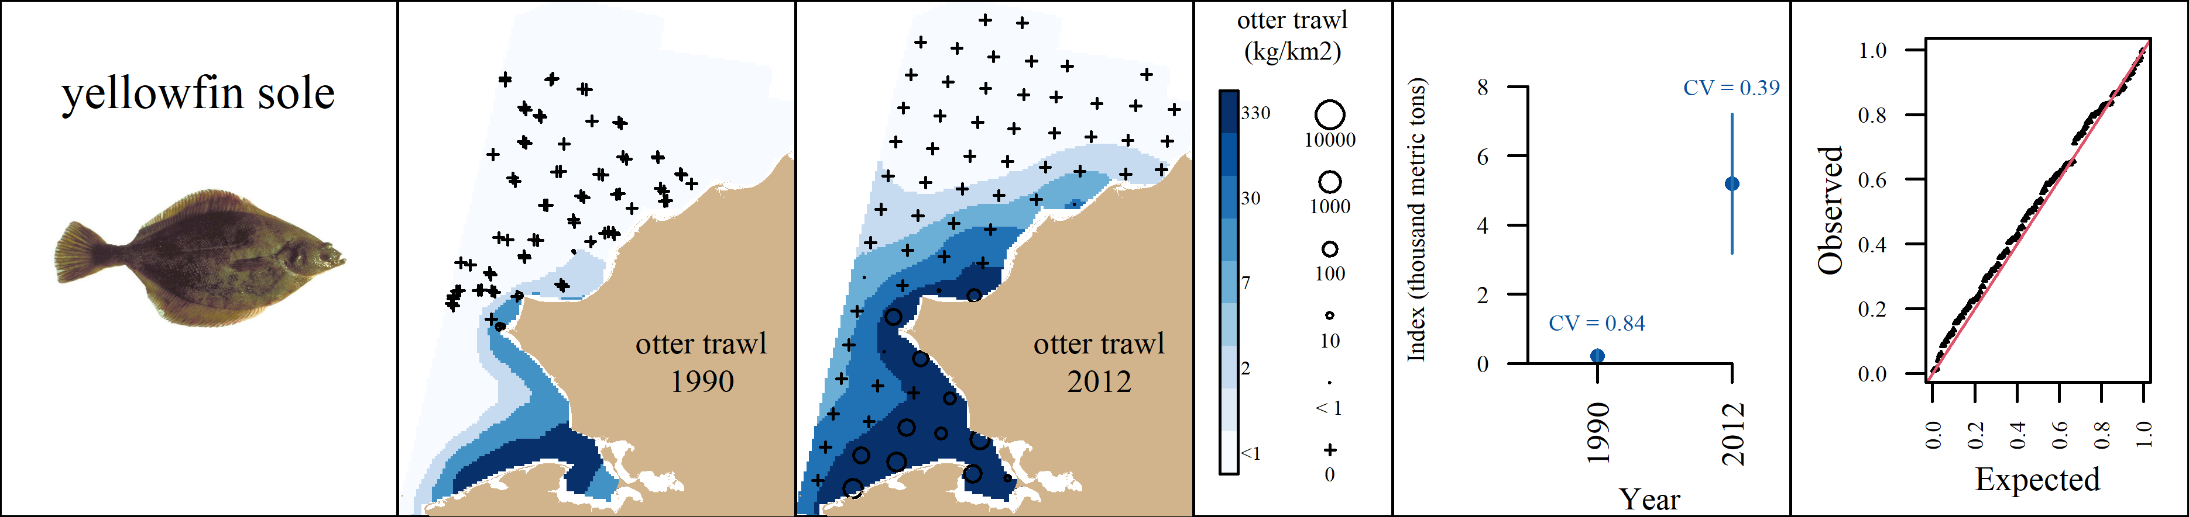 Appendix B18: VAST output for yellowfin sole (Limanda aspera) for the the otter trawl. From left to right, plots are generally formatted as: A) predicted density with observed densities superimposed, B) abundance indices with associated coefficients of variation, and C) QQ diagnostic plot.

