Additional Figures

SF1 Co-expression networks constructed by the rank-based method follow the power law distribution

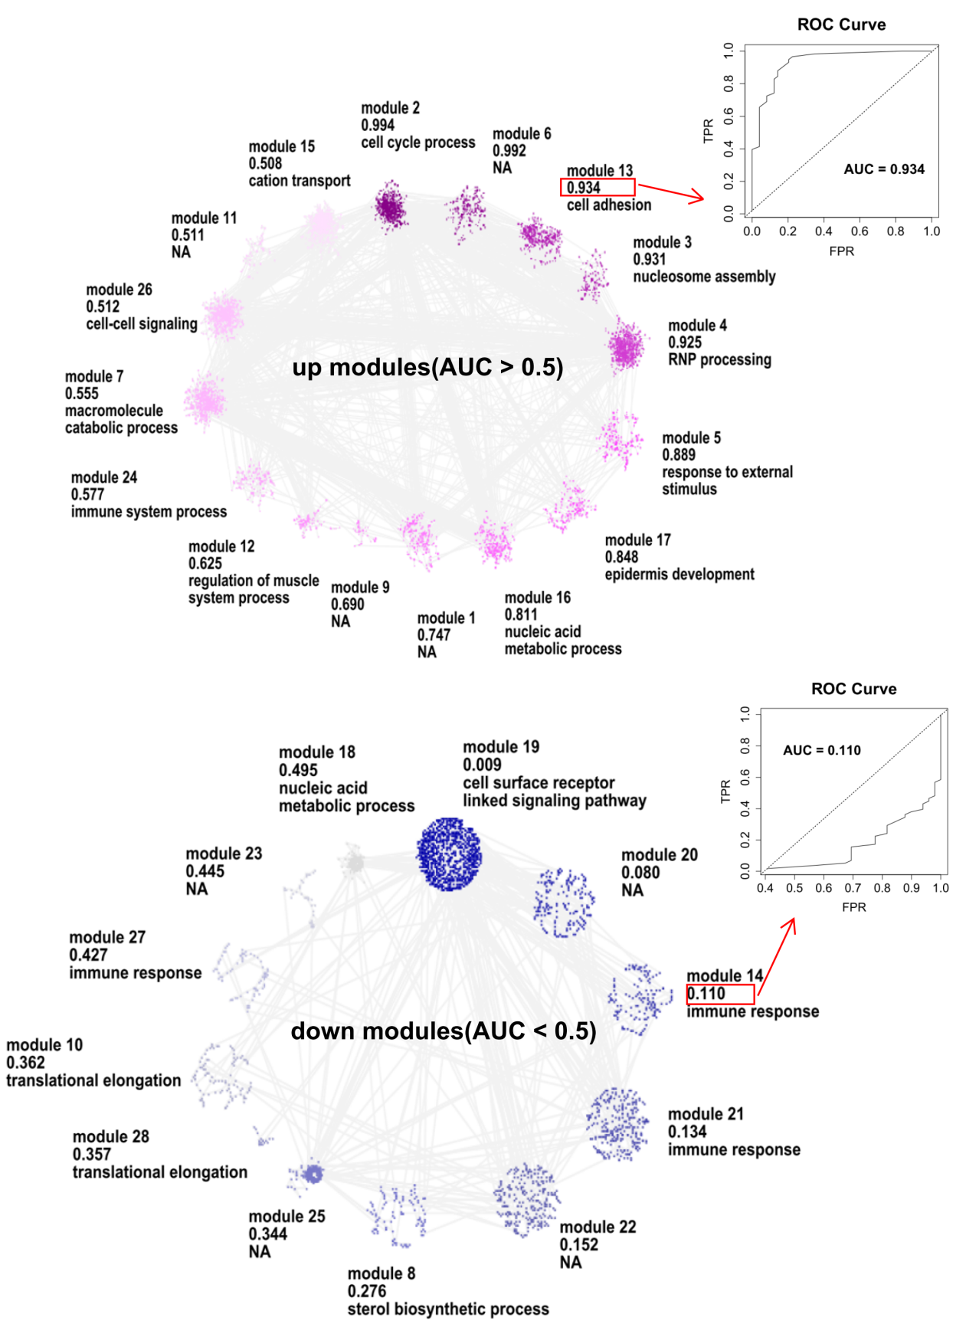
SF2 - Genes in cancer-specific modules are enriched in GO terms that associate with cancer development and progression.

SF3 The distribution of reaction numbers of metabolites and degree centrality in enzyme network.

SF4 Importance scores in each type of cancer.

SF5 siRNA efficiency test results.
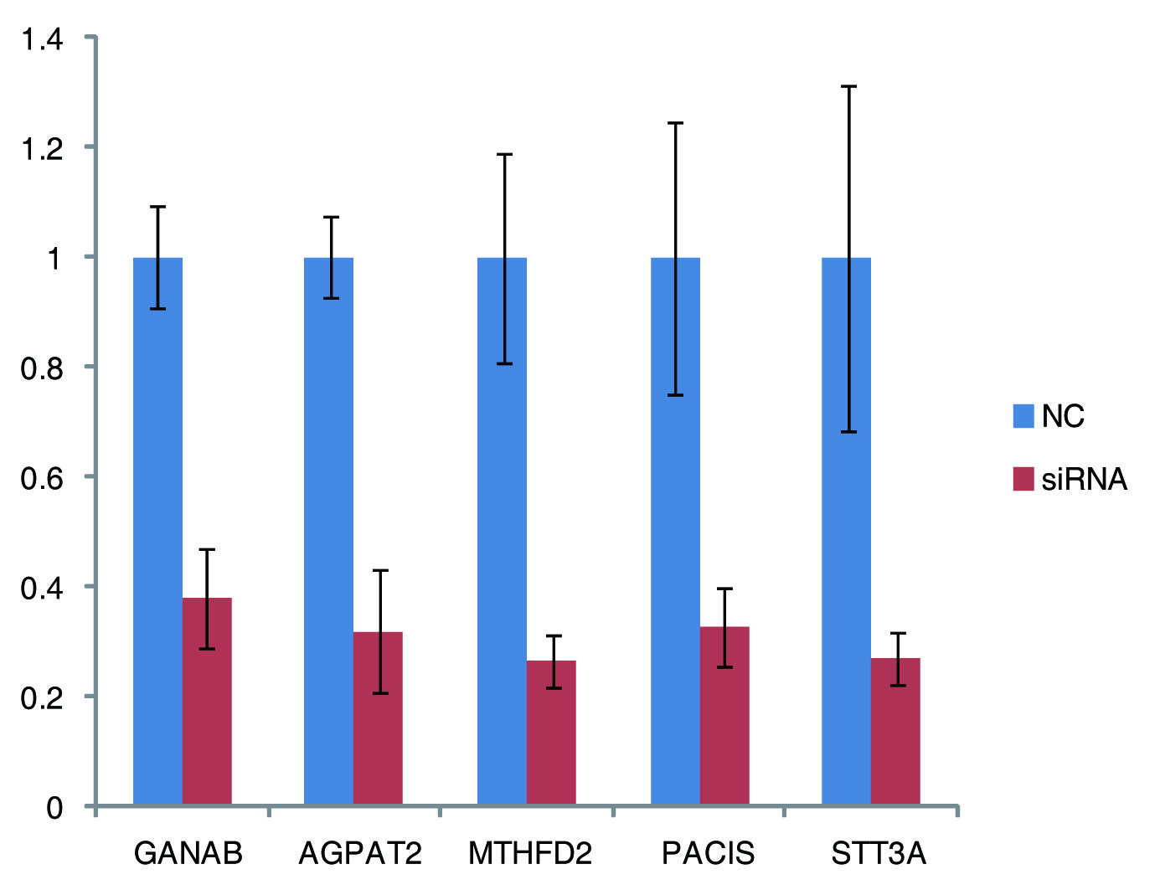

Additional Tables

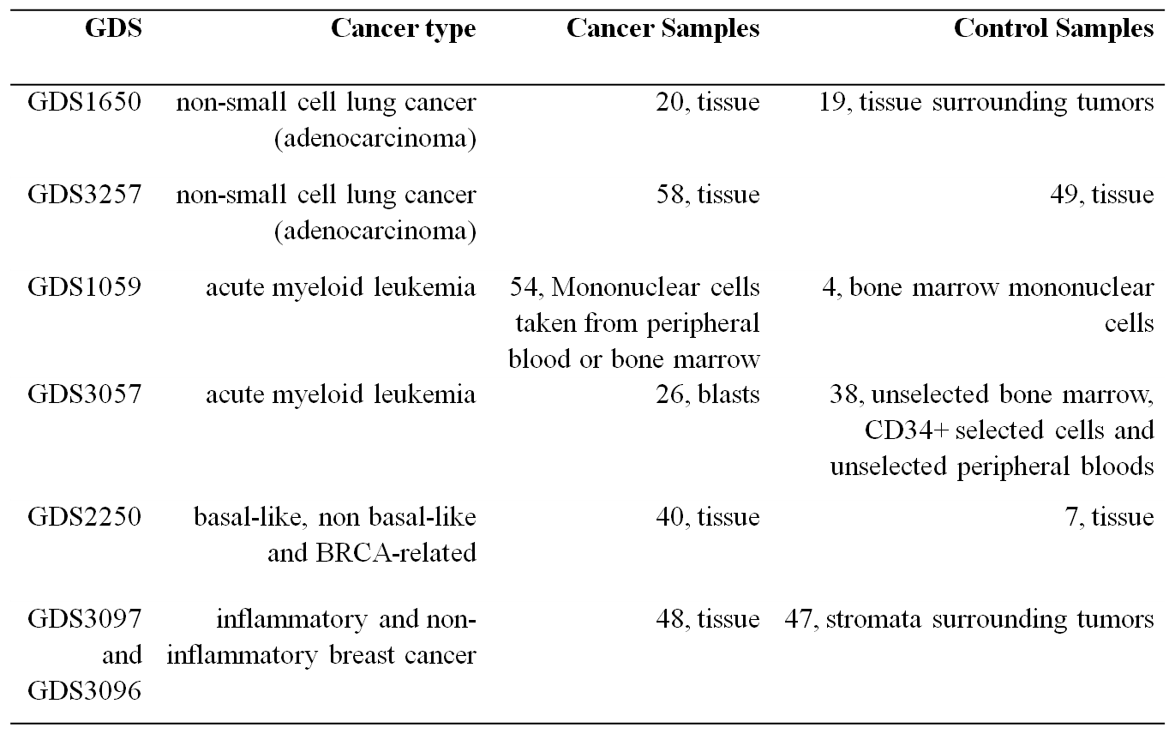
STable 1 - The detailed information of datasets used in our analysis

STable 2 - Cancer Hall Markers and our prediction results

