Supplementary Material

Experimental transmission of piscine orthoreovirus-1 (PRV-1) in different life stages of Atlantic salmon (Salmo salar) and brown trout (Salmo trutta)
Dhamotharan Kannimuthu¹ † *, HyeongJin Roh¹ †, H. Craig Morton¹, Ma. Michelle D. Peñaranda¹, Anne Vossgård², Tom Hansen¹, Per Gunnar Fjelldal¹, Egil Karlsbakk¹, Ingrid Fiksdal¹, Maria K. Dahle³, Håkon Berg-Rolness¹, Stig Mæhle¹, Ghebretnsae Dawit Berhe¹, Joachim Nordbø¹, Sonal Patel⁴, Abdullah Madhun¹, Søren Grove¹, and Bjørn Olav Kvamme¹
* Correspondence: Dhamotharan Kannimuthu: dhamotharan.kannimuthu@hi.no
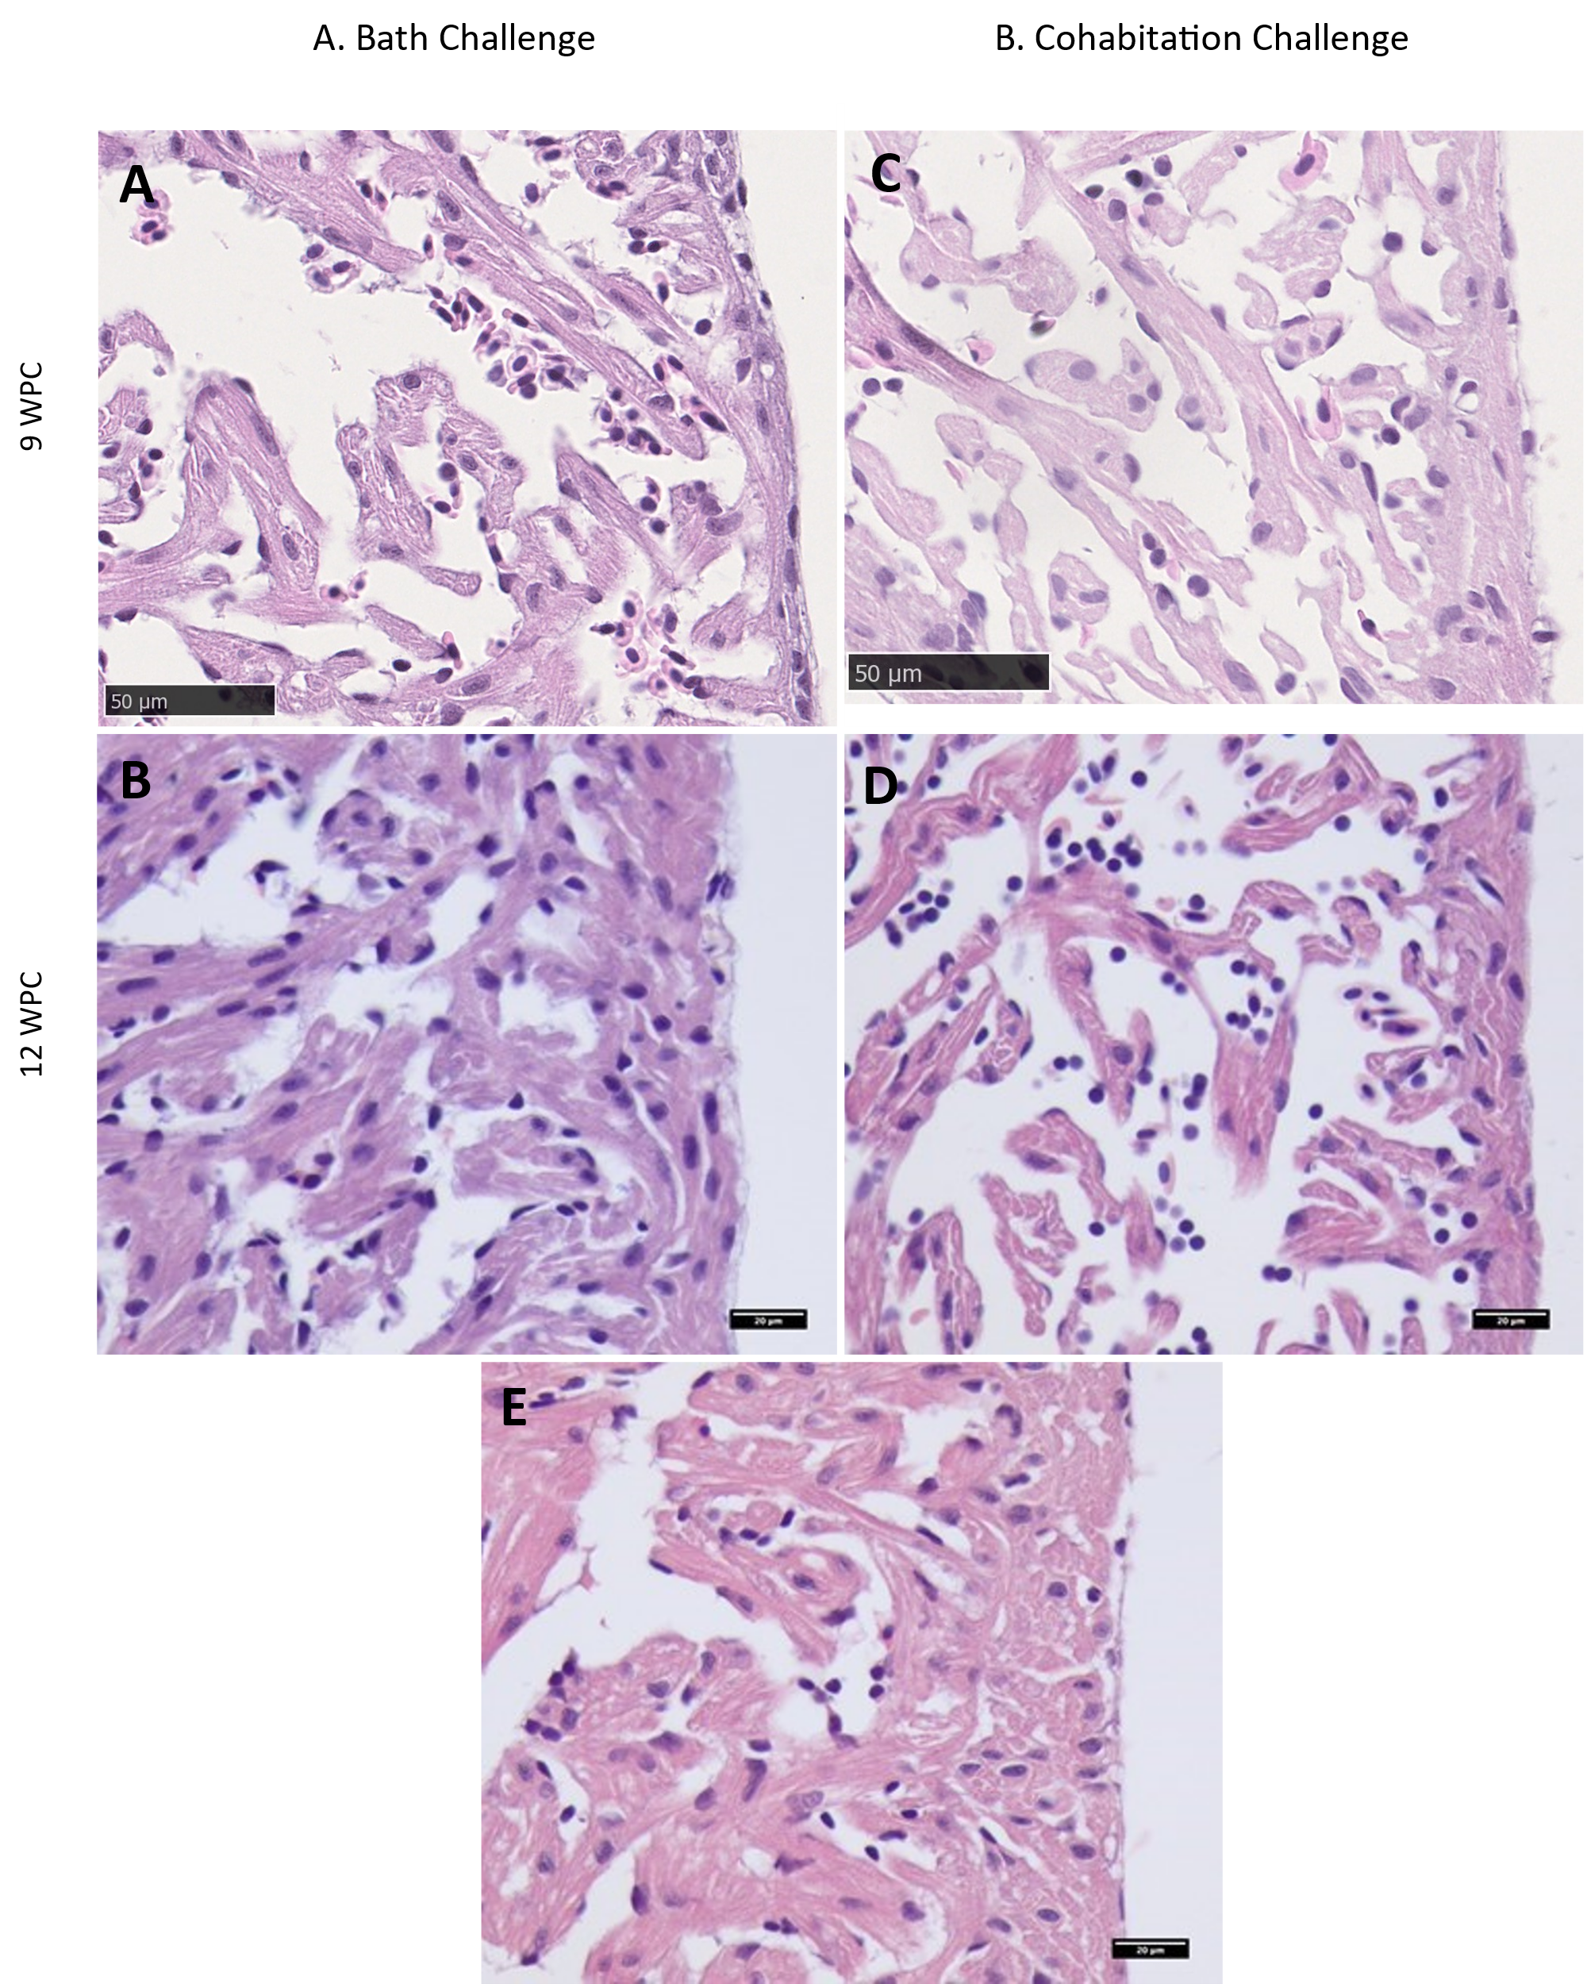
Figure S1. A and B) PRV-1 bath challenged sea trout fry heart at 9 and 12 WPC. C and D) PRV-1 cohabitation challenged sea trout heart sections at 9 and 12 WPC E) Noninfected control seatrout heart at 12 WPC

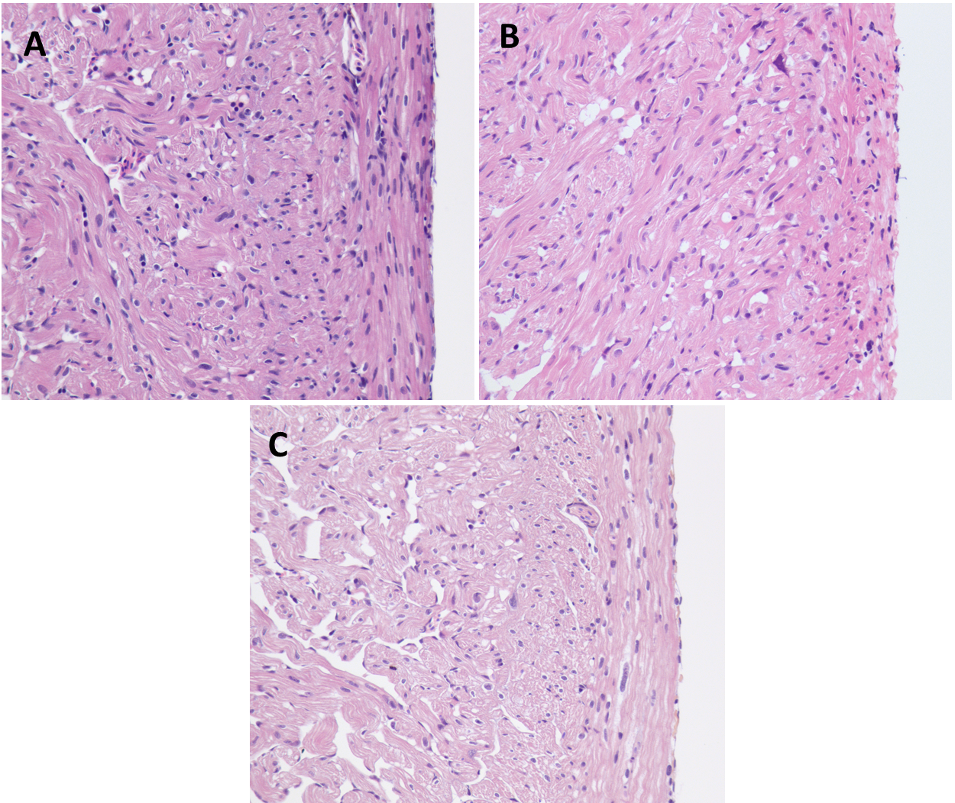

Figure S2. PRV-1 challenged sea trout post-smolts heart ventricle (A) in cohabitation challenge at 10WPC B) in IP challenge at 8WPC, and C) control heart at 10WPC.

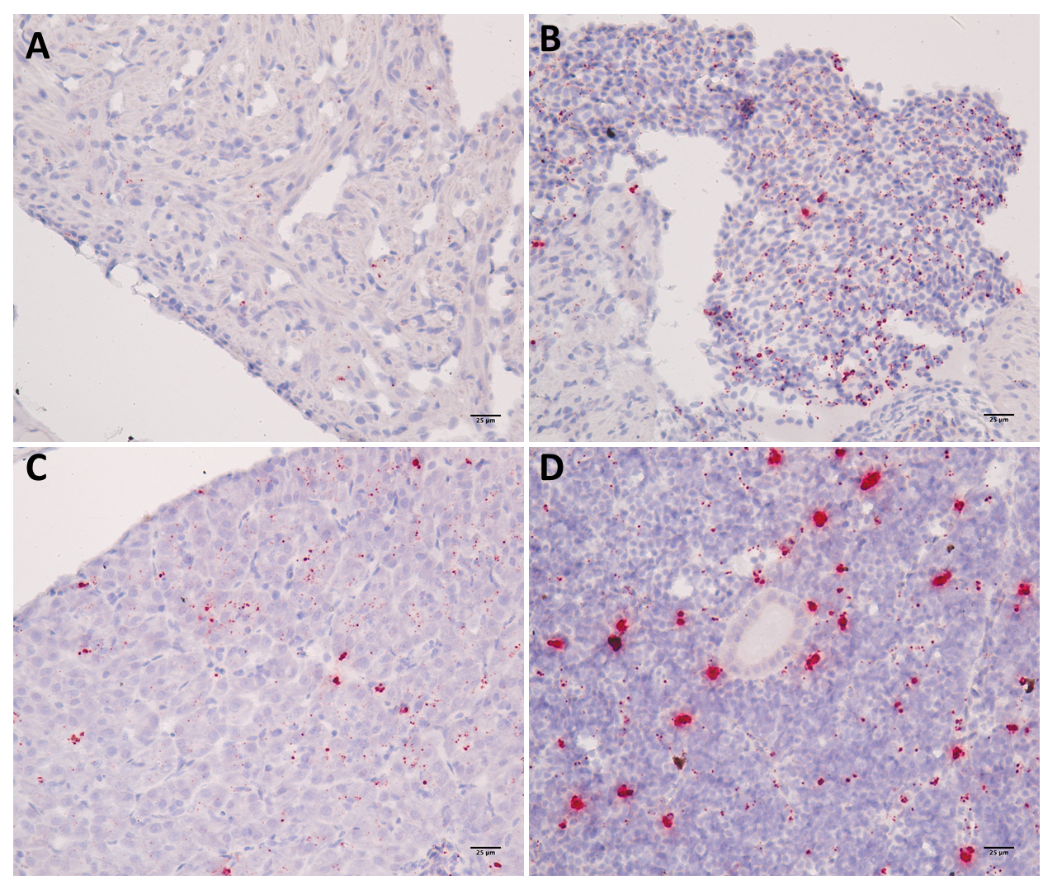
Figure S3. Micrographs showing PRV-1 in situ staining of bath challenged Atlantic salmon tissues at 9WPC. A&B) PRV-1 positive staining observed in cardiomyocytes and erythrocytes in heart ventricle C) Liver showing positive staining in hepatocytes and erythrocytes. D) In kidney, PRV-1 staining is observed both in erythrocytes and melanomacrophages.

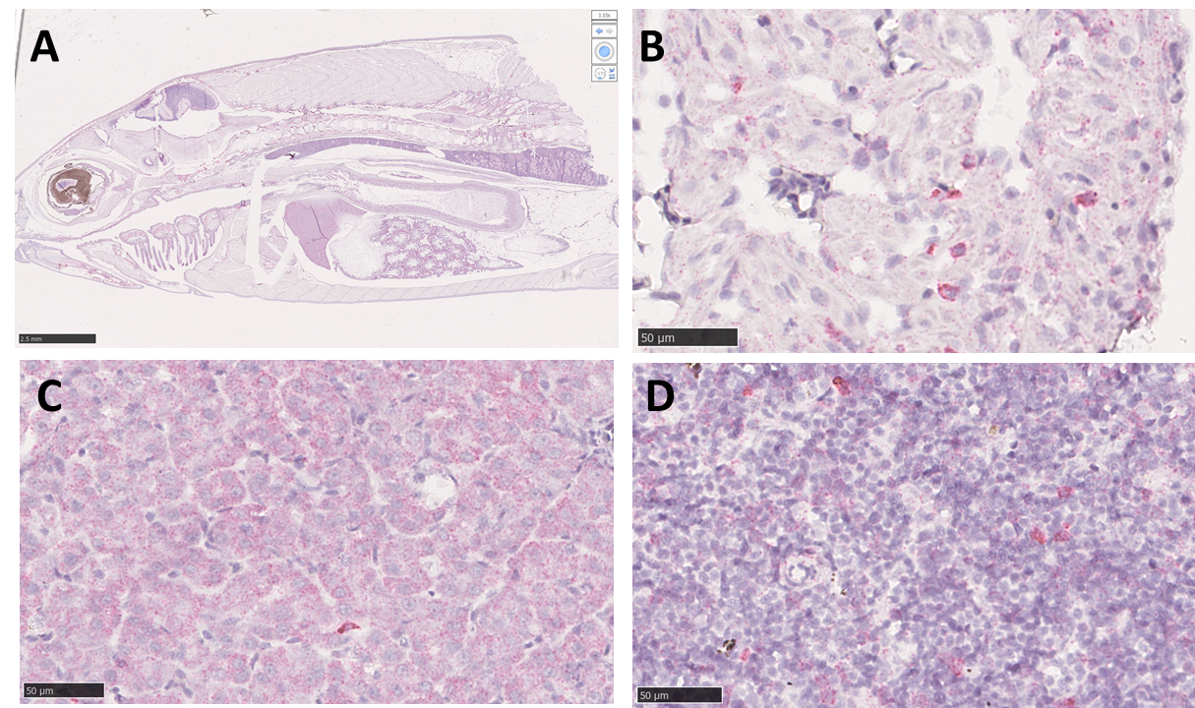
Figure S4. Micrographs showing PRV-1 bath challenged Atlantic salmon tissues stained with tissue control ISH probes PPIB. A) whole fry and the tissues B) heart ventricle C) Liver D) Head kidney.

Table S1. The histology scoring of PRV infected heart tissues of Atlantic salmon fry, parr and post smolts. The score for each group is displayed as mean ± standard deviation.
- Atlantic salmon fry
Group | 7WPC |  | 9WPC |  | 12WPC
 | Epi | Myo | Epi | Myo | Epi | Myo
Cohabitation challenge (n=7) | 0.29±0.27 | 0.14±0.24 | 1.00±0.58 | 0.29±0.39 | 0.64±0.38 | 0.21±0.57
Bath challenge (n=6) | 0.67±0.61 | 0.5±0.55 | 1.33±0.61 | 1.17±0.41 | 2.58±0.49 | 2.00±1.05

- Atlantic salmon parr
Group | 9WPC |  | 12WPC
 | Epicardium | Myocardium | Epicardium | Myocardium
Cohabitation challenge (n=7) | 1.40±0.76 | 1.13±1.05 | 1.52±0.81 | 1.79±0.95
- Atlantic salmon post smolts
Group | 8WPC |  | 10WPC
 | Epicardium | Myocardium | Epicardium | Myocardium
Cohabitation challenge (n=8) | 0.55±0.57 | 0.42±0.59 | 1.67±1.2 | 1.92±1.29
IP Challenge (n=8) | 0.67±0.20 | 0.77±0.33 | 0.59±0.29 | 0.63±0.36

