Journal of Vertebrate Paleontology
Supplementary Data 1

The oldest articulated ranid from Europe: A Pelophylax specimen from the earliest Oligocene of Chartres-de -Bretagne (NW France)

ALFRED LEMIERRE,*^{.1} DAMIEN GENDRY,² MARIE-MARGAUX POIRIER,² VALENTIN GILLET,² and ROMAIN VULLO²

¹Centre de Recherche en Paléontologie (CR2P) Paris, UMR 7207 CNRS-Muséum National d’Histoire Naturelle-Sorbonne Université, CP38, 8 rue Buffon, 75005 Paris, France, alfred.lemierre@outlook.com;
²Université Rennes, Géosciences, UMR CNRS 6118, Campus de Beaulieu, 263 avenue du Général Leclerc, 35042 Rennes, France, mariemargaux.poirier@orange.fr, valentin.gillet.37@gmail.com, romain.vullo@univ-rennes.fr, damien.gendry@univ-rennes.fr

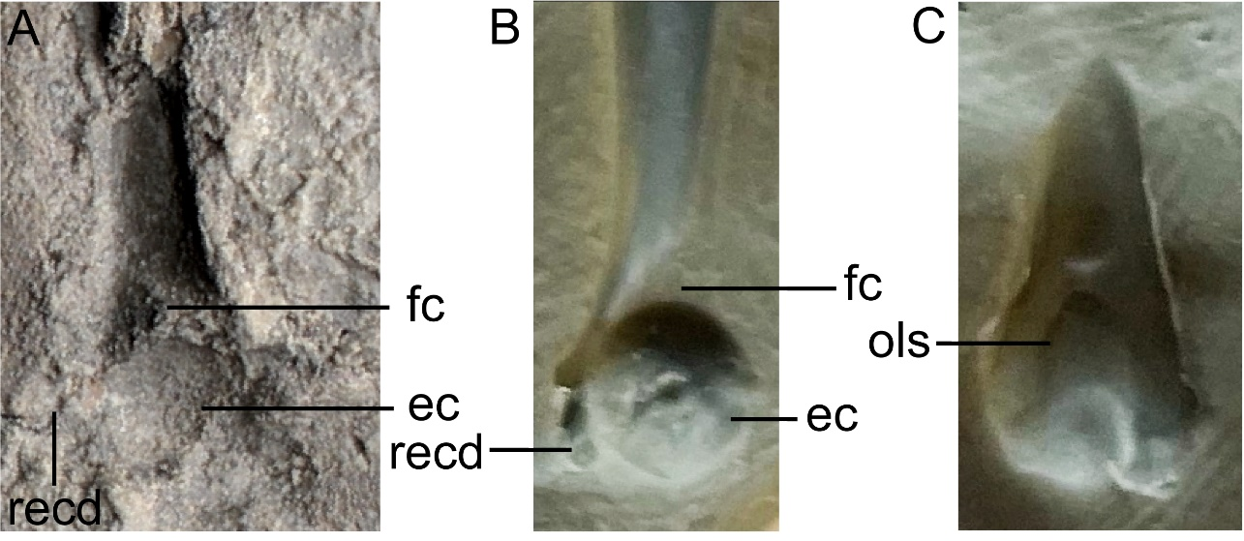
FIGURE S1. Comparison between the imprint of the humerus of IGR 144547 and the humerus of Pelophylax kl. esculentus. A, imprint of a humerus of IGR 144547 on M1, B, imprint of a humerus of P. kl. esculentus in ventral view and C, imprint of the same humerus in dorsal view. Abbreviations: ec, eminetia capitate; fc, fossa cubitalis; ols, oleocranon scar; recd, epicondylus radialis.

