**Supplementary Information**

*Study Species and Training*

Bats were kept in two groups of five individuals per cage and marked using non-toxic nail polish on their toes or via clipping of a small section of hair on the lower back. While in captivity individuals were fed a diet of mealworms provided in the cages or offered by hand after each flight session. Supplementary feeding was also provided using Harrison’s Bird Foods “Juvenile Formula” (Harrison’s Bird Foods, Brentwood, USA) mixed with water and offered by hand to the bats via a 1ml syringe.

*Metabolic Power Measurements*

Prior to all measurements bats were fasted for at least 6 h. To determine basal metabolic rate we measured oxygen consumption and carbon dioxide production of 10 bats using flow-through respirometry to determine basal metabolic rate. Bats were placed in 500 ml respirometry chambers through which outside air flowed at a rate of 350 ml min-1 STP. Bats were measured in their resting phase (from 10:00 to 16:00) and were fasted for at least 12h prior to measurements to ensure they were post absorptive. As the thermoneutral zone has yet to be established in this species we exposed each individual to controlled ambient temperatures between 28 and 35°C in 3°C increments. Ambient temperature was measured inside the respirometry using calibrated thermocouples and each bat remained at a given ambient temperature for at least 1.5h before the temperature was increased. We visually inspected the graph of VO2 against Ta to determine the inflection point for the lower critical temperature of the thermoneutral zone, which was below 31°C. Above this point VO2 was stable, and therefore we designated the thermoneutral zone *for P. nathusii* to lie between 31 and 35°C. We calculated basal metabolic rate as the average VO2 within this range. We used equation 10.6 from Lighton (1) to calculate the volume of oxygen consumed and converted this to W using a conversion factor of 20.1 J ml-1 O2 (2).

*Mechanical Power Measurements*

Images were captured using four cameras at a frame rate of fL=640 Hz and the system was calibrated using the LaVision Type 22 calibration plate, followed by the tomographic self-calibration routine in Davis 8.3.1 (LaVision Gmbh, Göttingen, Germany). We defined a right-handed coordinate system with *x* in the wind tunnel flow direction, *y* in the spanwise direction and *z* in the vertical upwards direction. TomoPIV raw images from our cameras were pre-processed using subtract sliding minimum over 5 pixels, followed by an intensity normalisation to a local average of 300 pixels, and finally a Gaussian 5×5 smoothing followed by multiplication with a factor 10. We used the processed images to calculate a 3D particle space using the FastMART routine. Velocity vectors were estimated using the 3D direct correlation routine with decreasing box size starting at 64×64×64 with 50% overlap (8×8×8 binning), followed by 48×48×48 with 50% overlap (4×4×4 binning), followed by 32×32×32 boxes with 50% overlap (2×2×2 binning), and for the final step 22×22×22 boxes with 50% overlap (three passes, no binning). Between rounds we used a two-times remove and insert filter (7×7×7 voxels) to remove erroneous vectors, followed by a two-times Gaussian smoothing (3×3×3 voxels). The last round was not smoothed. The resulting vector fields were post-processed using a remove and insert filter (5×5×5 voxels). Empty spaces were filled by interpolation and the final vector fields were smoothed with a one time 3×3×3 Gaussian filter. The final vector volume size was approximately 4.3×315×245 mm and approximately 4×217×170 vectors, resulting in a vector spacing of approximately 1.45 mm for all three axes (6.8 vectors/cm). For all further analyses we only used the second plane (in the x-dimension) in the volume.

The level of background noise in the flow varied notably between sequences and we therefore developed a method to reduce the influence of the background flow, which has a large impact on the mechanical power estimate. We estimated and subtracted the background flow for the individual sequences before estimating power. The procedure involved several steps, including an estimate of systematic variation (i.e. non-homogenous background flow over the measurement area) in the flow for all sequences, adjustment of the free stream flow for the individual sequences (i.e. the difference between expected and realized tunnel speed) and a masking procedure based on the total vorticity in the 3D-reconstruction of the wake. As the initial step we generated an averaged flow field for each of the three velocity components, u(y,z), v(y,z) and w(y,z), from all frames in each of the sequences. We then applied a separate threshold to each of the velocity components, adjusted to fit each sequence, to remove vectors deemed to belong to the wake of the bat. The areas occupied by the bat wake for each of the velocity components, were then combined and vectors deemed to belong to the wake were removed from each of each of the averaged velocity components, before we fitted a bipolynomial plane to each of the velocity components (using the Matlab fit functions poly33 for u and w and poly21 for v, with additional options “robust” and “bisquare”). For each of the velocity components we then averaged the fitted planes, after normalising with the free stream speed, for all the sequences in the analysis. In this way we estimated the systematic variation in the background flow in the measurement plane. The mismatch between the fitted plane and each of the velocity components in the averaged masked background flow was then calculated and added to the correction field i.e. making sure that the average velocity of the corrective flow field corresponded to the average velocity of each sequence. This background flow was subsequently subtracted from the flow of each sequence producing a flow field with the induced flow of the bat relative to a homogenous background flow.

Before analysing the data, we constructed a 3D mask using the total vorticity in the wake (3). This mask was adjusted manually for each sequence, depending on the background noise level, resulting in a narrow fit around the wake vorticity, excluding vorticity outside the wake. We then used the Helmholtz-Hodge decomposition to reconstruct the wake outside the wake. Visual inspection of the flow estimated by the Helmholtz-Hodge decomposition showed good agreement with the original wake, but with less noise. This reconstructed vector field, with the original measurements inside the mask, was then used to estimate the kinetic energy added to the wake during an integer number of wingbeats for each sequence.

$$E=\frac{1}{2}ρ ∭_{Wake volume }^{}{(u}_{}^{2}+v_{}^{2}+w_{}^{2})⋅\left(1+\frac{u}{U_{∞}}\right)dx dy dz$$

where ⍴ is the density of the air.

The power was subsequently calculated by dividing the energy in the wake with the number of wingbeats in the sequence (Nwb) and multiplying with the wingbeat frequency (fwb).

**Supplementary Table S1. Conversion efficiency for *P. nathusii* flying in a wind tunnel at air speeds rounded to the nearest 1ms-1 between 5 and 9 ms-1.**Efficiency data were calculated from either a) average metabolic power and mechanical power across all bats at each air speed or b) following the methods of (4) where median metabolic power was divided by average mechanical power across all bats at each air speed.

|  |  |  |  |
| --- | --- | --- | --- |
| **Speed (ms-1)** | **Whole animal conversion efficiency** | **Conversion efficiency (W/L corrected)** | **Muscle conversion efficiency** |
| 5 | 7.0 ± 0.7 a | 7.3 ± 0.8 a | 8.4 ± 0.9 a |
| 6 | 8.1 ± 0.9 a | 8.3 ± 0.8 a | 9.7 ± 1.1 a |
| 7 | 8.8 ± 0.9 a | 8.2 ± 0.9 a | 10.5 ± 1.0 a |
| 8 | 10.4 ± 0.8 a | 10.6 ± 0.8 a | 12.5 ± 1.0 a |
| 9 | 10.2 ± 2.0 a | 9.9 ± 1.6 a | 12.2 ± 2.3 a |
| 5 | 6.5 ± 0.7 b | 7.1 ± 0.8 b | 7.7 ± 0.8 b |
| 6 | 9.5 ± 1.1 b | 8.1 ± 0.7 b | 11.5 ± 1.3 b |
| 7 | 9.1 ± 0.9 b | 8.0 ± 0.8 b | 10.9 ± 1.0 b |
| 8 | 11.3 ± 0.9 b | 10.7 ± 0.8 b | 13.7 ± 1.0 b |
| 9 | 10.4 ± 2.0 b | 10.1 ± 1.6 b | 12.4 ± 2.4 b |

**Supplementary Table S2. List of species and corresponding morphological parameters used to estimate mechanical power in the Animal Flight Power Tool (5).** *wingbeat frequency and/or aspect ratio estimated from allometry

|  |  |  |  |  |  |  |
| --- | --- | --- | --- | --- | --- | --- |
| **Species** | **Body Mass (kg)** | **Wbf (Hz)** | **Cdb** | **Wingspan (m)** | **Wing Area (m)** | **Source** |
| *Anas crecca* | 0.237 | 8.0 | 0.2 | 0.582 | 0.046 | (6, 7) |
| *Anser indicus* | 2.6 | 3.9 | 0.2 | 1.46 | 0.250 | (8-10) |
| *Branta leucopsis* | 2.1 | 4.8 | 0.2 | 1.08 | 0.115 | (8) (11, 12) |
| *Calypte anna* | 0.0044 | 42.0 | 0.2 | 0.11 | 0.0016 | (10, 11) |
| *Carollia perspicillata* | 0.018 | 9.0 | 0.4 | 0.28 | 0.0136 | (4) |
| *Colibri coruscans* | 0.0085 | 24.0 | 0.2 | 0.185 | 0.005 | (13) |
| *Colibri thallasinus* | 0.0055 | 24.0 | 0.2 | 0.168 | 0.004 | (13, 14) |
| *Columba livia* | 0.326 | 5.5 | 0.2 | 0.67 | 0.0630 | (15, 16) |
| *Corvus cryptoleucus* | 0.480 | 4.2 | 0.2 | 1.01 | 0.1457* | (17) |
| *Corvus ossifragus* | 0.275 | 5.2 | 0.2 | 0.56 | 0.0603 | (18) |
| *Eidolon helvum* | 0.315 | 4.4 | 0.4 | 0.78 | 0.0879 | (19) |
| *Hypsignathus monstrosus* | 0.258 | 5.1 | 0.4 | 0.88 | 0.1150 | (19) |
| *Larus atricilla* | 0.347 | 3.8 | 0.2 | 0.88 | 0.1015 | (20) |
| *Leptonycteris yerbabuenae* | 0.022 | 10.8 | 0.4 | 0.33 | 0.0155 | (21, 22) |
| *Melopsittacus undulatus* | 0.037 | 14.0 | 0.2 | 0.29 | 0.0116 | (23, 24) |
| *Nymphicus hollandicus* | 0.081 | 8.5 | 0.2 | 0.48 | 0.0333 | (23, 25) |
| *Pastor (Sturnus) roseus* | 0.072 | 9.8 | 0.2 | 0.359 | 0.021 | (26) |
| *Phyllostomus hastatus* | 0.093 | 9.6 | 0.4 | 0.56 | 0.0417 | (27-29) |
| *Pipistrellus nathusii* | 0.0088 | 9.9 | 0.4 | 0.23 | 0.0077 | This study |
| *Pteropus alecto (gouldii)* | 0.779 | 3.0 | 0.4 | 1.35 | 0.2675 | (28, 30) |
| *Pteropus poliocephalus* | 0.666 | 3.4 | 0.4 | 1.30 | 0.2475 | (19, 30) |
| *Sturnus vulgaris* | 0.085 | 10.8 | 0.2 | 0.37 | 0.0208 | (31, 32) |
| *Sylvia atricapilla* | 0.019 | 16.9 | 0.2 | 0.23 | 0.0100 | (33) |

**Supplementary Table S3. Whole animal conversion efficiency estimated using Pmech from the *afpt,* and estimates made from our model incorporating body mass, compared to direct measurements for three species; *Carollia perspicillata* (4)*, Sylvia atricapilla* (33) and *Pipistrellus nathusii* (this study).** *N/A* marks data that were not calculated for our meta-analysis as they fell below the minimum power speed and/or were considered outside the range of accuracy given by the *afpt*.

|  |  |  |  |  |
| --- | --- | --- | --- | --- |
| **Species** | **Speed (ms-1)** | **Measured conversion efficiency (%)** | **Estimated conversion efficiency using *afpt* (%)** | **Estimated conversion efficiency from body mass (% ± s.e.)** |
| *Carollia perspicillata* | 3 | 7.6 | *N/A* | 6.7 ± 1.2 |
| *Carollia perspicillata* | 4 | 9.8 | 10.8 | 6.8 ± 1.2 |
| *Carollia perspicillata* | 5 | 7.2 | 7.3 | 7.0 ± 1.1 |
| *Carollia perspicillata* | 6 | 5.9 | 6.7 | 7.2 ± 1.1 |
| *Carollia perspicillata* | 7 | 6.1 | 7.0 | 7.4 ± 1.1 |
| *Pipistrellus nathusii* | 5 | 7.0 | 6.5 | 5.9 ± 1.2 |
| *Pipistrellus nathusii* | 6 | 8.1 | 7.4 | 6.1 ± 1.2 |
| *Pipistrellus nathusii* | 7 | 8.8 | 8.9 | 6.2 ± 1.2 |
| *Pipistrellus nathusii* | 8 | 10.4 | 12.4 | 6.4 ± 1.2 |
| *Pipistrellus nathusii* | 9 | 10.2 | 15.1 | 6.6 ± 1.2 |
| *Sylvia atricapilla* | 6 | 20.5 | *N/A* | 7.3 ± 1.1 |
| *Sylvia atricapilla* | 8 | 20.0 | 17.9 | 7.7 ± 1.1 |



**Supplementary Figure S1. Vortex structures of a bat flying at 7.3 ms-1, visualized with isosurfaces of q-criteria (3000) coloured by vertical velocity (red upwards flow and blue downwards flow).** The downstroke generates thrust and weight support, while the upstroke wake show the bat-characteristic inverse vortex rings indicative of negative weight support and thrust production.

**Supplementary Figure S2.** Comparing empirical conversion efficiencies between species *P. nathusii* (in this study), *C. perspicillata* (4) and *S. atricapilla* (33). Whole animal conversion efficiency was mass corrected for comparison by dividing each value by body mass0.24.

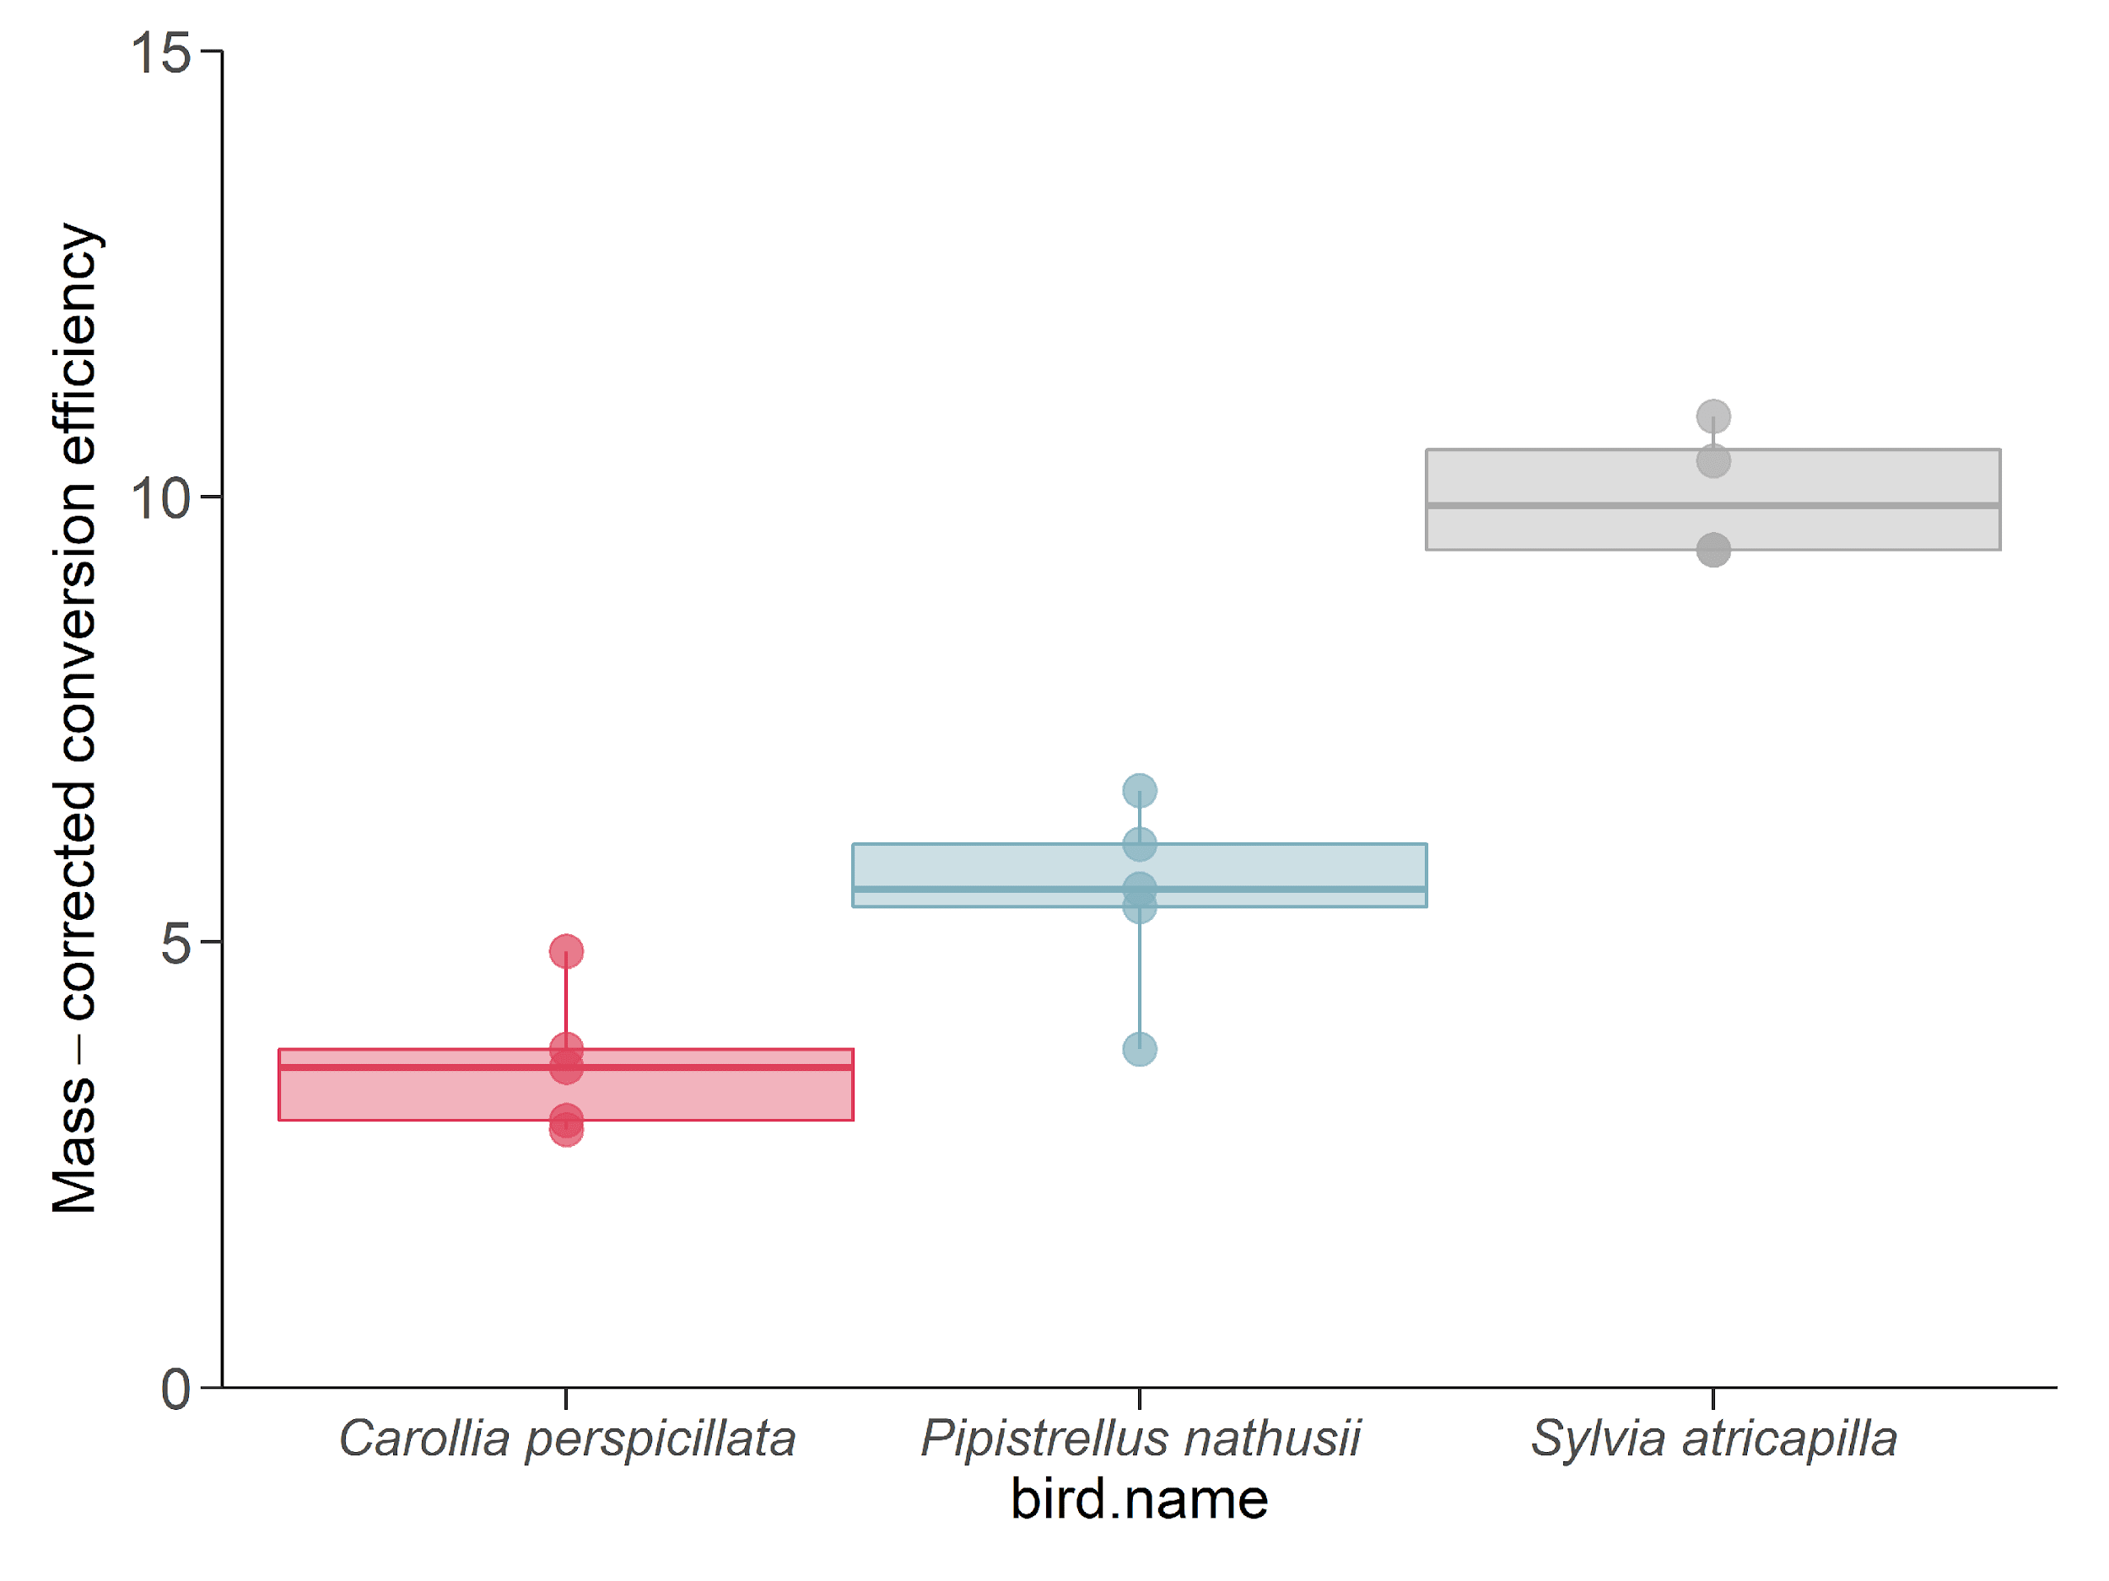

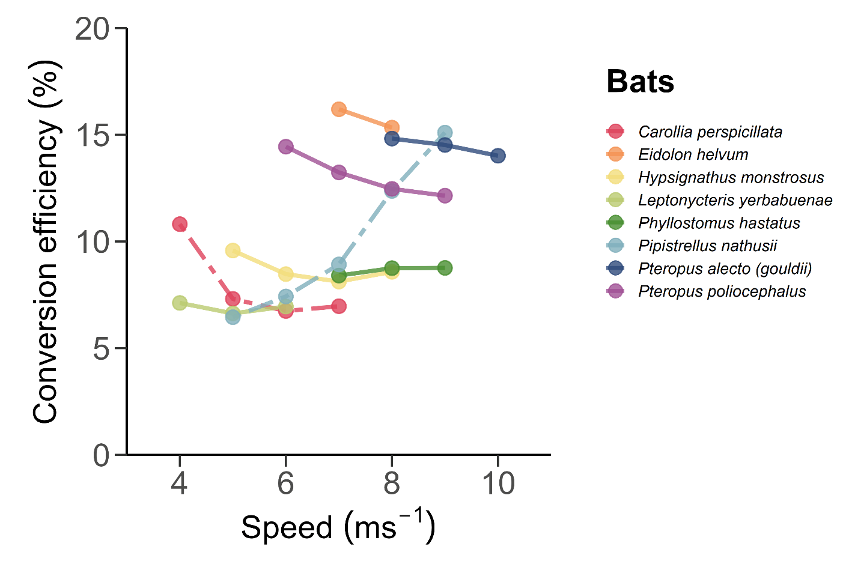

**Supplementary Figure S3.** Recreation of Figure 4A showing estimated conversion efficiency for 8 bat species on an extended axis.

**Additional References**

1. Lighton JR. Measuring metabolic rates: a manual for scientists: Oxford University Press; 2008.

2. Schmidt-Nielsen K. Animal Physiology: Adaptation and Environment. 5 ed. Cambridge: Cambridge University Press; 1997.

3. Johansson LC, Henningsson P. Butterflies fly using efficient propulsive clap mechanism owing to flexible wings. Journal of The Royal Society Interface. 2021;18(174):20200854.

4. von Busse R, Waldman RM, Swartz SM, Voigt CC, Breuer KS. The aerodynamic cost of flight in the short-tailed fruit bat (*Carollia perspicillata*): comparing theory with measurement. Journal of The Royal Society Interface. 2014;11(95):20140147.

5. Klein Heerenbrink M, Johansson LC, Hedenström A. Power of the wingbeat: modelling the effects of flapping wings in vertebrate flight. Proceedings of the Royal Society A: Mathematical, Physical and Engineering Sciences. 2015;471(2177):20140952.

6. Kvist A, Klaassen M, Lindström Å. Energy expenditure in relation to flight speed: What is the power of mass loss rate estimates? Journal of Avian Biology. 1998;29(4):485-98.

7. Pennycuick CJ, Klaassen M, Kvist A, Lindström Å. Wingbeat frequency and the body drag anomaly: wind-tunnel observations on a thrush nightingale (Luscinia luscinia) and a teal (Anas crecca). Journal of Experimental Biology. 1996;199(12):2757-65.

8. Ward S, Bishop CM, Woakes AJ, Butler PJ. Heart rate and the rate of oxygen consumption of flying and walking barnacle geese (*Branta leucopsis*) and bar-headed geese (*Anser indicus*). Journal of Experimental Biology. 2002;205:3347-56.

9. Bishop CM, Spivey RJ, Hawkes LA, Batbayar N, Chua B, Frappell PB, et al. The roller coaster flight strategy of bar-headed geese conserves energy during Himalayan migrations. Science. 2015;347(6219):250-4.

10. Hawkes LA, Balachandran S, Batbayar N, Butler PJ, Chua B, Douglas DC, et al. The paradox of extreme high-altitude migration in bar-headed geese <i>Anser indicus</i>. Proceedings of the Royal Society B: Biological Sciences. 2013;280(1750):20122114.

11. Alerstam T, Rosén M, Bäckman J, Ericson PGP, Hellgren O. Flight Speeds among Bird Species: Allometric and Phylogenetic Effects. PLOS Biology. 2007;5(8):e197.

12. Butler PJ, Woakes AJ. Heart Rate, Respiratory Frequency and Wing Beat Frequency of Free Flying Barnacle Geese Branta Leucopsis. Journal of Experimental Biology. 1980;85(1):213-26.

13. Berger M. Sauerstoffverbrauch von Kolibris (*Colibri coruscans* und *C. thallassinus*) beim Horizontalflug. In: Nachtigall W, editor. Biona Report 3 - Bird Flight - Vogelflug. Sttutgart: Gustav Fischer; 1985. p. 307–14.

14. Dakin R, Segre PS, Straw AD, Altshuler DL. Morphology, muscle capacity, skill, and maneuvering ability in hummingbirds. Science. 2018;359(6376):653-7.

15. Rothe HJ, Biesel W, Nachtigall W. Pigeon flight in a wind tunnel II. Gas exchange and power requirements. Journal of Comparative Physiology B. 1987;157(1):99-109.

16. Pennycuick CJ. A Wind-Tunnel Study of Gliding Flight in the Pigeon *Columba Livia*. Journal of Experimental Biology. 1968;49(3):509-26.

17. Hudson DM, Bernstein MH. Gas exchange and energy cost of flight in the white-necked raven, *Corvus cryptoleucus*. Journal of Experimental Biology. 1983;103(1):121-30.

18. Bernstein MH, Thomas SP, Schmidt-Nielsen K. Power input during flight of the fish crow, *Corvus Ossifragus*. Journal of Experimental Biology. 1973;58(2):401-10.

19. Carpenter RE. Flight physiology of intermediate-sized fruit bats (Pteropodidae). Journal of Experimental Biology. 1986;120:79-103.

20. Tucker VA. Metabolism during flight in the laughing gull, *Larus atricilla*. American Journal of Physiology-Legacy Content. 1972;222(2):237-45.

21. von Busse R, Hedenström A, Winter Y, Johansson LC. Kinematics and wing shape across flight speed in the bat, *Leptonycteris yerbabuenae*. Biology Open. 2012;1(12):1226-38.

22. von Busse R, Swartz SM, Voigt CC. Flight metabolism in relation to speed in Chiroptera: testing the U-shape paradigm in the short-tailed fruit bat *Carollia perspicillata*. Journal of Experimental Biology. 2013;216(11):2073-80.

23. Tobalske BW, Hedrick TL, Biewener AA. Wing kinematics of avian flight across speeds. Journal of Avian Biology. 2003;34(2):177-84.

24. Tucker VA. Respiratory exchange and evaporative water loss in the flying budgerigar. Journal of Experimental Biology. 1968;48(1):67-87.

25. Morris CR, Nelson FE, Askew GN. The metabolic power requirements of flight and estimations of flight muscle efficiency in the cockatiel (*Nymphicus hollandicus*). Journal of Experimental Biology. 2010;213(16):2788-96.

26. Engel S, Biebach H, Visser GH. Metabolic costs of avian flight in relation to flight velocity: a study in Rose Coloured Starlings (*Sturnus roseus*, Linnaeus). Journal of Comparative Physiology B. 2006;176(5):415-27.

27. Norberg UM, Rayner JMV. Ecological morphology and flight in bats (Mammalia; Chiroptera): Wing adaptations, flight performance, foraging strategy and echolocation. Philosophical Transactions of the Royal Society of London Series B, Biological Sciences. 1987;316(1179):335-427.

28. Thomas SP. Metabolism during flight in two species of bats, *Phyllostomus hastatus* and *Pteropus gouldii*. Journal of Experimental Biology. 1975;63:273-93.

29. Thomas SP, Suthers RA. The physiology and energetics of bat flight. Journal of Experimental Biology. 1972;57:317-35.

30. Bullen RD, McKenzie NL, Cruz-Neto AP. Aerodynamic power and mechanical efficiency of bat airframes using a quasi-steady model. CEAS Aeronautical Journal. 2014;5(3):253-64.

31. Ward S, Möller U, Rayner JMV, Jackson DM, Bilo D, Nachtigall W, et al. Metabolic power, mechanical power and efficiency during wind tunnel flight by the European starling *Sturnus vulgaris*. Journal of Experimental Biology. 2001;204(19):3311-22.

32. Ben-Gida H, Kirchhefer A, Taylor ZJ, Bezner-Kerr W, Guglielmo CG, Kopp GA, et al. Estimation of Unsteady Aerodynamics in the Wake of a Freely Flying European Starling (Sturnus vulgaris). PLOS ONE. 2013;8(11):e80086.

33. Hedh L, Guglielmo CG, Johansson LC, Deakin JE, Voigt CC, Hedenström A. Measuring power input, power output and energy conversion efficiency in un-instrumented flying birds. The Journal of Experimental Biology. 2020;223(18):jeb223545.