Supplementary Material

**Figure S1a:** The intensity map of the Mw7.8 earthquake (USGS) and the time evolution of the seismic activity with EAFZ between 1st Jan 2018-27th Feb 2023. Faults are shown by thin black lines (Emre *et al.* 2013). Time interval is shown on the lower left corner in each map.



**Figure S1b:** The station distribution in the aftershock zone and the locations of three large earthquakes (red stars). The uncertainties of the large earthquakes are shown with error ellipses (red lines). The number of stations used for the relocation of the Mw7.0 subevent is 49, with an azimuthal gap < 50 degree gives horizontal uncertainties less than 1 km (Figure S1b).

**Optical image correlation of Sentinel-2 satellite imagery**

The 2D component of the surface deformation field is retrieved by correlation of pre and post Sentinel-2 optical satellite images. Because of changing reflectance conditions (largely the result of fresh snowfall) between the latest pre-earthquake and first post-earthquake images, the resulting correlation map is relatively noisy, with large areas of failed pixels or biased correlation values. To mitigate these problems, we correlate 3 pre-event image (acquired: 20221101, 20230110, 20230125), with 2 post-event images (acquired: 20230209 and 20230914) and median stack the final displacement maps to maximize the areas of correlation. The short time period between the two post-event images, which are both within 3 and 8 days of the earthquake sequence, means they likely contain relatively little post-seismic deformation, and any difference in displacement between the two images will be well below the threshold of the correlation technique (~1/10th pixel).

We correlate band 8 of each pre/post combination of Sentinel-2 scenes, which in this case give the cleanest displacement fields, using the frequency-based correlator from the COSI-Corr software package (Leprince, et al., 2007). Correlating in the frequency domain works well for this earthquake, where there are significant differences in illumination conditions between the images.

Post-processing is important to reduce noise in the final correlation maps. Because the absolute value of displacement is dependent on the quality of the initial registration of the input images to a reference image and/or ground control points, and which is part of the initial production phase of the satellite images by ESA (and thus out of our control), correlation maps are typically biased at the global scale. We therefore remove a 1st-order trend from the east-west and north-south displacement components, based on displacement values in stable areas far from the rupture, which are assumed to have displacements of 0 m. High frequency outliers are removed based on local neighbourhood statistics; pixels are masked if they differ markedly from their local neighbours. Striping artifacts, resulting from mis-alignments of the charge-couple devices (CCD's) on the Sentinel-2 sensor, are removed by subtracting the median stripe bias estimated from the data. Unrealistic values are then masked. Finally, any remaining correlated noise is minimized using a random forest approach (Andreuttiova, et al., 2022), whereby high the frequency bias is predicted based on the local image grayscale values, and DEM elevation, slope, and azimuth from stable (non-deforming) regions. Because the region affected by the two earthquakes is large, we train the model using the correlation map, which has been masked around the fault, and flattened with a high order polynomial function. This allows us to train with data that is appropriate to correct bias in the epicentral region. Once the model is trained, we then predict the bias everywhere in the displacement map (including in the near-field of the ruptures), and remove this from the post-processed displacement maps. This approach helps to significantly reduce bias in the north-south component, which is strongly correlated with features in the imagery and topography. We use a median stacking method (Beyer, et al., 2008) to combine the various displacement maps, which helps to further increase the signal to noise ratio, while also minimizing high-frequency jitter in the across-track direction of the satellite (which is different depending on which dataset is used in for the correlation). Small data gaps are infilled, using an inpainting scheme (Beyer, et al., 2008). The final displacement maps represent a significant improvement on the basic correlations of individual images (Fig. S2).

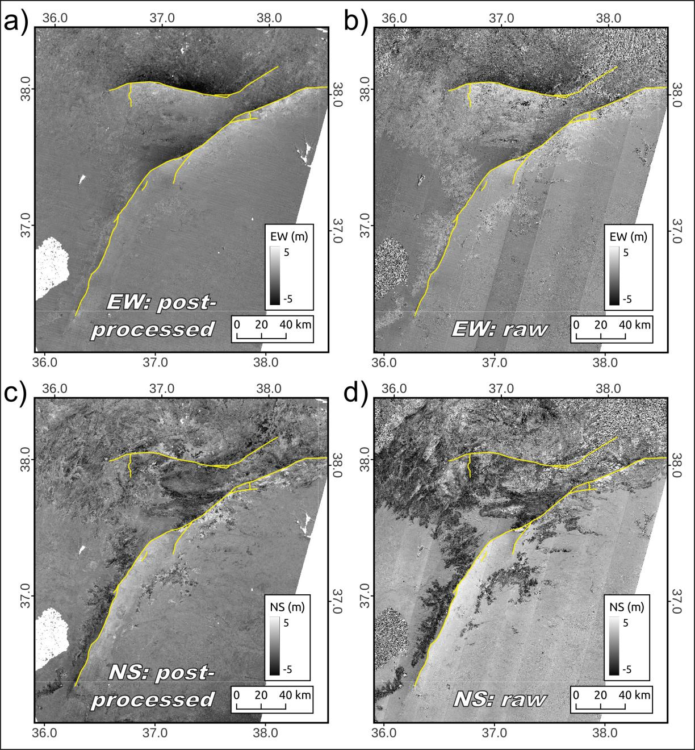

**Figure S2.** Comparison of the EW (a, b) and NS (c, d) displacement fields with stacking and post-processing (a, c) and from basic correlation (b, d) of a single pre/post image pair (band 8: 20230125 with 20230209). Yellow lines highlight the surface rupture produced in the Mw 7.8 and Mw 7.6 events of 6th February 2023.

**Figure S3:** Comparison of the distribution of the aftershocks between 6th Feb – 27th Feb and the image correlation maps showing (a) EW and (b) NS components of displacement from correlation of Sentinel-2 satellite images. Green circles represent the epicenters of the aftershocks and scaled by magnitude. Yellow stars show the epicenters of the 2023, Turkey earthquake sequence.

**Figure S4:** The best-fitting focal mechanism solutions from the near-field waveform inversion of the first 20 seconds of the 2023, Mw7.8 Kahramanmaraş earthquake. The event information is given on top of the plot. Left: Solution using 1D crustal model of Güvercin et al. (2022). Velocity waveform data (black) and model fits (red) for the vertical (Pz) and radial P waves (Pr) are shown in two columns. Station name, distance (km) and azimuth (degree) are shown on the left of the traces. Grid search over strike, dip and rake angles with 5° intervals and moment magnitude with a step size of 0.1 were used to determine best-fitting focal mechanism. Maximum time shifts were chosen as 2 for the Pnl. Waveform fits with a correlation less than 50 were manually eliminated.

**Figure S5:** a)Coulomb stress changes computed on receiver faults. b) Finite fault slip model of 2023, Mw7.8 and Mw7.6 Kahramanmaraş earthquakes (USGS, 2023).

**Table S1:** Focal mechanism solutions presented in this study.

|  |  |  |  |  |  |  |  |  |  |  |
| --- | --- | --- | --- | --- | --- | --- | --- | --- | --- | --- |
| Date | Time | Latitute | Longitude | Depht | M | Strike | Dip | Rake | Source | ID |
| 2023-02-06 | 01:17:35.00 | 37.212 | 37.019 | 14 | 7.0 | 208 | 80 | -20 | CAP(This Study) | 1a |
| 2023-02-06 | 01:17:35.00 | 37.212 | 37.019 | 10 | 7.8 | 222 | 64 | -27 | KOERI | 1b |
| 2023-02-06 | 10:24:48.00 | 38.061 | 37.25 | 10 | 7.6 | 273 | 67 | -9 | KOERI | 2 |
| 2023-02-06 | 12:02:13.00 | 38.124 | 36.447 | 10 | 6.0 | 216 | 84 | -1 | KOERI | 3 |
| 2023-02-06 | 15:14:34.00 | 37.959 | 37.709 | 2 | 5.2 | 65 | 90 | 74 | OCA | 4 |
| 2023-02-06 | 16:43:29.00 | 37.993 | 36.454 | 9 | 5.0 | 248 | 65 | -38 | USGS | 5 |
| 2023-02-06 | 18:03:53.00 | 38.053 | 36.501 | 11 | 5.2 | 226 | 55 | -64 | USGS | 6 |
| 2023-02-06 | 20:38:00.00 | 37.567 | 37.308 | 12 | 5.3 | 157 | 39 | -115 | USGS | 7 |
| 2023-02-06 | 21:15:17.00 | 38.06 | 37.036 | 10 | 4.8 | 50 | 65 | -12 | OCA | 8 |
| 2023-02-06 | 21:57:44.00 | 38.042 | 38.042 | 8 | 4.7 | 207 | 51 | -82 | OCA | 9 |
| 2023-02-07 | 03:08:58.00 | 37.983 | 37.607 | 11 | 5.0 | 287 | 90 | 45 | INGV | 10 |
| 2023-02-07 | 03:13:13.00 | 37.746 | 37.694 | 11 | 5.4 | 202 | 87 | 18 | USGS | 11 |
| 2023-02-07 | 07:11:21.00 | 38.133 | 38.614 | 12 | 5.4 | 62 | 72 | 39 | USGS | 12 |
| 2023-02-07 | 10:18:18.00 | 38.112 | 38.57 | 12 | 5.3 | 248 | 66 | -5 | USGS | 13 |
| 2023-02-07 | 15:49:01.00 | 37.986 | 36.433 | 20 | 5.0 | 221 | 32 | -77 | USGS | 14 |
| 2023-02-07 | 21:21:28.00 | 37.966 | 37.501 | 14 | 4.7 | 357 | 38 | 90 | GFZ | 15 |
| 2023-02-07 | 23:13:03.00 | 36.148 | 35.928 | 11 | 4.3 | 206 | 38 | -84 | GFZ | 16 |
| 2023-02-08 | 05:52:37.00 | 38.08 | 36.725 | 10 | 4.2 | 204 | 66 | -53 | USGS | 17 |
| 2023-02-08 | 07:48:39.00 | 38.032 | 36.485 | 22 | 5.0 | 248 | 54 | -36 | USGS | 18 |
| 2023-02-08 | 10:26:23.00 | 37.146 | 36.971 | 13 | 4.4 | 199 | 48 | -85 | USGS | 19 |
| 2023-02-08 | 11:11:54.00 | 38.02 | 37.681 | 13 | 5.4 | 208 | 87 | 170 | KOERI | 20 |
| 2023-02-08 | 11:24:01.00 | 37.985 | 37.985 | 5 | 4.5 | 96 | 85 | 18 | USGS | 21 |
| 2023-02-08 | 14:20:26.00 | 37.989 | 37.438 | 8 | 4.8 | 265 | 43 | -108 | USGS | 22 |
| 2023-02-10 | 01:51:00.00 | 37.843 | 37.843 | 8 | 4.3 | 194 | 45 | -105 | USGS | 23 |
| 2023-02-10 | 04:50:24.00 | 38.229 | 38.149 | 5 | 4.7 | 68 | 80 | 10 | USGS | 24 |
| 2023-02-10 | 17:00:50.00 | 37.918 | 36.265 | 7 | 4.7 | 234 | 65 | -2 | USGS | 25 |
| 2023-02-11 | 13:09:58.00 | 38.875 | 38.037 | 11 | 4.5 | 226 | 79 | 22 | USGS | 26 |
| 2023-02-11 | 14:11:25.00 | 37.997 | 36.358 | 7 | 3.8 | 265 | 85 | -30 | OCA | 27 |
| 2023-02-12 | 16:29:56.00 | 38.856 | 38.08 | 14 | 5.0 | 49 | 86 | 26 | USGS | 28 |
| 2023-02-13 | 11:59:17.00 | 36.886 | 36.574 | 14 | 4.4 | 180 | 58 | -129 | USGS | 29 |
| 2023-02-13 | 19:20:27.00 | 38.051 | 36.421 | 17 | 4.6 | 242 | 60 | -37 | USGS | 30 |
| 2023-02-14 | 23:14:02.00 | 38.621 | 37.456 | 5 | 4.5 | 92 | 83 | 29 | USGS | 31 |
| 2023-02-15 | 07:36:31.00 | 38.039 | 36.461 | 10 | 4.3 | 259 | 84 | -8 | GFZ | 32 |
| 2023-02-15 | 15:12:12.00 | 40.607 | 35.391 | 3 | 3.9 | 41 | 59 | -18 | OCA | 33 |
| 2023-02-15 | 22:25:57.00 | 38.076 | 36.632 | 11 | 4.4 | 225 | 75 | -15 | OCA | 34 |
| 2023-02-16 | 05:18:59.00 | 38.133 | 38.594 | 10 | 4.4 | 267 | 75 | 0 | GFZ | 35 |
| 2023-02-16 | 14:45:43.00 | 38.183 | 37.847 | 10 | 4.4 | 62 | 77 | 4 | GFZ | 36 |
| 2023-02-16 | 19:47:49.00 | 36.253 | 35.752 | 16 | 5.1 | 186 | 44 | -60 | USGS | 37 |
| 2023-02-17 | 00:35:59.00 | 39.154 | 40.172 | 17 | 4.5 | 212 | 61 | -17 | GFZ | 38 |
| 2023-02-17 | 14:58:58.00 | 37.950 | 36.316 | 10 | 4.4 | 203 | 47 | -78 | GFZ | 39 |
| 2023-02-20 | 17:04:27:00 | 36.343 | 36.124 | 16 | 6.4 | 225 | 56 | -25 | KOERI | 40 |
| 2023-02-20 | 15:53:47:00 | 36.136 | 36.053 | 10 | 5.0 | 200 | 37 | -97 | KOERI | 41 |

**Table S2:** Focal mechanism solutions of preseismicity obtained in this study.

|  |  |  |  |  |  |  |  |  |  |  |
| --- | --- | --- | --- | --- | --- | --- | --- | --- | --- | --- |
| Date | Time | Latitute | Longitude | Depht | M | Strike | Dip | Rake | Source | ID |
| 2012-09-19 | | 09:17:00 | 37.284 | 37.139 | 10 | 5.1 | 213 | 79 | -21 | CAP | 1 |
| 2019-03-22 | | 10:14:00 | 37.217 | 36.910 | 10 | 3.9 | 205 | 65 | -50 | CAP | 2 |
| 2021-10-17 | | 18:22:00 | 36.946 | 36.744 | 9 | 3.5 | 235 | 73 | -18 | CAP | 3 |
| 2022-07-13 | | 18:15:00 | 37.390 | 37.170 | 8 | 3.5 | 205 | 60 | -35 | CAP | 4 |
| 2022-07-26 | | 06:11:00 | 37.450 | 36.990 | 4 | 4.4 | 35 | 80 | 25 | CAP | 5 |
| 2022-10-20 | | 11:34:00 | 37.380 | 37.220 | 10 | 4.5 | 200 | 70 | -30 | CAP | 6 |
| 2022-10-20 | | 17:14:00 | 37.420 | 37.206 | 8 | 4.3 | 209 | 71 | -36 | CAP | 7 |
| 2022-12-18 | | 18:13:00 | 36.395 | 36.434 | 11 | 4.8 | 202 | 65 | -8 | CAP | 8 |

**Estimation of maximum magnitude (*M*max) and average recurrence period (*T*r)**

Molnar (1979) used the Gutenberg–Richter relationship and slip rate on a fault to estimate the recurrence time (*T*r) and maximum magnitude (*M*max) along a fault zone. Recently, Stevens & Avouac (2021) proposed a method to predict *M*max and *T*r by equating the geodetically accumulated strain to the one released by earthquakes considering the Gutenberg–Richter law and applied this method to India–Asia collision zone.

We estimate the *M*max and *T*r for different scenarios based on different dates and magnitudes of historical earthquakes using the strain rate field (Weiss *et al.* 2020) and the long-term seismicity from Guvercin et al (2022) following Stevens & Avouac (2021). This method assumes that the geodetic strain rates are stationary through time and the moment is conserved

The moment build-up rate is:

*m* ̇ = *c* g · μ · *T* s · *A* · ∈ ̇ (1)

where μ is the rigidity (35 GPa), A is the area where the strain rate is computed, *T*s is the seismogenic thickness and *c*g is the geometric factor and ∈ ̇ is the second invariant of the strain rate. The value of *c*g depends on the orientation and dip angle of the fault in order to take into account the partitioned horizontal strain rate onto the fault plane. It is computed using *c*g = 1/[sin δ · cos δ], where δ is the dip angle.

In order to determine the Gutenberg–Richter parameters, we utilized the expanded earthquake catalog from Güvercin et al. (2022). For the historical period, we computed mmax and return periods for 3 different scenarios based on different seismic cycles and calculate the a and b values.

Once the moment build-up rate and Gutenberg–Richter parameters are calculated, we computed Mmax for each scenario following

*M*max=1/(3/2-b)*(log10(1−2b/3) +log10(α·)−9−*a)* (2)

 where α is a constant related to the interseismic coupling which gives the ratio of the seismically released moment rate to the accumulated moment rate. The value of α is determined by calculating the average of the coupling coefficient distribution for each segment from Bletery *et al.* (2020) and assumed to be 0.4 and 0.3 for Palu and Pütürge segments, respectively. For the west of KMTJ, where fault coupling is not available, α is assumed to be 0.5. The recurrence time is calculated using *M*max,

*T*r = 1/10(*a*−*b M*max) (3)

**Figure S6:** Seismicity (AFAD Catalog with M3.0+) 2 months before and 2 month after 06.02.2023 Mw7.8 earthquake. The faults (gray lines) are from Emre et al. (2013).

**References**

Andreuttiova, L., Hollingsworth, J., Vermeesch, P., Mitchell, T. M., & Bergman, E., 2022. Revisiting the 1959 Hebgen Lake Earthquake Using Optical Image Correlation; New Constraints on Near‐Field 3D Ground Displacement. Geophysical Research Letters, 49(16), e2022GL098666.

Beyer, R. A., Alexandrov, O., & McMichael, S., 2018. The Ames Stereo Pipeline: NASA's open source software for deriving and processing terrain data. Earth and Space Science, 5(9), 537-548.

Leprince, S., Barbot, S., Ayoub, F., & Avouac, J. P., 2007. Automatic and precise orthorectification, coregistration, and subpixel correlation of satellite images, application to ground deformation measurements. IEEE Transactions on Geoscience and Remote Sensing, 45(6), 1529-1558.