Supplementary Material

Supplementary Tables

Table S1: Environmental parameters in seawater at Licun estuary and Zhanqiao Pier. Environmental parameters (mean ± standard error, n = 3) include temperature, salinity, dissolved oxygen and pH, which were measured by a Pro Plus handheld multiparameter meter.
 | Licun estuary | Zhanqiao Pier
Temperature (°C) | 16.2±0.1 | 16.5±0.5
Salinity | 29.63±0.1 | 31.30±0.3
Dissolved oxygen (%) | 104.2±0.5 | 123.0±1.0
pH | 8.20±0.02 | 8.40±0.02

Table S2: Results of one-way ANOVA tests showing the effect of different CO₂ enhancements (400, 700 and 1000 ppm) on the photosynthetic parameters of diatoms and cyanobacteria in muddy and sandy sediments (F_{v}/F_{m}: maximum quantum yield; α: photosynthetic efficiency; rETR_{max}: relative electron transport rate. Significant difference (P < 0.05) indicated in bold.
Parameters | Sediments | Algae | df | F | p-value
F_{v}/F_{m} | Mud | Diatom | 2 | 100.4 | < 0.001
 |  | Cyanobacteria | 2 | 31.2 | < 0.001
 | Sand | Diatom | 2 | 21.9 | 0.002
 |  | Cyanobacteria | 2 | 7.8 | 0.022
α | Mud | Diatom | 2 | 49.6 | < 0.001
 |  | Cyanobacteria | 2 | 4.7 | 0.090
 | Sand | Diatom | 2 | 7.7 | 0.043
 |  | Cyanobacteria | 2 | 0.054 | 0.949
rETR_{max} | Mud | Diatom | 2 | 20.8 | 0.002
 |  | Cyanobacteria | 2 | 23.3 | 0.001
 | Sand | Diatom | 2 | 7.3 | 0.024
 |  | Cyanobacteria | 2 | 3.3 | 0.109

Table S3: Results of one-way ANOVA tests showing the effect of different CO₂ enhancements (400, 700 and 1000 ppm) on the net growth rates of MPB, microalgae (diatoms and cyanobacteria), bacteria and viruses in muddy and sandy sediments. Significant difference (P < 0.05) indicated in bold.
Parameters | Sediments | df | F | p-value
MPB | Mud | 2 | 2.11 | 0.202
 | Sand | 2 | 2.16 | 0.197
Diatoms | Mud | 2 | 0.432 | 0.668
 | Sand | 2 | 0.651 | 0.555
Cyanobacteria | Mud | 2 | 11.5 | 0.009
 | Sand | 2 | 0.834 | 0.479
Bacteria | Mud | 2 | 1.7 | 0.274
 | Sand | 2 | 7.6 | 0.022
Viruses | Mud | 2 | 2.1 | 0.239
 | Sand | 2 | 1.4 | 0.323

Table S4: Results of one-way ANOVA tests showing the effect of different CO₂ enhancements (400, 700 and 1000 ppm) on the ratio of chlorophyll a to phaeophytin a (chl a/ phaeo a) and the biomass ratio of cyanobacteria to diatoms (cyanobacteria/ diatoms) in MPB for muddy and sandy sediments. Significant difference (P < 0.05) indicated in bold.
Parameters | Sediments | df | F | p-value
chl a/ phaeo a | Mud | 2 | 2.21 | 0.191
 | Sand | 2 | 0.155 | 0.860
cyanobacteria/ | Mud | 2 | 0.37 | 0.705
diatoms | Sand | 2 | 7.1 | 0.026

Table S5: Results of one-way ANOVA tests showing the effect of different CO₂ enhancements (400, 700 and 1000 ppm) on the relative abundance of bacterial phyla and orders in muddy and sandy sediments. Significant difference (P < 0.05) indicated in bold.
Parameters | Sediments | df | F | p-value
Proteobacteria | Mud | 2 | 1.2 | 0.362
 | Sand | 2 | 38 | < 0.001
Bacteroidota | Mud | 2 | 13.2 | 0.006
 | Sand | 2 | 19.8 | 0.002
Firmicutes | Mud | 2 | 24.1 | 0.001
 | Sand | 2 | 10.6 | 0.011
Rhodobacterales | Mud | 2 | 0.85 | 0.473
 | Sand | 2 | 29.6 | < 0.001
Alteromonadales | Mud | 2 | 3.1 | 0.116
 | Sand | 2 | 132.0 | < 0.001
Flavobacteriales | Mud | 2 | 14.4 | 0.005
 | Sand | 2 | 92.0 | < 0.001
Bacillales | Mud | 2 | 8.4 | 0.018
 | Sand | 2 | 8.2 | 0.019
Peptostreptococcales- | Mud | 2 | 122.6 | < 0.001
Tissierellales | Sand | 2 | 26.0 | 0.001

Table S6: Results of one-way ANOVA tests showing the effect of different CO₂ enhancements (400, 700 and 1000 ppm) on the relative abundance of eukaryotic phyla in muddy and sandy sediments. Significant difference (P < 0.05) indicated in bold.
Parameters | Sediments | df | F | p-value
Unclassified_d_Eukaryota | Mud | 2 | 13.2 | 0.006
 | Sand | 2 | 0.07 | 0.937
Rhodophyta | Mud | 2 | 1.1 | 0.379
 | Sand | 2 | 0.1 | 0.902
Bacillariophyta | Mud | 2 | 0.08 | 0.924
 | Sand | 2 | 13.9 | 0.006
Chlorophyta | Mud | 2 | 2.5 | 0.162
 | Sand | 2 | 1.7 | 0.258
Ciliophora | Mud | 2 | 3.8 | 0.086
 | Sand | 2 | 43.7 | < 0.001
Nematoda | Mud | 2 | 1.6 | 0.273
 | Sand | 2 | 2.9 | 0.134
Arthropoda | Mud | 2 | 0.84 | 0.476
 | Sand | 2 | NA | NA
Ascomycota | Mud | 2 | 2.4 | 0.171
 | Sand | 2 | 2.3 | 0.184

Table S7: Results of one-way ANOVA tests showing the effect of different CO₂ enhancements (400, 700 and 1000 ppm) on the function abundance predicted by FAPROTAX in muddy and sandy sediments. Significant difference (P < 0.05) indicated in bold.
Parameters | Sediments | df | F | p-value
chemoheterotrophy | Mud | 2 | 221.0 | < 0.001
 | Sand | 2 | 361.7 | < 0.001
aerobic | Mud | 2 | 131.1 | < 0.001
chemoheterotrophy | Sand | 2 | 234.9 | < 0.001
hydrocarbon degradation | Mud | 2 | 25.8 | 0.001
 | Sand | 2 | 282.2 | < 0.001
dark oxidation of | Mud | 2 | 0.20 | 0.822
sulfur compounds | Sand | 2 | 4.9 | 0.047
fermentation | Mud | 2 | 4.5 | 0.065
 | Sand | 2 | 3.2 | 0.115
nitrate reduction | Mud | 2 | 3.7 | 0.087
 | Sand | 2 | 2.7 | 0.147
respiration of sulfur | Mud | 2 | 32.2 | < 0.001
compounds | Sand | 2 | 29.9 | < 0.001
thiosulfate respiration | Mud | 2 | 36.3 | < 0.001
 | Sand | 2 | 30.6 | < 0.001

Table S8: Results of one-way ANOVA tests showing the effect of different CO₂ enhancements (400, 700 and 1000 ppm) on the function abundance predicted by PICRUST2 in muddy and sandy sediments. Significant difference (P < 0.05) indicated in bold.
Parameters | Sediments | df | F | p-value
Carbohydrate metabolism | Mud | 2 | 0.83 | 0.479
 | Sand | 2 | 0.20 | 0.822
Starch and sucrose metabolism | Mud | 2 | 5.4 | 0.046
 | Sand | 2 | 2.5 | 0.162
Energy metabolism | Mud | 2 | 0.60 | 0.577
 | Sand | 2 | 0.12 | 0.889
Glycolysis/Gluconeogenesis | Mud | 2 | 0.402 | 0.686
 | Sand | 2 | 0.06 | 0.939
Citrate cycle | Mud | 2 | 0.50 | 0.632
 | Sand | 2 | 0.07 | 0.934
Oxidative phosphorylation | Mud | 2 | 0.62 | 0.572
 | Sand | 2 | 0.02 | 0.976

Table S8: Results of one-way ANOVA tests showing the effect of different CO₂ enhancements (400, 700 and 1000 ppm) on the function abundance predicted by PICRUST2 in muddy and sandy sediments. Significant difference (P < 0.05) indicated in bold.
Parameters | Sediments | df | F | p-value
Biofilm formation | Mud | 2 | 11.0 | 0.010
Vibrio cholerae | Sand | 2 | 55.2 | < 0.001
Biofilm formation | Mud | 2 | 5.3 | 0.047
Escherichia coli | Sand | 2 | 8.2 | 0.019
Biofilm formation | Mud | 2 | 8.5 | 0.018
Pseudomonas aeruginosa | Sand | 2 | 20.5 | 0.002
Cell motility | Mud | 2 | 12.3 | 0.007
 | Sand | 2 | 18.1 | 0.003
Flagellar assembly | Mud | 2 | 10.5 | 0.011
 | Sand | 2 | 12.6 | 0.007
Bacterial chemotaxis | Mud | 2 | 14.8 | 0.005
 | Sand | 2 | 29.8 | < 0.001

Table S9: Changes in microphytobenthos chl a concentration of intertidal sandy and muddy sediments during a 28-day period under three different CO₂ treatments. Chl a concentration (mean ± standard error, n = 3) was measured on day 0 and day 28 by a Turner Designs 10-AU Fluorometer, with a unit of mg chl a m⁻². Three CO₂ treatments are 400 ppm, 700 ppm and 1000 ppm.
Sediment | Day | 400 | 700 | 1000
Sand | 0 | 341.23±21.48 | 341.23±21.48 | 341.23±21.48
Mud | 0 | 111.36±51.85 | 111.36±51.85 | 111.36±51.85
Sand | 28 | 1057.11±150.47 | 796.21±166.13 | 579.86±151.19
Mud | 28 | 414.41±10.52 | 180.56±62.00 | 260.90±42.69

Table S10: Changes in bacterial abundance of intertidal sandy and muddy sediments during a 28-day period under three different CO₂ treatments. Bacterial abundance (mean ± standard error, n = 3, unit: x 10⁹/L) was measured on day 0 and day 28 by a CytoFLEX Platform flow cytometer. Three CO₂ treatments are 400 ppm, 700 ppm and 1000 ppm.
Sediment | Day | 400 | 700 | 1000
Sand | 0 | 9.08±1.28 | 9.08±1.28 | 9.08±1.28
Mud | 0 | 23.51±2.22 | 23.51±2.22 | 23.51±2.22
Sand | 28 | 168.64±46.60 | 105.51±1.02 | 40.85±8.10
Mud | 28 | 149.92±33.04 | 94.72±12.56 | 72.40±25.05

Table S11: Changes in viral abundance of intertidal sandy and muddy sediments during a 28-day period under three different CO₂ treatments. Viral abundance (mean ± standard error, n = 3, unit: x 10¹⁰/L) was measured on day 0 and day 28 by a CytoFLEX Platform flow cytometer. Three CO₂ treatments are 400 ppm, 700 ppm and 1000 ppm.
Sediment | Day | 400 | 700 | 1000
Sand | 0 | 6.34±1.17 | 6.34±1.17 | 6.34±1.17
Mud | 0 | 3.82±1.23 | 3.82±1.23 | 3.82±1.23
Sand | 28 | 115.69±17.75 | 87.90±13.38 | 114.97±14.45
Mud | 28 | 40.65±7.53 | 80.46±14.14 | 54.12±4.91

Table S12: Topological features of co-occurrence networks of biotic communities in muddy and sandy intertidal sediments at different pCO₂ incubation conditions. Network analysis was conducted in R studio and Gephi. OTUs with an average relative abundance >0.1% and strong correlations (Spearman’s rank correlation coefficient, r > 0.9 (or r < −0.9)) were selected to construct the networks.
 | S400 | S700 | S1000 | M400 | M700 | M1000
Number of nodes | 152 | 164 | 148 | 211 | 196 | 200
Number of edges | 3293 | 3838 | 3143 | 5787 | 5731 | 6285
Positive correlations | 52.84% | 54.82% | 58.86% | 60.65% | 60.43% | 63.23
Negative correlations | 47.16% | 45.18% | 41.14% | 39.35% | 39.57% | 36.77
Average degree | 43.329 | 46.805 | 42.473 | 54.853 | 58.48 | 62.85
Network diameter | 1 | 1 | 1 | 1 | 1 | 1
Network density | 0.287 | 0.287 | 0.289 | 0.261 | 0.3 | 0.316
Modularity | 6.872 | 4.153 | 1.909 | 1.674 | 1.76 | 1.33
Average clustering | 1 | 1 | 1 | 1 | 1 | 1
coefficient

Supplementary Figures

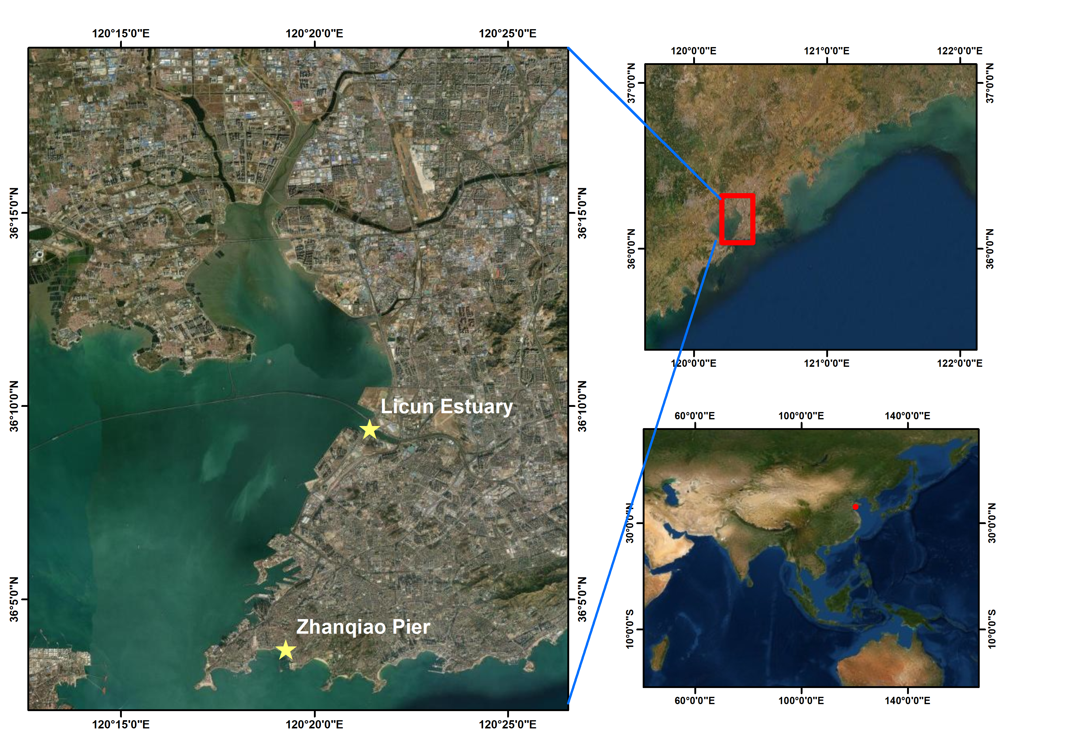

Figure S1: Location of the sampling sites in the Qingdao area, China. Both sites are located in an area characterized by intense urban and industrial development. Muddy sediments were collected at Licun estuary and sandy sediments were collected at Zhanqiao Pier.

Figure S2: Effects of ocean acidification on the ratio of chlorophyll a to phaeophytin a in muddy and sandy intertidal sediments. Brown color represents sandy sediments, and blue color represents muddy sediments. Chlorophyll a and phaeophytin a concentration was measured by a Turner Designs 10-AU Fluorometer, with a unit of mg chl a m⁻². Three CO₂ treatments are 400 ppm, 700 ppm and 1000 ppm.

Figure S3: Effects of ocean acidification on the MPB community composition in muddy and sandy intertidal sediments. Brown color represents sandy sediments, and blue color represents muddy sediments. Chl a concentration, as a proxy of biomass, was measured by a Phyto-PAM II Fluorometer. Three CO₂ treatments are 400 ppm, 700 ppm and 1000 ppm.

3. Data Availability
Data submitted to and accepted by The National Center for Biotechnology Information (NCBI, Bethesda, Maryland USA)
Accession Sample Name SPUID Organism Tax ID BioProject
SAMN31955048 Sample_1 Sample_1 marine sediment metagenome 412755 PRJNA907193
SAMN31955049 Sample_2 Sample_2 marine sediment metagenome 412755 PRJNA907193
SAMN31955050 Sample_3 Sample_3 marine sediment metagenome 412755 PRJNA907193
SAMN31955051 Sample_4 Sample_4 marine sediment metagenome 412755 PRJNA907193
SAMN31955052 Sample_5 Sample_5 marine sediment metagenome 412755 PRJNA907193
SAMN31955053 Sample_6 Sample_6 marine sediment metagenome 412755 PRJNA907193
SAMN31955054 Sample_7 Sample_7 marine sediment metagenome 412755 PRJNA907193
SAMN31955055 Sample_8 Sample_8 marine sediment metagenome 412755 PRJNA907193
SAMN31955056 Sample_9 Sample_9 marine sediment metagenome 412755 PRJNA907193
SAMN31955057 Sample_10 Sample_10 marine sediment metagenome 412755 PRJNA907193
SAMN31955058 Sample_11 Sample_11 marine sediment metagenome 412755 PRJNA907193
SAMN31955059 Sample_12 Sample_12 marine sediment metagenome 412755 PRJNA907193
SAMN31955060 Sample_13 Sample_13 marine sediment metagenome 412755 PRJNA907193
SAMN31955061 Sample_14 Sample_14 marine sediment metagenome 412755 PRJNA907193
SAMN31955062 Sample_15 Sample_15 marine sediment metagenome 412755 PRJNA907193
SAMN31955063 Sample_16 Sample_16 marine sediment metagenome 412755 PRJNA907193
SAMN31955064 Sample_17 Sample_17 marine sediment metagenome 412755 PRJNA907193
SAMN31955065 Sample_18 Sample_18 marine sediment metagenome 412755 PRJNA907193
SAMN31955066 Sample_19 Sample_19 marine sediment metagenome 412755 PRJNA907193
SAMN31955067 Sample_20 Sample_20 marine sediment metagenome 412755 PRJNA907193
SAMN31955068 Sample_21 Sample_21 marine sediment metagenome 412755 PRJNA907193
SAMN31955069 Sample_22 Sample_22 marine sediment metagenome 412755 PRJNA907193
SAMN31955070 Sample_23 Sample_23 marine sediment metagenome 412755 PRJNA907193
SAMN31955071 Sample_24 Sample_24 marine sediment metagenome 412755 PRJNA907193
SAMN31955072 Sample_25 Sample_25 marine sediment metagenome 412755 PRJNA907193
SAMN31955073 Sample_26 Sample_26 marine sediment metagenome 412755 PRJNA907193
SAMN31955074 Sample_27 Sample_27 marine sediment metagenome 412755 PRJNA907193
SAMN31955075 Sample_28 Sample_28 marine sediment metagenome 412755 PRJNA907193
SAMN31955076 Sample_29 Sample_29 marine sediment metagenome 412755 PRJNA907193
SAMN31955077 Sample_30 Sample_30 marine sediment metagenome 412755 PRJNA907193
SAMN31955078 Sample_31 Sample_31 marine sediment metagenome 412755 PRJNA907193
SAMN31955079 Sample_32 Sample_32 marine sediment metagenome 412755 PRJNA907193
SAMN31955080 Sample_33 Sample_33 marine sediment metagenome 412755 PRJNA907193
SAMN31955081 Sample_34 Sample_34 marine sediment metagenome 412755 PRJNA907193
SAMN31955082 Sample_35 Sample_35 marine sediment metagenome 412755 PRJNA907193
SAMN31955083 Sample_36 Sample_36 marine sediment metagenome 412755 PRJNA907193
https://www.ncbi.nlm.nih.gov/biosample/31955048
https://www.ncbi.nlm.nih.gov/biosample/31955049
https://www.ncbi.nlm.nih.gov/biosample/31955050
https://www.ncbi.nlm.nih.gov/biosample/31955051
https://www.ncbi.nlm.nih.gov/biosample/31955052
https://www.ncbi.nlm.nih.gov/biosample/31955053
https://www.ncbi.nlm.nih.gov/biosample/31955054
https://www.ncbi.nlm.nih.gov/biosample/31955055
https://www.ncbi.nlm.nih.gov/biosample/31955056
https://www.ncbi.nlm.nih.gov/biosample/31955057
https://www.ncbi.nlm.nih.gov/biosample/31955058
https://www.ncbi.nlm.nih.gov/biosample/31955059
https://www.ncbi.nlm.nih.gov/biosample/31955060
https://www.ncbi.nlm.nih.gov/biosample/31955061
https://www.ncbi.nlm.nih.gov/biosample/31955062
https://www.ncbi.nlm.nih.gov/biosample/31955063
https://www.ncbi.nlm.nih.gov/biosample/31955064
https://www.ncbi.nlm.nih.gov/biosample/31955065
https://www.ncbi.nlm.nih.gov/biosample/31955066
https://www.ncbi.nlm.nih.gov/biosample/31955067
https://www.ncbi.nlm.nih.gov/biosample/31955068
https://www.ncbi.nlm.nih.gov/biosample/31955069
https://www.ncbi.nlm.nih.gov/biosample/31955070
https://www.ncbi.nlm.nih.gov/biosample/31955071
https://www.ncbi.nlm.nih.gov/biosample/31955072
https://www.ncbi.nlm.nih.gov/biosample/31955073
https://www.ncbi.nlm.nih.gov/biosample/31955074
https://www.ncbi.nlm.nih.gov/biosample/31955075
https://www.ncbi.nlm.nih.gov/biosample/31955076
https://www.ncbi.nlm.nih.gov/biosample/31955077
https://www.ncbi.nlm.nih.gov/biosample/31955078
https://www.ncbi.nlm.nih.gov/biosample/31955079
https://www.ncbi.nlm.nih.gov/biosample/31955080
https://www.ncbi.nlm.nih.gov/biosample/31955081
https://www.ncbi.nlm.nih.gov/biosample/31955082
https://www.ncbi.nlm.nih.gov/biosample/31955083

