Supplementary Material

Stochastic schemes for the perturbation of the atmospheric boundary conditions in ocean general circulation models

Andrea Storto*, Chunxue Yang
* Correspondence: Andrea Storto: andrea.storto@cnr.it

Supplementary Figures and Tables

Supplementary Figures

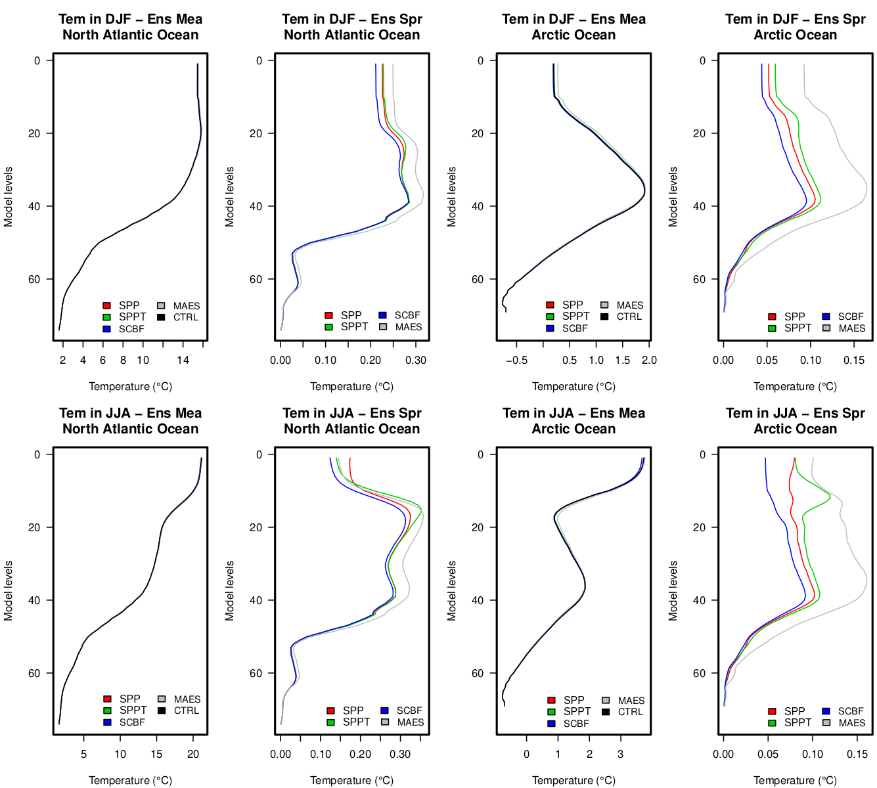
Supplementary Figure 1. Time-averaged vertical profiles of temperature ensemble mean, for the two regions North Atlantic (south of 60°N) and Arctic (north of 60°N) Oceans, and the winter (DJF) and summer (JJA) seasons.

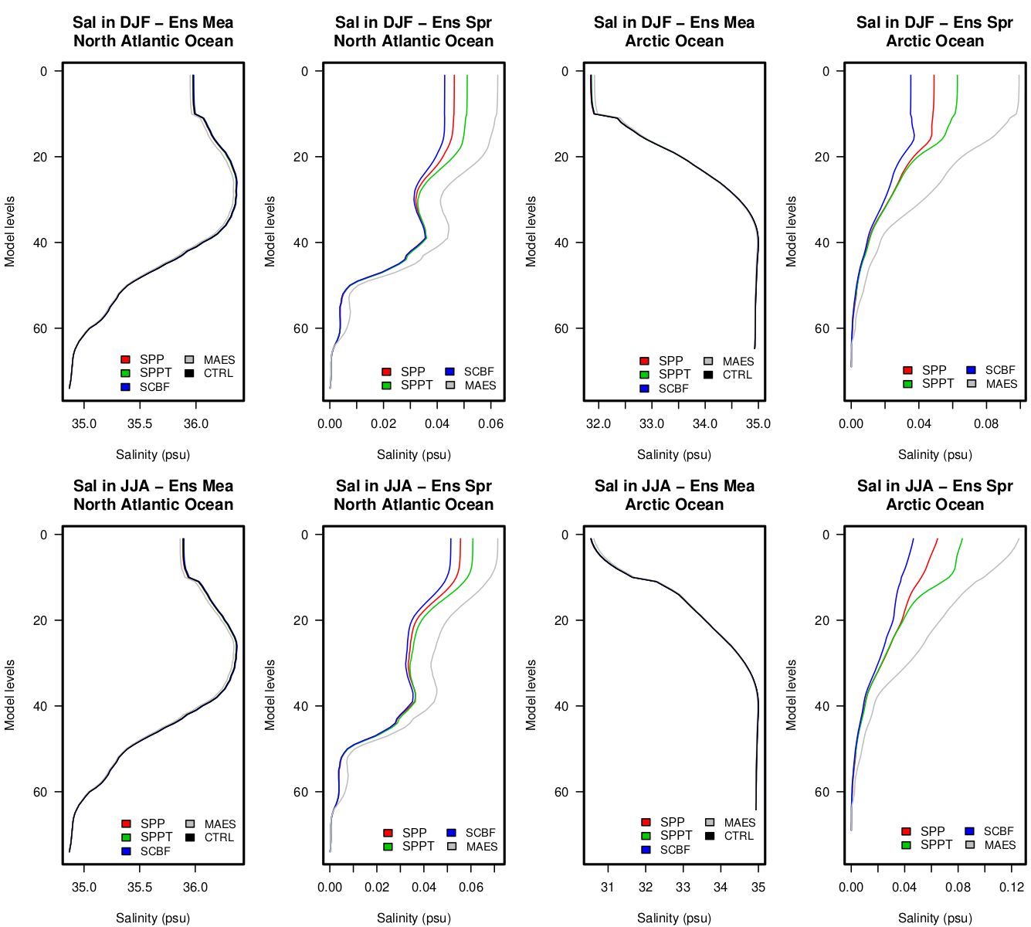
Supplementary Figure 2. As for Supplementary Figure 1, but for salinity.

