**Supplementary material for** **Finale: Impact of the ORCHESTRA/ENCORE programmes on Southern Ocean heat and carbon understanding**

Figure S1: Flight tracks of research aircraft missions. Left panel: flying out from the Falkland Islands over open water in February 2019. The purple flight track shows a comparison flight near the mast of the JCR research vessel (see Figure S2). Right panel: flying out from Rothera Research Station over the marginal sea ice area near Marguerite Bay and the sea ice area in the Weddell Sea, as well as over open water and the glider area (Figure 4).

Figure S2 (a-f) : Aircraft observed (black line) time series of a) altitude, b) atmospheric pressue, c) wind speed, d) friction velocity (u*), e) temperature and f) sensible heat flux, compared with contemporanious ship measurements using (purple, d,f)) eddy covariance and (blue, d,f)) bulk formula approaches. All units as labelled.

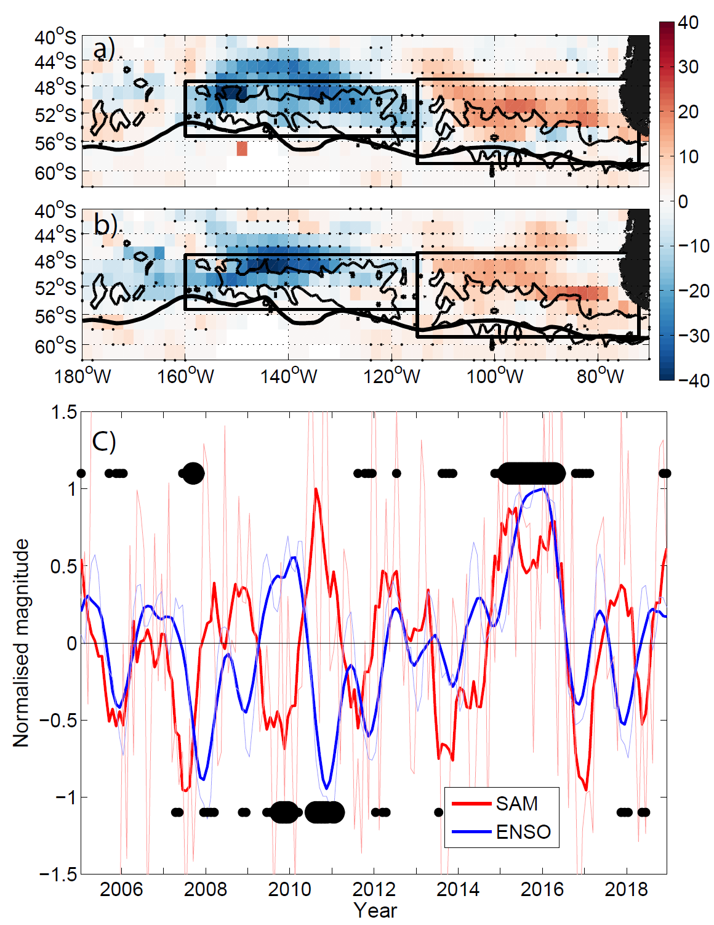

Figure S3: (a) ENSO and (b) SAM regression onto detrended SAMW thickness anomalies 2005–2018 derived from gridded Argo data showing that the two modes have similar regional impacts. Each index is normalized by one standard deviation to give indicative impact on thickness (i.e., meters per standard deviation of the index, m std−1). Stippling indicates a statistically significant correlation at the 95% level. (c) Normalized monthly SAM (red) and ENSO3.4 (blue). Bold lines indicate three month running mean of index. Positive (negative) black dots indicate when SAM and ENSO are in (out of) phase and at least one exceeds one standard deviation in magnitude, and large black dots indicate when both exceed one standard deviation in magnitude. Note that these largely fall ‘in phase’ prior to 2008, then ‘out of phase’ until around 2012 and ‘in phase’ again afterwards. As noted in (1) these align with respective periods of relatively strong, weak and strong ‘see-saw’ dipole behaviour in the South East Pacific mixed layer depths and subsequent SAMW layer thicknesses. Figure reproduced from (1).



Figure S4: AABW volumes in m3 (defined as water with σ4>45.88≈γn>28.11 kgm-3) over 20 years of model integration contained within a box enclosing the Weddell Sea and the Atlantic sector, between 65.5oW and 20oW, and south of 24oS. The densest water formed in the σ-z simulation (NAAS12SZT) remains relatively constant in volume following the 1950s, while the z partial steps (NAAS12ZPS) declines steadily.

|  |  |  |  |  |
| --- | --- | --- | --- | --- |
| **Cruise number** | **Ship** | **Dates** | **Location** | **Observations** |
| JR15006 | RRS James Clark Ross | 2016-03-31 — 2016-04-26 | Weddell Sea, A23 | T,S, ocean velocity, DO (uncalibrated), meteorology, δ18O (including land and sea ice) |
| JR16002 | RRS James Clark Ross | 2016-11-10 — 2016-12-03 | SR1b | T,S, ocean velocity, DO (uncalibrated), meteorology, δ18O, 3x deep Apex float deployment |
| JR16004 | RRS James Clark Ross | 2017-01-24 — 2017-03-13 | A23 | T,S, ocean velocity, DO (uncalibrated), meteorology, δ18O, |
| JR16005 | RRS James Clark Ross | 2017-03-17 — 2017-05-08 | Orkney Passage | T,S, ocean velocity, DO (uncalibrated), 6x mooring recovery, turnaround and calibration. |
| JR17001 | RRS James Clark Ross | 2017-11-21 — 2017-12-21 | SR1b, SACCF process study | T,S, ocean velocity, DO, meteorology, δ18O, 4x Slocum glider, 1x Hydroid glider, 1x waveglider, MASIN overflight, heat air-sea fluxes |
| JR17003 | RRS James Clark Ross | 2018-01-26 — 2018-02-18 | A23 | T,S, ocean velocity, DO (uncalibrated), meteorology, δ18O |
| JC159 | RRS James Cook | 2018-02-28 — 2018-04-10 | 24oS | T,S, ocean velocity, DO, meteorology, δ18O, nutrients, TA, DIC, 13/14C isotopes. 8x floats |
| JR18002 | RRS James Clark Ross | 2018-11-03 — 2018-11-22 | SR1b | T,S, ocean velocity, DO, meteorology, δ18O, nutrients, TA, DIC, 13/14C |
| JR18004 | RRS James Clark Ross | 2019-01-06 — 2019-02-17 | Discovery Bank process study, Orkney Passage | T,S, ocean velocity, DO (uncalibrated), meteorology, δ18O, VMP, 2 EM-APEX floats, 1x Slocum glider, Heat/carbon air-sea fluxes, , 6x mooring recovery, turnaround and calibration |
| JR18005 | RRS James Clark Ross | 2019-02-21 — 2019-04-15 | ANDREXII | T,S, ocean velocity, DO, meteorology, δ18O, nutrients, TA, DIC, 13/14C isotopes, 2x MASIN overflights, 2x deep Arvor floats, 6x SOCCOM floats, heat/carbon air-sea fluxes |
| DY113 | RRS Discovery | 2020-02-04 — 2020-03-13 | SR1b, A23 | T,S, ocean velocity, DO, meteorology, δ18O, nutrients, 4x Argo floats, Heat/carbon air-sea fluxes |
| JC211 | RRS James Cook | 2021-02-02 – 2021-03-07 | SR1b, A23 | T,S, ocean velocity, DO, meteorology, δ18O, 4x Argo floats |
| DY158 | RRS Discovery | Planned 22/23 Season | Orkney Passage, A23 | T,S, ocean velocity, DO (uncalibrated), meteorology, δ18O, 6 x mooring recovery, turnaround and calibration |

Table S1: Summary of ORCHESTRA cruise elements, dates and sample collection. For full cruise reports please see https://www.bodc.ac.uk/resources/inventories/cruise_inventory.

**References**

1. Meijers AJS, Cerovečki I, King BA, Tamsitt V. A See-Saw in Pacific Subantarctic Mode Water Formation Driven by Atmospheric Modes. Geophysical Research Letters. 2019;46(22):13152–60.