Supplemental Material

This document contains supplementary material for: Leidman SZ, Rennermalm ÅK, Muthyala R, Skiles SM and Getraer A (2023), Intraseasonal variability in supraglacial stream sediment on the Greenland ice sheet. Front. Earth Sci. 11:969629. doi: 10.3389/feart.2023.969629

Author for correspondence: Sasha Leidman, sasha.leidman@rutgers.edu

Tables
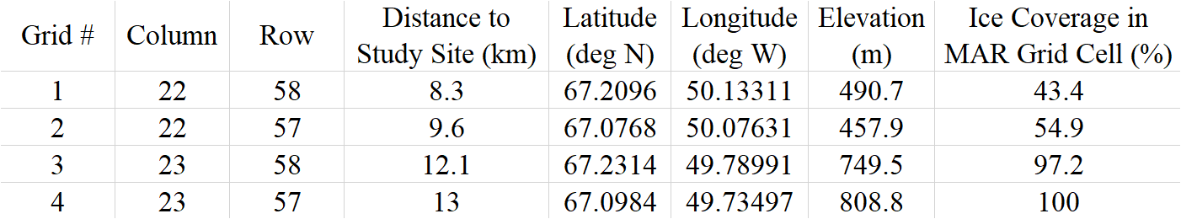
Supplementary Table 1: Geographic information about the 15 km resolution MAR v3.11.5 grid cells used for calculating the average runoff within our study site. Distances, geographic coordinates, and elevation are calculated from the center of the grid cell.

Figures
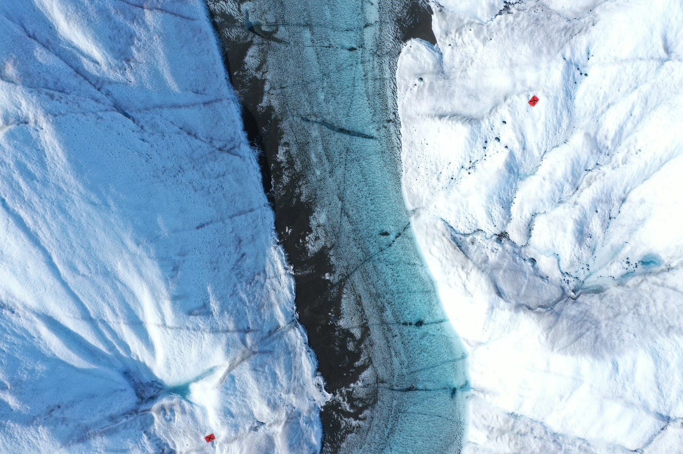
Supplementary Figure 1: UAV image taken by a Mavic 2 Pro on August 14th, 2019 showing two of the 0.35 x 0.25 m orange markers used as ground control points.
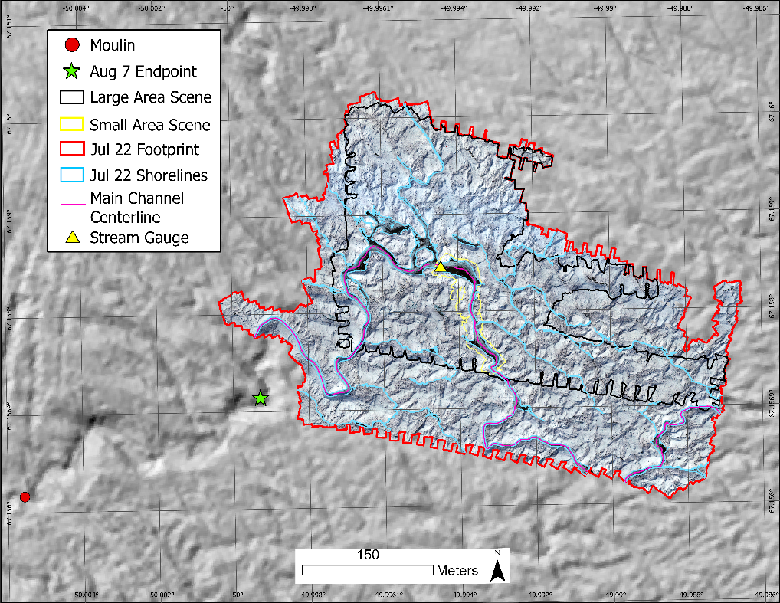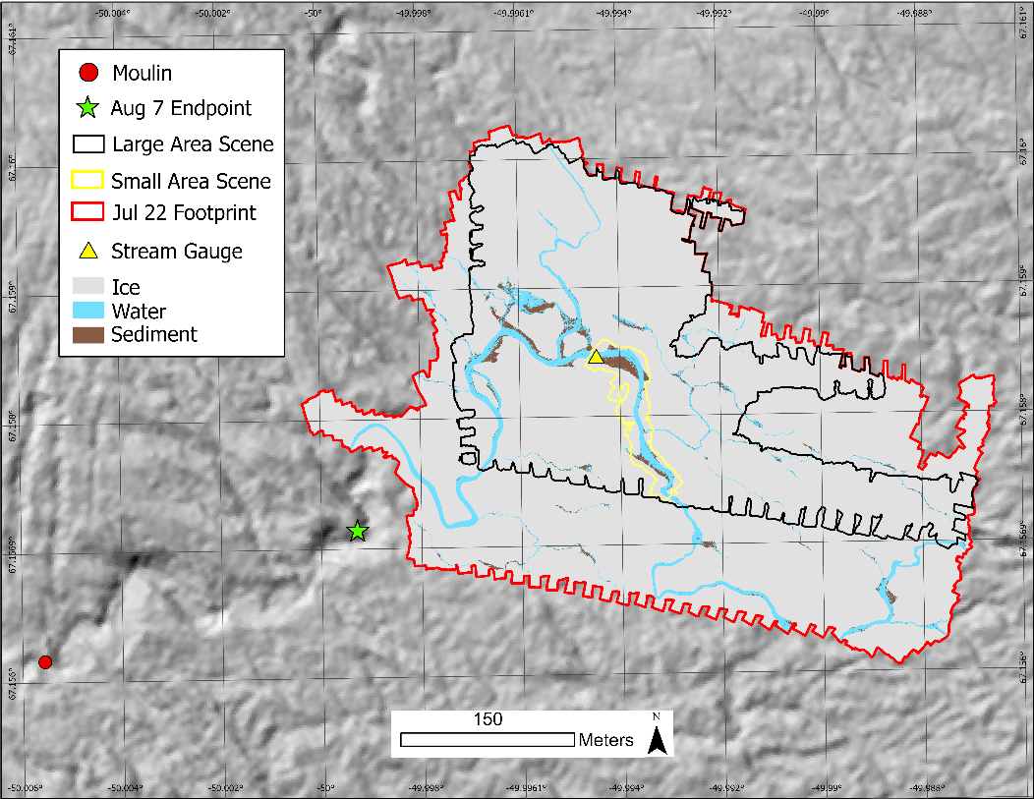
Supplementary Figure 2: Map depicting the mosaiced UAV imagery collected on July 22, 2019 (above) and the supervised classification of that imagery (below) along with the hand digitized stream shorelines (light blue), location of the centerline of the main channel (pink), the footprint of the mosaic imagery (red), the outline of the large and small area scene used for analysis of stream and sediment statistics (black and yellow respectively), the location of the furthest visible downstream location of the main channel from August 7th, 2019 (green star), the moulin (red circle), and the location of the stream gauge used to determine water level throughout the field season (yellow triangle). Background imagery is a hillshade of the ArcticDEM (Polar Geospatial Center et al., 2018) collected on August 20th, 2018.
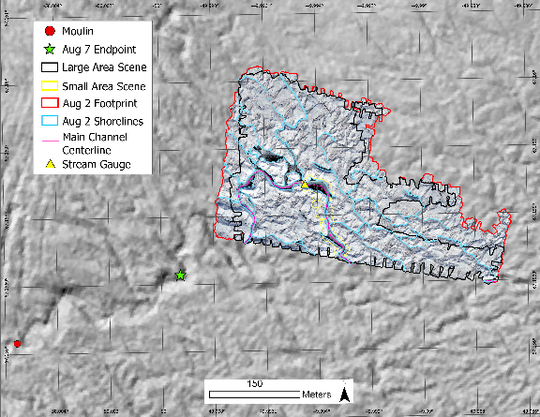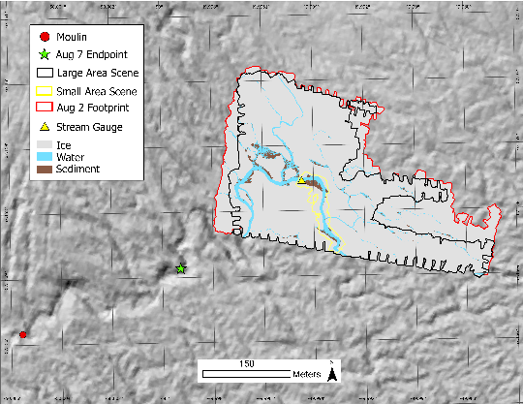
Supplementary Figure 3: Map depicting the mosaiced UAV imagery collected on August 2, 2019 (above) and the supervised classification of that imagery (below) along with the hand digitized stream shorelines (light blue), location of the centerline of the main channel (pink), the footprint of the mosaic imagery (red), the outline of the large and small area scene used for analysis of stream and sediment statistics (black and yellow respectively), the location of the furthest visible downstream location of the main channel from August 7th, 2019 (green star), the moulin (red circle), and the location of the stream gauge used to determine water level throughout the field season (yellow triangle). Background imagery is a hillshade of the ArcticDEM (Polar Geospatial Center et al., 2018) collected on August 20th, 2018.
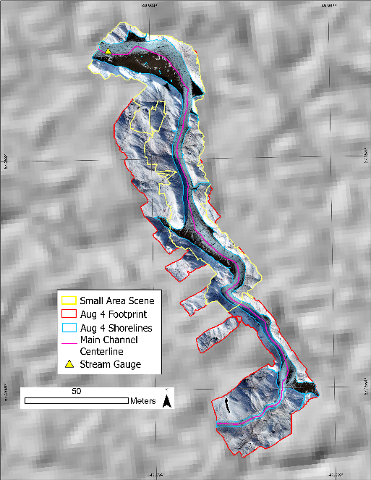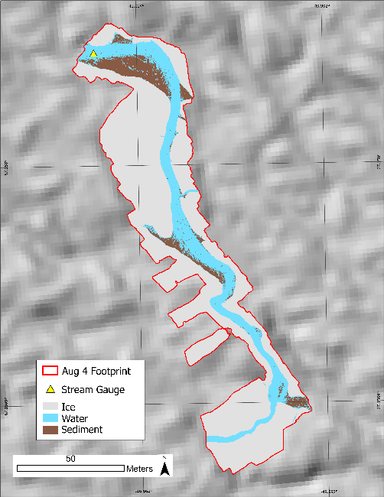
Supplementary Figure 4: Map depicting the mosaiced UAV imagery collected on August 4, 2019 (left) and the supervised classification of that imagery (right) along with the hand digitized stream shorelines (light blue), location of the centerline of the main channel (pink), the footprint of the mosaic imagery and small area scene (red and yellow respectively), and the location of the stream gauge used to determine water level throughout the field season (yellow triangle). Background imagery is a hillshade of the ArcticDEM (Polar Geospatial Center et al., 2018) collected on August 20th, 2018.
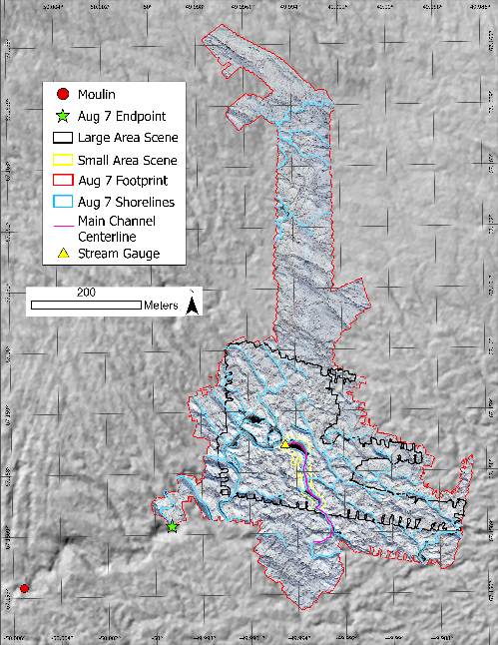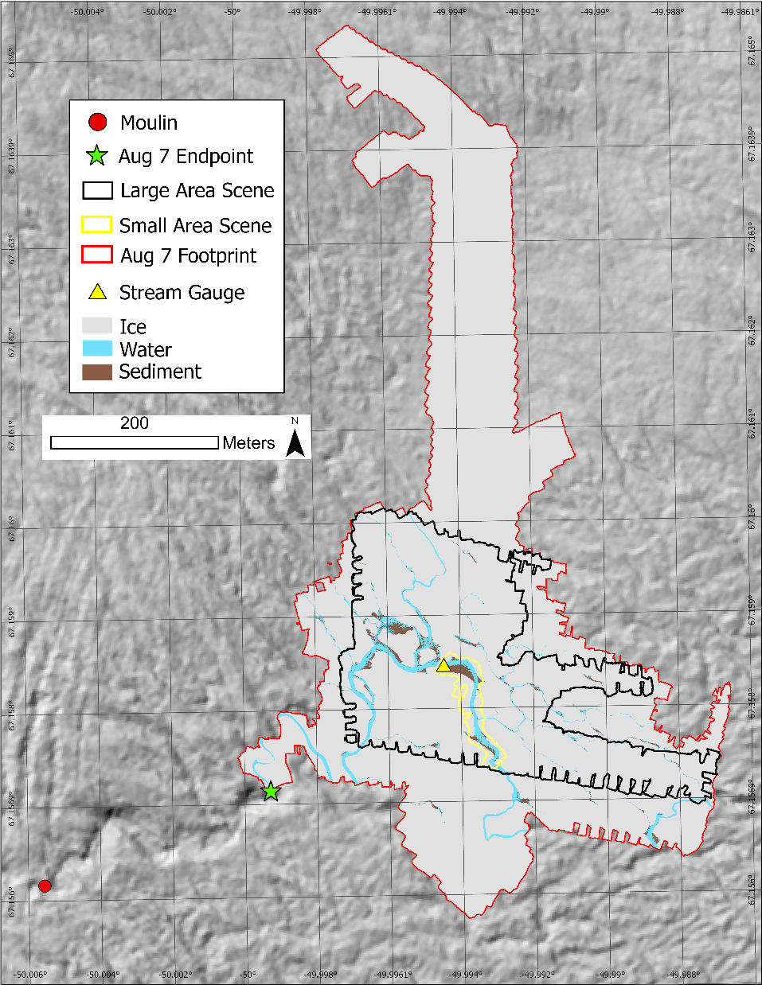
Supplementary Figure 5: Maps depicting the mosaiced UAV imagery collected on August 7, 2019 (left) and the supervised classification of that imagery (right) along with the hand digitized stream shorelines (light blue), location of the centerline of the main channel (pink), the outline of the large and small area scene used for analysis of stream and sediment statistics (black and yellow respectively), the footprint of the mosaic imagery (red), the location of the furthest visible downstream location of the main channel (green star), the moulin (red dot), and the location of the stream gauge used to determine water level throughout the field season (yellow triangle). Background imagery is a hillshade of the ArcticDEM (Polar Geospatial Center et al., 2018) collected on August 20th, 2018.
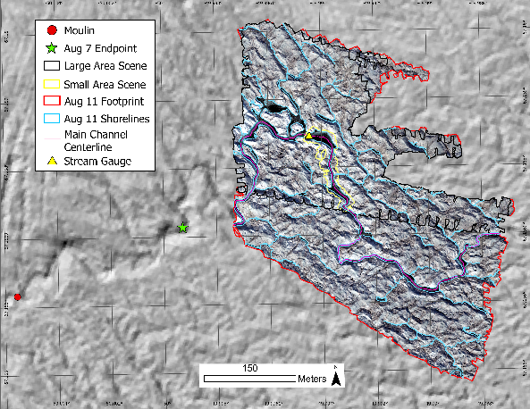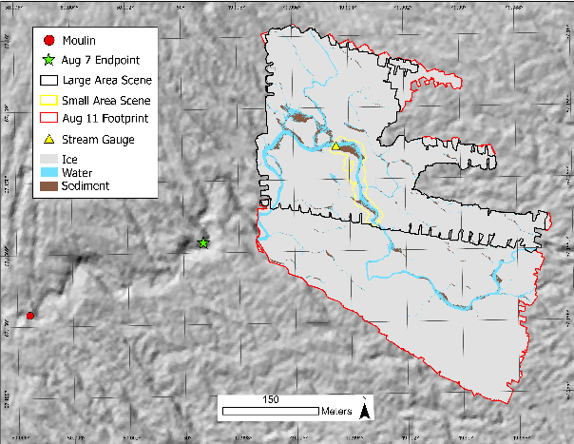
Supplementary Figure 6: Map depicting the mosaiced UAV imagery collected on August 11th, 2019 (above) and the supervised classification of that imagery (below) along with the hand digitized stream shorelines (light blue), location of the centerline of the main channel (pink), the outline of the large and small area scene used for analysis of stream and sediment statistics (black and yellow respectively), the footprint of the mosaic imagery (red), the location of the furthest visible downstream location of the main channel from August 7, 2019 (green star), the moulin (red dot), and the location of the stream gauge used to determine water level throughout the field season (yellow triangle). Background imagery is a hillshade of the ArcticDEM (Polar Geospatial Center et al., 2018) collected on August 20th, 2018.
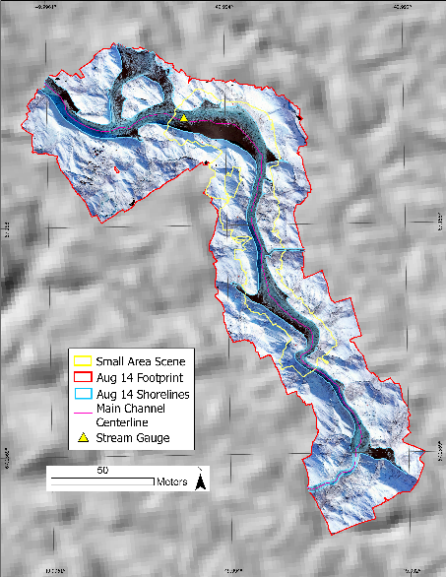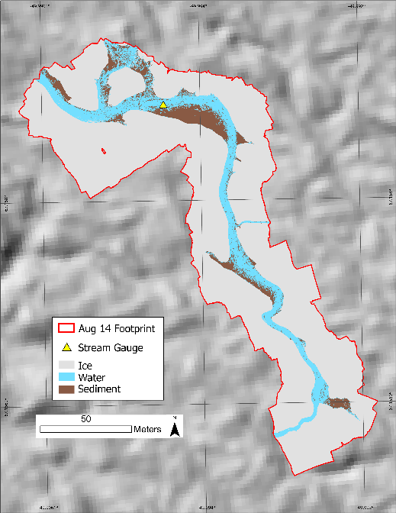
Supplementary Figure 7: Map depicting the mosaiced UAV imagery collected on August 14, 2019 (left) and the supervised classification of that imagery (right) along with the hand digitized stream shorelines (light blue), location of the centerline of the main channel (pink), the footprint of the mosaic imagery (red), the outline of the small area scene used for analysis of stream and sediment statistics (yellow), and the location of the stream gauge used to determine water level throughout the field season (yellow triangle). Background imagery is a hillshade of the ArcticDEM (Polar Geospatial Center et al., 2018) collected on August 20th, 2018.
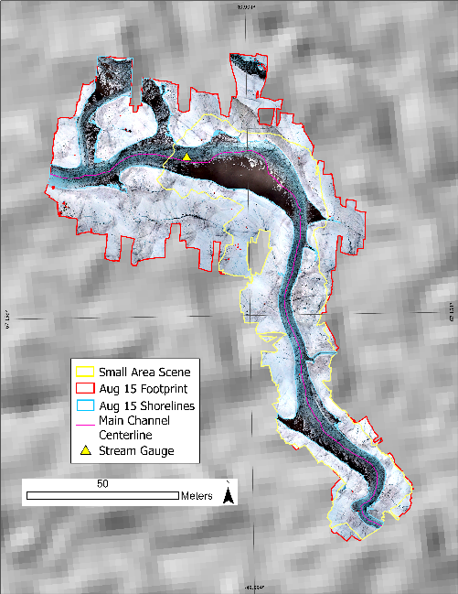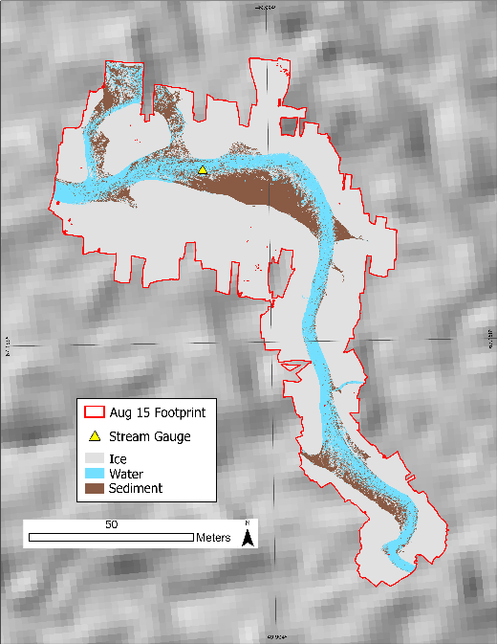
Supplementary Figure 8: Map depicting the mosaiced UAV imagery collected on August 15, 2019 (left) and the supervised classification of that imagery (right) along with the hand digitized stream shorelines (light blue), location of the centerline of the main channel (pink), the footprint of the mosaic imagery (red), the outline of the small area scene used for analysis of stream and sediment statistics (yellow), and the location of the stream gauge used to determine water level throughout the field season (yellow triangle). Background imagery is a hillshade of the ArcticDEM (Polar Geospatial Center et al., 2018) collected on August 20th, 2018.

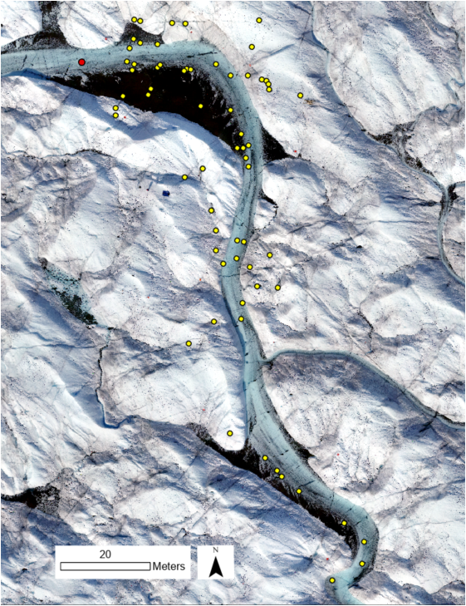
Supplementary Figure 9: Map showing the location of reflectance measurements made using the Analytical Spectral Devices (ASD) Fieldspec4 Pro spectrometer in yellow and the water stage logger in red. Background imagery is from the August 17th UAV flight.

Supplementary Figure 10: Stage height (also known as water level) recorded in the main channel using a LevelloggerTM. Stage was corrected for changes in atmospheric pressure using a Barologger placed on shore ~100 m away from the in-stream logger. The Levellogger was placed in a perforated metal box attached to a pole drilled in place in the middle of the channel. Measurements were taken every minute.

Supplementary Figure 11: Rating curve showing the relationship between observed Levellogger water level measurements (h) and Flowtracker2 ADV discharge measurements (Q) (Left). Relationship between runoff values from MAR v3.11.5 (R) and daily averaged discharge extrapolated from the rating curve for the main stream channel extrapolated from continuously monitored stream stage and a rating curve derived from 33 river discharge measurements throughout the observation period (Right).

Supplementary Figure 12: Relationship between water surface slope and classified sediment cover for each 1 m section of the main channel. Plot on the right is the absolute value of the values presented in the plot on the left with a log scale for the X-axis.

Supplementary Figure 13: Relationship between stream width and average incoming solar radiation for each 1 m stream section within the 22-July flight footprint. The regression line shows the relationship between stream width (w) and incoming solar radiation (Radiation).
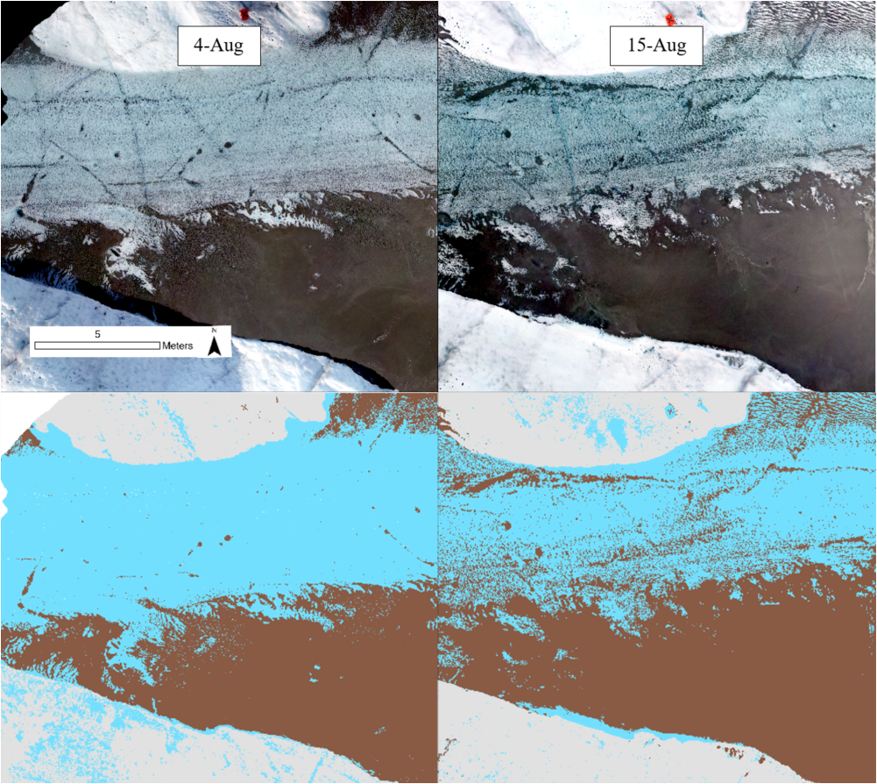
Supplementary Figure 14: Orthomosaic imagery of a section of the stream channel collected on August 4th, 2019 (Upper Left) and August 15th, 2019 (Upper Right) as well as the results of the Maximum Likelihood supervised classification for August 4th (Lower Left) and August 15th (Lower Right) after in-stream ice pixels were converted to water. August 4th and August 15th represent the flight dates with the lowest and highest sediment cover respectively.

Supplementary Figure. 15: Relationship between stream width (w) and sediment cover (SC) with regression lines for each flight. All relationships are statistically significant (p<<0.01).

Supplementary Figure 16: Box plot showing the minimum, quartile, median, and max values of incoming solar radiation for bare ice and water and sediment inside and outside of the digitized stream boundary for 22-July (referred to as Rive and No River in the figure respectively).

Supplementary Figure 17: Fourier analysis of the periodicity of average sediment cover along the main channel stream length. Peaks at 128 and 512 meters indicated that sediment concentrations peak at each of those intervals. The line has been smoothed to better represent the data.

Supplementary Figure 18: Rose diagram showing the orientation of all of the streams digitized from the July 22nd, 2019 flight. Stream sections were partitioned at junction points with tributaries and the orientation was determined in ArcGIS Pro in a UTM 22N projection. Values in the figure indicate the percentage of streams within the image extent that are oriented within 22.5 degrees of the indicated direction and have lengths less than the value shown on the right. The diagram shows that streams are predominantly oriented in the NW/SE orientation, especially larger streams.

Supplementary Figure 19: Average of sediment cover in each 1 m zone of the main stream channel between 582 and 757 meters from the 7-Aug endpoint with vertical bars at each point indicating the standard deviation of sediment cover values. This stream reach corresponds to the section where all 7 flights overlap. The blue line indicates the average daily water level recorded within the main channel. The black dots indicate the average sediment cover for each 1 m cross-sectional zone for each flight.

Supplementary Figure 20: Daily average wind speed measurements between the flight dates of this study. Measurements were taken from the KAN_L station operated by PROMICE. d is equal to the number of days since January 1st, 1900.

