Supplementary Figures:

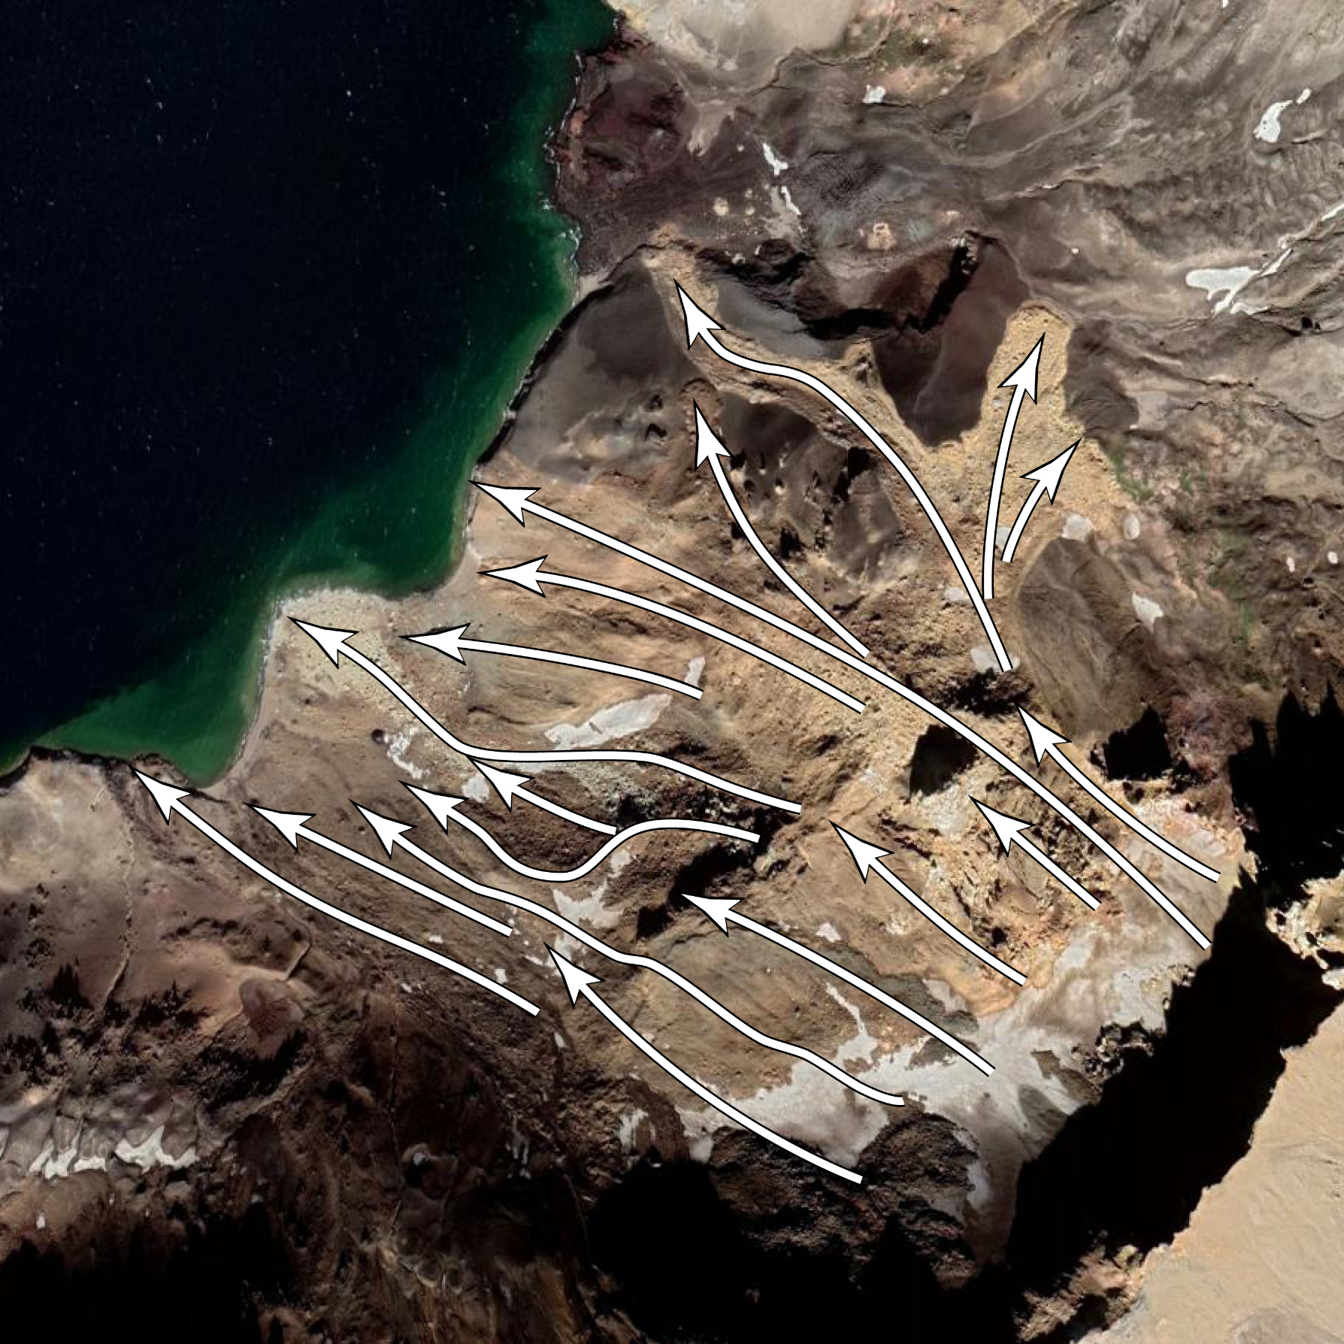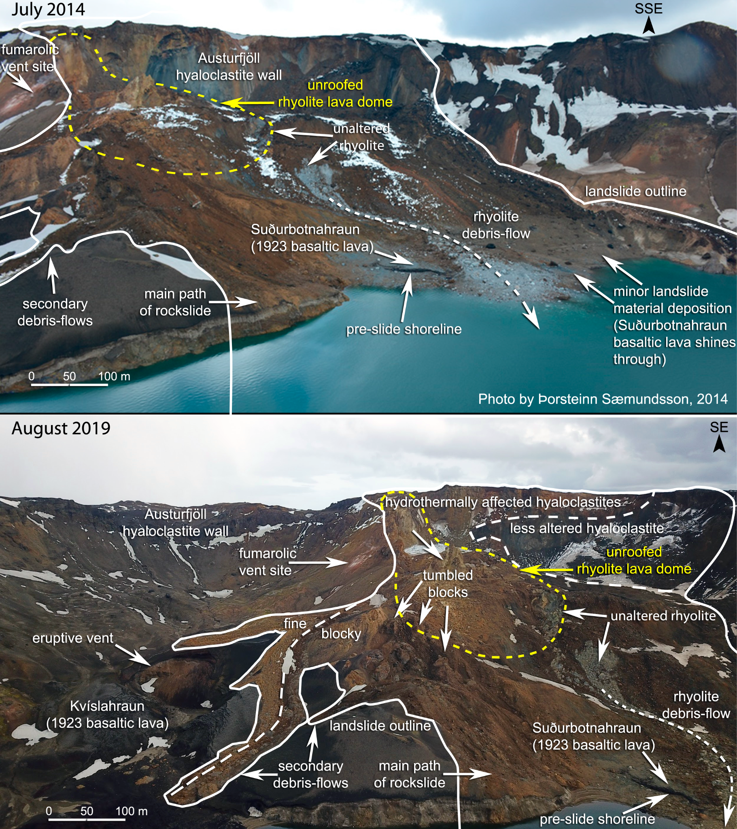
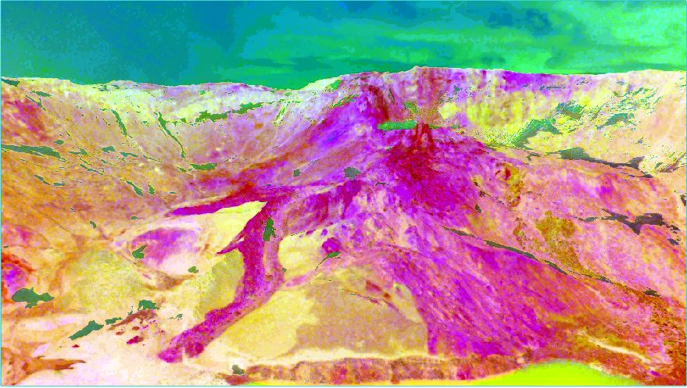
Fig. S1. [Upper left] Nadir view of landslide area from google earth and direction of mass movement. [Upper right] High resolution aerial view of the 2014 landslide as seen by drone hovering above Öskjuvatn. [Bottom] RGB composite of the 3 principal components derived from the drone image by means of PCA. Viewing direction is towards the East. The brownish mix of materials in the landslide and the hydrothermally altered rocks in the caldera wall are highlighted by PCA in dark red to magenta colors.

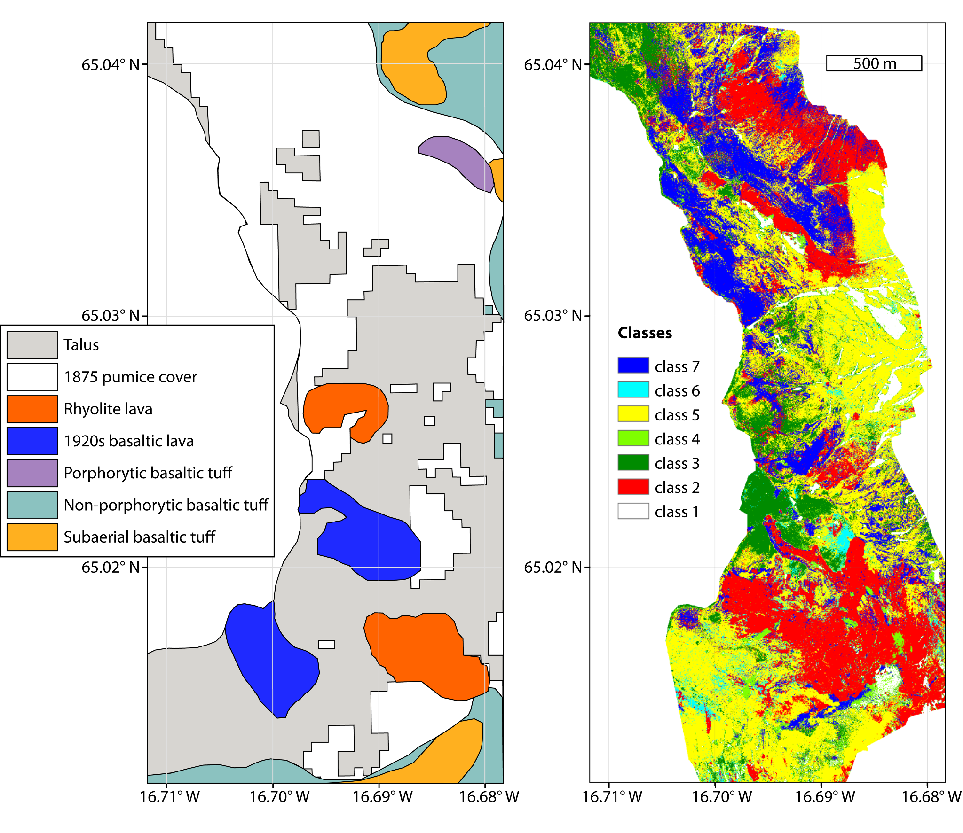Fig. S2. Thematic maps of the study area A. adapted from literature (Graettinger et al., 2013 and Graettinger, 2012) compared to B. our classification. Talus in A corresponds to classes 2 and 5 in B. Pumice cover in A is clipped to the Askja/Öskjuvatn caldera, while these outlines are not resolved in B, but differentiated as any of the classes 1 to 7. Basaltic lava in A corresponds to classes 3 and 6 in B. Rhyolite, non-porphyritic basaltic tuff and subaerial basaltic tuff are not resolved in B, though much of the class 2 material in B consists of hydrothermally altered rhyolite found in the northern section of the landslide.
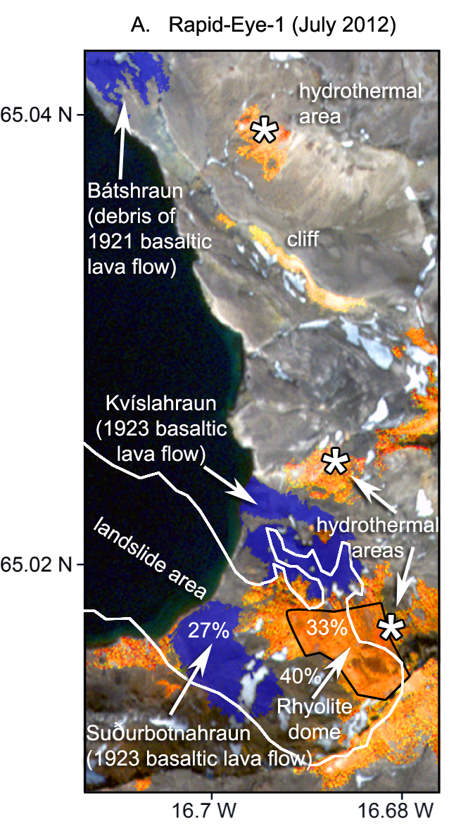
Fig. S3. Rapid-Eye-1 scene of 2012 showing the pre-slide material coverage of the landslide depositional area. Prior to the slide, 27 % of the 0.77 km² large area were covered by basaltic lava flows (blue), 33% by altered rocks (orange), and 40% by undifferentiated talus (not colorized). Areas covered by altered rocks were highlighted and extracted by means of saturation stretch applied to the image in HSL color space. Areas covered by basaltic lava flows were selected on the basis of similar colorization of pixels within corresponding outlines given in the geological maps of Graettinger et al..

