Supplementary Material

The recurrent pathogenic Pro890Leu substitution in CLTC affects clathrin-mediated endocytosis and synaptic transmission
Luca Pannone, Valentina Muto, Francesca Nardecchia, Martina Di Rocco, Emilia Marchei, Federica Tosato, Stefania Petrini, Giada Onorato, Enrico Lanza, Lucia Bertuccini, Filippo Manti, Viola Folli, Serena Galosi, Elia Di Schiavi, Vincenzo Leuzzi, Marco Tartaglia*, Simone Martinelli*
*Correspondence: Simone Martinelli, simone.martinelli@iss.it or Marco Tartaglia, marco.tartaglia@opbg.net

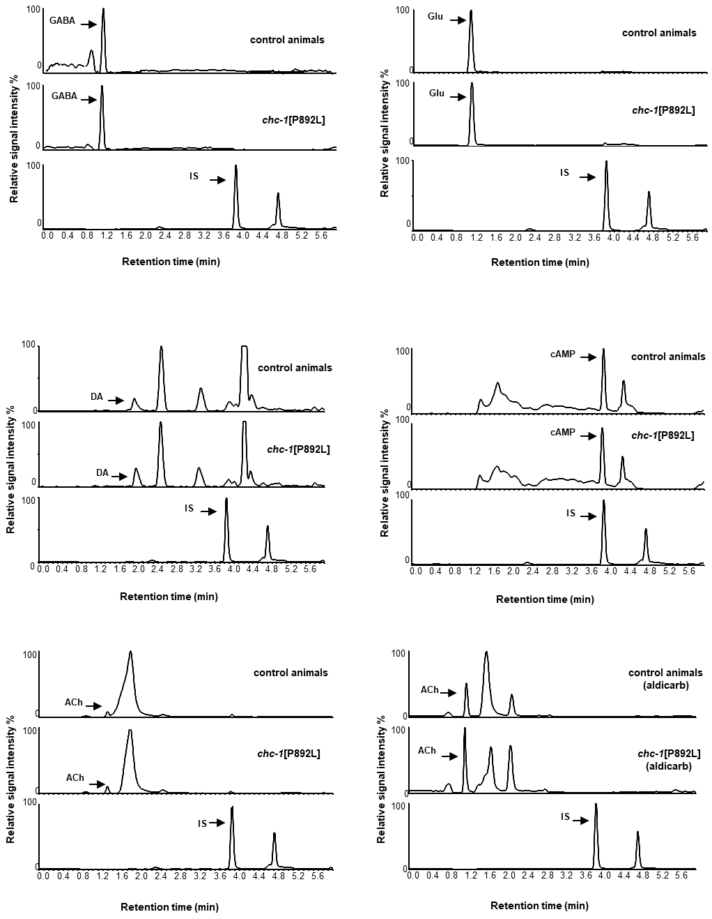

Supplementary Figure S5. UHPLC–MS/MS chromatograms. MRM traces of gamma-amino butyric acid (GABA), glutamic acid (Glu), acetylcholine (ACh), dopamine (DA), cyclic adenosine monophosphate (cAMP), and isoproterenol (internal standard, IS) in control and chc-1[P890L] animals. For ACh quantification, nematodes were treated with aldicarb, an acetylcholinesterase inhibitor, in order to avoid ACh degradation. The quantifier mass transition (see Table 2) of neurotransmitters and the internal standard are shown.
Supplementary Table S1. Mobile-phase gradient in UHPLC-MS/MS separation.
Time (min) | % mobile phase A | % mobile phase B
0 | 99.0 | 1.0
0.50 | 99.0 | 1.0
1.20 | 90.0 | 10.0
1.50 | 80.0 | 20.0
1.90 | 75.0 | 25.0
2.80 | 40.0 | 60.0
3.20 | 20.0 | 80.0
3.25 | 0.0 | 100.0
4.25 | 0.0 | 100.0
5.00 | 99.0 | 1.0
10.00 | 99.0 | 1.0

Supplementary Table S2. UHPLC–MS/MS parameters for the MRM acquisition mode (quantification and confirmation).
Analytes | Relative Retention time | MRM transitions
 |  | Quantification |  |  | Confirmation
 |  | m/z | CVª | CE^{b} | m/z | CVª | CE^{b}
GABA | 0.30 | 103.90 > 86.80 | 16 | 8 | 103.90 > 68.90 | 16 | 14
Glu | 0.30 | 148.00 > 84.00 | 16 | 14 | 148.00 > 101.90 | 16 | 12
Ach | 0.35 | 146.20 > 87.00 | 20 | 14 | 146.20 > 60.00 | 20 | 14
DA | 0.63 | 153.90 > 136.80 | 20 | 10 | 153.90 > 91.00 | 20 | 28
cAMP | 1.01 | 330.27 > 136.05 | 30 | 22 | 330.27 > 119.05 | 30 | 46
Isoproterenol (IS)^{c} | 1.00 | 212.20 > 194.21 | 20 | 10
ªCV, cone voltage; ^{b}CE, collision energy; ^{c}IS, internal standard.

