Table S1. Sampling conditions.
Sites | Shrimp fishing area | Latitude / Longitude | Sampling date | Fishing depth | Fishing gear
Northeast Newfoundland Coast | SFA-6 | 50° 18' N / 54° 1 W | 2019-10-20 | 250–275 m | Commercial shrimp trawl
St. Lawrence Estuary | SFA-12 | 48° 36' N / 68° 35' W | 2018-05-23 to 2018-05-28 | 120–150 m | Rigid frame trawl
Eastern Scotian Shelf | SFA-15 | 45° 23' N / 61° 2' W | 2019-02-17 | 50–100 m | Shrimp traps

Table S2. Individuals pooled for de novo transcriptome construction. Origin, physiological and laboratory conditions of individuals whose RNA extracted from abdominal muscle was used to construct the de novo transcriptome of Pandalus borealis.
ID | BioSamples accession number * | Origin | Geographical coordinate | Sex | Physiological condition | Oxygen (%) | pH_{T} (total scale) | Temperature (°C)
TPB002 | NA | Offshore of Rimouski | 48° 40' N 68° 35' W | Female | Stable at bottom | 100 | 7.9 | 4.5
TPB003 | NA | Offshore of Rimouski | 48° 40' N 68° 35' W | Female | Stable at bottom | 100 | 7.9 | 4.5
TPB004 | NA | Offshore of Rimouski | 48° 40' N 68° 35' W | Female | Stable at bottom | 100 | 7.9 | 4.5
TPB005 | NA | Offshore of Rimouski | 48° 40' N 68° 35' W | Female | Stable at bottom | 100 | 7.9 | 4.5
TPB008 | NA | Offshore of Rimouski | 48° 40' N 68° 35' W | Male | Stable at bottom | 100 | 7.9 | 4.5
TPB009 | NA | Offshore of Rimouski | 48° 40' N 68° 35' W | Male | Stable at bottom | 100 | 7.9 | 4.5
TPB011 | NA | Offshore of Rimouski | 48° 40' N 68° 35' W | Male | Stable at bottom | 100 | 7.9 | 4.5
TPB013 | NA | Offshore of Rimouski | 48° 40' N 68° 35' W | NA | Swimming | 100 | 7.9 | 4.5
TPB014 | NA | Offshore of Rimouski | 48° 40' N 68° 35' W | NA | Swimming | 100 | 7.9 | 4.5
TPB015 | NA | Offshore of Rimouski | 48° 40' N 68° 35' W | NA | Swimming | 100 | 7.9 | 4.5
TPB016 | NA | Offshore of Rimouski | 48° 40' N 68° 35' W | NA | Swimming | 100 | 7.9 | 4.5
TPB018 | NA | Offshore of Rimouski | 48° 40' N 68° 35' W | NA | Dying | 100 | 7.9 | 4.5
TPB019 | NA | Offshore of Rimouski | 48° 40' N 68° 35' W | NA | Dying | 100 | 7.9 | 4.5
TPB020 | NA | Offshore of Rimouski | 48° 40' N 68° 35' W | NA | Dying | 100 | 7.9 | 4.5
TPB021 | NA | Offshore of Rimouski | 48° 40' N 68° 35' W | NA | Dying | 100 | 7.9 | 4.5
TPB022 | NA | Esquiman | 50° 44' N 57° 29' W | Female | NA | 100 | 7.75 | 10
TPB024 | NA | Esquiman | 50° 44' N 57° 29' W | Female | NA | 100 | 7.75 | 10
TPB030 | NA | Esquiman | 50° 44' N 57° 29' W | Female | NA | 100 | 7.75 | 6
TPB031 | NA | Esquiman | 50° 44' N 57° 29' W | Female | NA | 100 | 7.75 | 2
TPB032 | NA | Esquiman | 50° 44' N 57° 29' W | Female | NA | 100 | 7.75 | 2
TPB033 | NA | Esquiman | 50° 44' N 57° 29' W | Female | NA | 100 | 7.75 | 2
TPB034 | NA | Esquiman | 50° 44' N 57° 29' W | Female | NA | 100 | 7.75 | 6
TPB035 | NA | Esquiman | 50° 44' N 57° 29' W | Female | NA | 100 | 7.75 | 6
TPB036 | NA | Esquiman | 50° 44' N 57° 29' W | Female | NA | 100 | 7.75 | 6
TPB038 | NA | Esquiman | 50° 44' N 57° 29' W | Female | NA | 100 | 7.4 | 2
TPB039 | NA | Esquiman | 50° 44' N 57° 29' W | Female | NA | 100 | 7.4 | 2
TPB041 | NA | Esquiman | 50° 44' N 57° 29' W | Female | NA | 100 | 7.4 | 6
TPB058 | NA | NNC | 50° 18' N 54° 17' W | Female | NA | 100 | 7.4 | 2
TPB059 | NA | NNC | 50° 18' N 54° 17' W | Female | NA | 100 | 7.4 | 2
TPB060 | NA | NNC | 50° 18' N 54° 17' W | Female | NA | 100 | 7.4 | 2
TPB061 | SAMN32174160 | NNC | 50° 18' N 54° 17' W | Female | NA | 100 | 7.75 | 10
TPB062 | SAMN32174168 | NNC | 50° 18' N 54° 17' W | Female | NA | 100 | 7.75 | 10
TPB063 | SAMN32174176 | NNC | 50° 18' N 54° 17' W | Female | NA | 100 | 7.75 | 10
TPB064 | NA | NNC | 50° 18' N 54° 17' W | Female | NA | 100 | 7.4 | 2
TPB065 | NA | NNC | 50° 18' N 54° 17' W | Female | NA | 100 | 7.4 | 2
TPB066 | NA | NNC | 50° 18' N 54° 17' W | Female | NA | 100 | 7.4 | 2
TPB067 | SAMN32174193 | NNC | 50° 18' N 54° 17' W | Female | NA | 100 | 7.75 | 2
TPB068 | SAMN32174201 | NNC | 50° 18' N 54° 17' W | Female | NA | 100 | 7.75 | 2
TPB069 | SAMN32174208 | NNC | 50° 18' N 54° 17' W | Female | NA | 100 | 7.75 | 2
TPB070 | SAMN32174207 | NNC | 50° 18' N 54° 17' W | Female | NA | 100 | 7.75 | 6
TPB071 | SAMN32174214 | NNC | 50° 18' N 54° 17' W | Female | NA | 100 | 7.75 | 6
TPB072 | SAMN32174161 | NNC | 50° 18' N 54° 17' W | Female | NA | 100 | 7.75 | 6
TPB073 | SAMN32174215 | NNC | 50° 18' N 54° 17' W | Female | NA | 100 | 7.75 | 2
TPB074 | SAMN32174162 | NNC | 50° 18' N 54° 17' W | Female | NA | 100 | 7.75 | 2
TPB075 | SAMN32174170 | NNC | 50° 18' N 54° 17' W | Female | NA | 100 | 7.75 | 2
TPB076 | NA | NNC | 50° 18' N 54° 17' W | Female | NA | 100 | 7.75 | 2
TPB077 | NA | NNC | 50° 18' N 54° 17' W | Female | NA | 100 | 7.75 | 2
TPB078 | NA | NNC | 50° 18' N 54° 17' W | Female | NA | 100 | 7.75 | 2
TPB079 | NA | NNC | 50° 18' N 54° 17' W | Female | NA | 100 | 7.4 | 6
TPB080 | NA | NNC | 50° 18' N 54° 17' W | Female | NA | 100 | 7.4 | 6
TPB081 | NA | NNC | 50° 18' N 54° 17' W | Female | NA | 100 | 7.4 | 6
TPB082 | SAMN32174184 | NNC | 50° 18' N 54° 17' W | Female | NA | 100 | 7.75 | 10
TPB083 | SAMN32174192 | NNC | 50° 18' N 54° 17' W | Female | NA | 100 | 7.75 | 10
TPB084 | SAMN32174200 | NNC | 50° 18' N 54° 17' W | Female | NA | 100 | 7.75 | 10
TPB085 | SAMN32174169 | NNC | 50° 18' N 54° 17' W | Female | NA | 100 | 7.75 | 6
TPB086 | SAMN32174177 | NNC | 50° 18' N 54° 17' W | Female | NA | 100 | 7.75 | 6
TPB087 | SAMN32174185 | NNC | 50° 18' N 54° 17' W | Female | NA | 100 | 7.75 | 6
TPB088 | NA | NNC | 50° 18' N 54° 17' W | Female | NA | 100 | 7.4 | 10
TPB089 | NA | NNC | 50° 18' N 54° 17' W | Female | NA | 100 | 7.4 | 10
TPB090 | NA | NNC | 50° 18' N 54° 17' W | Female | NA | 100 | 7.4 | 10
TPB091 | NA | NNC | 50° 18' N 54° 17' W | Female | NA | 100 | 7.4 | 10
TPB092 | NA | NNC | 50° 18' N 54° 17' W | Female | NA | 100 | 7.4 | 10
TPB093 | NA | NNC | 50° 18' N 54° 17' W | Female | NA | 100 | 7.4 | 10
TPB094 | SAMN32174178 | SLE | 48° 35' N 68° 36' W | Female | NA | 100 | 7.75 | 6
TPB095 | SAMN32174186 | SLE | 48° 35' N 68° 36' W | Female | NA | 100 | 7.75 | 6
TPB096 | SAMN32174194 | SLE | 48° 35' N 68° 36' W | Female | NA | 100 | 7.75 | 6
TPB097 | SAMN32174202 | SLE | 48° 35' N 68° 36' W | Female | NA | 100 | 7.75 | 2
TPB098 | SAMN32174209 | SLE | 48° 35' N 68° 36' W | Female | NA | 100 | 7.75 | 2
TPB099 | SAMN32174216 | SLE | 48° 35' N 68° 36' W | Female | NA | 100 | 7.75 | 2
TPB100 | SAMN32174163 | SLE | 48° 35' N 68° 36' W | Female | NA | 100 | 7.75 | 10
TPB101 | SAMN32174171 | SLE | 48° 35' N 68° 36' W | Female | NA | 100 | 7.75 | 10
TPB102 | SAMN32174179 | SLE | 48° 35' N 68° 36' W | Female | NA | 100 | 7.75 | 10
TPB103 | SAMN32174187 | SLE | 48° 35' N 68° 36' W | Female | NA | 100 | 7.75 | 2
TPB104 | SAMN32174195 | SLE | 48° 35' N 68° 36' W | Female | NA | 100 | 7.75 | 2
TPB105 | SAMN32174203 | SLE | 48° 35' N 68° 36' W | Female | NA | 100 | 7.75 | 2
TPB106 | SAMN32174210 | SLE | 48° 35' N 68° 36' W | Female | NA | 100 | 7.75 | 6
TPB107 | SAMN32174217 | SLE | 48° 35' N 68° 36' W | Female | NA | 100 | 7.75 | 6
TPB108 | SAMN32174164 | SLE | 48° 35' N 68° 36' W | Female | NA | 100 | 7.75 | 6
TPB109 | SAMN32174172 | SLE | 48° 35' N 68° 36' W | Female | NA | 100 | 7.75 | 10
TPB110 | SAMN32174180 | SLE | 48° 35' N 68° 36' W | Female | NA | 100 | 7.75 | 10
TPB111 | SAMN32174188 | SLE | 48° 35' N 68° 36' W | Female | NA | 100 | 7.75 | 10
TPB112 | NA | SLE | 48° 35' N 68° 36' W | Female | NA | 30 | 7.9 | 4.5
TPB113 | NA | SLE | 48° 35' N 68° 36' W | Female | NA | 30 | 7.9 | 4.5
TPB114 | NA | SLE | 48° 35' N 68° 36' W | Female | NA | 30 | 7.9 | 4.5
TPB115 | NA | SLE | 48° 35' N 68° 36' W | Female | NA | 30 | 7.9 | 4.5
TPB116 | NA | SLE | 48° 35' N 68° 36' W | Female | NA | 30 | 7.9 | 4.5
TPB117 | NA | SLE | 48° 35' N 68° 36' W | Female | NA | 30 | 7.9 | 4.5
TPB118 | SAMN32174181 | ESS | 45° 23' N 61° 2' W | Female | NA | 100 | 7.75 | 10
TPB119 | SAMN32174189 | ESS | 45° 23' N 61° 2' W | Female | NA | 100 | 7.75 | 10
TPB120 | SAMN32174197 | ESS | 45° 23' N 61° 2' W | Female | NA | 100 | 7.75 | 10
TPB121 | NA | ESS | 45° 23' N 61° 2' W | Female | NA | 100 | 7.4 | 10
TPB122 | NA | ESS | 45° 23' N 61° 2' W | Female | NA | 100 | 7.4 | 10
TPB123 | NA | ESS | 45° 23' N 61° 2' W | Female | NA | 100 | 7.4 | 10
TPB124 | NA | ESS | 45° 23' N 61° 2' W | Female | NA | 100 | 7.4 | 2
TPB125 | NA | ESS | 45° 23' N 61° 2' W | Female | NA | 100 | 7.4 | 2
TPB126 | NA | ESS | 45° 23' N 61° 2' W | Female | NA | 100 | 7.4 | 2
TPB127 | SAMN32174205 | ESS | 45° 23' N 61° 2' W | Female | NA | 100 | 7.75 | 2
TPB128 | SAMN32174212 | ESS | 45° 23' N 61° 2' W | Female | NA | 100 | 7.75 | 2
TPB129 | SAMN32174219 | ESS | 45° 23' N 61° 2' W | Female | NA | 100 | 7.75 | 2
TPB130 | SAMN32174166 | ESS | 45° 23' N 61° 2' W | Female | NA | 100 | 7.75 | 10
TPB131 | SAMN32174174 | ESS | 45° 23' N 61° 2' W | Female | NA | 100 | 7.75 | 10
TPB132 | SAMN32174182 | ESS | 45° 23' N 61° 2' W | Female | NA | 100 | 7.75 | 10
TPB133 | NA | ESS | 45° 23' N 61° 2' W | Female | NA | 100 | 7.4 | 6
TPB134 | NA | ESS | 45° 23' N 61° 2' W | Female | NA | 100 | 7.4 | 6
TPB135 | NA | ESS | 45° 23' N 61° 2' W | Female | NA | 100 | 7.4 | 6
TPB136 | NA | ESS | 45° 23' N 61° 2' W | Female | NA | 100 | 7.4 | 6
TPB137 | NA | ESS | 45° 23' N 61° 2' W | Female | NA | 100 | 7.4 | 6
TPB138 | NA | ESS | 45° 23' N 61° 2' W | Female | NA | 100 | 7.4 | 6
TPB139 | NA | ESS | 45° 23' N 61° 2' W | Female | NA | 100 | 7.4 | 2
TPB140 | NA | ESS | 45° 23' N 61° 2' W | Female | NA | 100 | 7.4 | 2
TPB141 | NA | ESS | 45° 23' N 61° 2' W | Female | NA | 100 | 7.4 | 2
TPB145 | SAMN32174190 | ESS | 45° 23' N 61° 2' W | Female | NA | 100 | 7.75 | 2
TPB146 | SAMN32174198 | ESS | 45° 23' N 61° 2' W | Female | NA | 100 | 7.75 | 2
TPB147 | SAMN32174206 | ESS | 45° 23' N 61° 2' W | Female | NA | 100 | 7.75 | 2
TPB148 | SAMN32174213 | ESS | 45° 23' N 61° 2' W | Female | NA | 100 | 7.75 | 6
TPB149 | SAMN32174220 | ESS | 45° 23' N 61° 2' W | Female | NA | 100 | 7.75 | 6
TPB150 | SAMN32174167 | ESS | 45° 23' N 61° 2' W | Female | NA | 100 | 7.75 | 6
TPB151 | SAMN32174175 | ESS | 45° 23' N 61° 2' W | Female | NA | 100 | 7.75 | 6
TPB152 | SAMN32174183 | ESS | 45° 23' N 61° 2' W | Female | NA | 100 | 7.75 | 6
TPB153 | SAMN32174191 | ESS | 45° 23' N 61° 2' W | Female | NA | 100 | 7.75 | 6
* BioSample accession number is provided for each of the 54 individuals from the temperature treatment experiment used in this study. BioSample accession number for the library of pooled individuals is SAMN32174199.
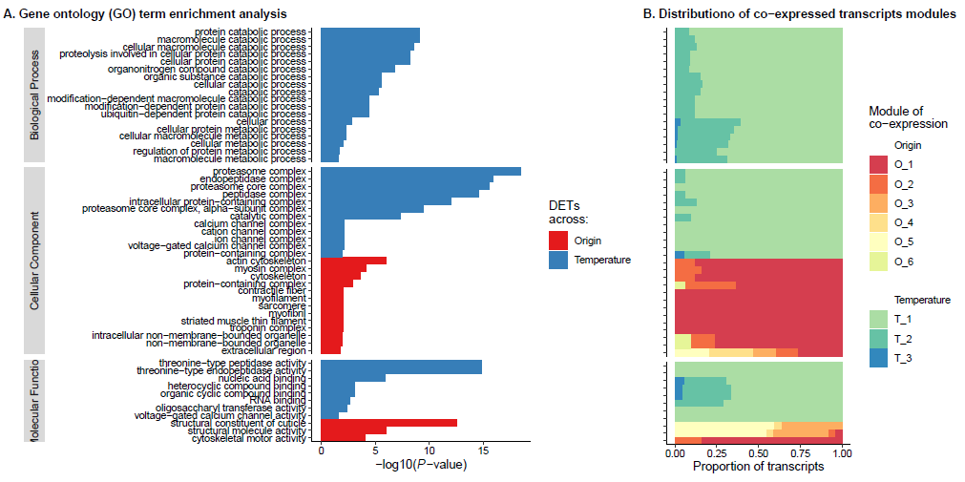
Figure S1. Functions of differentially expressed transcripts. A. GO enrichment analysis for transcripts differentially expressed across origins (red) and treatments (blues). Only enriched GO terms with FDR < 0.05 are represented. B. Distributions across GO terms of co-expressed transcripts modules. Module names beginning with O and T identify DETs across origin and treatment, respectively.

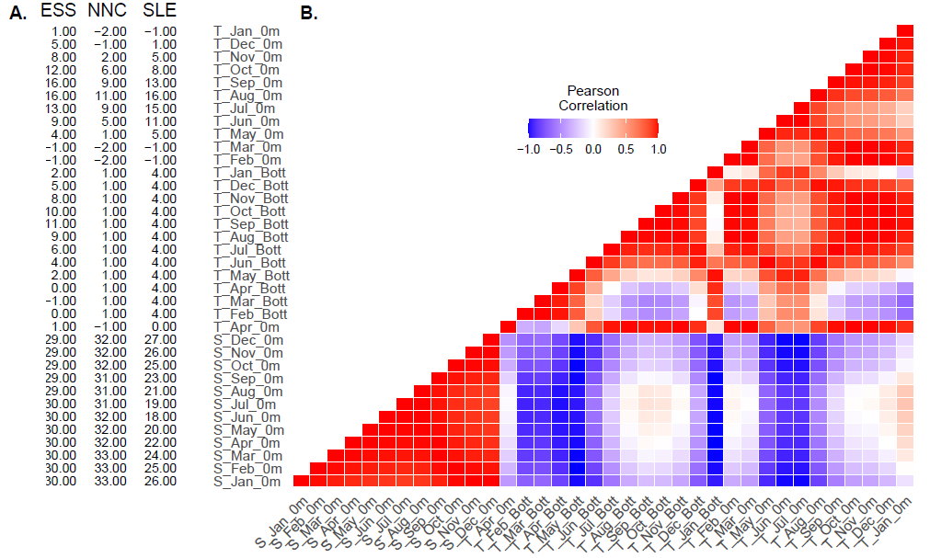
Figure S2. Environmental conditions of collecting sites. A. Raw mean monthly values of salinity (S in PSU) and temperature (T in °C) at sea surface (0m) and bottom (Bott). B. Correlation matrix of sampling site environmental data between pairs of each parameter.

